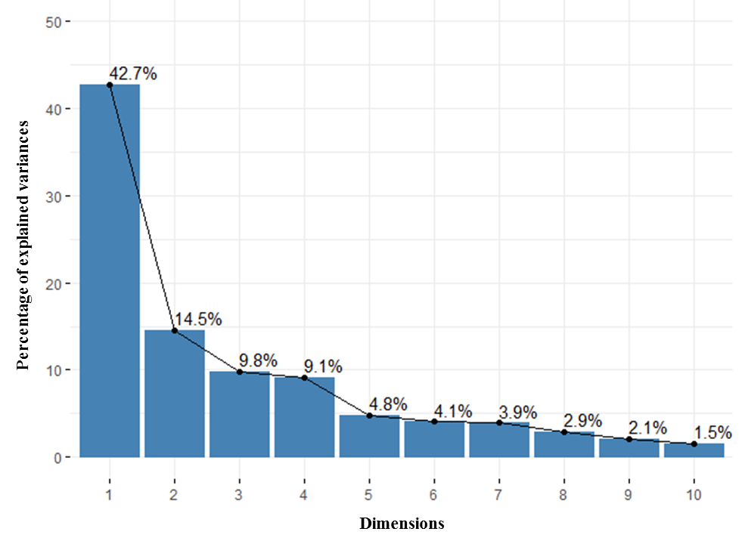

Fig. S1 Plot of eigenvalues from the PCA. The first two dimensions explained 57.2 % of the total inertia of the data.

Table S1 Description of the studied experimental site
Soil physico-chemical attributes before the installation of the previous crop (September 2017)
Soil depth | 0 – 20 cm | 20 – 40 cm
Texture
Clay | 20.5 | 21.2
Silt | 24.5 | 25.1
Sand | 55.5 | 53.7
pH_{water} | 5.46 | 5.44
EC (dS/m) | 0.87 | 0.46
Total CaCO3 (%) | 4.72 | 4.95
Active CaCO3 (%) | 3.47 | 3.62
OM (%) | 1.32 | 0.88
C (mg/g) | 10.39 | 5.97
Total N (mg/g) | 0.99 | 0.81
C/N | 10.5 | 7.37
Available P (mg/kg) | 9.75 | 9.4
Weather attributes during the two growing seasons (2017/2018)
Average annual rainfall (mm) | 160
Average annual temperature (° C) | 20.4
Average of maximal temperature of the warmest month (° C) | 36.4
Average of minimal temperature of the coldest month (°C) | 10

EC, electric conductivity; OM, organic matter; total CaCO₃, total calcium carbonate; active CaCO₃, active calcium carbonate; C, carbon; N, nitrogen; P, phosphorus; K, potassium; Na, sodium.

Table S2 Pearson correlation among measured parameters of pearl millet after barley as preceding crop
 | Chl a | Chl b | Chl a+b | Carote-noid | BF GS1 | BF GS2 | RC | DB | GY | TKW | N.Pa-  nicles | N. Tillers | Flavonoid | Poly- phenol | Soluble sugars | P | K | Na | Crude proteins | Fiber
Chl a | 1.00
Chl b | -0.31 | 1.00
Chl a+b | 0.88 **** | 0.16 | 1.00
Carotenoid | -0.29 | 0.51 * | -0.09 | 1.00
BF GS1 | 0.59 ** | 0.46 * | 0.79 **** | 0.34 | 1.00
BF GS2 | 0.36 | 0.63 ** | 0.64 ** | 0.52  * | 0.88 **** | 1.00
RC | 0.74 *** | 0.23 | 0.83 **** | 0.10 | 0.89 **** | 0.85 **** | 1.00
DB | 0.71 *** | 0.43 | 0.95 **** | 0.13 | 0.86 **** | 0.75 *** | 0.79 **** | 1.00
GY | 0.77 **** | 0.36 | 0.97 **** | 0.09 | 0.90 **** | 0.79 **** | 0.88 **** | 0.98 **** | 1.00
TKW | -0.52 * | 0.73 *** | -0.23 | 0.86 **** | 0.34 | 0.47 * | 0.02 | 0.04 | 0.01 | 1.00
N. Panicles | 0.32 | 0.74 *** | 0.66 | 0.24 | 0.88 **** | 0.87 **** | 0.78 **** | 0.78 **** | 0.81 **** | 0.42 | 1.00
N. Tillers | 0.80 **** | 0.29 | 0.96 **** | 0.16 | 0.84 **** | 0.77 **** | 0.85 **** | 0.97 **** | 0.98 **** | -0.03 | 0.70 *** | 1.00
Flavonoid | -0.01 | 0.32 | 0.13 | 0.87 **** | 0.39 | 0.38 | 0.08 | 0.31 | 0.24 | 0.65 ** | 0.16 | 0.33 | 1.00
Polyphenol | 0.86 **** | -0.17 | 0.82 **** | 0.02 | 0.58 ** | 0.32 | 0.52 * | 0.76 *** | 0.74 *** | -0.27 | 0.24 | 0.80 **** | 0.42 | 1.00
Soluble sugars | 0.36 | 0.20 | 0.39 | 0.60 ** | 0.79 **** | 0.75 *** | 0.72 *** | 0.43 | 0.52 | 0.51 * | 0.55 * | 0.50 | 0.52 * | 0.33 | 1.00
P | 0.40 | -0.80 **** | 0.00 | 0.04 | -0.09 | -0.28 | -0.02 | -0.18 | -0.12 | -0.31 | -0.53 * | -0.01 | 0.27 | 0.45 * | 0.28 | 1.00
K | 0.72 *** | -0.59 ** | 0.45 * | -0.05 | 0.32 | -0.04 | 0.28 | 0.31 | 0.33 | -0.33 | -0.13 | 0.39 | 0.33 | 0.81 **** | 0.37 | 0.84 **** | 1.00
Na | -0.13 | -0.03 | -0.19 | 0.83 **** | 0.15 | 0.17 | -0.05 | -0.10 | -0.10 | 0.58 ** | -0.16 | -0.01 | 0.85 **** | 0.18 | 0.59 ** | 0.57 ** | 0.38 | 1.00
Crude proteins | 0.08 | 0.00 | 0.07 | 0.67 ** | 0.22 | 0.08 | -0.08 | 0.19 | 0.11 | 0.40 | -0.11 | 0.21 | 0.93 **** | 0.52 * | 0.38 | 0.53 * | 0.57 ** | 0.85 **** | 1.00
Fiber | -0.47 * | 0.88 **** | -0.08 | 0.26 | 0.26 | 0.48 * | 0.15 | 0.13 | 0.11 | 0.63 ** | 0.65 ** | -0.01 | -0.07 | -0.53 * | 0.10 | -0.90 **** | -0.80 **** | -0.26 | -0.39 | 1.00

Table S3 Pearson correlation among measured parameters of pearl millet after fenugreek/barley as preceding crop
 | Chl a | Chl b | Chl a+b | Carote-noid | BF GS1 | BF GS2 | RC | DB | GY | TKW | N.Pa-  nicles | N. Tillers | Flavonoid | Poly- phenol | Soluble sugars | P | K | Na | Crude proteins | Fiber
Chl a | 1.00
Chl b | -0.26 | 1.00
Chl a+b | 0.97 **** | -0.30 | 1.00
Carotenoid | 0.15 | -0.66 ** | 0.11 | 1.00
BF GS1 | 0.94 **** | -0.52 * | 0.93 **** | 0.44 | 1.00
BF GS2 | 0.93 **** | -0.48 * | 0.97**** | 0.24 | 0.95 **** | 1.00
RC | 0.82**** | -0.42 | 0.92 **** | 0.09 | 0.83 **** | 0.95 **** | 1.00
DB | 0.95 **** | -0.20 | 0.98 **** | -0.02 | 0.86 **** | 0.95 **** | 0.93 **** | 1.00
GY | 0.90 **** | -0.38 | 0.97 **** | 0.09 | 0.88 **** | 0.98**** | 0.99 **** | 0.97 **** | 1.00
TKW | 0.86**** | 0.16 | 0.80 **** | -0.20 | 0.68 ** | 0.64 ** | 0.56 * | 0.77 **** | 0.65 | 1.00
N. Panicles | 0.85 **** | -0.60 ** | 0.91 **** | 0.25 | 0.90 **** | 0.98**** | 0.97**** | 0.90 **** | 0.97 **** | 0.51 | 1.00
N. Tillers | 0.94 **** | -0.10 | 0.97 **** | -0.13 | 0.82 **** | 0.90 **** | 0.88 **** | 0.99 **** | 0.94 **** | 0.86 **** | 0.84 **** | 1.00
Flavonoid | 0.75  *** | 0.09 | 0.60 ** | 0.30 | 0.67 ** | 0.51 * | 0.28 | 0.55 * | 0.42 | 0.76 **** | 0.33 | 0.57 ** | 1.00
Polyphenol | -0.74 *** | 0.30 | -0.84 **** | 0.18 | -0.68 ** | -0.87 **** | -0.95 **** | -0.90 **** | -0.93 **** | -0.51 * | -0.90 **** | -0.87 **** | -0.15 | 1.00
Soluble sugars | -0.51 * | 0.11 | -0.65 ** | 0.37 | -0.42 | -0.67 ** | -0.85 **** | -0.75 *** | -0.79 **** | -0.33 | -0.72  *** | -0.73 *** | 0.10 | 0.94 **** | 1.00
P | -0.22 | -0.76 *** | -0.07 | 0.34 | 0.03 | 0.12 | 0.26 | -0.10 | 0.12 | -0.59  ** | 0.31 | -0.20 | -0.67 ** | -0.22 | -0.27 | 1.00
K | 0.90 **** | -0.52 * | 0.96 **** | 0.19 | 0.92 **** | 0.99**** | 0.97**** | 0.94**** | 0.98**** | 0.62  ** | 0.99 **** | 0.90 **** | 0.41 | -0.90 **** | -0.72  *** | 0.20 | 1.00
Na | 0.89 **** | -0.39 | 0.79 **** | 0.45  * | 0.91 **** | 0.78 **** | 0.52 * | 0.71 *** | 0.66 ** | 0.72 *** | 0.68 ** | 0.69 *** | 0.86 **** | -0.42 | -0.10 | -0.25 | 0.73 *** | 1.00
Crude proteins | 0.76 **** | 0.28 | 0.80 **** | -0.28 | 0.58 ** | 0.69 *** | 0.73 *** | 0.86 **** | 0.78 **** | 0.77 **** | 0.59  ** | 0.89 **** | 0.53  * | -0.73 *** | -0.71 *** | -0.38 | 0.66 ** | 0.43 | 1.00
Fiber | 0.02 | 0.03 | 0.22 | -0.16 | 0.04 | 0.25 | 0.57 * | 0.30 | 0.40 | -0.17 | 0.33 | 0.25 | -0.38 | -0.52 * | -0.73 *** | 0.42 | 0.28 | -0.34 | 0.46  * | 1.00
Table S4 Pearson correlation among measured parameters of pearl millet after fenugreek as preceding crop
 | Chl a | Chl b | Chl a+b | Carote-noid | BF GS1 | BF GS2 | RC | DB | GY | TKW | N.Pa-  nicles | N. Tillers | Flavonoid | Poly- phenol | Soluble sugars | P | K | Na | Crude proteins | Fiber
Chl a | 1.00
Chl b | -0.41 | 1.00
Chl a+b | -0.82 **** | 0.34 | 1.00
Carotenoid | -0.93 **** | 0.56 * | 0.81 **** | 1.00
BF GS1 | -0.21 | 0.78 **** | 0.19 | 0.33 | 1.00
BF GS2 | 0.08 | 0.79 **** | -0.24 | 0.15 | 0.73 *** | 1.00
RC | 0.85 **** | -0.18 | -0.56 * | -0.76 **** | -0.28 | 0.07 | 1.00
DB | 0.63 ** | 0.24 | -0.63 ** | -0.39 | 0.02 | 0.63 ** | 0.72 *** | 1.00
GY | 0.01 | 0.85 **** | -0.14 | 0.22 | 0.75 *** | 0.99 **** | 0.06 | 0.61 ** | 1.00
TKW | 0.10 | 0.56 * | 0.22 | 0.06 | 0.17 | 0.34 | 0.46 * | 0.51 * | 0.43 | 1.00
N. Panicles | -0.13 | 0.66 ** | 0.45 * | 0.19 | 0.71 *** | 0.34 | 0.09 | -0.05 | 0.42 | 0.62 ** | 1.00
N. Tillers | -0.29 | 0.21 | -0.19 | 0.40 | 0.20 | 0.48 * | -0.53 | 0.15 | 0.42 | -0.47 * | -0.50  * | 1.00
Flavonoid | -0.84 **** | 0.26 | 0.72 *** | 0.92 **** | -0.04 | -0.07 | -0.67 ** | -0.34 | -0.01 | -0.01 | -0.13 | 0.43 | 1.00
Polyphenol | 0.70 *** | -0.38 | -0.27 | -0.71 *** | -0.43 | -0.33 | 0.89 **** | 0.33 | -0.32 | 0.49  * | 0.17 | -0.83 **** | -0.60 ** | 1.00
Soluble sugars | -0.65 ** | 0.60 ** | 0.51 * | 0.84 **** | 0.16 | 0.38 | -0.38 | 0.13 | 0.44 | 0.34 | 0.03 | 0.50  * | 0.86 **** | -0.52  * | 1.0 0
P | -0.70 *** | 0.71 *** | 0.69 *** | 0.85 **** | 0.26 | 0.33 | -0.32 | 0.04 | 0.42 | 0.54  * | 0.32 | 0.21 | 0.79 **** | -0.37 | 0.94 **** | 1.00
K | 0.15 | 0.08 | -0.51 * | 0.04 | -0.06 | 0.52 * | 0.00 | 0.61 ** | 0.51 * | -0.18 | -0.60  ** | 0.83 **** | 0.19 | -0.40 | 0.42 | 0.11 | 1.00
Na | -0.84 **** | 0.76 *** | 0.60 ** | 0.93 **** | 0.54 * | 0.46 * | -0.72 *** | -0.19 | 0.50  * | 0.08 | 0.24 | 0.56 * | 0.76 *** | -0.81  **** | 0.82 **** | 0.82 **** | 0.20 | 1.00
Crude proteins | 0.41 | 0.47 * | -0.04 | -0.21 | 0.27 | 0.45 * | 0.73 *** | 0.65 ** | 0.52  * | 0.93 **** | 0.64  ** | -0.48 * | -0.31 | 0.60  ** | 0.09 | 0.26 | -0.13 | -0.14 | 1.00
Fiber | -0.13 | 0.63 ** | -0.19 | 0.35 | 0.62 | 0.89 **** | -0.27 | 0.44 | 0.86 **** | -0.03 | 0.01 | 0.82 **** | 0.22 | -0.66 ** | 0.52  * | 0.34 | 0.74 *** | 0.61 ** | 0.04 | 1.00

Chl a; chlorophyll a content, Chl b, chlorophyll b content, Chl a+b, chlorophyl a+b content, FB (GS1); fresh biomass at stem elongation growth stage, FB (GS2); fresh biomass at heading growth stage, DB; dry biomass, RC; AMF root colonization, N.Tillers; Tillers number, N.Panicles; Panicles number, GY; grain yield, TKW; thousand kernel weight, P; phosphorus, K; potassium, Na; sodium. *, **, ***, *** Significant at p < 0.05, p < 0.01, p < 0.001, and p < 0.0001, respectively.

