Supplementary information
Longitudinal Microbial and Molecular Dynamics in the Cystic Fibrosis Lung after Elexacaftor-Tezacaftor-Ivacaftor therapy

Christian Martin ¹, Douglas V. Guzior ^{1,2}, Cely T. Gonzalez ¹, Maxwell Okros ¹,Jenna Mielke ³, Lienwil Padillo ³, Gabriel Querido ³, Marissa Gil ³, Ryan Thomas ⁴, Marc McClelland ⁵, Doug Conrad ³, Stefanie Widder ^{6#}, Robert A. Quinn ^{1#∗}

- Department of Biochemistry and Molecular Biology, Michigan State University, East Lansing, MI, USA
- Department of Microbiology and Molecular Genetics, Michigan State University, East Lansing, MI, USA
- Department of Medicine, University of California San Diego, La Jolla, CA, USA
- Department of Pediatrics and Human Development, Michigan State University, East Lansing, MI, USA
- Corewell Health, Grand Rapids, MI, USA
- Department of Medicine, Research Division Infection Biology, Medical University of Vienna, Austria

*Correspondence: quinnrob@msu.edu
Department of Biochemistry and Molecular Biology, Michigan State University, East Lansing, MI, USA.
#Co-Last author: stefanie.widder@meduniwien.ac.at and quinnrob@msu.edu
Department of Medicine, Research Division Infection Biology, Medical University of Vienna, Austria.
Department of Biochemistry and Molecular Biology, Michigan State University, East Lansing, MI, USA.
Supplementary methods.

MZmine 3 settings

Mass detection
Raw data files: Evaluation not executed.
Scans: MS level (1), Scan definition ()
Scan types (IMS): All scan types
Mass detector: Centroid
Noise level: 200000.0
Detect isotope signals below noise level: false
m/z tolerance: 5.0E-4 m/z or 10.0 ppm
Maximum charge of isotope m/z: 1

Mass detection
Raw data files: Evaluation not executed.
Scans: MS level (2), Scan definition ()
Scan types (IMS): All scan types
Mass detector: Centroid
Noise level: 5000.0
Detect isotope signals below noise level: false
m/z tolerance: 5.0E-4 m/z or 10.0 ppm
Maximum charge of isotope m/z: 1

ADAP Chromatogram Builder
Raw data files: Evaluation not executed.
Scans: MS level (1),
Min group size in # of scans: 5
Group intensity threshold: 200000.0
Min highest intensity: 200000.0
Scan to scan accuracy (m/z): 0.02 m/z or 5.0 ppm

Local minimum feature resolver
Feature lists: Aligned feature list filtered_100_850Da subtracted_1e04
Suffix: resolved
Original feature list: KEEP
MS/MS scan pairing: false
Retention time tolerance: 0.1 minutes
MS1 to MS2 precursor tolerance (m/z): 0.02 m/z or 5.0 ppm
Limit by RT edges: true
Combine MS/MS spectra (TIMS): false
Lock to feature mobility range: false
Minimum merged intensity (absolute, IMS): false (250.0)
Minimum merged intensity (relative, IMS): true (0.01)
Dimension: Retention time
Chromatographic threshold: 0.8
Minimum search range RT/Mobility (absolute): 0.02
Minimum relative height: 0.01
Minimum absolute height: 200000.0
Min ratio of peak top/edge: 2.0
Peak duration range (min/mobility): [0.0..0.2]
Min # of data points: 4

Group MS2 scans with features
Feature lists:
Retention time tolerance: 0.1 minutes
MS1 to MS2 precursor tolerance (m/z): 0.02 m/z or 5.0 ppm
Limit by RT edges: true
Combine MS/MS spectra (TIMS): false
Lock to feature mobility range: false
Minimum merged intensity (absolute, IMS): true (200000.0)
Minimum merged intensity (relative, IMS): true (0.02)

13C isotope filter (formerly: isotope grouper)
Name suffix: deisotoped
m/z tolerance: 0.02 m/z or 5.0 ppm
Retention time tolerance: 0.2 minutes
Mobility tolerance: false (null)
Monotonic shape: false
Maximum charge: 5
Representative isotope: Most intense
Never remove feature with MS2: false
Original feature list: KEEP

Joining aligner
Feature list name: Aligned feature list
m/z tolerance: 0.02 m/z or 5.0 ppm
Weight for m/z: 75.0
Retention time tolerance: 0.2 minutes
Weight for RT: 25.0
Mobility tolerance: false (null)
Mobility weight: 1.0
Require same charge state: false
Require same ID: false
Compare isotope pattern: false
Isotope m/z tolerance: 0.001 m/z or 5.0 ppm
Minimum absolute intensity: 10000.0
Minimum score: 0.9
Compare spectra similarity: false
Spectral m/z tolerance: 0.001 m/z or 10.0 ppm
MS level: 2
Compare spectra similarity: Weighted dot-product cosine
Weights: MassBank (mz^2 * I^0.5)
Minimum cos similarity: 0.7
Handle unmatched signals: KEEP ALL AND MATCH TO ZERO
Original feature list: KEEP

Feature list blank subtraction
Aligned feature list:
Blank/Control raw data files: Evaluation not executed.
Minimum # of detection in blanks: 20
Fold change increase: true (10.0)
Suffix: subtracted_1e04

Filtering feature list rows
Feature lists: Aligned feature list filtered_100_850Da subtracted_1e04
Minimum features in a row (abs or %): true (2.0)
Minimum features in an isotope pattern: true (3)
Validate 13C isotope pattern: true
m/z tolerance: 5.0E-4 m/z or 10.0 ppm
Max charge: 1
Estimate minimum carbon: true
Remove if 13C: true
Remove redundant isotope rows: false
m/z: true ([100.0..850.0])
Retention time: false ([2.0..10.0])
features duration range: false ([0.0..10.0])
Chromatographic FWHM: false ([0.0..1.0])
Charge: false ([1..2])
Kendrick mass defect: false
Kendrick mass defect: [0.0..1.0]
Kendrick mass base:
Shift: 0.0
Charge: 1
Divisor: 1
Use Remainder of Kendrick mass: false
Parameter: No parameters defined
Only identified?: false
Text in identity: false ()
Text in comment: false ()
Keep or remove rows: Keep rows that match all criteria
Feature with MS2 scan: true
Never remove feature with MS2: true
Reset the feature number ID: true
Mass defect: false (null)
Original feature list: KEEP

Molecular networking settings
A molecular network was created with the Feature-Based Molecular Networking (FBMN) workflow ¹. The mass spectrometry data were first processed with MZmine3 and the results were exported to GNPS for FBMN analysis. MS/MS spectra were window filtered by choosing only the top 4 fragment ions in the +/- 0.02 Da window throughout the spectrum. The precursor ion mass tolerance was set to 0.02 Da and the MS/MS fragment ion tolerance to 0.02 Da. A molecular network was then created where edges were filtered to have a cosine score above 0.65 and more than 4 matched peaks. Further, edges between two nodes were kept in the network if and only if each of the nodes appeared in each other’s respective top 10 most similar nodes. Finally, the maximum size of a molecular family was set to 100, and the lowest scoring edges were removed from molecular families until the molecular family size was below this threshold. The spectra in the network were then searched against GNPS spectral libraries ². The library spectra were filtered in the same manner as the input data. All matches kept between network spectra and library spectra were required to have a score above 0.65 and at least 4 matched peaks. The molecular networks were visualized using Cytoscape software ³.

Supplementary tables
Subject ID | Inhaled Antibiotic | Azithromycin
P18 | Cayston | No
P239 | Cayston, Tobi | Yes
P262 | Cayston | Yes
P299 | Cayston | No
P3 | None | Yes
P399 | Cayston | No
P415 | None | No

Table S1. Antibiotic treatment recorded on every single subject on ETI.

Subject ID | Variance Explained (Metabolome) | Variance Explained (Microbiome)
P18 | 3.38% | 38.88%
P239 | 79.95% | 55.95%
P262 | 24.01% | 35.08%
P299 | 28.40% | 28.65%
P3 | 26.04% | -6.55%
P399 | 28.97% | 20.22%
P415 | 4.46% | 38.00%

Table S2. Random forest variable explained scores for both, the metabolome and microbiome when evaluated their association with the time in which samples were taken after treatment.

Supplementary figures

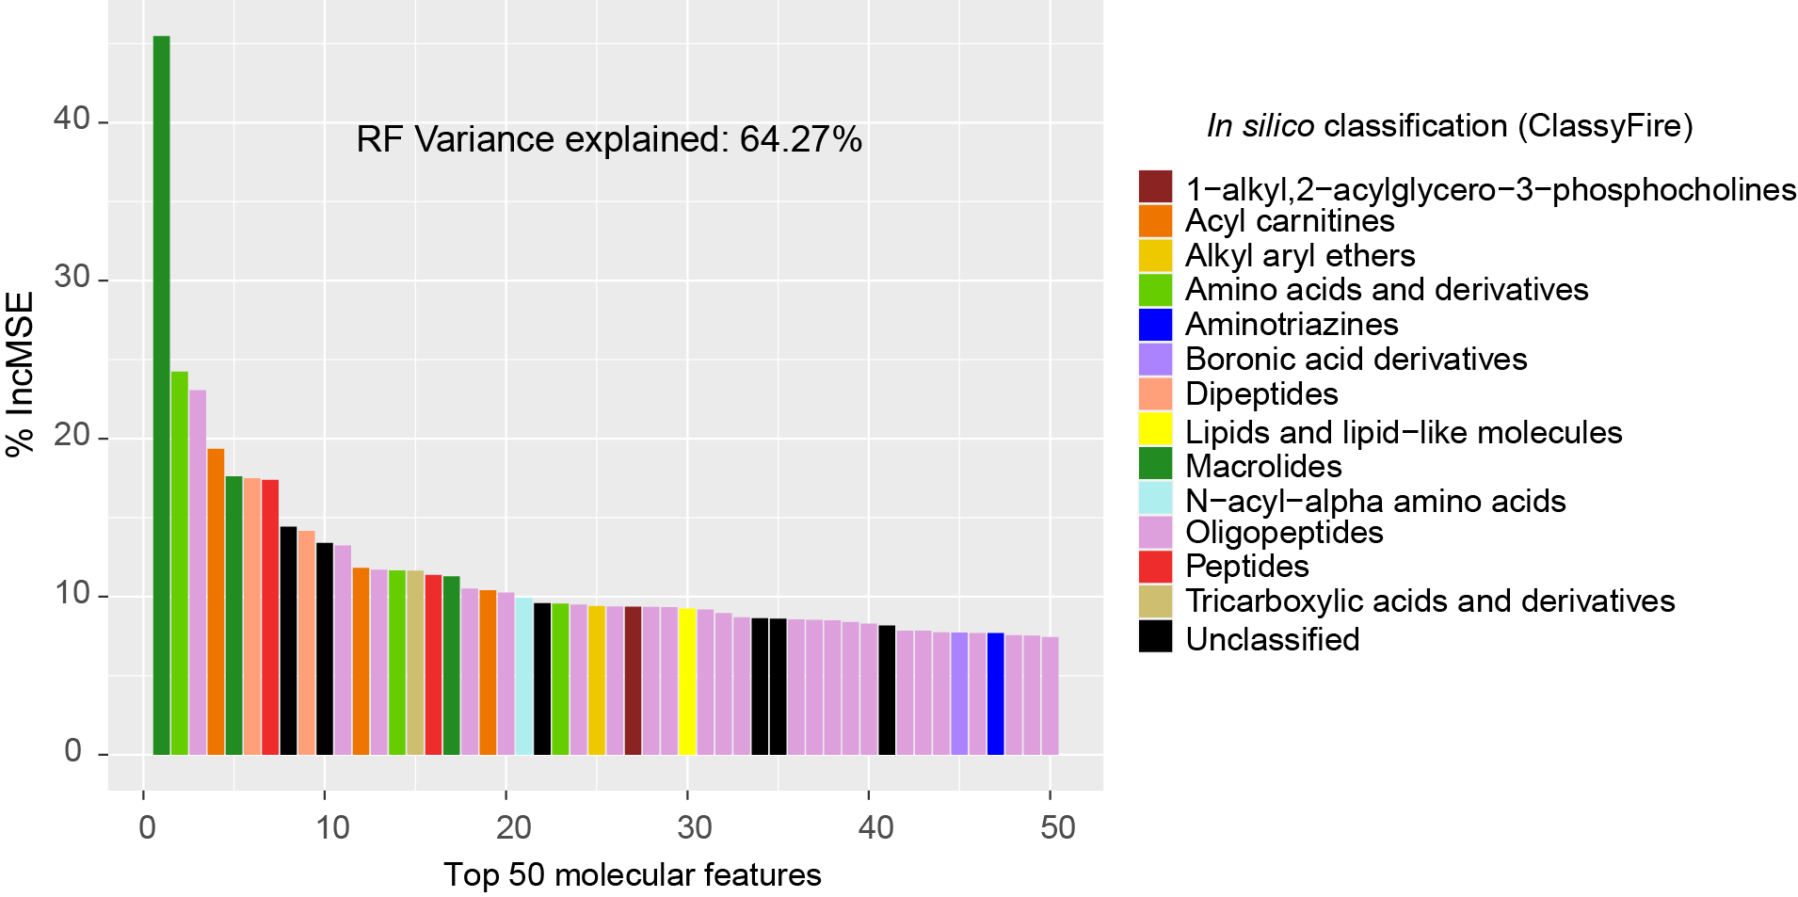
Figure S1. Top 50 molecular features obtained after random forest regression analysis of the metabolome of sputum from pwCF on ETI and the time since the overall subject started on the treatment. Colors represent the in silico molecular classification generated through CANOPUS in Sirius 5.7.
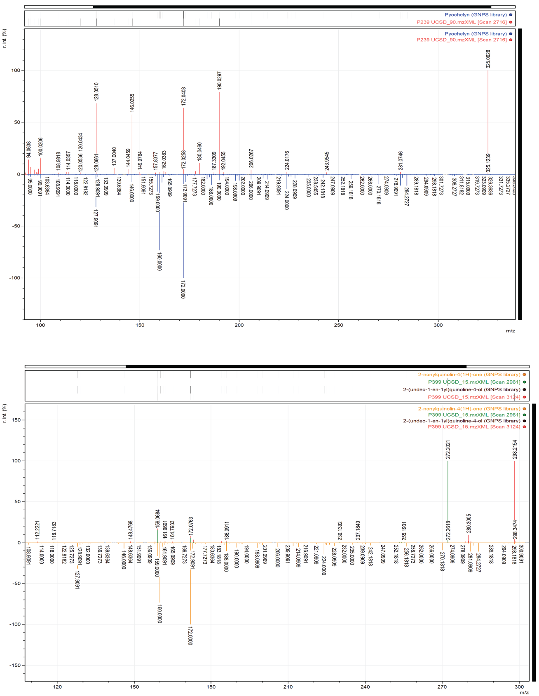
Figure S2. MS/MS patterns through GNPS mass spectral libraries. Pyochelin ([M+H⁺], m/z = 325.0625), 2-nonylquinolin-4(1H)-one ([M+H⁺], m/z = 272.1995) and 2-(undec-1-en-1yl)quinoline-4-ol ([M+H⁺], m/z = 298.2165) are displayed.

Supplementary references
1. Nothias, L.-F. et al. Feature-based molecular networking in the GNPS analysis environment. Nat. Methods 17, 905–908 (2020).
2. Reproducible molecular networking of untargeted mass spectrometry data using GNPS | Nature Protocols. https://www.nature.com/articles/s41596-020-0317-5.
3. Cytoscape: A Software Environment for Integrated Models of Biomolecular Interaction Networks. https://genome.cshlp.org/content/13/11/2498.
4. Dührkop, K. et al. SIRIUS 4: a rapid tool for turning tandem mass spectra into metabolite structure information. Nat. Methods 16, 299–302 (2019).

