Supplemental materials

Table of contents Page
- Secondary outcomes ……………………………………………………………………...1
- ICD9/10 codes ……………………………………………………………………………1
- Supplemental methods and definitions …………………………………………………1-2
- Supplemental Figure 1: patient inclusion/exclusion flow chart …………………………..2
- Supplemental Table 1: seizure data ………………………………………………………3
- Supplemental Table 2: Univariate logistic regression analysis of potential risk factors.…3 associated with early post-traumatic seizures
- Supplemental Table 3: Bivariate binary logistic regression analysis for early post ……...3 traumatic seizure including age and Marshall score
- Supplemental Table 3: Bivariate binary logistic regression analysis for early post ……...3 traumatic seizure including age and hematoma evacuation
Secondary outcomes definitions
Secondary outcome included the association between early posttraumatic seizures and ICU length of stay, hospital length of stay and in hospital mortality. The definitions are as follows.
Outcome | Definition
Epileptiform activity on the continuous electroencephalograph (cEEG) | Based on EEG report from epileptologist interpretation within electronic medical record (EMR)
Immediate phenytoin level prior to seizure | Available level prior to reported time of seizure (adjusted for hypoalbuminemia and renal function)
In-hospital seizure after 1 week | As documented clinical seizure within the EMR
ICU length of stay | Number of days spent in the intensive care unit
Hospital length of stay | Number of days spent in the hospital
In-hospital mortality | As documented within the EMR

ICD-9/10 codes
S02, S03, S06, S07, 800, 801, 802, 803, 804, 852.2, 854, 951.9

Supplemental Methods and Definitions:
Phenytoin levels
- Appropriately drawn phenytoin maintenance level was defined as a level drawn 6-8 hours following a dose to reflect a trough level. Maintenance phenytoin level typically dosed every 8 hours. A window of 6-8 hours was chosen as levels may be drawn early or late in practice.
Winter ME. Basic Clinical Pharmacokinetics. 5th edition. Philadelphia, PA: Lippincott Williams & Wilkins; 2010.
- Inappropriately drawn phenytoin maintenance level was defined as a level drawn within 6 hours of a dose or greater than 8 hours following a dose.
- Phenytoin levels were corrected for hypoalbuminemia and renal dysfunction using the closest albumin and serum creatinine results preceding the phenytoin level (Corrected phenytoin = measured phenytoin level / [ (adjustment x albumin, g/dL) + 0.1] Adjustment = 0.275; in patients with creatinine clearance <20 mL/min, adjustment = 0.2.)
Kiang TK, Ensom MH. A Comprehensive Review on the Predictive Performance of the Sheiner-Tozer and Derivative Equations for the Correction of Phenytoin Concentrations. Ann Pharmacother. 2016;50(4):311-325. doi:10.1177/1060028016628166
Marshall Score
Category | Definition
Diffuse injury I | No visible intracranial pathology seen on CT
Diffuse injury II | Cisterns are present with midline shift 0-5mm and/or lesion densities present no high- or mixed-density lesion >25mL; may include bone fragments and foreign bodies
Diffuse injury III | Cisterns compressed or absent with midline shift 0-5mm, no high- or  mixed-density lesion > 25mL
Diffuse injury IV | Midline shift > 5 mm, no high- or mixed-density lesion > 25mL
Diffuse injury V (evacuated mass lesion) | Any lesion surgically evacuated
Diffuse injury VI (non-evacuated mass lesion) | High- or mixed-density lesion > 25mL, not surgically evacuated
Marshall LF, Marshall SB, Klauber MR, et al. The diagnosis of head injury requires a classification based on computed axial tomography. J Neurotrauma. 1992;9 https://globalneuro.org/uploads/files/Marshall_CT_Score_paper_abstract.pdf.

Supplemental Figure 1: patient inclusion/exclusion flow chart
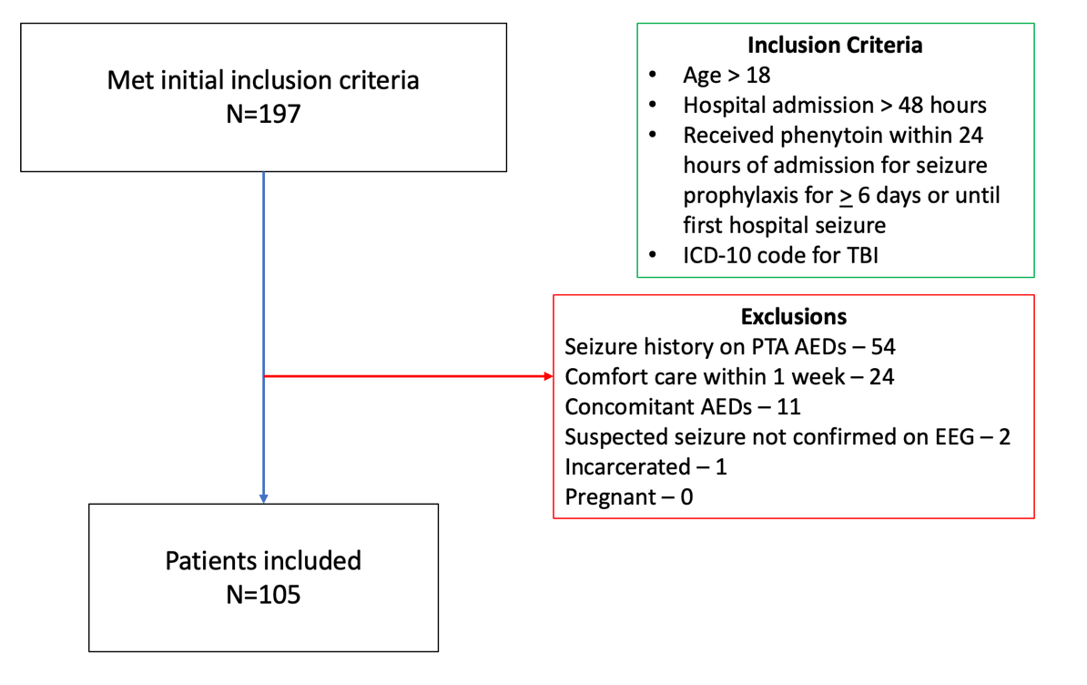

Supplemental Table 1: seizure data
Frequency
(n = 14)
Early post-TBI seizure, n (%)  Focal  Generalized | 13 (93%)  1 (7%)
Epileptiform activity on cEEG, n (%)  Status epilepticus  Clinical  Subclinical seizures | 5 (36%)  1 (7%)  8 (57%)
Seizure classification based on neurologist notes documented in the electronic medical record.
Supplemental Table 2: Univariate logistic regression analysis of potential risk factors associated with early post-traumatic seizures
Variable | Odds Ratio (95% CI) | p-Value
Age | 1.04 (1.01 – 1.07) | 0.01
Marshall score | 1.7 (1.15-2.61) | 0.02
Marshall score > 2 | 6.4 (1.68-24.77) | 0.01
Number of Neurosurgery procedures | 1.95 (1.09-3.49) | 0.05
Hematoma evacuation | 5.80 (1.78-18.94) | 0.02

Supplemental Table 3: Bivariate binary logistic regression analysis for early post traumatic seizure including age and Marshall score > 2
Variable | Odds Ratio (95% CI) | p-Value
Age | 1.05 (1.01-1.08) | 0.01
Marshall score > 2 | 7.44 (1.80-30.83) | 0.01

Supplemental Table 4: Bivariate binary logistic regression analysis for early post traumatic seizure including age and hematoma evacuation
Variable | Odds Ratio (95% CI) | p-Value
Age | 1.04 (1.01-1.07) | 0.02
Hematoma evacuation | 5.0 (1.46-17.11) | 0.01

