Accumulation of microplastics in edible tissues of livestock (cow and sheep)

Farkhondeh Bahrani¹, Azam Mohammadi², Sina Dobaradaran^{1,2,3,4*}, Gabriel E. De-la-Torre⁵, Hossein Arfaeinia^{1,2}, Bahman Ramavandi^{1, 2}, Reza Saeedi^{6,7}, Agnes Tekle-Röttering⁸
¹Department of Environmental Health Engineering, Faculty of Health and Nutrition, Bushehr University of Medical Sciences, Bushehr, Iran
²Systems Environmental Health and Energy Research Center, The Persian Gulf Biomedical Sciences Research Institute, Bushehr University of Medical Sciences, Bushehr, Iran
³Instrumental Analytical Chemistry and Centre for Water and Environmental Research (ZWU), Faculty of Chemistry, University of Duisburg-Essen, Essen, Germany
⁴Centre for Water and Environmental Research, University of Duisburg-Essen, Universitätsstr. 5, Essen, 45141, Germany
⁵Grupo de Investigación de Biodiversidad, Medio Ambiente y Sociedad, Universidad San Ignacio de Loyola, Lima, Peru
⁶Workplace Health Promotion Research Center, Shahid Beheshti University of Medical Sciences, Tehran, Iran
⁷Department of Health and Safety, and Environment (HSE), School of Public Health and Safety, Shahid Beheshti University of Medical Sciences, Tehran, Iran
⁸ Westfälische Hochschule Gelsenkirchen, Neidenburger Strasse 43, Gelsenkirchen 45877, Germany
*Systems Environmental Health and Energy Research Center, Bushehr University of Medical Sciences, Bushehr, Iran. E-mail addresses: sina_dobaradaran@yahoo.com, s. dobaradaran@bpums.ac.ir.

Contents
Table S1. The mean number of MPs (items/g) in the liver, meat, and tripe of cow and sheep as well as statistical difference between their various tissues.
Table S2. Size distribution, shape, and color of identified MPs in the liver, meat, and tripe tissues of cow and sheep.
Fig. S1. Some of detected MPs in the cow and sheep tissues.
Fig. S2. Spectra Raman of polymers identified in the MPs of tissue samples.

Table S1. The mean number of MPs (items/g) in the liver, meat, and tripe of cow and sheep as well as statistical difference between their various tissues.
Livestock | Tissue | Sample. No |  |  |  |  | Mean ± SD | Total mean ± SD | p-value* | p-value**
 |  | S₁ | S₂ | S₃ | S₄ | S₅
Cow | Liver | 0 | 0.02 | 0.04 | 0.6 | 0.02 | 0.14 ± 0.23 | 0.14 ± 0.05 | 0.93 | 0.77
Cow | Meat | 0.04 | 0.16 | 0.38 | 0.3 | 0.08 | 0.19 ± 0.13 | 0.14 ± 0.05 | 0.93 | 0.77
Cow | Tripe | 0.12 | 0.2 | 0.1 | 0.02 | 0.3 | 0.15 ± 0.1 | 0.14 ± 0.05 | 0.93 | 0.77
Sheep | Liver | 0.06 | 0.1 | 0.02 | 0.1 | 0.04 | 0.06 ± 0.03 | 0.13 ± 0.02 | 0.52 | 0.77
Sheep | Meat | 0.08 | 0.1 | 0.3 | 0.06 | 0 | 0.11 ± 0.1 | 0.13 ± 0.02 | 0.52 | 0.77
Sheep | Tripe | 0.02 | 0.34 | 0.12 | 0.12 | 0.08 | 0.14 ± 0.11 | 0.13 ± 0.02 | 0.52 | 0.77
*Difference between different tissues of each livestock.
** Difference between both livestock.
p-value: Significant at p-value< 0.05.

Table S1. Size distribution, shape, and color of identified MPs in the liver, meat, and tripe tissues of cow and sheep.
Characteristics | Category |  |  |  |  |  |  |  |  |  |  |  |  | Sample
 |  | S₁ |  |  |  |  |  | S₂ |  |  |  |  |  | S₃ |  |  |  |  |  | S₄ |  |  |  |  |  | S₅
 |  | Cow |  |  | Sheep |  |  | Cow |  |  | Sheep |  |  | Cow |  |  | Sheep |  |  | Cow |  |  | Sheep |  |  | Cow |  |  | Sheep
 |  | Liver | Meat | Tripe | Liver | Meat | Tripe | Liver | Meat | Tripe | Liver | Meat | Tripe | Liver | Meat | Tripe | Liver | Meat | Tripe | Liver | Meat | Tripe | Liver | Meat | Tripe | Liver | Meat | Tripe | Liver | Meat | Tripe
Size | < 25 μm | 0 | 0 | 1 | 0 | 0 | 0 | 0 | 0 | 0 | 0 | 0 | 0 | 0 | 4 | 0 | 0 | 0 | 1 | 0 | 4 | 0 | 1 | 0 | 1 | 0 | 0 | 1 | 0 | 0 | 1
Size | 25-50 μm | 0 | 0 | 2 | 0 | 0 | 0 | 0 | 0 | 0 | 0 | 0 | 0 | 0 | 6 | 5 | 1 | 2 | 0 | 0 | 2 | 0 | 0 | 1 | 0 | 0 | 1 | 4 | 0 | 0 | 2
Size | 50-100 μm | 0 | 2 | 1 | 0 | 1 | 0 | 0 | 0 | 5 | 1 | 2 | 3 | 0 | 0 | 0 | 0 | 6 | 2 | 0 | 2 | 0 | 1 | 0 | 1 | 0 | 0 | 2 | 0 | 0 | 0
Size | 100-500 μm | 0 | 0 | 1 | 1 | 1 | 0 | 0 | 4 | 1 | 2 | 1 | 7 | 1 | 3 | 0 | 0 | 5 | 2 | 0 | 5 | 0 | 2 | 0 | 1 | 0 | 0 | 3 | 2 | 0 | 0
Size | 500-1000 μm | 0 | 0 | 1 | 2 | 0 | 0 | 1 | 1 | 0 | 1 | 0 | 3 | 1 | 4 | 0 | 0 | 0 | 1 | 0 | 0 | 0 | 0 | 1 | 0 | 1 | 3 | 3 | 0 | 0 | 1
Size | 1000-5000 μm | 0 | 0 | 0 | 0 | 2 | 1 | 0 | 3 | 4 | 1 | 2 | 4 | 0 | 2 | 0 | 0 | 2 | 0 | 1 | 2 | 3 | 1 | 1 | 3 | 0 | 0 | 2 | 0 | 0 | 0
Shape | Fiber | 0 | 2 | 5 | 3 | 4 | 1 | 1 | 5 | 10 | 5 | 5 | 14 | 2 | 19 | 0 | 0 | 15 | 6 | 1 | 9 | 3 | 4 | 3 | 5 | 1 | 4 | 14 | 2 | 0 | 4
Shape | Fragment | 0 | 0 | 1 | 0 | 0 | 0 | 0 | 3 | 0 | 0 | 0 | 3 | 0 | 0 | 5 | 1 | 0 | 0 | 0 | 5 | 0 | 0 | 0 | 1 | 0 | 0 | 1 | 0 | 0 | 0
Shape | Film | 0 | 0 | 0 | 0 | 0 | 0 | 0 | 0 | 0 | 0 | 0 | 0 | 0 | 0 | 0 | 0 | 0 | 0 | 0 | 1 | 0 | 1 | 0 | 0 | 0 | 0 | 0 | 0 | 0 | 0
Color | Black | 0 | 1 | 0 | 0 | 1 | 0 | 0 | 0 | 5 | 1 | 4 | 10 | 1 | 8 | 0 | 0 | 5 | 2 | 1 | 9 | 1 | 1 | 2 | 1 | 1 | 1 | 9 | 1 | 0 | 2
Color | White/Transparent | 0 | 0 | 3 | 1 | 2 | 1 | 0 | 8 | 0 | 3 | 0 | 4 | 0 | 2 | 5 | 1 | 2 | 1 | 0 | 4 | 0 | 4 | 1 | 3 | 0 | 0 | 2 | 1 | 0 | 1
Color | Blue | 0 | 1 | 0 | 1 | 0 | 0 | 0 | 0 | 2 | 1 | 1 | 1 | 0 | 3 | 0 | 0 | 5 | 0 | 0 | 2 | 1 | 0 | 0 | 2 | 0 | 3 | 1 | 0 | 0 | 1
Color | Red | 0 | 0 | 1 | 0 | 0 | 0 | 0 | 0 | 1 | 0 | 0 | 2 | 0 | 6 | 0 | 0 | 1 | 1 | 0 | 0 | 1 | 0 | 0 | 0 | 0 | 0 | 1 | 0 | 0 | 0
Color | Yellow/Brown | 0 | 0 | 2 | 1 | 1 | 0 | 1 | 0 | 2 | 0 | 0 | 0 | 1 | 0 | 0 | 0 | 2 | 2 | 0 | 0 | 0 | 0 | 0 | 0 | 0 | 0 | 2 | 0 | 0 | 0
Total |  | 0 | 2 | 6 | 3 | 4 | 1 | 1 | 8 | 10 | 5 | 5 | 17 | 2 | 19 | 5 | 1 | 15 | 6 | 3 | 15 | 3 | 5 | 3 | 6 | 1 | 4 | 15 | 2 | 0 | 4

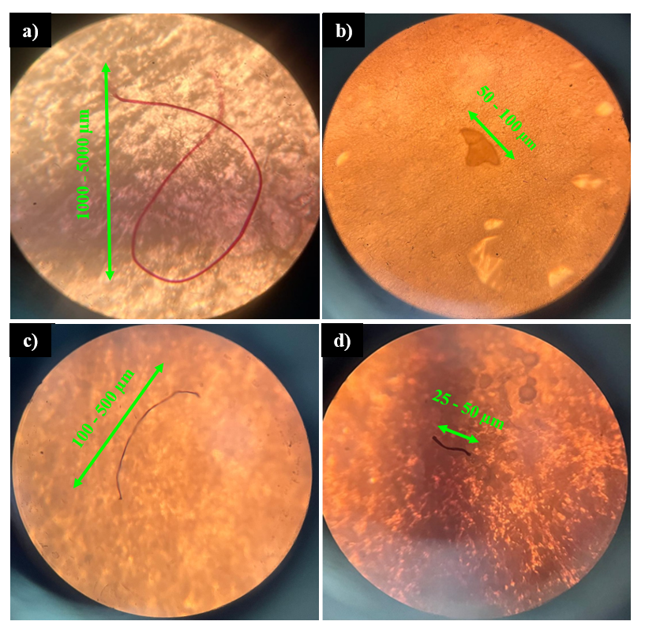
Fig. S1. Some of detected MPs in the cow and sheep tissues.

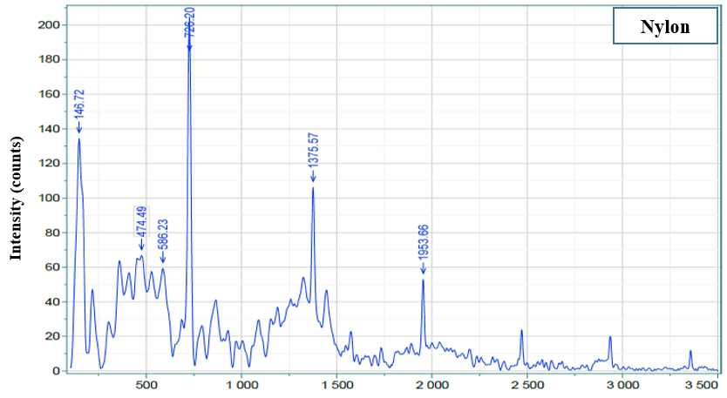
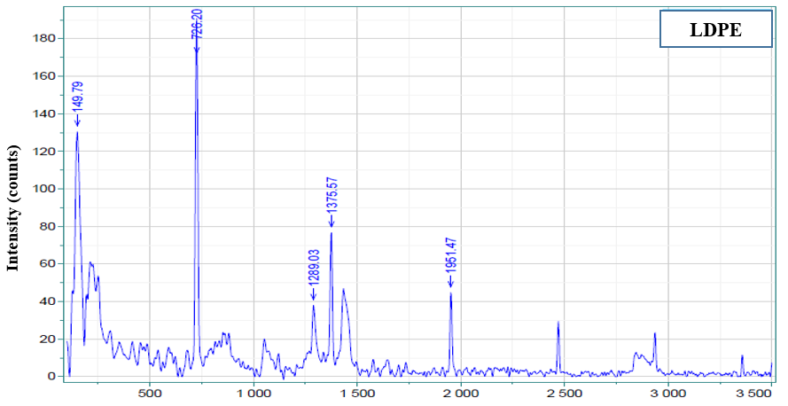
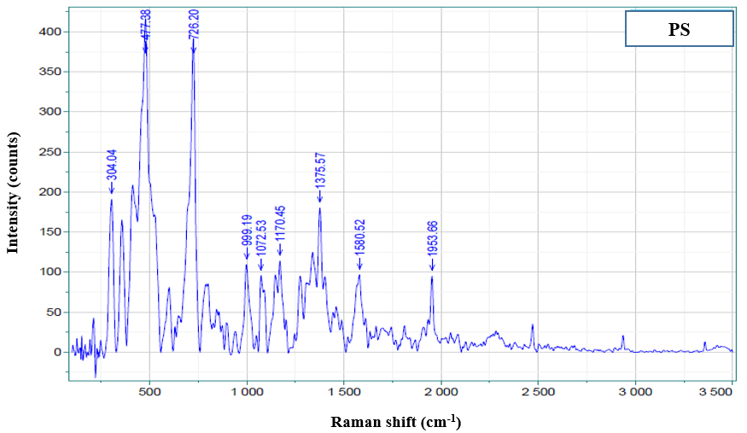
Fig. S2. Spectra Raman of polymers identified in the MPs of tissue samples.

