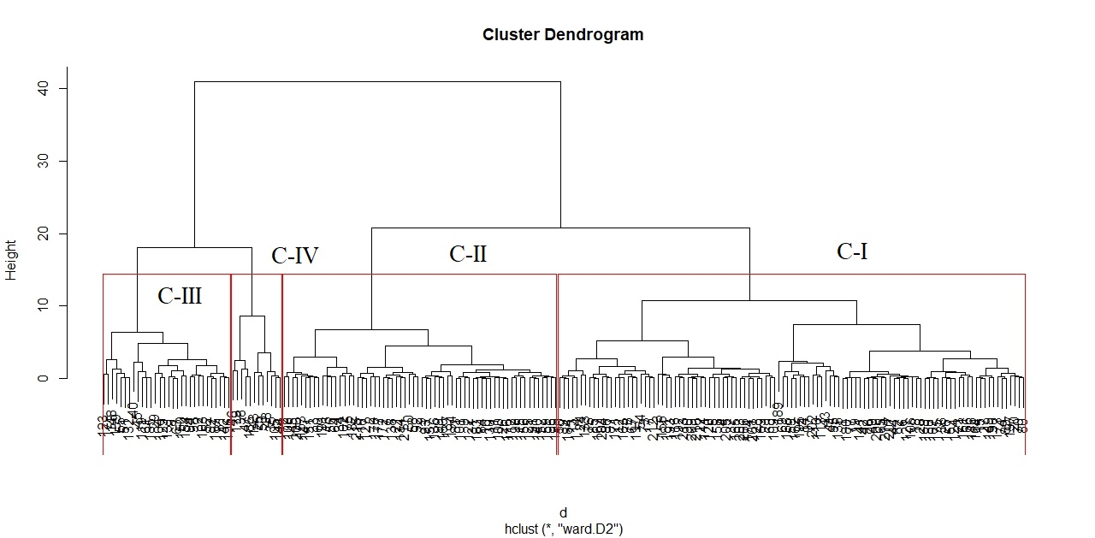
Supplementary S7: dendrogram of 216 sorghum accessions based on drought induces at Werer experimental site.

