Supplementary Materials for

Injectable core-shell microcapsules deliver prime-boost immunisation against malaria in a single shot
Authors: Romain Guyon*, Sören Reinke, Adam Truby, Lee Sims, Adrian V. S. Hill, Luca Bau, Eleanor Stride and Anita Milicic*
*Corresponding authors romain.guyon@ndm.ox.ac.uk
. anita.milicic@ndm.ox.ac.uk

The PDF file includes:

Materials and Methods
Figs. S1 to S13
Table S1

Other Supplementary Materials for this manuscript include the following:

Movie S1

Materials and Methods
All chemicals used are listed in the relevant section below, and were purchased from Sigma Aldrich, unless stated overwise.
R21 adjuvanted vaccine
The virus-like particle R21 vaccine was produced as described previously³⁴. The LMQ adjuvant was manufactured by the Vaccine Formulation Institute (VFI) as described previously⁴⁹, and contains QS-21 saponin and the synthetic TLR4 ligand 3D-6-acyl-PHAD incorporated into neutral liposomes composed of 1,2-dioleoyl-sn-glycero-3-phosphocholine (DOPC) and cholesterol. The R21/LMQ mouse priming dose was defined as 1 µg of R21, 5 µg of QS21 and 2 µg of 3D6AP, while the booster dose (encapsulated in microcapsules or given as a booster injection) was defined as 1 µg of R21, 0.7 µg of QS21 and 0.3 µg of 3D6AP. The SMNP adjuvant was kindly supplied by Irvine lab (MIT), and contains the TLR4 agonist MPLA incorporated into self-assembled complexes of saponin, cholesterol and phospholipids. Both priming and booster dose of R21/SMNP were defined as 0.5 µg of R21 and 0.5 µg of MPLA. For all experiments, DD Prime regimens combined the respective priming and booster doses in a single injection.
Fluorescent labelling of the R21 vaccine
R21 was labelled with Alexa Fluor 647 (AF-R21) to enable the measurement of encapsulation efficiency and microcapsules core size post encapsulation by microfluidics. Buffer exchange of a 0.5 mL R21 stock solution (0.38 mg/mL in Tris Buffer) was performed using an ultra-centrifugal filter unit (30 kDa cut-off, Amicon, Sigma-Aldrich) and centrifuged 3 times at 10,000 g for 10 minutes at 4 °C, using phosphate buffer saline (PBS) as the replacing buffer. R21 in PBS was then mixed in a 0.5 mL Eppendorf tube with 50 μL of 4 mg/mL Alexa Fluor 647 NHS ester (ThermoFisher) suspended in DMSO, and vortexed for 30 seconds at 3,000 rpm. The labelling reaction was incubated on a rotating shaker for 1.5 hours at 30 rpm mix mode, 28 °C, protected from light. Removal of unincorporated dye and washing of the labelled product was done by 6 cycles of diafiltration (30 kDa cut-off, Amicon, Sigma-Aldrich) at 10,000 g for 10 minutes at 4 °C, using PBS. Labelled R21 was stored at -80 °C.
Microcapsule manufacture by microfluidics
Microfluidic chips were produced by common soft lithography and polydimethylsiloxane (PDMS) replication method⁵⁰. Following computer-aided design of the microfluidic channels (AutoCAD, AutoDesk), the corresponding SU-8 soft lithography positive moulds were manufactured externally by Micrux Technologies. The moulds were made hydrophobic by vapor deposition of trimethylchlorosilane (TMCS, Sigma-Aldrich) to prevent sticking during PDMS replication. PDMS was mixed at a 10:1 ratio of pre-polymer to curing agent (SYLGARD 184, Dow) and poured onto the positive SU-8 mould. After de-gassing in a vacuum chamber until no air bubbles were visible, the PDMS was cured in an oven overnight at 65 °C. The PMDS layer was peeled off the mould and each chip design cut out with a razor blade. Inlets and outlets were punched with a blunt 18G needle, the chips cleaned with isopropanol, dried with nitrogen, and bonded to a flat PDMS slab by plasma exposition in a plasma chamber (HPT-200, Henniker plasma) for 3 min at 100% power. After plasma exposition, the PDMS chip design and PDMS slab were pressed together for 30 seconds and their bonding strengthened on a hot plate at 115 °C for 30 seconds.
Immediately following plasma bonding, spatially constrained hydrophilic coating was performed to ensure the hydrophilicity of the second intersection of the flow focusing design, adapted from previously reported method⁵¹. In brief, a coating solution of 1% (w/v) polyvinyl alcohol (PVA, 30-70 kDa Mw, 87-90% hydrolyzed) in deionized water (DI water) was injected from the outer inlet at 100 mbar while continuously flushing air was through the inner and middle inlet at 50 mbar to protect the first intersection from the coating solution. The treatment was performed for 5 minutes before flushing all channels with air and drying the chip for 5 minutes at 115 °C on a hot plate. The process was repeated 3 times to ensure durable and reliable hydrophilic coating in the relevant segment of the chip. Following coating, the microfluidic chips were left at 60 °C for a minimum of 48 hours to allow any uncoated parts to recover their hydrophobicity. Chips were then stored at room temperature and used for microfluidic emulsification within 3 months of manufacture.
Fluidics formulation
The following fluid compositions were used for the emulsification processes.
Inner fluid: For in vitro assays, fluorescent dextran payloads were dissolved in 1X PBS.
For in vivo injections, AF-R21 solution was mixed with R21 solution at a ratio 1:4 then completed with the corresponding adjuvant solution (LMQ or SMNP). The inner core fluid was kept on ice in the dark for the time of production.
Middle fluid: Poly(D,L-lactic-co-glycolic acid) polymers (PLGA, Resomer, Evonik) were dissolved in dimethyl carbonate (DMC, Sigma-Aldrich) solvent, in a glass vial at room temperature, at the maximum observed compatible concentration with the microfluidic setup before clogging (Table S1). The glass vials were agitated on a rolling shaker for 2 hours to ensure complete dissolution of the polymer. Solvent selection was performed based on toxicity, water miscibility, viscosity, PDMS compatibility and lack of denaturing effects⁵².
Outer fluid: 3%(w/v) PVA (9-10k Mw, 80% hydrolyzed, Sigma-Aldrich) was dissolved in DPBS (1X, Gibco).
Microfluidic double emulsification
To perform microfluidic Water-in-Oil-in-Water (W/O/W) emulsification, a pressure driven microfluidic setup was assembled. Compressed air was generated from a compressor (6-4 quiet running compressor, Jun-Air) and fed to a microfluidics dedicated pressure controller (OB1, Elveflow). Separated reservoirs containing the inner, middle and outer fluids, supplied by Darwin Microfluidics or custom manufactured in Delrin, were precisely pressurized by the pressure controller and their liquid content pushed into the microfluidic chip through PTFE tubing (1/32” outer diameter, 300 μm inner diameter, Darwin microfluidics) and ¼ 28” fittings. The emulsification process was monitored using an inverted microscope (DMi8, Leica) operated in brightfield, and a high-speed camera (Nova S16 from Phantom). The injected pressures were set respectively to 200, 300, and 400 mbar initially, to prefill all channels and reduce risk of backflow. After 2 minutes the flow pressures were changed to the required pressure and monitored using the high-speed camera. Videos of the production were taken, and the core and outer droplet diameter and frequency measured using a dedicated software (DMV, developed at Wayne State University⁵³) and ImageJ. The pressures were adjusted manually until the droplets reached the desired diameter and maximum generation frequency. Double emulsions were collected in a glass petri dish and transferred to a glass vial (22 mL) filled with outer fluid. Extraction of the solvent was performed over 48 hours at room temperature on a roller shaker, replacing the PBS extraction media every 12 hours. Resulting microcapsules were then filtered using mini cell strainers (100 μm, pluriSelect) and stored in 2 mL of DPBS in Eppendorf tubes at 4 °C until use. If shelf-dried, the volume of DPBS was reduced to a minimum, and the Eppendorf were left at room temperature for 48 hrs.
Quality control was performed by fluorescent microscopy imaging, as described in the corresponding section.
Batch emulsification
To produce particles by batch emulsification (BE), 100 μL of inner fluid was pipetted into 500 μL of middle fluid. The mix was vortexed at 3,000 rpm for 1 minute in a 2 mL LoBind Eppendorf. The resulting water-in-oil emulsion was transferred by pipetting into 10 mL of the outer fluid in a 15 mL glass vial, and vortexed at 2,500 rpm for 1 minute. The resulting water-in-oil-in-water emulsion was left to rest for 15 minutes. Extraction of the solvent was performed over 48 hours at room temperature on a roller shaker, replacing the PBS extraction media every 12 hours. Particles were then filtered using mini cell strainers (100 μm, pluriSelect) and stored in 2 mL of PBS in Eppendorf tubes at 4 °C until use.
In vitro release assay
Produced microcapsules encapsulating dextran-TRITC were divided equally into 3-4 aliquots, suspended in 0.01% (w/v) Tween 80 (Sigma-Aldrich) in PBS in 2 mL LoBind Eppendorf tubes, and incubated in a rotating incubator (Roto-Therm, Benchmark Scientific) kept at 37 °C at 20 rpm. The combination of the full rotation and the presence of Tween 80 surfactant in the release media prevented microcapsules aggregation and sedimentation. At relevant timepoints, depending on the PLGA formulation, microcapsules were temporarily sedimented by centrifugation for 30 seconds at 50 g, and 1 mL of supernatant was replaced with fresh releasing media to provide sink conditions. 200 μL of the removed media were used for quantification of the released payload. Image release monitoring and SEM imaging were also performed at relevant timepoints. The effect of different microcapsules formulation parameters on the in vitro release was tested separately.
Release quantification
The amount of dextran-TRITC released from the microcapsules was measured by fluorescent spectroscopy (FLUOstar Omega, BMG Labtech), using a standard curve. The release was normalized to the initial total encapsulated content for each replicate by measuring the remaining unreleased dextran-TRITC at the experimental end point, after mechanically breaking up the microcapsules with a cell homogenizer for 30 seconds at 30,000 rpm (IKA T 10 Basic Ultra Turrax Homogenizer, Cole-Parmer) and centrifugation to remove PLGA debris, at 15,000 g for 10 minutes (Fig. S13). The amount released at each timepoint was corrected for the dilution resulting from the partial replacement of the releasing media.
Fluorescent microscopy imaging for microcapsule characterization and monitoring of in vitro release
For each image, 20 μL of microcapsules suspension were mixed with 200 μL of 0.01% (w/v) Tween 80 in PBS in Cellview slides (Greiner) and multi-tile imaging was performed with an inverted microscope (TiE2, Nikon, 10X objective) in the brightfield and TRITC fluorescent channel. The image tiles were processed with MATLAB Image Processing Toolbox to measure the core and shell fluorescence and the diameter of each microcapsule. Briefly, each image was smoothed by applying a bilateral filter or a gaussian filter for the brightfield and fluorescent channels respectively. Background fluorescence was removed from the fluorescence channel, and contrast was enhanced in the brightfield channel. Each individual droplet or microcapsule was detected using a Hough transform algorithm and separated from each other by watershed segmentation in case of touching. Masking techniques were used to associate each microcapsule in brightfield with its core in fluorescence, and the diameter and fluorescence of the different regions of each microcapsule were measured for different timepoints, including immediate post-production quality control.
For each microcapsule, the fluorescence profile was computed by averaging the fluorescence intensities of pixels at equal distance (normalized radius) from the core center.
Coefficients of variation (CV) for the core and outer microcapsules diameter distributions were computed as the ratio of standard deviation to arithmetic mean and reported as a percentage.
As the microcapsules are a single core-shell system, encapsulation efficiency was computed as the ratio (%) between the number of core and outer microcapsules detected.
Fluorescence microscopy images of microcapsules containing dextran-TRITC as the model payload were produced by enhancing the contrast by contrast stretching, allowing 0.35% of pixel saturation, and overlaying the TRITC and brightfield channels.
SEM imaging of the in vitro release
The µCap morphology immediately after production or at different timepoints of in vitro degradation was imaged using a field emission gun scanning electron microscope (FEG-SEM, Zeiss Sigma 300) with an acceleration voltage of 2 kV. Before imaging, 10 μL of microcapsules in suspension in PBS or release media was pipetted and spread onto a conductive adhesive carbon tape attached to a SEM pin stub and a thin film of Pd/Au coating was sputtered onto the sample (Q150R ES Dual Carbon/Sputter Coater, Quorum Technologies).
Injectability Assay
A target dose of 100 µg of encapsulated dextran-TRITC was chosen to approximate the concentration of microcapsules used in in vivo experiments with R21. Microcapsules were resuspended accordingly to contain this target dose in a 50 µL volume of injection media, and loaded in a 100 μL Gas Tight glass syringes (Hamilton).
The assay was performed by injecting the target dose in PBS in an Eppendorf using 25G, 27G or 30G needles (Terumo), replicating the assay 5 times per needle gauge condition. The microcapsule shells were then broken using a cell homogenizer (Cole-Parmer) and the released dose delivered measured by fluorescent spectroscopy. The injectability was computed as the ratio between the dose delivered and the target dose.
R21 loaded microcapsule formulation and quality control
Quality control of the produced microcapsules was performed by microscopic image quality control, as described in the corresponding section, using the AF-R21 as the fluorescent marker within the core. Quantification of the encapsulated R21 was performed by mechanically breaking the microcapsules shells: 500 μL of the produced microcapsules batch was added to 500μL of PBS and homogenized for 30 seconds with a cell homogenizer (Cole-Parmer) to break up the microcapsules. Released R21 was isolated from the PLGA microcapsules debris by centrifugation at 15,000 g for 10 minutes, and the concentration of R21 in the supernatant determined using the micro–BCA Protein assay (ThermoFisher). From this, the number of microcapsules required to achieve a vaccine mouse dose was calculated (in the order of 100,000 microcapsules per mouse).
Depending on the regimen, the correct number of microcapsules, antigen in solution and adjuvant were resuspended in 0.25% (w/v) medium viscosity carboxymethylcellulose (CMC, Sigma-Aldrich). CMC was added to prevent early sedimentation of the microcapsules.
Mouse immunizations
Mice were maintained at the Wellcome Centre for Human Genetics or the John Ratcliffe Hospital, University of Oxford, housed under Specific Pathogen Free (SPF) conditions and in accordance with the recommendations of the UK Animals (Scientific Procedures) Act 1986 and ARRIVE guidelines. Protocols were approved by the University of Oxford Animal Care and Ethical Review Committee for use under Project Licenses P9804B4F1 or PP0984913B granted by the UK Home Office.
Six to 10-week-old female inbred BALB/c mice (Envigo, UK) were immunized intramuscularly with a total volume of 50 μL in the tibialis muscle under 3% isoflurane anesthesia. All injections were performed with 100 μL Gas Tight glass syringes (Hamilton), with 1.40 mm barrel inner diameter to improve the µCap injectability⁵⁴.
ELISA for measurement of antibody titres
NANP or Cterm-specific IgG ELISAs to detect antibodies against the central repeat (NANP) or the C-terminal (Cterm) regions of CSP were performed as previously described³⁴. Serum was obtained by collecting blood from the lateral tail vein in a microcuvette tube. Blood was allowed to clot for 2 hours at room temperature before centrifugation at 13,000 rpm for 4 minutes and sera removed and stored at −20 °C until use. Nunc-Immuno Maxisorp 96 well plates were coated with 2μg/mL NANP6 peptide (Mimotopes, NANPNANPNANPNANPNANPNANPC) or 1μg/mL Cterm peptide (ProImmune, EPSDKHIKEYLNKIQNSLSTEWSPCSVTCGNGIQVRIKPGSANKPKDELDYANDIEKKICKMEKCS) in carbonate-bicarbonate coating buffer overnight at 4 °C. Plates were washed with PBS-Tween (0.05% v/v) and blocked with 2% BSA in PBS-Tween for 1 hour at RT. Sera were serially diluted 3-fold between 1:100 and 1:24,300 in 1% BSA in PBS-Tween and added to plate in duplicates at the appropriate dilution for the vaccine regimen and time. Plates were incubated for 1.5 hours at room temperature and then washed as before. Fc-specific goat anti-mouse IgG conjugated to alkaline phosphatase (AP) (1:5000, Sigma-Aldrich, A1418), was added for 1 hour at room temperature. Following the final wash, plates were developed by adding p-nitrophenylphosphate at 1 mg/mL in diethanolamine buffer and OD was read at 405 nm. Total IgG concentrations in sera were calculated as ELISA Units (EU) by interpolation against a standard curve of monoclonal 2A10 (MR4, MRA-183A) for NANP-specific or a serum pool of previously R21-immunised mice for Cterm-specific ELISA. Sera from naïve mice were used as negative control.
Malaria challenge
Malaria challenge was carried out using transgenic Plasmodium berghei (P. berghei) parasites carrying an additional copy of the P. falciparum CSP gene at the 230p locus under the control of the P. berghei UIS4 promoter⁵⁵, produced as described previously^{34,56}. For all experiments 1,000 transgenic P. berghei sporozoites were injected intravenously (i.v.) in a total volume of 100 µL into the lateral tail vein. From day 5 post challenge mice were monitored for infection by thin-film blood smear (fixed in methanol and stained in 10% Giemsa for 30 min) and culled when >1% parasitaemia was observed. If no parasites were detected on day 12 after challenge, mice were considered sterilely protected.
Statistical Analysis
All statistical analysis was performed in R (version 4.2.1). Results were deemed to be statistically significant if p<0.05. For antibody titre, non-inferiority (NI) was declared if the 95% confidence interval for a fold change was entirely above the non-inferiority threshold, which was set at 0.5 in accordance with previous reports^{57,58}.
Analysis of in vitro kinetic profiles. Time to 50% release from microcapsules in vitro was estimated as the mean of time to 50% release (obtained for each replicate by linear interpolation). Confidence intervals were estimated using the t-distribution.
Analysis of in vivo immune kinetic profiles. Following previous reports^{59,60} and recommendations⁶¹, longitudinal antibody titres were fitted, after log-transformation, with a generalized additive model (GAM), using the mgcv package (version 1.8-40). Penalized cubic regression splines were used to model the time covariate for each regimen, with 10 knots placed evenly throughout its range. Regimen was modelled as a fixed effect, and random effects for subject and subject by time interaction were also included to account for within-subject correlations.
Marginal sampling distributions of the lag time, i.e., the time to reach 50% peak antibody titre of the Prime regimen, were generated for each regimen, following⁶², by repeatedly: 1) sampling model coefficients from the multivariate normal posterior distribution, 2) predicting log titres at 0.01 week steps, and 3) estimating lag time as the time to reach 50% of Prime peak titre. This process was repeated 10,000 times per regimen. Geometric mean titre fold change and mean additional delay, and their 95% CI, are then estimated from the corresponding sampling distributions.
Analysis of antibody titres at the times of challenge. Geometric mean fold changes were calculated from the measured titres by bootstrapping differences of mean log-transformed titres and back-transforming the mean of the bootstrap distributions. Bias-corrected and accelerated (BCa) bootstrap confidence intervals are reported (10,000 resamples).
Vaccine efficacy. Regimen efficacy (defined as sterile protection in a malaria challenge, which corresponds, in this malaria model, to the standard definition of 1 minus risk ratio relative to unvaccinated, as all unvaccinated mice develop parasitemia) was modelled by a log-binomial regression, using challenge week, regimen, adjuvant and interaction between regimen and challenge week as covariates. Confidence intervals were estimated using the profile-likelihood method.

Supplementary figures

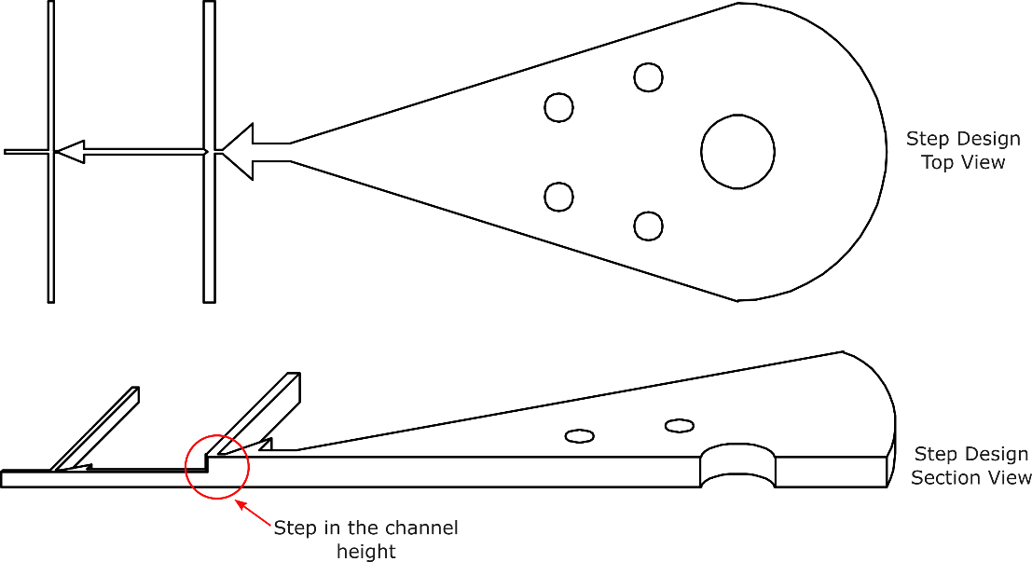

Fig. S1: Stepped microfluidic W/O/W chip design.
Top and section view of the stepped microfluidic layout developed and used in this study.

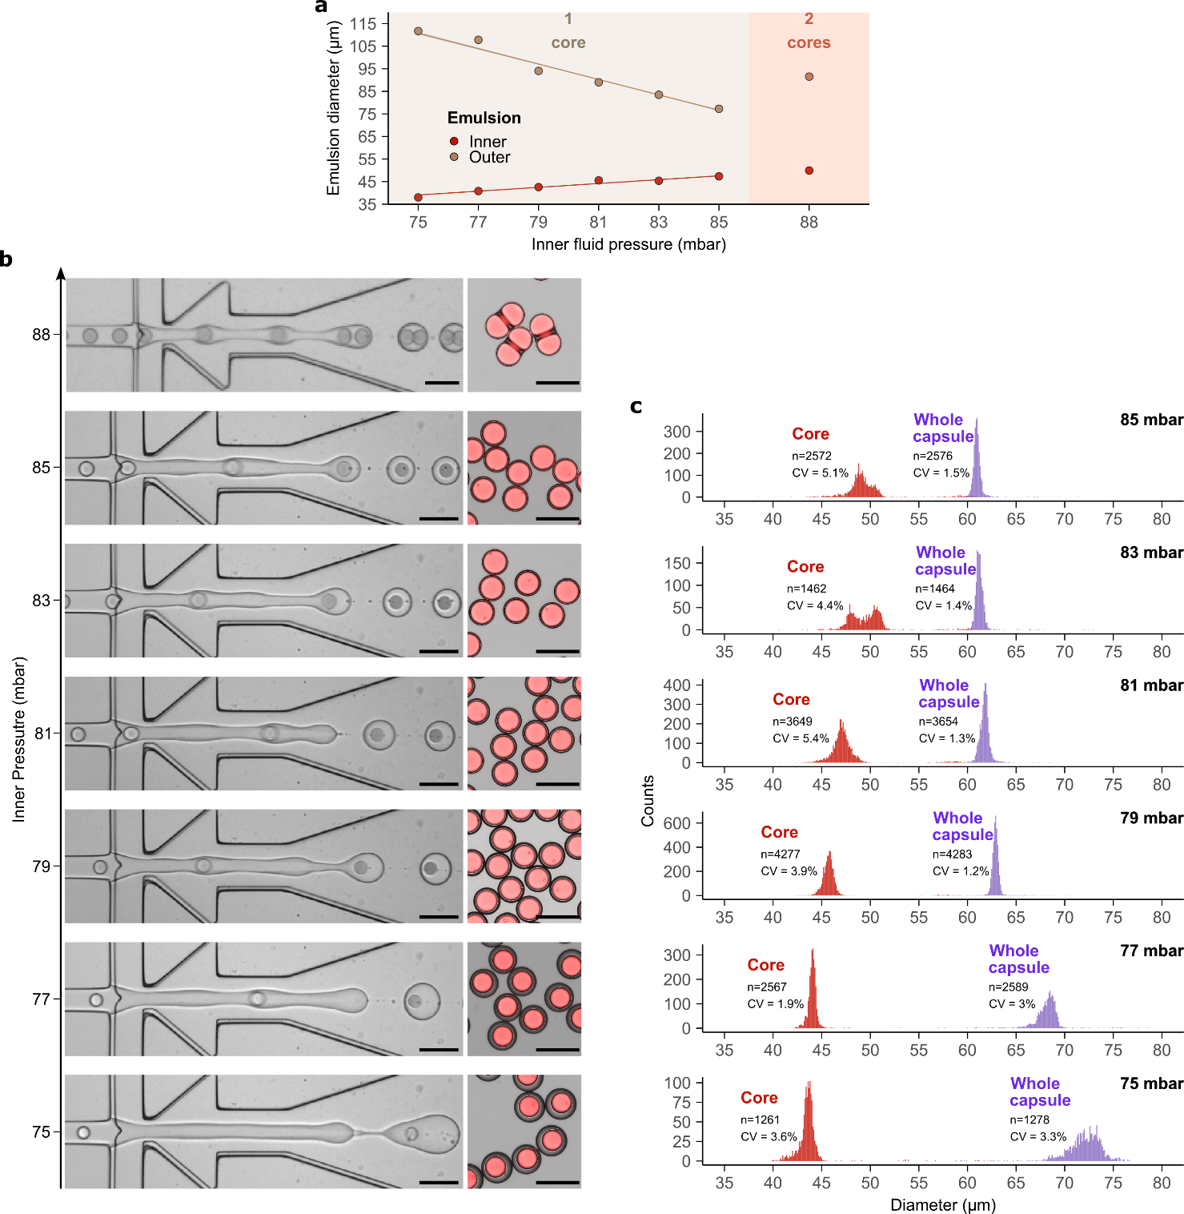

Fig. S2: The size and loading of microcapsules are controlled by the inner fluid pressure.
a) Evolution of the core and outer diameters of the W/O/W droplets (mean ± SD, n>10).
b) Stepped microfluidic process at different inner fluid pressures and the resulting dextran-TRITC loaded microcapsules; high-speed camera images of the emulsification process (left) and fluorescence microscopy images (right) of the corresponding microcapsules produced, TRITC signal and brightfield are overlayed.
c) Corresponding microcapsules (mean ± SD, n displayed for each distribution) with different inner fluid pressures, using a stepped microfluidic manufacturing process. All scale bars = 100µm.
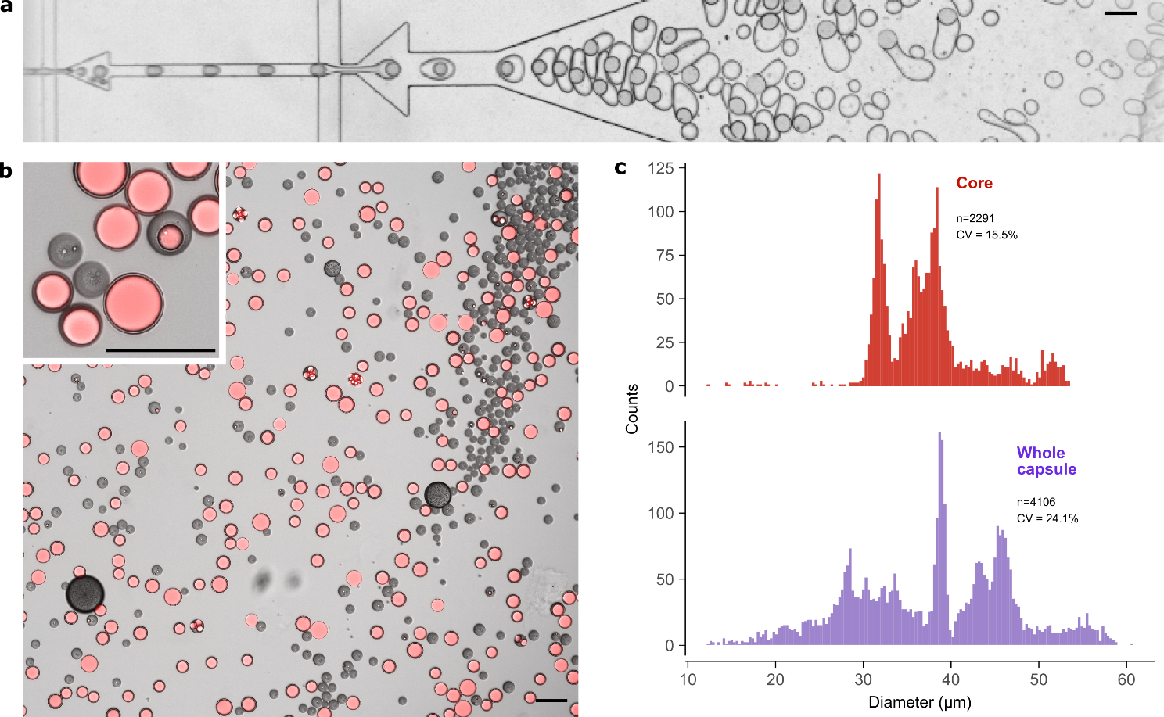

Fig. S3: Flat microfluidic design results in heterogeneous microcapsules with poor encapsulation efficiency.
a) High-speed camera microscopy image of the microfluidic W/O/W emulsification process in a flat microfluidic design.
b) Fluorescence microscopy images of the resulting particles following solvent extraction, using dextran-TRITC as core payload model and 7-17kDa 50:50 L:G PLGA as the shell polymer; TRITC and brightfield are overlayed.
c) Corresponding core and microcapsule diameter distribution.
All scale bars = 100µm.

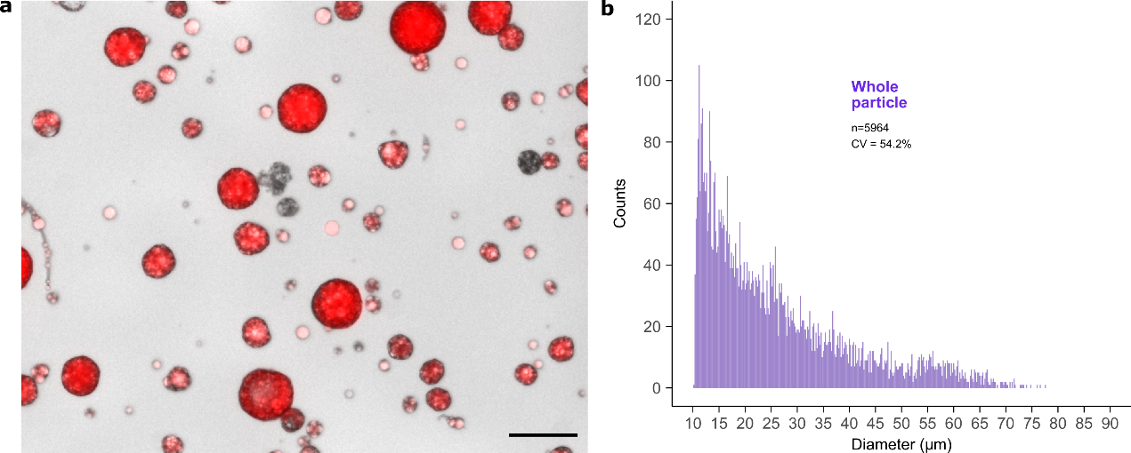

Fig. S4: Batch emulsified manufacturing method results in heterogeneous particles in terms of size and encapsulation efficiency.
a) Fluorescence microscopy image of particles produced by batch emulsification, following solvent extraction, using dextran-TRITC as core payload model and 7-17kDa 50:50 L:G PLGA as the shell polymer; TRITC and brightfield are overlayed. Scale bar = 100µm
b) Corresponding core and particle diameter distribution.

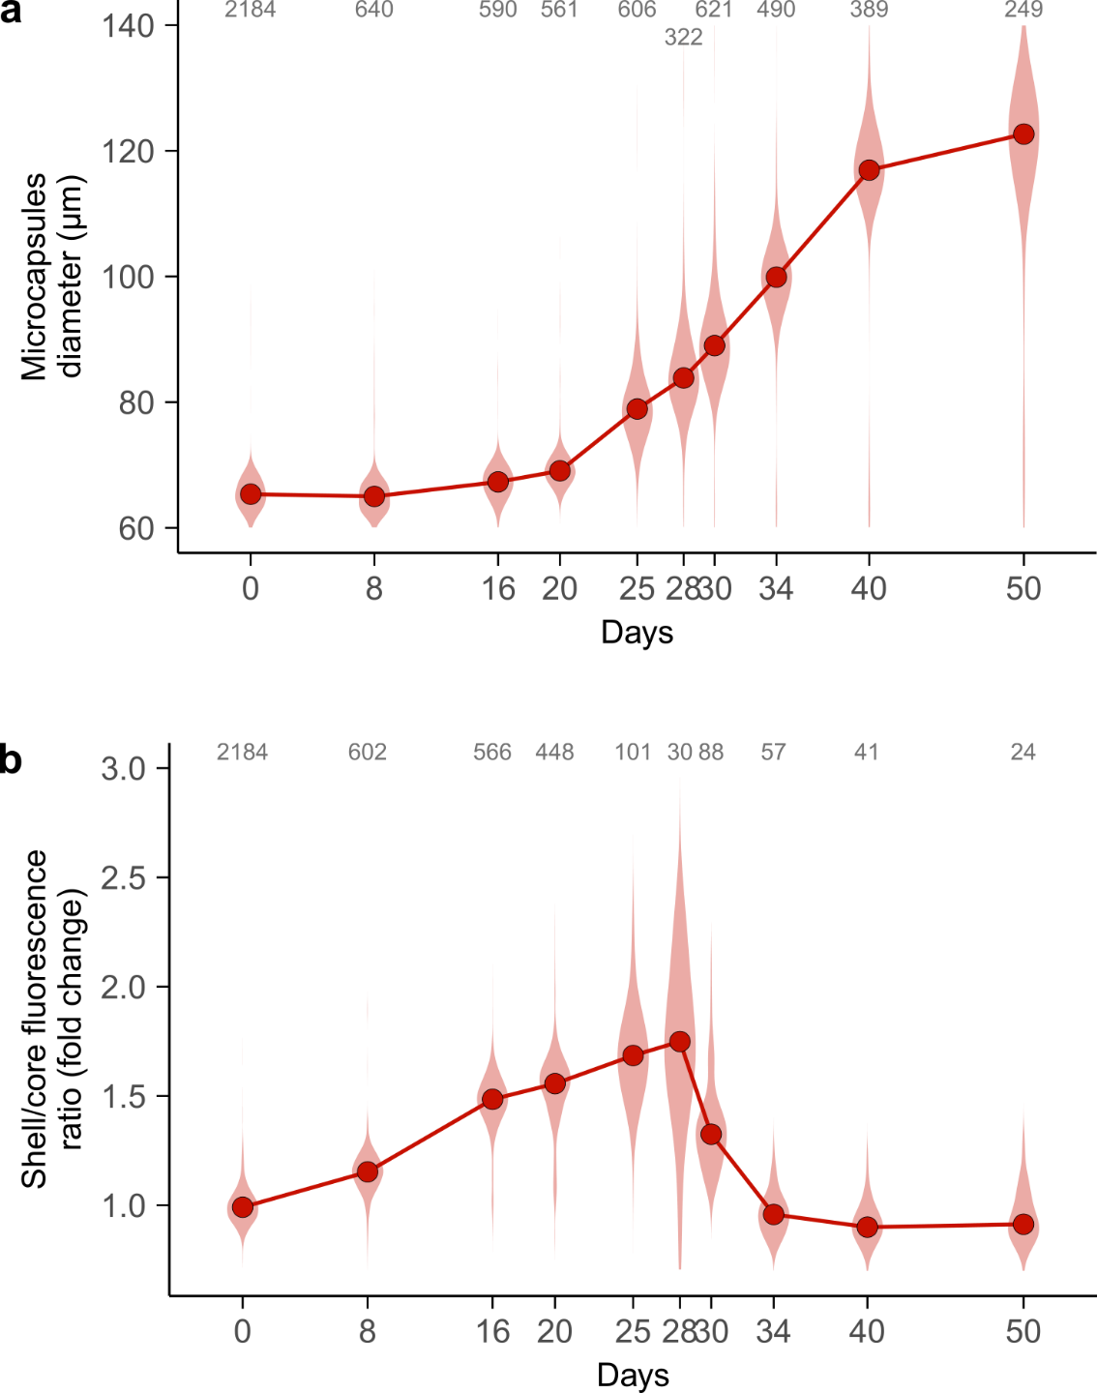

Fig. S5: Morphological changes of microcapsules with in vitro degradation.
a) Evolution of the microcapsules diameter and b) shell/core fluorescence ratio (loaded microcapsules only), with in vitro degradation time (median and violin plot distribution, n is shown for each timepoint).

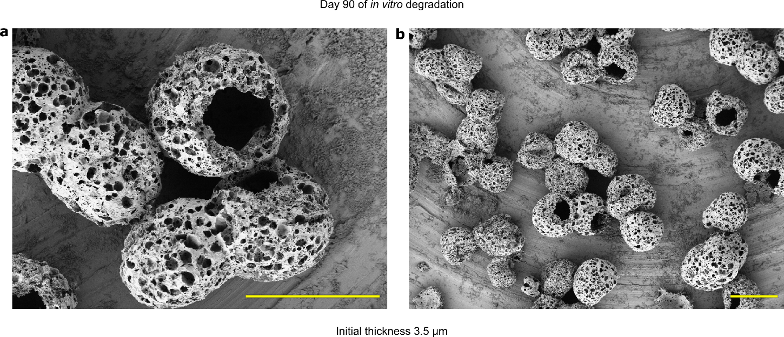

Fig. S6: Thin shell microcapsules ultimately release in vitro due to mechanical fracture.
a) and b) SEM images of microcapsules with initial shell thickness of 3.5 µm after 90 days of in vitro degradation at different magnification. Scale bar is 100 µm.

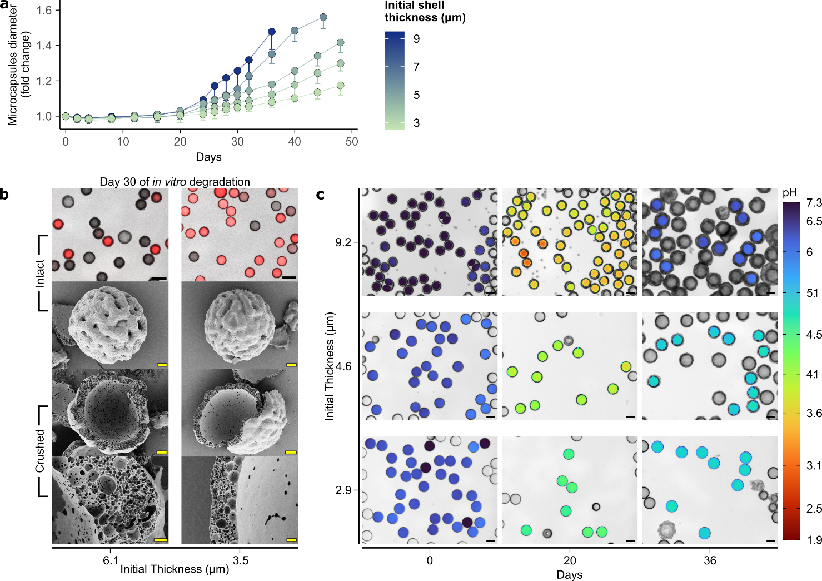

Fig. S7: Microcapsules with initial thicker shell demonstrate a higher diameter increase and intra-shell pore network following degradation and payload release, with a higher drop of core pH.
a) Evolution of microcapsules diameter (mean + SD, n>300 for each point) during in vitro incubation, for different initial shell thicknesses.
b) Fluorescence microscopy and SEM images of microcapsules of different initial thickness after 30 days of in vitro degradation, using dextran-TRITC/FITC as the core payload, and 7-17 kDa 50:50 L:G ratio PLGA as the shell polymer. TRITC signal and brightfield are overlayed. Scale bars are 100 µm (top row), 20 µm (second and third row) and 2 µm (bottom row).
c) Corresponding fluorescence microscopy images of microcapsules with different initial shell thickness at different timepoints of in vitro degradation. A color map of pH calculated from the TRITC/FITC ratio is overlayed with brightfield. Scale bar is 100 µm.

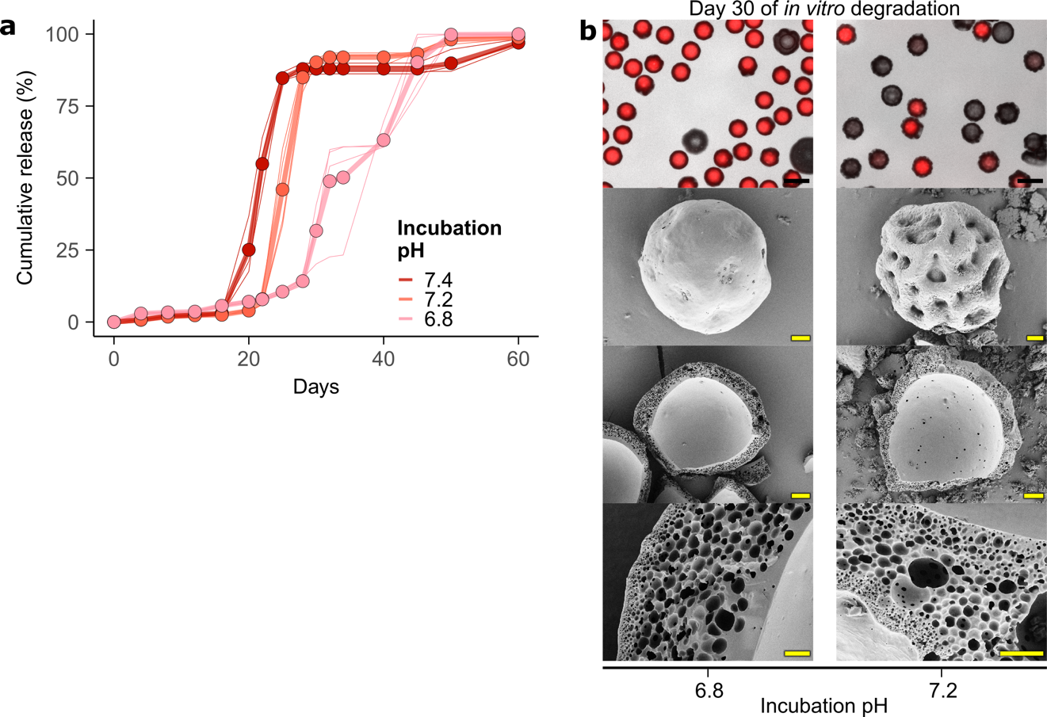

Fig. S8: Incubation pH delays the release in vitro from microcapsules.
a) The effect of varying incubation pH on the kinetics of in vitro release. Mean of batch replicates (points joined by thick lines), and individual batch replicates data (thin lines) are shown (n=4). The release data for pH 7.4 are the same as displayed in Fig. 2.
b) Fluorescence microscopy and SEM images of microcapsules after 30 days of in vitro degradation in different incubation pH, using dextran-TRITC/FITC as the core payload, and 7-17 kDa 50:50 L:G ratio PLGA as the shell polymer; TRITC signal and brightfield are overlayed. Scale bars are 100 µm (top row), 20 µm (second and third row) and 2 µm (bottom row).

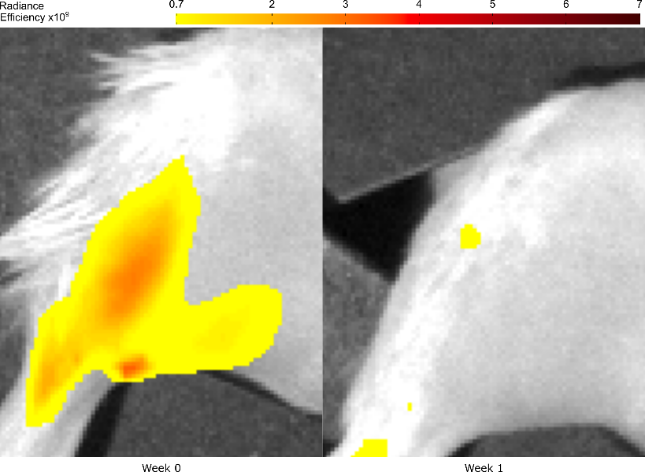

Fig. S9: Unencapsulated 40kDa dextran-TRITC is cleared within 1 week following intramuscular injection in mice.
IVIS imaging showing the radiance efficiency signal ((p/sec/cm²/sr)/(µW/cm²)) clearance of unencapsulated 40kDa dextran-TRITC injected intramuscularly.

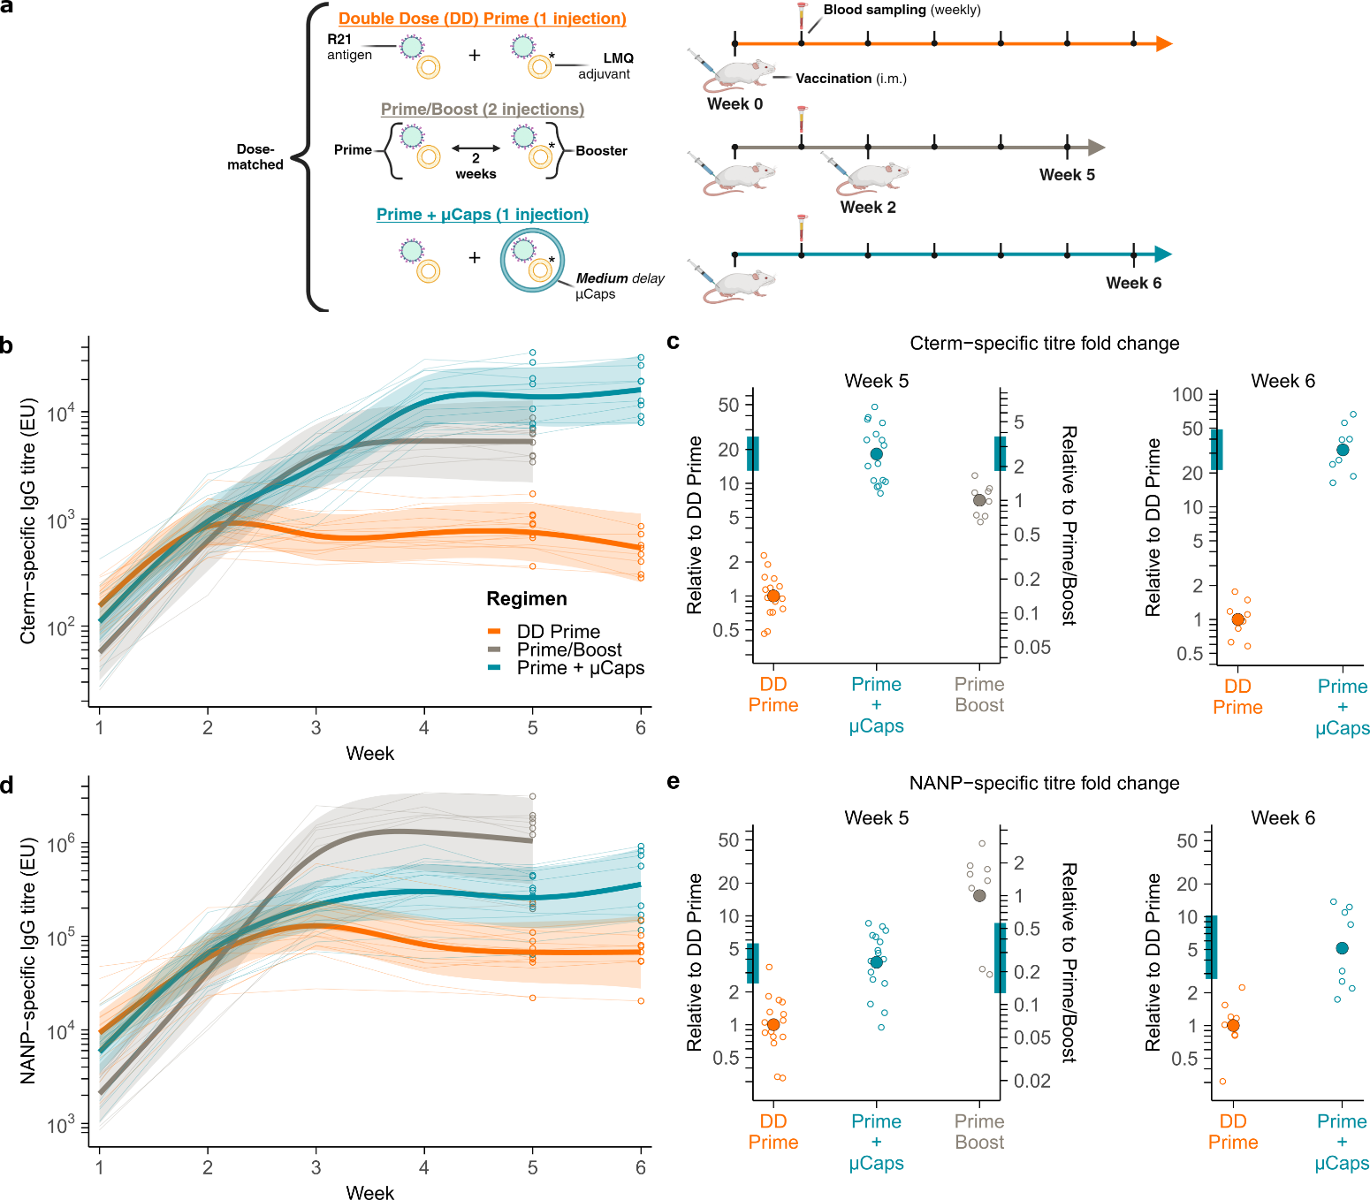

Fig. S10: Immunogenicity of the Prime+µCaps regimen when using the LMQ adjuvant.
a) Summary of the experimental protocol. A * symbol indicates that only a fraction (1/7th) of the LMQ adjuvant was used due to supplied concentration limitations.
b) Cterm and d) NANP-specific antibody responses for different regimens of dose-matched adjuvanted R21, (Week 1-5: DD Prime n=16, Prime+µCaps n=16, Prime/Boost n=8; Week 6: DD Prime n=8, Prime+µCaps n=8). Regimen-level responses from GAM fits (thick lines), 95% simultaneous CI (ribbons), individual mouse responses (thin lines) and antibody titres at time of challenge (circles) are shown.
c) Cterm and e) NANP-specific titre fold changes of Prime+µCaps compared to DD Prime or Prime/Boost at the Weeks 6 and 11 are plotted with individual mouse data (open circles), and their geometric mean (closed circle). Bootstrap 95% BCa CI are displayed as colored band on the fold change axis.
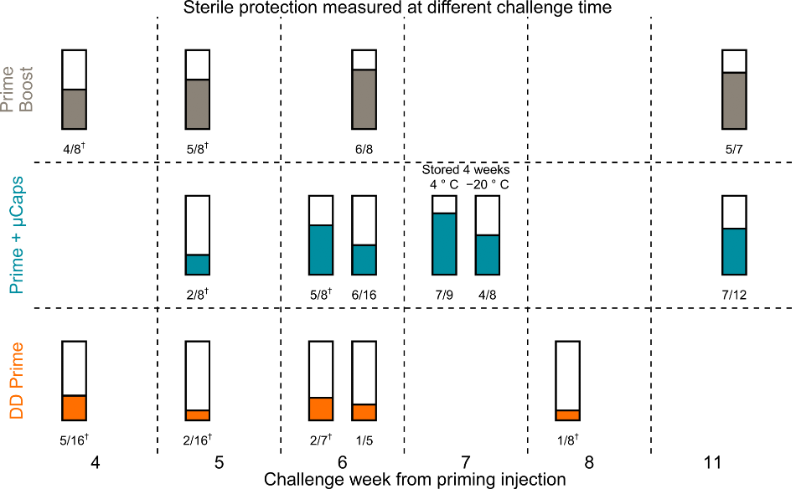

Fig. S11: Observed sterile protection depending on the regimen and time of challenge.
Sterile protection against malaria challenge performed at different time from priming injection, in separated experimental mice groups, receiving different vaccine regimens (see Fig. 5a). Each color bar corresponds to the rate of sterile protection in Balb/c mice immunized with the indicated regimen. Ratios of protected/total number of mice are displayed below each bar. Groups where LMQ adjuvant was used instead of SMNP are designated by †.

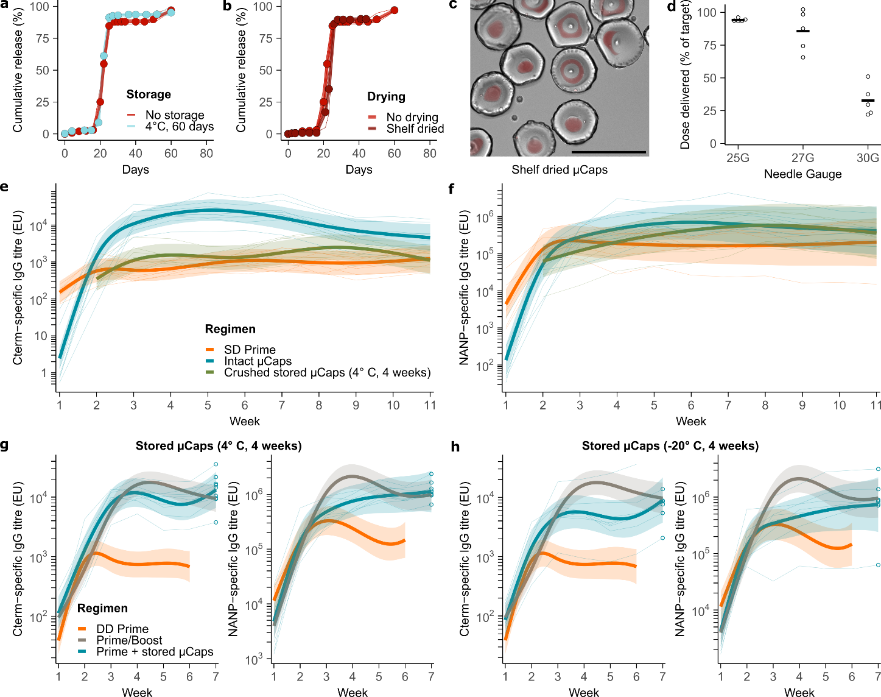
Fig. S12: Microcapsules meet technical requirements for deployment in malaria endemic countries
Effect of a) storing microcapsules for 60 days at 4°C, or b) shelf drying for 48 h at room temperature on in vitro release kinetics using 50 mg/mL 40 kDa dextran-TRITC as the payload, compared to freshly prepared microcapsules.
c) Fluorescence microscopy image of shelf-dried microcapsules (7-17 kDa 50:50 L:G) immediately after reconstitution in DPBS, with dextran-TRITC as model core payload; TRITC signal and brightfield are overlayed. Scale bar is 100 µm.
d) Percentage of target dose (100 µg) of dextran-TRITC recovered after injection with different gauge needles (n=5 per group). Individual repeats (circles) and means (crossbars) are shown.
e) Cterm and f) NANP-specific antibody responses for different regimens of dose-matched adjuvanted R21, (crushed, n=7; rest, n=8). Regimen-level responses from GAM fits (thick lines), 95% simultaneous CI (ribbons), individual mouse responses (thin lines) are shown. Intact microcapsules were injected immediately after production. Crushed microcapsules were kept stored for 4 weeks at 4 °C and broken by mechanical homogenization before injection.
Cterm and NANP-specific antibody responses for dose-matched adjuvanted R21 regimens of Prime+µCaps after 4 weeks of storage at g) 4°C or h) -20 °C (4 °C, n=9; -20 °C, n=8). Regimen-level responses from GAM fits (thick lines), 95% simultaneous CI (ribbons), individual mouse responses (thin lines) and antibody titres at time of challenge (circles) are shown. Regimen-level titres of DD Prime and Prime/Boost regimen from Fig. 4 are displayed for reference.
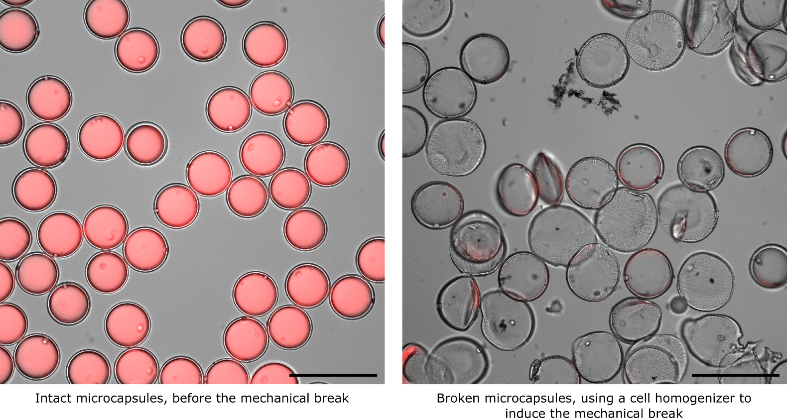
Figure. S13: Mechanical homogenization allows the break-up and full release of the payload from microcapsules.
Fluorescence microscopy image of microcapsules loaded with a mix of AF-R21 and R21 (10X objective, AF and brightfield channels are overlayed), produced by microfluidic double emulsification, and broken up mechanically using a cell homogenizer for 30 seconds. Scale bar = 100μm

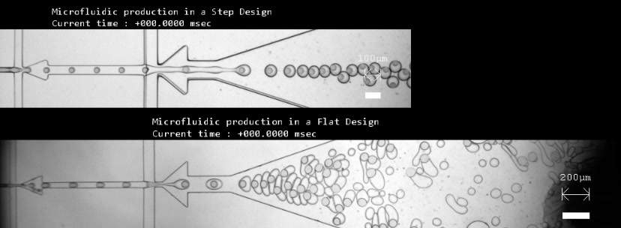
Supplementary Videos

Video S1: Stepped versus flat microfluidic emulsification process.
High-speed camera microscopy video of the microfluidic W/O/W emulsification process in a stepped (top) or flat (bottom) microfluidic design (slowed down 167 times).
The size and loading of microcapsules are controlled by the inner fluid pressure.

Supplementary Tables

Table S1: Summary of the PLGA concentrations used for the middle fluid formulation.
Polymer name | Mw (kDa) | End cap | Lactide:Glycolide ratio | Concentration  %(w/v)
Resomer R 502 | 7-17 | ester | 50:50 | 17.75
Resomer R 505 | 54-69 | ester | 50:50 | 7.5
Resomer R 753 S | 24-38 | ester | 75:25 | 12
Resomer R 202 S | 7-17 | ester | 100:00 | 17.75

