Extended Data Figures

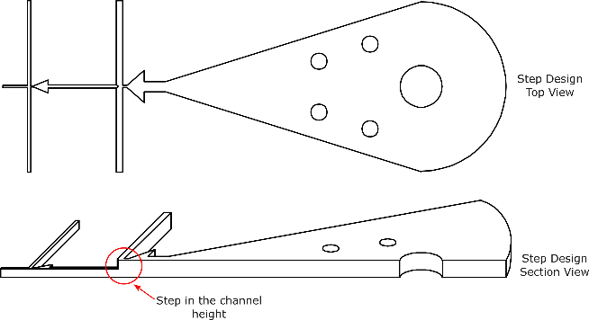

Extended Data Figure 1. Stepped microfluidic W/O/W chip design.
Top and section view of the stepped microfluidic layout developed and used in this study.

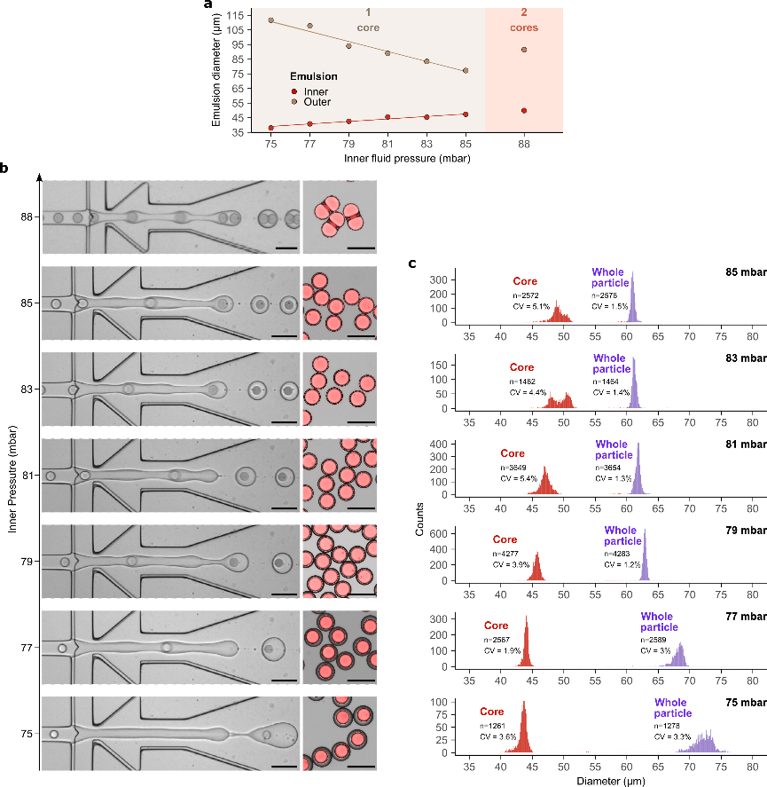

Extended Data Figure 2. The size and loading of LCSS particles are controlled by the inner fluid pressure.
a) Evolution of the core and outer diameters of the W/O/W droplets (mean ± SD, n>10).
b) Stepped microfluidic process at different inner fluid pressures and the resulting dextran-TRITC loaded LCSS particles; high-speed camera images of the emulsification process (left) and fluorescence microscopy images (right) of the corresponding LCSS particles produced, TRITC signal and brightfield are overlayed.
c) Corresponding LCSS particles (mean ± SD, n displayed for each distribution) with different inner fluid pressures, using a stepped microfluidic manufacturing process. All scale bars = 100µm.

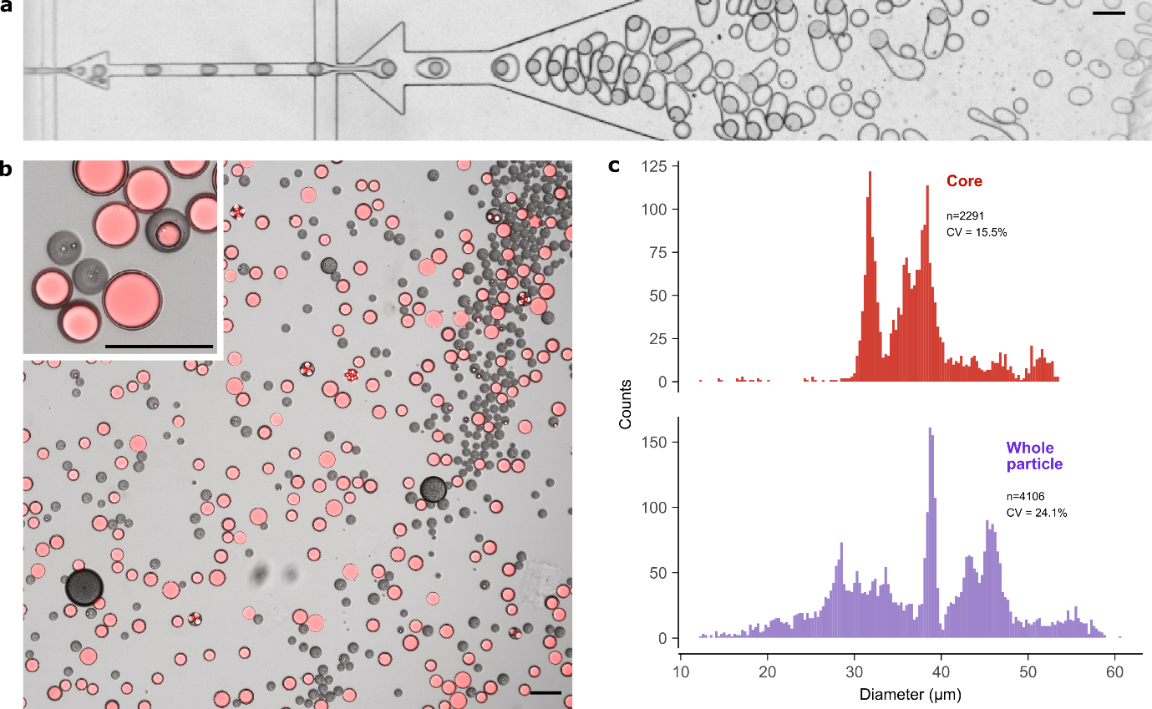

Extended Data Figure 3. Flat microfluidic design results in heterogeneous particles with poor encapsulation efficiency.
a) High-speed camera microscopy image of the microfluidic W/O/W emulsification process in a flat microfluidic design.
b) Fluorescence microscopy images of the resulting particles following solvent extraction, using dextran-TRITC as core payload model and 7-17kDa 50:50 L:G PLGA as the shell polymer; TRITC and brightfield are overlayed.
c) Corresponding core and particle diameter distribution.
All scale bars = 100µm.

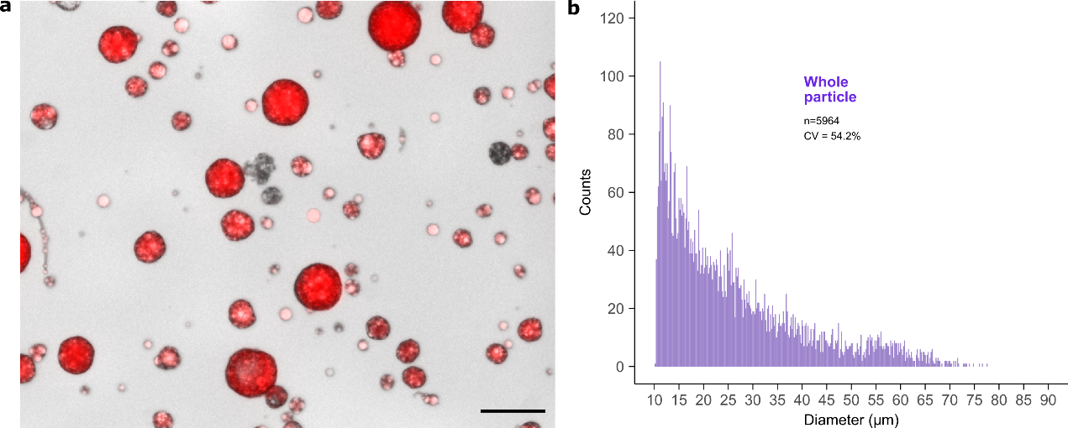

Extended Data Figure 4. Batch emulsified manufacturing method results in heterogeneous particles in terms of size and encapsulation efficiency.
a) Fluorescent microscopy image of particles produced by batch emulsification, following solvent extraction, using dextran-TRITC as core payload model and 7-17kDa 50:50 L:G PLGA as the shell polymer; TRITC and brightfield are overlayed. Scale bar = 100µm
b) Corresponding core and particle diameter distribution.

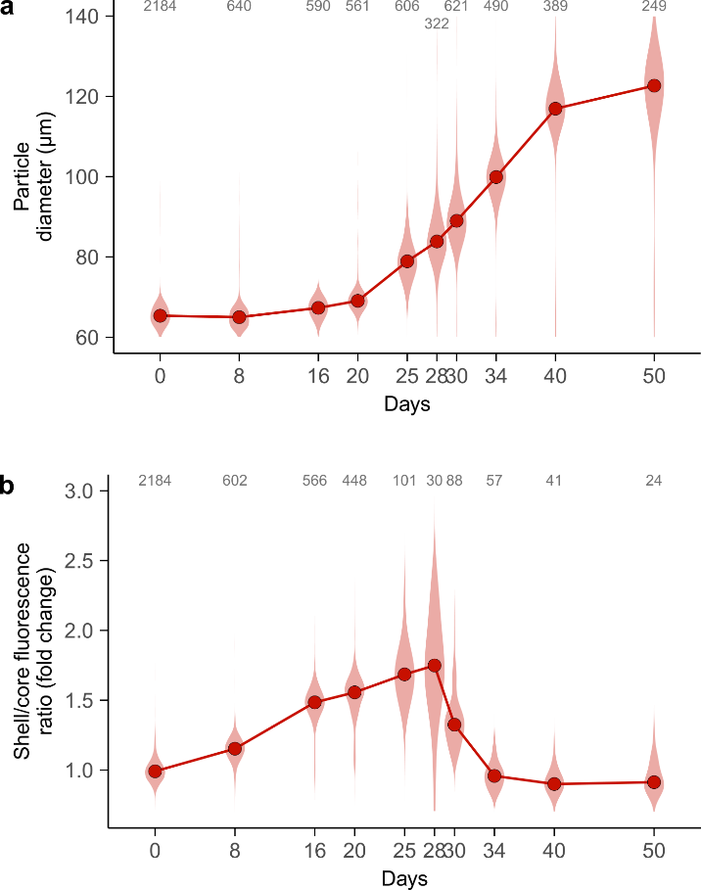

Extended Data Figure 5. Morphological changes of LCSS particles with in vitro degradation.
a) Evolution of the LCSS particle diameter and b) shell/core fluorescence ratio (loaded particles only), with in vitro degradation time (median and violin plot distribution, n is shown for each timepoint).

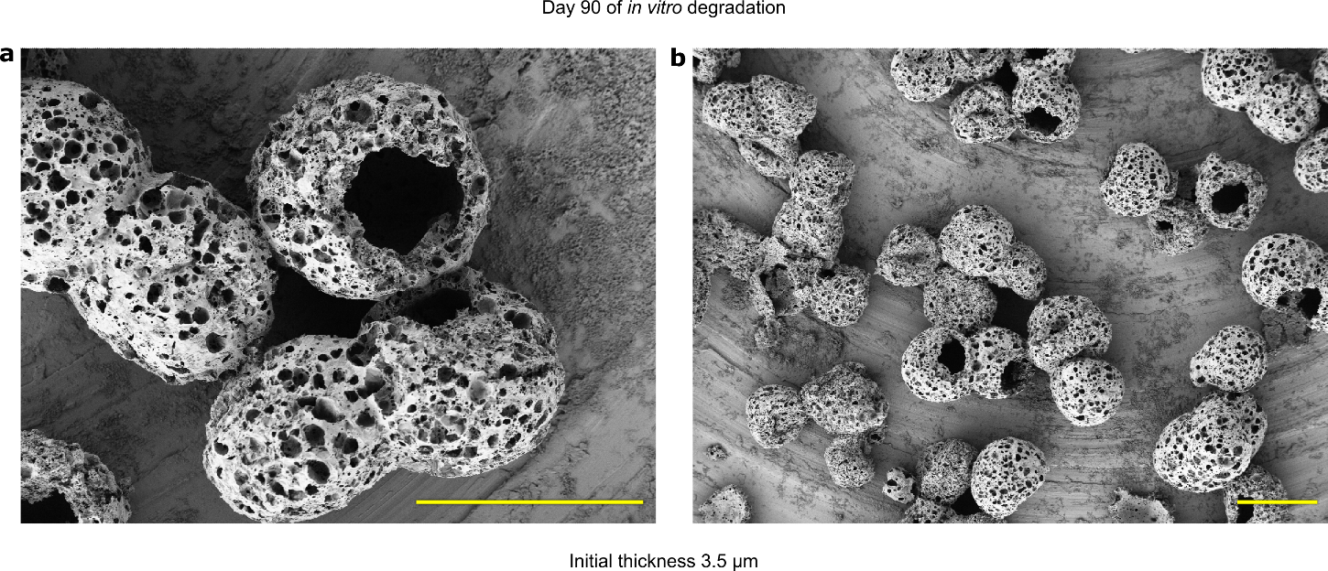

Extended Data Figure 6. Thin shell LCSS particles ultimately release in vitro due to mechanical fracture.
a) and b) SEM images of LCSS particles with initial shell thickness of 3.5 µm after 90 days of in vitro degradation at different magnification. Scale bar is 100 µm.

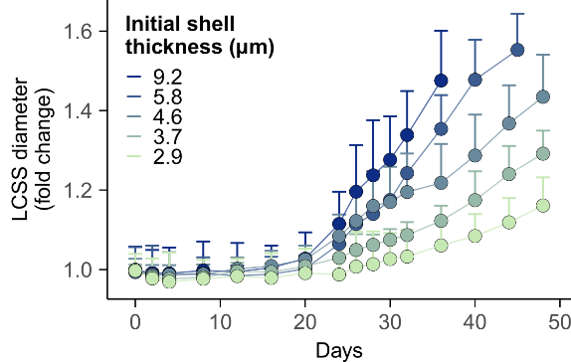

Extended Data Figure 7. LCSS particles with initial thicker shell demonstrate a higher diameter increase following degradation and payload release.
Evolution of LCSS particle diameter (mean + SD, n>300 for each point) during in vitro incubation, for different initial particle shell thicknesses.

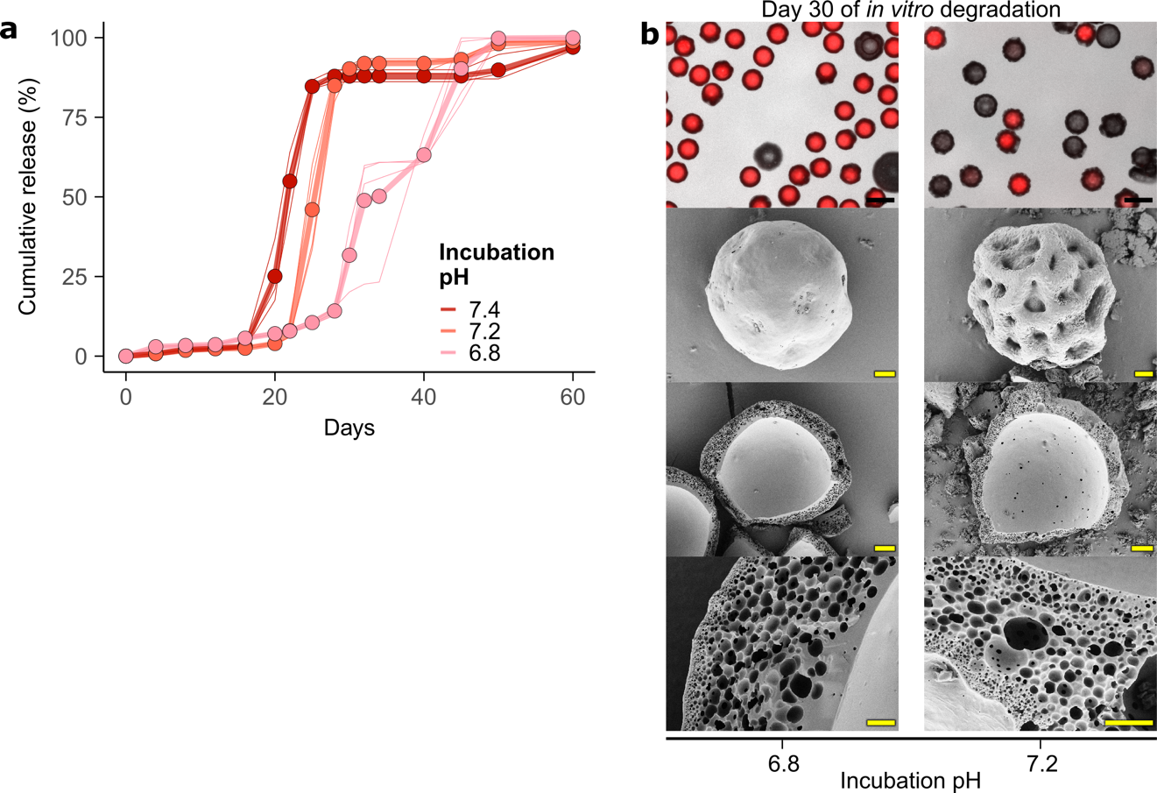

Extended Data Figure 8. The incubation pH delays the release in vitro from LCSS particles.
a) The effect of varying the incubation pH on the kinetics of in vitro release. Mean of batch replicates (points joined by thick lines), and individual batch replicates data (thin lines) are shown (n=4). The release data for pH 7.4 are the same as displayed in Fig. 2.
b) Fluorescent microscopy and SEM images of LCSS particles after 30 days of in vitro degradation in different incubation pH, using dextran-TRITC/FITC as the core payload, and 7-17 kDa 50:50 L:G ratio PLGA as the shell polymer; TRITC signal and brightfield are overlayed. Scale bars are 100 µm (top row), 20 µm (second and third row) and 2 µm (bottom row).

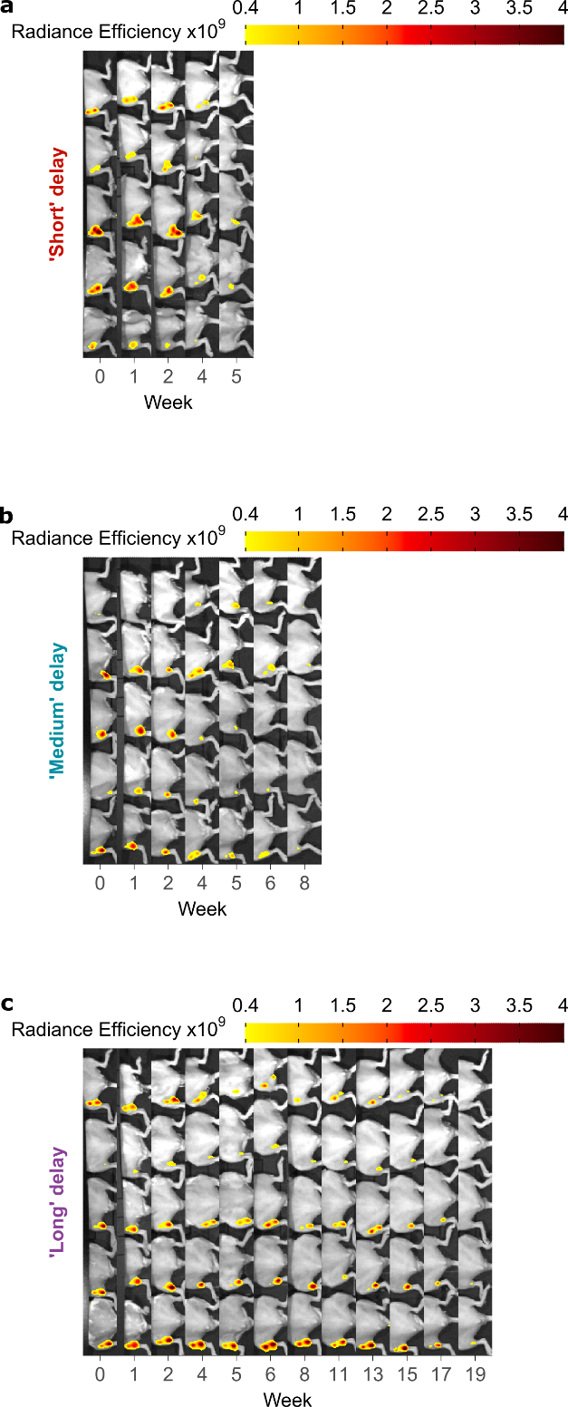

Extended Data Figure 9. Signal from fluorescent dextran-TRITC loaded LCSS particles injected in mice disappear at different times modulated by the polymer shell formulation.
Full data set of the IVIS imaging showing the change over time of the fluorescent dextran-TRITC payload signal from a) Short, b) Medium, and c) Long delay LCSS particles injected intramuscularly in mice. Radiance efficiency (p/sec/cm²/sr)/(µW/cm²), n=5/group.

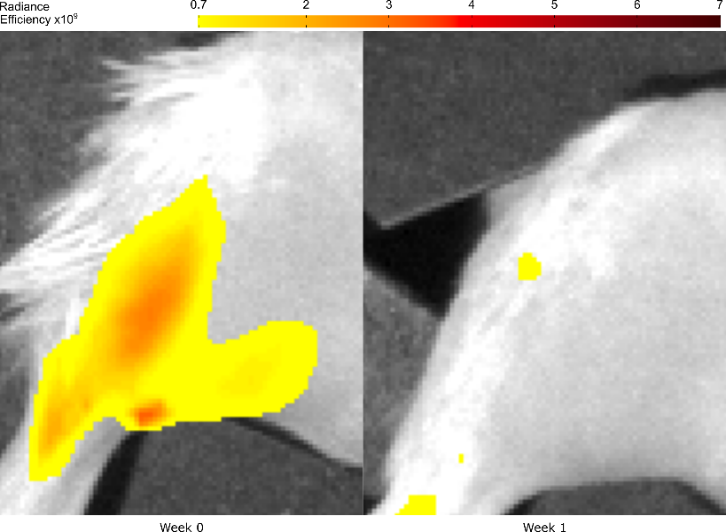

Extended Data Figure 10. Unencapsulated 40kDa dextran-TRITC is cleared within 1 week following intramuscular injection in mice.
IVIS imaging showing the radiance efficiency signal ((p/sec/cm²/sr)/(µW/cm²)) clearance of unencapsulated 40kDa dextran-TRITC injected intramuscularly.

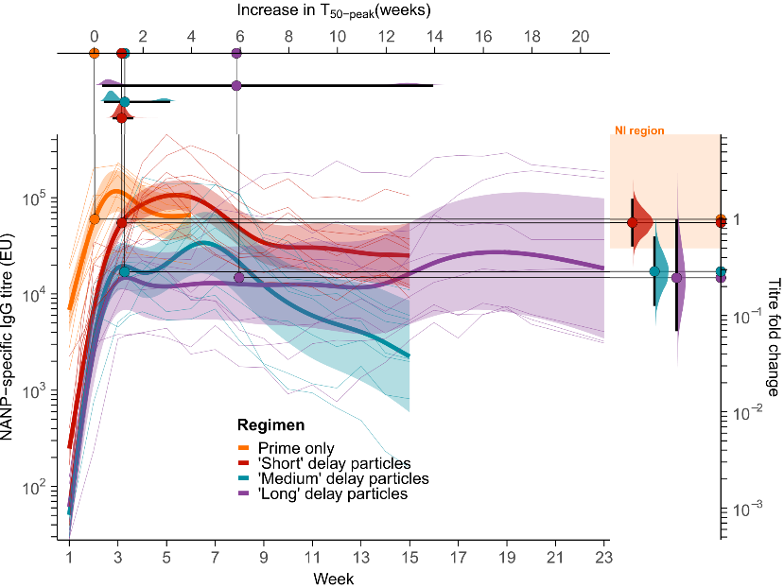

Extended Data Figure 11. Ab response against the NANP epitope following One-shot P-B regimen with different LCSS particle formulations.
NANP-specific antibody responses for partially adjuvanted R21 encapsulated in Short, Medium and Long delay LCSS particles, compared to a non-encapsulated control (Prime only) of fully adjuvanted R21 (n=8/group). Regimen-level responses from GAM fits (thick lines), 95% CI (ribbons) and individual mice responses (thin lines) are shown. The closed circle on each of the regimen-level curves corresponds to the estimated time (mean) and value (geometric mean) to reach 50% of the peak titre (T_{50peak}).
Comparisons between each regimen and the Prime only control are displayed as marginal distributions of titre fold change (right of graph) and additional delay (above graph) at T_{50peak} with 95% CI (black bar). The noninferiority (NI) region is shown as a shaded orange band.
Short particles: 1.1 wk T_{50peak} delay (95% CI [0.8-1.6]) and 1 fold change in peak titres (95% CI [0.5-1.6]; Medium particles: 1.3 wk T_{50peak} delay (95% CI [0.4-3.1]) and 0.3 fold change in peak titres (95% CI [0.1-0.6]; Long particles: 5.9 wk T_{50peak} delay (95% CI [0.3-14]) and 0.3 fold change in peak titres (95% CI [0.07-0.9]).

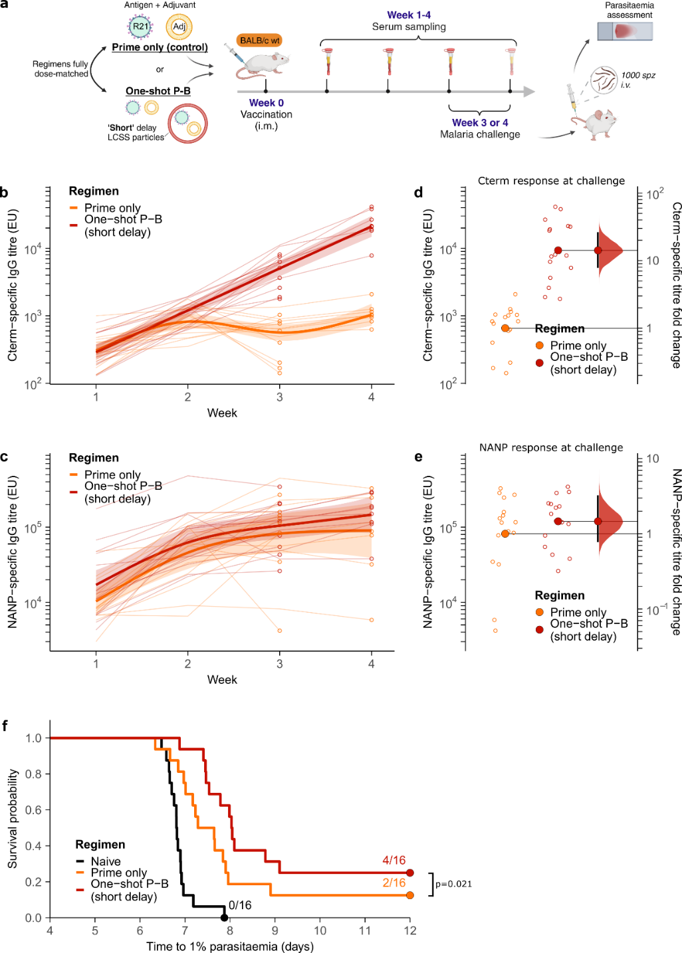

Extended Data Figure 12. Immunogenicity and efficacy of One-shot P-B with Short delay LCSS particles.
a) Cterm and b) NANP-specific antibody responses for Prime and partially adjuvanted R21 encapsulated in Short delay LCSS particles (One-shot P-B) compared to a non-encapsulated control (Prime only) of dose-matched adjuvanted R21 (n=8/regimen for each challenge). Regimen-level responses from GAM fits (thick lines), 95% CI (ribbons), individual mice responses (thin lines) and antibody titres at time of challenge (circles) are shown.
Corresponding Cterm (d) and NANP-specific (e) antibody titres at time of challenge for each group (open circles) are plotted with their geometric mean (closed circle). Bootstrap distributions of the titre fold change compared to Prime only are shown at the right, with 95% CI (black bar).
f) Survival following malaria challenge at week 5 or 6 (pooled data), plotted as Kaplan-Meier curves. Statistical analysis was done by Cox regression, adjusted for the time of challenge. Hazard ratio = 0.39 95% CI [0.17-0.87], p<0.026.

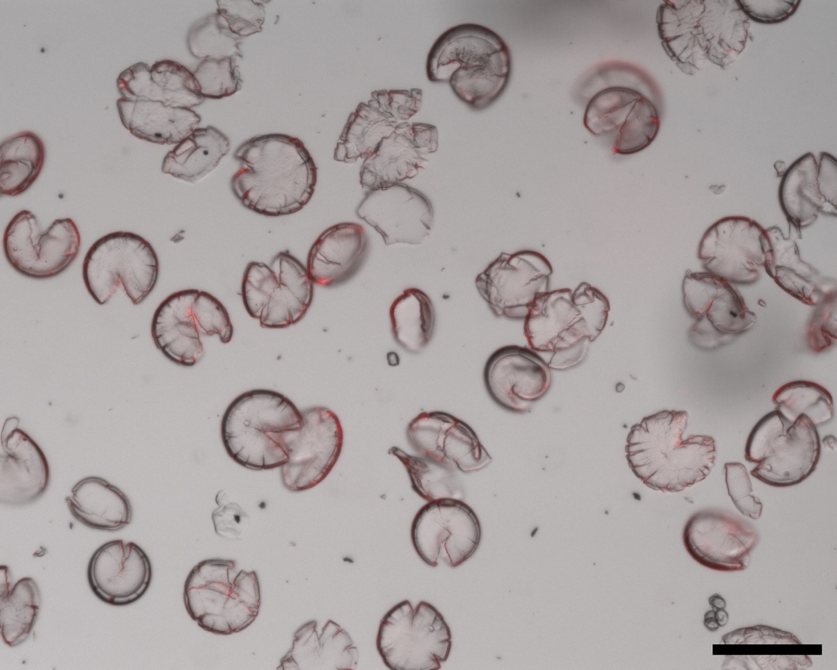

Extended Data Figure 13: Mechanical homogenisation allows the break-up and full release of the payload from LCSS PLGA particles.
Microscopy image of LCSS PLGA particles loaded with a mix of AF-R21 and R21 (10X objective, AF and brightfield channels are overlayed), produced by microfluidic double emulsification, and broken up mechanically using a cell homogeniser for 30 seconds. Scale bar = 100μm
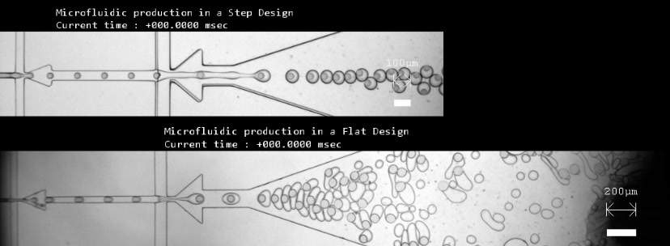

Extended Data Video. Stepped versus flat microfluidic emulsification process.
High-speed camera microscopy video of the microfluidic W/O/W emulsification process in a stepped (top) or flat (bottom) microfluidic design (slowed down 167 times).
The size and loading of LCSS particles are controlled by the inner fluid pressure.

Extended Data Tables

Extended Data Table 1: Summary of the PLGA concentrations used for the middle fluid formulation.
Polymer name | Mw (kDa) | End cap | Lactide:Glycolide ratio | Concentration  %(w/v)
Resomer R 502 | 7-17 | ester | 50:50 | 17.75
Resomer R 503 | 24-38 | ester | 50:50 | 12
Resomer R 504 | 38-54 | ester | 50:50 | 10.75
Resomer R 505 | 54-69 | ester | 50:50 | 7.5
Resomer R 753 S | 24-38 | ester | 75:25 | 12
Resomer R 202 S | 7-17 | ester | 100:00 | 17.75

Parameter |  | Manufacturing | PLGA polymer shell |  | Dextran core payload |  | Initial Thickness  (µm) | Incubation  pH | Storage | Time to 50% release  T₅₀ (days), 95%CI
Parameter |  | Manufacturing | Mw (kDa) | L:G | Mw (kDa) | concentration  (mg/mL)
Manufacturing, Fig2 |  | Stepped microfluidics | 7-17 | 50:50 | 40 | 50 | 7.2 | 7.4 | none | 21.7 [20.7-22.6]
Manufacturing, Fig2 |  | Batch emulsification |  |  |  |  |  |  |  | 3.6 [3.3-3.9]
Initial Thickness, Fig3 |  | Stepped microfluidics | 7-17 | 50:50 | 40 | 50 | 7.2 | 7.4 | none | 21.7 [20.7-22.6]
Initial Thickness, Fig3 |  |  |  |  |  |  | 6.1 | 7.4 | none | 19 [18.8-19.2]
Initial Thickness, Fig3 |  |  |  |  |  |  | 3.5 | 7.4 | none | 79.1 [77-81.2]
Incubation pH, Fig3 |  | Stepped microfluidics | 7-17 | 50:50 | 40 | 50 | 7.2 | 7.4 | none | 21.7 [20.7-22.6]
Incubation pH, Fig3 |  |  |  |  |  |  |  | 7.2 | none | 25.3 [23.9-26.6]
Incubation pH, Fig3 |  |  |  |  |  |  |  | 6.8 | none | 32.8 [27.9-37.8]
PLGA polymer shell formulation,  Fig4 |  | Stepped microfluidics | 7-17 | 50:50 | 40 | 50 | 7.2 | 7.4 | none | 21.7 [20.7-22.6]
PLGA polymer shell formulation,  Fig4 |  | Stepped microfluidics | 24-38 | 50:50 |  |  |  |  |  | 21.5 [19.1-23.8]
PLGA polymer shell formulation,  Fig4 |  | Stepped microfluidics | 38-54 | 50:50 |  |  |  |  |  | 26 [24.7-27.3]
PLGA polymer shell formulation,  Fig4 |  | Stepped microfluidics | 54-69 | 50:50 |  |  |  |  |  | 32.6 [30.6-34.6]
PLGA polymer shell formulation,  Fig4 |  | Stepped microfluidics | 24-38 | 75:25 |  |  |  |  |  | 77.5 [69.8-85.2]
PLGA polymer shell formulation,  Fig4 |  | Stepped microfluidics | 7-17 | 100:0 |  |  |  |  |  | 186 [140-233]
Dextran concentration, Fig4 |  | Stepped microfluidics | 7-17 | 50:50 | 40 | 50 | 7.2 | 7.4 | none | 21.7 [20.7-22.6]
Dextran concentration, Fig4 |  |  |  |  |  | 10 | 7.2 | 7.4 | none | 20.5 [11.6 – 29.5]
Dextran Mw, Fig4 |  | Stepped microfluidics | 7-17 | 50:50 | 40 | 50 | 7.2 | 7.4 | none | 21.7 [20.7-22.6]
Dextran Mw, Fig4 |  | Stepped microfluidics | 7-17 | 50:50 | 4.4 |  |  |  |  | 19.8 [16.8-22.7]
Dextran Mw, Fig4 |  | Stepped microfluidics | 7-17 | 50:50 | 75 |  |  |  |  | 22.3 [18-36]
Storage conditions, Fig4 |  | Stepped microfluidics | 7-17 | 50:50 | 40 | 50 | 7.2 | 7.4 | none | 21.7 [20.7-22.6]
Storage conditions, Fig4 |  |  |  |  |  |  |  |  | 4°C, 60days | 21.4 [20.9-21.8]
Extended Data Table 2: In vitro release parameters and corresponding Time to 50% release T₅₀.

