Extreme rainfall and landslides as a response to human-induced climate change: a case study at Baixada Santista, Brazil, 2020

Danilo Couto de Souza¹, Natália Machado Crespo²,
Douglas Vieira da Silva¹, Lila Mina Harada³,
Renan Muinos Parrode de Godoy¹, Leonardo Moreno Domingues¹,
Rafael Luiz⁴, Cassiano Antonio Bortolozo^{4,5}, Daniel Metodiev⁴,
Marcio Roberto Magalhães de Andrade⁴, Andrew J. Hartley⁷,
Rafael Cesario de Abreu¹, Sihan Li⁶, Fraser C. Lott⁷,
Sarah Sparrow^{8*}

¹Instituto de Astronomia, Geofísica e Ciências Atmosféricas, Universidade de São Paulo, R. do Matão, 1226, São Paulo, 05508-090, São Paulo, Brazil.
²Department of Atmospheric Physics, Faculty of Mathematics and Physics, Charles University, V Holešovičkách 747/2, Prague, 180 00, Czech Republic.
³Escola de Artes, Ciências e Humanidades, Universidade de São Paulo, R. Arlindo Béttio, 1000, São Paulo, 03828-000, Brazil.
⁴National Center for Monitoring and Early Warning of Natural Disasters, Estrada Doutor Altino Bondensan, 500, São José dos Campos, 12247-016, Brazil.
⁵Institute of Science and Technology,São Paulo State University, Rodovia Presidente Dutra, Km 137.8, São José dos Campos, 12247-004, Brazil.
⁶Department of Geography,University of Sheffield, , Sheffield, S10 2TN, United Kingdom.
⁷Met Office Hadley Centre, FitzRoy Road, Exeter, EX1 3PB, United Kingdom.
⁸Engineering Science,Oxford e-Research Centre, Keble Road, Oxford, OX1 3QG, United Kingdom.
*Corresponding author. E-mail: sarah.sparrow@oerc.ox.ac.uk

A set of data products are used to frame the extreme precipitation event that occurred on March 2nd and 3rd, 2020 at Baixada Santista. Here we present additional information that characterized the event. In this supplementary information (SI) we show Figures S.1 and S.2, and Tables T.1, T.2, T.3 and T.4, which support the article with additional information.

Figure S.1 shows the accumulated precipitation during the rainfall episode that triggered the disaster at Baixada Santista. The estimates are derived from MERGE and show a volume >300 mm over the Baixada Santista.

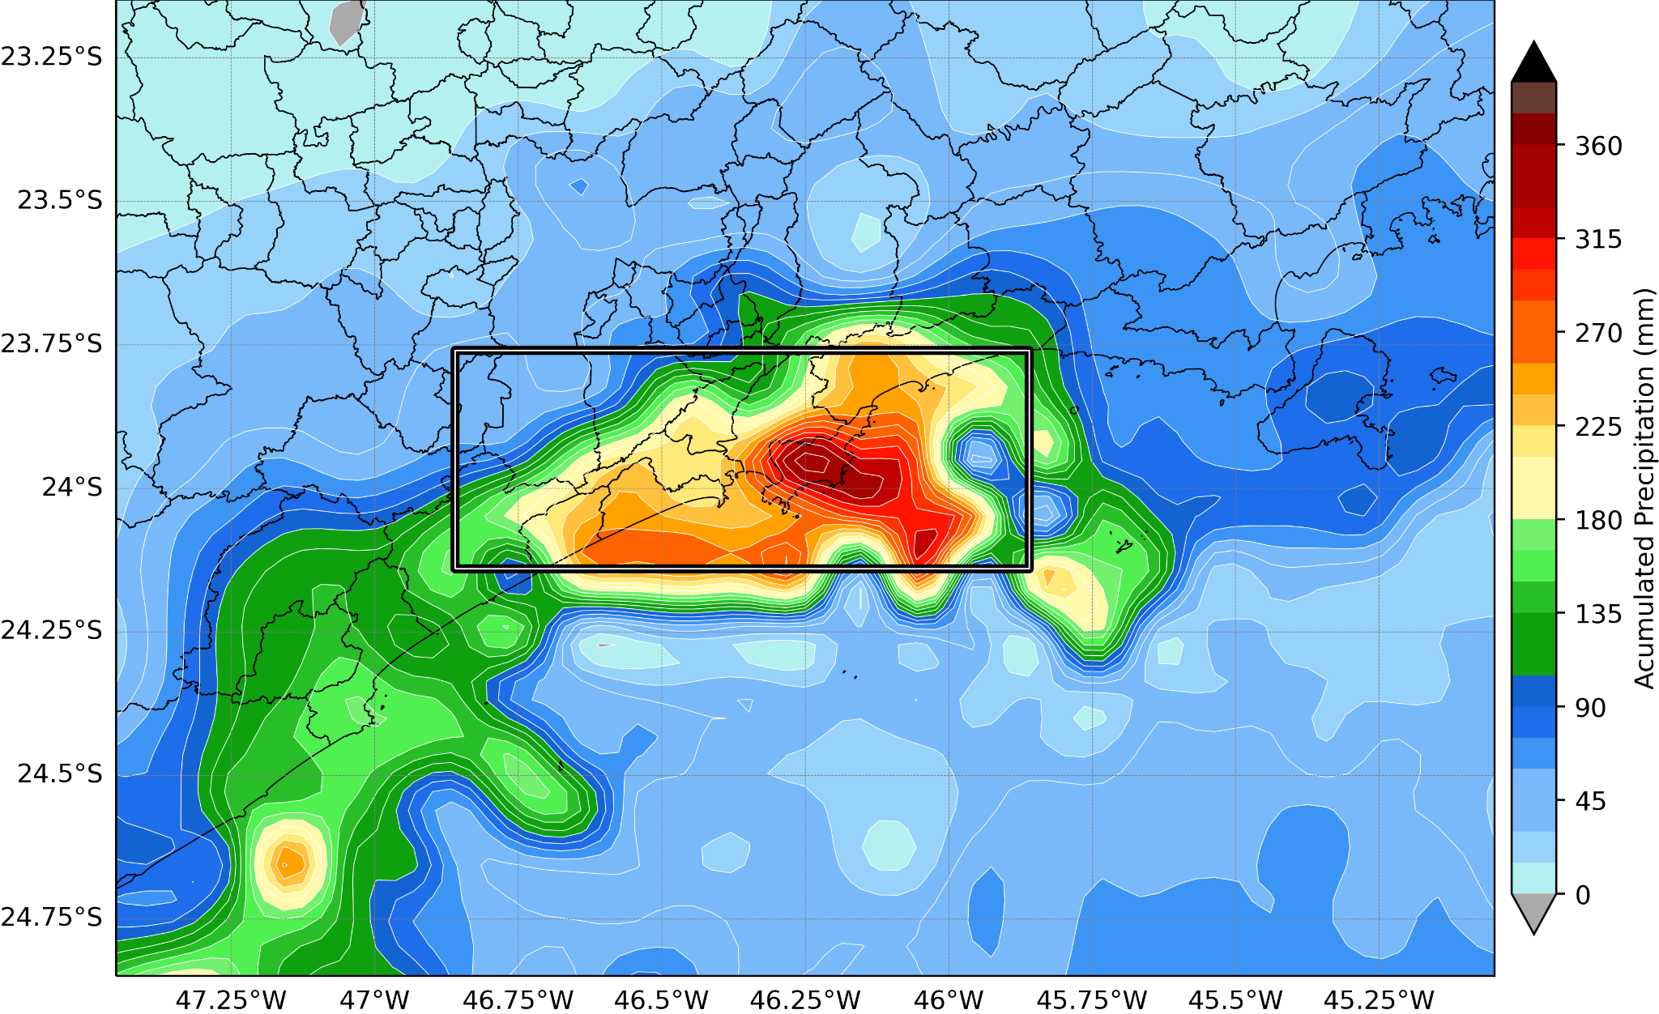
Figure S.1: MERGE Accumulated precipitation from 01/03/2020 0000 UTC to 03/03/2020 2300 UTC. The black rectangle indicates the Baixada Santista region: from 45°W to 47.5°W and from 23°S to 25°S.

To capture similar events along the climatological time series statistical tests were made using CPC data with different indexes for maximum precipitation. We opted by using maximum precipitation accumulated along 3 (RX3day_{max}) and 60 (RX60day_{max}), in order to identify long and short term events.

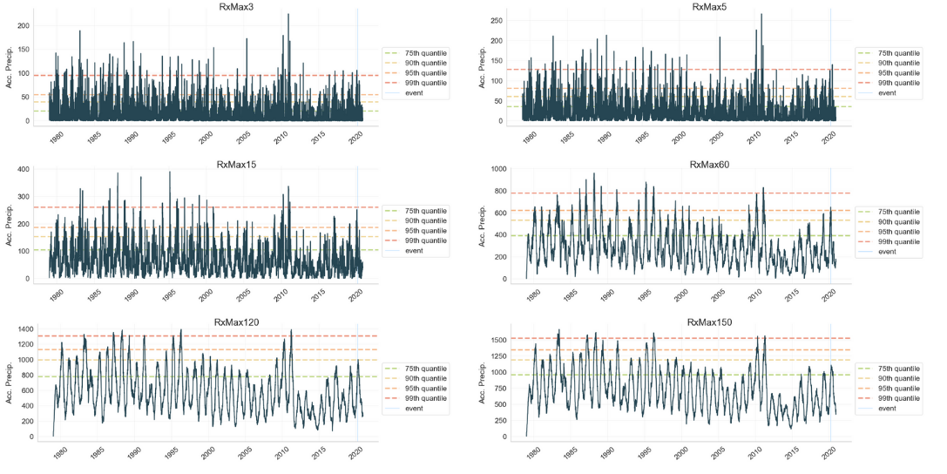
Figure S.2: Distinct RXday_{max} testd for the CPC climatological period (1979 to 2022). The vertical line represents the 2020 event while the horizontal lines represent the quantiles for each metric.

The tables T.1, T.2, T.3, and T.4 present the socioeconomic impacts caused by the rainfall and landslides in Baixada Santista. The data for T.1, T.2, and T.3 were selected from the Integrated Disaster Information System (S2iD - https://s2id.mi.gov.br/). Readers are advised to check the S2iD domain for raw data usage. Table T.4 summarizes the land cover changes derived from the MapBiomas dataset (https://plataforma.brasil.mapbiomas.org/).

Table T.1: Human damage and property losses as a consequence of the extreme precipitation event and landslide in Baixada Santista on March, 2-3, 2020.

Damages from extreme precipitation
 | Number of the affected people |  |  |  |  |  |  | Dwellings (units)
Municipality | Deaths | Injured |  | Homeless |  | Displacement |  | Damaged |  | Destroyed
Guarujá | 33 | 37 |  | 169 |  | 954 |  | 954 |  | 169
Santos | 8 | 10 |  | 214 |  | 984 |  | 255 |  | 230
São Vicente | 3 |  |  | 5 |  | 425 |  | 105
Total | 44 | 47 |  | 388 |  | 2363 |  | 1314 |  | 399
Damages from landslide
Guarujá | 13 |  | 37 |  | 52 |  | 198 |  | 281 |  | 170
Santos | 8 |  | 10 |  | 68 |  |  |  | 256 |  | 17
São Vicente | 2 |  |  |  |  |  | 18 |  | 10
Total | 23 |  | 47 |  | 120 |  | 216 |  | 547 |  | 187

Table T.2: Total cost for material damage as a consequence of the extreme precipitation event in Baixada Santista on March, 2-3, 2020. All values are expressed in BRL (Brazilian currency).

Municipality | Dwellings | Public health facilities | Public teaching facilities | Public facilities providing other services | Public facilities for community use | Public infrastructure works | Total  (BRL)
Guarujá | - | 380,268.00 | - | - | - | 90,000,000.00 | 90,380,268.00
Santos | - | 405,500.00 | 259,600.00 | 1,570,500.00 | 2,300,000.00 | 53,205,071.66 | 57,740,671.66
São Vicente | 51,200,000.00 | 480,847.53 | 1,800,000.00 | - | 250,000.00 | 10,166,250.80 | 63,897,098.33
Total (BRL) | 51,200,000.00 | 1,266,615.53 | 2,059,600.00 | 1,570,500.00 | 2,550,000.00 | 153,371,322.46 | 212,018,037.99

Table T.3: Total public economic losses as a consequence of the extreme precipitation event in Baixada Santista on March, 2-3, 2020. All values are expressed in BRL (Brazilian currency).

Municipality | Public health and medical emergency care | Drinking water supply | Rainwater sewer and sanitary | Urban cleaning disposal system | Disinfestation system | Electricity generation and distribution | Local, regional and long-distance transport | Distribution of fuels | Teaching | Total
Guarujá | 380,268.00 | - | - | 950,000.00 | 166,360.00 | - | - | - | 85,078.35 | 1,581,706.35
Santos | 405,500.00 | - | - | - | - | - | - | - | 259,600.00 | 665,100.00
São Vicente | 120,000.00 | 105,000.00 | 500,000.00 | 25,000.00 | 3,000.00 | 15,000.00 | 205,000.00 | 80,000.00 | 10,000.00 | 1,063,000.00
Total | 905,768.00 | 105,000.00 | 500,000.00 | 975,000.00 | 169,360.00 | 15,000.00 | 205,000.00 | 80,000.00 | 354,678.35 | 3,309,806.35

Table T.4: Land cover change and the expansion of urbanised areas in the municipalities of Guarujá, Santos and São Vicente from 1985 to 2021. . Data from MapBiomas platform (https://plataforma.brasil.mapbiomas.org/)..

 | Natural formations (land cover, in km²) |  | Farming (land use, in km²) |  | Urbanised área (km²)
Municipality | 1985 | 2021 | 1985 | 2021 | 1985 | 2021
Guarujá | 98.39 | 91.24 | 27.02 | 15.08 | 17.86 | 36.97
Santos | 236.62 | 230.94 | 17.80 | 13.78 | 26.31 | 36.02
São Vicente | 111.12 | 114.01 | 20.81 | 7.99 | 16.07 | 25.99
Total | 446.13 | 436.19 | 65.63 | 36.85 | 60.24 | 98.98

