Supplementary material
In this section, I present information on the methodology used. Also, there is information that supplements the results presented in the paper in relation to:
- the participation of African and non-African countries in the articles addressing neonatal conditions,
- the main path analysis using different seeds (Figure 1 to Figure 5),
- a brief description of the studies in the main path analysis.
Main Path Analysis
In the MPA, for each edge in the citation network, it is determined the traversal count using the search path count (SPC), the search path link count (SPLC), or the search path node pair (SPNP) (Verspagen, 2007). Having the traversal counts, makes possible to search for the most relevant path(s) using the local, global, or key-route main path algorithms (Liu & Lu, 2012). Here, I used the SPLC to determine the significance of each edge. The SPLC counts all paths that start at any node and end at a sink (a node that cites other nodes, but is not cited), and determines how many of these paths each edge is on. In choosing the SPLC, I followed the argument of Liu, Lu, & Ho, 2019. Applying a messenger and tollway analogy, the authors concluded that the SPLC is the best transversal count “as it emulates most closely the knowledge diffusion scenario in the scientific and technological development where individual papers or patents not only pass knowledge, but also are knowledge sources themselves” (Liu, Lu, & Ho, 2019, page 386).
To find the main path(s), between the local, global and key-route algorithms, I chose the key-route because it is the only algorithm that guarantees the inclusion of the top link (the one with the highest traversal count) (Liu & Lu, 2012). The key-route algorithm starts with a seed, the edge with the highest traversal count, and then searches forward until a sink is hit, and backwards from the tail node until a source (a node that is cited but does not cite others) is hit. The resulting paths are merged to form a network of main paths (Liu & Lu, 2012). This type of search allows the use of several seed edges. Here I explored the seeds with the top 5, 10, 15, 20 and 25, but discarded the one with the top 25 because the subnetwork became too blurred.

Table A1. The participation of scientists from African countries in the articles, published between 2000 and 2019, on NC
Country | Pub (nº) | Country | Pub (nº)
Egypt | 232 | Burkina Faso | 13
South Africa | 212 | Mozambique | 13
Nigeria | 186 | Rwanda | 13
Tanzania | 101 | Madagascar | 10
Kenya | 92 | Côte d'Ivoire | 10
Ethiopia | 81 | Botswana | 10
Uganda | 77 | Gabon | 8
Ghana | 75 | Niger | 5
Malawi | 64 | Algeria | 4
Zambia | 52 | Togo | 3
Gambia | 31 | Sierra Leone | 3
Tunisia | 24 | Burundi | 3
Democratic Republic of the Congo | 21 | The People's Republic of the Congo | 3
Morocco | 20 | Central African Republic | 2
Cameroon | 20 | Guinea Bissau | 2
Zimbabwe | 20 | South Sudan | 2
Sudan | 19 | Angola | 2
Senegal | 19 | Chad | 2
Benin | 14 | Eritrea | 1

Table A2. The participation of scientists from non-African countries in the articles, published between 2000 and 2019, on NC
Country | Pub (nº) | Country | Pub (nº)
USA | 384 | South Korea | 4
UK | 188 | Portugal | 4
India | 63 | Czech Republic | 4
Australia | 55 | Bolivia | 4
Switzerland | 52 | Costa Rica | 3
Canada | 51 | Bahrain | 3
Pakistan | 51 | Greece | 3
France | 47 | Poland | 3
The Netherlands | 43 | Iran | 3
Norway | 42 | Serbia | 3
Finland | 33 | Papua New Guinea | 3
Germany | 33 | Romania | 3
Brazil | 32 | Luxembourg | 3
Sweden | 32 | Slovakia | 3
Belgium | 32 | Uruguai | 3
Spain | 24 | Qatar | 3
Bangladesh | 22 | Sri Lanka | 3
Denmark | 22 | Kyrgyzstan | 3
China | 21 | Croatia | 3
Argentina | 21 | Lithuania | 3
Italy | 20 | Cambodia | 3
Saudi Aravia | 15 | Micronesia | 2
Guatemala | 15 | Iceland | 2
Thailand | 13 | Iraq | 2
Singapore | 10 | Estonia | 2
Japan | 10 | Ukraine | 2
Nepal | 9 | Georgia | 2
Indonesia | 8 | Panama | 2
Vietnam | 8 | Slovenia | 2
Austria | 8 | Libya | 2
Chile | 7 | Myanmar | 1
Philippines | 7 | Bhutan | 1
Mexico | 7 | Yemen | 1
New Zealand | 7 | Kazakhstan | 1
Oman | 7 | Jamaica | 1
Turkey | 7 | Albania | 1
Malaysia | 6 | Malta | 1
Israel | 6 | Latvia | 1
Peru | 5 | Armenia | 1
Ireland | 5 | Bosnia and Herzegovina | 1
United Arab Emirates | 5 | North Macedonia | 1
Jordan | 4 | Montenegro | 1
Russia | 4 | Hungary | 1
Colombia | 4 | Syria | 1
Lebanon | 4 | Haiti | 1

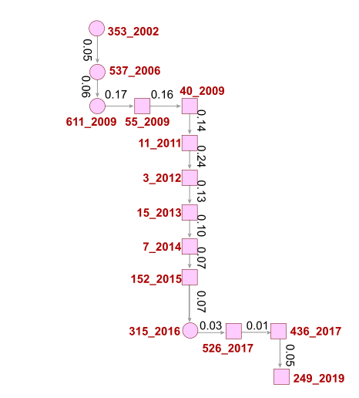
Figure A1. Main path analysis according to the different types of research collaboration: DRC (ellipse) and IRC (box). It includes as a seed the top 5 edges.

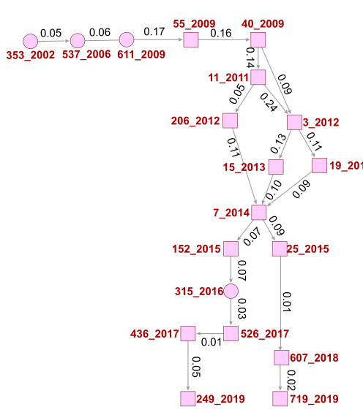
Figure A2. Main path analysis according to the different types of research collaboration: DRC (ellipse) and IRC (box). It includes as a seed the top 10 edges.

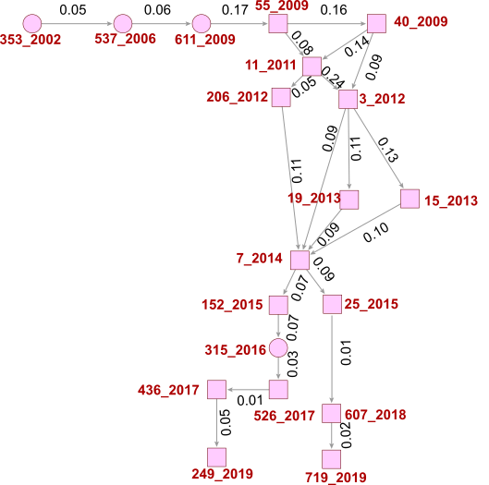
Figure A3. Main path analysis according to the different types of research collaboration: DRC (ellipse) and IRC (box). It includes as a seed the top 15 edges.
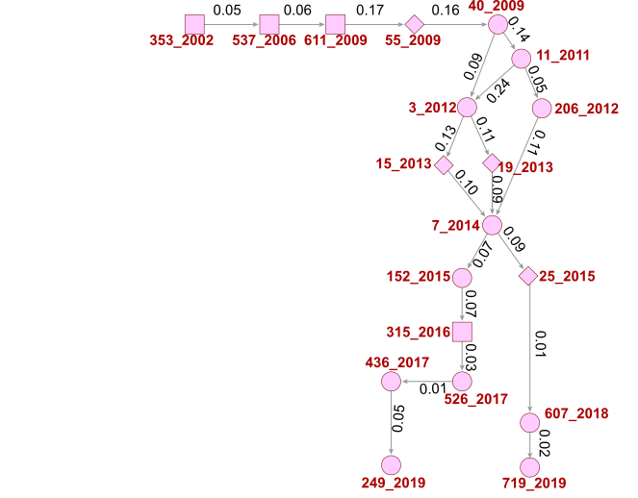
Figure A4. Main path analysis according to the different types of IRC: DRC (box); IRC_{inter} (ellipse); IRC_{inter_intra} (diamond). It includes as a seed the top 10 edges.
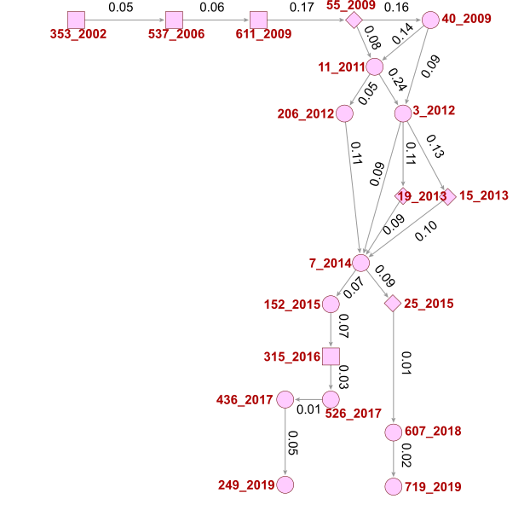
Figure A5. Main path analysis according to the different types of IRC: DRC (box); IRC_{inter} (ellipse); IRC_{inter_intra} (diamond). It includes as a seed the top 15 edges

Description of the studies in the MPA
Buchmann, Pattinson, & Nyathikazi, 2002 (node 353_2002)
The study uses data from the Perinatal Problem Identification Programme (PPIP) in South Africa to describe the contribution of intrapartum-related birth asphyxia to total perinatal mortality for the year 2000. This event accounted for 4.8 deaths per 1000 births. Labour-related asphyxia, as the most important obstetric cause, accounted for 73% of deaths related to intrapartum-related birth asphyxia, and maternal delay in seeking attention during labour was the most important preventable factor (for about 37% of deaths).
In addition to the important statistics on intrapartum-related birth asphyxia, the paper highlights the importance of having the PPIP to audit perinatal deaths.
Buchmann & Pattinson, 2006 (node 537_2006)
The following study is a continuation of the previous. The authors' aim was to identify more clearly the events leading to perinatal death from intrapartum hypoxia. In this study, data sheets in a confidential enquiry format were sent to hospitals, which agreed to participate in the study, to obtain information on each death caused by labour-related intrapartum hypoxia. Considering various aspects - labour, foetal monitoring, neonatal resuscitation, staff, facilities, and mode of delivery - the authors concluded that “Labour-related intrapartum hypoxia is a common and preventable cause of perinatal death in South Africa, and the majority of these deaths occur in low-risk situations where labour appears to proceed normally”. The authors point out that adequate foetal heart rate monitoring in women in labour is crucial to prevent the high mortality rate.
Velaphi & Pattinson, 2007 (node 484_2007)
Based on the high rate of perinatal mortality in South Africa due to intrapartum asphyxia (4.8/1000 births) reported in the previous study (Buchmann, Pattinson, & Nyathikazi, 2002), the authors analysed the primary obstetric causes of neonatal deaths due to asphyxia-hypoxia, the final causes of neonatal death in infants born asphyxiated, and the avoidable factors. The results showed that intrapartum asphyxia was the most important obstetric cause (accounting for more than 60% of all neonatal deaths due to asphyxia-hypoxia). Hypoxic-ischaemic encephalopathy, meconium aspiration syndrome and persistent pulmonary hypertension of the newborn were identified as the main final causes of death in infants born asphyxiated. Finally, the study found that among the avoidable factors, those related to health workers were the most common. 13% of deaths from asphyxia-hypoxia could have been avoided if there had been adequate foetal monitoring. Among administrative problems, inadequate facilities in neonatal units and lack of transport were the most prominent (both accounted for 4.6% of all deaths). Also, delay in seeking medical help during labour (a patient–related factor) in 111 patients resulted in 7.6 % of deaths.
Buchmann & Velaphi, 2009 (node 611_2009)
The findings of Velaphi & Pattinson, 2007 led the authors of this study to advocate for an audit of hypoxic ischemic encephalopathy (HEI) aimed at identifying its clinical causes, associated suboptimal care and avoidable factors. The authors propose an audit based on confidential inquiries and discuss the aspects that should be considered in this type of tool so that the results provide valuable insights for clinical practise. In suggesting the topics to be addressed, the authors mention the pre-conceptual, antepartum and intrapartum factors and the elements of suboptimal care found in previous studies, including those mentioned by Buchmann & Pattinson, 2006.
Pattinson et al., 2009 (node 55_2009)
The study addresses the use of perinatal mortality audits in LMICs. Using a systematic literature review on this topic in low- and middle-income settings, the authors highlighted the positive impact of such a tool in reducing perinatal mortality. In discussing the challenges of designing and implementing perinatal mortality audits in a national setting, South Africa is used in one of the case studies, highlighting the PPIP mentioned in previous studies and its benefits. The authors conclude that perinatal mortality audits in low-resource settings have great potential and appear to be feasible at the community level.
Lawn et al., 2009 (node 40_2009)
The study summarises the evidence on interventions to reduce intrapartum stillbirths and intrapartum-related neonatal deaths based on a systematic review of nearly 30 000 article titles or abstracts. For 193 countries grouped by neonatal mortality (which is considered an indicator of a health system), information is presented on various aspects of intrapartum care, obstetric care, neonatal resuscitation, strategies to link communities to facility-based care, community-based care for 60 million non-facility births, and perinatal audits as described in the previous study (Pattinson et al., 2009), focusing on countries in the groups that have high neonatal mortality (African and Asian countries). The authors concluded that intrapartum care needs improvement in high performing countries (wealthy countries). For the countries where most deaths occur (mainly Africa and Asia), the authors emphasise the need for urgent strategic planning and investment to scale up effective care at birth, neonatal resuscitation, and community mobilisation. Finally, they stress the crucial role of audits as a strategy to reduce perinatal mortality.

Lawn, Wilczynska-Ketende, & Cousens, 2006 (node 18_2006)
The study highlights the high mortality rate of infants in the first 4 weeks of life and the need to develop strategies to reduce this burden. However, successful strategies can only be developed if information on the main causes of neonatal deaths is available. While there are tools to collect this information in rich countries, such as vital registration, information on causes of death is lacking in LMICs, where 99% of deaths occur, because there are no data collection tools. Therefore, the authors used estimates to produce statistics on the main causes of death. In 2000, the authors estimated that the leading causes of neonatal death worldwide were infections (sepsis/pneumonia, tetanus and diarrhoea, 35%), preterm birth (28%) and asphyxia (23%). In Africa, sepsis/pneumonia, asphyxia and preterm birth were responsible for 27%, 24% and 23% of total neonatal deaths in 2000.
Black et al., 2010 (node 6_2010)
The authors recognised the importance of having estimates of the main causes of death in children under 5 years of age if we are to define interventions that target these causes. In this study, statistics show that in 2008, 68% of all deaths in children younger than 5 years worldwide were due to infectious diseases, and 41% of deaths involved neonates. Based on the model of Lawn, Wilczynska-Ketende, & Cousens, 2006 (the study mentioned above), the authors estimated that preterm birth complications, birth asphyxia, sepsis and pneumonia were the leading causes of neonatal deaths (12%, 9%, 6% and 4%, respectively). They also found that most deaths occurred in Africa and Southeast Asia. 50% of all child deaths occurred in India, Nigeria, the Democratic Republic of Congo, Pakistan and China.
Baiden et al., 2006 (node 151_2006)
The study recognises that a two-thirds reduction in under-five mortality between 1990 and 2015 is only possible if strategies are in place to address the major causes of death in sub-Saharan Africa (SSA, the region where most deaths occur). However, there is a lack of information on the main causes of death in this region because the systems to collect the data have not yet been established. Using the Demographic Surveillance System (DSS), which routinely conducts a VA (a method of asking the family of the dead infant about the characteristics of the child's final illness), the authors recorded 1118 neonatal deaths in Kassena–Nankana District (KND) in northern Ghana between 1995 and 2002. Using this tool, the authors found that 63% of deaths occurred in the early neonatal period (first seven days of life) and 57% of deaths were due to prematurity and birth injuries. They also found that infectious causes were the main cause of late neonatal deaths (66% of all deaths). In this way, the authors identified the main causes of neonatal deaths in the district and enabled the development and implementation of strategies to reduce mortality rates. They also showed how routinely collected data at DSS sites in sub-Saharan Africa can be used to assess trends in key demographic and health indicators.
Edmond et al., 2008b (node 100_2008)
Considering that estimating the causes of perinatal and neonatal deaths is essential for developing and evaluating the performance of maternal and newborn health programmes, the authors analysed the accuracy of VA as a tool for obtaining information on causes of death. They highlighted the importance of studies examining the main causes of neonatal deaths using VA as the previous one (Baiden et al., 2006). However, they stressed that these studies should be complemented by research on the performance of such a technique if it is to be widely accepted in the community. The causes of death reported by VA were compared with those collected from the four hospitals in central Ghana. The authors used the classification system of causes of death in Lawn, Wilczynska-Ketende, & Cousens, 2006 and found that among the 502 stillbirths and neonatal deaths with a hospital and VA diagnosis, 94.0%, 84.8% and 98.4% of antepartum stillbirths, intrapartum stillbirths and neonatal deaths were correctly classified by VA according to the time of death. The VA performed poorly in diagnosing stillbirths such as congenital anomalies and maternal haemorrhage. Accuracy was higher for intrapartum obstetric complications and antepartum maternal disease. For neonatal deaths, sensitivity was over 60% for all major causes, and specificity was 76% for birth asphyxia but more than 85% for prematurity and infections.
Edmond et al., 2008a (node 87_2008)
This study is a follow-up to the study by Edmond et al. (with the same authors), which aimed to describe the timing and distribution of causes of stillbirths and neonatal deaths according to the place of death (health facility or home). Using a community-level questionnaire VA (the revised version of the World Health Organisation), the study found that infections were the most common cause of death in the antepartum (10.1%) and the neonatal period (40.3%). The main cause of intrapartum deaths was obstetric complications (59.3 %). The authors found no significant differences in the causes of stillbirths in health facilities and at home. There were significantly fewer neonatal deaths due to birth asphyxia at home (20.8%) than in health facilities (44.8%) and more deaths due to infections (49.6% at home and 31.0% in health facilities).
Lawn et al., 2011 (node 11_2011)
The study by Lawn et al., addressed the lack of information on stillbirths despite the enormous number of cases (about 2.65 million in 2008). The authors presented epidemiological data to identify interventions to reduce stillbirths, particularly in LMICs where 98% of stillbirths occur in the third trimester (more than three-quarters of them in South Asia and SSA). Through the research, the authors: (1) identified gaps in the definition of stillbirths and provided their definition, (2) noted the lack of national estimates of causes of stillbirths (here they mention the critical role of national estimates of neonatal causes of death in reducing deaths, as reported in Black et al., to get the attention to the need of having such estimates on stillbirths), and (3) revealed information on the geography associated with the occurrence of this event (here they highlight the high stillbirth rates in Africa) and provided data on when stillbirths occur and why. They also: (1) suggested a series of recommendations to improve national data on this issue and addressed the usability of VA to identify the main causes of stillbirths as described by Edmond et al., 2008a in their study for Central Ghana, (2) discussed, how stillbirths can be reduced through the use of tools that audit mortality (the authors mention the South African Perinatal Audit in Pattinson et al., 2009 as a good example) and the collection of data on pregnancy and childbirth care as supported by the findings of the Lawn et al., 2009 study, and (3) identified research priorities on this topic. Using this information, the authors have shown that stillbirths are a non-negligible burden and that there is still much to be done at various levels (especially data collection) if we are to reduce stillbirth rates specifically in LMICs such as in Africa.

Pitt et al., 2012 (node 206_2012)
The study is related to donor funding for newborn survival. The authors developed a methodology based on key concepts to analyse aid flows to newborns. They examined funding that exclusively benefits newborns or is also intended to improve the health of other population groups as well (hereafter not-exclusively newborns). Using the Creditor Reporting System (CRS)Aid Activity database, the authors found that the total value of aid provided for programmatic or advocacy activities (non-research activities) regarding the not-exclusively newborns increased from US$38.4 million in 2002 to US$717.1 million in 2010, while this value for projects that exclusively benefited newborns was US$5.7 million in 2010. Tanzania, Nigeria, Sudan and Ethiopia are among the 10 countries that received the largest amount of aid related to not- exclusively newborns between 2002 and 2010. Zambia, Tanzania and Mozambique are among the 10 countries that received the largest amount of aid exclusively for newborns. The picture changes when looking at the amount of aid per live birth, where there are only three African countries in the top 10 that received the highest amount of aid(Eritrea and Liberia for not-exclusively newborns and Zambia and Eritrea for exclusively newborns). Finally, the US and the United Nations Children's Fund (UNICEF) provided the highest value of non-research funding, mentioning newborns and exclusively benefiting newborns, respectively. The authors also emphasised the consistency of their findings with the conclusions of Lawn et al., 2011, i.e., that stillbirths receive too little attention on the global health agenda despite their importance for public health.
Blencowe et al., 2012 (node 3_2012)
The authors point out that there are no national systematic data on preterm birth and cross-national time trends, even though complications of preterm birth account for 35% of annual neonatal deaths worldwide. The authors begin with a discussion of the causes of preterm birth and refer to the study by Lawn et al., 2009 to highlight that the highest burden countries (which include most African countries) have very low rates of preterm birth due to induction of labour or elective caesarean section. Further, the authors highlight the lack of clear rules and guidelines for the registration of live births, methods for measuring gestational age and other aspects essential for measuring preterm births. Therefore, referring to the study by Lawn et al., 2011, the authors present an overview of definitions and variable cut-offs that apply to pregnancy outcomes related to preterm births and stillbirths. They used this information to produce global, regional, and national estimates of preterm birth rates for 184 countries in 2010. The authors estimated that 14.9 million babies were born preterm and that more than 60% of babies were born in South Asia and SSA. In terms of the number of preterm births in 2010, Nigeria and the Democratic Republic of Congo were among the top 10 countries.
Lee et al., 2013 (node 15_2013)
This is another study that highlights the importance of having national estimates, this time for neonates born too small for gestational age at full term (≥37 weeks gestation; term-SGA) and for the co-occurrence of small for gestational age and preterm birth (preterm-SGA) in LMICs. In 2010, more than 32 million babies were born too small for gestational age in these countries (27% of live births). Based on the previous study, the authors present estimates for the prevalence of preterm SGA at the national (138 LMICs) and regional levels in 2010. In North Africa and SSA, 1.2% and 2.0% of live births were preterm-SGA, respectively, values lower than the 3% in Southeast Asia (the maximum value found by the authors). The prevalence of term-SGA in North Africa and SSA in 2010 was 8.5% and 23.5% respectively, much lower than the 41.5% in South Asia.
Christian et al., 2013 (node 19_2013)
The authors addressed the risk of stunting, wasting and underweight in children aged 12-60 months in LMICs. In these countries, in 2011, 148 million children were estimated to be stunted. The authors noted that foetal growth and birth weight are likely to influence child growth and that high rates of low birth weight and childhood stunting coexist among children in several countries. Because low birth weight can be a consequence of foetal growth restriction or preterm birth, the authors estimated study-specific and pooled risk estimates for stunting, wasting and underweight due to foetal growth restriction or preterm birth using statistics from previous studies (Blencowe et al., 2012; Lee et al., 2013, described above) to highlight the high number of both events in these countries. The children were divided into 4 groups: Appropriate size for gestational age (AGA) and preterm birth; SGA and term; SGA and preterm; and AGA and term (the reference group). For LMICs, the authors found that relative to AGA and term, the odds ratios for stunting associated with AGA and preterm, SGA and term, and SGA and preterm were 1.93, 2.43 and 4.51, respectively. A similar magnitude of risk was also observed for wasting and underweight. In SSA, the odds ratios for stunting associated with AGA and preterm, SGA and term, and SGA and preterm were 2.13, 2.36 and 5.95, respectively. Similar values were also observed for wasting and underweight, except for wasting and SGA and preterm with a lower odds ratio (3.44).
Lawn et al., 2014 (node 7_2014)
The authors aimed to review the status of newborn health and progress since the 2005 Lancet Neonatal Survival Series. They highlight the fact that newborn survival and preterm birth make part of national agendas due to the policy hook of the Millennium Development Goals and improved epidemiological estimates. However, they draw on Pitt et al., 2012 study to emphasize that adequate funding is missing.
The authors found that the global neonatal mortality rate (NMR) has decreased by 37% since 1990, from 33 to 21 deaths per 1000 live births. However, in SSA, the NMR decreased by only 28%. In 2012, nine countries had an NMR above 40 (40 deaths per 1000 live births) and eight of these were African (Central African Republic, Mali, Democratic Republic of Congo, Lesotho, Angola, Guinea-Bissau, Somalia and Sierra Leone). Considering previous statistics, a series of epidemiological analyses and consultations, a target of no more than 10 stillbirths per 1000 total births and no more than 10 neonatal deaths per 1000 live births was set for 2035.
However, the authors stated that to achieve the target it is necessary to have information that will help in defining and implementing action plans. Looking at previous studies or through their own calculations, it was found that the countries with the highest NMR also have the highest fertility rates coupled with thin coverage of care. Therefore, these are the ones that need the most attention. As for the main causes of neonatal deaths in 2012, complications of preterm birth, intrapartum-related conditions, and infections stand out.
To go further, the authors drew on previous studies on preterm birth and SGA (Blencowe et al., 2012; Christian et al., 2013; Lee et al., 2013, as described above) to discuss the estimated consequences of SGA and preterm birth in terms of neonatal mortality and stunting. Babies who are term SGA low birthweight are at risk of stunting and adult-onset metabolic conditions, while those that represent preterm births are at the highest risk of neonatal death, and important risk of long-term neurodevelopmental impairment, stunting, and non-communicable conditions. Other neonates have life-threatening or disabling conditions including intrapartum-related brain injury, severe bacterial infections, or pathological jaundice.

Althabe et al., 2015 (node 25_2015)
The authors investigated the use of antenatal corticosteroids in pregnant women at high risk of preterm birth to reduce the high neonatal mortality associated with preterm birth found in the previous study (Lawn et al., 2014). The study included clusters at seven sites of the Global Network for Women’s and Children’s Health Research (Argentina, Zambia, Guatemala, India, India, Pakistan, and Kenya). Studies reporting the administration of this type of treatment in hospitals with neonatal intensive care units emphasised the positive effect in reducing neonatal mortality. However, the authors did not find the same positive results in these clusters. The authors reported a relative increase of 11-12% in neonatal and perinatal mortality in the overall population.
Massawe et al., 2018 (node 607_2018)
The study examined the effect of a care package on reducing neonatal mortality in the first 7 days after birth in infants with an estimated gestational age of 28 to 34 6/7 weeks in four hospitals in Tanzania. The package, which has been shown to be successful in high-income countries, included the administration of antenatal corticosteroids to mothers in preterm labour, maternal antibiotics in active labour, immediate stabilisation/resuscitation of the newborn including avoidance of moderate hypothermia (< 36˚C), and early neonatal antibiotics. In defining this strategy, the authors considered the key findings of Althabe et al., 2015 that the administration of antenatal corticosteroids was associated with an increase in neonatal and perinatal mortality. Implementation of the care package in four hospitals in Tanzania led to a decrease in neonatal mortality in the first 7 days after birth. The authors pointed out the increase in mortality when the package included only the administration of antenatal corticosteroids and maternal antibiotics only or only the administration of antenatal corticosteroids only. The authors discuss the latter results in light of the findings of Althabe et al., 2015, as the results in both studies are consistent. Finally, the authors emphasise that the care package is very attractive if these results can be observed in other settings with limited resources. In addition to the good results in reducing neonatal mortality, the authors also highlight the ease of administration by an obstetrician and the low cost ($6-7 per mother-infant pair).
Moshiro et al., 2019 (node 719_2019)
n a prospective observational study of newborns admitted to Haydom, a rural hospital in Northern Tanzania, the authors identified intrapartum-related complications (birth asphyxia and meconium aspiration syndrome accounted for 58% of all deaths), prematurity and presumed sepsis as the leading causes of death. After identifying the main causes of death, the authors highlight several strategies that can be used to reduce the high mortality rates. In combination with the findings of the previous study (Massawe et al., 2018), , the authors recommend the administration of antenatal corticosteroids to women at immediate risk of preterm labour and antibiotics to women with preterm rupture of membranes to reduce high preterm mortality. Other recommendations include continuous foetal heart rate monitoring after delivery, more effective resuscitation, and endotracheal intubation.
Slusher et al., 2015 (node 152_2015)
The study addressed hyperbilirubinemia one of the pathologies that affect term and near-term newborn infants in LMICs, as mentioned in Lawn et al., 2014.
Although previous studies have shown that filtered sunlight is successful in lowering total bilirubin (e.g., Slusher et al., 2014), its performance has not been studied in comparison with conventional phototherapy.
The authors compared the effect of filtered sunlight and conventional phototherapy in the treatment of hyperbilirubinemia in term and late-preterm neonates in Island Maternity Hospital, Nigeria. The results showed that phototherapy with filtered sunlight is safe and has the same efficacy as conventional phototherapy.
Olusanya, Imosemi, & Emokpae, 2016 (node 315_2016)
The authors investigated the use of BiliChek and JM-103 bilirubinometers in estimating total serum bilirubin (TSB) in black African newborns. Based on the results of previous studies showing a reduced risk of severe hyperbilirubinemia but an increased risk of kernicterus underpinned by glucose-6-phosphate dehydrogenase (G6PD) deficiency, the authors analysed transcutaneous bilirubin and TSB in 1553 late preterm and term neonates at Island Maternity Hospital in Nigeria.
Using a set of possible predictors of bilirubin, including G6PD levels as determined in the study by Slusher et al., 2015, the authors highlighted the limitations of transcutaneous bilirubin as a screening tool or proxy for TSB in black African neonates contrary to the studies that have found a positive association between the two. The authors noted that current transcutaneous bilirubin devices are only highly sensitive at low TSB levels and tend to overestimate TSB with increasing age in African neonates. The authors argue that these findings should be considered in the management of infants at risk of kernicterus to avoid unnecessary blood sampling.
Greco et al., 2017 (node 526_2017)
This study explored the performance and accuracy of the JM-103 transcutaneous bilirubinometer and Bilistick System (BS) in measuring TSB in 126 newborns with a gestational age of > 36 weeks readmitted and investigated for jaundiced at the Neonatal Intensive Care Unit of Cairo University Children’s Hospital. The authors used the results of the previous study (Olusanya, Imosemi, & Emokpae, 2016) to highlight the need to investigate the usefulness of these tools. When compared to the reference method (analysis in a clinical laboratory), the authors found that both JM-103 and BS are reliable methods for screening jaundiced newborns and that the BS can be an alternative to the JM-103 device in resource-limited settings due to its low cost.
Keahey et al., 2017 (node 436_2017)
Considering the advantages and disadvantages of available instruments for measuring bilirubin, the authors have developed a low-cost, battery-powered reader that can rapidly quantify serum bilirubin levels from small drops of whole blood applied to a lateral flow card, the BiliSpec. The new device was tested at Queen Elizabeth Central Hospital in Blantyre, Malawi, using the blood of 94 newborns at risk of jaundice. Comparison of the results obtained with the BiliSpec with those obtained with a laboratory reference standard showed a good correlation (r=0.97). The authors also found a slight overestimation of bilirubin concentration compared to the laboratory reference; a deviation of 0.3 mg/dL was found. Referring to previous studies, including that of Greco et al., 2017, the authors emphasise the higher accuracy of the new device and the need for fewer user steps and disposables.
Bell et al., 2019 (node 249_2019)
This study recognises the need to have a device for measuring bilirubin whose characteristics are compatible with an environment characterised by limited resources. A potentiometric sensor for the quantification of free bilirubin in blood serum is presented. Looking at the disadvantages of the devices developed and presented in previous studies, such as in Keahey et al., 2017, the authors highlighted the unnecessary separation of blood components to measure the amount of bilirubin as an advantage of the potentiometric sensor.

References
Althabe, F., Belizan, J. M., McClure, E. M., Hemingway-Foday, J., Berrueta, M., Mazzoni, A., . . . Buekens, P. M. (2015). A population-based, multifaceted strategy to implement antenatal corticosteroid treatment versus standard care for the reduction of neonatal mortality due to preterm birth in low-income and middle-income countries: the ACT cluster-randomised trial. Lancet, 385(9968), 629-639. doi:10.1016/s0140-6736(14)61651-2
Baiden, F., Hodgson, A., Adjuik, M., Adongo, P., Ayaga, B., & Binka, F. (2006). Trend and causes of neonatal mortality in the Kassena-Nankana district of northern Ghana, 1995-2002. Tropical Medicine & International Health, 11(4), 532-539. doi:10.1111/j.1365-3156.2006.01582.x
Bell, J. G., Mousavi, M. P. S., Abd El-Rahmana, M. K., Tan, E. K. W., Homer-Vanniasinkam, S., & Whitesides, G. M. (2019). Paper-based potentiometric sensing of free bilirubin in blood serum. Biosensors & Bioelectronics, 126, 115-121. doi:10.1016/j.bios.2018.10.055
Black, R. E., Cousens, S., Johnson, H. L., Lawn, J. E., Rudan, I., Bassani, D. G., . . . Who, U. (2010). Global, regional, and national causes of child mortality in 2008: a systematic analysis. Lancet, 375(9730), 1969-1987. doi:10.1016/s0140-6736(10)60549-1
Blencowe, H., Cousens, S., Oestergaard, M. Z., Chou, D., Moller, A. B., Narwal, R., . . . Lawn, J. E. (2012). National, regional, and worldwide estimates of preterm birth rates in the year 2010 with time trends since 1990 for selected countries: a systematic analysis and implications. Lancet, 379(9832), 2162-2172. doi:10.1016/s0140-6736(12)60820-4
Buchmann, E. J., & Pattinson, R. C. (2006). Babies who die from labour-related intrapartum hypoxia: a confidential enquiry in South African public hospitals. Tropical Doctor, 36(1), 8-10. doi:10.1258/004947506775598879
Buchmann, E. J., Pattinson, R. C., & Nyathikazi, N. (2002). Intrapartum-related birth asphyxia in South Africa - Lessons from the First National Perinatal Care Survey. Samj South African Medical Journal, 92(11), 897-901. Retrieved from <Go to ISI>://WOS:000179516100034
Buchmann, E. J., & Velaphi, S. C. (2009). Confidential enquiries into hypoxic ischaemic encephalopathy. Best Practice & Research Clinical Obstetrics & Gynaecology, 23(3), 357-368. doi:10.1016/j.bpobgyn.2008.12.004
Christian, P., Lee, S. E., Angel, M. D., Adair, L. S., Arifeen, S. E., Ashorn, P., . . . Black, R. E. (2013). Risk of childhood undernutrition related to small-for-gestational age and preterm birth in low- and middle-income countries. International Journal of Epidemiology, 42(5), 1340-1355. doi:10.1093/ije/dyt109
Edmond, K. M., Quigley, M. A., Zandoh, C., Danso, S., Hurt, C., Agyei, S. O., & Kirkwood, B. R. (2008a). Aetiology of stillbirths and neonatal deaths in rural Ghana: implications for health programming in developing countries. Paediatric and Perinatal Epidemiology, 22(5), 430-437. doi:10.1111/j.1365-3016.2008.00961.x
Edmond, K. M., Quigley, M. A., Zandoh, C., Danso, S., Hurt, C., Agyei, S. O., & Kirkwood, B. R. (2008b). Diagnostic accuracy of verbal autopsies in ascertaining the causes of stillbirths and neonatal deaths in rural Ghana. Paediatric and Perinatal Epidemiology, 22(5), 417-429. doi:10.1111/j.1365-3016.2008.00962.x
Greco, C., Iskander, I. F., Akmal, D. M., El Houchi, S. Z., Khairy, D. A., Bedogni, G., . . . Zabetta, C. D. C. (2017). Comparison between Bilistick System and transcutaneous bilirubin in assessing total bilirubin serum concentration in jaundiced newborns. Journal of Perinatology, 37(9), 1028-1031. doi:10.1038/jp.2017.94
Keahey, P. A., Simeral, M. L., Schroder, K. J., Bond, M. M., Mtenthaonnga, P. J., Miros, R. H., . . . Richards-Kortum, R. R. (2017). Point-of-care device to diagnose and monitor neonatal jaundice in low-resource settings. Proceedings of the National Academy of Sciences of the United States of America, 114(51), E10965-E10971. doi:10.1073/pnas.1714020114
Lawn, J. E., Blencowe, H., Oza, S., You, D. Z., Lee, A. C. C., Waiswa, P., . . . Lancet Every Newborn Study, G. (2014). Every Newborn: progress, priorities, and potential beyond survival. Lancet, 384(9938), 189-205. doi:10.1016/s0140-6736(14)60496-7
Lawn, J. E., Blencowe, H., Pattinson, R., Cousens, S., Kumar, R., Ibiebele, I., . . . Lancet's Stillbirths Series, S. (2011). Stillbirths: Where? When? Why? How to make the data count? Lancet, 377(9775), 1448-1463. doi:10.1016/s0140-6736(10)62187-3
Lawn, J. E., Kinney, M., Lee, A. C. C., Chopra, M., Donnay, F., Paul, V. K., . . . Darmstadt, G. L. (2009). Reducing intrapartum-related deaths and disability: Can the health system deliver? International Journal of Gynecology & Obstetrics, 107, S123-S142. doi:10.1016/j.ijgo.2009.07.021
Lawn, J. E., Wilczynska-Ketende, K., & Cousens, S. N. (2006). Estimating the causes of 4 million neonatal deaths in the year 2000. International Journal of Epidemiology, 35(3), 706-718. doi:10.1093/ije/dyl043
Lee, A. C. C., Katz, J., Blencowe, H., Cousens, S., Kozuki, N., Vogel, J. P., . . . Birth, C. S.-P. (2013). National and regional estimates of term and preterm babies born small for gestational age in 138 low-income and middle-income countries in 2010. Lancet Global Health, 1(1), E26-E36. doi:10.1016/s2214-109x(13)70006-8
Liu, J. S., & Lu, L. Y. Y. (2012). An Integrated Approach for Main Path Analysis: Development of the Hirsch Index as an Example. Journal of the American Society for Information Science and Technology, 63(3), 528-542. doi:10.1002/asi.21692
Liu, J. S., Lu, L. Y. Y., & Ho, M. H. C. (2019). A few notes on main path analysis. Scientometrics, 119(1), 379-391. doi:10.1007/s11192-019-03034-x
Massawe, A., Kidanto, H. L., Moshiro, R., Majaliwa, E., Chacha, F., Shayo, A., . . . Perlman, J. M. (2018). A care bundle including antenatal corticosteroids reduces preterm infant mortality in Tanzania a low resource country. Plos One, 13(3). doi:10.1371/journal.pone.0193146
Moshiro, R., Perlman, J. M., Mdoe, P., Kidanto, H., Kvaloy, T., & Ersdal, H. L. (2019). Potential causes of early death among admitted newborns in a rural Tanzanian hospital. Plos One, 14(10). doi:10.1371/journal.pone.0222935
Olusanya, B. O., Imosemi, D. O., & Emokpae, A. A. (2016). Differences Between Transcutaneous and Serum Bilirubin Measurements in Black African Neonates. Pediatrics, 138(3). doi:10.1542/peds.2016-0907
Pattinson, R., Kerber, K., Waiswa, P., Day, L. T., Mussell, F., Asiruddin, S., . . . Lawn, J. E. (2009). Perinatal mortality audit: Counting, accountability, and overcoming challenges in scaling up in low- and middle-income countries. International Journal of Gynecology & Obstetrics, 107, S113-S122. doi:10.1016/j.ijgo.2009.07.011
Pitt, C., Lawn, J. E., Ranganathan, M., Mills, A., & Hanson, K. (2012). Donor Funding for Newborn Survival: An Analysis of Donor-Reported Data, 2002-2010. Plos Medicine, 9(10). doi:10.1371/journal.pmed.1001332
Slusher, T. M., Olusanya, B. O., Vreman, H. J., Brearley, A. M., Vaucher, Y. E., Lund, T. C., . . . Stevenson, D. K. (2015). A Randomized Trial of Phototherapy with Filtered Sunlight in African Neonates. New England Journal of Medicine, 373(12), 1115-1124. doi:10.1056/NEJMoa1501074
Velaphi, S., & Pattinson, R. (2007). Avoidable factors and causes of neonatal deaths from perinatal asphyxia-hypoxia in South Africa: national perinatal survey. Annals of Tropical Paediatrics, 27(2), 99-106. doi:10.1179/146532807x192462
Verspagen, B. (2007). Mapping Technological Trajectories as Patent citation Networks: a Study on the History of Fuel Cell Research. Advances in Complex Systems (ACS), 10, 93-115. doi:10.1142/S0219525907000945

