Responses of Soil Water Potential and Plant Physiological Status to Pulsed Rainfall Events in Arid Northwestern China: Implications to Disclose the Water-use Strategies of Desert Plants
Yuanyuan Ma^{a, b, c}, Hu Liu^{a, b*}, Wenzhi Zhao^{a, b}, Li Guo^{d, e}, Qiyue Yang^{a, b}, Yulong Li^{f}, Jintao Liu^{g}, Omer Yetemen^{h}
ª Northwest Institute of Eco-Environment and Resources, Chinese Academy of Sciences, Lanzhou, 730000, China
^{b} Linze Inland River Basin Research Station, Chinese Ecosystem Research Network, Lanzhou 730000, China
^{c} University of Chinese Academy of Sciences, Beijing 100029, China
^{d} Department of Ecosystem Science and Management, The Pennsylvania State University, University Park, PA 16802, U.S.A.
^{e} State Key Laboratory of Hydraulics and Mountain River Engineering, Sichuan University, Chengdu, 610000, China
^{f} Hebei Key Laboratory of Geological Resources and Environment Monitoring and Protection, Shijiazhuang, 050021, China
^{g} State Key Laboratory of Hydrology-Water Resources and Hydraulic Engineering, Hohai University, Nanjing 210098, China
^{h} Eurasia Institute of Earth Sciences, Istanbul Technical University, Maslak, Istanbul 34469, Turkey
* Corresponding author: Hu Liu (lhayz@lzb.ac.cn), Northwest Institute of Eco-Environment and Resources, Chinese Academy of Sciences, 320# Dong Gang Road, Lanzhou, 730000, China

Fig. S1 (a) Location of the experimental station in the Heihe River Basin; (b) location of the experimental site in the Linze Inland River Basin; (c) aerial photograph of the rainfall intercept-guide devices (-10%, +10%, -20%, +20%, -30%, and +30%) and control group (CK); (d) photograph of the rainfall intercept-guide device (-30%)
Fig. S2 Daily rainfall and corresponding daily soil water potential (SWP) changes at five soil depths (20, 40, 60, 80, and 100 cm) under different rainfall interception treatments (-30%, -20%, -10%, CK, +10%, +20%, and +30%) from May 1 to October 31, 2016 to 2018. The gray dotted line indicates the minimum SWP for Haloxylon ammodendron growth according to Yang et al. (2014)
Fig. S3 Response values of T_{p-p} (mean ± SD) in three soil depths (a, 20 cm; b, 40 cm; c, 60 cm) under different treatments for two different antecedent rainfall conditions: events with rainfall in the first 48 hours (R) and without rainfall for 168 hours or more (NR). Numbers 1-3 represent three rainfall groups: 0-5 mm, 5-15 mm, and >15 mm, respectively. T1 to T7 represent -30%, -20%, -10%, CK, +10%, +20%, and +30% rainfall treatments, respectively. Red line, average increase of T_{p-p} with antecedent rainfall; blue line, average increase in T_{p-p} without antecedent rainfall
Fig. S4 Correlation coefficients of influencing factors (Ts, soil temperature; E*, net radiation; RH, relative humidity; T, atmospheric temperature; VP, vapor pressure) of SWP in shallow soil (a, b: 20 cm; c, d: 40 cm) of study period under different treatments (a, c: -30%; b, d: +30%)
Fig. S5 Correlation between soil temperature and SWP under different rainfall interception treatments ((a)~(f) are -10%, -20%, -30%, +10%, +20%, and +30%, respectively) in response to continuous rainfall events (28.2 mm) starting on August 31, 2018
Fig. S6 SWP under different rainfall treatments (-10%, -20%, -30%, +10%, +20%, and +30%, respectively) in response to continuous rainfall events (28.2 mm) starting on August 31, 2018. The circles in the figure indicate the maximum SWP change per unit time. The black dotted lines indicate the minimum SWP for Haloxylon ammodendron growth according to Yang et al. (2014)

Fig. S1
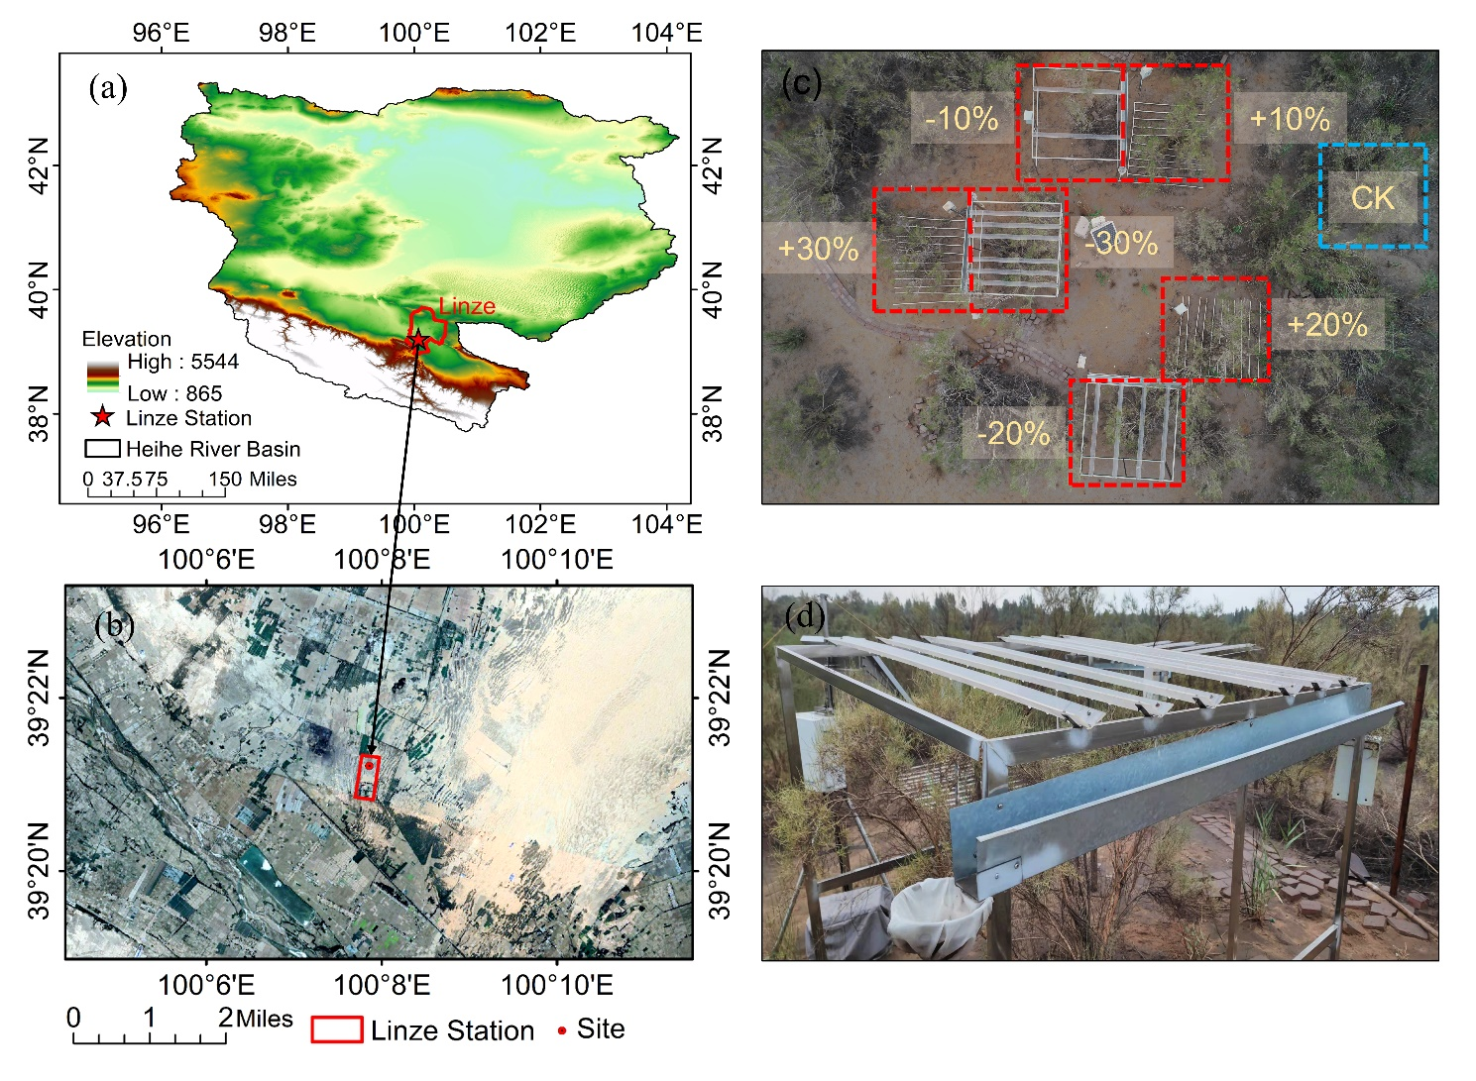

Fig. S2

Fig. S3

Fig. S4

Fig. S5

Fig. S6

Table S1 Dynamic changes of photosynthetic rate (P_{r}), stomatal conductance (g_{s}), transpiration rate (T_{r}), and water use efficiency (WUE) of HA responding to different rainfall events (5~10 mm, 2~5 mm, and 0~2 mm) under seven treatments (-30%, -20%, -10%, CK, +10%, +20%, and +30%) (dynamic change of plant physiological indices (ΔX) = the value for the day before rainfall (X_{i}) - the value for the day after rainfall (X_{j}))
Rainfall event (mm) | Treatment | ΔP_{n} (μmol CO₂ m⁻²s⁻¹) | ΔG_{s} (mol H₂O m⁻²s⁻¹) | ΔT_{r} (mmol H₂O m⁻²s⁻¹) | ΔWUE (µmol CO₂·mmol⁻¹ H₂O)
5~10 | -30% | 1.82 | -0.02 | 0.13 | 0.31
5~10 | -20% | 5.64 | 0.06 | 2.81 | -0.04
5~10 | -10% | 1.00 | -0.08 | -2.53 | 1.43
5~10 | CK | -3.66 | 0.00 | 0.19 | -0.72
5~10 | +10% | -5.94 | -0.07 | -2.61 | 0.41
5~10 | +20% | -3.86 | -0.17 | -1.92 | 0.43
5~10 | +30% | -11.81 | -0.09 | 1.02 | -1.91
2~5 | -30% | -7.38 | -0.04 | -1.15 | -1.66
2~5 | -20% | -7.96 | -0.04 | -1.34 | -1.57
2~5 | -10% | -3.43 | -0.01 | 0.45 | -1.08
2~5 | CK | -6.96 | -0.03 | -0.10 | -1.59
2~5 | +10% | -7.41 | -0.04 | -1.19 | -0.98
2~5 | +20% | -1.14 | 0.00 | 0.64 | -0.65
2~5 | +30% | -7.34 | -0.04 | -1.03 | -1.16
0~2 | -30% | 6.81 | 0.07 | 1.11 | 1.02
0~2 | -20% | 7.67 | 0.06 | 0.71 | 1.45
0~2 | -10% | 3.90 | -0.02 | -0.12 | 0.88
0~2 | CK | 10.76 | 0.06 | 0.75 | 2.34
0~2 | +10% | 6.48 | 0.05 | 1.75 | 0.24
0~2 | +20% | 3.54 | 0.02 | -2.14 | 2.15
0~2 | +30% | 6.43 | 0.04 | 1.34 | 0.48

References
Yang W, Feng W, Jia Z, Zhu Y, Guo J (2014b) Soil water threshold for the growth of Haloxylon ammodendron in the Ulan Buh desert in arid northwest China. S Afr J Bot 92:53-58. doi: 10.1016/j.sajb.2014.02.001

