Supplementary information
Boosting the Efficiency and Stability of Blue TADF Emitters by Perdeuteration
Tianyu Huang¹, Qi Wang¹, Hai Zhang¹, Yuewei Zhang¹, Ge Zhan², Dongdong Zhang¹*, Lian Duan^{1,3}*

¹ Key Laboratory of Organic Optoelectronics, Department of Chemistry, Tsinghua University, Beijing, 100084, China
² Beijing National Laboratory for Molecular Sciences (BNLMS), State Key Laboratory of Rare Earth Materials Chemistry and Applications, College of Chemistry and Molecular Engineering, Peking University Beijing, 100871, China
³ Laboratory of Flexible Electronics Technology, Tsinghua University, Beijing, 100084, China

Supplementary Notes
1. Materials synthesis
Supplementary Scheme 1 Synthesis procedure of D-5CzBN and D-5tCzBN.
Synthesis of Carbazole-d₉. Carbazole-d₉ was synthesized by PtO₂-catalyzed H-D exchange reaction. In a stainless-steel vessel, platinum (IV) oxide (0.34 g, 1.5 mmol), deuterium oxide 100 mL, and carbazole (5.0 g, 29.9 mmol) were added. The vessel was placed in an autoclave, sealed, and heated at 250 ℃ for 10 h. Then the vessel was cooled to room temperature. The mixture in the vessel was extracted with CH₂Cl₂ several times. The combined organic layers were dried over Na₂SO₄ and concentrated in vacuo. The crude product was purified by silica-gel column chromatography and carbazole-d₉ was obtained (4.9 g, 93.5%, 99.9D%).
Synthesis of D-5CzBN. Under a nitrogen atmosphere, carbazole-d (4.66 g, 26.41 mmol) was added to a two-necked round bottom flask equipped with a reflux condenser. The addition of sodium hydride (1.66 g, 41.43 mmol) followed by DMF (50 mL) resulted in a yellow solution, which was stirred for 30 min at room temperature. Afterward, 2,3,4,5,6-pentafluorobenzonitrile (1.00g, 5.18 mmol) was dissolved by 20 mL DMF and dropped into the reaction flask, and the mixture was stirred at 80°C for 12 hours. The mixture was poured into water and the crude product was purified by silica-gel column chromatography (PE: CH₂Cl₂=4:1) and followed by recrystallization. D-5CzBN (4.2 g, 4.33 mmol, 84%, 99.9 D%) was obtained as a yellow solid.
Supplementary Scheme 2 Synthesis procedure of D-5tCzBN.
Synthesis of tBuCz-d₂₅. In a stainless-steel vessel, platinum (IV) oxide (0.5 g, 2.2 mmol), deuterium oxide 100 mL, 3,6-di-tert-butyl-9H-carbazole (5.0 g, 17.9 mmol) were added and heated at 250 ℃ for 10 h. After cooling to room temperature, the crude product was extracted by methylene chloride and recrystallized by petroleum ether. Then repeat the reaction above for twice and tBuCz-d₂₅ was obtained after purification (2.8 g, 56%, 92.0 D%).
Synthesis of D-5tCzBN. D-5tCzBN was synthesized as same as D-5CzBN. Under nitrogen atmosphere, tBuCz-d₂₅ (1.70 g, 5.6 mmol) was added to a two-necked round bottom flask equipped with a reflux condenser. The addition of sodium hydride (0.25 g, 6.2 mmol) followed by DMF (20 mL) resulted in a yellow solution, which was stirred for 30 min at room temperature. Afterward, 2,3,4,5,6-pentafluorobenzonitrile (0.2 g, 1.04 mmol) was dissolved by 5 mL DMF and dropped into the reaction flask, and the mixture was stirred at 80°C for 12 hours. The mixture was poured into water and the crude product was purified by silica-gel column chromatography (PE: CH₂Cl₂=4:1). D-5tCzBN (1.3 g, 0.81 mmol, 78%, 92.0 D%) was obtained as a yellow solid.

2. Calculation method of k_{RISC}, k_{nr}^{S} and k_{nr}^{T}
Method A. The rate of the RISC process (k_{RISC}) was estimated from the experimentally observable rate constants and the photoluminescence quantum efficiencies of the prompt and delayed components according to the reported method. Here, k_{p} and k_{d} are the rate constants of the prompt and delayed fluorescence components, respectively, k_{ISC} is the intersystem crossing rate constant from singlet to triplet states, and φ_{p} and φ_{d} are the photoluminescence quantum efficiencies of the prompt and delayed components. By assuming k_{nr}^{S} <<k_{r,S}, k_{ISC} and k_{p}>>k_{d}, the corresponding rate constants can be calculated with the following equations:
$$k_{r}^{S}=φ_{p}k_{p}+φ_{d}k_{d}≈φ_{p}k_{p}$$
$$k_{ISC}=k_{p}(1-φ_{p})$$
$$k_{RISC}=\frac{k_{p}k_{d}}{k_{ISC}}\frac{φ_{d}}{φ_{p}}$$
$$k_{nr}^{T}=k_{d}-φ_{p}k_{RISC}$$

Method B. To further evaluate the effect of deuteration on non-radiative decay rate (k_{nr}^{S}), the assumption k_{nr,S}<<k_{r,S} in Method A cannot be sustained. To simplify the analysis, we have to hold the assumption that k_{r}^{T} = 0 and k_{nr}^{T} ≈ 0. Thus, according to the publications, equations can be listed as follows:
$${k_{p}+k}_{d}=k_{r}^{S}+k_{nr}^{S}+k_{ISC}+k_{RISC}$$
$$k_{r}^{S}+k_{nr}^{S}≈\frac{k_{p}k_{d}}{k_{RISC}}$$
$$k_{RISC}≈\frac{{k_{p}+k}_{d}}{2}±\sqrt{{\left(\frac{{k_{p}+k}_{d}}{2}\right)}^{2}-{k_{p}k}_{d}\left(1+\frac{φ_{d}}{φ_{p}}\right)}$$
$$k_{r}^{S}≈\left(k_{r}^{S}+k_{nr}^{S}\right)φ_{PL}$$
$$k_{nr}^{S}≈\left(k_{r}^{S}+k_{nr}^{S}\right)\left(1-φ_{PL}\right)$$
The calculation results of D-5CzBN, 5CzBN, D-5tCzBN and 5tCzBN by using Method B are listed below:
 | k_{ISC}  (×10⁸ s⁻¹) | k_{RISC}  (×10⁵ s⁻¹) | k_{r}+ k_{nr}^{S}  (×10⁷ s⁻¹) | k_{r}  (×10⁷ s⁻¹) | k_{nr}^{S}  (×10⁶ s⁻¹)
D-5CzBN | 1.74 | 10.0 | 1.74 | 1.53 | 2.09
5CzBN | 1.81 | 9.44 | 1.86 | 1.39 | 4.65
D-5tCzBN | 1.86 | 13.3 | 1.69 | 1.62 | 0.68
5tCzBN | 1.64 | 11.2 | 1.66 | 1.45 | 2.16

Supplementary Figures
Supplementary Fig. 1 Simulated FT-IR spectra of 5CzBN/D-5CzBN and 5tCzBN/D-5tCzBN.

Supplementary Fig. 2 Measured FT-IR spectra of 5CzBN/D-5CzBN and 5tCzBN/D-5tCzBN.

Supplementary Fig. 3 (a) Photo-aging curves of 5CzBN/D-5CzBN and (b) 5tCzBN/D-5tCzBN in doped films. (c)-(f) Fluorescent spectra of 5CzBN/D-5CzBN and 5tCzBN/D-5tCzBN in doped films.
Supplementary Fig. 4 Fluorescent spectra of (a) 5CzBN, (b) D-5CzBN, (c) 5tCzBN, and (d) D-5tCzBN in doped films.

Supplementary Fig. 5 Phosphorescent spectra of 5CzBN/D-5CzBN and 5tCzBN/D-5tCzBN in toluene solution (10⁻⁵ mol L⁻¹).
Supplementary Fig. 6 Fluorescent spectra of 5tCzBN/D-5tCzBN in solvents with different polarities.
Supplementary Fig. 7 Fluorescent spectra of 5CzBN/D-5CzBN and 5tCzBN/D-5tCzBN in single crystal states.

Supplementary Fig. 8 EL transient decay curves of the devices.
Supplementary Fig. 9 The absorption spectrum of v-DABNA and emission spectra of D-5CzBN and D-5tCzBN.

Supplementary Fig. 10 Current density-voltage-luminance (J-V-L) characteristics of TADF-devices.
Supplementary Fig. 11 (a) Current efficiency- and (b) Power efficiency- Luminance characteristics of the TADF-devices.
Supplementary Fig. 12 Current density-voltage-luminance (J-V-L) characteristics of TSF and phosphorescent devices.
Supplementary Fig. 13 (a) Current efficiency- and (b) Power efficiency-Luminance characteristics of TSF and phosphorescent devices.

Supplementary Fig. 14 TGA and DCS curves of 5CzBN and D-5CzBN.
Supplementary Fig. 15 Reduction curves of 5CzBN/D-5CzBN and 5tCzBN/D-5tCzBN.
Supplementary Fig. 16 Single crystal structures and packing mode of 5CzBN and D-5CzBN single crystals.

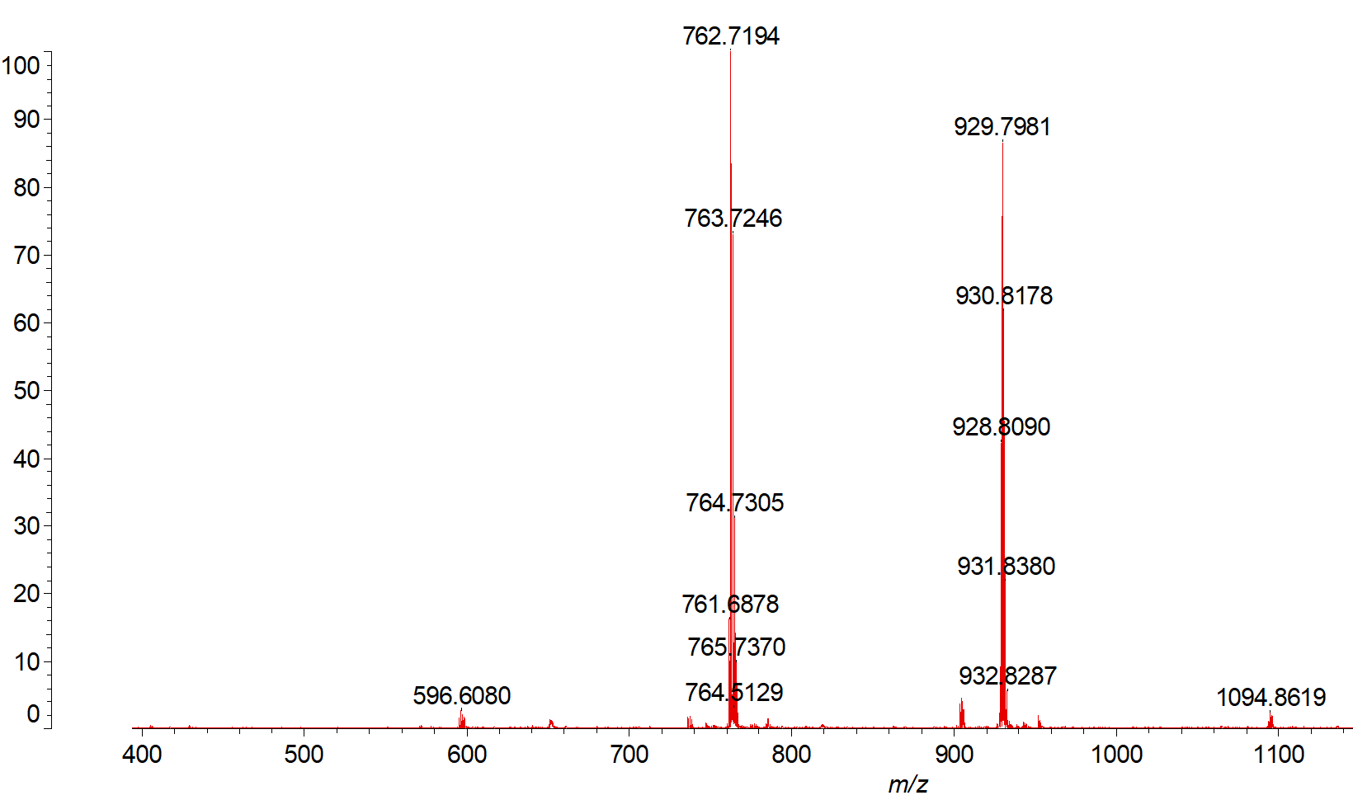
Supplementary Fig. 17 MALDI-TOF-MS of 5CzBN
Supplementary Fig. 18 MALDI-TOF-MS of D-5CzBN
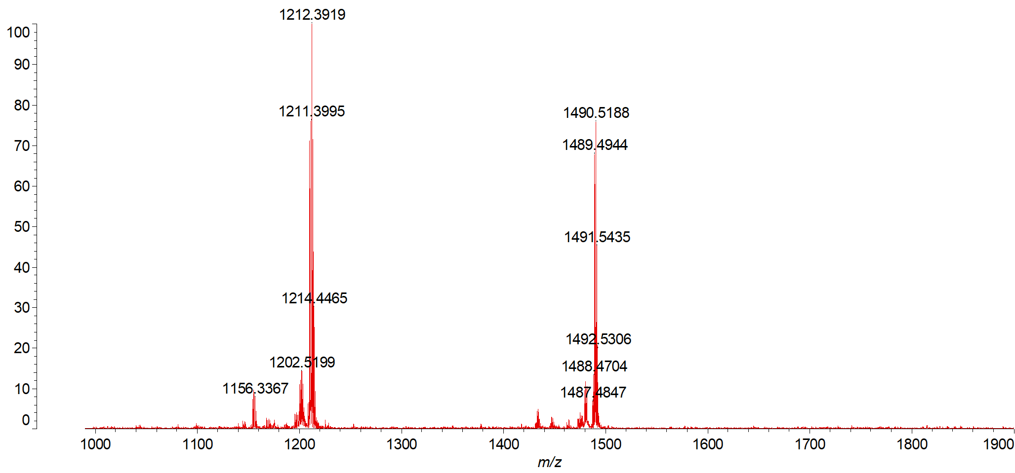
Supplementary Fig. 19 MALDI-TOF-MS of 5tCzBN

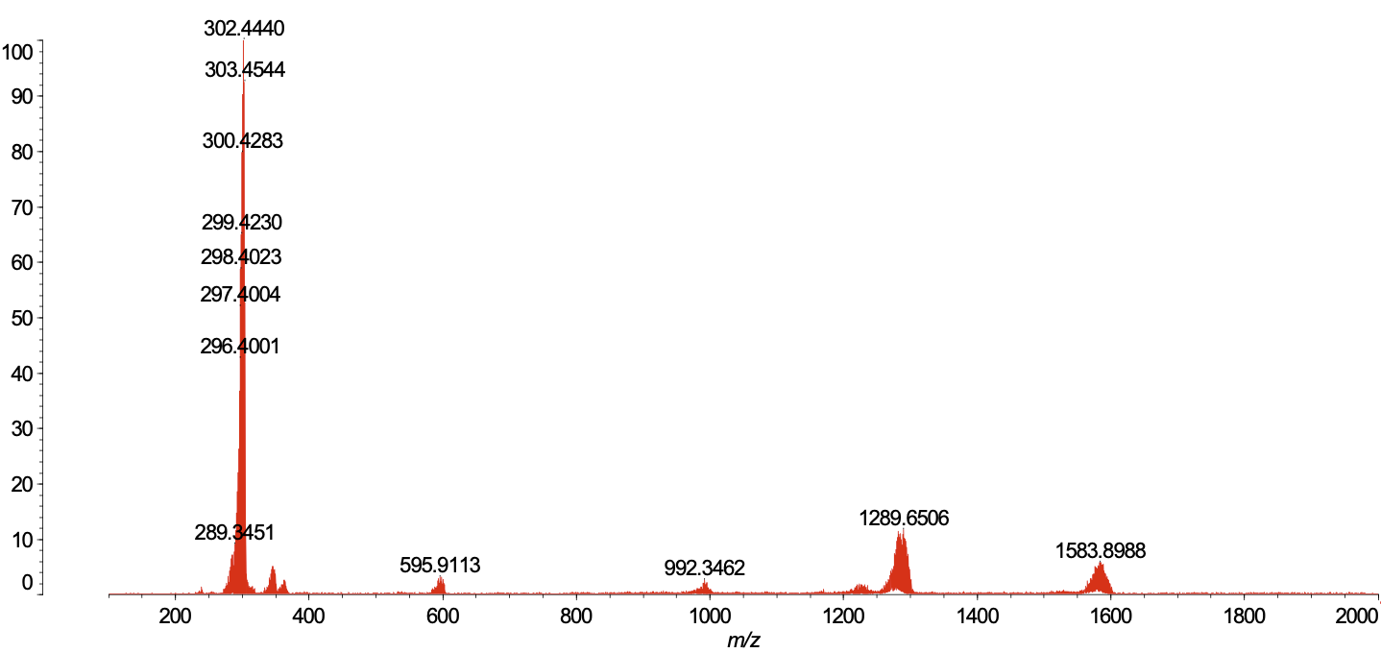
Supplementary Fig. 20 MALDI-TOF-MS of D-5tCzBN
Supplementary Fig. 21 ¹H-NMR of 5CzBN with succinic anhydride as an internal standard (Chemical shift at ~2.95 ppm).
Supplementary Fig. 22 ¹H-NMR of D-5CzBN with succinic anhydride as an internal standard (Chemical shift at ~2.94 ppm).

Supplementary Fig. 23 ¹H-NMR of 5tCzBN with succinic anhydride as an internal standard (Chemical shift at ~2.93 ppm).
Supplementary Fig. 24 ¹H-NMR of D-5tCzBN with succinic anhydride as an internal standard (Chemical shift at ~2.97 ppm).

