Supplementary material
S288T mutation altering MmpL3 periplasmic domain channel and H-bond network: A novel dual drug resistance mechanism
Ling Liu^{a,†}, Qing Luo^{b,†}, Quanshan Shi^{a, †}, Yutong Geª, Zhigang Zhangª, Xinru Yueª, Lingkai Tangª, Li Liangª, Jianping Hu^{a,*}
ª Key Laboratory of Medicinal and Edible Plants Resources Development of Sichuan Education Department, School of Pharmacy, Chengdu University, Chengdu, 610106, China
^{b} Faculty of Applied Sciences, Macao Polytechnic University, Macao, 999078, China
* Corresponding author. E-mail address: hjpcdu@163.com (J. H.)
† These authors contributed equally to this work

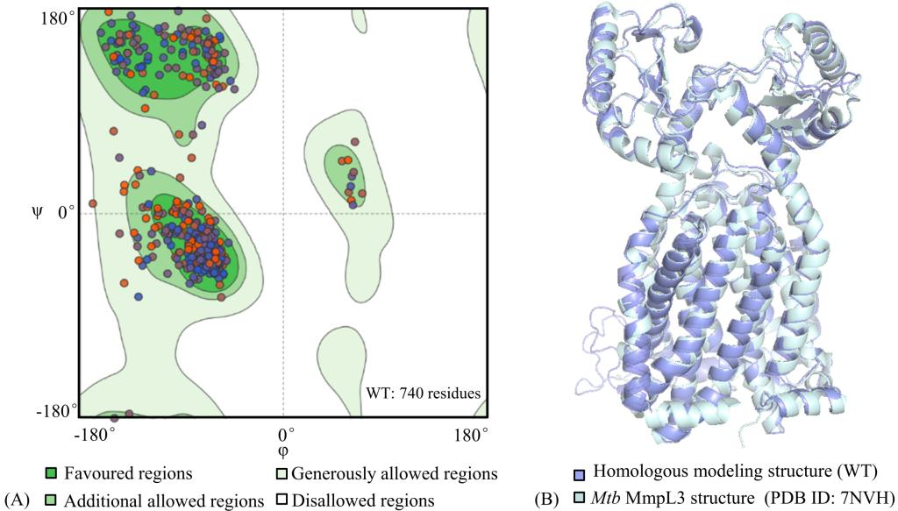
Figure S1. Ramachandran plot of homologous modeling model of Mtb MmpL3, as well as its structural superimposition with the newly reported crystal 7NVH. MmpL3 model and the newly reported crystal 7NVH both are represented by pale cyan and light blue respectively.

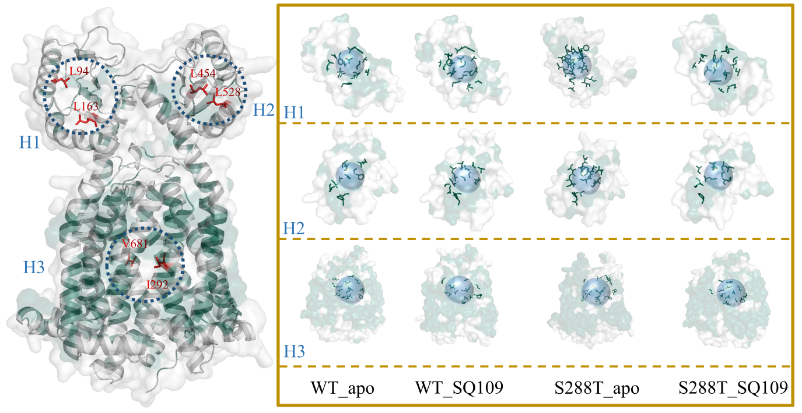
Figure S2. Hydrophobic core in the WT_apo, WT_SQ109 and S288T_SQ109 systems. H1 and H2 represent the PN and PC domains respectively, as well as H3 represents the transmembrane helices domain. Hydrophobic and hydrophilic amino acids are shown in green and white, respectively.

Table S1. Comparison of residues constituting transmission channels in periplasmic domain for the WT_apo and S288T_apo systems
Systems | Residues forming transmission channelª | Contact residue pairs^{b}
WT_apo | Q40, G42, F43, Y44, S54, D58, R63, D64, R65, S66, G67, H68, R113, Q116, A117, G119, M120, F129, S131, D139, L166, Q167, V169, A170, L173, I422, Y426, G446, Y447, R448, T449, N450, P451, T453, I483, P485, Q494, E495, R496, A497, Q512, N513, G514, G543, T544, L547, E548 | Q40-A170, F43-I422, Y44-L547, D58-R63, D58-R496, R63-D139, D64-R496, G119-Y447, M120-F129, F129-Y447, D139-Q167, N450-T544, P451-N513, P451-G543, P451-T544, T453-Q512, T453-G543, I483-N513, I483-G514, Q494-Q512, R496-Q512
S288T_apo | Q40, F43, Y44, V51, S54, V55, D58, R63, D64, S66, G67, H68, Q116, T118, G119, M120, D139, D140, L166, Q167, V169, A170, L173, T174, I422, Y426, L427, Y447, R448, T449, N450, P451, T453, I483, E484, P485, D486, N487, D488, N491, M492, W493, Q494, R496, Q512, N513, G514, G543, T544, L547, E548 | Q40-D140, Y44-V51, Y44-L547, V51-L547, S54-G543, D58-R63, D58-R496, R63-D139, R63-R496, D64-R496, G67-L166, H68-L166, H68-Q167, L173-I422, L173-L427, P451-N513, P451-G514, T453-Q512, T453-G543, I483-M492, I483-N513, I483-G514, E484-M492, P485-N491, P485-M492, M492-N513, W493-Q512, W493-N513, Q494-Q512, R496-Q512
ª The distribution of residues forming transmission channel, where the format of purple bold underline indicates specific pore residues in the two systems.
^{b} Residue pairs with a distance of less than 4 Å in transmission channels, where the specific ones are represented by the green, bold, and underlined formats for the two systems.

