Supplementary figures

Fig. 1: Evaluating the Diagnostic Performance of Various Models in the validation set using Receiver Operating Characteristics Curves and Values of the Area Under the Curves.

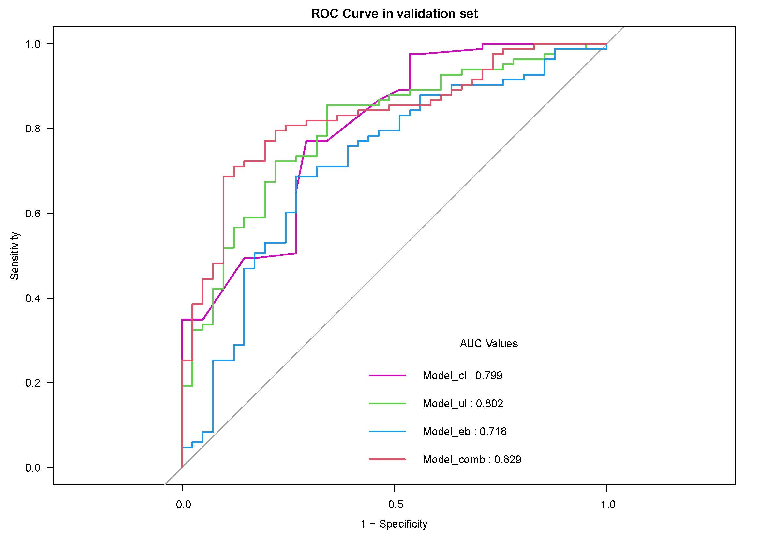
Fig 2. The Decision Curve Analysis (DCA) demonstrates the role of the Ultrasound imaging radiomics combined prediction model in diagnosing benign and malignant thyroid nodules in the validation set. The vertical axis represents the net benefit, and the horizontal axis represents different risk thresholds.
