Supplementary Information

Zero-length photo-crosslinking by organoiridium catalyst for intracellular interactome mapping

Jung Seung Nam^{1,2,6,7}†, Myeong-Gyun Kang³†, Chang-Mo Yoo³, Chae Gyu Lee^{1,2}, Jeong Kon Seo^{4,5}*, Hyun-Woo Rhee³*, Tae-Hyuk Kwon^{1,2}*

¹Department of Chemistry, Ulsan National Institute of Science and Technology (UNIST), Ulsan 44919, Republic of Korea
²Center for Wave Energy Materials, Ulsan National Institute of Science and Technology (UNIST), Ulsan 44919, Republic of Korea
³Department of Chemistry, Seoul National University, Seoul 08826, Republic of Korea
⁴UNIST Central Research Facility, Ulsan National Institute of Science and Technology (UNIST), Ulsan 44919, Republic of Korea
⁵Graduate School of Semiconductor Materials and Devices, Ulsan National Institute of Science and Technology (UNIST), Ulsan 44919, Republic of Korea
⁶Institute for Cancer Genetics, Department of Genetics and Development, Columbia University Irving Medical Center, New York, NY 10032, USA
⁷Herbert Irving Comprehensive Cancer Center, Columbia University Irving Medical Center, New York, NY 10032, USA
†These authors contributed equally to this work.

*Correspondence to: jkseo6998@unist.ac.kr, rheehw@snu.ac.kr, and kwon90@unist.ac.kr

Table of Contents

Supplementary Methods
Supplementary Scheme 1: Synthetic pathway of two rationally designed iridium photocatalysts.

Supplementary Figures
Supplementary Figure 1: Introduction of POINT system.
Supplementary Figures 2–9: ¹H and ¹³C NMR characterization for chemicals.
Supplementary Figure 10: Emission profiling depending on the concentration of HaloTag protein.
Supplementary Figure 11: Single electron transfer (SET) mediated type I ROS generation.
Supplementary Figure 12: Competition assay with biotin-HTL and Ir-HTL.
Supplementary Figure 13: Photo-crosslinking efficiency of Ir-HTL and sIr-HTL on nucleus membrane.
Supplementary Figure 14: In-vitro photo-crosslinking in FRB-FKBP model system.
Supplementary Figure 15: Live cell photo-crosslinking in FRB-FKBP model system.
Supplementary Figure 16: Visualization of Ir-HTL localised pattern in non-transfected cells.
Supplementary Figure 17: Photo-crosslinked signal of EGFP.
Supplementary Figure 18: Detail profiling of photo-crosslinking band on Western blot.
Supplementary Figure 19: Comparative analysis of Spotlight and POINT method.
Supplementary Figure 20: Cell viability evaluation for POINT method.
Supplementary Figure 21: Optimisation of SA-bead enrichment process under SDS washing.
Supplementary Figure 22: Identification of significantly enriched proteins by POINT method.
Supplementary Figure 23: Similarity analysis of each sample by scattering plot.
Supplementary Figure 24: Distribution of subcellular localisation of enriched interactomes.
Supplementary Figure 25: High-resolution confocal imaging using Airyscan mode.
Supplementary Figure 26: Ponceau S staining to prove same loading quantity of protein.
Supplementary Figure 27: Interactome crosslinking pattern comparison.

Supplementary Tables
Supplementary Table 1: Summary of the differences between POINT and other methods.
Supplementary Table 2: Plasmid construct information.
Supplementary References
Supplementary Methods
Materials. Utilized chemical and biological reagents in this research were adequately purchased from various commercial vendors (Sigma Aldrich, Alfa Aesar, Acros Organics, TCI Chemicals, Strem Chemicals, SAMCHUN Chemicals, Thermo Fisher Scientific, Gibco, Pall corporation Biosesang and Invitrogen). Any reagents that do not note source were used as received.
Analysis equipment. All synthesized chemicals were confirmed by ¹H-NMR and newly synthesized chemicals were supported by ¹³C-NMR (Agilent; 400MR-DD2), FT-IR (PerkinElmer; Spectrum Two) and HR-MS (Bruker; maXisTM HD Ultra-high resolution Q-TOF LC MS/MS system (The Cooperative Laboratory Center of Pukyong National University, Busan, Republic of Korea)). Photo-physical results for two Ir(III) complexes (Ir-HTL and sIr-HTL) were obtained by an UV-visible spectrophotometer (Shimadzu; UV-2600), fluorometer (ISS Inc.; PC1TM Photo Counting Spectrofluorometer and Agilent; Cary Eclipse), microplate reader (Molecular Devices; SpectraMax® M5) and time-correlated single photon counting instrument (PicoQuant; FluoTime300) equipped with 450 nm cw and pulsed diode laser head (LDH-D-C-450) and a laser diode driver (PicoQuant; PDL820, <70 ps pulse width and 196 kHz–40 MHz repetition rate). Intracellular images of synthesized chemical were acquired by confocal microscopy (Carl Zeiss LSM980) and Western blot signals from photo-crosslinking were recorded with imaging system (Bio-rad; ChemiDocTM MP). Lastly, mass sample for interactome analysis of protein of interest (POI) was analyzed by orbitrap mass spectrometry (Thermo Fisher Scientific; Q Exactive Plus orbitrap mass spectrometry equipped with a nanoelectrospray ion source).
Cell preparation equipment. HEK293T cell was cultured under 37 °C and 5% CO2 (ESCO; CelCulture® CO₂ Incubators). Cells were handled in biological safety cabinets (ESCO; Class II, Type A2 Biological Safety Cabinets) and condition of the cells was checked by cell imaging system (Thermo Fisher Scientific; EVOS® Fl Microscope).
UV-vis and photoluminescence spectrometer. The 10 mM stock solutions of Ir-HTL and sIr-HTL were prepared as dissolved in DMSO. The solutions were diluted into tdH₂O at a ratio 1000:1 to attain 10 μM concentration. Absorbance and emissive property of respective 10 μM solution was recorded by UV-vis and photoluminescence spectrometer. UV-vis spectra were recorded in the range of 200–700 nm and photoluminescence spectra were in the range of 500–800 nm with 430 nm excitation.
Time-correlated single photon counting (TCSPC). 10 μM solutions of Ir-HTL and sIr-HTL was prepared with or without 1 equivalent HaloTag protein. Time-resolved photoluminescence signal of the solutions was recorded by time-correlated single photon counting (TCSPC) set up (PicoQuant; FluoTime300) and module (PicoQuant; PicoHarp 300E) equipped with a photomultiplier tube (PicoQuant; PMA-C 182-N-M). Lifetime from phosphorescence decay of Ir(III) complex was fitted and calculated by FluoFit software, keeping that χ² value is approached to under 1.0 for credible data.
HaloTag protein titration. 10 μM solutions of Ir-HTL and sIr-HTL were prepared with 0, 0.5, 1, 2.5, 5, 10, 20 μM HaloTag protein. For fully bound formation between Ir(III) complex and HaloTag protein, the solutions were incubated for 1 hour with gentle agitation. The emission spectra of each sample between 500–700 nm was recorded with 430 nm excitation and 2 nm step width through microplate reader (Molecular Devices; SpectraMax® M5).
Binding kinetics between HaloTag protein and Ir(III) complex. 1 μL of 1 mM Ir(III) complex stock solution dissolved in DMSO was diluted to 79 μL tdH₂O. The solution was put into 100 μL cuvette, and then 20 μL of 50 μM HaloTag protein was added to the solution. Right after, the emission intensity change was recorded at 558 nm with 430 nm excitation through abovementioned microplate reader (time interval = 5 s and total time = 360 s).
Evaluation of electron transfer capability through type I ROS generation assay. Dihydrorhodamine 123 assay (DHR123) is representative assay for detecting type I ROS (e.g., O₂•– and OH•) generated by electron transfer. Therefore, DHR123 (InvitrogenTM, MA, USA) was utilized as the chemical sensor for type I ROS in vitro analysis. Stock solution of Ir-HTL and DHR123 was 10 mM dissolved in DMSO. The mixture of Ir-HTL and DHR123 was prepared in tdH₂O (final concentration: [Ir-HTL or sIr-HTL] = 10 μM and [DHR123] = 10 μM). The solution was photo-irradiated and then the activated fluorescence by ROS generation from iridium photocatalyst was recorded by fluorometer (λ_{ex} = 505 nm).
Competition assay for identifying intracellular binding of Ir-HTL. HEK293T cells were seeded in 24 well plate and incubated in the DMEM (GibcoTM) containing 10% FBS (Atlas Biologicals) and 1% 10,000 U/mL Penicillin-Streptomycin (GibcoTM) under 37 °C and 5% CO₂ condition. When confluency is about 70%, HaloTag-NLS or Lamin A/C-HaloTag was transfected with Turbofect® transfection reagent (Thermo Fisher Scientific). 2 μM of Ir(III) complex was incubated for 2 hours (culture media:DMSO = 1000:1, v/v%) and additional incubation was proceeded to wash out unbound Ir(III) after fresh media change. 10 μM Biotin-HTL was post-incubated for an hour and the cells were lysed by RIPA protein extraction buffer solution (50 mM Tris-HCl pH 7.5, 150 mM NaCl, 1% NP-40, 0.5% deoxycholic acid, 0.1% SDS, 1 mM PMSF) containing 1% HaltTM protease inhibitor cocktail (Thermo Fisher Scientific) for 1 hour at 4 °C. Protein concentration of lysate was quantified by bicinchoninic acid (BCA) assay (Thermo Fisher Scientific) and 20 μg proteins for each lysate were separated by electrophoresis. After transfer of the proteins from gel to nitrocellulose membrane (Pall corporation), the proteins on the membrane were visualized by Ponceau S solution (0.1 v/w% Ponceau S in 5% acetic acid) and the membrane was destained with 0.1% Tween-20 in Tris-buffered saline (TBST). The membrane was incubated with 2% skim milk solution to block background signal from non-specific antibody adsorption for 1 hour. The membrane was immunostained by SA-HRP in DPBS (Thermo Fisher Scientific). The residual of SA-HRP was strictly washed three times by TBST. Immunostained signal was visualized by chemiluminescence imaging system (Bio-rad; ChemiDocTM MP).
Cell viability assay of Ir-HTL system. For the stable attachment of Hek293T cells, plates were coated with poly-L-lysine (cat. No. P8920, Sigma) for 5 min, washed with sterile triple distilled water, and dried for 2 h. Then, Hek293T cells (6.0×10⁴ cells/well) were seeded on 12 well plate and incubate overnight. Cells were transfected with PTBP-GFP (500 ng/well) and GBP-HaloTag-NLS (500 ng/well) using Lipofectamine 3000. The cells were washed with fresh media after 4 h incubation of genes and further incubated for 24 h. The transfected cells were treated with Ir-HTL (0 and 2 μM, 0.1% DMSO) for 2 h, washed with fresh media and incubated for 8 h, followed by media change. For photoirradiation conditions, the cells were irradiated upon LED arrays (λ=405 nm, 225 mJ/cm²) and 3-(4,5-Dimethylthiazol-2-yl)-2,5-Diphenyltetrazolium Bromide (MTT, 250 μL of 5 mg/mL in PBS) solution was treated for 4 h. The culture media was changed to DMSO and the absorbance of Formazan dyes were analyzed using microplate reader (λ_{abs} = 570 nm, Infinite 200 pro). For intrinsic cytotoxicity evaluation, the cells were further incubated 24 h and treated with MTT solution for 4 h. Then, the culture media was changed to DMSO and their absorbance were detected.
Photo-crosslinking in FKBP12-FRB model system. For in-vitro photo-crosslinking with purified proteins, HaloTag-FRB (1 μL, 100 μM) and FKBP12-EGFP (1 μL, 100 μM) were added in 6 μL PBS. Then, rapamycin (1 μL, 100 μM) and Ir-HTL (1 μL, 100 μM) were added or DMSO was added as a control for an hour. Samples were irradiated by home-made LED array for 5 min and loaded on 10% SDS-PAGE. After 1 hour running at 150 V, gel was stained by R-250 Coomassie staining solution for visualization of crosslinked band.
For in-cell photo-crosslinking, FKBP25-HaloTag and FRB-EGFP were co-expressed in HEK293T cells seeded in 12 well plate. Then, 2 μM of Ir(III) complex was incubated for 2 hours and washed by DMEM overnight. 100 nM rapamycin was treated for an hour and cells were irradiated by home-made LED array for 5 min. Right after, DPBS was suctioned and 100 mL RIPA protein extraction buffer solution containing 1% HaltTM protease inhibitor cocktail was added and incubated at 4 °C for 1 hour. The lysis solution was moved into 1.5 mL microtube (Eppendorf) and the solution of whole proteins was obtained from supernatant after centrifuge (16,000 xg, 5 minutes, 4 °C). Concentration of the respective protein solution was accurately quantified by BCA assay. The lysis solution was mixed with 5x SDS-PAGE loading buffer (Biosesang), and then protein denaturation was conducted at 90 °C in heating block for 5 min. Subsequently, cooling step at 4 °C was followed. Protein loading amount was 20 μg. The whole protein was separated by electrophoresis on the 6% SDS-PAGE gel and the proteins on the gel were transferred to the nitrocellulose membrane. Transferred proteins on the membrane were visualized by Ponceau S solution (0.1 v/w% Ponceau S in 5% acetic acid) and the membrane was destained with 0.1% Tween-20 in Tris-buffered saline (TBST). The membrane was incubated with 2% skim milk solution to block background signal from non-specific antibody adsorption for 1 hour. Subsequently, the 2% skim milk solution was substituted to primary antibody solution (α-V5, Invitrogen, R960-25; 5000:1 dilution and α-GFP, Invitrogen, MA5-15256; 3000:1 dilution in 2% skim milk TBST solution) and further 1 h incubation was proceeded. Non-attached antibody was strictly washed 3 times with TBST for 5 min each. Anti-mouse HRP as secondary antibody (BioRad, 170-6516; 3000:1 dilution in 2% skim milk TBST solution) was incubated for 30 min and the membrane was washed again 3 times with TBST for 10 min each. Western blot chemiluminescence signals treated by ClarityTM Western ECL Substrate were recorded with abovementioned imaging system.
Western blot to identify intracellular photo-crosslinking. HEK293T cells were seeded in 12 well plate and incubated in the DMEM containing 10% FBS and 1% 10,000 U/mL Penicillin-Streptomycin under 37 °C and 5% CO₂ condition. When confluency of the cell is about 70%, plasmid construct was properly transfected. Note that GBP-HaloTag-NLS or Lamin A/C was transfected for validation of photo-crosslinking efficiency and GBP-HaloTag-NLS and POI-EGFP (POU2F1; POU class 2 homobox 1, PTBP1; polypyrimidine tract-binding protein 1, and PSMA2; proteasome subunit α type 2) were co-transfected for spatially resolved photo-crosslinking experiment. 2 μM of Ir(III) complex was incubated for 2 hours (culture media:DMSO = 1000:1, v/v%). The media containing Ir(III) complex was changed with fresh media and additional incubation was proceeded to wash out background unbound Ir(III) complex for overnight. After checking proper POI targeting of Ir(III) complex with fluorescence microscopy (Thermo Fisher Scientific; EVOS Fl®), DMEM media was changed to Dulbecco’s phosphate buffered saline (DPBS) and washed two times. Then, the cells were irradiated with home-made LED array (405 nm, 225 mJ/cm²). Note that samples with irradiation free condition skipped this step. The next Western blot process followed same procedure for FKBP12-FRB model system crosslinking.
Line-cut analysis for identifying photo-crosslinking efficiency. Line-cut profile data was obtained by ImageJ software (National Institute of Health, NIH)¹ and detailed procedure referred to previously reported paper.^{2,3} The background of Western blot for photo-crosslinking in Figs. 1 and 2 and Supplementary Fig. 13 was properly subtracted in the software (background subtraction ball-point size: 13 pt). The line-cut intensity profiles along the line were compared with correlation value (R²). The R² was taken from following equation.
$$R^{2}=\frac{\frac{1}{N}\sum_{k=1}^{N}{I_{i}(k)I_{j}(k)}}{\sqrt{\frac{1}{N}\sum_{k=1}^{N}{I_{i}{\left(k\right)}^{2}}}\sqrt{\frac{1}{N}\sum_{k=1}^{N}{I_{j}{\left(k\right)}^{2}}}} \left(1\right)$$
Photo-crosslinking efficiency (η_{c}) in Fig.1 and Supplementary Fig.13 was calculated by below equation including R², from which change between two line-cut profiling results with or without photo-irradiation was quantified.
$$η_{c}(\%)=\left(1-R^{2}\right) × 100 \% \left(2\right)$$
Confocal imaging to verify GFP-GBP system. HEK293T cells were seeded in 12 well plate with confocal glass (18 mm Marienfeld SuperiorTM Deckgläser) and incubated in the DMEM containing 10% FBS and 1% 10,000 U/mL Penicillin-Streptomycin under 37 °C and 5% CO₂ condition. When confluency of the cell is about 60%, plasmid construct was properly transfected with Turbofect® transfection reagent (Thermo Fisher Scientific). GBP-HaloTag-NLS and POI-EGFP (POU2F1; POU class 2 homobox 1, PTBP1; polypyrimidine tract-binding protein 1, and PSMA2; proteasome subunit α type 2) were co-transfected for spatially resolved photo-crosslinking experiment. 2 μM of Ir-HTL was incubated for 2 hours (culture media:DMSO = 1000:1, v/v%). The media containing Ir(III) complex was changed with fresh media and additional incubation was proceeded to wash out background unbound Ir(III) complex for overnight. DMEM media was changed to DPBS and washed two times. Then, the cells were fixed with paraformaldehyde for 15 min under 4°C and additionally washed with cold MeOH for 5 min at -20 °C to obtain clear localisation pattern. MeOH was changed to DPBS and the confocal image was recorded by Carl Zeiss LSM980 confocal microscopy. The all of image processing utilized ZEN 3.0 blue edition.

Synthesis of organoiridium photocatalyst.
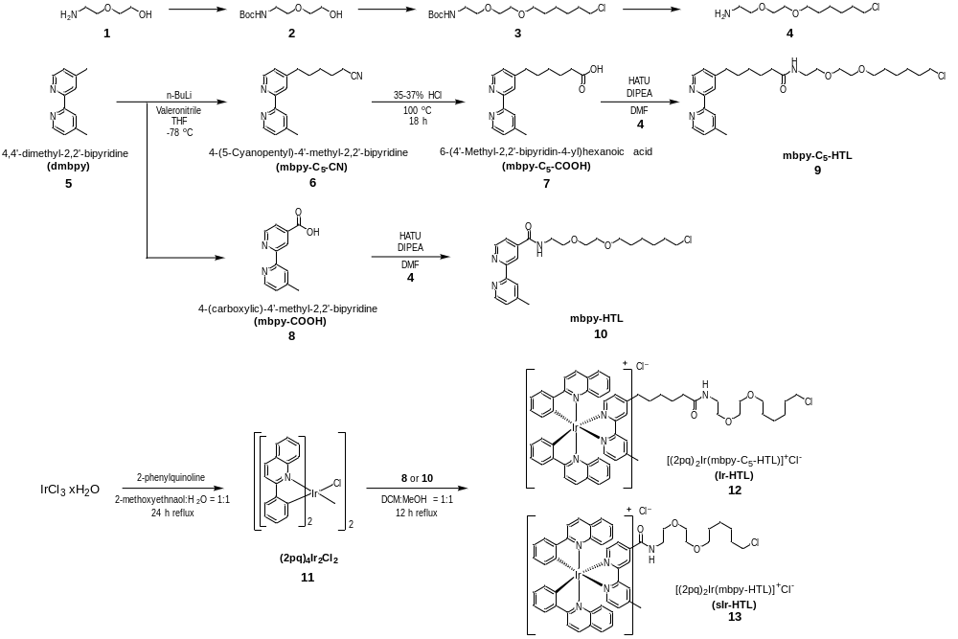
Supplementary Scheme 1. Synthetic pathway of two rationally designed iridium photocatalysts.
tert-butyl(2-(2-hydroxyethoxy)ethyl)carbamate [2]
The synthetic procedures for HaloTag ligand synthesis (HTL) from 2 to 4 were referred to previously reported paper.⁶ The 2-2(aminoethoxy)ethanol (1) (1.00 g, 9.51 mmol) was dissolved in anhydrous EtOH (20 mL) and added slowly di-tert-butyl dicarbonate (2.69 g, 12.36 mmol) to the solution at 0 °C. The solution was stirred at room temperature for 2 h and evaporated. The product extracted with CH₂Cl₂ and dried over MgSO₄. Filtrate was then concentrated in vacuo to yield colorless product (2). Without further purification, next step was proceeded.
tert-butyl (2-(2-((6-chlorohexyl)oxy)ethoxy)ethyl)carbamate [3]
A solution of 2 (1.00 g, 4.87 mmol) and NaH (175 mg, 7.29 mmol) dissolved in THF (7 mL) and DMF (3.5 mL) was stirred for 30 min at 0 °C. 6-chloro-1-iodohexane (1.68 g, 6.81 mmol) was added to the solution. The reaction mixture vigorously stirred overnight. After reaction finished, the reaction was quenched with saturated NH₄Cl. Crude product extracted with ethyl acetate (20 mL x 3) and dried over MgSO₄. The solution was concentrated in vacuo and the crude product was purified by silica gel column chromatography. The colorless product was obtained (760 mg, 48.1%). R_{f} = 0.60 (Hex:EA = 4:1, v/v%).
2-(2-((6-chlorohexyl)oxy)ethoxy)ethanamine (HTL) [4]
Trifluoroacetic acid (TFA) (1.34 g, 11.73 mmol) was slowly injected to a solution of 3 (380 mg, 1.17 mmol) dissolved in anhydrous CH₂Cl₂ (10 mL) at 0 °C. The reaction mixture stirred at room temperature for 2 h. After checking the completion of Boc deprotection by TLC analysis, the solvent was evaporated. The acidic condition was turned into basic condition with addition of anhydrous K₂CO₃ (1.62 g, 11.73 mmol) in MeOH (5 mL). The mixture was filtered, and the filtrate was concentrated in vacuo. The crude product was purified by silica gel column chromatography with EA containing 2% MeOH (v/v) to yield 4 (152 mg, 58.0%). R_{f} = 0.30 (EA:MeOH = 50:1, v/v%).¹H NMR (400 MHz, CDCl₃): δ (ppm) = 4.086 (s), 3.690 (t, J = 4.4 Hz, 2H), 3.620 (m, 2H), 3.563 (m, 2H), 3.520 (td, J = 6.8 Hz, 1.6 Hz, 2H), 3.446 (td, J = 6.8 Hz, 1.6 Hz, 2H), 3.146 (t, J = 4.8 Hz, 2H), 1.757 (p, J = 7.2 Hz, 2H), 1.573 (p, J = 6.8 Hz, 2H), 1.434 (p, J = 7.6 Hz, 2H), 1.328 (p, J = 7.6 Hz, 2H).
4-(5-cyanopentyl)-4’-methyl-2,2’-bipyridine [6]
Procedures for synthesis of 6 and 7 were followed by previously reported method.⁷ To a solution of diisopropylamine (129 mg, 1.28 mmol) in THF (5 mL) was injected dropwise n-butyllithium (1.6 M in hexane, 0.80 mL, 1.14 mmol) at -78 °C for 15 min. A solution of 4,4’-dimethyl-2,2’-bipyridine (5) (200 mg, 1.08 mmol) dissolved in THF (5 mL) was injected to above activated lithium diisopropylamide (LDA) solution at -78 °C and vigorously stirred for 1 h. After activation of 4,4’-dimethyl-2,2’-bipyridine, 5-bromovaleronitrile (194 mg, 1.20 mmol) in THF (5 ml) was added to the solution and the mixture was additionally stirred for 2 h at 0 °C in ice-bath. The reaction was quenched with 20 mL water and neutralized with 1N HCl. The crude product extracted with EA (50 mL x 3) and organic phase dried over MgSO₄ and concentrated in vacuo. This crude product was purified by silica gel column chromatography. R_{f} = 0.60 (only EA) to yield 4 (240 mg, 83.3%). ¹H NMR (400 MHz, CDCl₃): $δ$ (ppm) = 8.566 (d, 1H, J = 4.8 Hz), 8.537 (d, 1H, J = 4.8 Hz), 8.226 (m, 2H), 7.130 (m, 2H), 2.722 (t, 2H, J = 7.2 Hz), 2.441 (s, 3H), 2.347 (t, 2H, J = 7.2 Hz), 1.726 (m, 4H), 1.525 (m, 2H).
6-(4’-methyl-2,2’bipyridin-4-yl)hexanoic acid [7]
35–37% concentrated HCl (5 mL) was injected to 4-(5-cyanopentyl)-4’-methyl-2,2’-bipyridine (4) (240 mg, 0.90 mmol) in reaction pot under inert condition with N₂ gas. The reaction mixture was heated at 100 °C overnight. After reaction was finished, pH value of reaction mixture was adjusted to 4.0–4.5 with 6N NaOH aqueous solution. Extracted with chloroform and organic phase dried over MgSO₄. Filtrate was concentrated in vacuo and triturate with dichloromethane and n-hexane to yield 7 (165 mg, 64.2%). ¹H NMR (400 MHz, CDCl₃): $δ$ (ppm) = 8.563 (m, 2H), 8.225 (s, 1H), 8.186 (s, 1H), 7.180 (d, 1H, J = 2.4 Hz), 7.145 (d, 1H, J = 2.0 Hz), 2.726 (t, 2H, J = 7.6 Hz), 2.456 (s, 3H), 2.360 (t, 2H, J = 7.2 Hz), 1.724 (m, 4H), 1.406 (p, 2H, J = 7.6 Hz).
4-(Carboxylic)-4’-methyl-2,2’-bipyridine (mbpy-COOH) [8]
Procedure for synthesis of 9 was referred to by previously reported method.^{8,9} To a solution of 4,4’-dimethyl-2,2’-bipyridine (500 mg, 2.7 mmol) in 1,4-dioxane (20 mL) was added selenium dioxide (400 mg, 3.62 mmol) under inert condition with argon purging. The mixture was refluxed for 24 h. The precipitates containing selenium metal were removed by a Celite® filtration and the filtrate was concentrated in vacuo. The residue was dissolved in EtOH (15 mL), and then a solution of silver nitrate (500 mg, 2.95 mmol) dissolved in H₂O (5 mL) was added. To the solution, 1 N NaOH (12.5 mL) was added dropwise by utilizing dropping funnel over 20 min and the reaction mixture was additionally stirred at room temperature for 24 h. After removal of EtOH by evaporation, the insoluble silver oxide was removed by filtration. The filtrate was acidified with 1 N HCl until pH becomes 3.5, leading to white precipitates. The precipitates were filtered and dried under vacuum to yield 9 (283 mg, 48.7%). ¹H NMR (400 MHz, d₆-DMSO): $δ$ (ppm) = 13.76 (br, -COOH), 8.871 (dd, J = 5.2 Hz, 0.8 Hz, 1H), 8.806 (s, 1H), 8.591 (d, J = 1.2 Hz, 1H), 8.329 (s, 1H), 7.876 (dd, J = 5.2 Hz, 1.6 Hz, 1H), 7.395 (d, J = 4.8 Hz, 1H).
mbpy-C₅-HTL [9]
6-(4’-methyl-2,2’bipyridin-4-yl)hexanoic acid (60 mg, 0.211mmol) and (O-(7-Aza-1H-benzotriazol-1-yl)-N,N,N',N'-tetramethyluronium hexafluorophosphate (HATU) (72 mg, 0.190 mmol) were dissolved in 3 mL DMF. N,N-diisopropylethylamine (DIPEA) (109 mg, 0.844 mmol) was injected in prepared solution and vigorously stirred for 10 – 15 min. After activation of carboxylic acid with DIPEA, prepared solution of 2-(2-((6-chlorohexyl)oxy)ethoxy)ethanamine (4) (57 mg, 0.253 mmol) dissolved in 3 mL DMF was slowly injected in the reaction pot. The mixture was stirred for 6 h under room temperature and N₂ inert condition. After reaction finished, the mixture extracted with dichloromethane and washed with H₂O and brine. Extracted organic layer dried over MgSO₄. MgSO₄ filtered out and residual solvent of filtrate was removed in vacuo. Crude product was purified with column chromatography. R_{f} = 0.45 (only EA). ¹H NMR (400 MHz, CDCl₃): δ (ppm) = 8.532 (dd, J = 6.5, 5.1 Hz, 2H), 8.207 (dd, J = 5.2, 0.8 Hz, 2H), 7.120 (dt, J = 4.8, 2.0 Hz, 2H), 6.002 (s, 1H), 3.590 (m, 2H), 3.525 (m, 6H), 3.442 (m, 4H), 2.689 (t, J = 8.0 Hz, 2H), 2.429 (s, 3H), 2.162 (t, J = 7.6 Hz, 2H), 1.711 (m, 6H), 1.585 (p, J = 7.2 Hz, 2H), 1.401 (m, 6H). ¹³C NMR (101 MHz, CDCl₃): δ (ppm) = 172.83, 156.06, 155.98, 152.52, 148.98, 148.88, 148.16, 124.63, 123.90, 122.02, 121.22, 71.22, 70.21, 69.97, 69.85, 44.98, 39.07, 38.58, 36.50, 35.26, 32.47, 30.06, 29.42, 28.86, 26.64, 25.39, 25.37, 21.17. HR-ESI-MS: calcd. for C₂₇H₄₁ClN₃O₃ [M+H]⁺ and C₂₇H₄₀ClN₃O₃Na [M+Na]⁺, 490.2831 and 512.2650; measured: 490.2829 and 512.2645. FT-IR (neat cm⁻¹): 409, 524, 558, 645, 670, 754, 844, 992, 1039, 1107, 1121, 1243, 1349, 1377, 1461, 1553, 1595, 1645, 1723, 2862, 2930, 3055, 3298 (br, amide).
mbpy-HTL [10]
6-(4’-methyl-2,2’bipyridin-4-yl)hexanoic acid (100 mg,0.467 mmol) and HATU (177 mg, 0.467 mmol) were dissolved in 3 mL DMSO. DIPEA (237 mg, 1.870 mmol) was injected in prepared solution and vigorously stirred for 10–15 min. After activation of carboxylic acid with DIPEA, prepared solution of 2-(2-((6-chlorohexyl)oxy)ethoxy)ethanamine (4) (125 mg, 0.560 mmol) dissolved in 3 mL DMSO was slowly injected in the reaction pot. The mixture was stirred for 6 h under room temperature and N₂ inert condition. After reaction finished, the mixture extracted with dichloromethane and washed with H₂O and brine. Extracted organic layer dried over MgSO₄. MgSO4 filtered out and residual solvent of filtrate was removed in vacuo. Crude product was purified with column chromatography to yield 10 (85 mg, 43.4%). R_{f} = 0.35 (only EA). ¹H NMR (400 MHz, CDCl₃): δ (ppm) = 8.793 (dd, J = 5.2 Hz, 0.8 Hz, 1H), 8.681 (dd, J = 0.8 Hz, 0.8 Hz, 1H), 8.540 (dd, J = 4.8 Hz, 0.8 Hz, 1H), 8.270 (t, J = 0.8 Hz, 1 H), 7.178 (ddd, J = 4.8 Hz, 0.8 Hz, 0.8 Hz, 1H), 7.151 (s, 1H, -NH-), 3.706 (m, 4H),3.664 (m, 2H), 3.606 (m, 2H), 3.465 (q, 6.8 Hz, 4H), 2.460 (s, 3H), 1.692 (m, 2H), 1.544 (p, 7.2 Hz, 2H), 1.321 (m, 4H). ¹³C NMR (101 MHz, CDCl₃): δ (ppm) = 165.72, 156.92, 155.12, 149.95, 148.92, 148.41, 142.72, 125.13, 122.13, 121.69, 117.82, 71.28, 70.27, 70.03, 69.56, 44.95, 39.96, 32.43, 29.34, 26.60, 25.31, 21.19. HR-ESI-MS: calcd. for C₂₂H₃₁ClN₃O₃ [M+H]⁺, 420.2048; measured: 420.2053. FT-IR (neat cm⁻¹): 519, 558, 602, 649, 668, 682, 728, 754, 772, 844, 905, 993, 1039, 1099, 1249, 1284, 1303, 1320, 1364, 1456, 1548, 1597, 1652, 2861, 2933, 3058, 3307 (br, amide).
[(2pq)₂IrCl]₂ [11]
A mixture of IrCl₃·xH₂O and 2-phenylquinoline in round bottom flask (RBF) was dissolved in 2-methoxyethanol/H₂O (3:1, v/v) which had been deaerated with N₂ bubbling. The solution refluxed during 24 h under an inert condition with N₂ gas. Water poured in that RBF after solution cooled down to room temperature. Precipitation occurred right after water pouring process and this solid filtered out through Büchner funnel. The solid washed with n-hexane and cold diethyl ether. This crude product was utilized for next step without further purification. This dimer was obtained using previously reported synthetic method by Nonoyama.¹⁰
[(2pq)₂Ir(mbpy-C₅-HTL)]⁺Cl⁻ (Ir-HTL) [12]
A solution that [(2pq)₂IrCl]₂ (7) (50 mg, 0.039 mmol) and mbpy-C₅-HTL (48 mg, 0.098 mmol) (6) were dissolved in deaerated DCM:MeOH = 1:1 (v/v) was refluxed overnight. The solvent was removed in vacuo after reactor cooled down to room temperature. Final product was dissolved with a minimal amount of EtOH and by-product that is undissolved in EtOH was filtered out. Filtrate was evaporated subsequently in vacuo. Final orange Ir-HTL product (41 mg, 46.0%) was obtained through trituration with DCM and n-hexane. ¹H NMR (400 MHz, d₆-DMSO): $δ$ (ppm) = 8.529 (dd, J = 6.8, 8.8 Hz, 4H), 8.359 (s, 1H), 8.300 (s, 1H), 8.261 (d, J = 8.0 Hz, 2H), 7.905 (m, 4H), 7.801 (t, J = 5.2 Hz, 1H), 7.489 (t, J = 6.0 Hz, 2H), 7.406 (t, J = 8.0 Hz, 2H), 7.228 (d, J = 9.2 Hz, 1H), 7.180 (d, J = 9.2 Hz, 1H), 7.127 (t, J = 7.6 Hz, 2H), 7.050 (m, 2H), 6.787 (td, J = 6.79 (tdd, J = 7.6, 2.6, 1.3 Hz, 2H), 6.385 (dd, J = 7.6, 4.8 Hz, 2H), 3.550 (t, J = 6.8 Hz, 2H), 3.419 (s, 4H), 3.334 (m, 4H), 3.120 (q, J = 6.0 Hz, 2H), 2.624 (t, J = 7.6 Hz, 2H), 2.380 (s, 3H), 2.005 (t, J = 7.2 Hz, 2H), 1.640 (p, J = 7.2 Hz, 2H), 1.513 (p, J = 7.6 Hz, 2H), 1.428 (m, 4H), 1.318 (p, J = 7.2 Hz, 2H), 1.240 (m, 2H), 1.088 (p, J = 6.4 Hz, 2H). ¹³C NMR (101 MHz, CDCl₃): δ (ppm) = 173.62, 169.88, 169.85, 156.43, 155.50, 155.39, 152.17, 151.46, 151.29, 147.53, 147.53, 146.82, 146.53, 145.54, 145.53, 139.77, 139.75, 134.68, 134.62, 131.16, 131.12, 130.78, 128.95, 128.94, 128.15, 127.51, 127.50, 127.43, 126.96, 126.87, 126.81, 125.21, 124.76, 124.29, 122.81, 122.77, 117.31, 117.20, 109.98, 77.20, 71.21, 70.14, 69.86, 45.13, 39.05, 36.04, 34.87, 32.51, 29.52, 29.35, 28.35, 26.66, 25.33, 24.90, 21.09. HR-ESI-MS: calcd. for C₅₇H₆₀Cl₂IrN₅O₃, 1090.4010; measured: 1090.4008. FT-IR (neat cm⁻¹): 415, 442, 506, 556, 642, 659, 726, 736, 764, 788, 837, 1040, 1081, 1126, 1218, 1244, 1276, 1291, 1338, 1426, 1449, 1463, 1486, 1516, 1545, 1580, 1606, 1651, 2861, 2931, 3050, 3429 (br, amide).
[(2pq)₂Ir(mbpy-HTL)]⁺Cl⁻ (sIr-HTL) [13]
A solution that [(2pq)₂IrCl]₂ (7) (80 mg, 0.063 mmol) and mbpy-HTL (66 mg, 0.157 mmol) (6) were dissolved in deaerated DCM:MeOH = 1:1 (v/v) was refluxed overnight. Next step to yield sIr-HTL (13) (110 mg, 82.7%) was same as above. ¹H NMR (400 MHz, CDCl₃): δ (ppm) = 9.745 (s, 1H, br), 9.627 (s, 1H), 9,190 (s, 1H), 8.163 (m, 4H), 8.038 (d, J = 6.0 Hz, 1H), 7.985 (d, J = 8.0 Hz, 2H), 7.902 (d, J = 6.0 Hz, 1H), 7.685 (d, J = 8.0 Hz, 2H), 7.353 (q, J = 7.2 Hz, 2H), 7.286 (d, J = 9.2 Hz, 1H), 7.225 (d, 8.8 Hz, 1H), 7.134 (m, 3H), 7.020 (t, J = 7.6 Hz, 1H), 6.941 (t, J = 7.6 Hz, 1H), 6.804 (t, J = 7.2 Hz, 2H), 6.526 (dd, J = 6.4, 7.6 Hz, 2H), 3.757 (q, J = 6.4 Hz, 2H), 3.662 (m, 4H), 3.542 (t, J = 4.8 Hz, 2H), 3.498 (t, J = 6.8 Hz, 2H), 3.411 (t, J = 6.4 Hz, 2H), 2.512 (s, 3H), 1.737 (p, J = 6.8 Hz, 2H), 1.540 (p, J = 7.2 Hz, 2H), 1.400 (p, J = 7.6 Hz, 2H), 1.319 (p, J = 7.2 Hz, 2H). ¹³C NMR (101 MHz, CDCl₃): δ (ppm) = 169.83, 169.70, 162.80, 156.54, 155.44, 152.38, 151.26, 151.02, 147.55, 147.39, 147.34, 146.11, 145.51, 145.45, 143.80, 139.94, 139.76, 134.69, 134.58, 131.68, 131.14, 130.89, 130.81, 129.03, 128.84, 128.08, 127.50, 127.40, 127.36, 127.09, 126.92, 126.88, 126.71, 126.50, 124.81, 124.60, 122.99, 122.81, 122.66, 117.30, 117.08, 77.33, 77.01, 76.69, 71.09, 70.01, 69.93, 68.89, 45.12, 39.68, 32.55, 29.44, 26.70, 25.38, 21.31.HR-ESI-MS: calcd. for C₅₂H₅₀ClIrN₅O₃ [M-Cl]⁺, 1020.3227; measured: 1020.3229. FT-IR (neat cm⁻¹): 438, 506, 557, 570, 594, 641, 659, 681, 697, 711, 725, 736, 764, 788, 833, 865, 1039, 1072, 1107, 1126, 1167, 1216, 1238, 1275, 1291, 1305, 1337, 1405, 1435, 1449, 1463, 1483, 1515, 1545, 1579, 1605, 1661, 2859, 2929, 3049, 3241 (br, amide).

Supplementary Figures

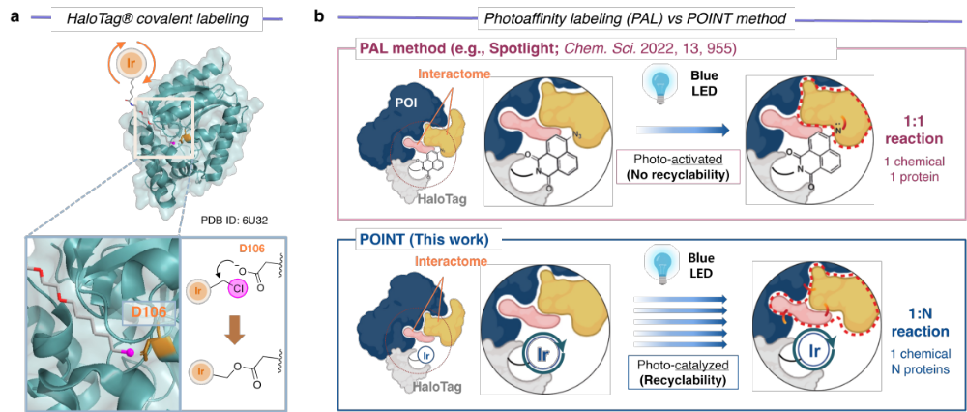
Supplementary Figure 1. Introduction of POINT system. (a) Working mechanism of HaloTag labelling by iridium photocatalyst incorporating haloalkane ligand. (b) Comparison between photoaffinity labeling (PAL) and POINT method developed in this work.

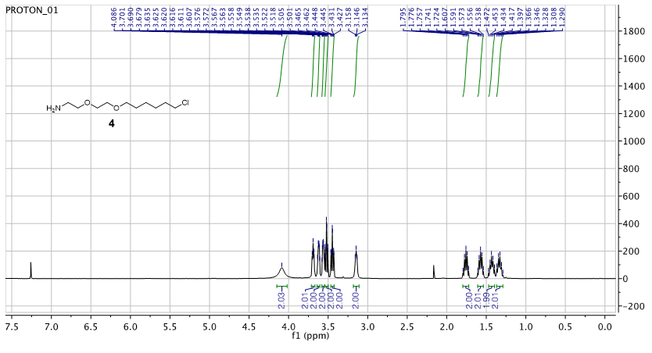
Supplementary Figure 2. ¹H-NMR of 2-(2-((6-chlorohexyl)oxy)ethoxy)ethanamine (4) in CDCl₃.

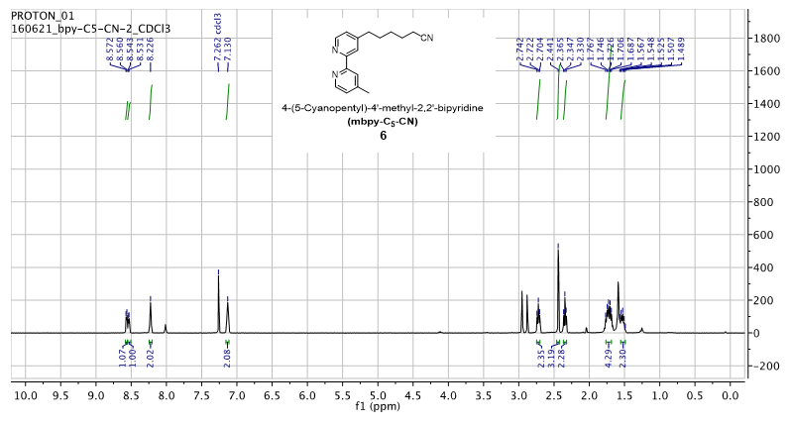
Supplementary Figure 3. ¹H-NMR of 4-(5-cyanopentyl)-4’-methyl-2,2’-bipyridine (6) in CDCl₃.
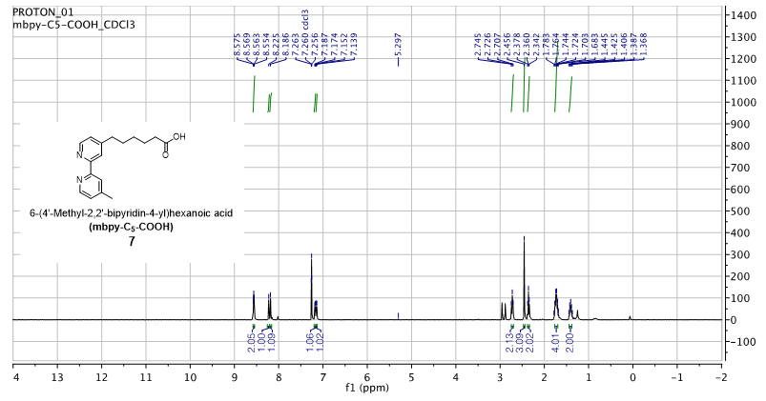
Supplementary Figure 4. ¹H-NMR of 6-(4’-methyl-2,2’bipyridin-4-yl)hexanoic acid (7) in CDCl₃.

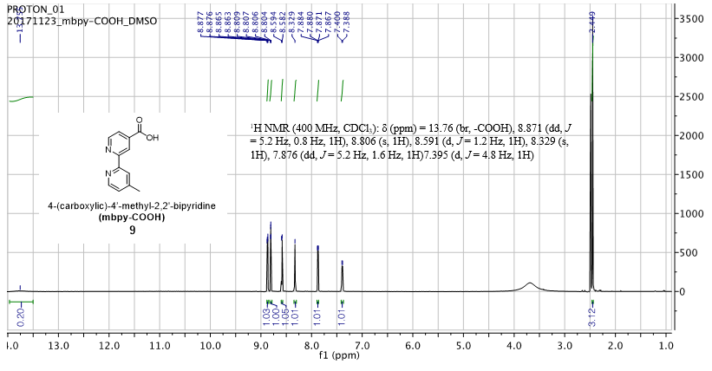
Supplementary Figure 5. ¹H-NMR of mbpy-COOH (8) in d₆-DMSO.
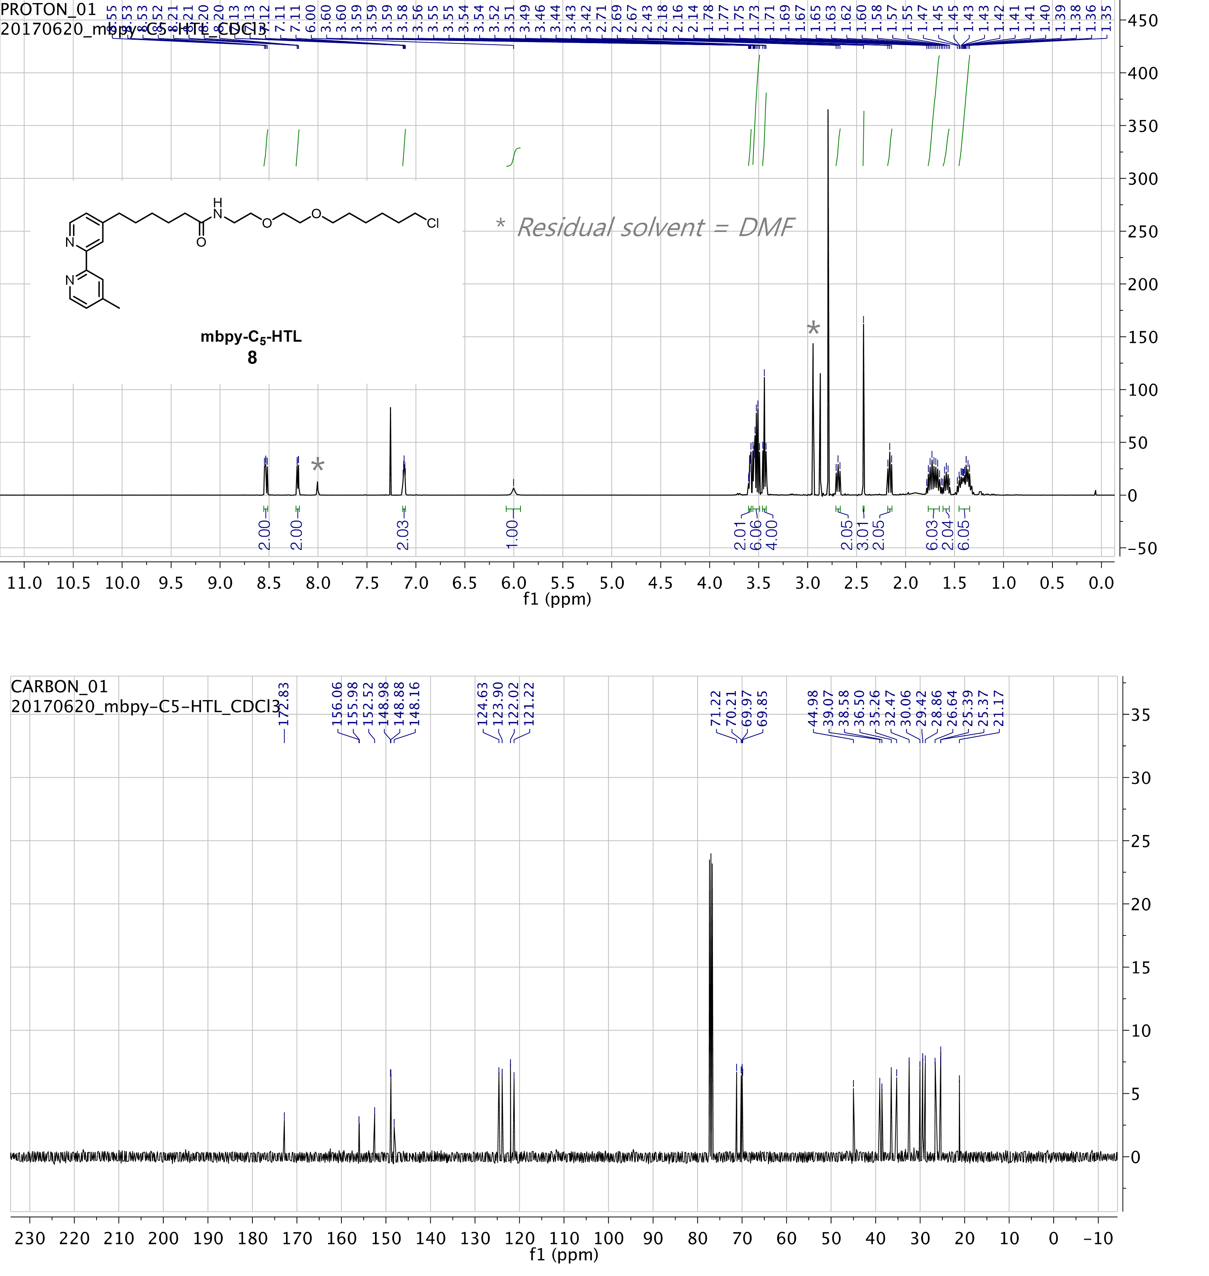
Supplementary Figure 6. ¹H-NMR and ¹³C-NMR of mbpy-C₅-HTL (9) in CDCl₃. Grey asterisk marks indicate residual solvent, DMF.

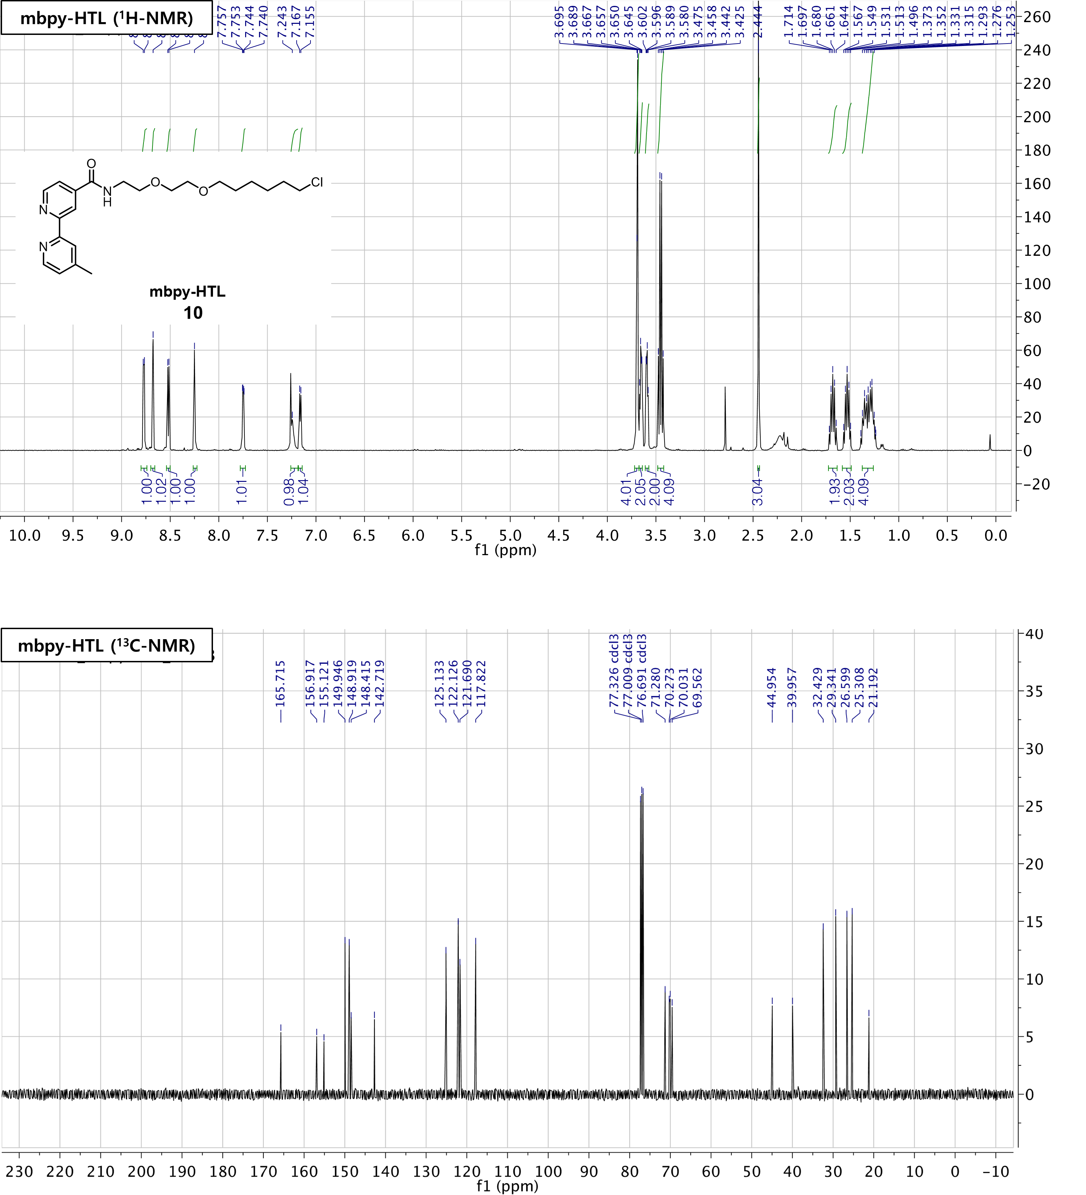
Supplementary Figure 7. ¹H-NMR and ¹³C-NMR of mbpy-HTL (10) in CDCl₃.

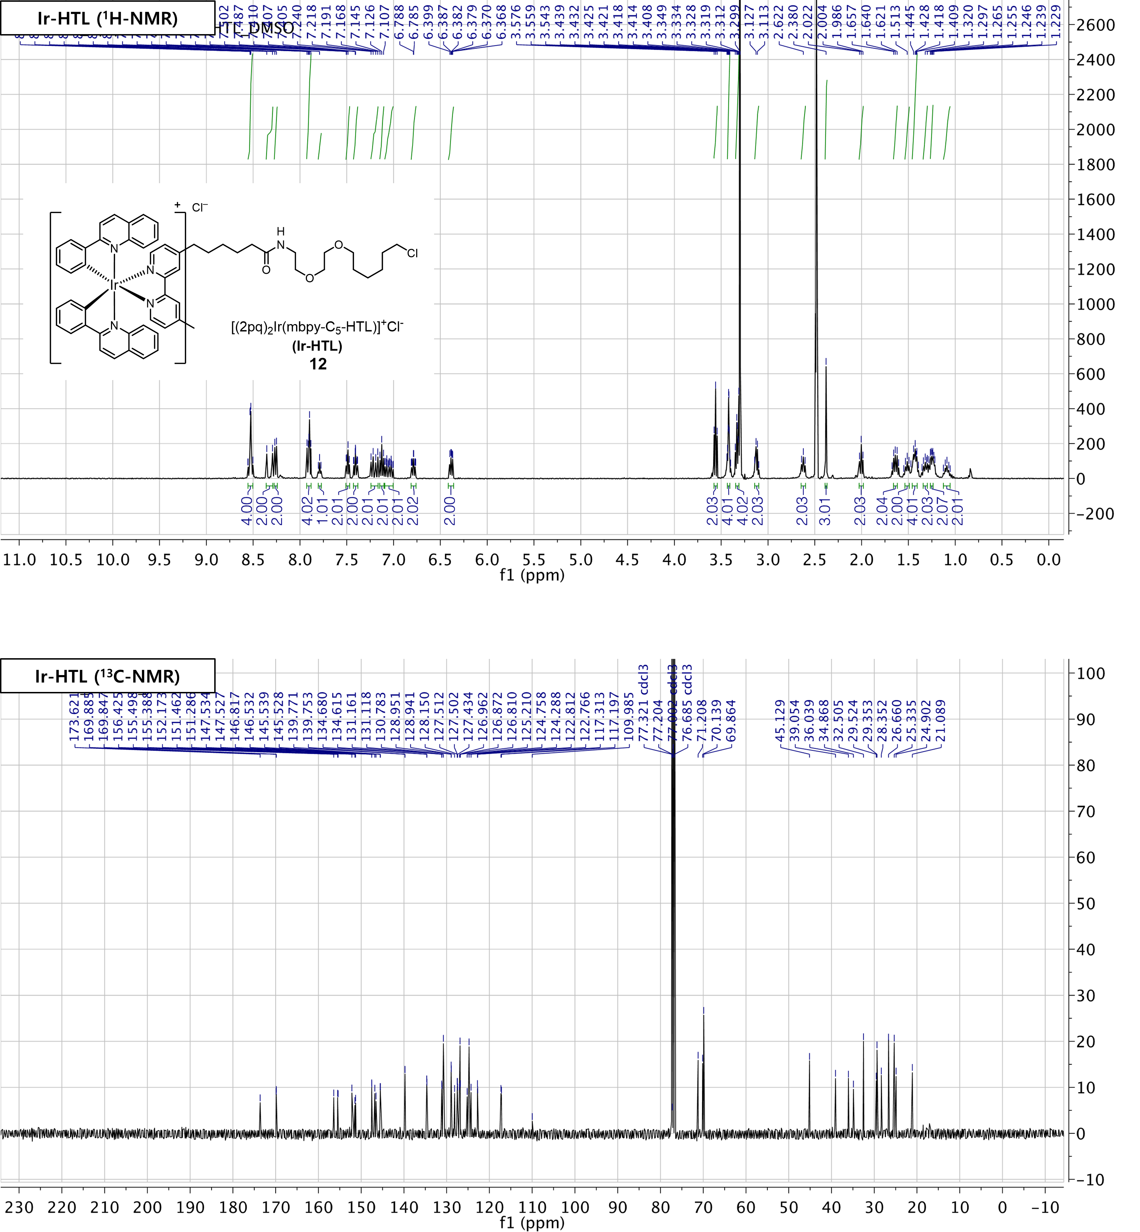
Supplementary Figure 8. ¹H-NMR and ¹³C-NMR of Ir-HTL (12) in d₆-DMSO and CDCl₃, respectively.

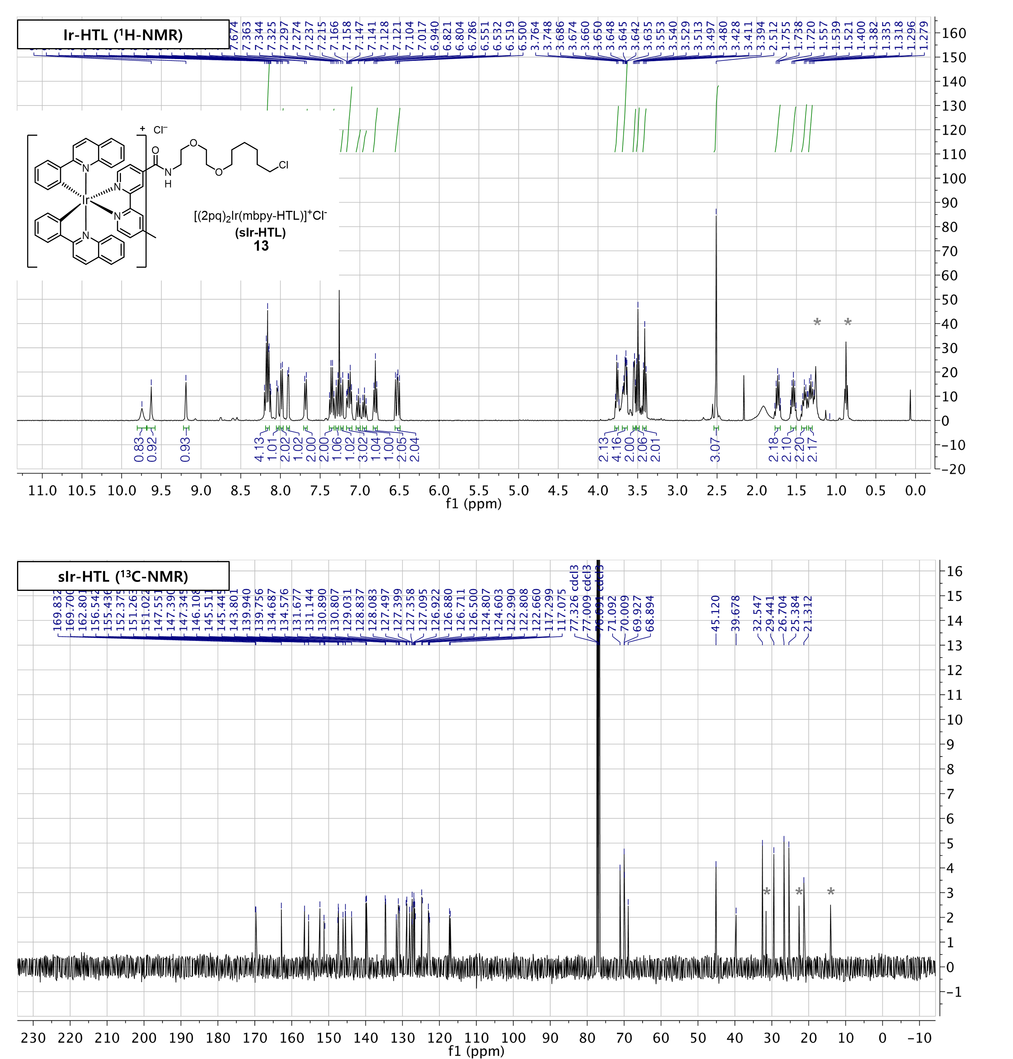
Supplementary Figure 9. ¹H-NMR and ¹³C-NMR of sIr-HTL (13) in CDCl₃.

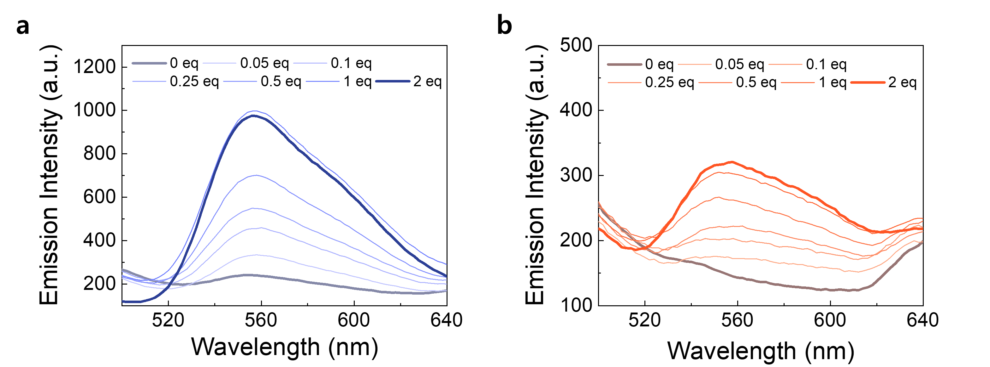
Supplementary Figure 10. Emission profiling depending on the concentration of HaloTag protein. Emission spectra of (a) Ir-HTL or (b) sIr-HTL with the titration of purified HaloTag protein. Enhancement of emission intensity is saturated at the 1 equivalent point, which indicates the 1:1 binding of Ir(III) complex and HaloTag protein.

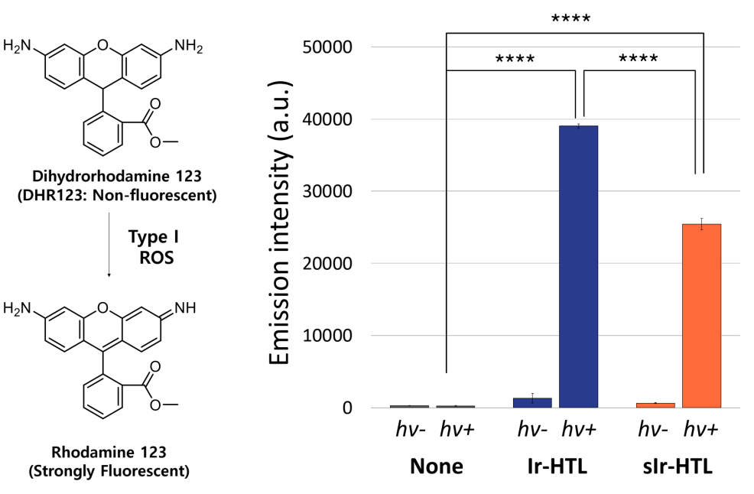
Supplementary Figure 11. Single electron transfer (SET) mediated type I ROS generation by photoactivation of Ir(III) complex. The detection of type I ROS was proved by dihydrorhodamine 123 chemical probe of which emission is activated by type I ROS-mediated oxidation. Data with error bars are presented as mean (SD) (n = 3). **** p < 0.0001
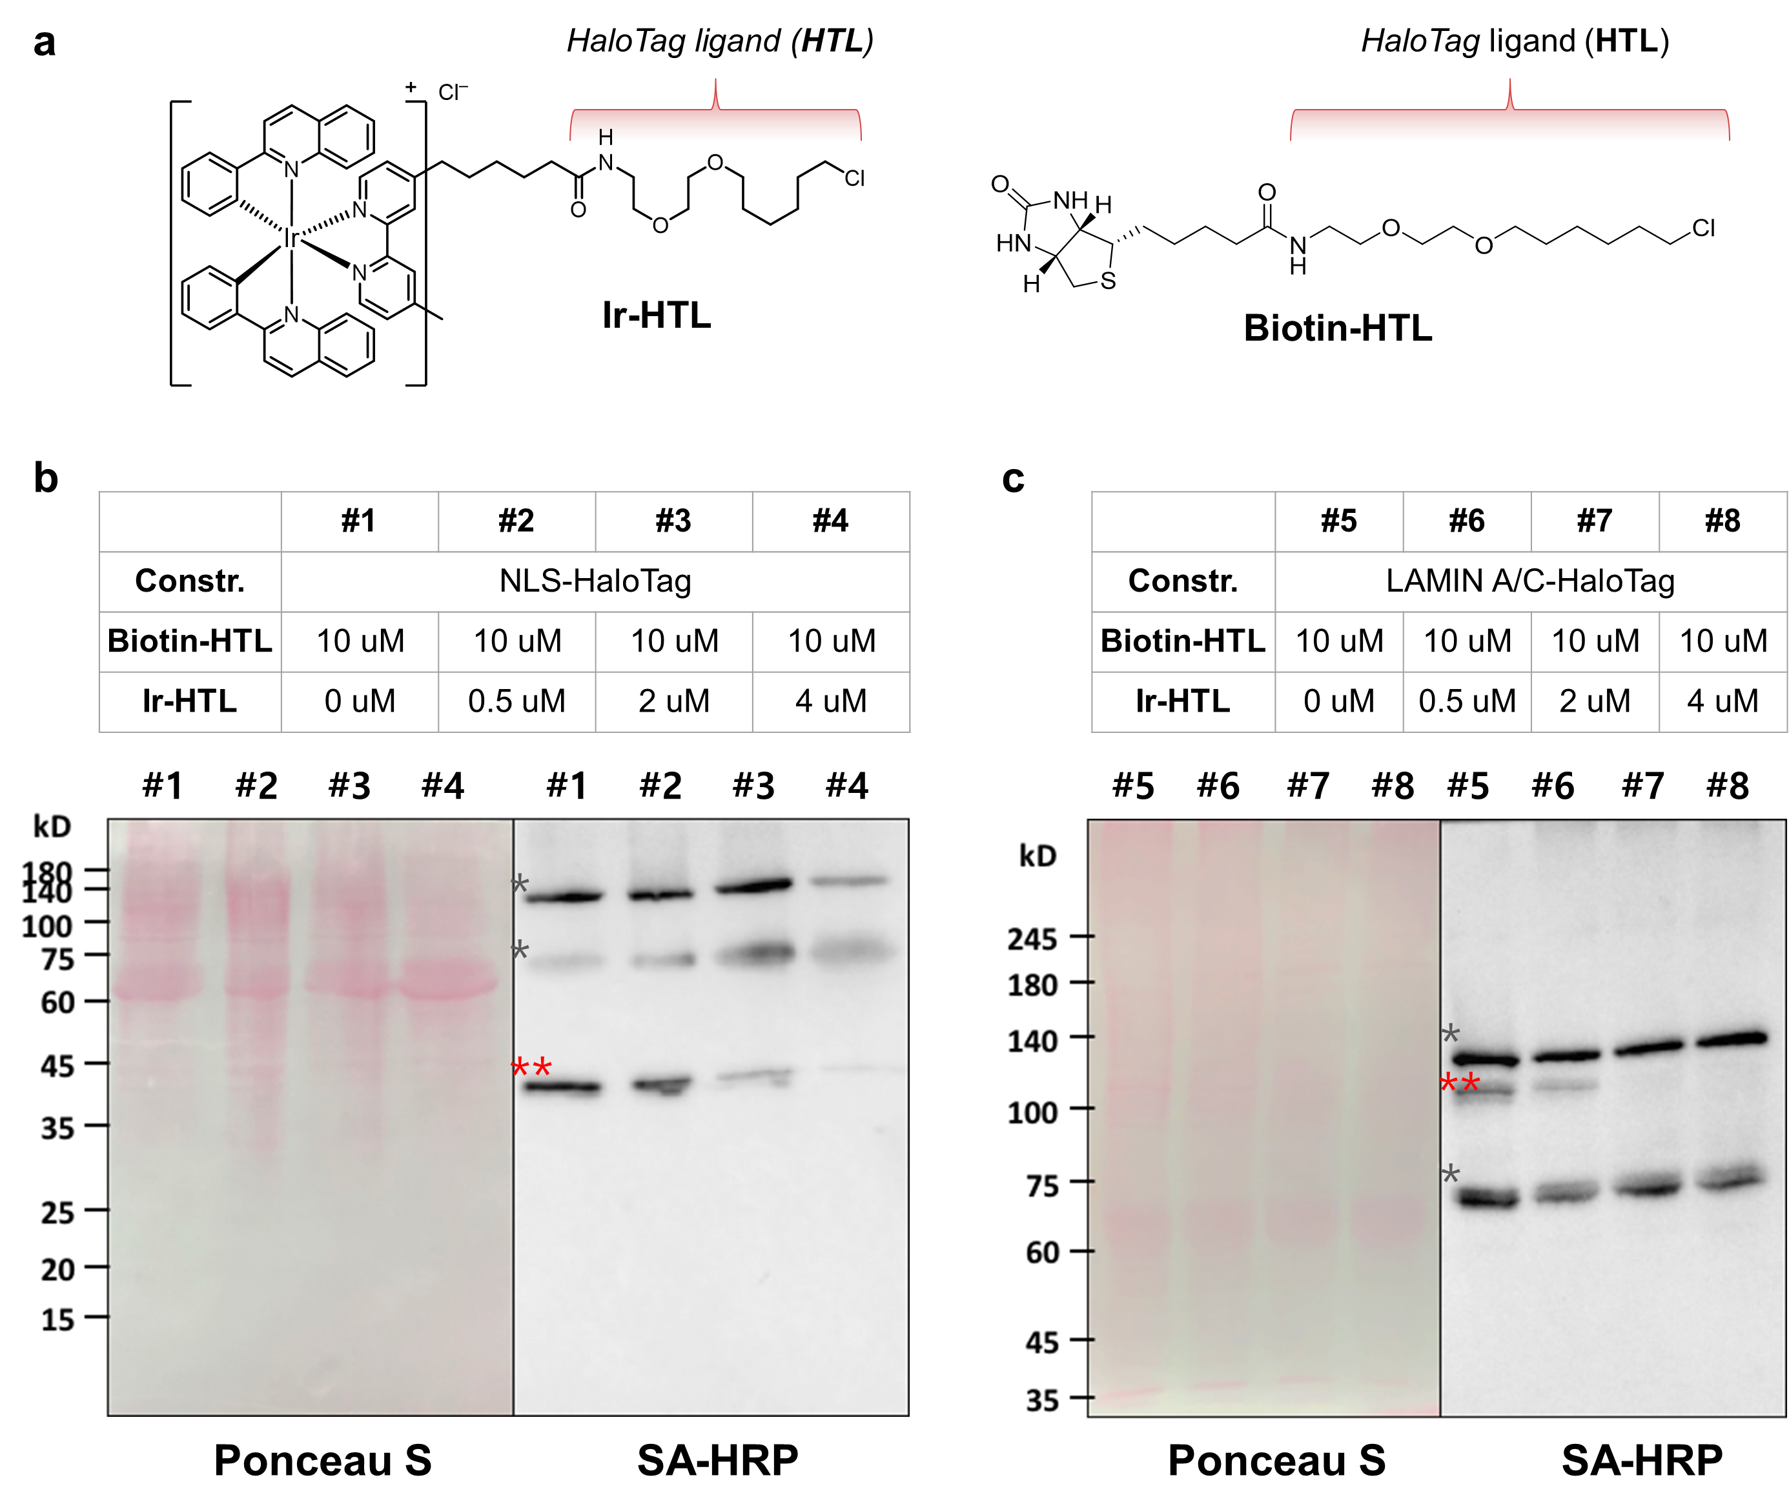
Supplementary Figure 12. Competition assay with Biotin-HTL and Ir-HTL. (a) Chemical structure of Ir-HTL and Biotin-HTL. (b–c) Western blot for identifying binding of Ir-HTL to HaloTag® protein under competitive condition with Biotin-HTL. Two different constructs (NLS-HaloTag and LAMIN A/C-HaloTag) were utilized. Grey asterisk marks indicate endogenously biotinylated proteins at ~70 and 130 kD. Red double asterisk indicates the signal of target POI labeled by Biotin-HTL. Biotin-HTL cannot label to HaloTag protein after Ir-HTL pre-incubation.

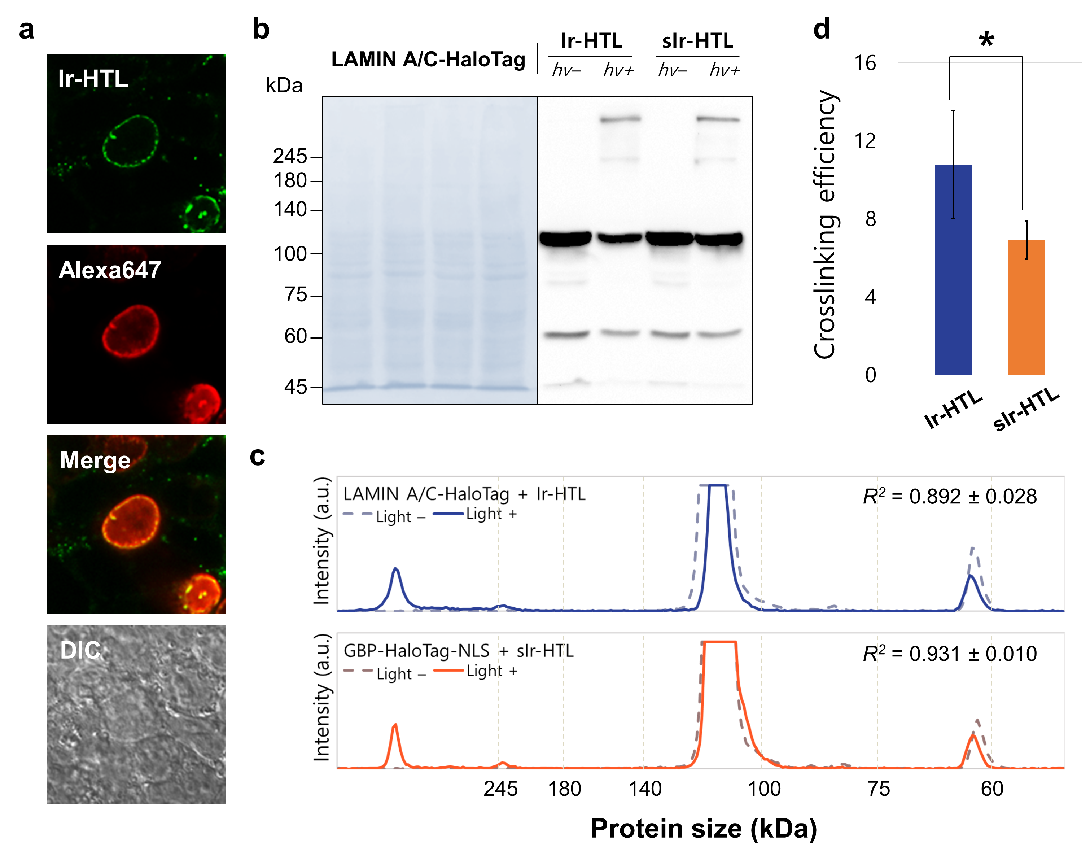
Supplementary Figure 13. Photo-crosslinking efficiency of Ir-HTL and sIr-HTL on nucleus membrane. (a) Confocal image of Ir(III) complex which is localised on Lamin A/C which consists of nucleus membrane. (b) Western blotting to clarify photo-crosslinking of LAMIN A/C-HaloTag with Ir(III) complexes. (c) Line-cut spectra of Western blot signal from Figure S13b. (d) Crosslinking efficiency of Ir-HTL and sIr-HTL located on Lamin A/C. Crosslinking efficiency of two Ir(III) complexes when located on nucleus membrane. Data with error bars are presented as mean (SD) (n = 3). *p < 0.05

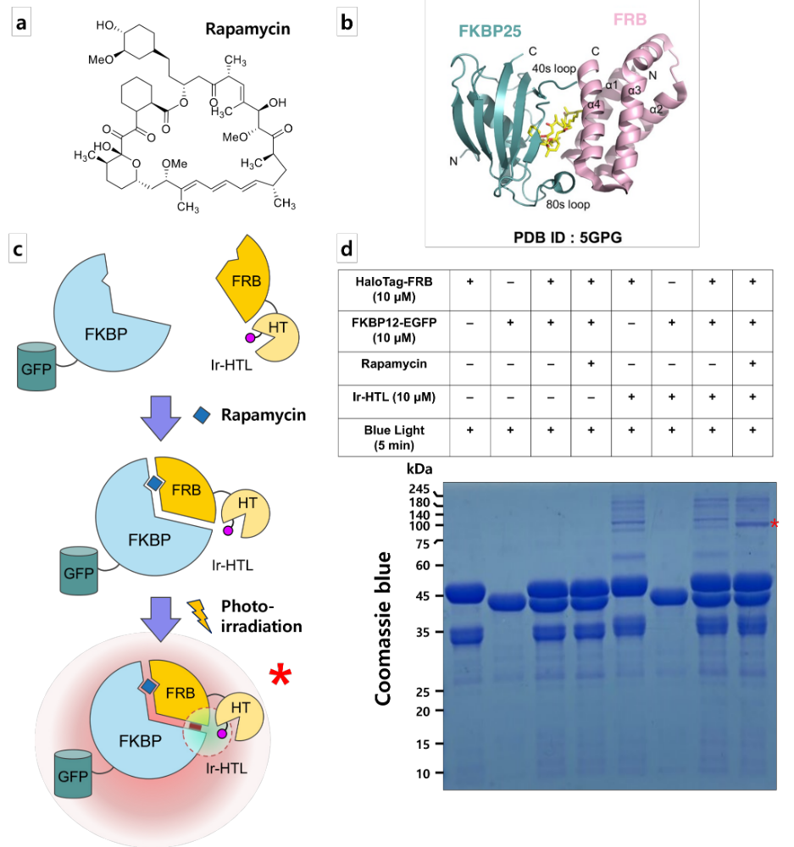
Supplementary Figure 14. In-vitro photo-crosslinking in chemically induced dimerization system with FK506 binding protein (FKBP)–FKBP-rapamycin binding protein (FRB) to elucidate the importance of protein adjacency in photo-crosslinking reaction. (a) Structure of rapamycin. (b) Crystal structure of FKBP25-FRB with rapamycin. (c) Schematic illustration of photo-crosslinking in rapamycin induced dimerization system. Ir(III) complex bound to HaloTag-FRB only makes FRB-FKBP crosslinked protein complex in the presence of Rapamycin (red asterisk mark). (d) Coomassie blue staining to identify crosslinked proteins. The band of red asterisk mark corresponds to FRB-FKBP crosslinked protein complex. The photo-crosslinking reaction did not occur with negative control condition (without light or Ir-HTL) (lane #1–4), and without HaloTag-FRB (lane #6).

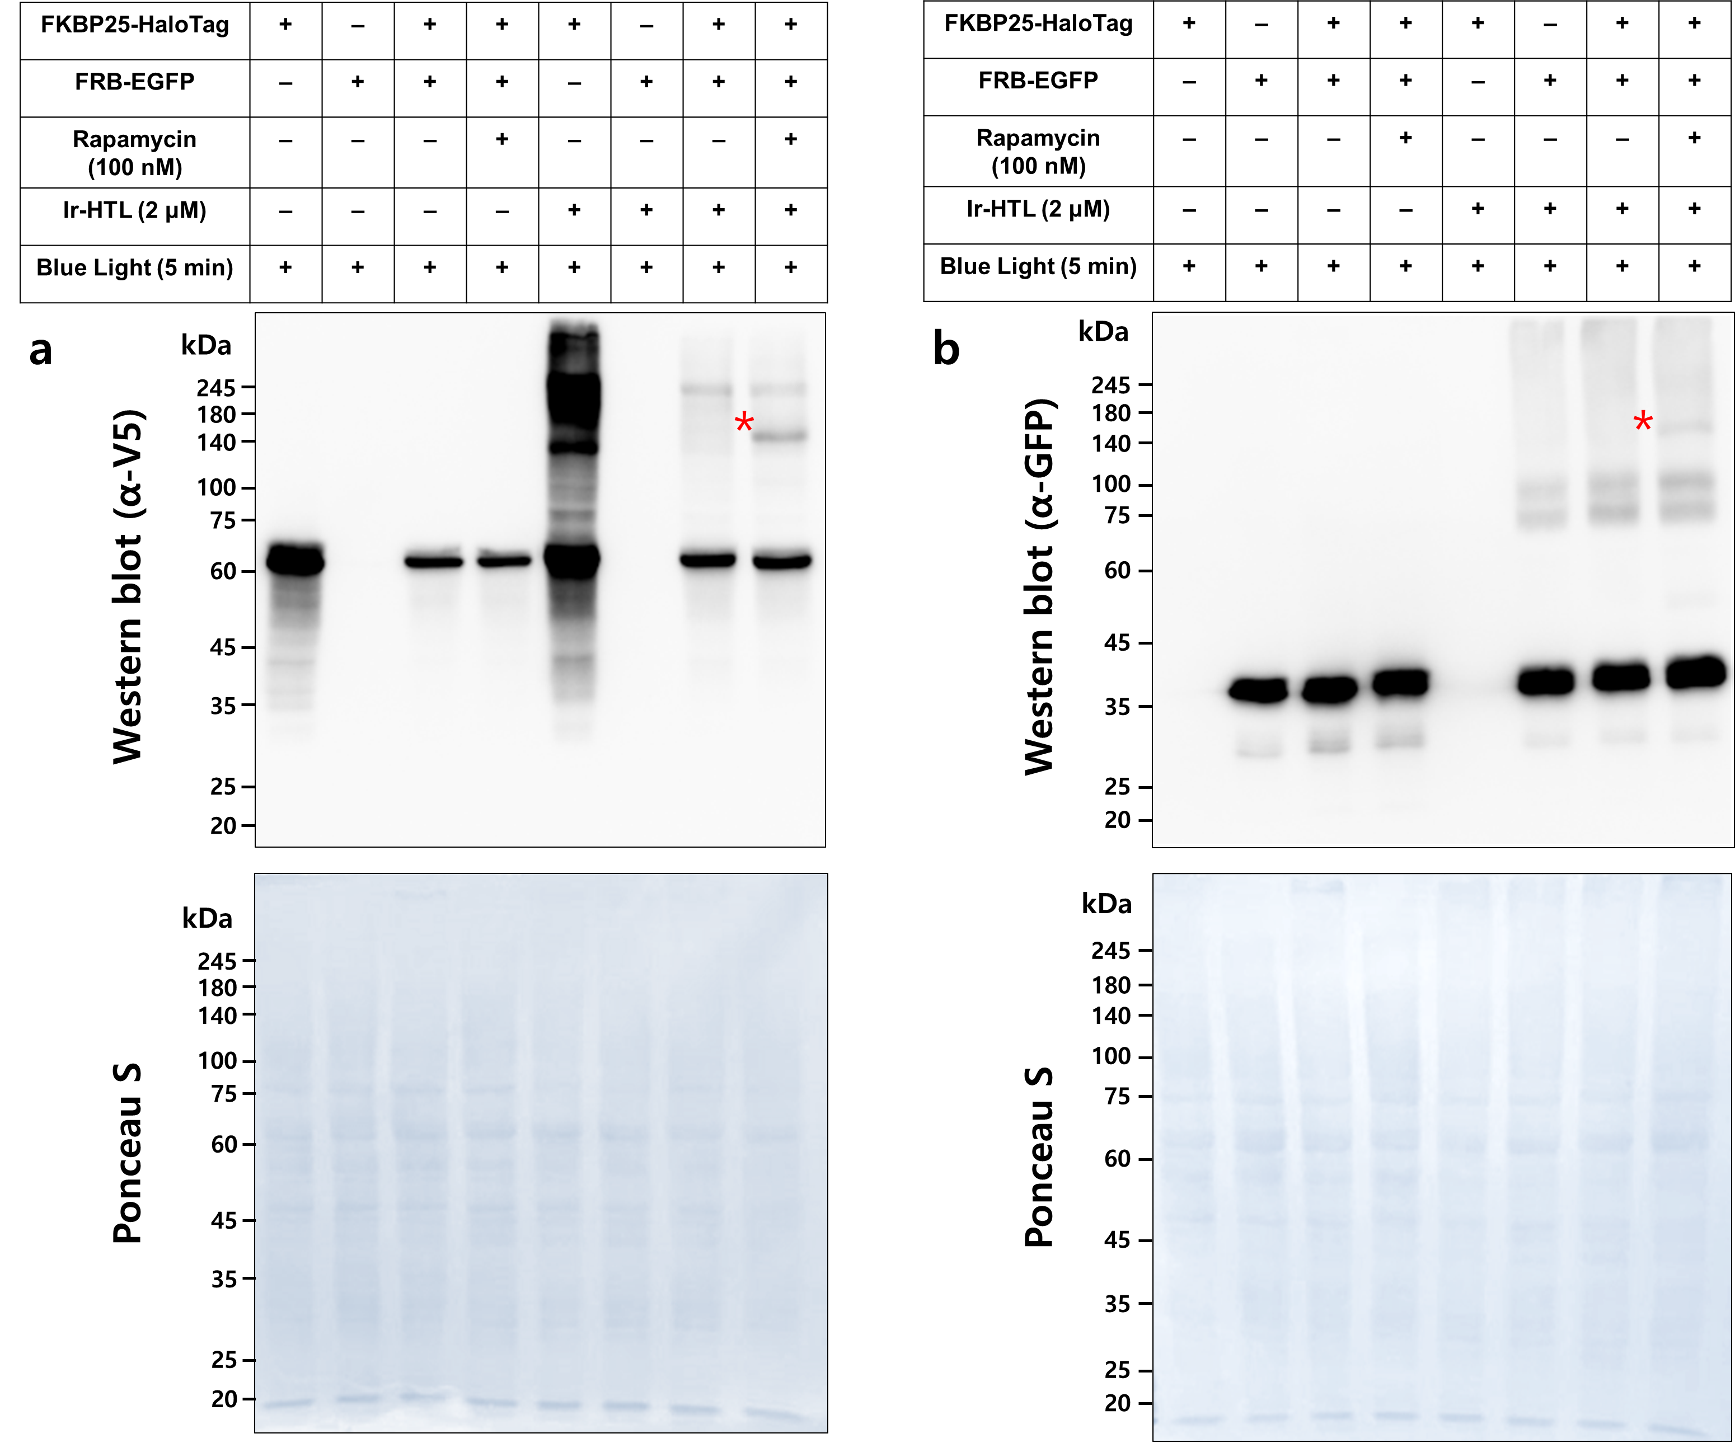

Supplementary Figure 15. Live cell photo-crosslinking in FRB-FKBP25 model system with Ir-HTL. The signals from immunostaining of (a) FKBP25-V5-HaloTag (63 kDa) and (b) FRB-EGFP (40 kDa). Red asterisk mark indicates newly generated crosslinking band under the condition of FRB-FKBP dimerization induced by the treatment of rapamycin. It is remarkably noted that photo-crosslinking method can capture interaction networks that vary depending on stimuli.

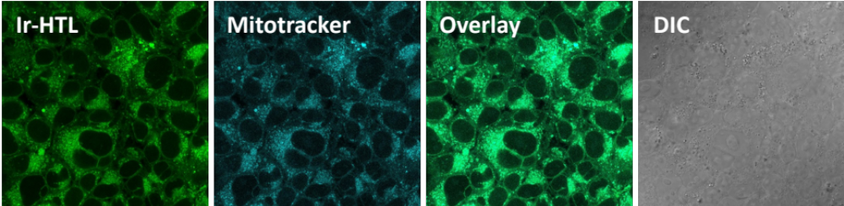

Supplementary Figure 16. Visualization of Ir-HTL localised pattern in the non-transfected cells (i.e., no expression of the GBP-HaloTag-NLS construct) using confocal microscopy. Condition: [Ir-HTL] = 2 µM, [MitoTracker] = 0.5 µM, and incubation time = 2 h and 30 min, respectively.

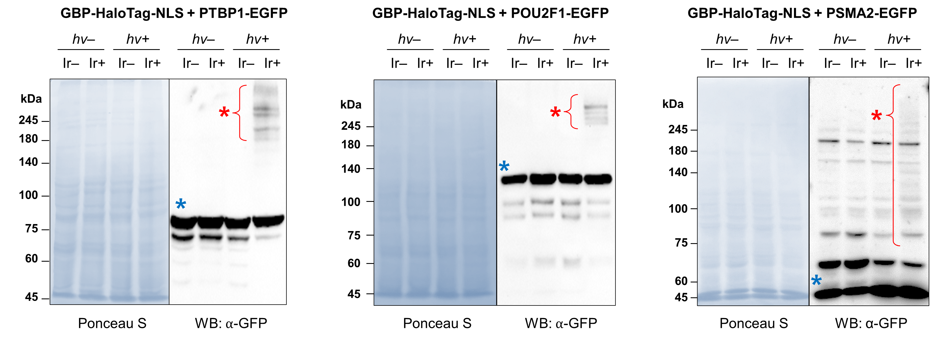
Supplementary Figure 17. Photo-crosslinked signal of EGFP under the condition of expression of GBP-HaloTag-NLS and POI-EGFP. Blue asterisk mark indicates the monomer and red asterisk mark indicates crosslinked signals.

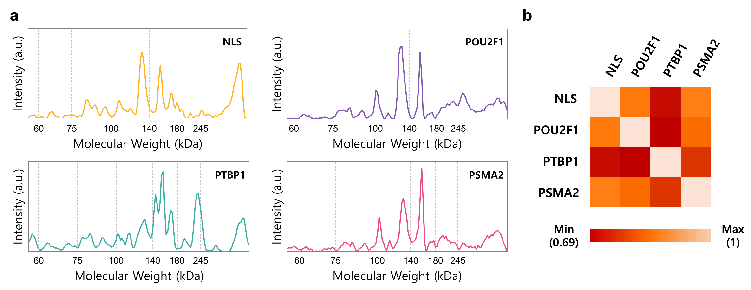
Supplementary Figure 18. Detail profiling of photo-crosslinking band on Western blot with α-V5. (a) Line-cut spectra on the photo-crosslinked lane with Ir(III) complex and photo-irradiation for respective POI. (b) Correlation heat map between photo-crosslinking line-cut spectra of respective POIs. Correlation value presents the similarity between two spectra and the result indicates the photo-crosslinking signals on specific locations targeting POI are distinctive.

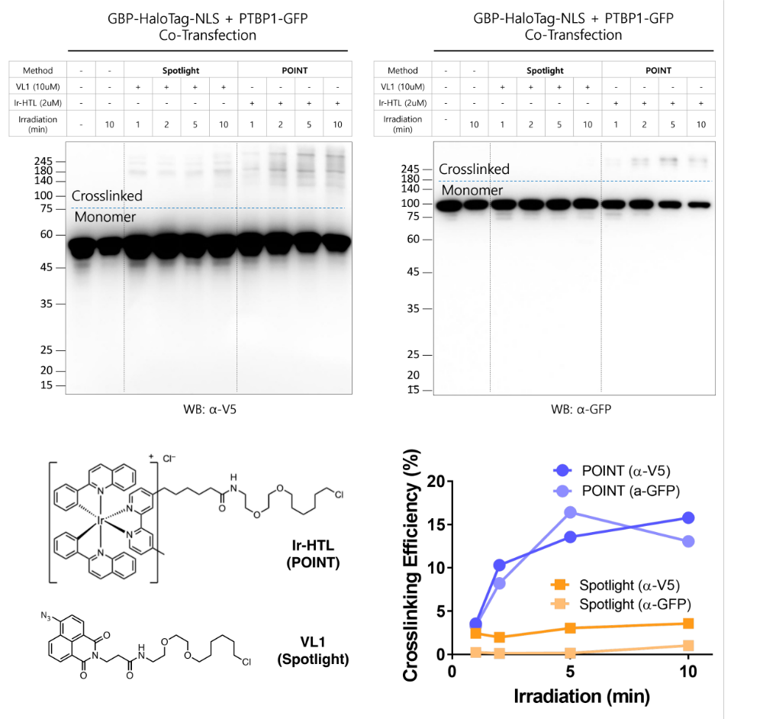
Supplementary Figure 19. Comparative analysis of the proximity photo-crosslinking method (Spotlight)¹³ and photo-crosslinking by the organoiridium catalyst for intracellular interactome mapping (POINT) with VL1 and Ir-HTL, respectively. The crosslinking efficiency was calculated using the ratio of the signal intensity of the crosslinked to the monomer.

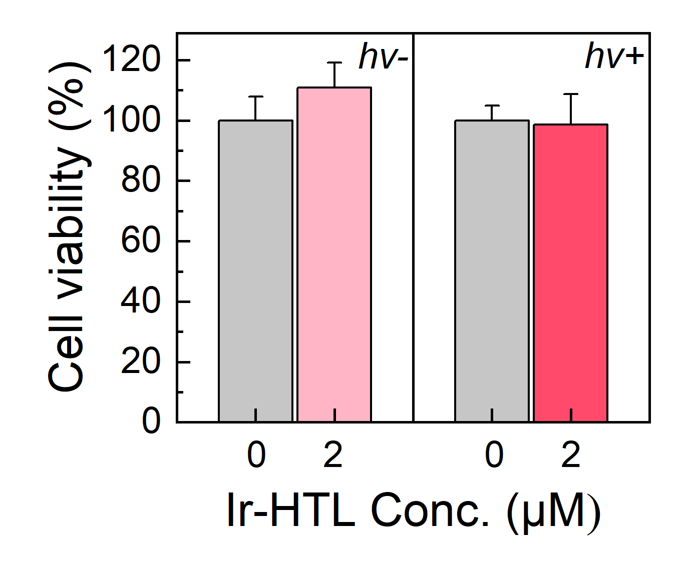
Supplementary Figure 20. Cell viability evaluation for POINT method using MTT assay. Condition: [Ir-HTL] = 2 mM, Ir-HTL incubation time = 2 hours, washing time = overnight, photo-irradiation = 405 nm for 10 min. Data with error bars are presented as mean (SD) (n = 4).

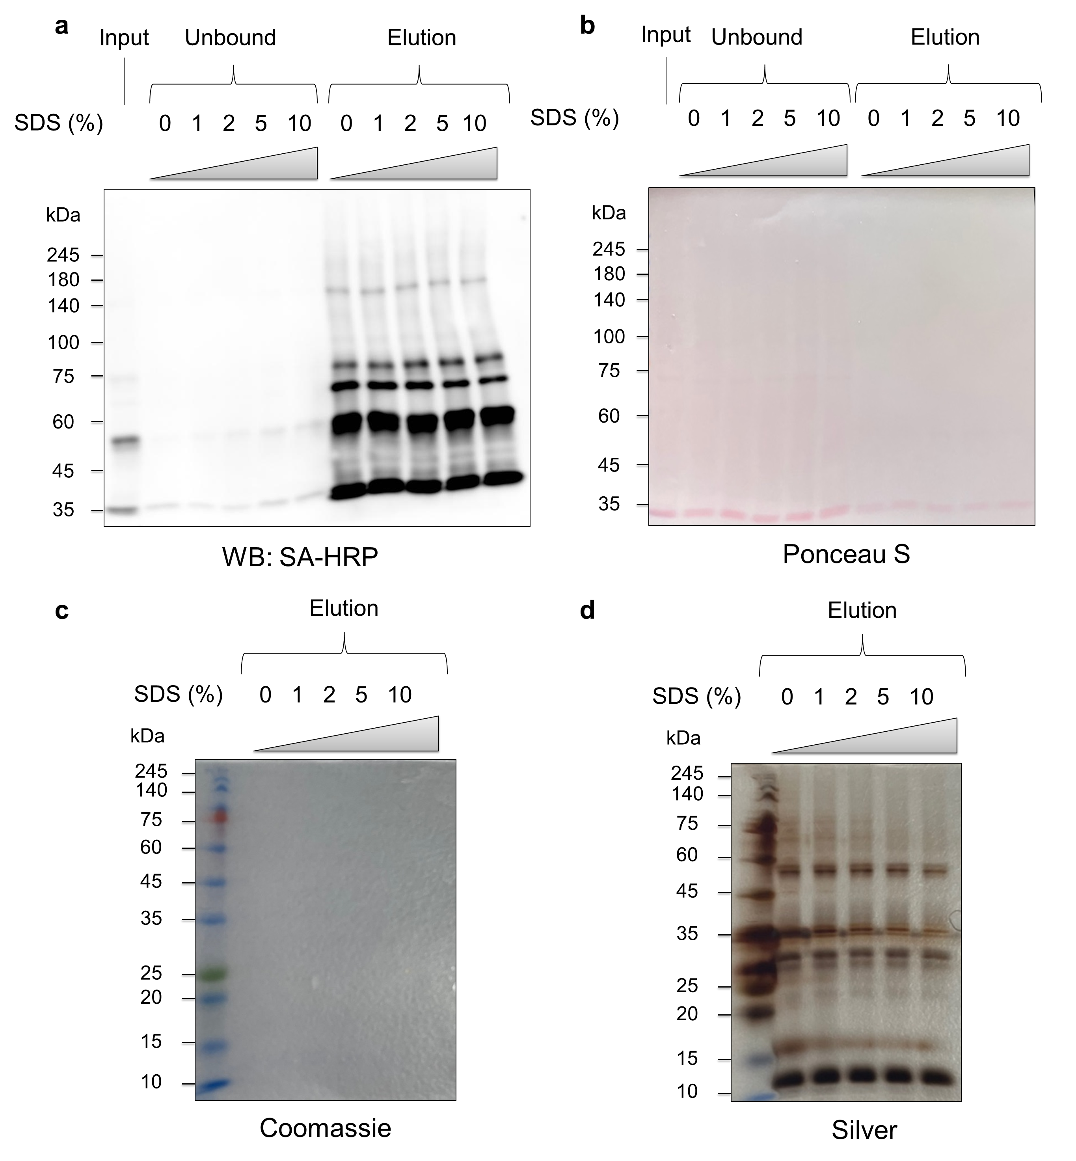
Supplementary Figure 21. Optimisation of SA-bead enrichment process under sodium dodecyl sulfate (SDS) washing for the removal of non-specific binding proteins. (a) SA-bead enrichment for biotinylated bait (crosslinked proteins) depending on SDS washing concentration. Biotin-steraptavidin binding is strong so that enrichment signal was not affected by harsh SDS washing condition. (b) Ponceau S staining for verifying enrichment result. (c) Commassie staining for identifying entire quantity of enriched proteins. However, no signals are detected because of its less sensitivity. (d) Silver staining for sensitively identifying entire quantity of enriched proteins. Depending on the increased SDS concentration, total quantity of enriched proteins gradually dcreased because of the removal of non-specific proteins bound to crosslinked proteins.
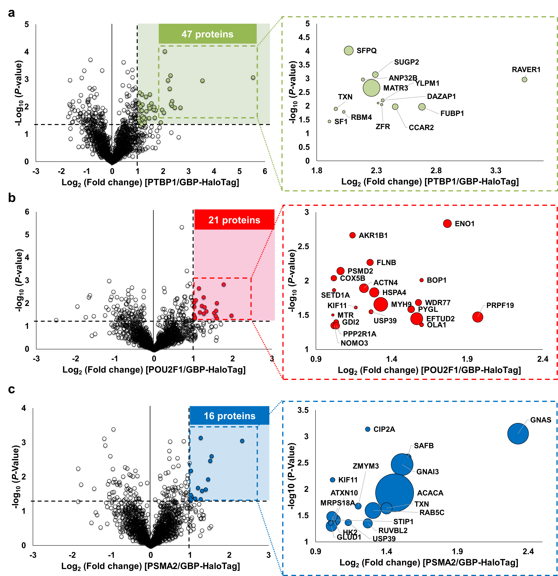
Supplementary Figure 22. Identification of significantly enriched proteins for targeting three respective proteins of interests (POIs) by POINT. Volcano plots showing statistically significant enriched-proteins (47, 16, and 21 proteins for (a) PTBP1; green, (b) POU2F1; red, and (c) PSMA2; blue, respectively) by proteomic analysis based on photo-crosslinking. Cut-off condition: -Log₁₀ (P-value) > 1.3 and Log₂ (Fold change) > 1. The part of significantly enriched-proteins are enlarged (box with dotted line). The bubble size means the mass signal intensity of biotinylated peptides.

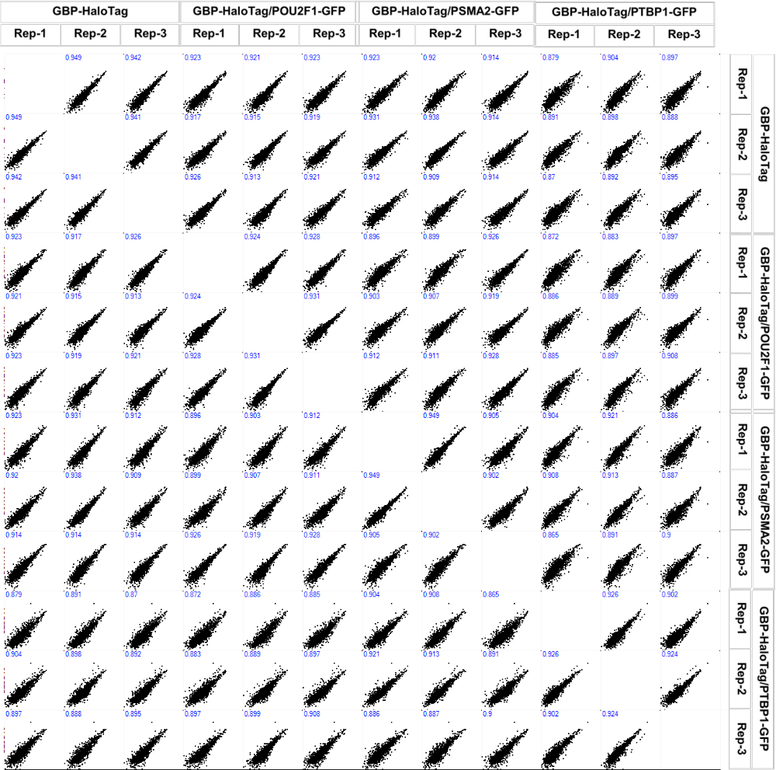
Supplementary Figure 23. Similarity analysis of each sample by scatter plotting and Pearson correlation value.

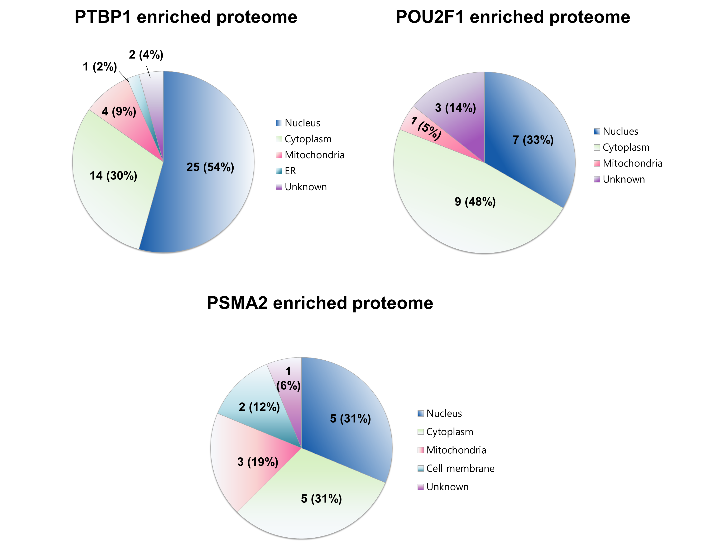
Supplementary Figure 24. Distribution of subcellular localisation of enriched interactomes visualized by pie chart.

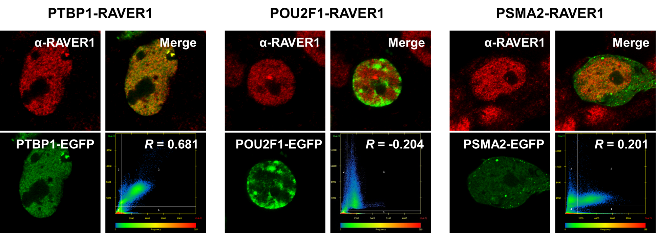
Supplementary Figure 25. High-resolution confocal imaging using Airyscan mode for co-localisation analysis. Note that the images were processed by ZEN Blue 3.0.

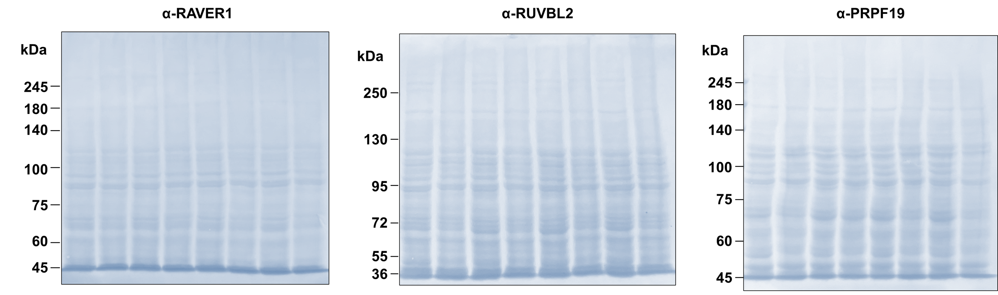
Supplementary Figure 26. Ponceau S staining to prove same loading quantity of proteins for respective lanes. This Ponceau result is connected with Figures 4d–f.

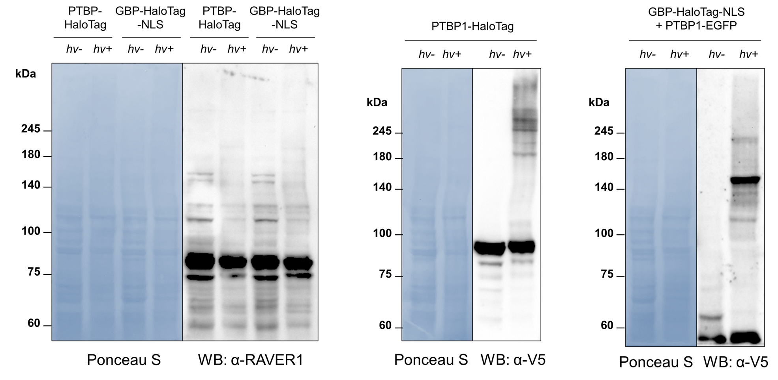
Supplementary Figure 27. Interactome crosslinking pattern comparison between PTBP1-HaloTag and GBP-HaloTag-NLS-PTBP1-GFP.

Supplemental Tables
Supplementary Table 1. Summary of the differences between POINT and other methods. Advantages are marked in blue, and disadvantages are marked in red.
 | POINT  (This study) | µMap  (Science, 2020) | Small molecule target ID (PNAS, 2022) | Chroma-µMap (Nature, 2023) | Spotlight  (Chem. Sci. 2022)
Ir photocat. incubation | Intracellular (live cell) | After detaching cells from culture (pellet) | After detaching cells from culture (pellet) | After nuclei  isolation following cell detachment | Intracellular  (live cell)
Labeling process | Iridium-catalyzed protein−protein crosslinking | Diffusive diazirine labeling | Diffusive diazirine labeling | Diffusive diazirine labeling | Nitrene-induced protein-protein crosslinking
Labeling  intermediate | Oxidized tyrosine on the proteins | Carbene  on the probe | Carbene on the probe | Carbene on the probe | Nitrene on the probe
Labeling  recyclability | Recyclable  photocatalyzed  labeling | Recyclable with sufficient diazirine | Recyclable with sufficient diazirine | Recyclable with sufficient diazirine | No recyclability
POI-targeting  system | GBP-HaloTag system | Antibody | Drug binding | Split inteins | HaloTag system
Range of  applicable POIs | Proteins that can be engineered with GFP | Membrane proteins | Druggable proteins | Proteins that can be engineered with split intein | Proteins that can be engineered with HaloTag

Supplementary Table 2. Plasmid construct information.
Name (expected size) | Features | Promotor / vector | Details
PSMA2-EGFP (53.1 kDa) | NotI-PSMA2-BamHI-EGFP-STOP-XhoI | CMV / pCDNA3 | PSMA2 (NM_002787.5)
POU2F1-EGFP (105.0 kDa) | NotI-POU2F1-BamHI-EGFP-STOP-XhoI | CMV / pCDNA3 | POU2F1 (NM_001198783.2)
PTBP1-EGFP (86.6 kDa) | NotI-PTBP1-BamHI-EGFP-STOP-XhoI | CMV / pCDNA3 | PTBP1 (NM_031990.4)
GBP-V5-Halotag-AP-NLS (54.2 kDa) | KpnI-GBP-BamHI-V5-Halotag-TEV site-AP-NotI-NLS-STOP-XhoI | CMV / pCDNA5 | The GBP (GFP-targeting nanobody) gene was cloned from mKate2-P2A-APEX2-GBP, a gift from Rob Parton (Addgene plasmid # 67650) (Ariotti et al., 2015)¹¹  AP (Acceptor peptide): GLNDIFEAQKIEWHE  NLS (Nuclear localisation signal): SRADPKKKRKVDPKKKRKVDPKKKRKV
AP-V5-Halotag-LAMIN A/C (111.3 kDa) | KpnI-AP-NheI-V5-Halotag-EcoRI-AflII-LAMIN A/C-STOP-XhoI | CMV / pCDNA5 | LAMIN A/C was a gift from Sang-Hee Shim (Korea University) (Kwon et al., 2020)¹²  V5: GKPIPNPLLGLDST  AP (Acceptor peptide): GLNDIFEAQKIEWHE
AP-V5-Halotag-NLS (40.5 kDa) | KpnI-AP-V5-Halotag-EcoRI-NLS-STOP-NotI | CMV / pCDNA5 | AP (Acceptor peptide): GLNDIFEAQKIEWHE  V5: GKPIPNPLLGLDST  NLS (Nuclear localisation signal): SRADPKKKRKVDPKKKRKVDPKKKRKV
PTBP1-V5-HaloTag-AP | HindIII-PTBP1-BamHI-KpnI-V5-HaloTag-TEV-AP-STOP- | CMV/pCDNA5 | PTBP1 (NM_031990.4)  V5: GKPIPNPLLGLDST  AP (Acceptor peptide): GLNDIFEAQKIEWHE  TEV: EDLYFQS
FKBP25-HaloTag | KpnI-FKBP25- BamHI-NheI-V5-HaloTag-TEV-AP-STOP | CMV/pCDNA5 | FKBP25 (NM_002013.4)  V5: GKPIPNPLLGLDST  AP (Acceptor peptide): GLNDIFEAQKIEWHE  TEV: EDLYFQS
EGFP-FRB | AgeI-EGFP- HindIII-EcoRI-FRB-STOP-BamHI | CMV/pEGFP | EGFP: enhanced green fluorescence protein  FRB: FKBP12-Rapamycin Binding domain of mTOR  Addgene number: 25919
FKBP12-EGFP | NdeI-FKBP12-HindIII-NotI-EGFP-10aa linker-XhoI-His6-STOP | T7/pET21a | FKBP12 (NM_000801.5)  EGFP: enhanced green fluorescence protein  10 aa linker: GGSGGSGGSR  His6: Histidine Tag
HaloTag-FRB | His6-HaloTag-TEV-SacI-FRB-NheI-8aa linker-BamHI-V5-STOP-NotI | T7/pH6HTN | His6: Histidine Tag  8 aa linker: SGGSGGSR  TEV: EDLYFQS

Supplementary References
- Scheneider, C. A., Rasband, W. S., Eliceiri, K. W. (2012). NIH Image to ImageJ: 25 years of image analysis. Nat. Methods 9, 671–675.
- Lee, S.-Y., Kang, M.-G., Park, J.-S., Lee, G., Ting, A. Y., Rhee, H.-W. (2016). APEX fingerprinting reveals the subcellular localization of proteins of interest. Cell Rep. 15, 1837–1847.
- Lee, C., Nam, J. S., Lee, C. G., Park, M., Yoo, C.-M., Rhee, H.-W., Seo, J. K., Kwon, T.-H. (2021) Analysing the mechanism of mitochondrial oxidation-induced cell death using a multifunctional iridium(III) photosensitiser. Nat. Commun. 12, 26.
- Rappsilber, J., Mann, M., Ishihama, Y. (2007). Protocol for micro-purification, enrichment, pre-fractionation and storage of peptides for proteomics using StageTips. Nat. Prot. 2, 1896–1906.
- Keller, A., Nesvizhskii, A. I., Kolker, E., Aebersold, R. (2002). Anal. Chem. 74, 5383–5392.
- Singh, V., Wang, S., Kool, E. T. (2013). Genetically encoded multispectral labeling of proteins with polyfluorophores on a DNA backbone. J. Am. Chem. Soc. 135, 6184–6191.
- Tanaka, K., Tainaka, K., Kamei, T., Okamoto, A. (2007). Direct labeling of 5-methylcytosine and its applications. J. Am. Chem. Soc.129, 5612–5620.
- Sato, S., Nakamura, H. (2013). Ligand-directed selective protein modification based on local single-electron-transfer catalysis. Angew. Chem. Int. Ed. 52, 8681–8684.
- Matínez, M. Á., Carranza, M. P., Massaguer, A., Santos, L., Organero, J. A., Aliende, C., Llorens, R., Ng-Choi, I., Feliu, L.; Planas, M., Rodríguez, A. M. et al. (2017). Synthesis and biological evaluation of Ru(II) and Pt(II) complexes bearing carboxyl groups as potential anticancer targeted drugs. Inorg. Chem. 56, 13679–13696.
- Nonoyama, M. (1974). Benzo[h]quinolin-10-yl-N Iridium(III) Complexes. Bull. Chem. Soc. J. 47, 767–768.
- Ariotti, N., Hall, T. E., Rae, J., Ferguson, C., McMahon, K.-A., Martel, N., Webb, R. E., Webb, R. I., Teasdale, R. D., Parton, R. G. (2015). Modular detection of GFP-labeled proteins for rapid screening by electron microscopy in cells and organisms. Dev. Cell. 35, 513–525.
- Kwon, J., Park, J.-S., Kang, M., Choi, S., Park, J., Kim, G. T., Lee, C., Cha, S., Rhee, H.-W., Shim, S.-H. (2020). Bright ligand-activatable fluorescent protein for high-quality multicolor live-cell super-resolution microscopy. Nat. Commun. 11, 273.
- Mishra, P. K., Kang, M.-G., Lee, H., Kim, S., Choi, S., Sharma, N., Park, C.-M., Ko, J., Lee, C., Seo, J. K. et al. (2022). A chemical tool for blue light-inducible proximity photo-crosslinking in live cells. Chem. Sci. 13, 955–966.

