Multifunctional Mesoporous Hollow Silica Nanorod for Optical Imaging and Drug Delivery
Yanli Wu^{1*}, Xiaogao Guan¹, Xianzhu Xu², Ruchun Yang¹, Fangfang Kong^{1*}, Xi Chen¹, Qiang Xiao¹
- Jiangxi Key Laboratory of Organic Chemistry, Jiangxi Science and Technology Normal University, Nanchang, 330013, China
- College of Life Science, Jiangxi Normal University, Nanchang 330031, China

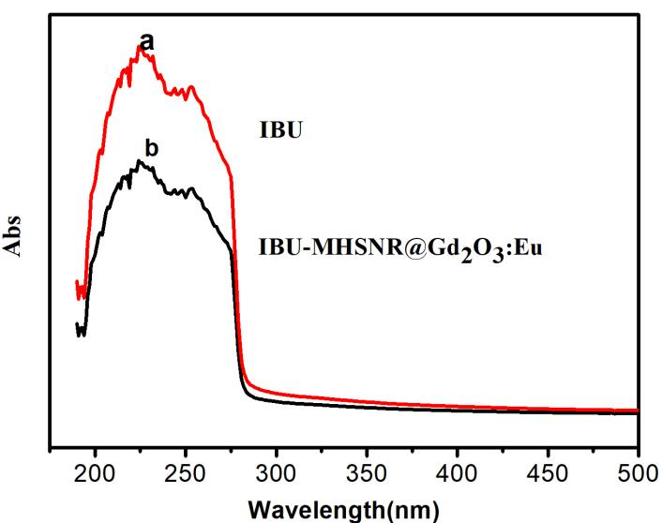
Fig.S1 UV-vis spectra of IBU and IBU-MHSNR@Gd₂O₃:Eu
Fig.S2 presented the FTIR spectra of the hollow silica nanorod (curve 1) and Gd₂(CO₃)₃:Eu coated hollow silica nanorod (curve 2) . In curve 1, all absorption peaks can be ascribed to the pure silica , the absorption band near 3420 cm^{–1} was determined as the tensile vibration of -OH, the peak of CH_{x} (2924, 2850 cm⁻¹)was from CTAB, the peak at 1640 cm^{–1} was caused by the bending vibration of H-O-H, the two strong peaks at 1080 and 795 cm^{–1} were due to the asymmetric and symmetric stretching of Si-O-Si, respectively, while the peak at 960 cm^{–1} corresponded to the symmetric stretch of Si-OH. In curve 2, except the mentioned above peaks, two absorption bands at 1506 cm⁻¹, 1408 cm⁻¹ appeared, which were ascribed to the bands of V_{as} O-C-O, this indicate the presence of the carbonate group.
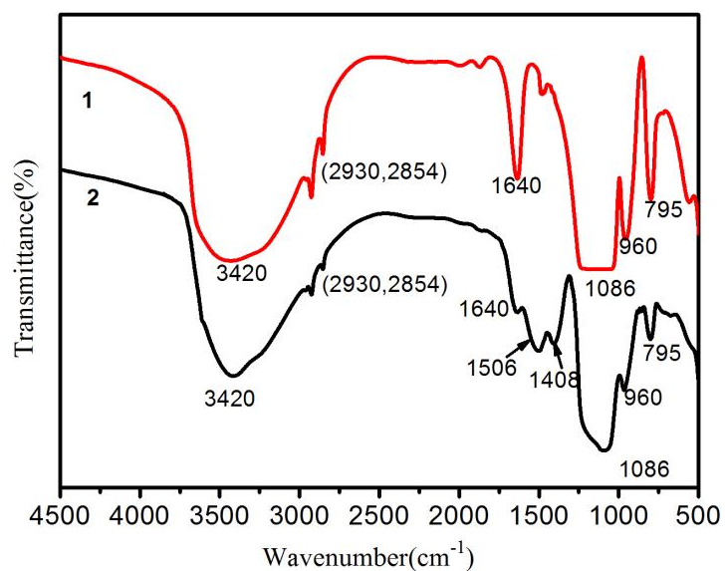
Fig.S2 infrared spectrum of HSNR@Gd₂(CO₃)₃

