Ap4A modulated quorum sensing in treated bacteria to resistant kanamycin
Xia Ji^{1#*}, Ruojing Yu^{1#}, Cuilin Zhang¹, Meilian Zhu¹, Tianshu Cai², Weiwei Li²
¹School of Life Science, Huizhou University, Huizhou, 516007, China
²Huizhou Health Sciences Polytechnic, Huizhou, 516025, China
# These authors contributed equally to this work
* Correspondence:
Xia Ji: xiaji@hzu.edu.cn; Liangxiong Xu: xlx048@huz.edu.cn; Weiwei Li: lweiwei925@163.com

Keywords: kanamycin, diadenosine tetraphosphate Ap4A, biofilm, apaH gene, quorum sensing
Running Title: Ap4A Regulated Bacterial Quorum Sensing
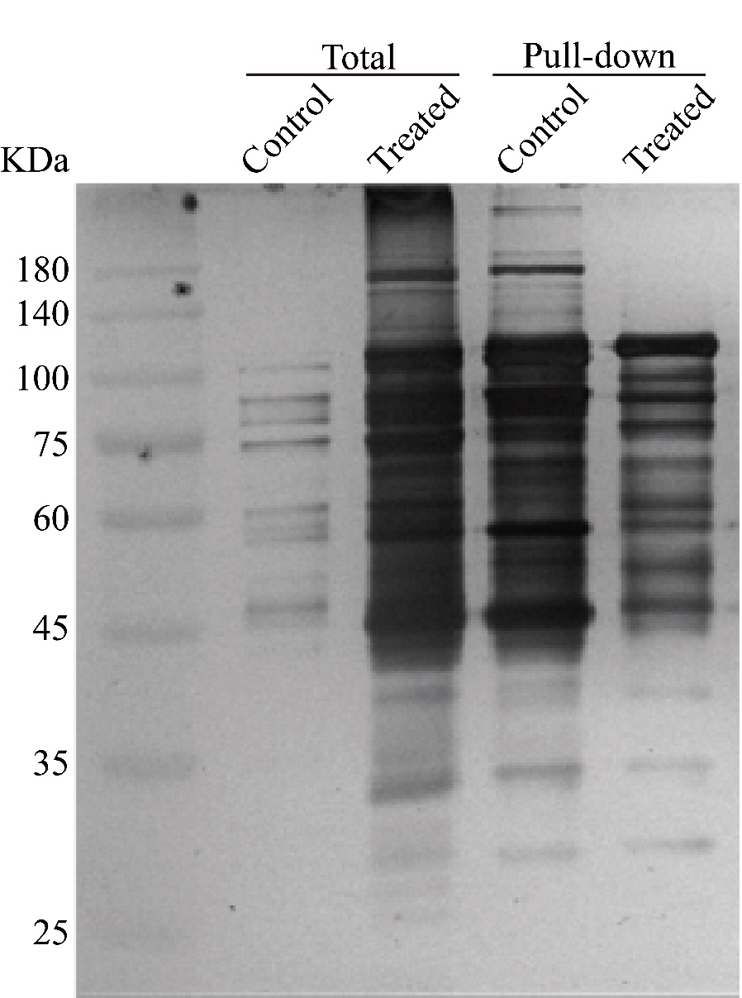
Supplementary Figure 1.Screening Ap4A binding candidate proteins. Silver stain of the Ap4A binding candidate proteins after Ap4A-biotin immunoprecipitation (IP) with the protein lysate of 100 μg/ml kanamycin treatment or not treatment with E. coli K12-MG1655.
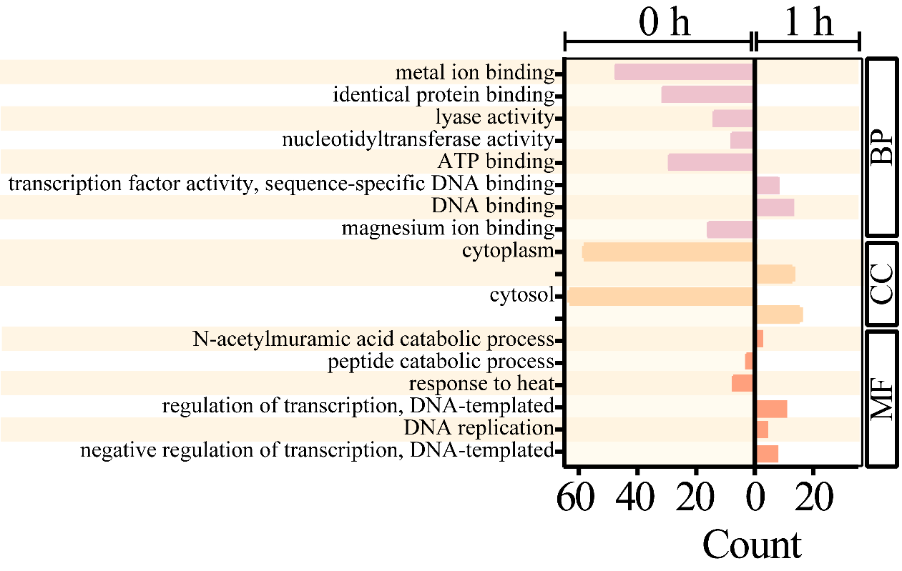
Supplementary Figure 2.Gene ontology (GO) analysis of proteome data from Ap4A binding proteins under kanamycin treatment E. coli K12-MG1655.
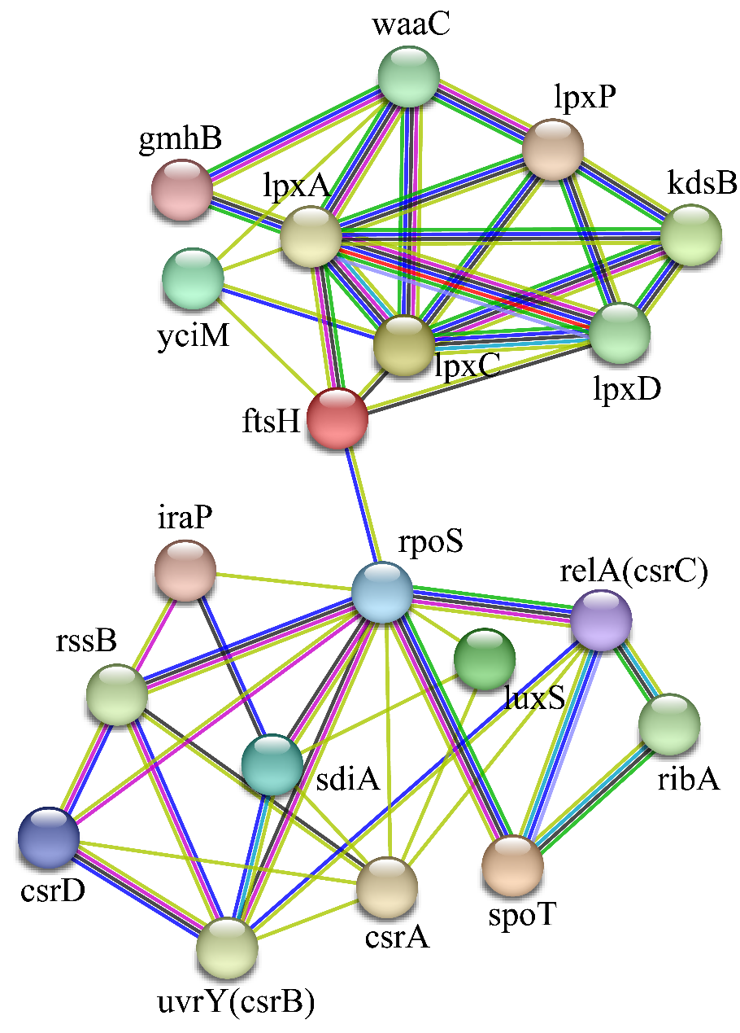
Supplementary Figure 3.The protein-protein interaction (PPI) network analyses of Ap4A binding proteins in E. coli K12 MG1655.
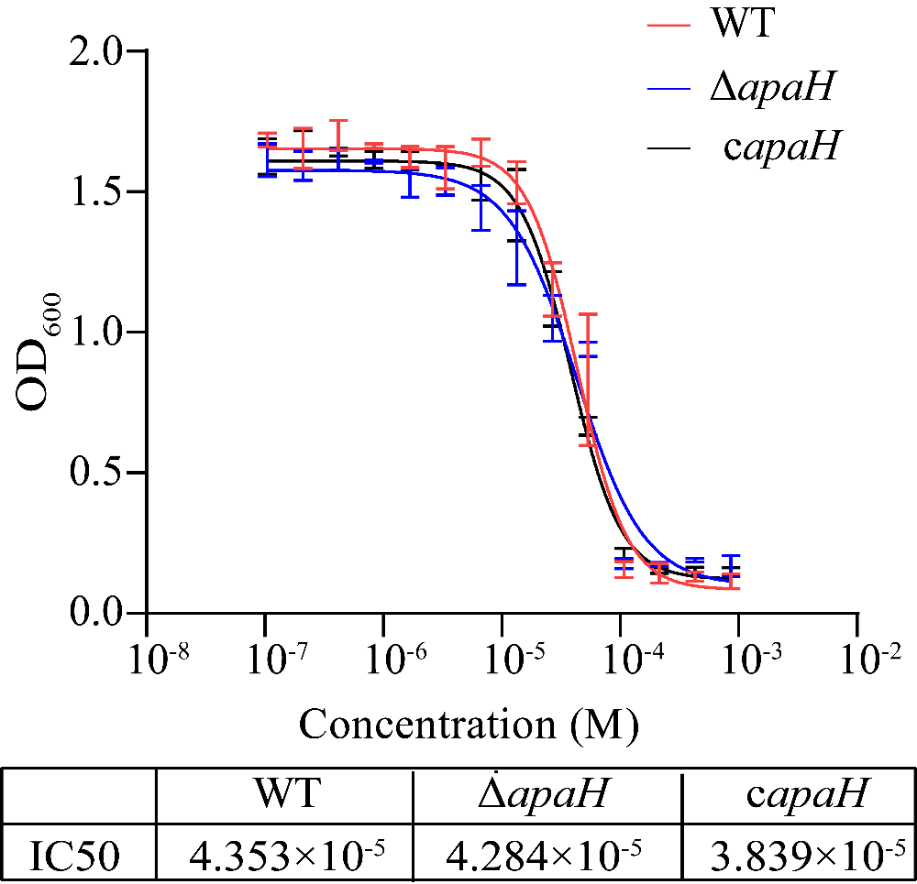
Supplementary Figure 4.The kanamycin MIC of the wild-type, mutant strain ΔapaH, and complemented strain were tested on Luria-Bertani (LB) medium.
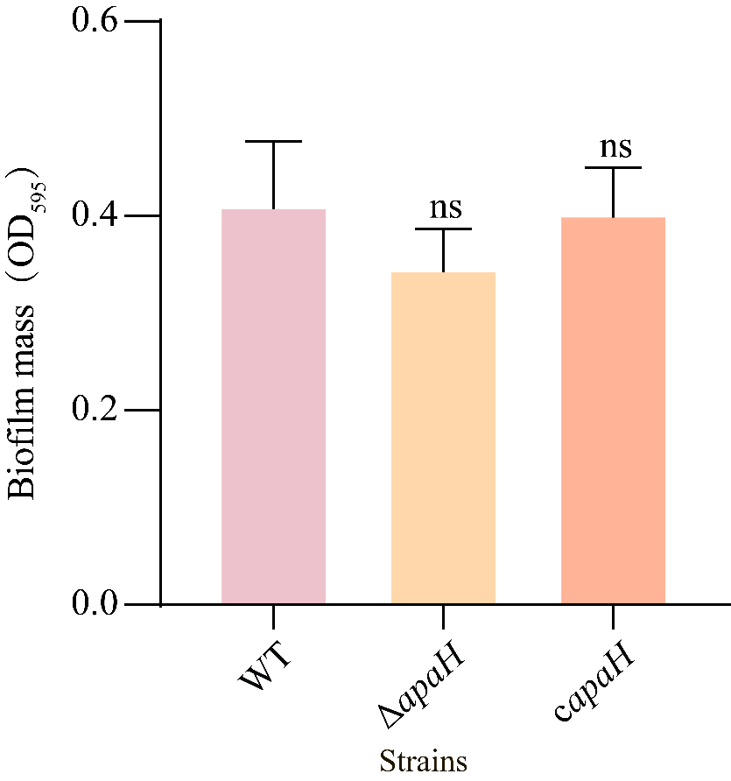
Supplementary Figure 5.The biofilm formation of the wild-type, apaH mutant and complemented strains without kanamycin treatment.

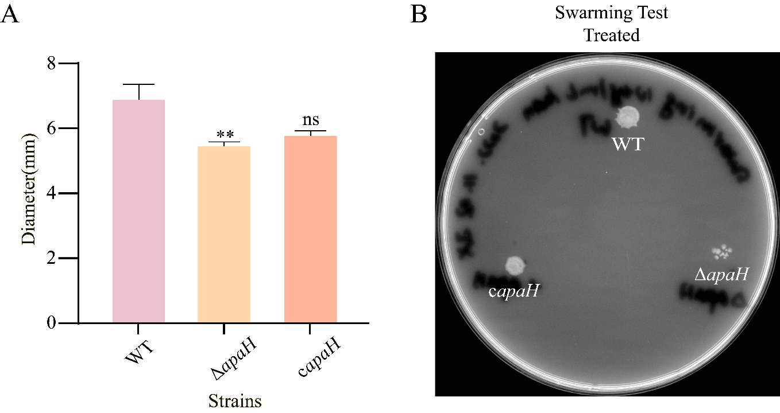
Supplementary Figure 6. The swarming motility of wild-type, apaH mutant and complemented strains with kanamycin treatment. (A)The swarming motility diameter of wild-type, apaH mutant and complemented strains. (B)The swarming motility of wild-type, apaH mutant and complemented strains were tested on Luria-Bertani (LB) plates containing 10 μg/ml kanamycin, 0.5% agar.

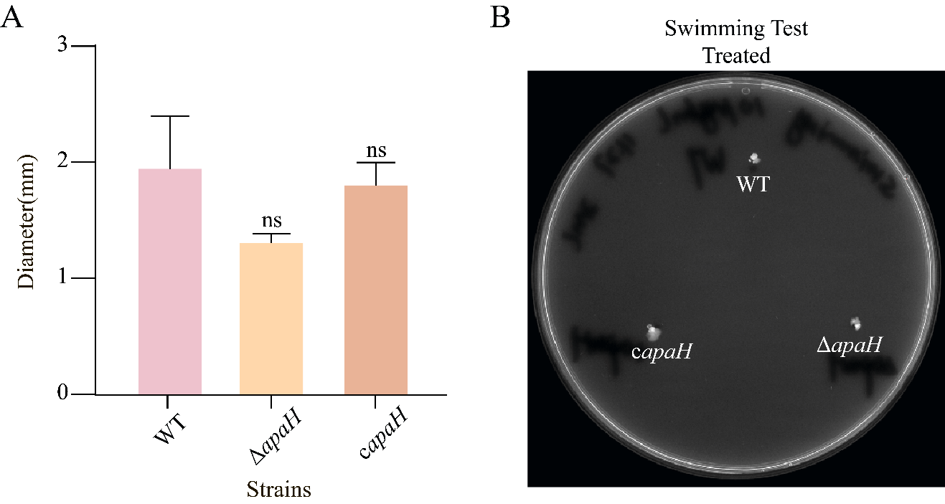
Supplementary Figure 7. The swimming motility of wild-type, apaH mutant and complemented strains with kanamycin treatment. (A)The swimming motility diameter of wild-type, apaH mutant and complemented strains. (B) The swimming motility of wild-type, apaH mutant and complemented strains were tested on Luria-Bertani (LB) plates containing 10 μg/ml kanamycin, 0.3% agar.

Supplementary Table 1: Bacterial strains used in this study
name | description | reference/source
MG1655 | Wild type Escherichia coli, containing pBAD24 plasmid, amp^{r} | [1]
ΔapaH | Escherichia coli; in-frame deletion of apaH (deleting amino acids from 1 to 280), containing pBAD24 plasmid, amp^{r} | [1]
CΔapaH | MG1655-ΔapaH containing pBAD24-MG1655apaH plasmid, amp^{r} | [1]

Supplementary Table 2: Primers used in this study
name | Primer sequences（5'-3'） | length（nt） | Position | Product size （bp） | reference/source
rpoD | F:TCTGCGTATGCGTTTCGGTATC | 22 | 3214720-3214741 | 136 | [2]
rpoD | R:ACGGCTCGGGTGACGCAGTT | 20 | 3214836-3214855 | 136 | [2]
rpoS | F:CATAATCGCCCGTTCAATCG | 20 | 2867075-2867094 | 156 | this study
rpoS | R:CGTTATGGCAATCGTGGTCTG | 21 | 2867210-2867230 | 156 | this study
csrA | F:AGTAACTGGACTGCTGGGATTT | 22 | 2818963-2818984 | 172 | this study
csrA | R:ACTCGTCGAGTTGGTGAGAC | 20 | 2819115-2819134 | 172 | this study
csrB | F:CGGTTCGTTTCGCAGCATTC | 20 | 2924191-2924210 | 153 | this study
csrB | R:GGCCAGGGACACTTCAGG | 18 | 2924326-2924343 | 153 | this study
csrC | F:GGACGCTAACAGGAACAATGAC | 22 | 4051045-4051066 | 186 | this study
csrC | R:CCTTAACGGGTCTTACAATCCTTGC | 25 | 4051206-4051230 | 186 | this study
sdiA | F:GATAATAACTAACCCACGCCTCAGG | 25 | 1996619-1996643 | 161 | this study
sdiA | R:GAGGATGGAGACCGCAGAAGA | 21 | 1996759-1996779 | 161 | this study
luxS | F:GGATCTGATTCTGATCCTGCACTT | 24 | 2814373-2814396 | 199 | this study
luxS | R:ACCCTGGAGCACCTGTTTG | 19 | 2814553-2814571 | 199 | this study
lpxA | F:GAGATTTATCAGTTCGCCTCCATCG | 25 | 202740-202764 | 157 | this study
lpxA | R:TGCCCACCTTCGTCAATCCAC | 21 | 202876-202896 | 157 | this study
lpxC | F:AAGATGGCGATAAGTGGGCTGA | 22 | 106972-106993 | 174 | this study
lpxC | R:CACGCATGAAACCGAACGT | 19 | 107127-107145 | 174 | this study
lpxD | F:CGACAAAGTGACGGTTACGGG | 21 | 201810-201830 | 157 | this study
lpxD | R:CGATTTCAGACGCTTGCTCAT | 21 | 201946-201966 | 157 | this study
lpxP | F:GGTTTGATGTTGAAGGGTTGGA | 22 | 2495964-2495985 | 165 | this study
lpxP | R:CCATCAGCTGATTATTATGTGGACG | 25 | 2496104-2496128 | 165 | this study

Supplementary Table 3: Interacting proteins
Protein | Gene | Note | Reference
RNA polymerase, sigma S (sigma 38) factor | rpoS | master regulator of general stress response | [3]
carbon storage regulator | csrA | a new kind of global regulator, which facilitates specific mRNA decay | [4]
D-glycero-beta-D-manno-heptose-1,7-bisphosphate 7-phosphatase | gmhB | a partially redundant enzyme in the synthesis of ADP-heptose for the lipopolysaccharide (LPS) core | [5]
ADP-heptose: LPS heptosyltransferase 1 | waaC | an acceptor for the Kdo transferase | [6]
UDP-3-O-acyl-N-acetylglucosamine deacetylase | lpxC | the inhibition of early-stage lipid A enzymes | [7]
3-deoxy-manno-octulosonate cytidylyltransferase | kdsB | codes for the CTP:CMP-3-deoxy-D-manno-octulosonate cytidyltransferase | [8]
DNA-binding transcriptional dual regulator SdiA | sdiA | a QS transcription factor that uses acyl-homoserine lactones (AHLs) | [9]
DNA-binding transcriptional repressor Zur | zuR | the Zinc Uptake Regulator | [10]
GTP cyclohydrolase 2 | ribA | flanking genes | [11]

Reference
1. Ji X, Zou J, Peng H, Stolle A-S, Xie R, Zhang H, et al. Alarmone Ap4A is elevated by aminoglycoside antibiotics and enhances their bactericidal activity. Proc Natl Acad Sci U S A. 2019;116:9578–85.
2. Schütze A, Benndorf D, Püttker S, Kohrs F, Bettenbrock K. The Impact of ackA, pta, and ackA-pta Mutations on Growth, Gene Expression and Protein Acetylation in Escherichia coli K-12. Front Microbiol. 2020;11:233.
3. Adnan M, Morton G, Singh J, Hadi S. Contribution of rpoS and bolA genes in biofilm formation in Escherichia coli K-12 MG1655. Mol Cell Biochem. 2010;342:207–13.
4. Liu MY, Gui G, Wei B, Preston JF, Oakford L, Yüksel Ü, et al. The RNA Molecule CsrB Binds to the Global Regulatory Protein CsrA and Antagonizes Its Activity in Escherichia coli. Journal of Biological Chemistry. 1997;272:17502–10.
5. Holmes CL, Smith SN, Gurczynski SJ, Severin GB, Unverdorben L v., Vornhagen J, et al. The ADP-Heptose Biosynthesis Enzyme GmhB is a Conserved Gram-Negative Bacteremia Fitness Factor. Infect Immun. 2022;90.
6. Klein G, Lindner B, Brabetz W, Brade H, Raina S. Escherichia coli K-12 Suppressor-free Mutants Lacking Early Glycosyltransferases and Late Acyltransferases. Journal of Biological Chemistry. 2009;284:15369–89.
7. Zhou P, Hong J. Structure- and Ligand-Dynamics-Based Design of Novel Antibiotics Targeting Lipid A Enzymes LpxC and LpxH in Gram-Negative Bacteria. Acc Chem Res. 2021;54:1623–34.
8. Strohmaier H, Remler P, Renner W, Högenauer G. Expression of genes kdsA and kdsB involved in 3-deoxy-D-manno-octulosonic acid metabolism and biosynthesis of enterobacterial lipopolysaccharide is growth phase regulated primarily at the transcriptional level in Escherichia coli K-12. J Bacteriol. 1995;177:4488–500.
9. Sperandio V. SdiA sensing of acyl-homoserine lactones by enterohemorrhagic E. coli (EHEC) serotype O157. Gut Microbes. 2010;1:432–5.
10. Peng ED, Schmitt MP. Identification of zinc and Zur-regulated genes in Corynebacterium diphtheriae. PLoS One. 2019;14:e0221711.
11. Baldridge GD, Li YG, Witthuhn BA, Higgins L, Markowski TW, Baldridge AS, et al. Mosaic composition of ribA and wspB genes flanking the virB8-D4 operon in the Wolbachia supergroup B-strain, wStr. Arch Microbiol. 2016;198:53–69.

