Facile synthesis and multiple application of ultralong-afterglow room temperature phosphorescence aggregate carbon dots from simple raw materials
Wenping Zhu, Like Wang, Weijie Yang, Yahong Chen, Zengchen Liu,* Yanxia Li, Yingying Xue
College of Chemistry and Chemical Eningeering, Henan Key Laboratory of Rare EarthFunctional Materials, International Joint Research Laboratory for Biomedical Nanomaterials of Henan, Zhoukou Normal University, Zhoukou 466001, P. R.China. E-mail: liuzengchen@zknu.cn

DFT calculations details：
Density functional theory (DFT) calculations were carried out with the B3LYP2 functional with the combination of Grimme’s D3BJ3 version of dispersion correction. The basis set of 6-31G (d, p) was adopted for the geometry optimization and frequency calculations. The geometries were fully optimized without any structural constraints. The harmonic frequency calculations were carried out at the same level of theory to verify that all structures have no imaginary frequency. The single-point energies were calculated at the level of B3LYP-D3BJ/6-311+(d,p). The binding energy (Eb) was calculated by the following equation:
Eb = E_{Complx} - (E_{M1} + E_{M2})
where E_{Complx}, E_{M1}, and E_{M2} represent the energies of the complex, and energies of the interacting molecules (trimesic acid and boric acid), respectively. The combined conformation search using xtb4 and molclus5 software.¹⁻⁵

Figure S1. The SEM image of the aggregate CDs

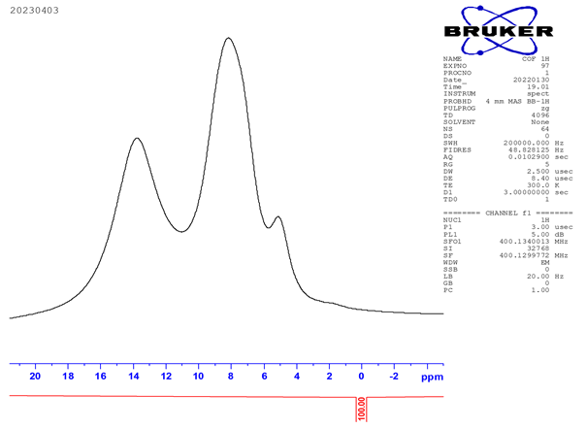
Figure S2. The solid-state ¹HNMR spectrum of aggregate CDs

Figure S3. The solid-state ¹³CNMR spectrum of aggregate CDs

Figure S4. The solid-state ¹¹BNMR spectrum of aggregate CDs

Figure S5. The XPS spectrum of C1s, O1s and B1s from the aggregate CDs

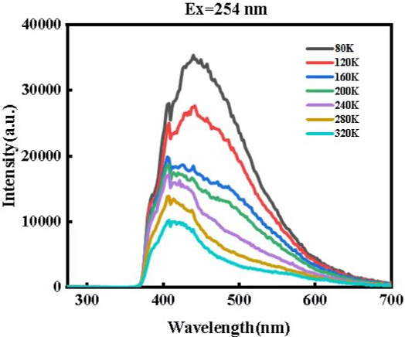
Figure S6. The RTP spectra with 254 nm excitation under different temperature (80 K, 120 K, 160 K, 200 K, 240 K, 280 K, 320 K)

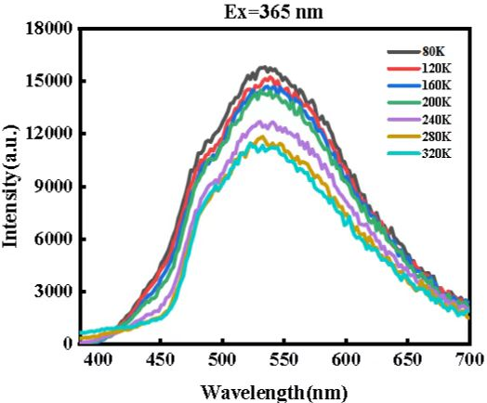
Figure S7. The RTP spectra with 365 nm excitation under different temperature (80 K, 120 K, 160 K, 200 K, 240 K, 280 K, 320 K)

References:
1.Tian, L. Molclus program, Version 1.9.9.9, http://www.keinsci.com/research/molclus.html.
2. Becke, A., Assessment of a long-range corrected hybrid functional. J. Chem. Phys. 1993, 98 (7), 5648-5652.
3. Grimme, S.; Ehrlich, S.; Goerigk, L., Effect of the damping function in dispersion corrected density functional theory. J. Comput. Chem. 2011, 32 (7), 1456-1465.
4. Frisch, M. J.; Trucks, G. W.; Schlegel, H. B.; Scuseria, G. E.; Robb, M. A.; Cheeseman, J. R.; Scalmani, G.; Barone, V.; Petersson, G. A.; Nakatsuji, H.; Li, X.; Caricato, M.; Marenich, A. V.; Bloino, J.; Janesko, B. G.; Gomperts, R.; Mennucci, B.; Hratchian, H. P.; Ortiz, J. V.; Izmaylov, A. F.; Sonnenberg, J. L.; Williams; Ding, F.; Lipparini, F.; Egidi, F.; Goings, J.; Peng, B.; Petrone, A.; Henderson, T.; Ranasinghe, D.; Zakrzewski, V. G.; Gao, J.; Rega, N.; Zheng, G.; Liang, W.; Hada, M.; Ehara, M.; Toyota, K.; Fukuda, R.; Hasegawa, J.; Ishida, M.; Nakajima, T.; Honda, Y.; Kitao, O.; Nakai, H.; Vreven, T.; Throssell, K.; Montgomery Jr., J. A.; Peralta, J. E.; Ogliaro, F.; Bearpark, M. J.; Heyd, J. J.; Brothers, E. N.; Kudin, K. N.; Staroverov, V. N.; Keith, T. A.; Kobayashi, R.; Normand, J.; Raghavachari, K.; Rendell, A. P.; Burant, J. C.; Iyengar, S. S.; Tomasi, J.; Cossi, M.; Millam, J. M.; Klene, M.; Adamo, C.; Cammi, R.; Ochterski, J. W.; Martin, R. L.; Morokuma, K.; Farkas, O.; Foresman, J. B.; Fox, D. J. Gaussian 16 Rev. A.01, Wallingford, CT, 2016.
5. Bannwarth, C.; Ehlert, S.; Grimme, S., GFN2-xTB—An Accurate and Broadly Parametrized Self-Consistent Tight-Binding Quantum Chemical Method with Multipole Electrostatics and Density-Dependent Dispersion Contributions. J. Chem. Theory Comput. 2019, 15 (3), 1652-1671.

