Table S1 Primers for Real-time PCR
Gene | Forward primer sequence | Reverse primer sequence
CHS | CAGCGAGCACAAGGCAGAGC | AACTTCCACCACAACCATGTCCTG
DFR | AACCTAACGCTGTGGAAGGC | CAAGTATCAATGGCTCCTCT
FLS | TTGGTGGACAAGGAACGAACAAGG | GCGATGGCGGTACTCAGCATAC
CHI  F3’H  F3’5’H | CATAGGGCGATTGATTTAGCGGC  CTGGAACCTGAACCCGTGAAAG  GCGGAGGGTATTCGTCCAGGCG | GCCCAATACGCAAACCGCCTCTC  GGTGTAGCCACGGTTCCAAAGC  TCCTCGTTATCAAACTGTCCCA
F3H | GGGGGTTTTATCTGAGGCTATGG | GGGTTGTGGGCATTTCGGGTAGA
ANS | CCAGGGGTATGGAAGCAAACTCG | CCGTTGAGTTCCTGGGTCTTCCT
3GT | CAGCCGCAAACCCGCCTCAGTCGC | GCGGTTGCTTTGGTTAGAGCCTGG
18S | AACCATAAACGATGCCGACCAGG | TTCAGCCTTGCGACCATACTCCC

Table S2 Total data filtering
Sample | Total Raw Reads (M) | Total Clean Reads (M) | Total Clean Bases(Gb) | Clean Reads Q20(%) | Clean Reads Q30(%) | Clean Reads Ratio(%)
Rbud_3_1 | 43.82 | 42.06 | 6.31 | 95.85 | 90.31 | 95.99
Rbud_3_2 | 43.82 | 42.11 | 6.32 | 95.91 | 90.4 | 96.09
Rbud_3_3 | 43.82 | 42.18 | 6.33 | 95.97 | 90.58 | 96.27
Rfull_3_1 | 43.82 | 42.26 | 6.34 | 96.84 | 92.04 | 96.44
Rfull_3_2 | 43.82 | 42.72 | 6.41 | 96.94 | 92.17 | 97.48
Rfull_3_3 | 43.82 | 42.44 | 6.37 | 97.05 | 92.38 | 96.85
Rmiddle_3_1 | 43.82 | 42.67 | 6.4 | 96.98 | 92.2 | 97.36
Rmiddle_3_2 | 43.82 | 42.33 | 6.35 | 96.92 | 92.09 | 96.59
Rmiddle_3_3 | 45.57 | 43.19 | 6.48 | 97.1 | 92.57 | 94.76
Wfull_1 | 47.33 | 42.24 | 6.34 | 96.5 | 91.5 | 89.25
Wfull_2 | 43.17 | 40.35 | 6.05 | 96.58 | 91.62 | 93.49
Wfull_3 | 43.82 | 42.37 | 6.36 | 96.89 | 92.09 | 96.68

Table S3 Quality indicators of UniGene
Sample | Total Number | Total Length | Mean Length | N50 | N70 | N90 | GC(%)
Rbud_3_1 | 42163 | 42155587 | 999 | 1568 | 1005 | 430 | 44.71
Rbud_3_2 | 41132 | 39444417 | 958 | 1476 | 942 | 420 | 44.94
Rbud_3_3 | 40007 | 40205274 | 1004 | 1529 | 1002 | 450 | 44.88
Rfull_3_1 | 32950 | 33108231 | 1004 | 1591 | 1021 | 427 | 45.16
Rfull_3_2 | 30041 | 29810826 | 992 | 1514 | 997 | 441 | 45.7
Rfull_3_3 | 35171 | 35723294 | 1015 | 1672 | 1054 | 418 | 44.6
Rmiddle_3_1 | 35275 | 34342848 | 973 | 1465 | 957 | 434 | 45.16
Rmiddle_3_2 | 36550 | 36944083 | 1010 | 1542 | 1007 | 451 | 45.1
Rmiddle_3_3 | 34186 | 34062112 | 996 | 1505 | 988 | 448 | 45.19
Wfull_1 | 36096 | 38184521 | 1057 | 1705 | 1116 | 447 | 44.68
Wfull_2 | 31172 | 27504122 | 882 | 1443 | 869 | 354 | 45.36
Wfull_3 | 29600 | 31662717 | 1069 | 1658 | 1101 | 478 | 45.37

Table S4 Assembly quality assessment Busco assembly evaluation results
Sample | Complete | Complete | Fragmented(F) | Missing(M)
Rubd_3_1  Rubd_3_2  Rubd_3_3  Rmiddle_3_1  Rmiddle_3_2  Rmiddle_3_3  Rfull_3_1  Rfull_3_2  Rfull_3_3  Wfull_1  Wfull_2  Wfull_3  All-Unigene | 191  179  188  162  175  166  174  175  179  166  145  173  140 | 85  95  92  80  93  88  75  66  60  89  64  75  158 | 18  19  16  35  25  33  29  34  33  27  43  32  1 | 9  10  7  26  10  16  25  28  31  21  51  23  4
Note: C (complete): match the sequence of busco database; F (fragmented): only some sequences can be compared to busco database; D (duplicate): multiple genes are compared to the same busco; M (missing) the filtered sequence.

Table S8 Differentially expressed proteins of anthocyanin pathway
Gene | Gene ID
  Mean_Ratio(Red/White)
CHS  CHI  F3H | CL11238.Contig5  CL6954.Contig1  CL7405.Contig3 | 0.819  0.975  0.917
DFR  FLS | CL8354.Contig1  CL1038.Contig2 | 0.929  0.948
F3’H | CL7702.Contig6 | 0.877
F3’5’H | / | /
ANS | CL3435.Contig1 | 1.187
3GT | CL10961.Contig11 | 0.968
Note:The significantly different proteins in a single experiment were screened under foldchange > 1.2 and Qvalue < 0.05. For the comparison with biological replicates, in the case of unpaired biological replicates, the final differential protein should be screened under two conditions: fold change > 1.2 (average value of the ratio of all comparison groups) and pvalue < 0.05 (t-test of all comparison groups).

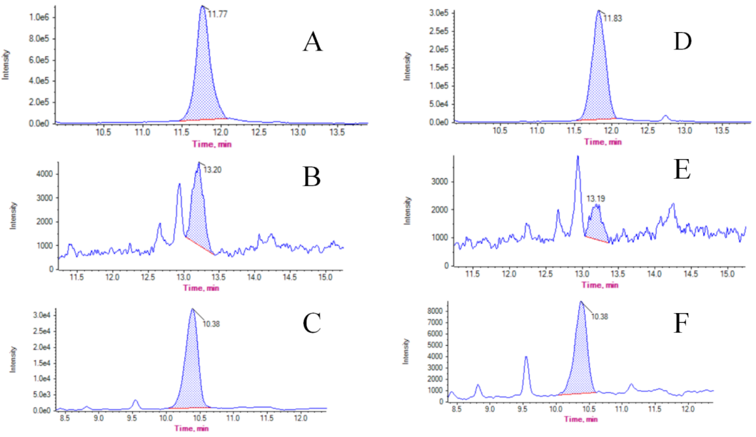
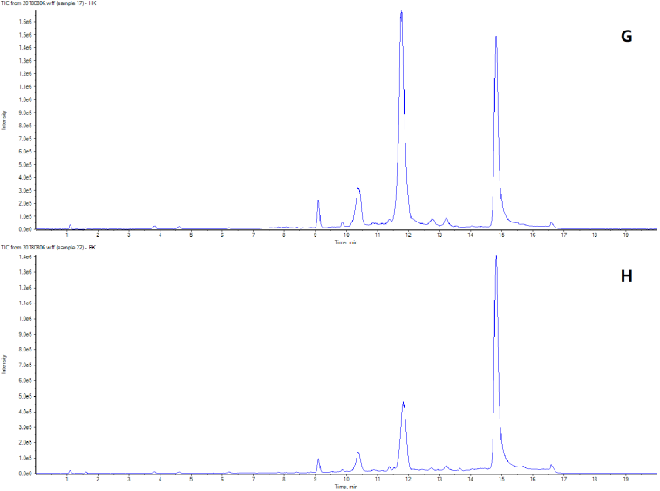
Fig. S1 HPLC-MS/MS Analysis of anthocyanin(A)Red flower cyanidin（B)Red flower Pelargonidin(C)Red flower Delphinidin(D)White flower cyanidin(E)White flower Pelargonidin（F）White flower Delphinidin.(G)Red flower Peak plot（H）White flower Peak plot
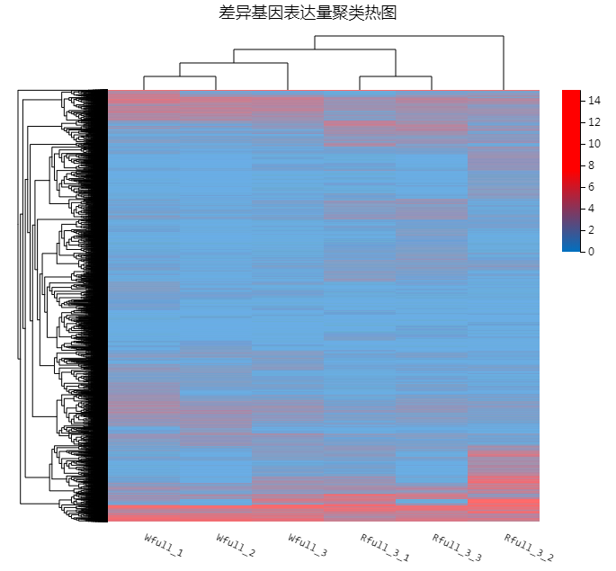
Fig. S2 Differential gene expression clustering heat map
Note:The horizontal axis represents log2 (FPKM+1) of the sample, and the vertical axis represents genes. In the default color matching, the redder the color of the color block, the higher the expression amount, and the bluer the color is, the lower the expression amount.

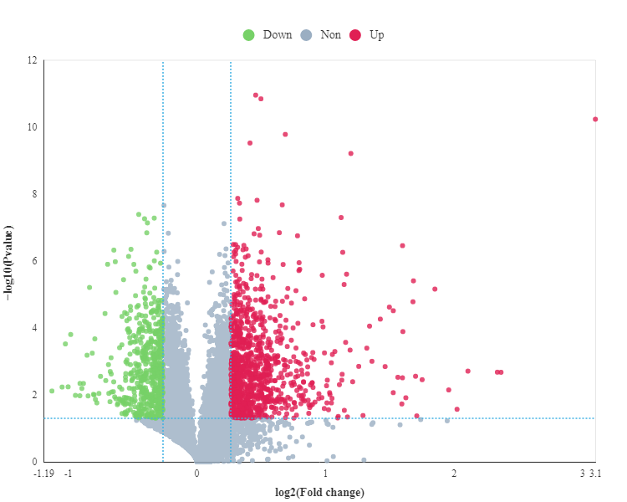
Fig. S3 iProteomic data: volcanic map of differential genes between red flower and white flower

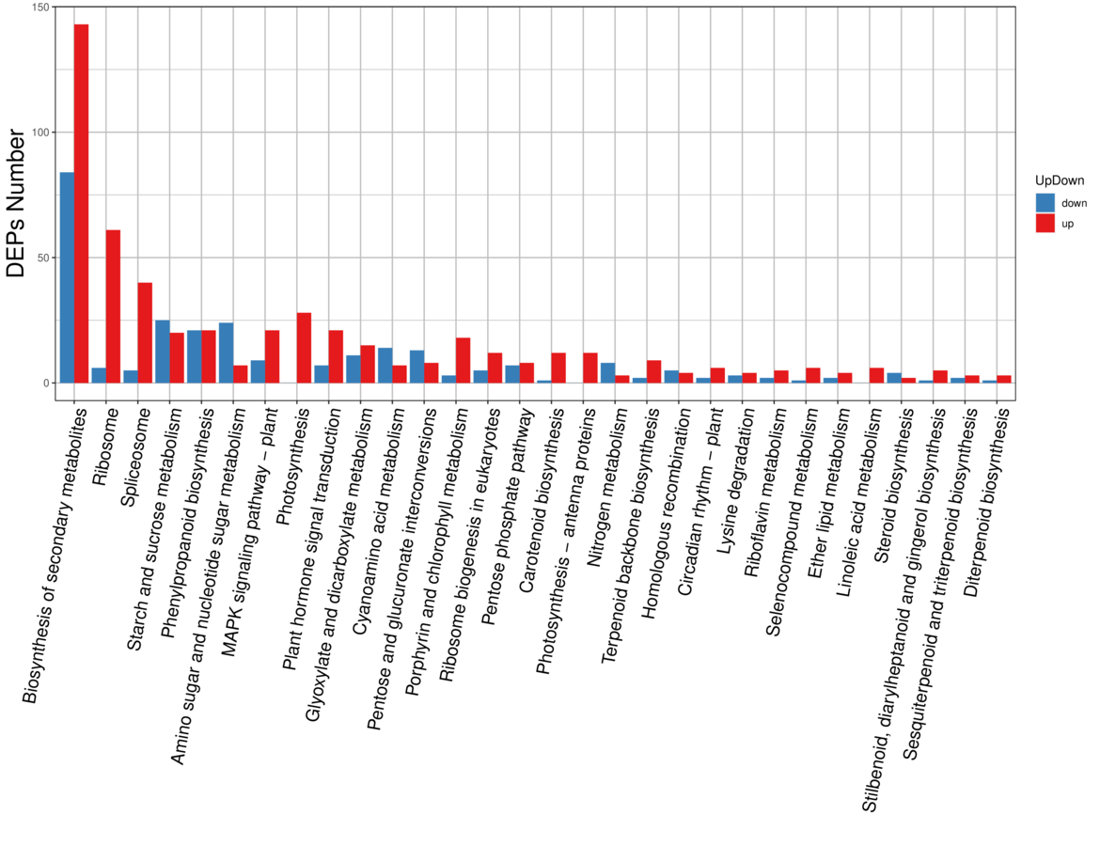
Fig.S4 KEGG classification of differential genes between red flower and white flower

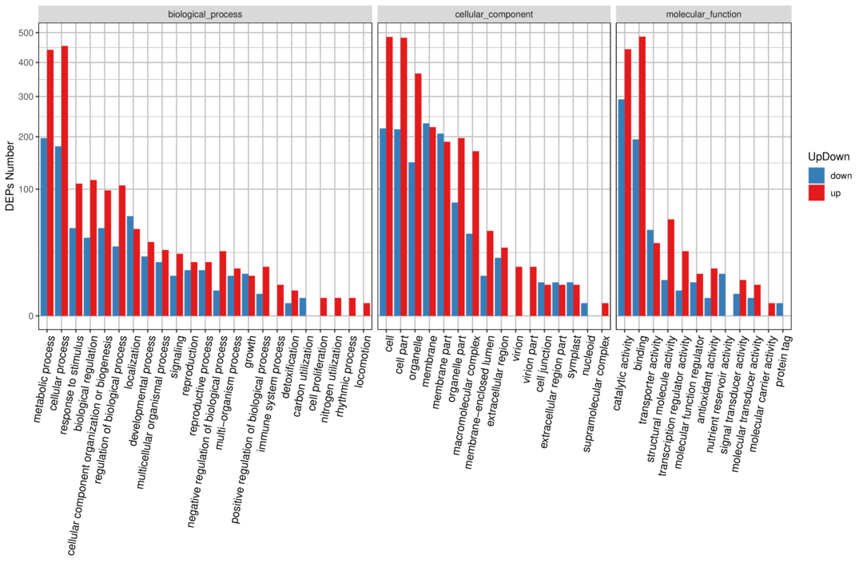
Fig.S5 GO classification of differential genes between red flower and white flower

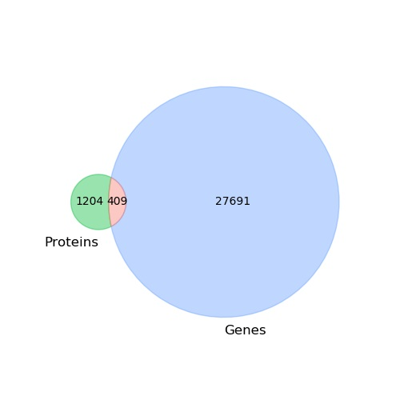
Fig. S6 Venn diag ram of the correlation number between all proteome and transcriptome atthe quantitative level.
Note:The light red circle represents the count correlated with the two omics, the light blue circle represents the count of genes specific to the transcriptome, and the lightg reen circle represents the count of proteins specific to the proteome.

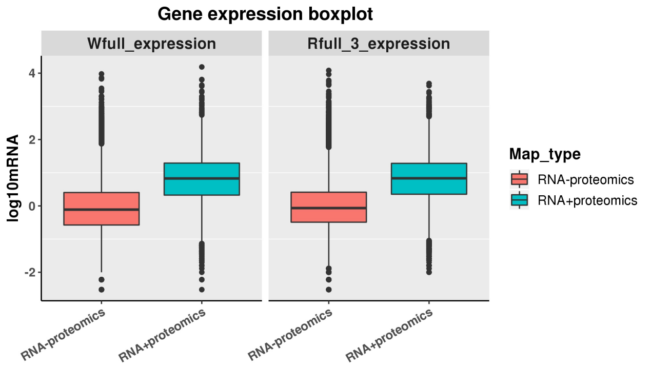
Fig. S7 Boxplot of correlated and uncorrelated g ene expressions.
Note:In the figure, green is the distribution of gene abundance correlated with proteome data in transcriptome data;red is the distribution of gene abundance that is uncorrelated with proteome data.

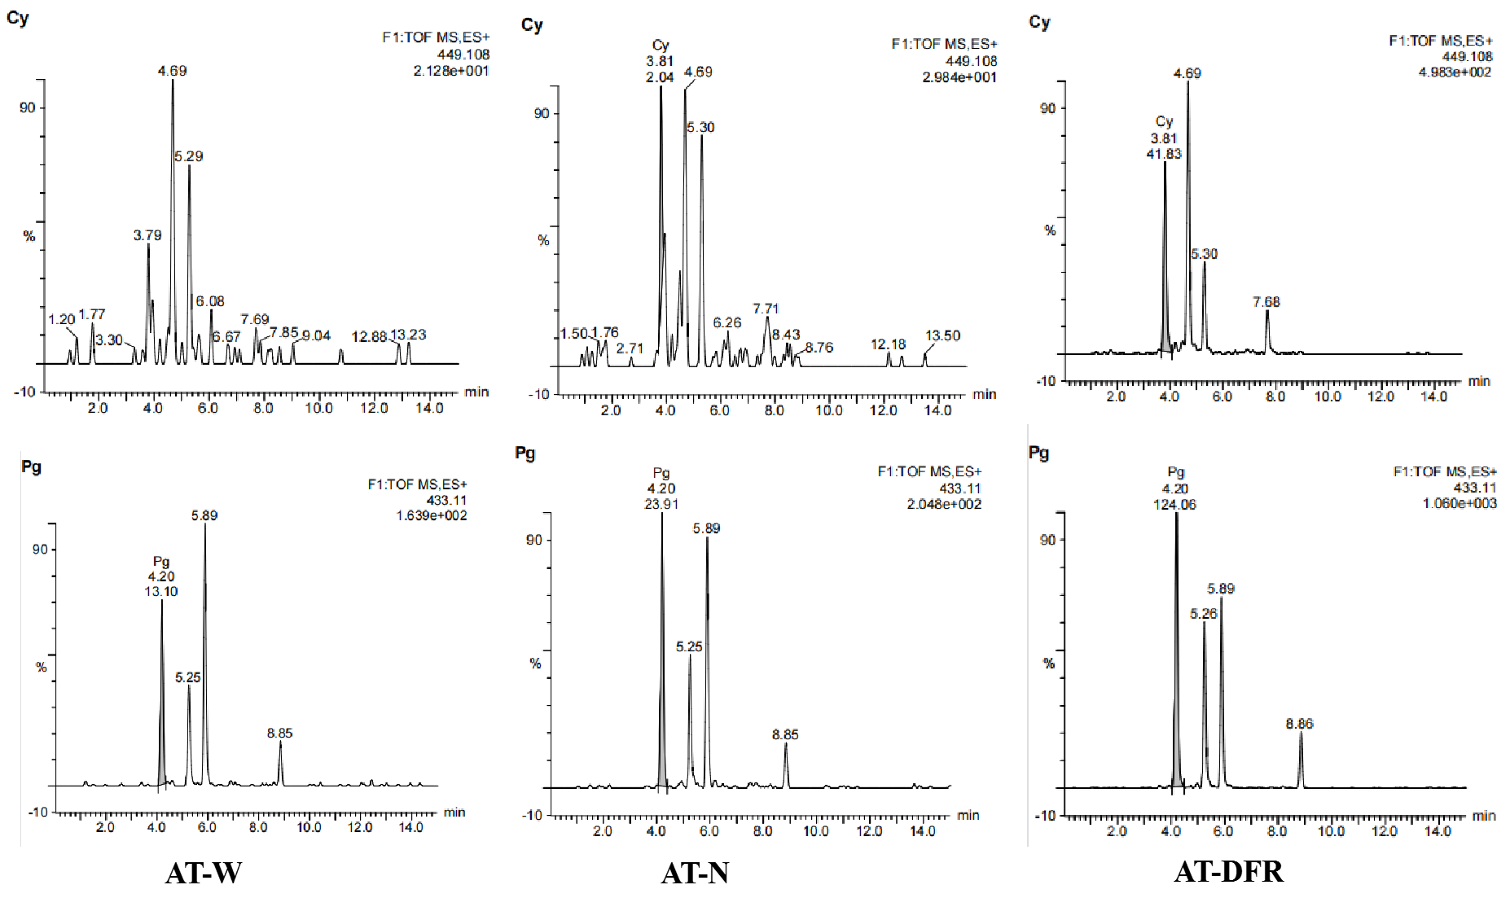
Fig. S8Arabidopsis anthocyanin content.Cy is cyanidin,Pg is Pelargonin

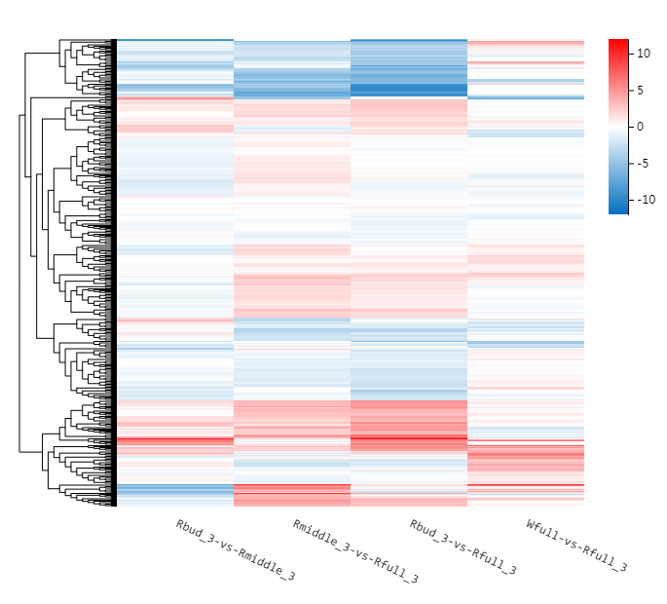
Fig. S9 MYB bHLH Transcription Factor Differential Clustering
Note:The horizontal axis represents log2 (FPKM+1) of the sample, and the vertical axis represents genes. In the default color matching, the redder the color of the color block, the higher the expression amount, and the bluer the color is, the lower the expression amount.

