Performance and mechanism analysis of sludge-based biochar loaded with Co and Mn as photothermal catalysts for simultaneous removal of acetone and NO at low temperature

Hongqiang Wang¹, Sheng Huang¹, Lei Liao¹, Shengpeng Mo¹, Xiaobin Zhou¹, Yinming Fan^{1,2*}
¹ School of Environmental Science and Engineering, Guilin University of Technology, Guilin 541000, China
² The Guangxi Key Laboratory of Theory and Technology for Environmental Pollution Control, Guilin University of Technology, Guilin 541000, China

1. Catalysts characterization
The surface morphology of the catalysts was characterized by scanning electron microscopy (SEM, TESCAN MIRA LMS) with an energy dispersive X-ray attachment (EDS). The crystalline structure of the catalysts was analyzed by X-ray powder diffraction (XRD, X´Pert3 Power). The phototube was a Cu-target ceramic phototube with a tube voltage of 40 kV, a tube current of 40 mA (λ=1.5406 Å), and X-ray scanning time, swept range, and scanning step size of 15 min, 5~90°, and 0.02, respectively.
X-ray photoelectron spectroscopy (XPS) studies were carried out a monochromatic Al Ka (hv=1486.6 eV) radiation was carried out by Thermo Scientific K-Alpha electron spectrometer. The binding energies were calibrated based on the C 1s peak at 284.80 eV, and the surface compositions and chemical states of Co 2p, Mn 2p, and O 1s were evaluated by calculating the areas of the photoelectron peaks and the binding energies. The chemical composition of the catalysts was analyzed by Fourier infrared spectroscopy (FT-IR, Frontier). The catalysts were characterized for H₂-temperature-programmed reduction (H₂-TPR) and O₂-temperature-programmed desorption (O₂-TPD) using Autochem II 2920 Micromeritics. When testing H₂-TPR, 0.100 g of catalyst was weighed and placed in a quartz reactor, preheated from room temperature to 200 °C and kept in a He gas stream for 1 h (30 mL·min⁻¹). After cooling to 50 °C, the catalyst was heated from room temperature to 800 °C in 10% H₂/Ar (30 mL·min⁻¹) at a rate of 10 °C·min⁻¹. When testing the O₂-TPD, 0.100 g of catalyst was weighed and placed in a 30 mL·min⁻¹ O₂ gas stream and held at 200 °C for 1 h. After cooling to 50 °C, the catalyst was heated from room temperature to 800 °C in a pure He gas stream (30 mL·min⁻¹) at a rate of 10 °C·min⁻¹.
The photoabsorption capacity of the catalysts was tested using a UV-visible spectrometer (UV-3600iPlus, Shimadzu, Japan). The transient photocurrent response (TPC) of the catalysts was measured by an electrochemical workstation (CHI760E). In this, the samples were prepared on conductive glass electrodes, the electrolyte was 0.5M Na₂SO₄ aqueous solution, and the reference electrode was Ag/AgCl.
2. Supplementary figures
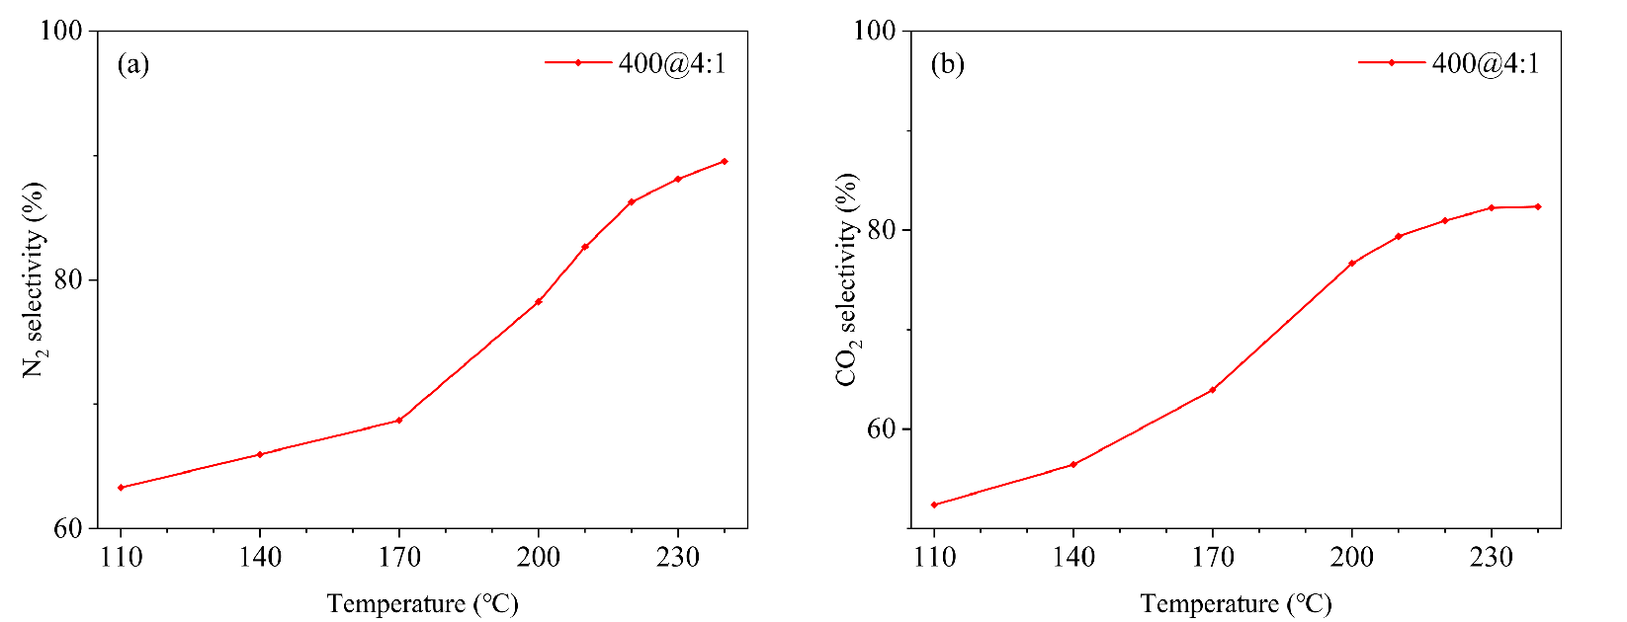
Fig. S. Selectivity of the products N₂ (a) and CO₂ (b)

