Online Supplement

Figure S1: Average A) physically unhealthy days and B) mentally unhealthy days by age band and loneliness status. Note: the 70+ years age band is not included in this figure because this age group consisted of only 24 participants.

A)

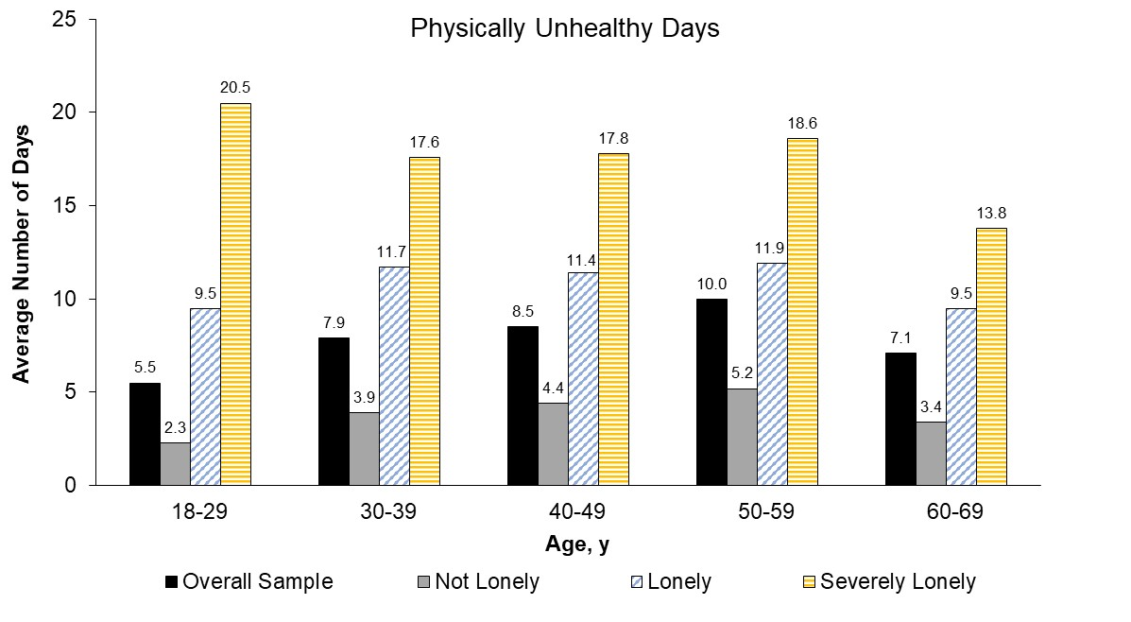

B)
