Supplementary Data

Atmospheric nitrogen deposition affects forest plant and soil system carbon : nitrogen : phosphorus stoichiometric flexibility: A meta-analysis

Xiyan Jiang ª, Xiaojing Wang ª, Yaqi Qiao ª, Yi Cao ª, Yan Jiao ª, An Yang ª,
Mengzhou Liu ^{a, b}, Lei Ma ^{a, b}, Mengya Song ^{a, b, c, *}, Shenglei Fu ^{a, b, *}

ª Key Laboratory of Geospatial Technology for the Middle and Lower Yellow River Regions, College of Geography and Environmental Science, Henan University, Kaifeng 475004, China
^{b} Henan Key Laboratory of Integrated Air Pollution Control and Ecological Security, College of Geography and Environmental Science, Henan University, Kaifeng 475004, China
^{c} Department of Forest Ecology and Management, Swedish University of Agricultural Sciences, Skogsmarksgränd 17, Umeå 901 83, Sweden

* Corresponding author:
Mengya Song, E-mail address: songmy@henu.edu.cn
Shenglei Fu, E-mail address: fsl@henu.edu.cn

Fig. S1 Displaying the global distribution of research sites (101 study sites) in the meta-analysis.

Fig. S2 Average effects (%) of N addition on SRL (specific root length), SLA (specific leaf area), soil pH, AN (soil available nitrogen), AP (soil available phosphorus), NH₄⁺ (soil ammonia nitrogen), and NO₃⁻ (soil nitrate nitrogen). Values represent means and 95% confidence intervals. The numbers with parentheses are the observations numbers.

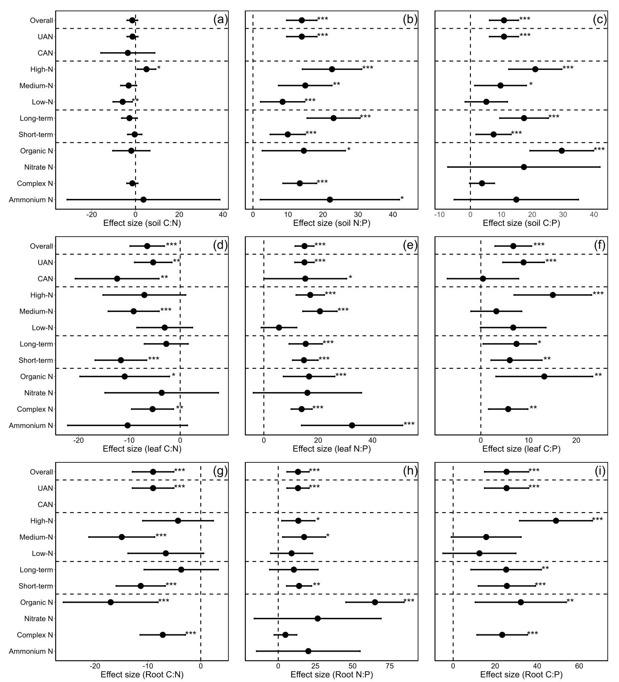
Fig. S3 Effects of different form, way, rate, and duration of nitrogen addition on plant and soil C-N-P stoichiometry (a-i). Notes: dots with error bars denote the overall mean values and the 95% conﬁdence interval (CI). * indicates that the impact of nitrogen addition is considered as significant (p < 0.05). UAN, understory addition nitrogen; CAN, canopy addition nitrogen.
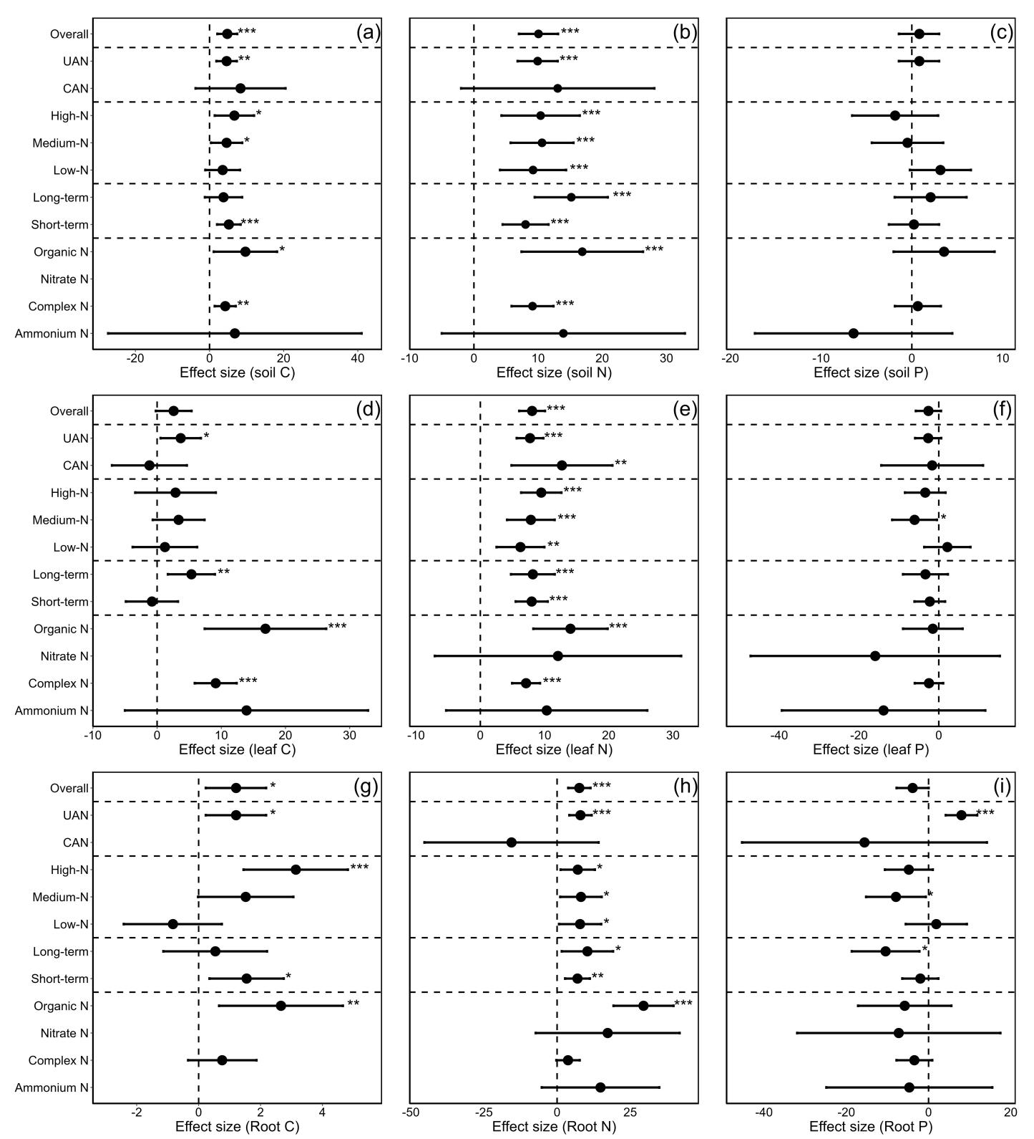
Fig. S4 Effects of different form, way, rate, and duration of nitrogen addition on plant and soil C, N, P (a-i). Notes: dots with error bars denote the overall mean values and the 95% conﬁdence interval (CI). * indicates that the impact of nitrogen addition is considered as significant (p < 0.05). UAN, understory addition nitrogen; CAN, canopy addition nitrogen.
Figure S5 Effects of different form, way, rate and duration of nitrogen addition on microbial biomass stoichiometry (a-f) Notes: dots with error bars denote the overall mean values and the 95% conﬁdence interval (CI). * indicates that the impact of nitrogen addition is considered as significant (p < 0.05). UAN, understory addition nitrogen; CAN, canopy addition nitrogen.

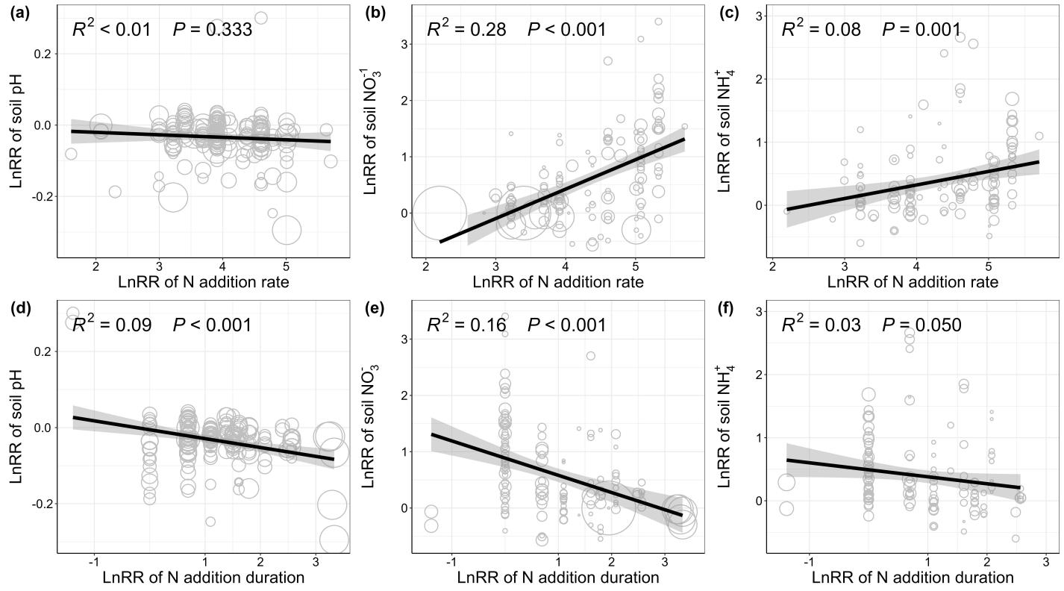
Fig. S6 Regression analysis between N application rate, duration and soil factors. The points represent the values predicted by the partial regression approach of N application rate and duration, and their sizes represent twice the weightings logarithm of relevant observations. Dashed lines show the average lnRR of soil factors, whereas black lines show the mean responses with the 95% CI shaded.

Table S1. Results from the Egger's tests of publication bias and fail-safe number on our findings. p-values < 0.05 indicates a significant publication bias. K represents the sample size of response variables. SN, soil nitrogen; SP, soil phosphorus; SC, soil carbon; AN, soil available nitrogen; AP, soil available phosphorus; NH₄⁺, soil ammonia nitrogen; NO₃⁻, soil nitrate nitrogen; MBC, soil microbial biomass carbon; MBN, soil microbial biomass nitrogen; MBP, soil microbial biomass phosphorus; LN, leaf nitrogen; LP, leaf phosphorus; LC, leaf carbon; RN, root nitrogen; RP, root phosphorus; RC, root carbon; SLA, specific leaf area; SRL, specific root length.
Various | Regtest_P_value | fsn_value | 5K+10
pH | 0.0286 | 1648097 | 860
NO₃⁻ | 0.6113 | inf | 690
NH₄⁺ | 0.9307 | inf | 675
SN | 0.0013 | 6155 | 980
SP | 0.8172 | 17 | 590
SC | 0.6325 | 5928 | 825
SN:P | 0.1547 | 644931 | 535
SC:N | 0.6091 | 0 | 1070
SC:P | 0.0018 | 1024 | 390
AN | <0.0001 | 1312 | 225
AP | 0.3919 | inf | 440
MBC | 0.81 | 36300 | 360
MBN | 0.9404 | 1734 | 235
MBP | 0.2393 | 36 | 60
MBC:MBN | 0.4699 | 0 | 235
MBC:MBN | 0.4699 | 0 | 235
LN | 0.0079 | 113236 | 1840
LP | 0.8373 | 531085 | 1950
LC | 0.8151 | inf | 410
LN:P | <0.0001 | 190443 | 2345
LC:N | 0.8495 | 4715 | 555
LC:P | 0.7863 | 587 | 365
RN | 0.5848 | inf | 935
RP | 0.6141 | Error | 805
RC | 0.1015 | 0 | 440
RN:P | 0.1871 | 204422 | 795
RC:N | 0.5524 | 9037 | 550
RC:P | 0.0784 | 5539 | 350
SRL | 0.979 | 0 | 145
SLA | 0.029 | 61 | 230

Table S2. The effects (p value) of N addition rate, N addition duration, N addition form, N addition way, soil depth, mean annual temperature (MAT), and mean annual precipitation (MAP) on RRs of C:N:P ratios of plants, soils, and microbial biomass.
Variables |  | Soil C:N | Soil N:P | Soil C:P | Microbial biomass C:N | Microbial biomass N:P | Microbial biomass C:P | Leaf C:N | Leaf N:P | Leaf C:P | Root C:N | Root N:P | Root C:P
NA intensity | QM | 15.313 | 49.136 | 30.566 | 0.202 | 5.61 | 2.232 | 17.014 | 86.056 | 18.535 | 27.08 | 12.886 | 36.189
NA intensity | p | 0.002 | <0.0001 | <0.0001 | 0.977 | 0.13 | 0.531 | 0.0007 | <0.0001 | 0.0003 | <0.0001 | 0.0049 | <0.0001
NA duration | QM | 2.409 | 50.999 | 25.529 | 0.04 | 6.18 | 1.129 | 22.074 | 72.626 | 12.135 | 24.141 | 12.39 | 22.398
NA duration | p | 0.3 | <0.0001 | <0.0001 | 0.98 | 0.045 | 0.569 | <0.0001 | <0.0001 | 0.002 | <0.0001 | 0.002 | <0.0001
NA form | QM | 1.517 | 40.405 | 21.674 | 2.31 | 23.81 | 3.26 | 16.025 | 76.704 | 14.147 | 24.854 | 46.935 | 23.057
NA form | p | 0.678 | <0.0001 | <0.0001 | 0.511 | <0.0001 | 0.353 | 0.003 | <0.0001 | 0.0008 | <0.0001 | <0.0001 | <0.0001
NA status | QM | 1.542 | NA | NA | 0.952 | NA | NA | 16.854 | 72.594 | 16.363 | NA | NA | NA
NA status | p | 0.463 | NA | NA | 0.621 | NA | NA | 0.0002 | <0.0001 | 0.0003 | NA | NA | NA
Soil depth | QM | 3.777 | 46.787 | 26.067 | 12.467 | 20.04 | 1.063 | NA | NA | NA | 30.582 | 9.14 | 11.108
Soil depth | p | 0.582 | <0.0001 | <0.0001 | 0.029 | 0.0002 | 0.786 | NA | NA | NA | <0.0001 | 0.1 | 0.049
Climate | QM | 41.962 | 42.093 | 20.784 | 3.741 | 9.997 | 9.72 | 23.107 | 106.779 | 24.473 | 26.246 | 27.68 | 42.418
Climate | p | <0.0001 | <0.0001 | 0.004 | 0.587 | 0.007 | 0.008 | 0.0008 | <0.0001 | <0.0001 | 0.0002 | 0.0003 | <0.0001
MAT | QE | 236596.061 | 63294.716 | 20047.015 | 15343.208 | 7354.675 | 5091.067 | 78765.4842 | 1548577.99 | 27106.301 | 59217.731 | 5321508.338 | 185849.445
MAT | p | <0.0001 | <0.0001 | <0.0001 | <0.0001 | <0.0001 | <0.0001 | <0.0001 | <0.0001 | <0.0001 | <0.0001 | <0.0001 | <0.0001
MAP | QM | 157.148 | 208.152 | 160.705 | 11.091 | NA | NA | 152.696 | 210.098 | 75.711 | 71.7 | 389.042 | 87.892
MAP | p | <0.0001 | <0.0001 | <0.0001 | 0.804 | NA | NA | <0.0001 | <0.0001 | <0.0001 | <0.0001 | <0.0001 | <0.0001
Notes: Q_{M}, heterogeneity in group cumulative effect sizes, NA, nitrogen addition.

Table S3. Relationships of forest C:N:P variables and soil factors (soil pH, NO₃⁻, NH₄⁺, AN and AP), MAT and MAP under N addition. NA indicates no application due to lack sampling size, and p < 0.05 are in bold.
variables | MAT |  |  | MAP |  |  | soil pH |  |  | soil NO₃⁻ |  |  | soil NH₄⁺ |  |  | AN |  |  | AP
variables | R² | P |  | R² | P |  | R² | P |  | R² | P |  | R² | P |  | R² | P |  | R² | P
soil C:N | 0.062 | <0.001 |  | 0.003 | 0.213 |  | 0.038 | 0.021 |  | 0.042 | 0.047 |  | 0.093 | 0.007 |  | 0.27 | 0.02 |  | 0.22 | 0.001
soil N:P | 0.015 | 0.108 |  | 0 | 0.57 |  | 0.201 | <0.001 |  | 0 | 0.732 |  | 0.011 | 0.299 |  | 0 | 0.35 |  | 0 | 0.54
soil C:P | 0.002 | 0.29 |  | 0 | 0.626 |  | 0.169 | <0.001 |  | 0 | 0.751 |  | 0.022 | 0.297 |  | 0 | 0.81 |  | 0.52 | <0.001
MBC:MBN | 0 | 0.786 |  | 0 | 0.494 |  | 0 | 0.566 |  | 0.002 | 0.324 |  | 0.027 | 0.265 |  | 0.45 | 0.13 |  | 0 | 0.78
MBN:MBP | 0 | 0.484 |  | 0.037 | 0.28 |  | 0 | 0.543 |  | 0 | 0.688 |  | NA | NA |  | 0 | 0.972 |  | 0 | 0.779
MBC:MBP | 0.36 | 0.038 |  | 0 | 0.755 |  | 0.072 | 0.28 |  | 0.075 | 0.277 |  | NA | NA |  | 0 | 0.83 |  | 0 | 0.761
leaf C:N | 0.023 | 0.062 |  | 0.016 | 0.101 |  | 0.037 | 0.244 |  | 0 | 0.875 |  | 0 | 0.601 |  | 0.04 | 0.15 |  | 0 | 0.4
leaf N:P | 0.012 | 0.009 |  | 0 | 0.494 |  | 0.069 | 0.031 |  | 0.072 | 0.013 |  | 0.033 | 0.066 |  | 0.2 | 0.17 |  | 0.47 | 0.08
leaf C:P | 0 | 0.361 |  | 0.019 | 0.13 |  | 0.052 | 0.322 |  | 0 | 0.528 |  | 0 | 0.845 |  | 0.02 | 0.28 |  | 0.03 | 0.25
root C:N | 0 | 0.484 |  | 0 | 0.57 |  | 0.005 | 0.294 |  | 0 | 0.547 |  | 0 | 0.808 |  | 0 | 0.37 |  | 0 | 0.67
root N:P | 0.001 | 0.272 |  | 0.002 | 0.244 |  | 0 | 0.806 |  | 0 | 0.857 |  | 0 | 0.547 |  | 0.8 | 0.20 |  | 0.06 | 0.28
root C:P | 0.05 | 0.037 |  | 0.083 | 0.01 |  | 0 | 0.656 |  | NA | NA |  | NA | NA |  | NA | NA |  | 0.25 | 0.42

Table S4 Percentage change (%) of forest C:N:P in response to N addition under different N ways. p value for each response variables indicate whether the corresponding percentage change is significantly different from zero and p < 0.05 are in bold. n represent the sample size which the numbers outside and inside parentheses represent the sample sizes of observations and number of references respectively. MBC:MBN, microbial biomass C:N ratio.
Response variables | N addition duration | QM | p(QM) | percentage change | 95%CI | p | n
Soil C:N | CAN | 1.542 | 0.463 | -3.512 | [-15.798, 8.774] | 0.575 | 8(212)
Soil C:N | UAN | 1.542 | 0.463 | -1.375 | [-3.807, 1.057] | 0.268 | 204(212)
MBC:MBN | CAN | 0.952 | 0.621 | 12.287 | [-13.734, 38.308] | 0.355 | 4(45)
MBC:MBN | UAN | 0.952 | 0.621 | -1.284 | [-9.413, 6.844] | 0.757 | 41(45)
Leaf C:N | CAN | 16.854 | <0.001 | -12.407 | [-20.626, -4.188] | 0.003 | 18(109)
Leaf C:N | UAN | 16.854 | <0.001 | -5.315 | [-8.976, -1.655] | 0.004 | 91(109)
Leaf N:P | CAN | 72.594 | <0.001 | 15.247 | [0.050, 30.443] | 0.049 | 24(467)
Leaf N:P | UAN | 72.594 | <0.001 | 14.962 | [11.425, 18.500] | <0.001 | 443(467)
Leaf C:P | CAN | 16.363 | <0.001 | 0.449 | [-7.002, 7.900] | 0.906 | 18(71)
Leaf C:P | UAN | 16.363 | <0.001 | 8.946 | [4.609, 13.282] | <0.001 | 53(71)

Table S5. Percentage change (%) of forest C:N:P in response to N addition under different climate types. p value for each response variables indicate whether the corresponding percentage change is significantly different from zero and p < 0.05 are in bold. n represent the sample size which the numbers outside and inside parentheses represent the sample sizes of observations and number of references respectively. MBC:MBN, microbial biomass C:N ratio.
Response variables | Climate type | Q_{M} | p(Q_{M}) | percentage change | 95%CI | p | n
Soil C:N | Alpine | 3.18 | 0.67 | -2.97 | [-13.49,7.54] | 0.58 | 11(212)
Soil C:N | Mediterranean | 3.18 | 0.67 | -4.36 | [-28.97,20.24] | 0.73 | 2(212)
Soil C:N | Subtropical | 3.18 | 0.67 | 1.33 | [-3.76,6.42] | 0.61 | 47(212)
Soil C:N | Temperate | 3.18 | 0.67 | -2.07 | [-4.92,0.79] | 0.16 | 149(212)
Soil C:N | Tropical | 3.18 | 0.67 | -7.03 | [-27.17,13.11] | 0.49 | 3(212)
Soil N:P | Mediterranean | 40.26 | <0.0001 | 14.29 | [-30.26,58.84] | 0.53 | 1(105)
Soil N:P | Subtropical | 40.26 | <0.0001 | 14.7 | [7.82,21.59] | <0.001 | 42(105)
Soil N:P | Temperate | 40.26 | <0.0001 | 12.58 | [6.62,18.54] | <0.001 | 56(105)
Soil N:P | Tropical | 40.26 | <0.0001 | 21.25 | [3.02,39.47] | 0.02 | 6(105)
Soil C:P | Mediterranean | 21.33 | 0.0003 | -2.04 | [-43.30,39.22] | 0.92 | 1(76)
Soil C:P | Subtropical | 21.33 | 0.0003 | 11.82 | [4.01,19.63] | 0.003 | 28(76)
Soil C:P | Temperate | 21.33 | 0.0003 | 9.9 | [3.68,16.12] | 0.002 | 44(76)
Soil C:P | Tropical | 21.33 | 0.0003 | 20.34 | [-3.48,44.16] | 0.09 | 3(76)
MBC:MBN | Subtropical | 1.33 | 0.51 | -6.51 | [-19.89,6.87] | 0.34 | 15(45)
MBC:MBN | Temperate | 1.33 | 0.51 | 3.14 | [-6.32,12.60] | 0.52 | 30(45)
Leaf C:N | Alpine | 21.28 | <0.0001 | -17.24 | [-30.21,-4.27] | 0.009 | 7(109)
Leaf C:N | Subtropical | 21.28 | <0.0001 | -9.06 | [-13.89,-4.22] | <0.001 | 51(109)
Leaf C:N | Temperate | 21.28 | <0.0001 | -2.48 | [-7.29,2.32] | 0.31 | 51(109)
Leaf N:P | Alpine | 81.67 | <0.0001 | 44.46 | [14.28,74.64] | 0.004 | 6(467)
Leaf N:P | Subtropical | 81.67 | <0.0001 | 13.24 | [8.35,18.13] | <0.001 | 229(467)
Leaf N:P | Temperate | 81.67 | <0.0001 | 17.37 | [12.31,22.44] | <0.001 | 213(467)
Leaf N:P | Tropical | 81.67 | <0.0001 | -0.3 | [-17.28,16.68] | 0.97 | 19(467)
Leaf C:P | Subtropical | 13.6 | 0.001 | 5.66 | [1.41,9.92] | 0.009 | 57(71)
Leaf C:P | Temperate | 13.6 | 0.001 | 11.39 | [2.83,19.96] | 0.009 | 14(71)
Root C:N | Alpine | 24.82 | <0.0001 | -5.51 | [-23.52,12.50] | 0.55 | 5(108)
Root C:N | Subtropical | 24.82 | <0.0001 | -3.68 | [-10.63,3.27] | 0.3 | 34(108)
Root C:N | Temperate | 24.82 | <0.0001 | -12.14 | [-17.06,-7.21] | <0.001 | 67(108)
Root C:N | Tropical | 24.82 | <0.0001 | -3.34 | [-31.81,25.12] | 0.82 | 2(108)
Root N:P | Alpine | 22.58 | 0.0002 | 41.87 | [-22.45,106.19] | 0.2 | 2(157)
Root N:P | Subtropical | 22.58 | 0.0002 | 25.95 | [14.56,37.34] | <0.001 | 64(157)
Root N:P | Temperate | 22.58 | 0.0002 | 3.11 | [-6.65,12.86] | 0.53 | 87(157)
Root N:P | Tropical | 22.58 | 0.0002 | 18.3 | [-27.20,63.79] | 0.43 | 4(157)
Root C:P | Subtropical | 43 | <0.0001 | 55.15 | [37.57,72.72] | <0.001 | 20(68)
Root C:P | Temperate | 43 | <0.0001 | 12.82 | [1.35,24.28] | 0.03 | 47(68)
Root C:P | Tropical | 43 | <0.0001 | 24.46 | [-54.14,103.07] | 0.54 | 1(68)

Table S6. Percentage change (%) of forest C:N:P in response to N addition under different soil depth. p value for each response variables indicate whether the corresponding percentage change is significantly different from zero and p < 0.05 are in bold. n represent the sample size which the numbers outside and inside parentheses represent the sample sizes of observations and number of references respectively. MBC:MBN, microbial biomass C:N ratio; MBN:MBP, microbial biomass N:P ratio; MBC:MBP, microbial biomass C:P ratio.
Response variables | Soil depth | Q_{M} | p(Q_{M}) | percentage change | 95%CI | p | n
Soil C:N | 0-10 | 3.78 | 0.58 | -2.83 | [-6.57,0.90] | 0.14 | 87(212)
Soil C:N | 0-15 | 3.78 | 0.58 | 3.09 | [-16.95,23.14] | 0.76 | 3(212)
Soil C:N | 0-20 | 3.78 | 0.58 | -2.25 | [-6.63,2.13] | 0.31 | 63(212)
Soil C:N | 10-20cm | 3.78 | 0.58 | 2.43 | [-4.69,9.54] | 0.5 | 24(212)
Soil C:N | O | 3.78 | 0.58 | 0.35 | [-5.53,6.22] | 0.91 | 35(212)
Soil N:P | 0-10 | 46.79 | <0.0001 | 15.03 | [8.41,21.65] | <0.001 | 45(105)
Soil N:P | 0-20 | 46.79 | <0.0001 | 7.43 | [0.58,14.28] | 0.03 | 40(105)
Soil N:P | 10-20cm | 46.79 | <0.0001 | 20.7 | [4.24,37.15] | 0.01 | 7(105)
Soil N:P | O | 46.79 | <0.0001 | 24.8 | [12.79,36.81] | <0.001 | 13(105)
Soil C:P | 0-10 | 26.07 | <0.0001 | 12.98 | [5.97,20.00] | <0.001 | 33(76)
Soil C:P | 0-20 | 26.07 | <0.0001 | 3.8 | [-4.25,11.84] | 0.36 | 25(76)
Soil C:P | 10-20cm | 26.07 | <0.0001 | 15.07 | [-2.95,33.09] | 0.1 | 5(76)
Soil C:P | O | 26.07 | <0.0001 | 17.48 | [6.29,28.67] | 0.002 | 13(76)
MBC:MBN | 0-10 | 12.47 | 0.03 | -3.57 | [-12.57,5.43] | 0.44 | 28(45)
MBC:MBN | 0-15 | 12.47 | 0.03 | 16.41 | [-31.22,64.04] | 0.5 | 1(45)
MBC:MBN | 0-20 | 12.47 | 0.03 | -32.82 | [-60.33,-5.32] | 0.02 | 3(45)
MBC:MBN | 10-20cm | 12.47 | 0.03 | 23.47 | [4.02,42.91] | 0.02 | 6(45)
MBC:MBN | O | 12.47 | 0.03 | 5.39 | [-12.63,23.40] | 0.56 | 7(45)
MBN:MBP | 0-10 | 22.34 | <0.001 | 15.24 | [-15.44,45.92] | 0.33 | 2(10)
MBN:MBP | 0-20 | 22.34 | <0.001 | 58.63 | [31.83,85.42] | <0.0001 | 3(10)
MBN:MBP | O | 22.34 | <0.001 | 5.88 | [-14.87,26.63] | 0.58 | 5(10)
MBC:MBP | 0-10 | 6.99 | 0.07 | 31.58 | [5.36,57.80] | 0.02 | 2(10)
MBC:MBP | 0-20 | 6.99 | 0.07 | 6.50 | [-14.91,27.91] | 0.55 | 3(10)
MBC:MBP | O | 6.99 | 0.07 | 8.71 | [-7.88,25.29] | 0.30 | 5(10)
Root C:N | 0-10 | 30.58 | <0.0001 | -8.83 | [-16.92,-0.73] | 0.03 | 21(91)
Root C:N | 0-20 | 30.58 | <0.0001 | -14.96 | [-24.57,-5.35] | 0.002 | 49(91)
Root C:N | 10-20cm | 30.58 | <0.0001 | -7.68 | [-26.92,11.56] | 0.43 | 3(91)
Root C:N | O | 30.58 | <0.0001 | -16.19 | [-24.09,-8.28] | <0.001 | 18(91)
Root N:P | 0-10 | 9.14 | 0.1 | 17.92 | [-10.23,46.08] | 0.21 | 35(132)
Root N:P | 0-15 | 9.14 | 0.1 | 42.01 | [-53.47,137.49] | 0.39 | 4(132)
Root N:P | 0-20 | 9.14 | 0.1 | 42.42 | [9.67,75.17] | 0.01 | 82(132)
Root N:P | 10-20cm | 9.14 | 0.1 | -1.51 | [-61.89,58.87] | 0.96 | 5(132)
Root N:P | O | 9.14 | 0.1 | 17.59 | [-37.54,72.72] | 0.53 | 6(132)
Root C:P | 0-10 | 11.11 | 0.049 | 1.6 | [-55.18,58.39] | 0.96 | 7(63)
Root C:P | 0-15 | 11.11 | 0.049 | 57.36 | [-32.43,147.16] | 0.21 | 4(63)
Root C:P | 0-20 | 11.11 | 0.049 | 62.86 | [20.54,105.19] | 0.004 | 43(63)
Root C:P | 10-20cm | 11.11 | 0.049 | 2 | [-71.30,75.30] | 0.96 | 3(63)
Root C:P | O | 11.11 | 0.049 | 27.24 | [-24.60,79.08] | 0.3 | 6(63)

