Supplementary Information for

Chiral Kirigami for Bend-Tolerant Real-Time Reconfigurable Holograms

Won Jin Choi*, Sang Hyun Lee1, Minjeong Cha, and Nicholas A. Kotov*
Corresponding authors: choi21@llnl.gov, kotov@umich.edu

The PDF file includes:

Materials and Methods
Supplementary Text
Figs. S1 to S8
Table S1
References

Materials and Methods
Fabrication of chiral kirigami metamaterials
The fabrication process for the chiral kirigami metamaterials began with spin-coating poly (methyl methacrylate) (PMMA 950 C4, Microchem) onto 4-inch silicon wafers. The PMMA layer served as a sacrificial layer, and Parylene CTM (SCS, Inc.) was deposited onto the PMMA layer using chemical vapor deposition (CVD) (PDS 2035CR, SCS, Inc.). The thickness of the Parylene CTM layer was set to ~6 μm, as confirmed by a surface profiler (Dektak XT, Bruker), and this is an important parameter for the kirigami mechanics, such as elasticity and stretchability. Slanted Au strip patterns were deposited onto the Parylene CTM layer using a standard photolithography technique and an e-beam evaporator (Enerjet evaporator). The thickness of the Au strip was ~45 nm, as measured by a quartz crystal monitor, and a ~5 nm chromium layer was applied as an adhesive. The kirigami cut patterns were then created using reactive ion etching (RIE) (LAM 9400, Lam Research), and an aluminum layer was used as a mask for the Parylene CTM. After RIE, the patterned substrate was soaked in an aluminum etchant solution (Aluminum etch Type A, Transene) to remove the aluminum masking layer, and then in acetone to dissolve the PMMA sacrificial layer.

Dimension of chiral kirigami pattern
Figure S1 shows a top view of the kirigami cut pattern without exhibiting its dimensions. The length (L_{cut}) and height (H_{cut}) of each cut is 500 μm and 5 μm, respectively. The horizontal and vertical spacings between cuts are set to 100 μm resulting in a horizontal period of 600 μm and a vertical period of 105 μm. The width of each Au strip varies from 5 to 100 μm (fig. S1b). Note that the width and height of each domain are 300 and 80 μm, respectively. In this work, we tested kirigami samples with slanted angles of 45°.

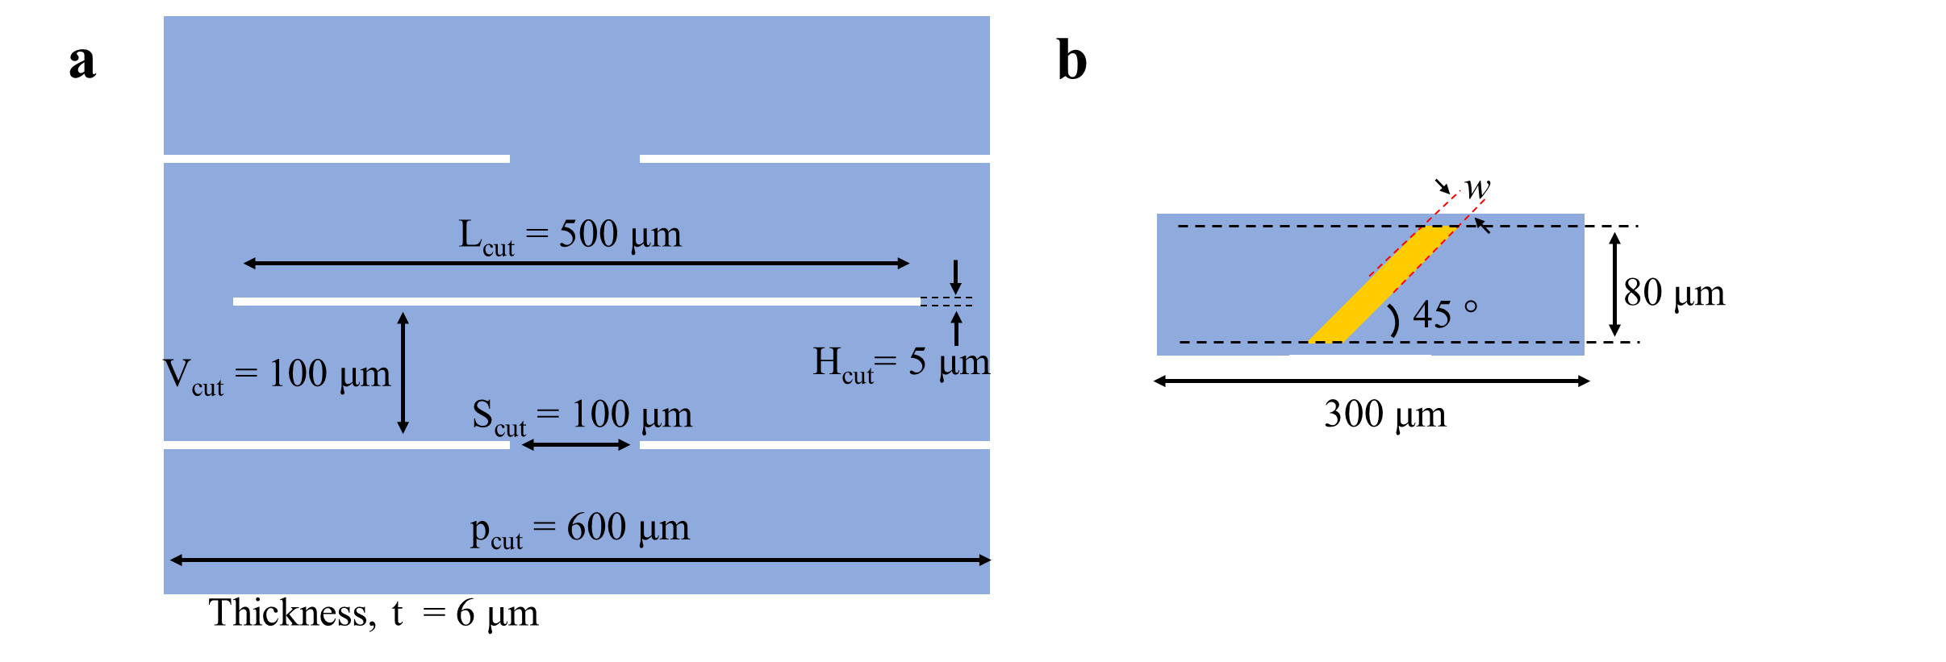
Fig. S1. Dimensions of chiral kirigami metamaterials. a, Top view of kirigami cut pattern. The length (L_{cut}) and the height (H_{cut}) of each individual cut are 500 μm and 5 μm, respectively. The horizontal (S_{cut}) and vertical (V_{cut}) spacing between cuts are set to 100 μm. b, Width (w) of each Au strip varies from 5 to 100 μm. Width and height of each domain are 300 and 80 μm, respectively. The slant angle (φ) is 45 degrees for all chiral kirigami metamaterials.

Integration of chiral kirigami substrate with linear actuator
Programmable application of strain is done by a linear actuator (U-521 PILine®, PI instrument). A 3D printed sample holder was used for integration of chiral kirigami substrates with the linear actuator, as described in ref. ¹. Throughout the paper, four strain states, ε = 0, 4.5, 13.5, 22.5%, of kirigami were investigated, which correspond to 0, 0.4, 1.2, and 2.0 mm, respectively. The reported precision of this linear actuator is 0.1 μm (ε = 0.001%).

Electromagnetic simulation
Electromagnetic simulations, including those for ellipticity, circular dichroism, chiral light propagation, and surface current norm distributions, were numerically investigated using commercial software (COMSOL Multiphysics® 6.0, COMSOL, Inc.). The 3D structures of the kirigami were generated using the mathematical expression described in the following section. The results of all chiroptical properties (ellipticity, circular dichroism) were calculated based on the same equations used in the experiments. Periodic boundary conditions (Floquet periodicity) were applied to the single unit cell of the kirigami pattern. It was confirmed that the calculation of the single unit cell and that of the periodic structure showed almost the same result.

Mathematical approach to strain-dependent kirigami geometry
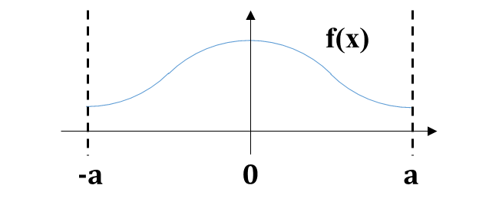
The seemingly complex structure of kirigami can be modeled with relatively simple boundary conditions. The modeling process starts with determining the proper function using the side view of the kirigami structure (blue line in fig. S2). Here, kirigami is the function, $f\left(x\right)$, that we would like to know.
Figure S2. Side view of the kirigami geometry under strain.

The first thing we considered was the property of continuity at the end. When thinking about the positions at $a$ and $-a$, given the kirigami is based on the periodic structure, $f\left(-a\right)=f\left(a\right),$ should be ensured.

The second consideration is the slope of $f\left(x\right)$, which can be calculated as its derivative. It is evident that at the maximum and minimum points, the slopes should be zero and we can get $f^{'}\left(-a\right)=f^{'}\left(0\right)=f^{'}\left(a\right)=0$. This also matches with the first condition about continuity at position $a$ and $-a.$

Another important condition that we determined is conservation of total length ($l$) because it should be kept constant regardless of shape deformation.

On the other hand, to calculate the total length, we needed to find the right model for the expression of curves. Considering the conditions mentioned above, two possible models are ‘cylindrical’ and ‘sinusoidal’ (fig. S3).

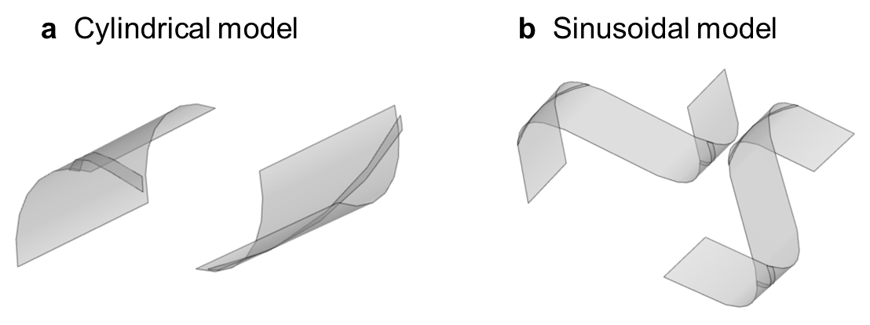
Figure S3. Two types of models that meet the required geometrical conditions for a kirigami structure.

Each model has advantages and disadvantages to consider when designing the metal patterns. The cylindrical model offers a simpler representation and calculation method, but its range of available kirigami patterns is limited to extreme cases such as highly stretched kirigami. In contrast, the sinusoidal model requires more complex numerical calculations for pattern representation but provides greater flexibility in shaping the pattern (fig. S4).

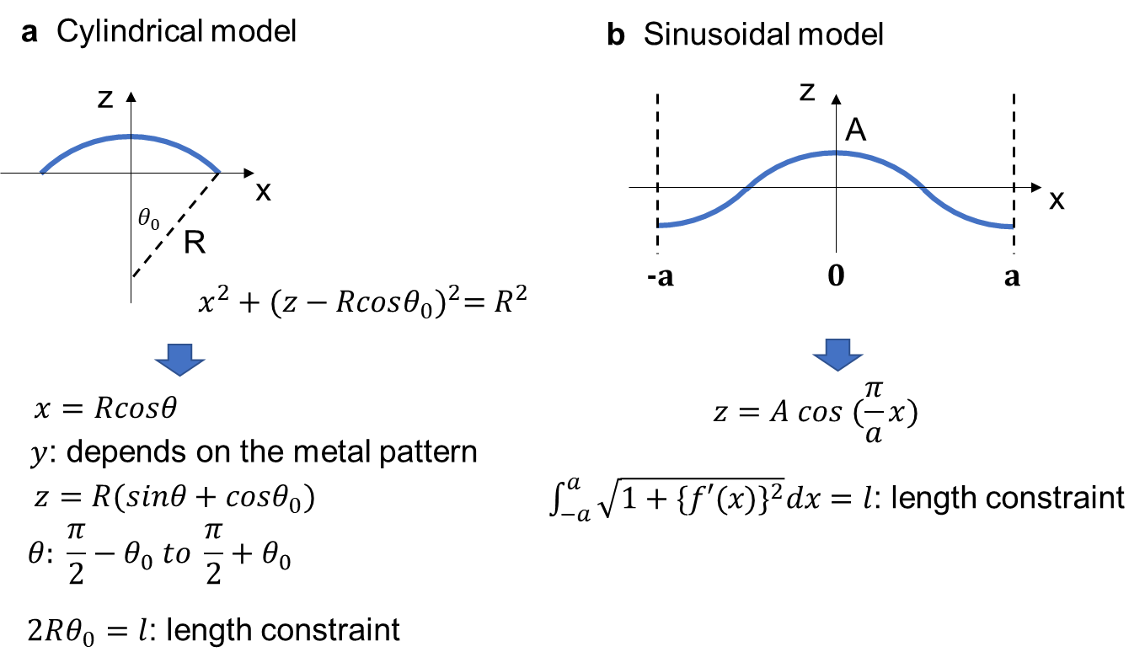

Figure S4. Coordinates and length of kirigami depending on each model.

Another important factor to consider when stretching the kirigami structure is tilting. As the material undergoes deformation, not only does buckling occur, but the structure also tilts. The tilting angle ($θ_{tilt})$ can be determined by the following equations; cylindrical model: $tan(θ_{tilt})=\frac{2R}{V_{cut}}(1-\frac{P_{cut}}{4R})$ and sinusoidal model: $tan(θ_{tilt})=\frac{2A}{V_{cut}}$, where $P_{cut}$ and $V_{cut}$ are width of unit cell and distance between cuts in vertical direction, respectively.
In this paper, we utilized the sinusoidal model to express higher similarity of deformed kirigami geometry with reality. To do this mathematically, two variables ($A$, which is the amplitude of the sinusoidal wave, and $a$, which is the half period of the sinusoidal wave) should be properly calculated with the conservation of the total length ($l$). For example, when the kirigami has no deformation, the amplitude of the sinusoidal wave will be zero ($A=0$) while the period of the sinusoidal wave will be equal to the total length ($2a=l$). The most extreme case of deformation with our sinusoidal model (which cannot be realized experimentally), the amplitude can be equal to one quarter of the total length ($A=l/4$) while the half period is equal to zero ($a=0$). With the values of these two variables lying in between the previous two examples, all the deformed kirigami geometries can be demonstrated.

Metal pattern on kirigami substrate
It is necessary to obtain the basic coordinates on the deformed kirigami platform to generate different types of metal patterns that change simultaneously with the kirigami. To do so, we should be able to keep track on any arbitrary point on the kirigami as it deforms (Fig. 1d). We can divide the process of finding the coordinates into two steps: (1) calculating the coordinates without incorporating the tilt, (2) applying the rotation operation with proper tilting angle to include the tilt of the kirigami in the global coordinate system.
With no strain, an arbitrary point on the kirigami can be selected: $(x_{0}, y_{0}, z_{0})$. Since the kirigami is not deformed, $z_{0}$ is equal to zero. After deformation with proper values of $A$ and $a$ without tilting, this arbitrary point can be expressed as $({x'}_{0}, {y'}_{0}, {z'}_{0})$. Since no tilting occurs, $y_{0}={y'}_{0}$, as we are utilizing the sinusoidal model, ${z'}_{0}=A cos(\frac{π}{a}{x'}_{0})$. Therefore, finding the relationship between $x_{0}$ and ${x'}_{0}$ enables full extraction of any arbitrary points on kirigami. To relate these two $x$ coordinates, we have to again use the length constraint, which can be written as $x_{0}=\int_{0}^{{x'}_{0}}{\sqrt{1+{\left\{\frac{Aπ}{a}sin⁡(\frac{π}{a}x)\right\}}^{2}}dx}$, where the left term is the length of the un-deformed kirigami from origin to position $x_{0}$ and the right term is the length of the deformed kirigami from origin to position ${x'}_{0}$. By numerically calculating this equation, we can obtain a full transformation from $(x_{0}, y_{0}, z_{0})$ to $({x'}_{0}, {y'}_{0}, {z'}_{0})$.
To include the tilting in this model, a proper rotation operator should be applied to the previously calculated deformed coordinates $({x'}_{0}, {y'}_{0}, {z'}_{0})$. The rotation axis of the deformed kirigami is the x-axis. If the coordinates after tilting are expressed as $\left(x_{1}, y_{1}, z_{1}\right)$,

$\left(\begin{aligned}x_{1} \\ y_{1} \\ z_{1}\end{aligned}\right)=R_{x}\left(θ_{tilt}\right)\left(\begin{aligned}{x^{'}}_{0} \\ {y^{'}}_{0} \\ {z^{'}}_{0}\end{aligned}\right)=\left[\begin{matrix}1 & 0 & 0 \\ 0 & cos θ_{tilt} & -sin θ_{tilt} \\ 0 & sin θ_{tilt} & cos θ_{tilt}\end{matrix}\right]\left(\begin{aligned}{x^{'}}_{0} \\ {y^{'}}_{0} \\ {z^{'}}_{0}\end{aligned}\right)$ (1)

Using these equations, we can generate the model of any deformed state with different metal width. Fig. S5 shows a few of the examples that can be reconstructed with various metal patterns on the kirigami.
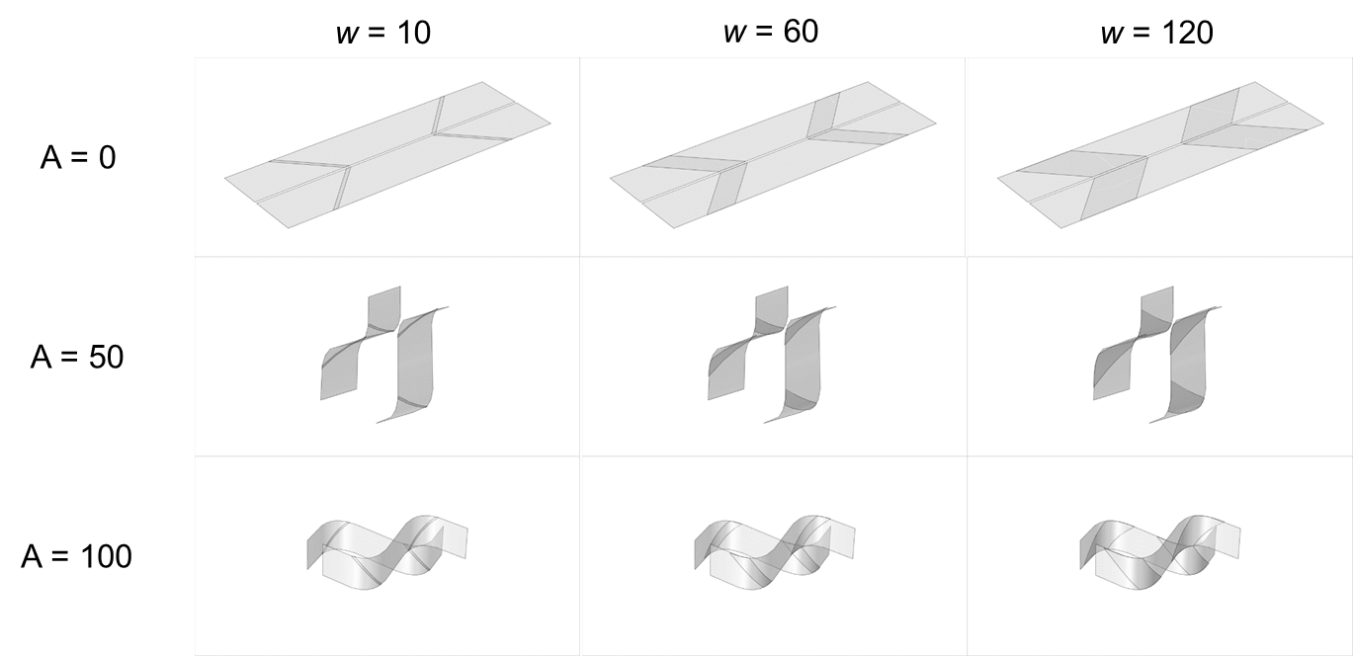
Figure S5. A few examples of kirigami structure with different widths of metal patterns.

Image processing for time-variable multiplexed hologram
Image processing for images to be demonstrated as tunable chiral holograms is required. The image (i.e., Mona Lisa) was first converted from color to grayscale to convert the 3-layer array information to a single-layer information. The image was then sampled down to match the number of pixels with the kirigami pixilation. Since the image is in grayscale, the values of each pixel lie between 0 and 255. To match these values with the width of the Au strips (w = 0, 5, 20, 40, 60, 80, 100 µm), 7 different ranges were determined as shown in Table S1 and converted to the appropriate width. To process these steps computationally and to generate proper photomasks for fabrication, the CAD file (fig. 6d) was generated using the KLayout Python module.

Table S1. Au strips width and grayscale pixel value matching.
Au strips width (µm) | Grayscale pixel value
0 | 0 ~ 36
5 | 37 ~ 73
20 | 74 ~ 110
40 | 111 ~ 147
60 | 148 ~ 184
80 | 185 ~ 221
100 | 222 ~ 256

THz-TDS measurements
Terahertz time-domain spectroscopy (THz-TDS) with three linear polarizers was used to measure the chiroptical responses of the chiral kirigami metamaterials (Menlo Systems, TeraSmart)². The Tera15-FC antenna module (Menlo Systems), which uses photoconductive antennas with a pulsed laser at 1560 nm, was used as an emitter for THz generation. Typical THz lenses (TPX50, Thorlabs) made of polymethyl pentene with a diameter of 1.5 inches and a focal length of 50 mm were used to produce collimated and focused THz beams. Raster scanning was achieved using a motorized XY stage (PI Instrument). The measurement method with three linear polarizers was used to determine the polarization rotation angle (θ), ellipticity (η), and THz circular dichroism (TCD) of arbitrarily polarized THz waves^{1,3}. For this purpose, an array of Au strips was fabricated on the Parylene CTM film and used as wire grid polarizers, exhibiting high extinction ratios (> 40 dB) over the ranges of 0.2 to 2.0 THz ²

Configuration of three polarizers
The configuration of the three polarizers for chiroptical measurements is the same as described elsewhere². The chiroptical responses of the chiral kirigami metamaterials were measured using a setup in which the orientation of the linear polarized THz beam was fixed horizontally (x-axis) to the optical breadboards, while the THz detector was fixed vertically (y-axis). The setup comprised three polarizers (P1, P2, and P3 in order from emitter). P1 was placed in front of the emitter, and its transmission direction, perpendicular to the wire grid orientation, was fixed to the x-axis to ensure that the input beam was linearly polarized. P3 was placed right before the THz emitter, and its transmission direction was fixed to the y-axis, making it cross-polarized to P1 and the emitter. P2 was placed between P1 and P3 and rotated to different orientations to determine the complete polarization state of the transmitted electric field.

Definition of kirigami orientations
Chiral kirigami metamaterials with w = 5 µm exhibit C4 symmetry. For accuracy, it is necessary to perform measurements for both horizontally and vertically polarized THz beams by rotating the kirigami samples by 90° using a rotation mount (RSP1, Thorlabs). The horizontal and vertical mounting orientations are defined as (i) the stretching direction is along the x direction for the horizontal orientation and (ii) the stretching direction is along the y direction for the vertical orientation.

Ellipticity, polarization rotation angle, and THz circular dichroism
The process of obtaining ellipticity, polarization rotation angle, and THz circular dichroism (TCD) begins with calculating the x and y components of the electric field¹. To calculate the x-component of the electric field, equation (2) is used, where $E_{+45°}\left(t\right)$ and $E_{-45°}\left(t\right)$ are the time-domain electric fields measured for the two polarizer orientations, +45° and -45° relative to the y-axis, respectively.

$$\begin{aligned}E_{x}\left(t\right)=E_{+45°}\left(t\right)-E_{-45°}\left(t\right)\#\left(2\right)\end{aligned}$$

The fast Fourier transform (FFT) is then used to obtain complex frequency-domain electric field spectra from the time-domain electric fields measured, as shown in equations (3).

${\tilde{E}}_{x}={\tilde{E}}_{x}\left(ω\right)=FFT\{E_{x}\left(t\right)\}$
$$\begin{aligned}{\tilde{E}}_{y}={\tilde{E}}_{y}\left(ω\right)=FFT\{E_{y}\left(t\right)\}\#\left(3\right)\end{aligned}$$

Once ${\tilde{E}}_{x}$ and ${\tilde{E}}_{y}$ are obtained, the Stokes equations are used to calculate the ellipticity and polarization rotation angle, as follows:

$$S_{0}={\tilde{E}}_{x}{\tilde{E}}_{x}^{*}+{\tilde{E}}_{y}{\tilde{E}}_{y}^{*}$$
$$S_{1}={\tilde{E}}_{x}{\tilde{E}}_{x}^{* }-{\tilde{E}}_{y}{\tilde{E}}_{y }^{*}$$
$$S_{2}={\tilde{E}}_{x}{\tilde{E}}_{y}^{*}+{\tilde{E}}_{y}{\tilde{E}}_{x}^{*}$$
$$\begin{aligned}S_{3}={i(\tilde{E}}_{x}{\tilde{E}}_{y}^{*}-{\tilde{E}}_{y}{\tilde{E}}_{x}^{*})\#\left(4\right)\end{aligned}$$

The polarization rotation angle (θ) and ellipticity (η) are defined by equations (5), where $-\frac{π}{2}≤θ≤\frac{π}{2}$ and $-\frac{π}{4}≤η≤\frac{π}{4}$.
$$θ=\frac{1}{2}tan^{-1}\left(\frac{S_{2}}{S_{1}}\right)$$
$$\begin{aligned}η=\frac{1}{2}sin^{-1}\left(\frac{S_{3}}{S_{0}}\right) \#\left(5\right)\end{aligned}$$

TCD is, by definition, the relative difference in transmission (or absorption) between RCP and LCP waves after passing through chiral kirigami metamaterials, and can be defined by

$$\begin{aligned}TCD =tan^{-1}\left(\frac{E_{R}-E_{L}}{E_{R}+E_{L}}\right)\#\left(6\right)\end{aligned}$$

where $E_{R}$ and $E_{L}$ are the magnitudes of the transmitted waves of RCP and LCP beams.

Transmission of the beams can be calculated from the Jones transfer matrix of a sample as described in equation (7).

$$\begin{aligned}T=\left({t_{xx} \atop t_{xy}}{ t_{yx} \atop t_{yy}}\right)\#\left(7\right)\end{aligned}$$

The magnitude of RCP and LCP can be calculated using transmission of the beams as follows:

$$\begin{aligned}E_{R}=\frac{1}{\sqrt{2}}\sqrt{{\left|t_{xx}+it_{yx}\right|}^{2}+{\left|t_{xy}+it_{yy}\right|}^{2}}\#\left(8\right)\end{aligned}$$
$$\begin{aligned}E_{L}=\frac{1}{\sqrt{2}}\sqrt{{\left|t_{xx}-it_{yx}\right|}^{2}+{\left|t_{xy}-it_{yy}\right|}^{2}}\#\left(9\right)\end{aligned}$$

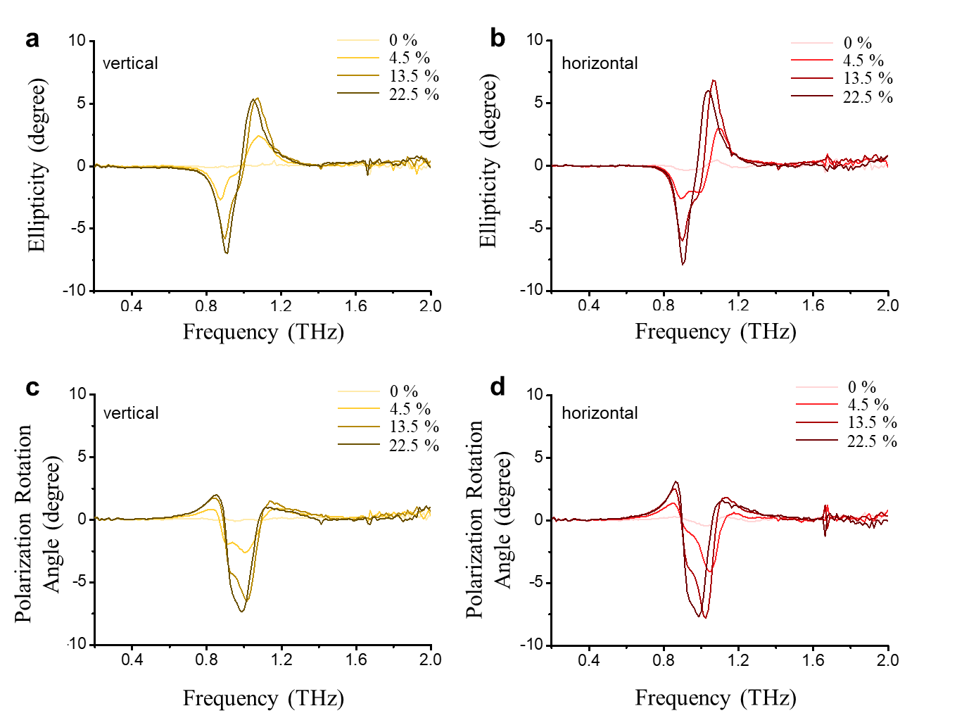

Figure S6. Ellipticity and polarization rotation angle of kirigami with 5 µm-wide Au strip measured at vertical (a and c) and horizontal (b and d) configurations, respectively. There is almost no difference between vertical and horizontal orientations for 5 µm-width CKMs.

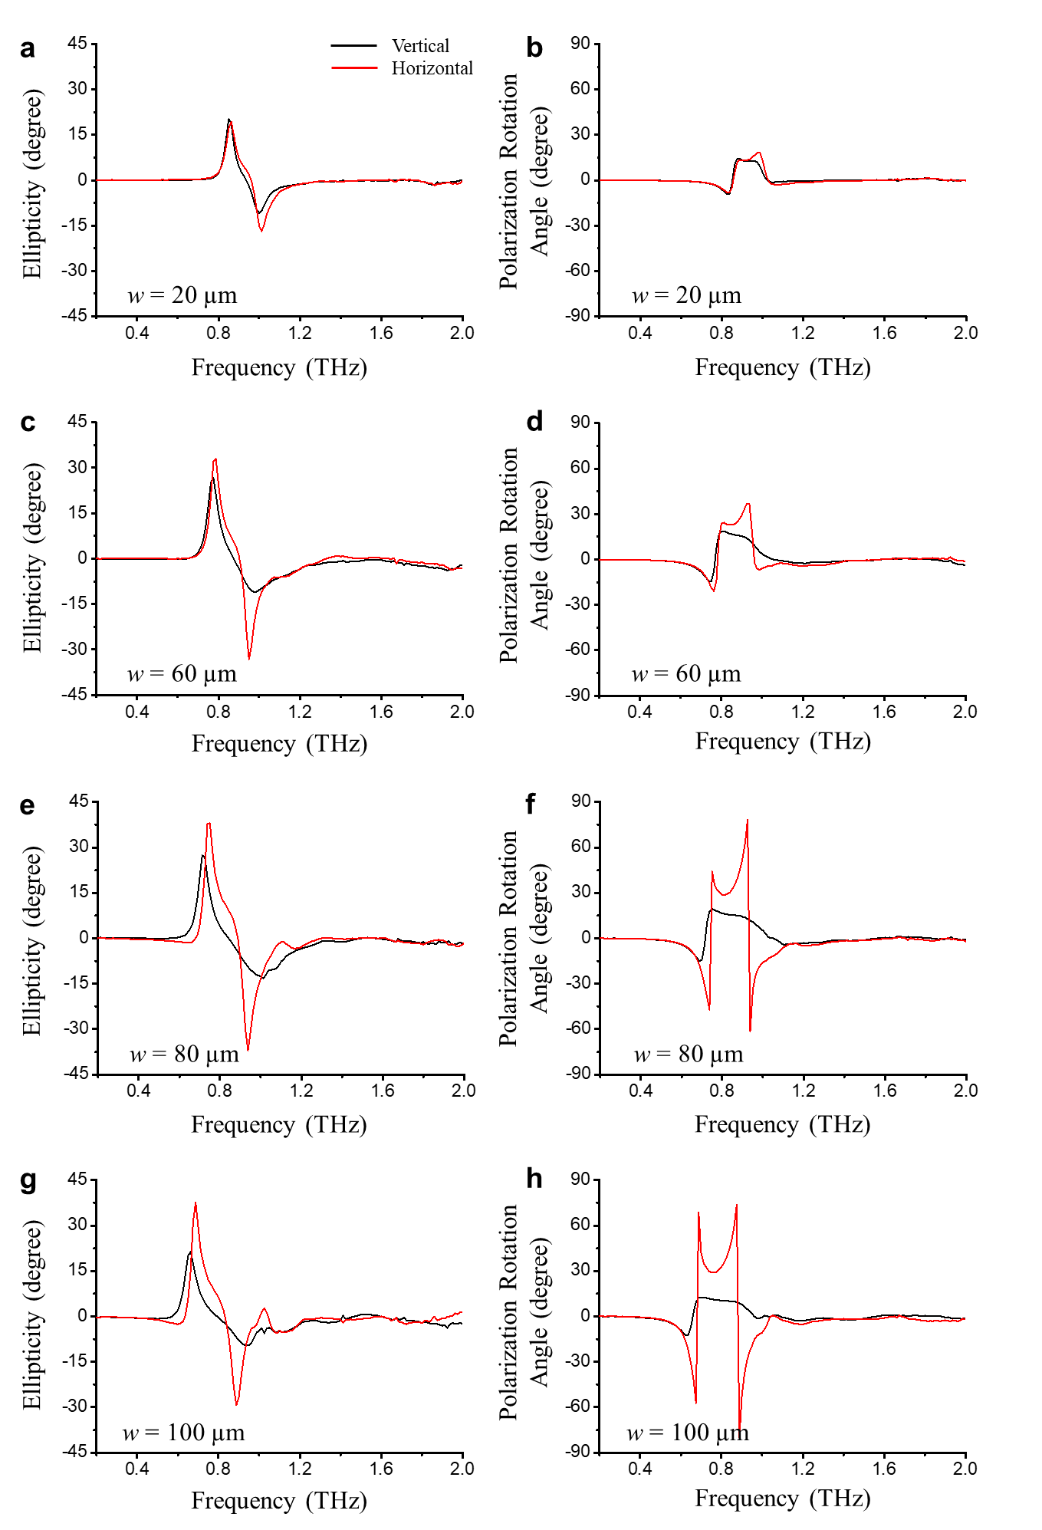

Figure S7. Ellipticity and polarization rotation angle of kirigami with Au strips of widths 20, 60, 80, and 100 µm in both vertical (black) and horizontal (red) configurations. All were measured at ε = 22.5% strain.

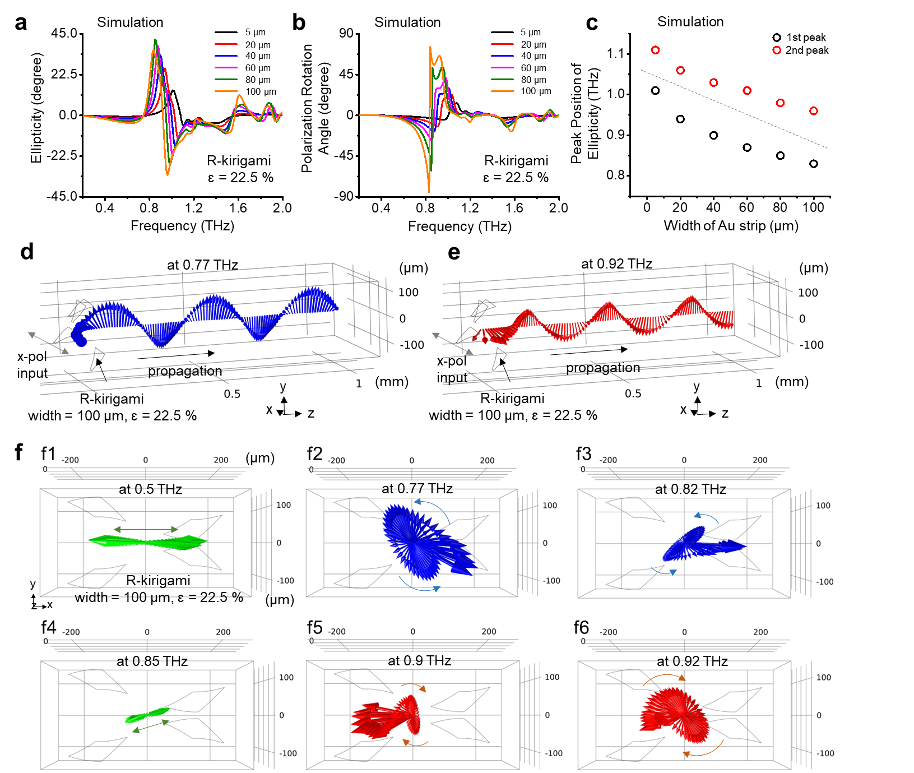

Figure S8. Electromagnetic simulation results of ellipticity and polarization rotation angle of CKM for different strain (0 – 22.5%). a, b, Relation between peak position/magnitude of calculated ellipticity and the width of Au strip. c, Relation between peak position of calculated ellipticity and the width of Au strip. d,e, Visualization of THz beam propagation in z-axis at 0.77 and 0.92 THz, respectively. f, x-y plane view of THz polarization at from 0.5 to 0.92 THz. F1-F6 show the evolution of polarization from linear to RCP and RCP to linear and linear to LCP.

Chirality measurement of CKMs and relation with optical activity
From the 3D mesh models of CKMs with different Au strip width and strain, the vertices of each mesh were taken to represent the 3D point-cloud structure of CKMs. The set of 3D points are plugged into the following Osipov-Pickup-Dunmur (OPD) equation⁴ to compute the parameterized OPD chirality indices. Also, for the direct comparison of chirality and optical activity, the area factor was considered. As the surface area is proportional to the absorption, the area factors are multiplied to the OPD values.

$$G_{OS}= \frac{4 !}{N^{4}}\frac{1}{3}\left[\sum_{\begin{aligned}&all permunation of \\ &i, j, k,l=1⋯N\end{aligned}}{w_{i}w_{j}w_{k}w_{l} ×\frac{\left[\left(r_{ij}×r_{kl}\right)∙r_{il}\right]\left(r_{ij}∙r_{jk}\right)\left(r_{jk}∙r_{kl}\right)}{{\left(r_{ij}r_{jk}r_{kl}\right)}^{n}{r_{il}}^{m}}}\right]$$
(10)

$$G_{OS_optics}=G_{OS} × (Surface Area factor)$$

To further analyze the KCM’s structural contribution in their chiral optical activity, the leave-one-out method was utilized when computing OPD by alternatively excluding a single point from the set of 3D point-cloud of each KCM. Therefore, 3D pointwise chirality contribution was analyzed by the following equation. The bigger the chirality contribution factor value at a certain point indicates the larger contribution of the points to the entire chirality and its optical activity.

$Chirality Contribution \left(v_{K}\right)=\left|OPD\left(v_{1},⋯v_{K},⋯v_{N}\right)-OPD(v_{1},⋯v_{K-1, }v_{K+1},⋯v_{N})\right|$ (11)

References and Notes

1. Choi, W. J. et al. Terahertz circular dichroism spectroscopy of biomaterials enabled by kirigami polarization modulators. Nat Mater 18, 820–826 (2019).
2. Choi, W. J. et al. Chiral Phonons in Microcrystals and Nanofibrils of Biomolecules. Nat Photonics (2022) doi:10.21203/rs.3.rs-248321/v1.
3. Kan, T. et al. Enantiomeric switching of chiral metamaterial for terahertz polarization modulation employing vertically deformable MEMS spirals. Nat Commun 6, 1–7 (2015).
4. Osipov, M. A., Pickup, B. T. & Dunmur, D. A. A new twist to molecular chirality: intrinsic chirality indices. Molec. Phys. 84, 1193–1206 (1995).

