Mesenchymal stem cells overexpressing interleukin-10 prevented allergic airway inflammation.
Peng-Peng Kuang ^{1,2†}, Xiao‑Qing Liu ^{1,2†}, Chan-Gu Li ^{1,2}, Bi-Xin He ^{1,2}, Ying-Chun Xie^{1,2}, Zi-Cong Wu^{1,3}, Cheng-Lin Li¹, Xiao-Hui Deng^{1,3} and Qing-Ling Fu ^{1,2, 3*}
¹Otorhinolaryngology Hospital, The First Affiliated Hospital, Sun Yat‑sen University, 58 Zhongshan Road II, Guangzhou 510080, Guangdong, People’s Republic of China.
²Division of Allergy, The First Affiliated Hospital, Sun Yat‑sen University, Guangzhou, People’s Republic of China.
³ Extracellular Vesicle Research and Clinical Translational Center, The First Affiliated Hospital, Sun Yat-sen University, Guangzhou 510080, PR China

† Peng-Peng Kuang and Xiao‑Qing Liu contributed equally to this work and share first Authorship.
*Correspondence:
Prof. Qing-Ling Fu
Otorhinolaryngology Hospital
The First Affiliated Hospital, Sun Yat-sen University
58 Zhongshan Road II, Guangzhou, Guangdong, 510080, P. R. China
Tel:86-20-87333733; Fax:86-20-87333733;
E-mail: fuqingl@mail.sysu.edu.cn

Supplementary Figures

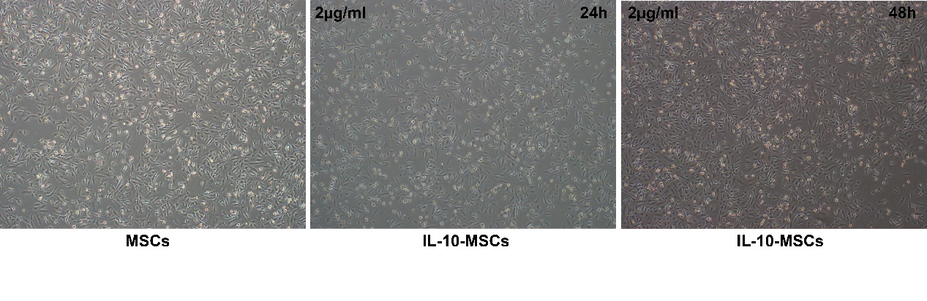
Supplementary Fig.1 iPSC-MSCs transfected with IL-10 gene were selected under 2 μg/ml puromycin.
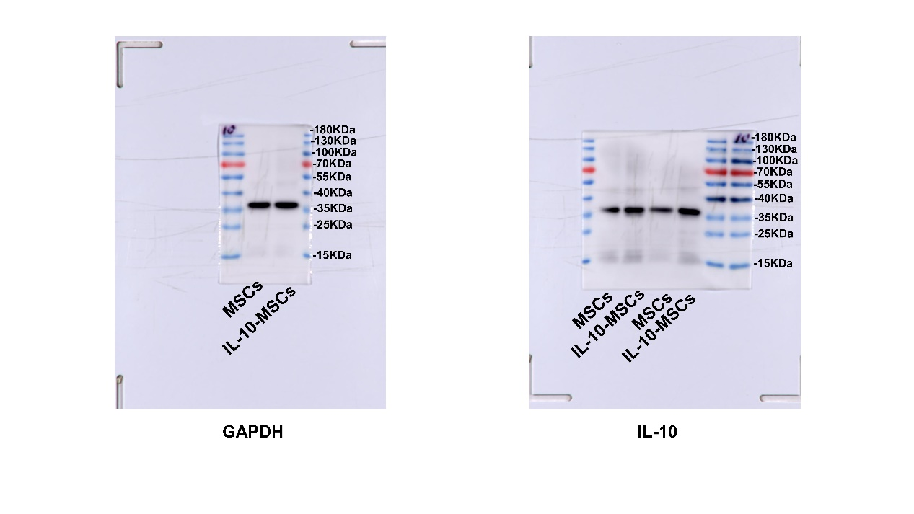
Supplementary Fig.2 Original uncropped blots for Fig. 1E.
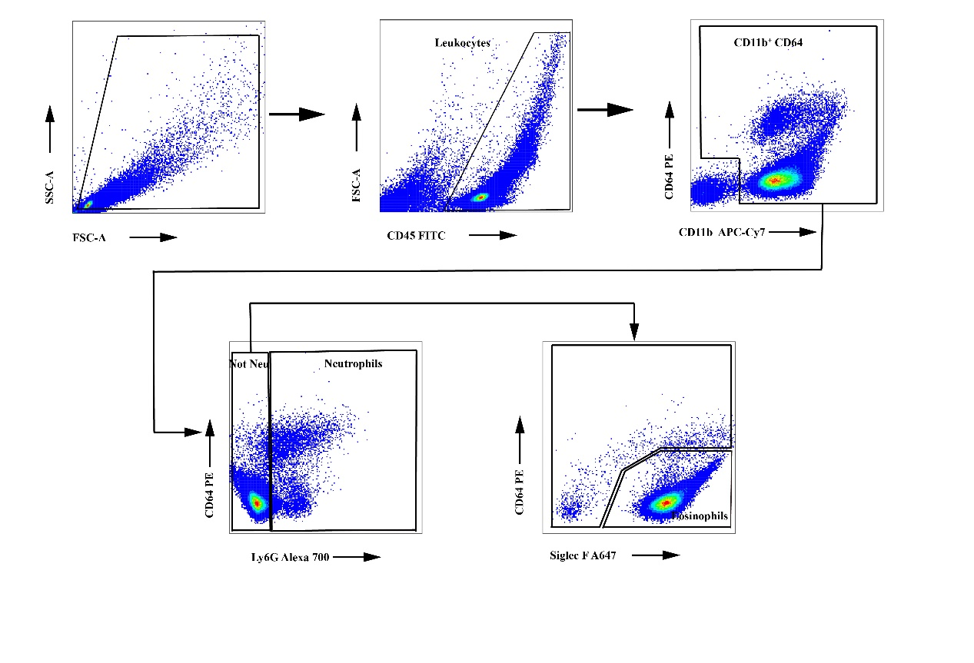
Supplementary Fig.3 Gating strategy for flow cytometry analyses of inflammatory cells in BALF.
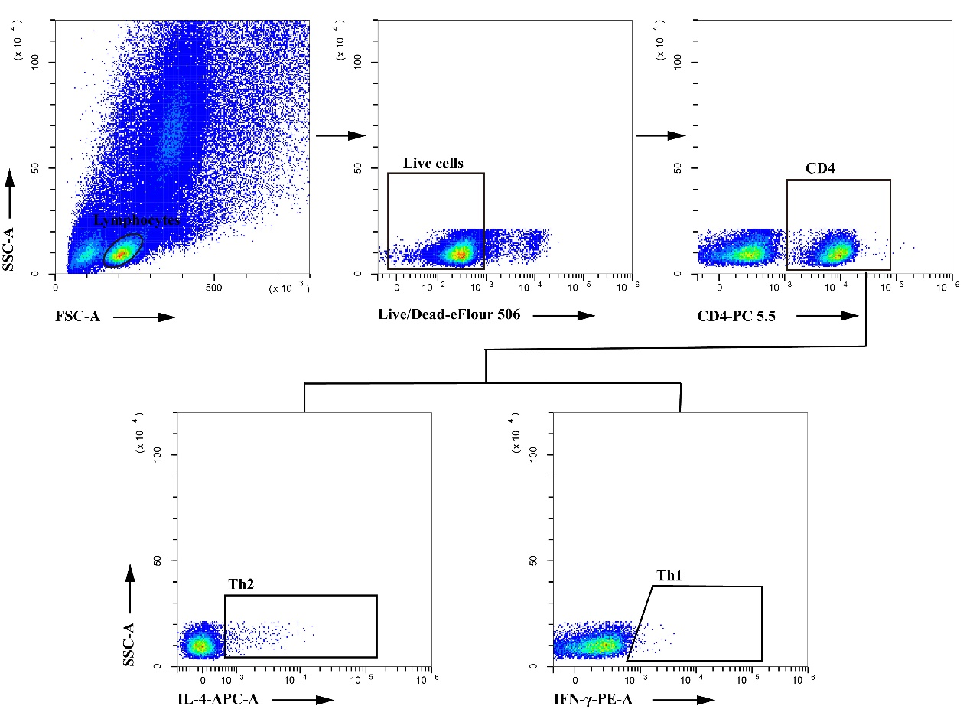
Supplementary Fig.4 Gating strategy for flow cytometry analyses of lung tissues.
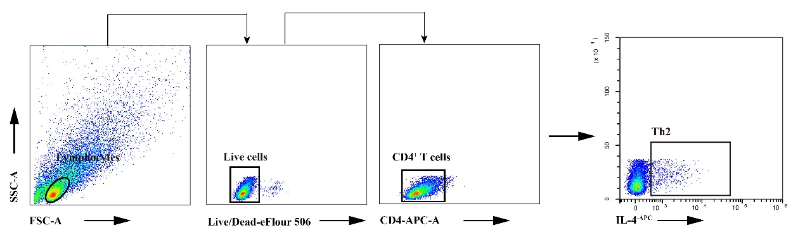
Supplementary Fig.5 Gating strategy for flow cytometry analyses of Th2 in PBMCs.

