Supplementary Information
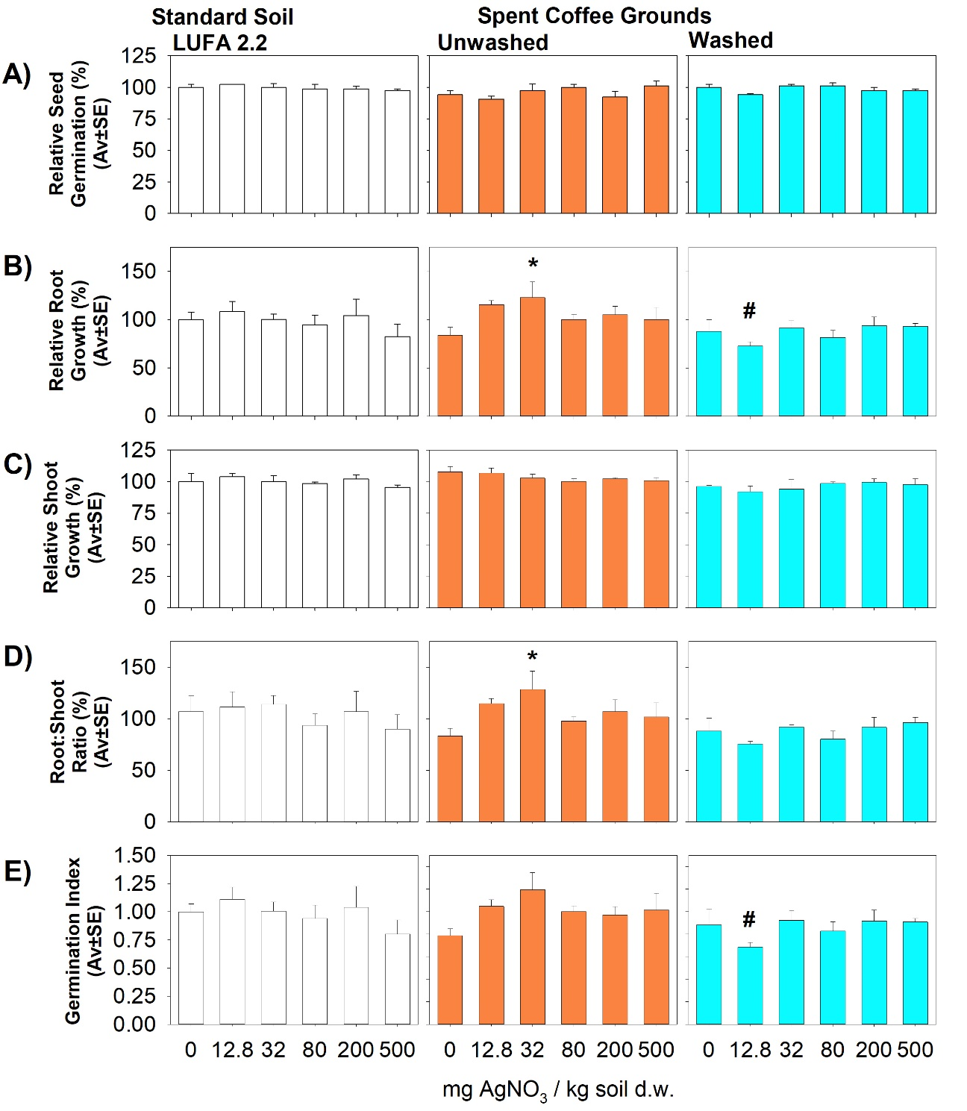Figure S1: Results of the seedling emergence test with L. sativum in LUFA 2.2 soil, unwashed and washed spent coffee grounds spiked with AgNO₃, after 7 days: A) Relative Seed Germination, B) Relative Root Growth, C) Relative Shoot Growth, D) Root:Shoot Ratio, E) Germination Index. * - Significant difference relative to the respective control, # - significant difference between substrates.
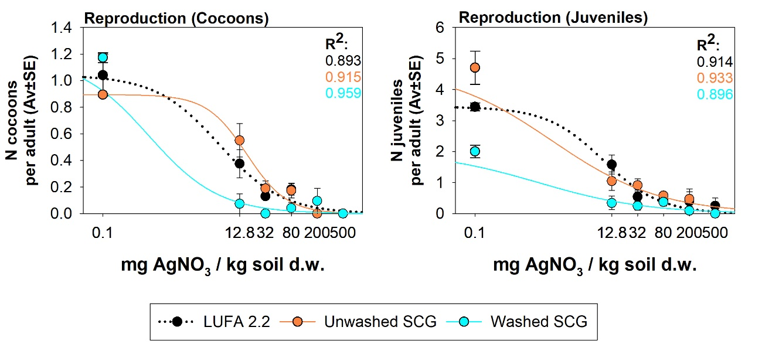
Figure S2: Estimated effect for E. andrei reproduction (cocoons and juveniles) in LUFA 2.2 soil, unwashed SCG and washed SCG spiked with AgNO₃.

Table S1: Principal Component Analysis (PCA) in-model components, variable loadings and explained variance. Correlation values over |0.6| are highlighted in bold.
 |  | PC1 | PC2 | PC3 | PC4
 | Variance (%) | 31.8 | 23.6 | 19.5 | 10.9
E. andrei response | Survival | 0.659 | -0.313 | 0.377 | -0.323
E. andrei response | Reproduction (Juveniles) | 0.499 | -0.462 | 0.558 | 0.238
E. andrei response | Reproduction (Cocoons) | 0.476 | -0.437 | 0.562 | 0.026
Microbial activity | SBR | 0.732 | -0.135 | -0.142 | 0.413
L. sativum response | RRG | 0.593 | 0.767 | 0.038 | -0.173
L. sativum response | RSR | 0.618 | 0.712 | -0.049 | -0.172
L. sativum response | GI | 0.591 | 0.731 | -0.032 | -0.224
Abiotic factors | AgNO₃ concentration | -0.434 | 0.328 | -0.544 | 0.451
Abiotic factors | pH | 0.616 | 0.138 | -0.022 | 0.617
Abiotic factors | EC | -0.139 | 0.509 | 0.557 | 0.523
Abiotic factors | % Humidity | -0.571 | 0.389 | 0.699 | 0.013
Abiotic factors | % OM | -0.611 | 0.381 | 0.672 | -0.026

Table S2: PCA Variables Correlation Matrix. Correlation values over |0.6| are highlighted in bold.
 | Surv. | Reprd. (Juv.) | Reprd. (Coc.) | SBR | RRG | RSR | GI | AgNO₃ conc. | pH | EC | % Hum. | % OM
Survival | 0.779
Reproduction (Juveniles) | 0.607 | 0.830
Reproduction (Cocoons) | 0.654 | 0.759 | 0.735
SBR | 0.337 | 0.446 | 0.338 | 0.745
RRG | 0.221 | -0.078 | -0.035 | 0.254 | 0.971
RSR | 0.221 | -0.089 | -0.049 | 0.292 | 0.940 | 0.920
GI | 0.221 | -0.114 | -0.062 | 0.246 | 0.948 | 0.925 | 0.934
AgNO₃ concentration | -0.739 | -0.564 | -0.644 | -0.098 | -0.105 | -0.085 | -0.100 | 0.795
pH | 0.155 | 0.379 | 0.237 | 0.690 | 0.364 | 0.374 | 0.327 | 0.069 | 0.780
EC | -0.210 | 0.131 | 0.038 | -0.033 | 0.239 | 0.160 | 0.156 | 0.16 | 0.296 | 0.862
% Humidity | -0.239 | -0.072 | -0.049 | -0.564 | -0.016 | -0.112 | -0.078 | 0.001 | -0.305 | 0.673 | 0.967
% OM | -0.260 | -0.112 | -0.080 | -0.605 | -0.040 | -0.134 | -0.098 | 0.013 | -0.354 | 0.639 | 0.967 | 0.971

