Association between type of immunosuppression and the incidence, microbiology and outcomes of ventilator-associated lower respiratory tract infections:
a retrospective multicenter study

Authors
Constance Bayon^{1*}, Louis Kreitmann^{2,3*}, Ignacio Martin-Loeches^{4,5}, Pedro Póvoa^{6,7,8}, Jorge Salluh^{9,10}, Anahita Rouzé^{1,11}, Anne-Sophie Moreau¹, Julien Labreuche¹², Saad Nseir^{1,13}, for the MIMOSA study group.

* Contributed equally

Affiliations
1. CHU Lille, Service de Médecine Intensive - Réanimation, F-59000 Lille, France.
2. Centre for Antimicrobial Optimisation, Department of Infectious Disease, Faculty of Medicine, Imperial College London, London W12 0HS, UK.
3. Department of Critical Care Medicine, Imperial College Healthcare NHS Trust, London, UK.
4. Department of Intensive Care Medicine, Multidisciplinary Intensive Care Research Organization (MICRO), Leinster D08NYH1, Dublin, Ireland.
5. Pulmonary Intensive Care Unit, Respiratory Institute, Hospital Clinic of Barcelona, IDIBAPS (Institut d'Investigacions Biomèdiques August Pi i Sunyer), University of Barcelona, ICREA CIBERes, Barcelona 08380, Spain.
6. NOVA Medical School, CHRC, NOVA University of Lisbon, Portugal.
7. Center for Clinical Epidemiology and Research Unit of Clinical Epidemiology, OUH Odense, University Hospital , Denmark.
8. Department of Intensive Care, Hospital de São Francisco Xavier, CHLO, Lisbon, Portugal.
9. Department of Critical Care and Postgraduate Program in Translational Medicine, D’Or Institute for Research and Education (IDOR), Rio de Janeiro, Brazil.
10. Programa de Pós-Graduação em Clínica Médica, Universidade Federal do Rio de Janeiro, Rio de Janeiro, Brazil.
11. Univ. Lille, CNRS, UMR 8576 - UGSF - Unité de Glycobiologie Structurale et Fonctionnelle, F-59000 Lille, France
12. CHU Lille, Department of Biostatistics, F59000-Lille, France.
13. Inserm U1285, Université de Lille, CNRS, UMR 8576-UGSF, F-59000, Lille, France

Supplementary material

Supplementary methods

Clinical variables
Demographic characteristics, severity scores, comorbidities, reasons for ICU admission, prior hospitalization and prior antibiotic use were recorded at baseline for all patients. VA-LRTI occurrence was recorded, as well as its type (VAT or VAP), the progression from VAT to VAP, and isolated microorganisms. Patient outcomes (28-day mortality, ICU length-of-stay and duration of IMV) were collected. Patients were followed up until day 28 or until ICU discharge if it occurred before.

Statistical analysis: imputation of missing values
To avoid case deletion in multivariate analyses due to the presence of missing data in covariates, multivariable regression models were performed after handling missing data by using a multiple imputation procedure [1]. Specifically, imputation of missing values was performed using a regression-switching approach (chained equations with m=20 obtained) under the “missing at random” assumption, using all baseline characteristics (Table 1), type of immunosuppression, and outcomes (event status and log of event time), with a predictive mean matching method for quantitative variables and a logistic regression model (binary, ordinal or multinomial) for categorical variables. Estimates obtained in the different imputed data sets were combined using Rubin’s rules [3].

Supplementary Table 1. Patient characteristics at admission according to data source
Characteristics | TAVEM  (n=582) | COVAPID  (n=272)
Hematologic malignancy | 483 (83.0) | 209 (76.8)
Age (years)¹ | 65 (55-74) | 65 (56-72)
Gender (male)² | 362 (62.2) | 130 (48.0)
BMI (kg/m²)³ | 25.4 (21.9-29.0) | 26.1 (22.9-29.6)
Comorbidities
Chronic heart disease³ | 109 (18.7) | 60 (22.6)
Diabetes mellitus³ | 97 (16.7) | 49 (18.4)
Chronic respiratory disease⁴ | 76 (13.1) | 39 (14.6)
COPD⁵ | 59 (10.1) | 38 (14.3)
Chronic kidney disease⁶ | 56 (9.6) | 25 (9.5)
Alcohol consumption⁵ | 39 (6.7) | 12 (4.5)
Cirrhosis³ | 32 (5.5) | 20 (7.5)
MacCabe classification⁷
Non-fatal | 197 (36.7) | 92 (36.4)
Fatal <5 years | 240 (44.7) | 125 (49.4)
Fatal <1 year | 100 (18.6) | 36 (14.2)
Category of ICU admission
Medical | 391 (67.2) | 261 (96.0)
Surgical | 148 (25.4) | 4 (1.5)
Trauma | 43 (7.4) | 7 (2.6)
Cause for ICU admission
Respiratory failure | 25 (4.3) | 219 (80.5)
ARDS | 41 (7.0) | 98 (36.0)
Pneumonia | 118 (20.3) | 159 (58.5)
Sepsis other than pneumonia | 96 (16.5) | 20 (7.4)
Shock | 68 (11.7) | 111 (40.8)
Acute heart failure | 20 (3.4) | 7 (2.6)
Neurological failure | 0 (0.0) | 47 (17.3)
Renal failure | 11 (1.9) | 79 (29.0)
Liver failure | 4 (0.7) | 17 (6.3)
Intoxication | 1 (0.2) | 0 (0.0)
Perioperative care | 2 (0.3) | 17 (6.3)
Cardiac arrest | 0 (0.0) | 14 (5.1)
COVID | 0 (0.0) | 51 (18.8)
Unknown | 113 (19.4) | 23 (8.5)
Origin
Out of hospital | 304 (52.2) | 101 (37.1)
Hospitalized for >24h | 278 (47.8) | 171 (62.9)
Severity scores in the 24-hours following ICU admission
SOFA⁸ | 9 (6-11) | 8 (5-11)
SAPS II⁹ | 53 (41-66) | 52 (41-65)
Antibiotic treatment¹⁰ | 521 / 579 (90.0) | 262 / 272 (96.3)
Values are no./total no. (%) or median (25th to 75th percentiles).
¹1 missing data (1 in TAVEM); ²1 missing data (0 in TAVEM); ³26 missing data (4 in TAVEM);³6 missing data (0 in TAVEM); ⁴5 missing data (0 in TAVEM); ⁵7 missing data (0 in TAVEM); ⁶8 missing data (0 in TAVEM); ⁷64 missing data (45 in TAVEM); ⁸ 2missing data (0 in TAVEM); ⁹14 missing data (2 in TAVEM); ¹⁰3 missing data (3 in TAVEM).
Abbreviations: ARDS: Acute respiratory Distress Syndrome; BMI: body mass index; COPD: chronic obstructive pulmonary disease; ICU: intensive care unit, SAPS-II: Simplified Acute Physiology Score II, SOFA: Sequential Organ Failure Assessment.

Supplementary Table 2. Unadjusted and adjusted effect sizes of type of immunosuppression type on the 28-day risk of first episodes of ventilator-associated lower respiratory tract infections according to study group
 | Other type of immuno-suppression | Hematologic malignancy |  | Unadjusted |  |  |  | Adjusted¹
 | (n=692) | (n=162) |  | cHR (95%CI) | P-Value | P Het |  | cHR (95%CI) | P-Value | P Het
VA-LRTI
TAVEM | 76 (15.7) | 14 (14.1) |  | 0.72 (0.40-1.28) | 0.26 | 0.19 |  | 0.79 (0.36-1.71) | 0.55 | 0.26
COVAPID | 63 (30.1) | 8 (12.7) |  | 0.39 (0.18-0.81) | 0.011 |  |  | 0.41 (0.17-0.95) | 0.037
VAT
TAVEM | 39 (8.1) | 6 (6.1) |  | 0.64 (0.27-1.51) | 0.31 | 0.64 |  | 0.71 (0.23-2.11) | 0.53 | 0.91
COVAPID | 16 (7.7) | 4 (6.4) |  | 0.89 (0.29-2.66) | 0.83 |  |  | 0.77 (0.32-1.82) | 0.55
VAP
TAVEM | 42 (8.7) | 9 (9.1) |  | 0.85 (0.41-1.74) | 0.65 | 0.12 |  | 0.88 (0.29-2.61) | 0.81 | 0.22
COVAPID | 54 (25.8) | 6 (9.5) |  | 0.35 (0.15-0.82) | 0.015 |  |  | 0.37 (0.15-0.89à | 0.025
Values are number of event (28-day cumulative incidence, %) unless otherwise as indicated.
¹adjusted for center and pre-specified baseline confounders (age, sex, SAPS II, McCabe score, COVID status, shock, ARDS and antibiotic treatment at admission)
Abbreviations: ARDS, Acute respiratory Distress Syndrome; cHR: cause-specific hazard ratio; CI: confidence interval; SAPS II: Simplified Acute Physiology Score II; VA-LRTI: ventilator-associated respiratory tract infection; VAT: ventilator-associated tracheobronchitis; VAP: ventilator-associated pneumonia.

Supplementary table 3 : Microbiological documentation of VA-LRTI cases
Microorganism | Hematologic malignancy  (n=22)¹ | Other type of immunosuppression (n=139)²
Klebsiella pneumoniae | 3 (11.1) | 29 (18.5)
Pseudomonas aeruginosa | 3 (11.1) | 35 (22.3)
Escherichia coli | 4 (14.8) | 12 (7.6)
Staphylococcus aureus | 1 (3.7) | 15 (9.6)
Stenotrophomonas maltophila | 1 (3.7) | 5 (3.2)
Alacligenes spp. | 2 (7.4) | 1 (0.6)
Streptococcus pneumoniae | 0 (0.0) | 6 (3.8)
Enterobacter cloacae | 2 (7.4) | 7 (4.5)
Enterobacter aerogenes | 1 (3.7) | 3 (1.9)
Staphylococcus spp. (other than S. aureus) | 1 (3.7) | 2 (1.3)
Serratia marcescens | 0 (0.0) | 2 (1.3)
Klebsiella oxytoca | 0 (0.0) | 1 (0.6)
Streptococcus spp. | 0 (0.0) | 1 (0.6)
Citrobacter spp. | 1 (3.7) | 0 (0.0)
Achromobacter spp. | 0 (0.0) | 1 (0.6)
Morganella morganii | 0 (0.0) | 1 (0.6)
MDR bacteria | 15 (71.4) | 89 (64.9)
Values are number (% of VA-LRTI cases) unless otherwise as indicated.
¹1 missing value, ²2missing values.
Abbreviations: VA-LRTI: ventilator-associated respiratory tract infection, MDR: multidrug-resistant.

Supplementary figure 1. Unadjusted and adjusted effect sizes of immunosuppression subtype on the 28-day prognostic outcomes
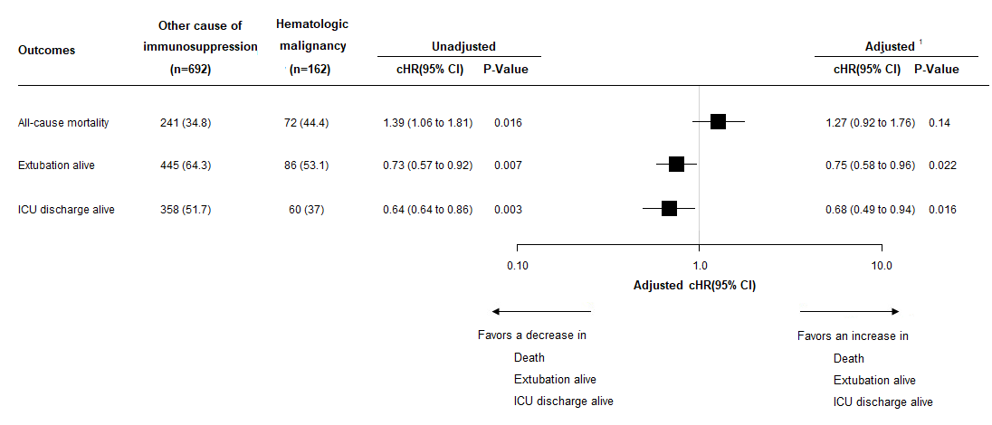
Values are number of event (28-day cumulative incidence, %) unless otherwise as indicated.
¹adjusted for center and pre-specified baseline confounders (age, sex, McCabe score, and cardiac arrest at admission).

Supplementary figure 2. 28-day cumulative incidence of death in ICU, successful weaning of IMV and ICU discharge alive
Figure 2a. 28-day cumulative incidence of death in ICU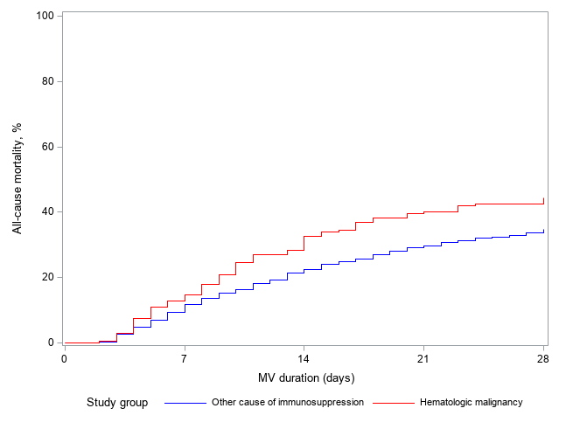
Figure 2b. 28-day cumulative incidence of successful weaning of IMV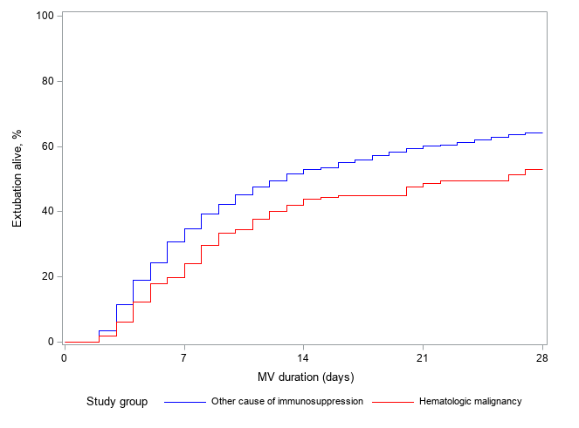

Figure 2c. 28-day cumulative incidence of ICU discharge alive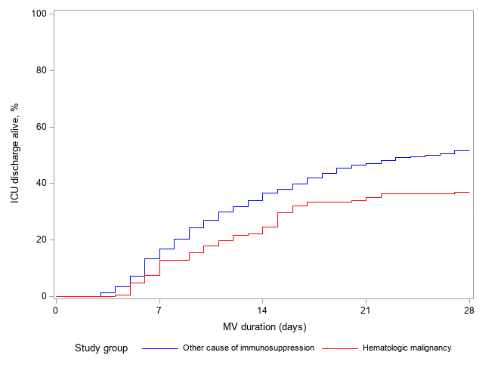

Supplementary references

1. Buuren SV, Groothuis-Oudshoorn K (2011) mice</b> : Multivariate Imputation by Chained Equations in R. J Stat Soft 45:. https://doi.org/10.18637/jss.v045.i03
2. Buuren S van, Groothuis-Oudshoorn K (2011) mice : Multivariate Imputation by Chained Equations in R. J Stat Soft 45:. https://doi.org/10.18637/jss.v045.i03
3. Rubin DB (1987) Multiple Imputation for Nonresponse in Surveys. John Wiley & Sons, Inc., Hoboken, NJ, USA

