Additional file 5: Detailed subgroup statistical analyses

Fig. 13 Forest plot and Funnel plot of different GnRH-a proposal subgroup analyses on pregnancy rate
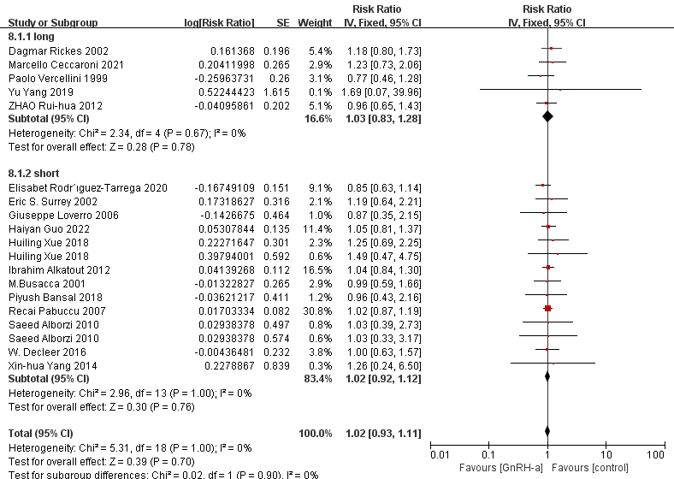
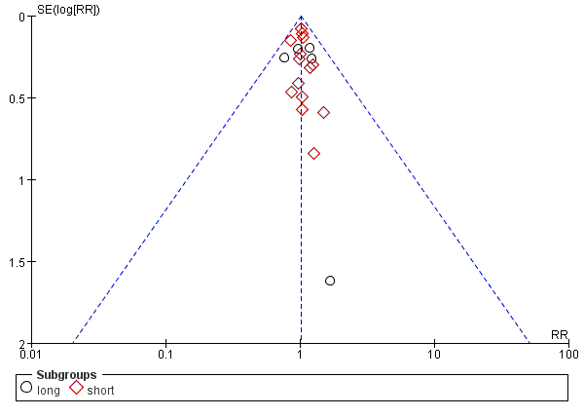

Fig. 14 Forest plot and Funnel plot of the different control subgroup analyses on pregnancy rate
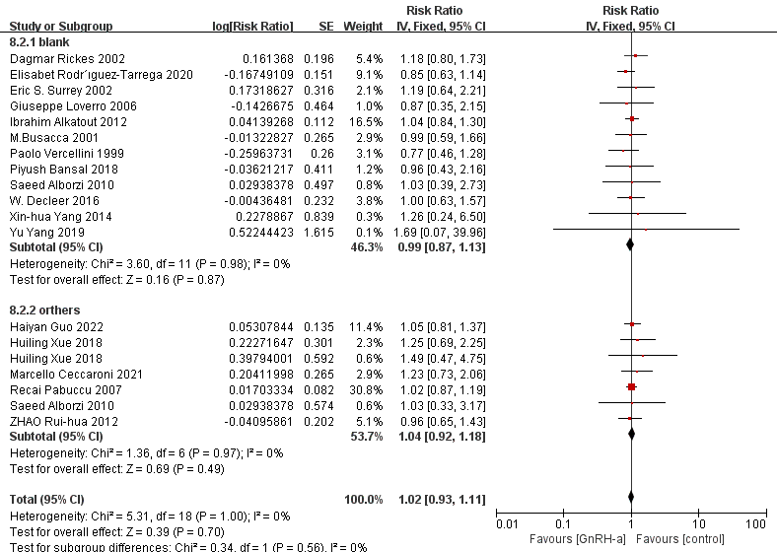
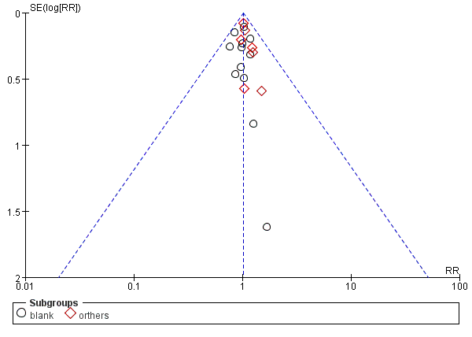

Fig. 15 Forest plot and Funnel plot of different conception ways subgroup analyses on pregnancy rate
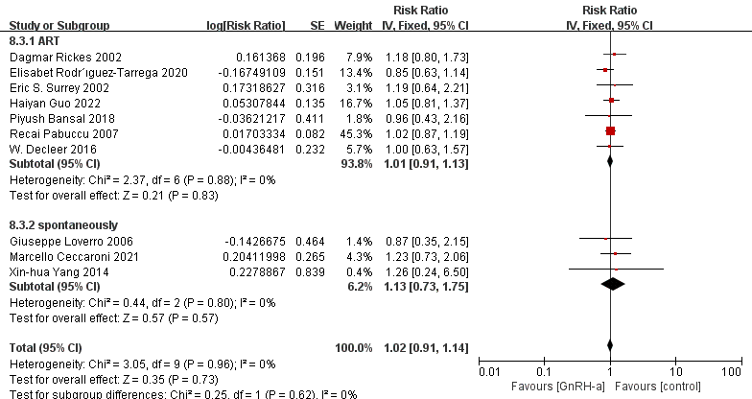
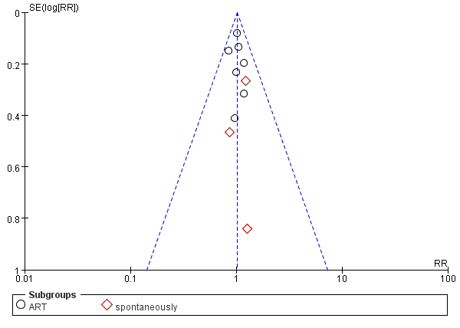

Fig. 16 Forest plot and Funnel plot of different study quality subgroup analyses on pregnancy rate
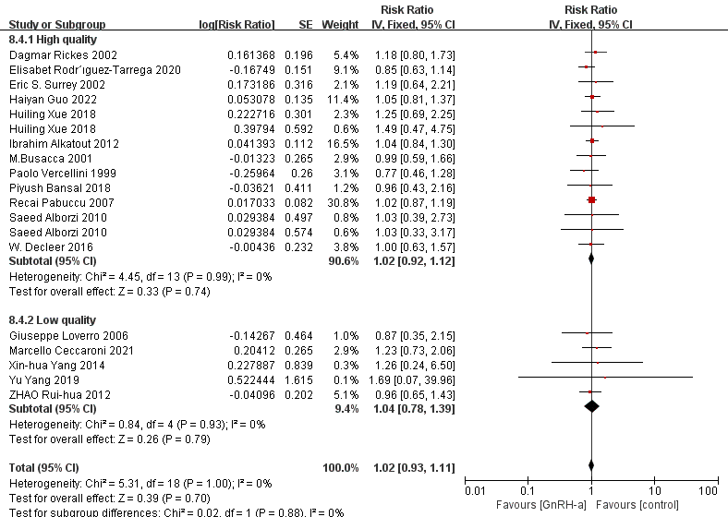
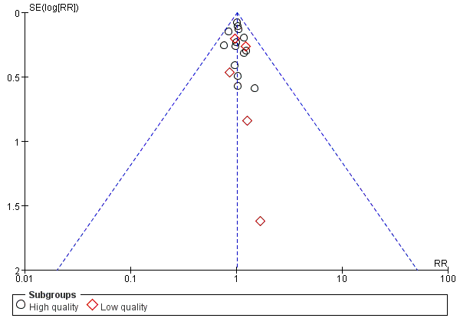

Fig. 17 Forest plot and Funnel plot of different GnRH-a proposal subgroup analyses on the live birth rate
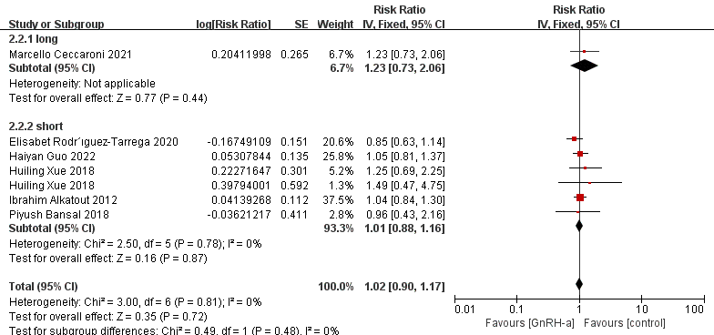
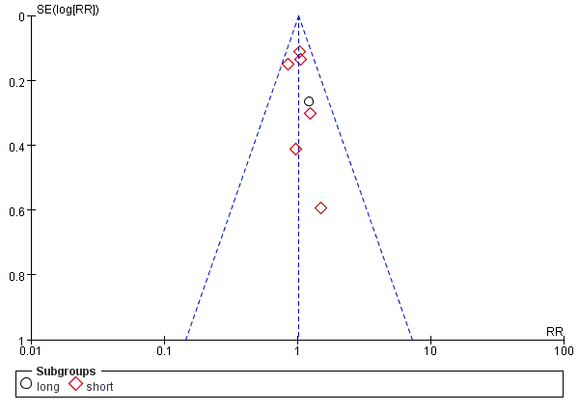

Fig. 18 Forest plot and Funnel plot of the different control subgroup analyses on the live birth rate
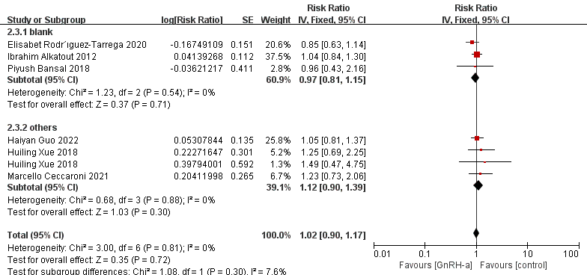
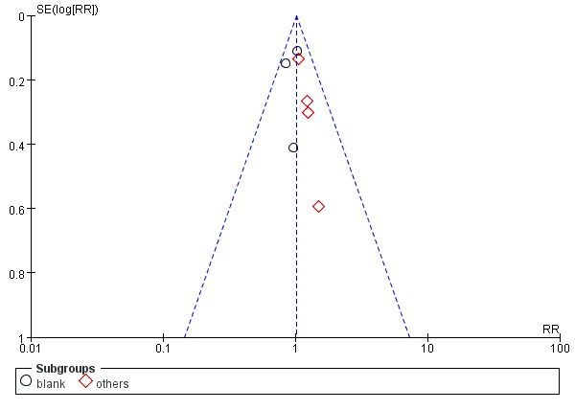

Fig. 19 Forest plot and Funnel plot of different conception ways subgroup analyses on the live birth rate
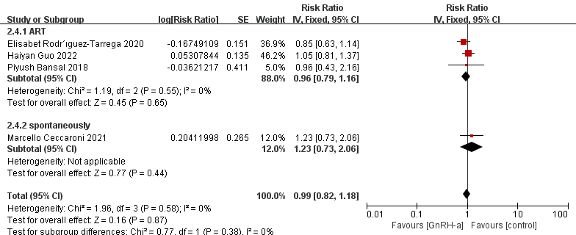
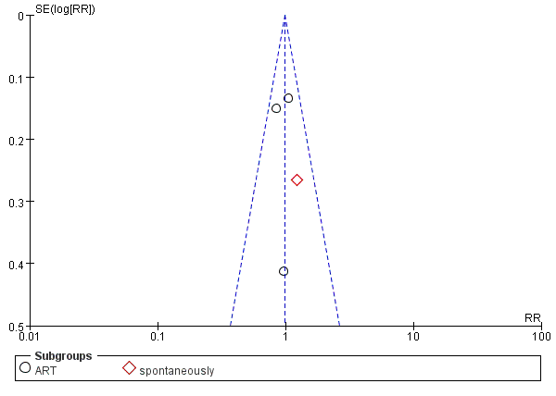

Fig. 20 Forest plot and Funnel plot of different study quality subgroup analyses on the live birth rate
