Supplementary Note 1
Non-Dimensionalization and Quantities Definitions
Reynolds number represents the ratio between inertial force and viscous force in flowing fluid. It is defined as:
$$\begin{aligned}Re=\frac{U_{∞}D_{H}}{ν}\#\left(1\right)\end{aligned}$$
Where D_{H} is the hydraulic diameter, which is defined as:
$$\begin{aligned}D_{H}=\frac{4A}{P}\#\left(2\right)\end{aligned}$$
Taking a cross section parallel to the inlet, A is the cross-sectional area, and P is the perimeter of the cross section.
Since in the simulation setup, the boundaries are set to be periodic, and the channel has a rectangular cross-sectional shape, D_{H} of the channel is just twice the height of the channel.
Then, the inlet Reynolds number can be calculated to be 222 for all cases under the setup of an inlet velocity of 0.022m/s.
To get rid of unit, temperature data are nondimensionalized as follows:
$$\begin{aligned}T_{ND}∶=\frac{T}{\frac{q"A_{heated}}{c_{p}\dot{m}}}\#(3)\end{aligned}$$
In this equation, A_{heated} represents the area of the heated surface, $c_{p}$ is the heat capacity of the fluid, $q"$ is the applied heat flux on the heated surface, and $\dot{m}$ is the mass flow rate of the fluid. The denominator of the equation stands for the calculated average temperature of the heated surface. With such a nondimensionalization method, positions with T_{ND} higher than 1 has temperature higher than average. The temperature non-uniformity can also be directly inspected by coloring the desired part with T_{ND}.
The enthalpy penetration ratio ($ϵ_{e}$) is defined as:
$$\begin{aligned}ϵ_{e}∶=\frac{A_{penetrated}}{A_{total}}×100\%\#\left(4\right)\end{aligned}$$
To further explain the meaning of the two areas, the explanation figure is done. (Fig. 1) As can be inferred from Fig. 1, taking a cross section on an arbitrary plane of the fluid regime that is oriented parallel to the flow inlet, the penetrated area is the area occupied by fluid that has reached already 99% of the total average enthalpy, while the total area is just the area of the fluid cross section.
The enthalpy of fluid is defined as:
$$\begin{aligned}\overline{H}=\frac{1}{\dot{m}}\iint_{A}{ρc_{p}U_{∞}TdA}\#\left(5\right)\end{aligned}$$
In which $ρ$ is the density of the fluid, and $U_{∞}$ is the average velocity of the fluid. Since the density, heat capacity, and average velocity are the same on one cross section of fluid, ratio between H can be simplified as the ratio between temperature. Then, A_{penetrated} is just the area enclosed by positions where $\frac{T_{local}}{T_{mean}}>99\%$. With such calculation, $ϵ_{e}$ can be gained.
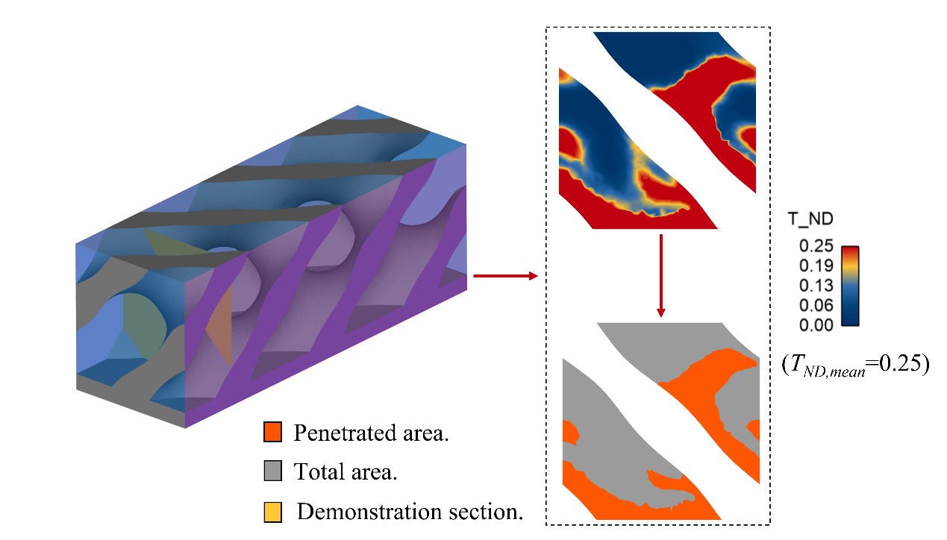
Fig. 1 | Demonstration of enthalpy penetration
The enthalpy penetration length (l) is defined as the length from the inlet position where $ϵ_{e}$ has reached 100%. Taking Fig. 2 as an example, l is taken as the x value at x/x_{max}= 0.3 for TPMS structure.
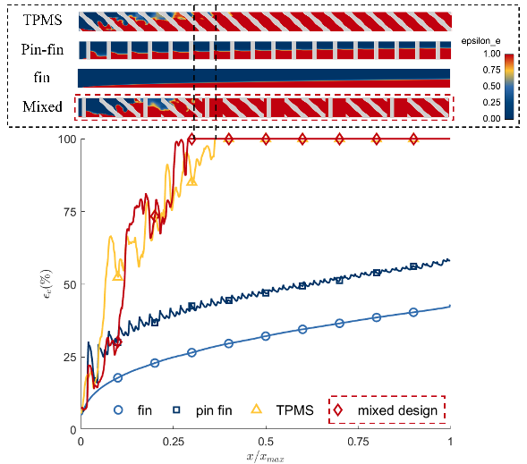
Fig. 2 | Fluid enthalpy penetration ratio under adiabatic walls case
The thermal resistance (R) is defined as:
$$\begin{aligned}R=\frac{T_{heated}-T_{ln}}{q"A_{heated}}\#\left(6\right)\end{aligned}$$
In which $T_{ln}$ is calculated as:
$$\begin{aligned}T_{ln}=\frac{T_{out}-T_{in}}{ln\frac{T_{out}}{T_{in}}}\#\left(7\right)\end{aligned}$$
With T_{out} as the outlet temperature, T_{in} as the inlet temperature, T_{ln} represents the logarithm mean temperature of fluid at the inlet and the outlet.
With such a definition, R represents the overall temperature increase of the test structure per unit heat input. This gives a direct demonstration of how well the test structure performs thermally. The higher R is, the worse the test structure performs.
The fluid average temperature (T_{m}) is calculated as:
$$\begin{aligned}T_{m}=T_{in}+\frac{q"xw}{\dot{m}c_{p}}\#\left(8\right)\end{aligned}$$
With x as the distance from flow inlet, w as the width of the channel, T_{m} represents the mean temperature of flow at the cross section with a distance of x from the inlet that is oriented parallel to the inlet.
The Biot number (Bi) is defined as:
$$\begin{aligned}Bi=\frac{hD_{H}}{k_{solid}}\#\left(9\right)\end{aligned}$$
In this equation, k_{solid} is the conductivity of solid. h is the convective heat transfer coefficient of fluid within the structure, which is defined as:
$$\begin{aligned}h=\frac{q"}{T_{heated}-T_{ln}}\#\left(10\right)\end{aligned}$$
To ensure that the convective heat transfer coefficient is only relevant to fluid performance, the isothermal case is used for the calculation of h. Here, $q"$ is gained by taking the area-averaged calculated heat flux of the whole contact surface with Ensight for each case.
To investigate the uniformity of heated surface in solid-fluid conjugate cases, nondimensional temperature standard deviation ($σ_{T}$) is introduced as:
$$\begin{aligned}σ_{T}=\frac{\int_{A}{{\left(T_{local}-\overline{T}\right)}^{2}dA}}{\left(T_{out}-T_{in}\right)\int_{A}{dA}}\#\left(11\right)\end{aligned}$$

Supplementary Note 2
CFD Simulation
To get well-converged CFD simulation result, the first step to do is to generate high-quality mesh. In the present study, two conventional structures were studied. Those two structures were simply generated with Pointwise through extrusion. For TPMS and mixed design structures, primary surface meshes were firstly produced by MathMod.
(a)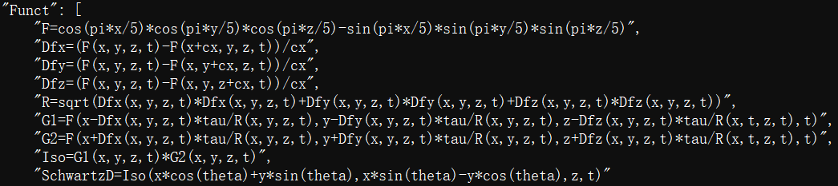
(b)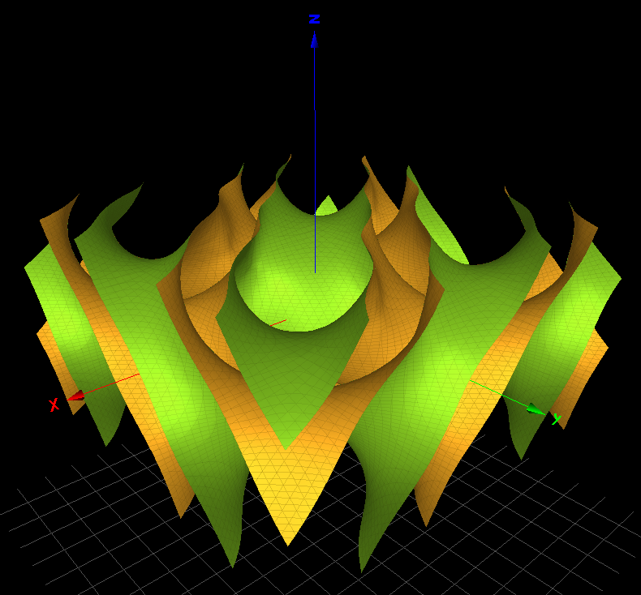
Fig. 3 | MathMod surface generation. a. Governing functions in MathMod. b. Surfaces generated by MathMod.
The F function in Fig. 3.a is the governing equation of the surfaces of Shwartz-D structure is as shown by Eqn. (11).
$$\begin{aligned}F=\cos\left(\frac{πx}{5}\right)\cos\left(\frac{πy}{5}\right)\cos\left(\frac{πz}{5}\right)-\sin\left(\frac{πx}{5}\right)\sin\left(\frac{πy}{5}\right)\sin\left(\frac{πz}{5}\right)\#\left(12\right)\end{aligned}$$
Then, the surface was translated to create two parallel surfaces with distance of 1mm from each other with the function provided in Fig. 3.a.

Supplementary Note 3
Post-processing of simulation data
Post-processing was done by Ansys Ensight. Temperature contours and flow paths were created. Temperature results from CFD simulation were exported to Ensight for thermal resistance calculation under different Bi with the journal function. 225 sets of data were post-processed separately. The average temperature of the heated surface, the inlet, and the outlet was calculated and output with Ensight. Then, data were read into MATLAB so that the logarithm mean temperature and the overall thermal resistance can be calculated. By matching the thermal resistance data with Bi, the R vs Bi plot can be gained with MATLAB.
The plot of $ϵ_{e}$ was also done with Ensight. Firstly, the average temperature was calculated by energy equilibrium. Then, different temperature on different cross-sectional surfaces with different distance from the inlet surface was applied to create iso-temperature surfaces on each surface. The surface area of the iso-temperature surfaces is divided by the total surface area of each surface to gain the value of $ϵ_{e}$ on each location. Such results were output into MATLAB to gain the final plot.
The cross-sectional temperature distribution was done in Ensight by simply taking the cross section of fluid in the middle between the two periodic surfaces and coloring the surface with $ϵ_{e}$.
The flow pathline that demonstrated the fluid mixing was created in Ensight by adding a horizontal line in the beginning of fin structures. Particles were released from the line for motion tracking. The movement was captured and combined into flow paths. Then, they were colored with T_{ND} or blue and red colors for different use of demonstration.

Supplementary Note 4
Manufacture of fins
All types of fins were manufactured with additive manufacturing (i.e., metal 3D-printing) service provided by Zhilei 3D printing factory, Wuhan, China, and Mohou 3D printing factory, Beijing, China. The model for manufacture was created with CAE software. For simple structure as fins and pin fins, it was directly drawn and extruded in Solidworks to create 3D models. For TPMS structure, it was first generated in Ansys Spaceclaim with a period of 5mm and a thickness of 1mm and then exported to Solidworks for post-processing. All the models were then exported as STL files and sent to the manufacturers for manufacture.

Supplementary Note 5
Experimental data acquisition
During measurement, all data were acquired with NI LabView. Firstly, flowrate was measured by the flowmeter and adjusted by the Arduino UNO board to be the desired value. Then, the heating plate was turned on to give the desired power output. Inlet and outlet temperature was measured by the two thermal couples inserted directly to the inlet and outlet positions of the channel. Temperature and water flowrate data were all gained with NI 9982 DAQ into LabView and stored in computer for post-processing. The output power data of the heating plate was taken down by hand from the power box.
After all data were taken, they were all output to MATLAB for post-processing. The temperature contour data measured by the IR camera was averaged as area-weighted temperature data. Afterwards, for the sake of accuracy, the outlet temperature was calculated through energy balance with the measured water flowrate. The logarithm mean temperature was then calculated. Finally, the thermal resistance was calculated with all the pre-calculated data. The calculated thermal resistance data was averaged and plotted with MATLAB as the final experimental result.
The experimental data were acquired with NI LabView. The data acquisition program was as shown in Fig. 3. Temperature contour of the heated plate was gained with Hikmicro IR camera.
(a)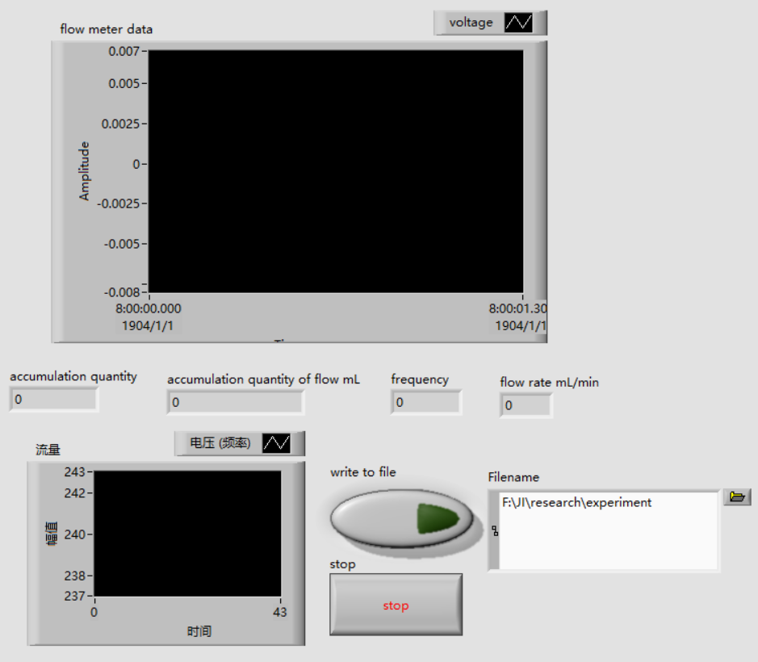
(b)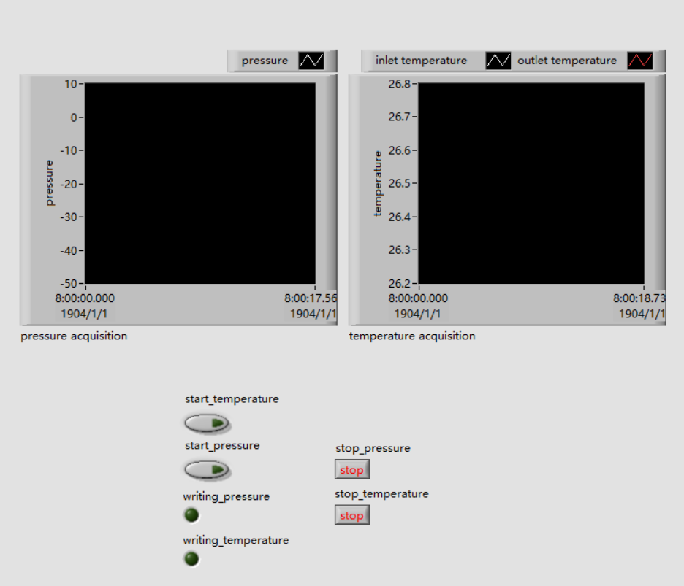
Fig. 3 | Data acquisition program. a. Flow rate acquisition program. b. Temperature acquisition program
Data acquired by the two acquisition programs are: (i) Inlet water temperature (T_{in}). (ii) Temperature contour of the heated plate (T_{heated}). (iii) Flow rate ( $\dot{V}$). (iv) Total power of the heated plate (q).
The contour plot of the temperature of the heated plate is done by MATLAB as shown in Fig. 4.
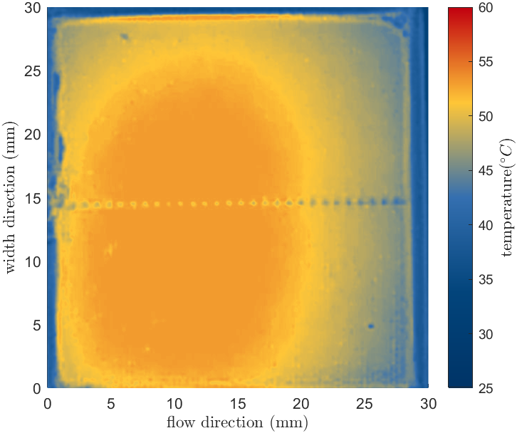
Fig. 4 | Temperature contour of heated plate
All data are acquired and output as .csv file to MATLAB for post-processing. A total 5 sets of above data are measured for each structure under one silicon grease condition. Silicon grease is removed and re-applied between the structure and the heated plate for three separated times for each structure to eliminate the influence of silicon grease. With the above procedure, 15 sets of data are gained for each structure for post-processing.
The MATLAB program calculates the outlet temperature with Eqn. 8 by taking x as the full length of the test part, and w as the width of the test part; It calculates the thermal resistance with Eqn. 6. All data are post-processed to make the box plot shown in the article. (Fig. 4)
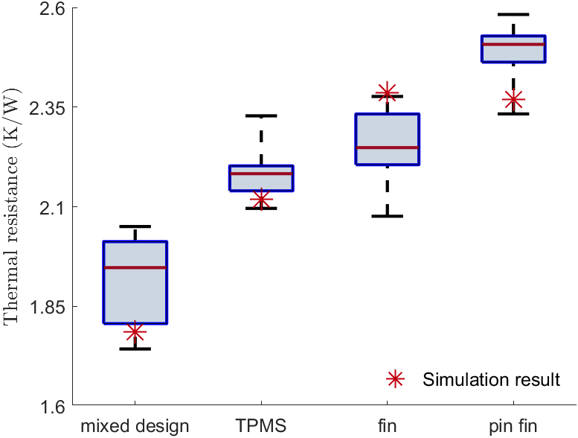
Fig. 5 | Box plot demonstration from MATLAB
From the above to the bottom, the whiskers on the box plot represents the following meanings: (i) Maximum (or Q₄ percentile), demonstrating the highest value of data; (ii) Third quartile (Q₃), demonstrating the middle value between Maximum and median value (iii) Median (or Q₂ percentile), demonstrating the middle value of data; (iv) First quartile (Q₁), demonstrating the middle value between median and minimum value; (v) Minimum (or Q₀ percentile), demonstrating the lowest value of data.

