eTable 1: List of sources used in systematic literature search
DATABASES
- Pubmed/medline
- Scopus
- Web of Science
- Embase
METASEARCH ENGINES
- Trip Database
- Epistemonikos
CPG DEVELOPER ORGANIZATIONS / CPG REPOSITORIES/DATABASES
- Guidelines International Network (GIN)
- National Institute for Clinical Excellence (UK)
- Guideline Central
- ECRI Guidelines Trust Database
- Canadian Medical Association Infobase of Clinical Practice Guidelines
- WHO guidelines
- US Preventive Services Task Force Guideline
- Scottish Intercollegiate Guidelines Network (SIGN)
- GuíaSalud, organismo del Sistema Nacional de Salud (SNS)
OPHTHALMOLOGY ASSOCIATIONS
- Pan American Association of Ophthalmology
- European Society of Ophthalmology
- American Academy of Ophthalmology
- International Council of Ophthalmology
- Royal Australian and New Zealand College of Ophthalmologists
- Royal College of Ophthalmologists
- European Vitreoretinal Society
- African Ophthalmology Council
- Asia Pacific Academy of Ophthalmology
- Sociedad Española de Retina y Vítreo
- Sociedad Española de Oftalmología
- EURETINA

eTable 2: Systematic literature search strategy and retrieved records.
N° | Source | URL | Search strategy | Records retrieve
DATABASES
1 | Pubmed/Medline | https://pubmed.ncbi.nlm.nih.gov/ | Item 1: (("Retinal Vein Occlusion"[Mesh] ) OR (Occlusion, Retinal Vein[Title/Abstract] OR Retinal Vein Occlusions[Title/Abstract] OR Vein Occlusion, Retinal[Title/Abstract] OR Retinal Vein Thrombosis[Title/Abstract] OR Retinal Vein Thromboses[Title/Abstract] OR Vein Thrombosis, Retinal[Title/Abstract] OR Thrombosis, Retinal Vein[Title/Abstract] OR Central Retinal Vein Occlusion[Title/Abstract] OR Branch Vein Occlusion[Title/Abstract] OR Branch Vein Occlusions[Title/Abstract] OR Occlusion, Branch Vein[Title/Abstract] OR Vein Occlusion, Branch[Title/Abstract] OR Retinal Branch Vein Occlusion[Title/Abstract]))  Item 2: (((clinical[tiab] AND pathway[tiab]) OR (clinical[tiab] AND pathways[tiab]) OR (practice[tiab] AND parameter[tiab]) OR (practice[tiab] AND parameters[tiab]) OR algorithms[mesh:noexp] OR care pathway[tiab] OR care pathways[tiab] OR clinical protocols[mesh:noexp] OR Consensus[mesh:noexp] or consensus development conference[pt:noexp] OR "Consensus Development Conference, NIH"[pt:noexp] OR "Consensus Development Conferences as Topic"[Mesh:noexp] OR "Consensus Development Conferences, NIH as Topic"[Mesh:NoExp] OR critical pathway[mesh:noexp] OR guidance[tiab] OR guideline*[ti] OR guidelines as topic[mesh:noexp] OR practice guidelines as topic[mesh:noexp] OR Health Planning Guidelines[mesh:noexp] OR practice guideline[mesh:noexp] OR "Practice Patterns, Physicians'"[Mesh:NoExp]))  Item 3: #1 AND #2 | 86 records  Selected: 4  - Retinal vein occlusion (RVO) guideline: executive summary  - Retinal Vein Occlusions Preferred Practice Pattern®  - Guidelines for the Management of Retinal Vein Occlusion by the European Society of Retina Specialists (EURETINA)  - Optimal Treatment of Retinal Vein Occlusion: Canadian Expert Consensus
2 | Scopus | https://www.scopus.com/home.uri | Item 1: (TITLE-ABS-KEY ( "Retinal Vein Occlusion*" ) OR TITLE-ABS-KEY ( "Retinal Vein Thrombos*" ) OR TITLE-ABS-KEY ( "Central Retinal Vein Occlusion" ) OR TITLE-ABS-KEY ( "Branch Vein Occlusion" ) )  Item 2: ( TITLE-ABS-KEY ( guideline ) OR TITLE-ABS-KEY ( consensus ) OR TITLE-ABS-KEY ( "clinical pathway" ) OR TITLE-ABS-KEY ( algorithms ) OR TITLE-ABS-KEY ( "clinical protocol*" ) OR TITLE-ABS-KEY ( "clinical practice guideline" ) OR TITLE-ABS-KEY ( "Practice Patterns" ) OR TITLE-ABS-KEY ( "practice guideline" ) )  Item 3: #1 AND #2 | 279 records  Selected: 4  - Retinal vein occlusion (RVO) guideline: executive summary  - Retinal Vein Occlusions Preferred Practice Pattern®  - Guidelines for the Management of Retinal Vein Occlusion by the European Society of Retina Specialists (EURETINA)  - Optimal Treatment of Retinal Vein Occlusion: Canadian Expert Consensus
3 | Web of Science | https://www.webofscience.com › wos | ((((TI=(“Retinal Vein Occlusion" OR "Retinal Vein Thrombosis" OR "Central Retinal Vein Occlusion" OR "Branch Vein Occlusion" )) OR AB=(“Retinal Vein Occlusion" OR "Retinal Vein Thrombosis" OR "Central Retinal Vein Occlusion" OR "Branch Vein Occlusion" )) OR AK=(“Retinal Vein Occlusion" OR "Retinal Vein Thrombosis" OR "Central Retinal Vein Occlusion" OR "Branch Vein Occlusion" )) OR KP=(“Retinal Vein Occlusion" OR "Retinal Vein Thrombosis" OR "Central Retinal Vein Occlusion" OR "Branch Vein Occlusion" ) AND (((TI=(Guideline OR consensus OR "clinical pathway" OR algorithms OR "clinical protocol" OR "clinical practice guideline" OR "Practice Patterns" OR "practice guideline")) OR AB=(Guideline OR consensus OR "clinical pathway" OR algorithms OR "clinical protocol" OR "clinical practice guideline" OR "Practice Patterns" OR "practice guideline")) OR AK=(Guideline OR consensus OR "clinical pathway" OR algorithms OR "clinical protocol" OR "clinical practice guideline" OR "Practice Patterns" OR "practice guideline")) OR KP=(Guideline OR consensus OR "clinical pathway" OR algorithms OR "clinical protocol" OR "clinical practice guideline" OR "Practice Patterns" OR "practice guideline")) | 127 records  Selected: 4  - Retinal vein occlusion (RVO) guideline: executive summary  - Retinal Vein Occlusions Preferred Practice Pattern®  - Guidelines for the Management of Retinal Vein Occlusion by the European Society of Retina Specialists (EURETINA)  - Optimal Treatment of Retinal Vein Occlusion: Canadian Expert Consensus
4 | Embase | https://www.embase.com | ('guideline' OR 'practice guideline' OR 'consensus' OR 'recommendations' OR 'clinical pathway' OR 'algorithm' OR 'protocol') AND ('retina vein occlusion'/exp OR 'retina vein occlusion') | 481 records  Selected: 4  - Retinal vein occlusion (RVO) guideline: executive summary  - Retinal Vein Occlusions Preferred Practice Pattern®  - Guidelines for the Management of Retinal Vein Occlusion by the European Society of Retina Specialists (EURETINA)  - Optimal Treatment of Retinal Vein Occlusion: Canadian Expert Consensus
METASEARCH ENGINES
1 | Trip Database | https://www.tripdatabase.com/ | Search: “retinal vein occlusion” Filters: Guidelines | 9 records  1 selected, already included:  Retinal Vein Occlusion (RVO) UK Guidelines 2015 Royal College of Ophthalmologists
2 | Epistemonikos | https://www.epistemonikos.org/en/ | (title:(Guideline OR consensus OR recommendation OR patterns OR pathway OR protocol) OR abstract:(Guideline OR consensus OR recommendation OR patterns OR pathway OR protocol)) AND (title:("retinal vein occlusion" OR "retina vein occlusion") OR abstract:("retinal vein occlusion" OR "retina vein occlusion")) | 36 records  2 records in French  No CPG.
CPG DEVELOPER ORGANIZATIONS / CPG repositories/databases

1 | Guidelines International Network | https://g-i-n.net/international-guidelines-library/ | “retinal vein occlusion” | 1 record  Selected: 0  GPC: Therapie der retinalen Venenverschlüsse mit intravitrealer Medikamenteneingabe und Laserkoagulation. S2e-LL (DOG)  Deleted:  Language: German  In process: Register date: September 2020 Estimated completion date: May 2023
2 | National Institute for Clinical Excellence (UK) | https://www.nice.org.uk/guidance | “retinal vein occlusion” | 4 records  Selected: 0  - Aflibercept for treating visual impairment caused by macular edema after branch retinal vein occlusion Technology appraisal guidance [TA409] Published: 28 September 2016  - Aflibercept for treating visual impairment caused by macular edema secondary to central retinal vein occlusion Technology appraisal guidance [TA305]Published: 26 February 2014  - Ranibizumab for treating visual impairment caused by macular edema secondary to retinal vein occlusion Technology appraisal guidance [TA283]Published: 22 May 2013  - Dexamethasone intravitreal implant for the treatment of macular edema secondary to retinal vein occlusion Technology appraisal guidance [TA229]Published: 27 July 2011  All were health technology assessments, no one were guidelines.
3 | Guideline Central | https://www.guidelinecentral.com/guidelines/ | “retinal vein occlusion” | 1 Record  Selected: 1  Flaxel, C. J., Adelman, R. A., Bailey, S. T., Fawzi, A., Lim, J. I., Vemulakonda, G. A., & Ying, G. (2019). Retinal Vein Occlusions Preferred Practice Pattern®. Ophthalmology. doi:10.1016/j.ophtha.2019.09.029
4 | ECRI Guidelines Trust Database | https://www.ecri.org/library/ | “retinal vein occlusion” | 0 records
5 | Canadian Medical Association Infobase of Clinical Practice Guidelines | https://joulecma.ca/cpg/homepage | “retinal vein occlusion” | 0 records
6 | WHO guidelines | https://www.who.int/publications/i?publishingoffices=c09761c0-ab8e-4cfa-9744-99509c4d306b | “retinal vein occlusion” | 0 records
7 | US Preventive Services Task Force Guideline | https://www.uspreventiveservicestaskforce.org/uspstf/topic_search_results?topic_status=P | “retinal vein occlusion”/ Vision and Hearing Disorders filter | 7 records  Selected: 0
8 | Scottish Intercollegiate Guidelines Network (SIGN) | https://www.sign.ac.uk/our-guidelines/ | “retinal vein occlusion” | 0 records
9 | GuíaSalud, organismo del Sistema Nacional de Salud (SNS) | https://portal.guiasalud.es/gpc/?_sfm_wpcf-estado=1 | “oclusión venosa de la retina” OR “oclusiones venosas de la retina” | 0 records
OPHTHALMOLOGY ASSOCIATIONS
1 | Pan American Association of Ophthalmology | https://paao.org/es/resources/ | “retinal vein occlusion” | 0 records
2 | European Society of Ophthalmology | https://soevision.org/ |  | 0 records
3 | American Academy of Ophthalmology | https://www.aao.org/guidelines-browse | Subspeciality: Retina/vitreous  Guidelines | 1 record  Selected: 1  Retinal Vein Occlusions PPP 2019
4 | International Council of Ophthalmology | https://icoph.org/eye-care-delivery/ico-international-clinical-guidelines-and-resources/ | - | 0 records
5 | Royal Australian and New Zealand College of Ophthalmologists | https://ranzco.edu/home/policies-and-guidelines/professional-and-clinical-guidelines/ | “retinal vein occlusion” | 0 records
6 | Royal College of Ophthalmologists | https://www.rcophth.ac.uk/standards-and-guidance/ | “retinal vein occlusion”/guideline | 1 record  Selected: 1  Retinal Vein Occlusion (RVO) Guidelines 17 FEB 2022
7 | European Vitreoretinal Society | http://www.evrs.eu/ | - | 0
8 | African Ophthalmology Council | http://www.aofsite.org/en/ | “retinal vein occlusion” | 0
9 | Asia Pacific Academy of Ophthalmology | https://apaophth.org/ | - | 0
10 | Sociedad Española de Retina y Vítreo | https://serv.es/publicaciones/guias-practica-clinica/ | - | Record:1  Selected: 1  “Manejo de las oclusiones venosas de la retina” guideline, SERV 2021.
11 | Sociedad Española de oftalmología | https://www.oftalmoseo.com/ | - | 0
12 | EURETINA | https://euretina.org/resource/?tag=euretina-guidelines | - | Record:1  Selected: 1  Guidelines for the Management of Retinal Vein Occlusion by EURETINA

eFigure 1: PRISMA flowchart summarizing the results of the screening and selection process of CPG for the diagnosis and management of RVO.
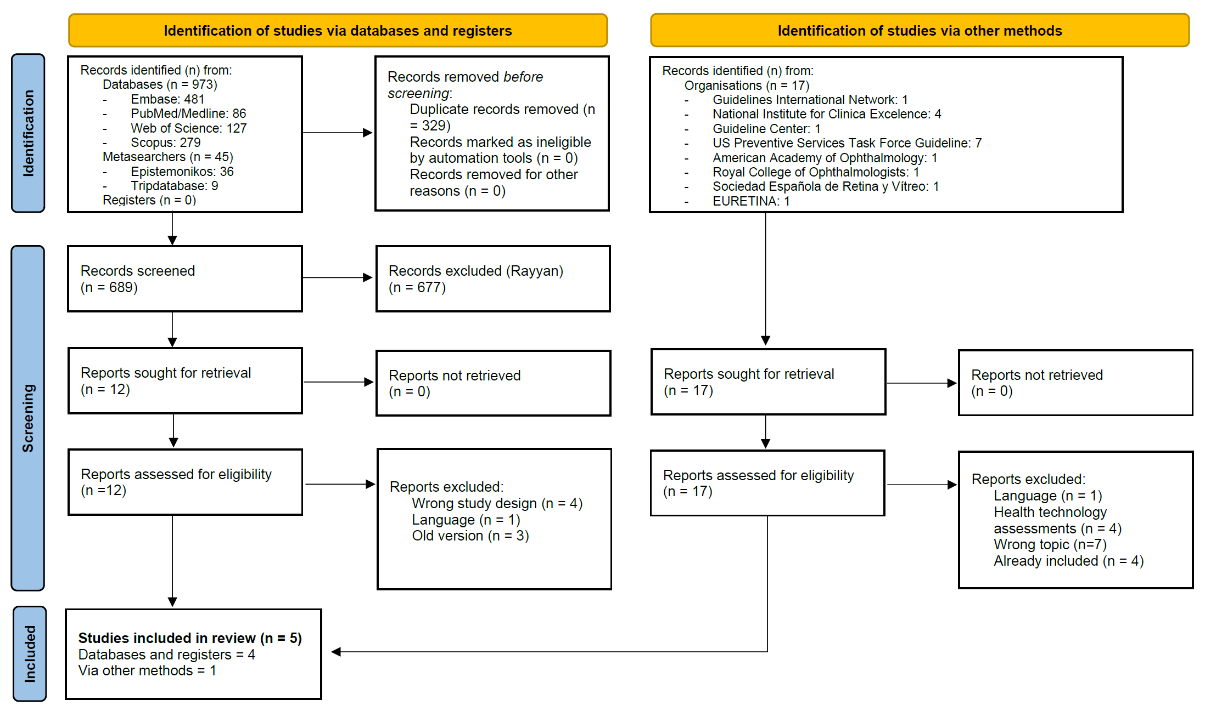

eTable 3: Clinical recommendations applicable for developing countries.
Risk factor for RVO | Hypertension, glaucoma, advanced age, heart attack history and stroke. Under 50 years old hypertension and hyperlipidemia are risk factors.
Diabetes | Probably not directly, but increase other risk factors.
Antiphospholipid syndrome | In the absence of risk factors, in patients under 50 years of age, or in bilateral cases.
Thrombophilia tests | No rutinary.  Thrombophilic abnormality does not alter management options or predict prognosis.
Anticoagulation or antiplatelet therapy | Not enough effectiveness
Ophthalmology role | Refer patients to a primary care physician.
Anti-VEGF therapy | Bevacizumab:  Macular edema due to CRVO (monthly and PRN regimens).  Ranibizumab:  Macular edema secondary to BRVO and CRVO  Aflibercept:  Macular edema secondary to BRVO and CRVO
Intravitreal steroids | First-line for patients with recent history of a major cardiovascular  event or who are unwilling to come for monthly injections (and/or monitoring) in the first 6 months of therapy
Pan Retinal Photocoagulation (PRP) | Iris new vessels (NVI) or angle new vessels (NVA) are visible.  PRP may be useful in preventing vitreous hemorrhage.
Sectorial laser | BRVO: Disc or retinal neovascularization
Grid laser | Focal laser photocoagulation as a second-line in ME secondary to BRVO
Neovascularization | Open anterior chamber angle: urgent anti-VEGF with PRP within the same day (prior to anti-VEGF treatment) or within 2 weeks initially.  PRP plus intravitreal bevacizumab (off license) can be repeated if NVI / NVA persist.
Follow-up / Stop /Stability | Monthly follow-up period for at least 1 year
Economic recommendation | Not applicable for developing countries

