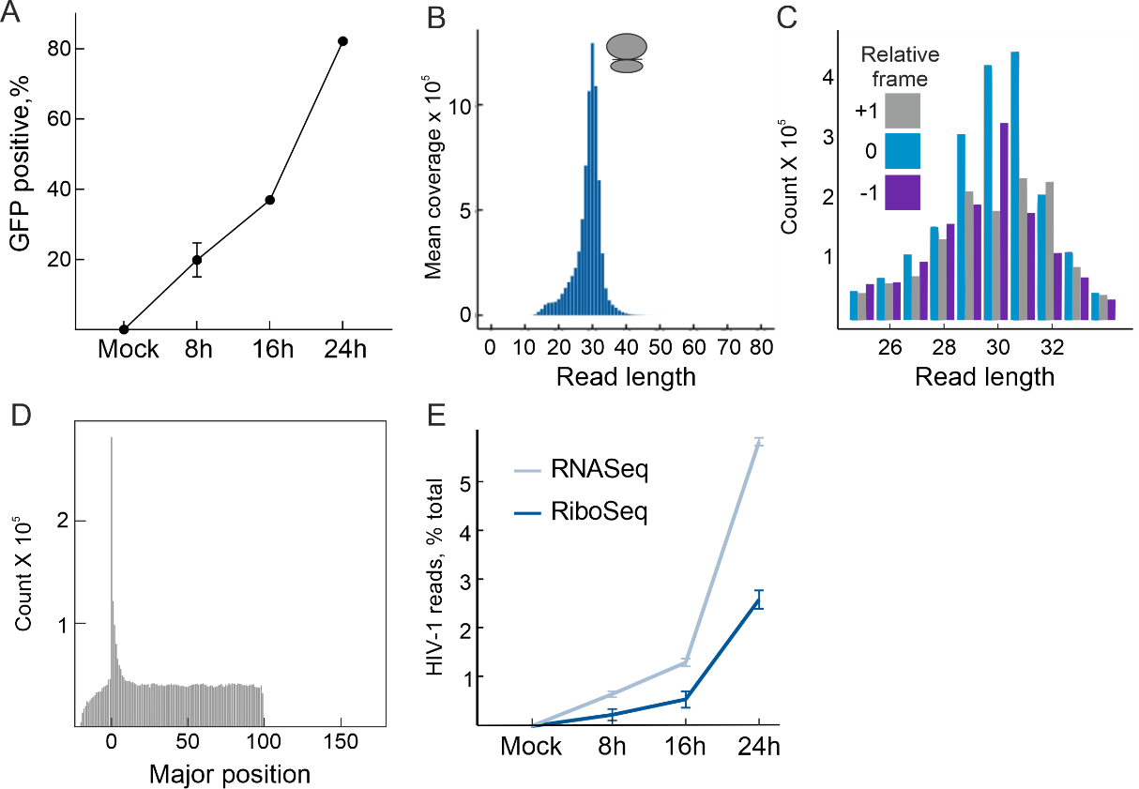
Supp. Figure 1: Related to Figure 1. (A) Flow cytometry based detection of GFP- expressing cells, indicating SupT1 cells infected with the HIV-iGFP virus. Read length (B) and frame distribution (C) distribution of all transcripts obtained from ribosome profiling libraries prepared from RNaseI- treated SupT1 cell lysates. (D) The number of reads starting within coding transcripts. The x axis is the relative position of the read start within the three regions (5'-UTR: <0; CDS: 0-100; 3'-UTR: >100). The major isoform is used as reference for each gene (the longest coding transcript). (E) Proportions of total RNASeq and RiboSeq reads mapping to HIV at each timepoint of infection.

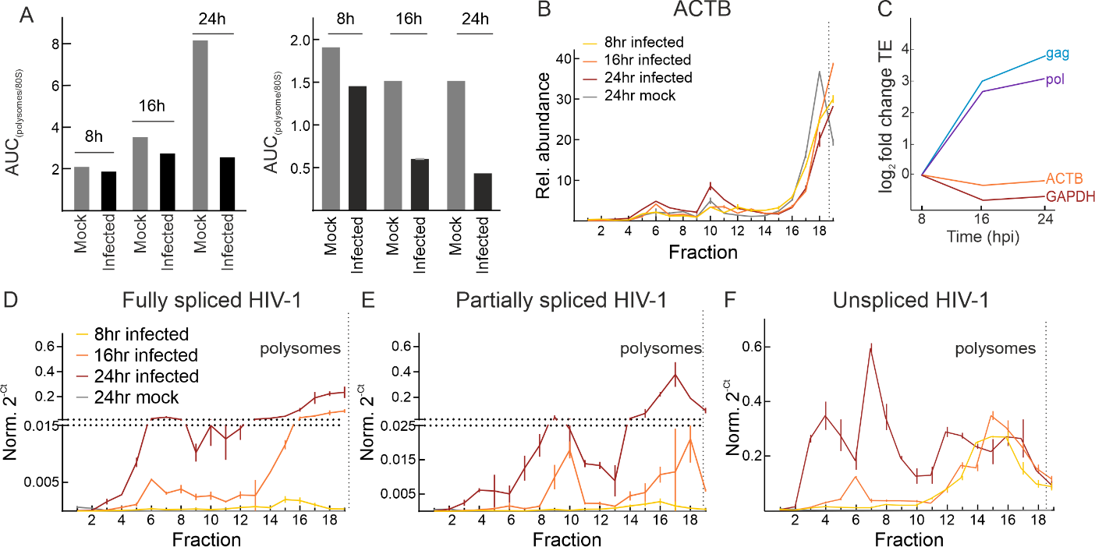
Supp. Fig. 2: Related to Figure 2. (A) Ratio of area under the curve (AUC) of 80S and polysome peaks for each timepoint of infection for both replicates. B) Relative abundance of ACTB along the polysome profile at each time point of infection and error bars display the ± SD of qPCR replicates. (C) Change in translation efficiency (calculated using RiboSeq data) of HIV genes – Gag, Pol and host genes – GAPDH, ACTB compared to 8 hours post infection. (D-F) Normalized 2^{-Ct} of HIV-1 RNAs was determined in all fractions and error bars display the ± SD of qPCR replicates.

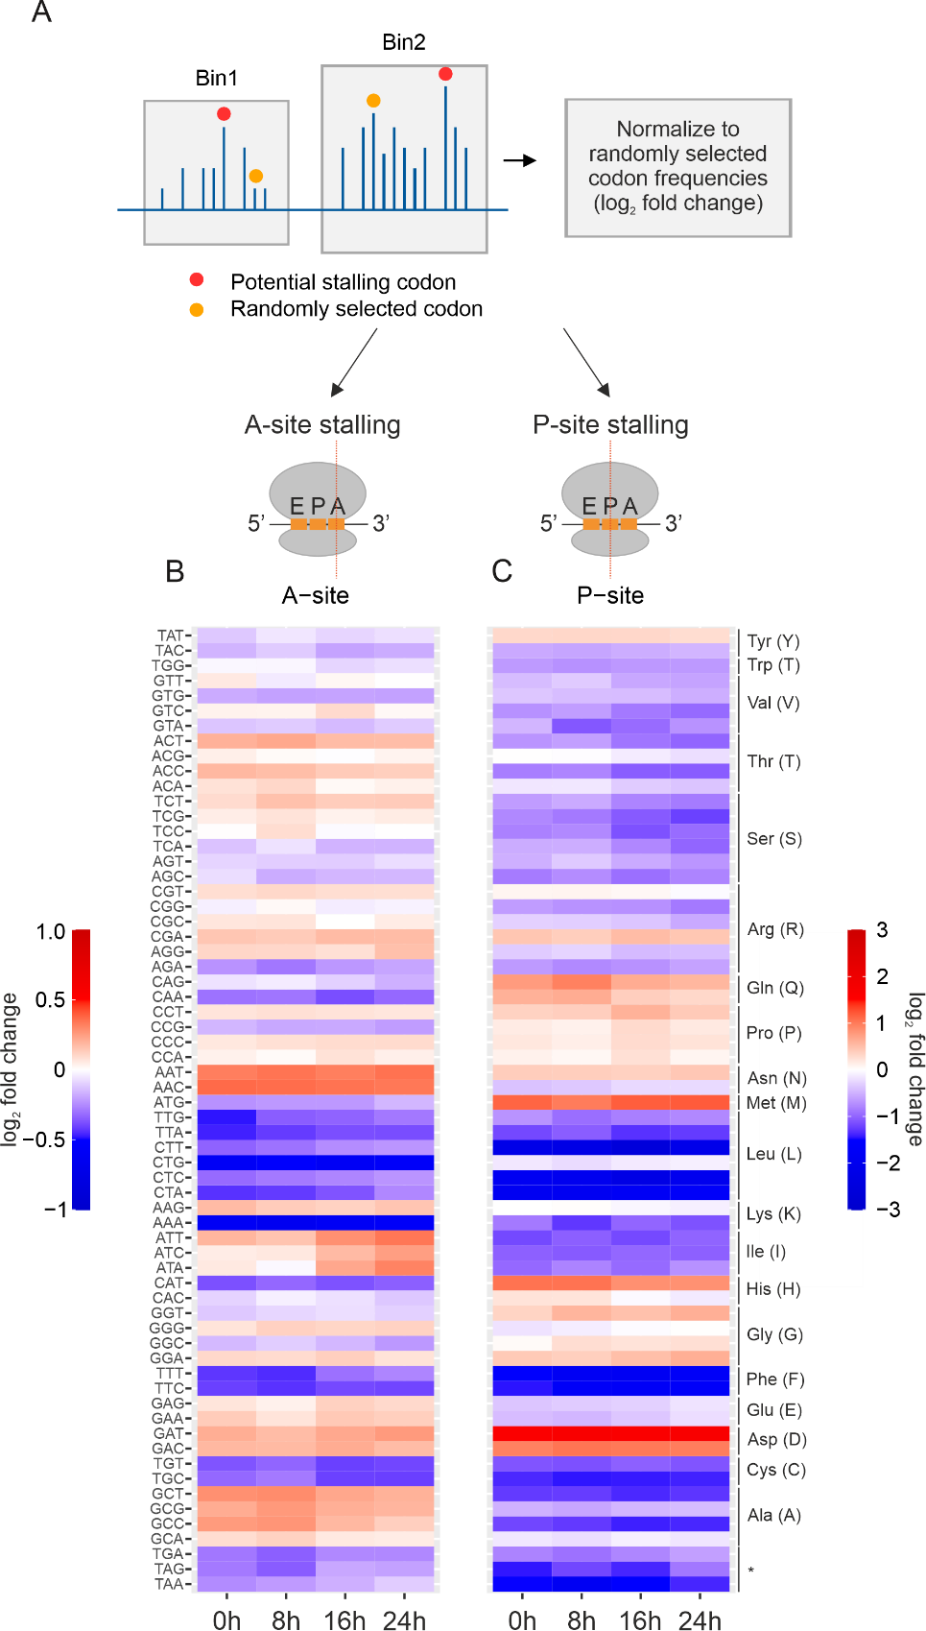
Supp. Figure 3: (A) Schematic representation of the human genome wide, codon specific stalling patterns. Bins are separated based on genomic distance and the first 5 codons of annotated coding sequences are excluded from analysis. Codon specific stalling in the (B) A-site and (C) P-site on a genome wide scale. Fold change (log₂) between randomized control (sampled 1000 times) and observed stalling frequencies of the codons are plotted at each timepoint.

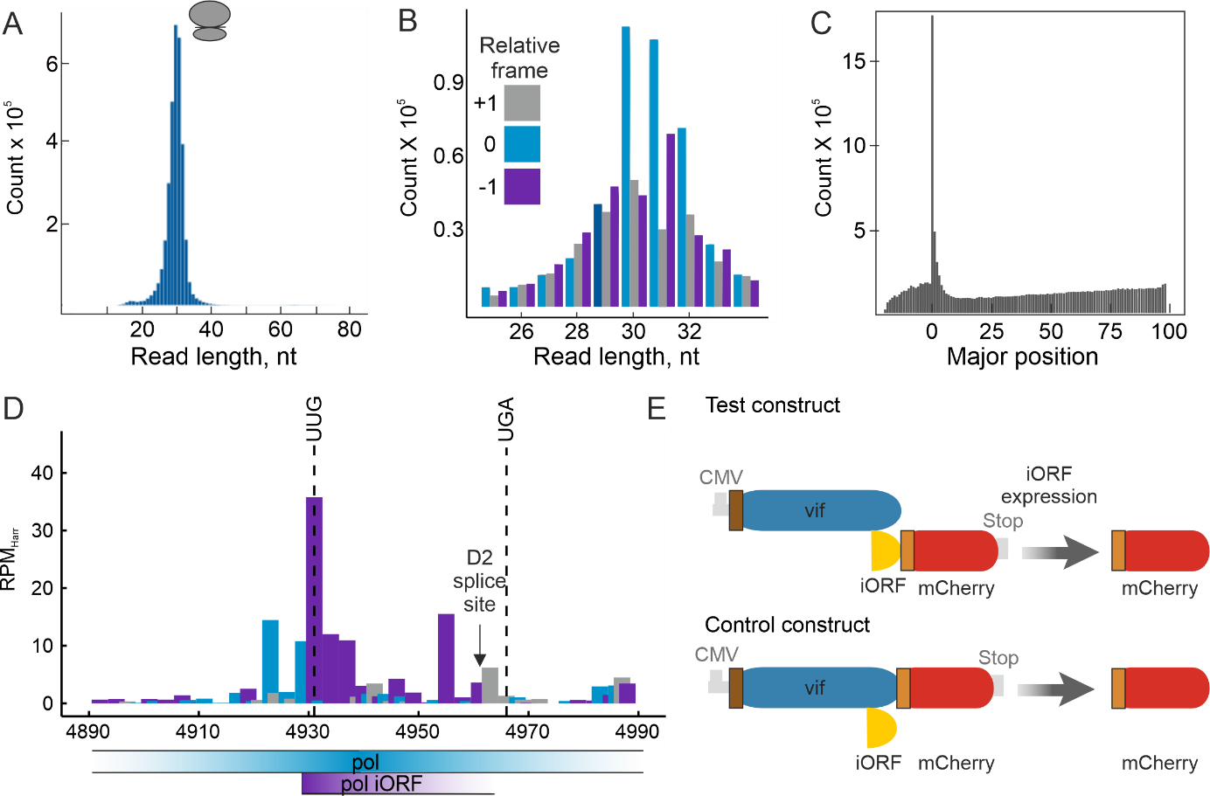
Supp. Figure 4: Related to Figure 4. Read length (A) and frame distribution (B) distribution of all transcripts obtained from harringtonine-treated ribosome profiling libraries prepared from SupT1 cell lysates. (C) The number of reads starting within coding transcripts for the Harringtonine RiboSeq dataset. The x axis is the relative position of the read start within the three regions (5'-UTR: <0; CDS: 0-100; 3'-UTR: >100). The major isoform is used as reference for each gene (the longest coding transcript). (D) Potential iORF in the viral Pol gene observed in cycloheximide RiboSeq data. The iORF encodes for twelve amino acids. However, the splice donor site D2 is located just before the annotated stop codon. (E) Fluorescence based- reporter assay to confirm in vitro expression of novel iORF in the HIV-1 Vif gene.

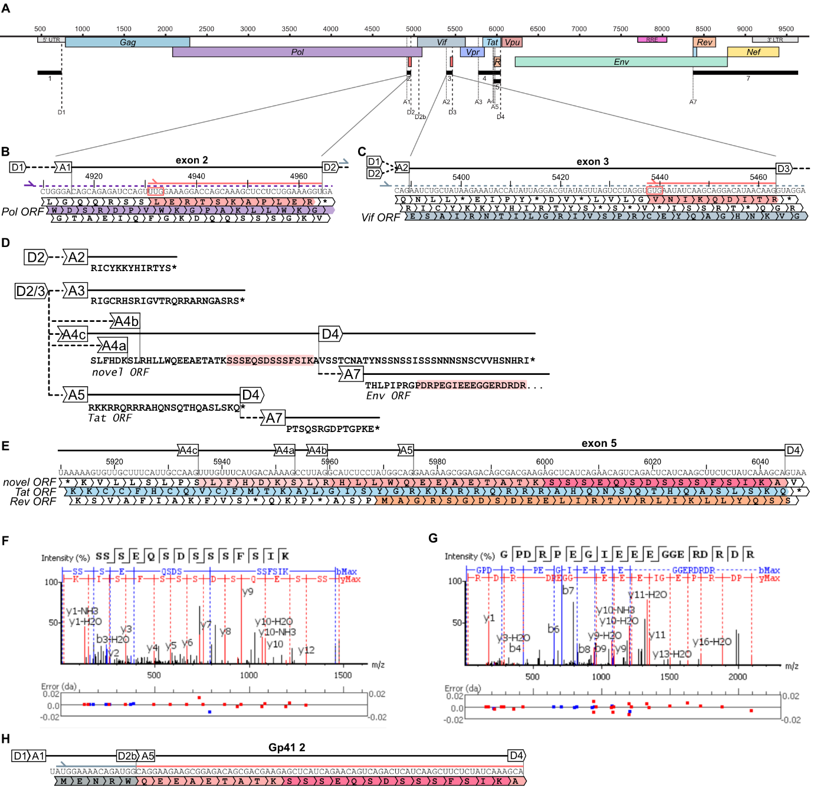
Supp. Figure 5: Related to Figure 4. (A) Schematic of HIV genome structure including major splice donor and acceptor sites, ORFs and exons. (B) Schematic of Pol iORF located within exon 2. (C) Schematic of Vif iORF located within exon 3. (D) Schematic showing translation products of Pol or Vif iORF spliced at D2/D3 respecitively to different acceptor sites. (E) Schematic showing translation frames of exon 5 with novel ORF colored in light red and unique peptide in pink. (F-G) Annotated fragmentation spectrum and delineated sequence fragmentation of (F) novel peptide encoded in exon 5 and (G) detected peptide of Env ORF after further translation across the D4A7 splice site, indicative of the confidence of the peptide identification. (H) Potential alternative source of the detected peptides from a cryptic D2bA5 splice event leading to transcript Gp41 2.

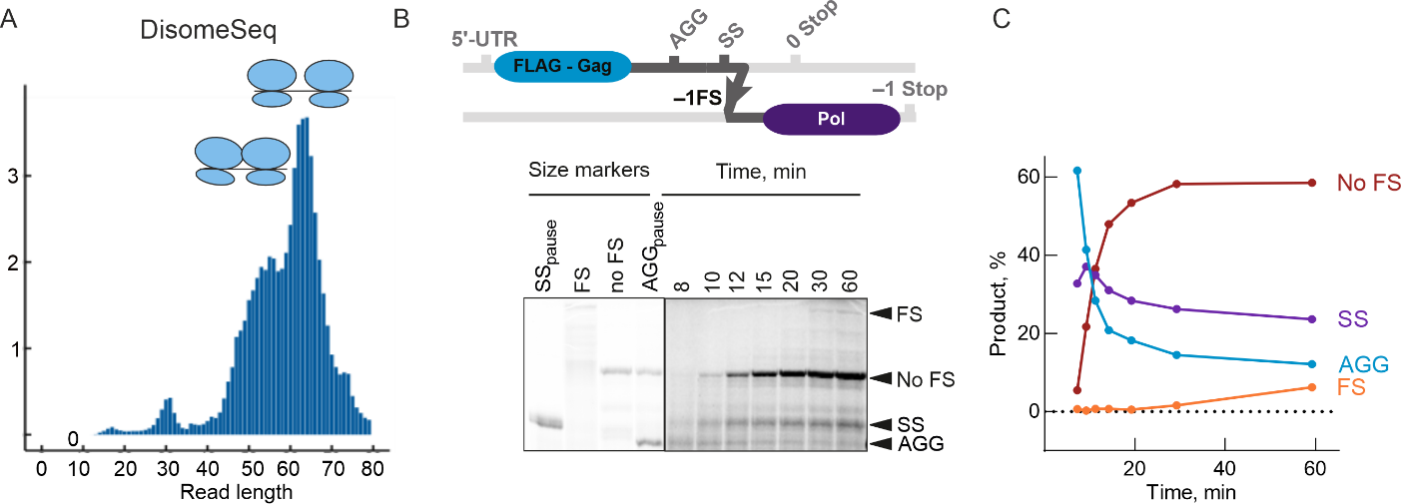
Supp. Figure 6: Related to Figure 5. (A) Read length distribution of all transcripts obtained from disome profiling libraries prepared from SupT1 cell lysates. (B) Schematics of the N-terminal FLAG-tagged frameshifting reporter consisting of the nucleotides 64 – 2687 (Δ1870 - 1881) of the HIV-1 genome (up). Time course of translation of reporter mRNA and controls in RRL (bottom). Briefly, in vitro transcribed reporter RNA was translated in RRL, after 3 min further initiation was halted by the addition of harringtonine, and aliquots were removed at various times and analyzed by SDS–PAGE. Size marker RNAs were similarly translated and analyzed to show the expected size of the ribosomal pause product (See also Methods). (C) The % product was quantified from the western blot and is plotted against time.

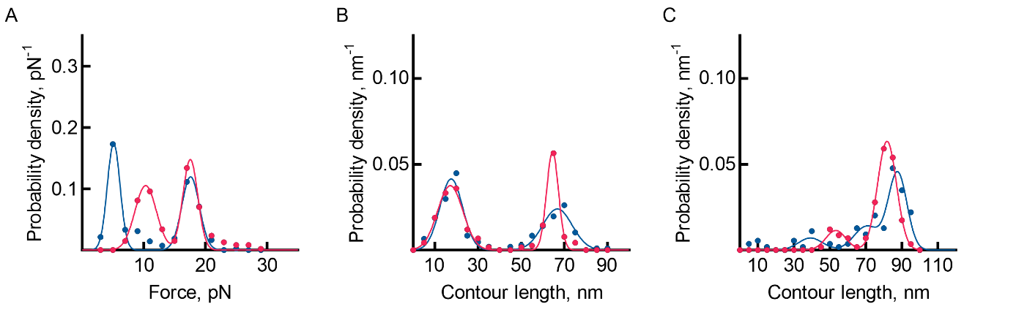
Supp. Figure 7: Related to Figure 6. Distributions of the force (A), contour length changes (B) and total contour length (C) for HIV-1 WT FSE. The unfolding and refolding distributions are colored in red and blue, respectively.

