For submission to Nature Photonics
Supplementary Information
for
Unveiling the Intrinsic Photophysics in Quasi-2D Perovskites
Bo-Han Li ^{a, d, †}, Haipeng Di ^{b, †}, Huang Li ^{a, c, †}, Jia-Cheng Wang ^{a, e}, Wen Zeng ^{a, e}, Da-Bing Cheng ª, Chuanyao Zhou ª, Xingan Wang ^{c}, Yan Shi ^{b}, Jiangfeng Song ^{b}, Yiying Zhao ^{b, *}, Xueming Yang ^{a, f} and Zefeng Ren ^{a, *}

a) State Key Laboratory of Molecular Reaction Dynamics and Dynamics Research Center for Energy and Environmental Materials, Dalian Institute of Chemical Physics, Chinese Academy of Sciences, Dalian 116023, China
b) Institute of Materials, China Academy of Engineering Physics, Jiangyou 621908, China
c) Department of Chemical Physics, University of Science and Technology of China, Hefei, 230026, China.
d) Beijing Academy of Quantum Information Sciences, 100193 Beijing, China.
e) University of Chinese Academy of Sciences, 19 A Yuquan Road, Beijing, 100049, P. R. China
f) Department of Chemistry, Southern University of Science and Technology, 1088 Xueyuan Road, Shenzhen, 518055, China

† These authors contributed equally to this work.
* Authors to whom correspondence should be addressed.
Email addresses: zhaoyiying@caep.cn; zfren@dicp.ac.cn
Ⅰ. Morphology and crystallinity characterization of the films
X-ray diffraction (XRD) were conducted to investigate the crystallinity of the (BA)₂(MA)_{n-1}Pb_{n}I_{3n+1} quasi-2D RP perovskite thin film. XRD patterns in Figure S1A show three dominant diffraction peaks located at 14.2°, 28.5° and 43.4°. According to the previous reports,^{1, 2} these diffraction peaks are corresponding to the (110), (220) and (314) crystal planes from tetragonal 3D perovskite MAPbI₃, and the (111), (202) and (313) crystal planes from 2D perovskite (BA)₂(MA)_{n-1}Pb_{n}I_{3n+1} (n=2, 3, 4), which makes it impossible to identify the perovskite phases in XRD patterns. Meanwhile, it can be seen that the thin film was in the preferred crystal orientation of <110> if it is tetragonal 3D perovskite phase. The film was very uniform with the full coverage and in dark color, shown in the optical photograph in the inset of Figure S1A. Many cracks can be seen on the surface of these BA₂MA₃Pb₄I₁₃ films, as shown in the photographs of optical microscopy and scanning electron microscopy (SEM) in Figure S1B and S1C. The thickness of these films is about 320 nm with a surface roughness of 16 nm from the cross-sectional SEM image in Figure S1D. These film parameters are comparable with the previous report.^{3, 4}
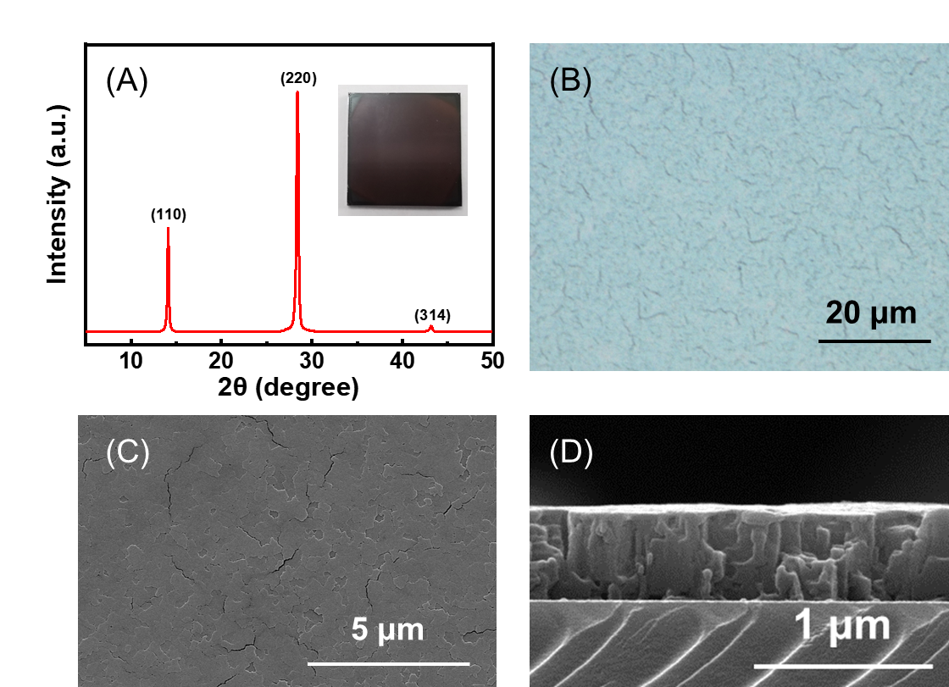
Figure S1. (A) XRD patterns, inset: optical photograph of the sample; (B) optical image; (C) Top-view and (D) cross-sectional SEM images of the (BA)₂(MA)₃Pb₄I₁₃ quasi-2D thin films.

II. The selected area electron diffraction (SAED) patterns and high-resolution transmission electron microscopy (HRTEM) images
The selected area electron diffraction (SAED) patterns, high-resolution transmission electron microscopy (HRTEM) images, and fast transform patterns of the sample were obtained to further investigate the phase structure and distribution. It can be seen in Figure S2A that the film thickness is about 320 nm from its cross-section TEM image. The SAED pattern in Figure S2B corresponds to a diameter around 320 nm (Figure S2A). The SAED pattern shows four diffraction rings marked as Φ1, Φ2, Φ3 and Φ4, indicating the polycrystalline nature of the sample. After conversion, the diffraction ring Φ1, Φ2, Φ3 and Φ4 are corresponding to the crystal plane of (224), (422), (433) and (611), marked in the XRD patterns of tetragonal MAPbI₃ phase in Figure S6C, respectively.⁵ Diffraction rings of 2D perovskite phase were not observed. Therefore, the three dominant diffraction peaks of XRD patterns in Figure S1A can be identified as the (110), (220) and (314) crystal planes of the tetragonal 3D perovskite MAPbI₃. The missing of diffraction rings of the low index crystal planes in the SAED patterns can be attributed to the preferred crystal orientation, which is consistent with the XRD patterns in Figure S1A. The quantity of the 2D perovskite phase may be insufficient for detection in both XRD and SAED patterns. The diffraction rings in the SAED of the cross-section of the whole film in Figure S6 can be identified as the crystal planes of the tetragonal 3D MAPbI₃ phase (n=∞ phase), suggesting that the n=∞ phase is dominant phase in (BA)₂MA₃Pb₄I₁₃ film.
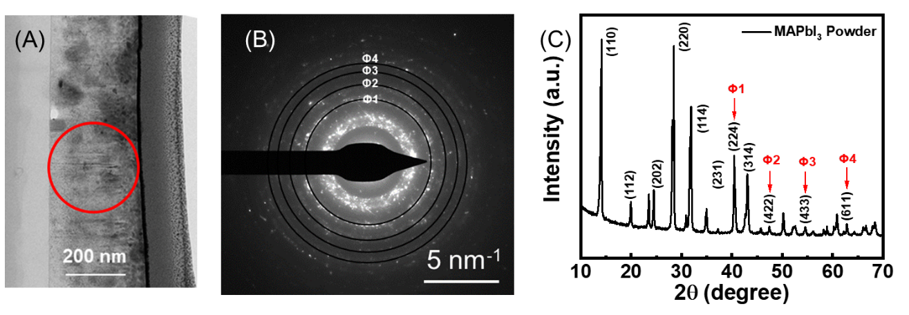
Figure S2 (A) Illustration of the selected region and (B) the selected area electron diffraction (SAED) pattern of the sample. (C) XRD patterns of the MAPbI₃ powder with tetragonal crystal structure.

The crystal structure and the phase distribution were characterized by HRTEM images. Two types of crystal lattices can be resolved in the HRTEM images. A lattice spacing of 3.2 Å corresponds to the MAPbI₃ 3D phase, and a lattice spacing of 7.0 Å corresponds to the n=1 phase.⁶ It can be seen that scattered crystal grains of 10-20 nm with a lattice spacing of 7.0 Å randomly distributed in the matrix of the MAPbI₃ 3D perovskite phase, which is consistent with the SAED patterns in the above. By comparing HRTEM images at the front side (Figure S3C and S3D) with those at the back side (Figure S3E and S3F), it can be observed that the density of the 2D phase at the back side is higher than that at the front side. No other lattice spacing can be discerned in the HRTEM images, possibly because the larger lattice spacing of the large-n phases is less distinguishable from the surrounding 3D phase.¹ It can be concluded that the 2D grains of 10- 20 nm are wrapped by the n=∞ phase, like a raisin-bread structure, and the number of 2D grains is larger near the substrate side.
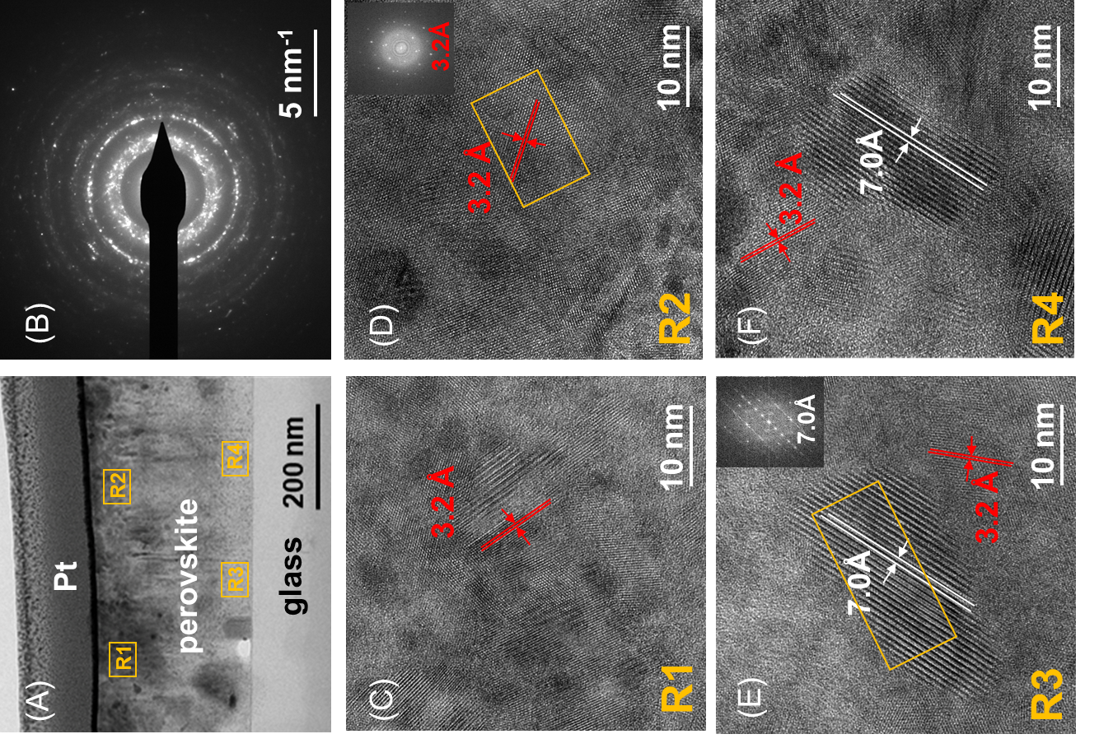
Figure S3. HRTEM images of the cross-section of the sample. (A) the cross-sectional brightfield TEM image; (B) the selected area electron diffraction (SAED) pattern; HRTEM images R1 (C) and R2 (D) at the front side and R3 (E) and R4 (F) at the back side, respectively. Inset: images of the fast-Fourier transforms (FFT) of the area in yellow square.

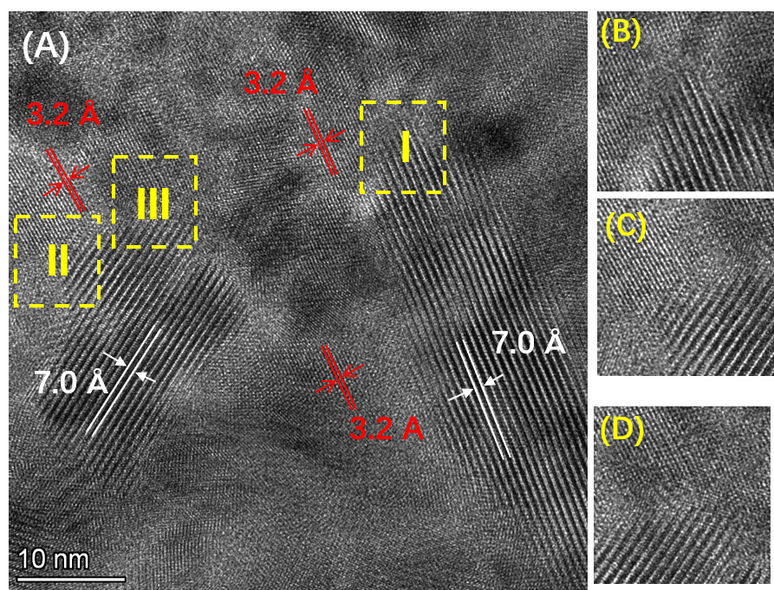
Figure S4. (A) HRTEM image of the cross-section of the (BA)₂MA₃Pb₄I₁₃ perovskite thin film. Three heterojunction structures marked as I, II and III. Zoom-in HRTEM images of (B) lateral epitaxial heterostructure, (C) partial epitaxial heterostructure; (D) heterostructure connected with a disordered interface.

IⅡ. Initial carrier density estimation
The photogenerated carrier density n is estimated as following expression
$n=\frac{P_{in}(1-R)(1-1/e)}{hν∙A∙d}$ (SIⅡ-1)
where P_{in} is the pump pulse energy, R is the reflectivity of the perovskite film at the excitation wavelength, hν is the photon energy of the pump, A is the area of the pump beam, and d is the penetration depth of the pump in the sample, which is equal to 1/α. For BA₂MA₃Pb₄I₁₃ thin film, R is about 11.3% at 517.5 nm, respectively. The fused silica window transmission of the sample cell is about 93%. The pump laser diameter is 3 mm at 517.5 nm. The penetration depth is about 80 nm at 517.5 nm. Hence, the photogenerated carrier density is corresponding to about 2.4×10¹⁵ cm⁻³ with pump energy 1 nJ per pulse at 517.5 nm.

IV. Quantitative analysis of electron transfer
The zero-delay position and the time resolution of dynamics curves were fitted by a convolution of a multi-exponential decay and a Gaussian function describing the instrument response function. If the rising bleach of small-n phases (n=4, 5) is caused by both excitation of 517.5 nm and the electron transfer from n=3 phase, the rising will become slow and the fitted time resolution is larger. The coincident rising edges for n=3, 4 and 5 and the fitting results below support that there is no measurable electron transfer between small-n phases, and only electron transfer from small-n phases to 3D phases.
For small-n phases, the bleaching signal is formed by multi exponential decays and a long lifetime decay background from the excited state absorption (ESA), which can be judged from the negative signal at long time delay. Each exponential decay corresponds to a specific charge transfer mechanism. The curve was fitted by multi exponential decay convoluted by the time resolution function as
$f\left(t\right)=IRF⊗\left(\left(\sum_{i}{A_{i}e^{-\frac{t-t_{0}}{t_{i}}}}+B_{0}e^{-\frac{t-t_{0}}{τ_{0}}}\right)H(t-t_{0})\right)+c$. (SⅣ-1)
where the instrument response function (IRF)
$IRF=A_{0}e^{-\frac{{\left(t-t_{0}\right)}^{2}}{2σ^{2}}}$ (SIV-2)
And the time resolution is $2\sqrt{2ln2}σ≈2.355σ$.
H(t) is defined as
$H\left(t\right)=\left\{\begin{aligned}1, t>0 \\ 0, t<0\end{aligned}\right.$ (SⅣ-3)
$A_{i}$ is the relative amplitude of each exponential decay. At least two exponential decays exist, the fastest one lasts within 1 ps and the other last tens or hundreds of ps. $B_{0}$ is the relative amplitude of the background from ESA. It should be a negative value, and its absolute value is usually much smaller than $A_{i}$, and τ₀ is tens of nanoseconds.
As shown in Figure S5, the curves are not well fitted with biexponential decays. Whereas, the triple exponential decay can well fit all the data of small-n phases in Figure S6. All the fitting results are summarized in Table S1.
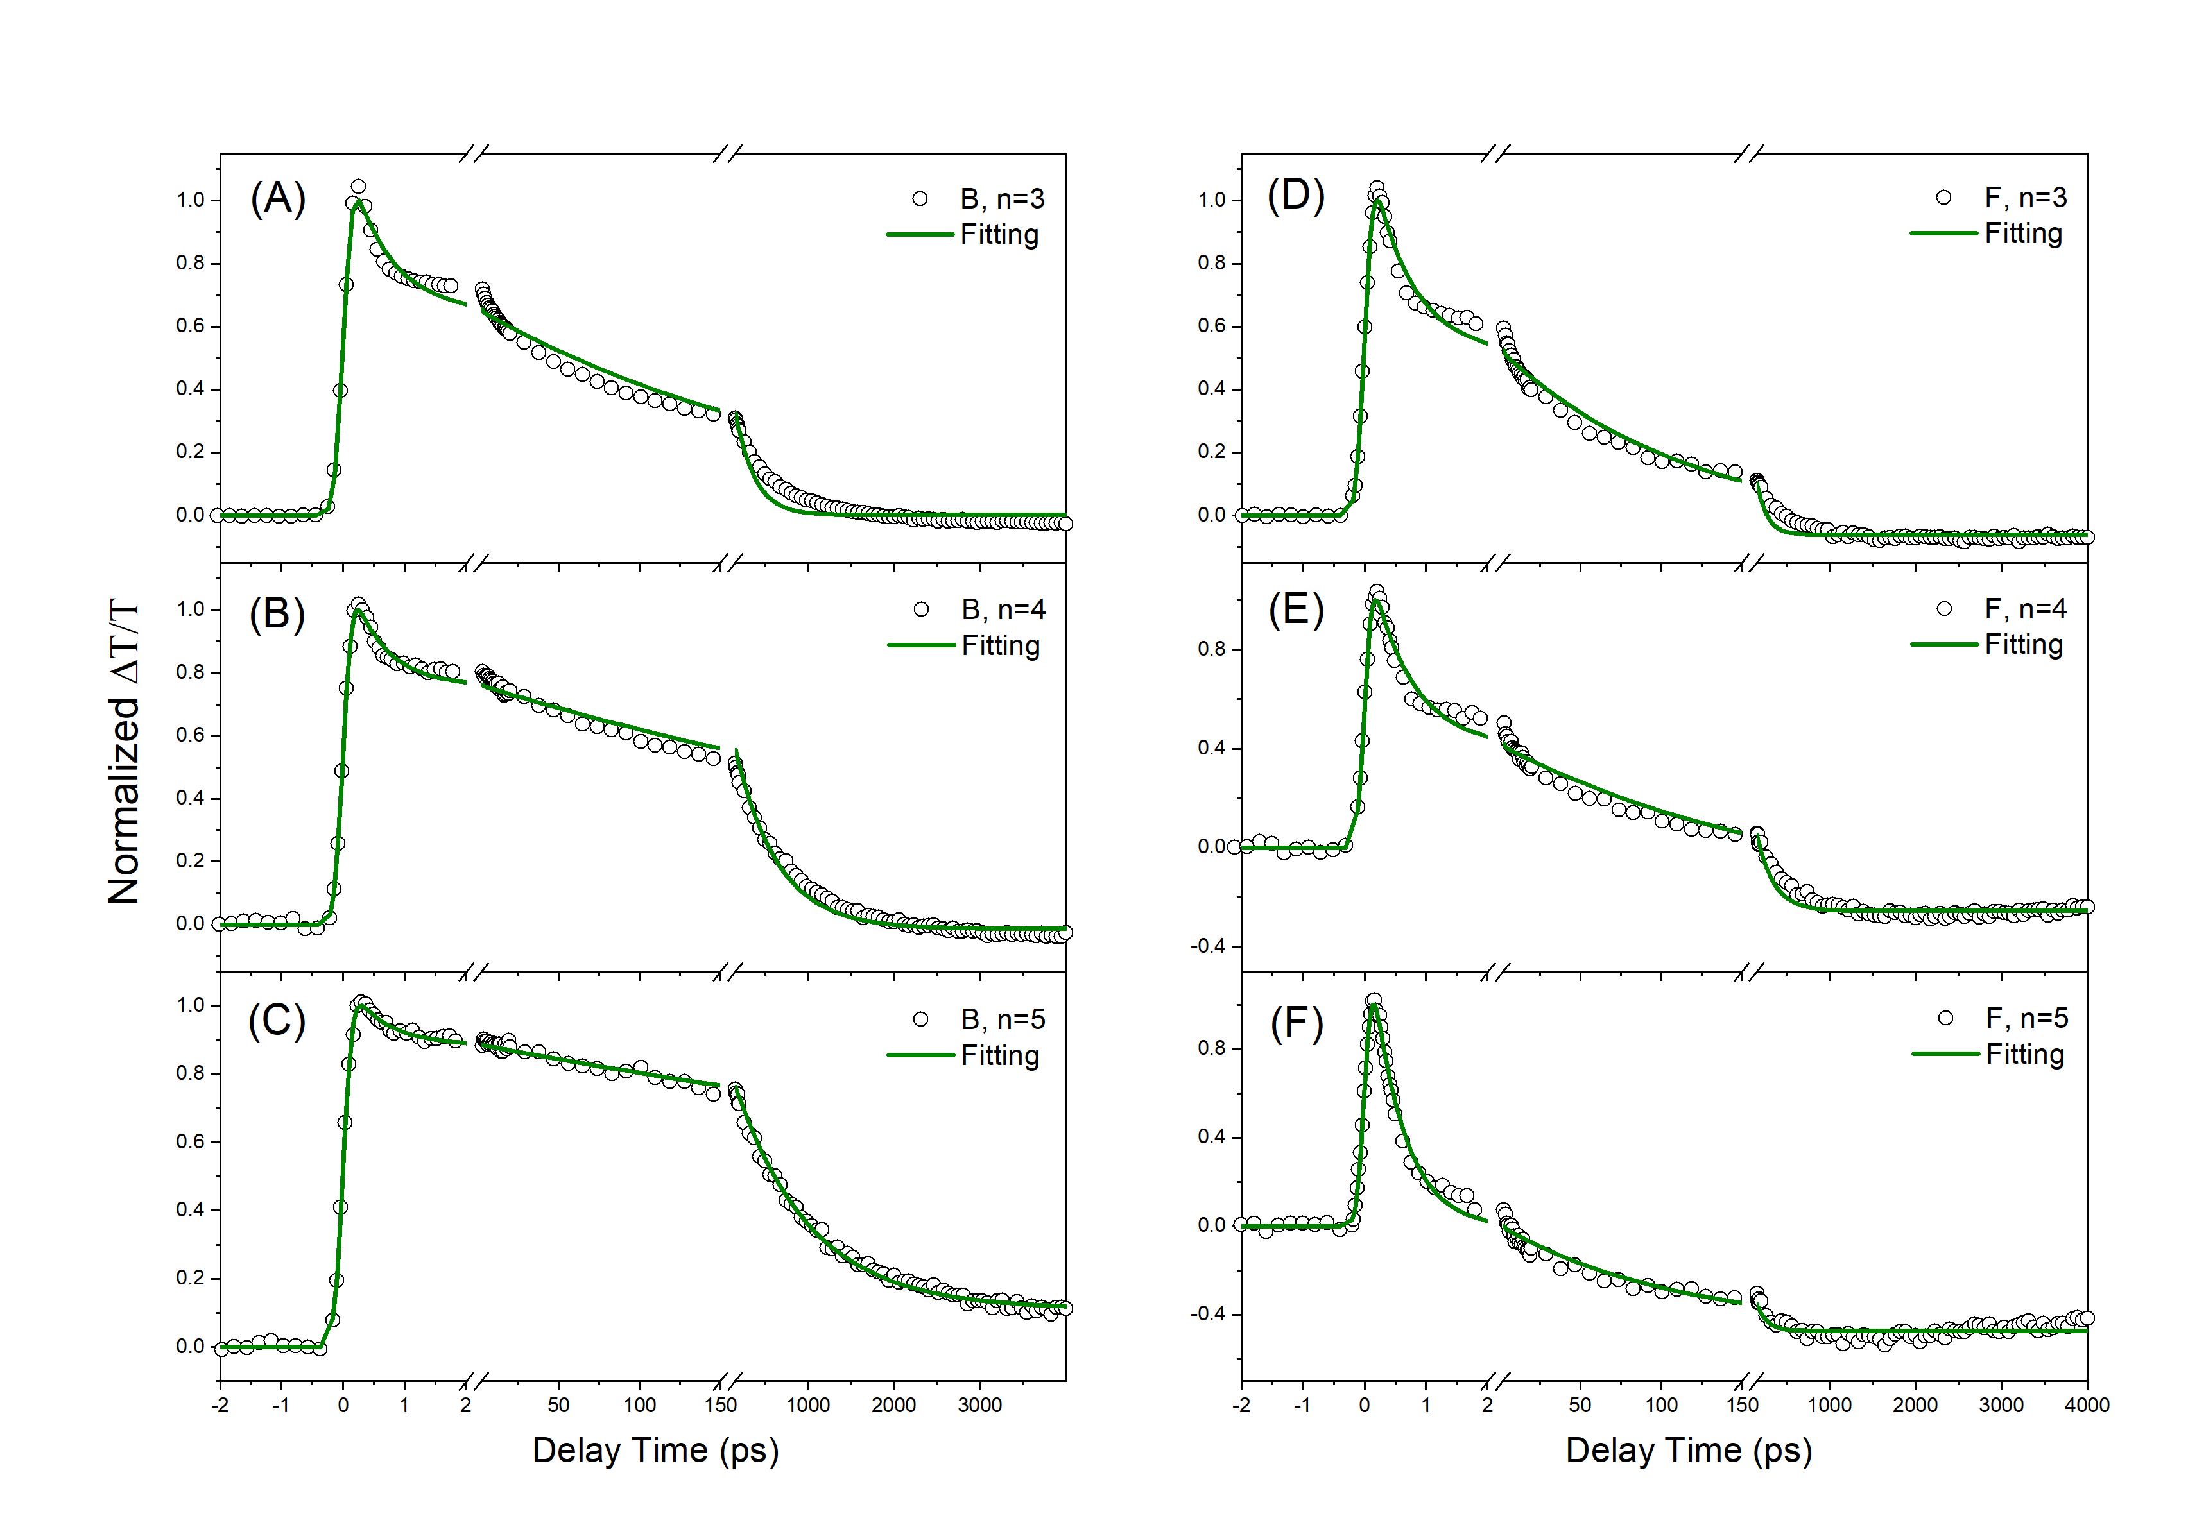Figure S5. Fitting results, based on biexponential decay, of TA dynamics probed at n=3, 4, 5 bands under back-excitation (A, B, C) and front-excitation (D, E, F) at 517.5 nm with 3 nJ per pulse.

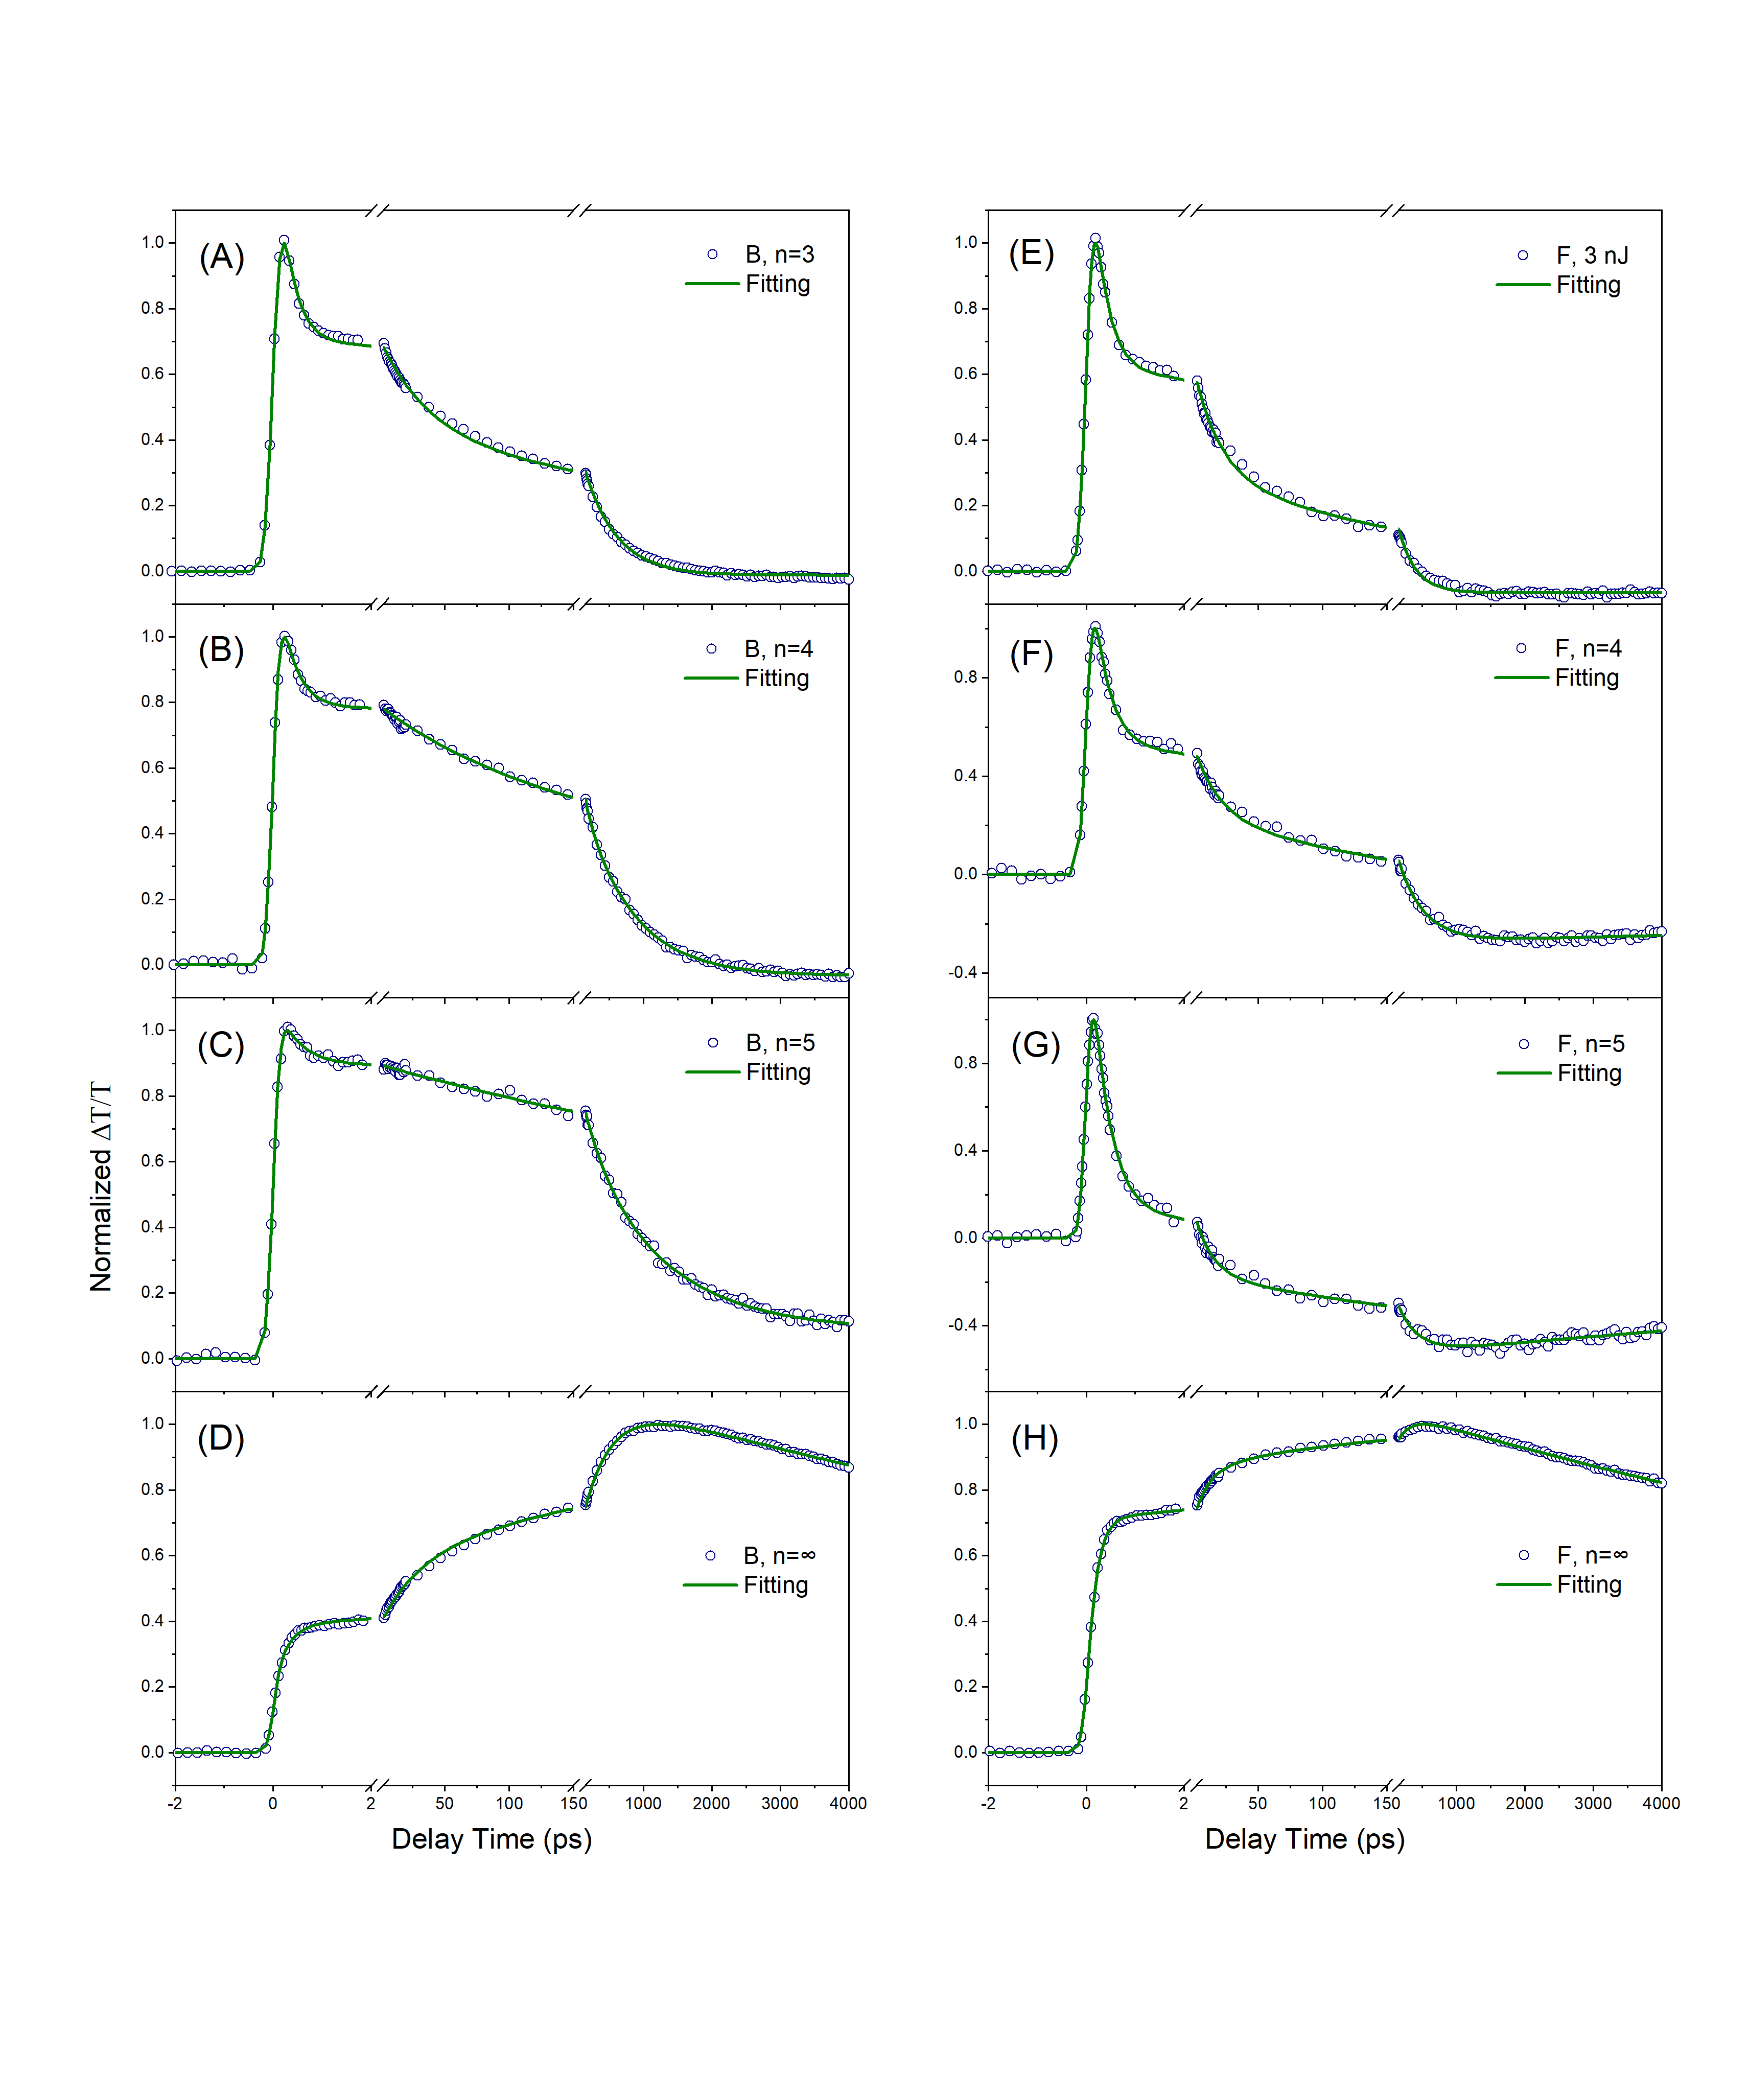Figure S6. Fitting results, based on triple exponential decay, of TA dynamics probed at n=3, 4, 5 and ∞ bands under back-excitation (A, B, C, D) and front-excitation (E, F, G, H) at 517.5 nm with 3 nJ per pulse.

Table S1. Fitting results of TA curve in Figure S5 by using Equation (SⅣ-1).
 | B, n=3 | B, n=4 | B, n=5 | F, n=3 | F, n=4 | F, n=5
A₁ | 0.72±0.04 | 0.48±0.02 | 0.20±0.02 | 0.85±0.04 | 0.92±0.03 | 1.50±0.03
T₁ (ps) | 0.29±0.02 | 0.33±0.02 | 0.47±0.05 | 0.29±0.02 | 0.34±0.02 | 0.29±0.01
A₂ | 0.28±0.01 | 0.21±0.01 | 0.18±0.06 | 0.32±0.01 | 0.29±0.01 | 0.36±0.02
T₂ (ps) | 37±2 | 99±8 | 316±68 | 20±1 | 20±2 | 14±1
A₃ | 0.43±0.01 | 0.61±0.01 | 0.62±0.05 | 0.36±0.01 | 0.50±0.01 | 0.37±0.01
T₃ (ps) | 476±13 | 732±18 | (1.2±0.1)×10³ | 251±12 | 372±19 | 292±25
-B₀ | 0.012±0.003 | 0.034±0.003 | -0.085±0.008# | 0.065±0.003 | 0.275±0.009 | 0.53±0.01
τ₀ (ps)† | inf | inf | inf | inf | (36±14)×10³ | (17±2)×10³
τ_{instrum} (ps) | 0.31±0.01 | 0.28±0.01 | 0.28±0.01 | 0.29±0.01 | 0.26±0.01 | 0.26±0.01
# Since the wavelength of n=5 is closed to the n= ꝏ, the TA signal can be partially from the signal of n= ꝏ.
† For these curves, B₀ is too small, that is the ESA can be negligible. We assume that τ₀ is large enough.

For the n=ꝏ phase, the bleaching signal consists of three ultrafast processes: direct excitation by pumping light, carrier transfer from small-n phases (n=3, 4, 5) and slow decay due to carrier recombination. For small-n phases, each phase has three possible heterojunction structures to connect with the n=ꝏ phase. It is impossible to distinguish the charge transfer from each small-n phase. But the time scale of carrier transfer can be categorized into sub 1 ps, tens of picoseconds and hundreds of picoseconds. The charge transfer for each structure can be approximately described by the average effect from all small-n phases. When the small-n phases with the same structure pumped by an infinitely short pulse, the carrier density can be described as
$\frac{dn_{i}}{dt}=N_{i}δ\left(t-t_{0}\right)-\frac{1}{τ_{i}}n_{i}$ (SIⅤ-4)
where i=1, 2, 3, represent three different structures, n_{i} is the average carrier density of all small-n phases with the same structure, and N_{i} is the total carrier density of the corresponding structure generated by photoexcitation. $δ\left(t\right)$ is defined as
$$δ\left(t\right)=0,t≠0$$
$\int_{-∞}^{+∞}{δ\left(t\right)dt=1}$ (SIⅤ-5)
And τ_{i} is defined as
$\frac{1}{τ_{i}}=\frac{1}{t_{i}}+\frac{1}{T_{i}}$ (SIⅤ-6)
where t_{i} is the average carrier transfer time, T_{i} is the average life time. By solving the above Equation (SIⅤ-4), we can obtain
$n_{i}=N_{i}H\left(t-t_{0}\right)e^{-\frac{t-t_{0}}{τ_{i}}}$ (SIⅤ-7)
where H(t) is defined as Equation (SIⅤ-3). The average transfer rate from small-n phases to the n=ꝏ phase is $\frac{n_{i}\left(t\right)}{t_{i}}$. The carrier dynamics equation in the n=ꝏ phase is written as
$\frac{dn_{∞}}{dt}{=N}_{∞}δ\left(t-t_{0}\right)+\sum_{i=1,2,3}{\frac{n_{i}\left(t\right)}{t_{i}}-\frac{n_{∞}}{t_{∞}}}$ (SIⅤ-8)
where $n_{∞}$ is the carrier density of the n=ꝏ phase, $N_{∞}$ is the carrier density directly excited by pumping and $t_{∞}$ is the lifetime of the n=ꝏ phase. Equation (SIⅤ-8) is solved as
$$\frac{dn_{∞}}{dt}+\frac{n_{∞}}{t_{∞}}=N_{∞}δ\left(t-t_{0}\right)+\sum_{i=1,2,3}{\frac{n_{i}\left(t\right)}{t_{i}}}$$
$$e^{\frac{\left(t-t_{0} \right)}{t_{∞}}}∙\frac{dn_{∞}}{dt}+e^{\frac{\left(t-t_{0} \right)}{t_{∞}}}∙\frac{n_{∞}}{t_{∞}}=e^{\frac{\left(t-t_{0} \right)}{t_{∞}}}(N_{∞}δ\left(t-t_{0}\right)+\sum_{i=1,2,3}{\frac{n_{i}\left(t\right)}{t_{i}}})$$
$$e^{\frac{\left(t-t_{0} \right)}{t_{∞}}}∙\frac{dn_{∞}}{dt}+\frac{n_{∞}d\left(e^{\frac{\left(t-t_{0} \right)}{t_{∞}}}\right)}{dt}=e^{\frac{\left(t-t_{0} \right)}{t_{∞}}}(N_{∞}δ\left(t-t_{0}\right)+\sum_{i=1,2,3}{\frac{n_{i}\left(t\right)}{t_{i}}})$$
$$\int_{-∞}^{T}{\frac{d\left(n_{∞}(t)e^{\frac{\left(t-t_{0} \right)}{t_{∞}}}\right)}{dt}}=\int_{-∞}^{T}{e^{\frac{\left(t-t_{0} \right)}{t_{∞}}}(N_{∞}δ\left(t-t_{0}\right)+}\sum_{i=1,2,3}{\frac{n_{i}\left(t\right)}{t_{i}}})dt$$
$ξ=T-t_{0}$, the equation is simplified as
$$n_{∞}e^{\frac{ξ}{τ_{∞}}}=\left\{\begin{aligned}0, ξ<0 \\ N_{∞}+\sum_{i}{\frac{N_{i}(1-e^{-\left(\frac{1}{τ_{i}}-\frac{1}{τ_{∞}}\right)ξ})}{t_{i}\left(\frac{1}{τ_{i}}-\frac{1}{τ_{∞}}\right)}，ξ>0}\end{aligned}\right.$$
$n_{∞}\left(T\right)=H(T-t_{0})\left[N_{∞}e^{-\frac{T-t_{∞}}{τ_{∞}}}+\sum_{i}{N_{i}\frac{(e^{-\frac{T-t_{∞}}{τ_{∞}}}-e^{-\frac{T-t_{0}}{τ_{i}}})}{t_{i}\left(\frac{1}{τ_{i}}-\frac{1}{τ_{∞}}\right)}}\right]$ (SIⅤ-9)
The signal of the n=ꝏ phase is $n_{∞}\left(T\right)$ convoluted by the IRF function. The convolution of an exponential function with IRF is
$e^{-\frac{t-t_{0}}{τ}}⨂IRF=\frac{1}{2}A_{0}e^{\frac{σ^{2}}{2τ^{2}}}∙\left(1+\operatorname{erf}\left(\frac{t-t_{0}-\frac{σ^{2}}{τ}}{\sqrt{2}σ}\right)\right)e^{-\frac{t-t_{0}}{τ}}$ (SIⅤ-10)
where erf(x) is defined as
$\operatorname{erf}\left(x\right)=\int_{0}^{x}{2/\sqrt{π}∙e^{-t^{2}}dt}$ (SIⅤ-11)
If $τ≫σ$, the equation is approximate to
$e^{-\frac{t-t_{0}}{τ}}⨂IRF≈\frac{1}{2}A_{0}∙\left(1+\operatorname{erf}\left(\frac{t-t_{0}}{\sqrt{2}σ}\right)\right)e^{-\frac{t-t_{0}}{τ}}$ (SIⅤ-12)
The curve of the n=ꝏ phase is written as
$f\left(t\right)=\frac{1}{2}N_{0}\left(1+\operatorname{erf}\left(\frac{t-t_{0}}{\sqrt{2}σ}\right)\right)e^{-\frac{t-t_{0}}{τ_{∞}}}+\frac{1}{2}a_{1}\left[\left(1+\operatorname{erf}\left(\frac{t-t_{0}}{\sqrt{2}σ}\right)\right)-e^{\frac{σ^{2}}{2τ_{1}^{2}}}\left(1+\operatorname{erf}\left(\frac{t-t_{0}-\frac{σ^{2}}{τ}}{\sqrt{2}σ}\right)\right)e^{-\frac{t-t_{0}}{τ_{1}}}\right]⋅e^{-\frac{t-t_{0}}{τ_{∞}}}+\frac{1}{2}\left(\frac{a_{2}}{τ_{2}\left(\frac{1}{τ_{2}}-\frac{1}{τ_{∞}}\right)}\right)∙\left(1+\operatorname{erf}\left(\frac{t-t_{0}}{\sqrt{2}σ}\right)\right)⋅\left(e^{-\frac{t-t_{0}}{τ_{∞}}}-e^{-\frac{t-t_{0}}{τ_{2}}}\right)+\frac{1}{2}\left(\frac{a_{3}}{τ_{3}\left(\frac{1}{τ_{3}}-\frac{1}{τ_{∞}}\right)}\right)∙\left(1+\operatorname{erf}\left(\frac{t-t_{0}}{\sqrt{2}σ}\right)\right)⋅\left(e^{-\frac{t-t_{0}}{τ_{∞}}}-e^{-\frac{t-t_{0}}{τ_{3}}}\right)+C_{0}$ (SIⅤ-13)
where$τ_{2}, τ_{3}≫σ$, $τ_{∞}≫τ_{1}$, and $a_{1}=N_{1}$, $a_{2}=N_{2}\frac{τ_{2}}{t_{2}}$ and $a_{3}=N_{3}\frac{τ_{3}}{t_{3}}$ (The decay life time of small-n phases is $τ_{i}$ and the electron transfer time is $t_{i}$, so the ratio of transferred carriers is $\frac{τ_{i}}{t_{i}}$. $a_{2}$ and $a_{3}$ is the ratio of the transferred carriers.) Here, $σ$ is fixed. We assume the time resolution is 0.26 ps. $σ=0.26/2.355$. The fitting results are shown in Figure S6 and Table S2.

Table S2. Fitting results of TA curve in Figure S4 by using Equation (SIⅤ-13).
 | B, n=ꝏ | F, n=ꝏ
$N_{0}$ (Directly excited n=ꝏ phase) | 0.22±0.02 | 0.24±0.05
$τ_{∞}$ (ps) | (17.9±0.4)×10³ | (16.8±0.2)×10³
$$a_{1}$$ | 0.18±0.02 | 0.47±0.05
$τ_{1}$ (ps) | 0.30±0.03 | 0.18±0.01
$$a_{2}$$ | 0.21±0.01 | 0.15±0.01
$τ_{2}$ (ps) | 31±1 | 11.8±0.7
$$a_{3}$$ | 0.49±0.01 | 0.18±0.01
$τ_{3}$ (ps) | 397±10 | 194±10
Time resolution  (ps, fixed) | 0.26 | 0.26

V. Quantitative analysis of hole transfer
The excitation of the n=ꝏ phase at 720 nm causes a strong ESA, which exhibits a large negative ΔT/T signal. This ESA signal decays very slow (> 10 ns). The lifetime of ESA depends on the probe wavelength. We assume the excitation pulse shape is a δ function. For a small-n phase (n=3, 4, 5), the hole transfer related to the heterojunction structure type is described as ($h_{ji}$ is the total numbers of holes in the crystal grain of the n=∞ phase connected with the small-n phase, j represents the type of the small-n phase, i represents the heterojunction structure type, $A_{ji}$ is the total initial numbers of the excited holes):
$\frac{dh_{ji}}{dt}=A_{ji}δ\left(t-t_{0}\right)-\frac{1}{τ_{ji}}h_{ji}$ (SV-1)
then
$h_{ji}=A_{ji}H\left(t-t_{0}\right)e^{- \frac{t-t_{0}}{τ_{ji}}}$ (SV-2)
${1/t}_{ji}$ is the transfer rate and $T_{i}$ is the lifetime of excited holes in the n=∞ phase. Hence,
$\frac{1}{τ_{ji}}=\frac{1}{t_{ji}}+\frac{1}{T_{i}}$ (SV-3)
$H\left(t\right)=\left\{\begin{aligned}1,t>0 \\ 0,t<0\end{aligned}\right.$ (SV-4)
$h_{j}$ is the total numbers of holes in the small-n phase. The total transfer rate is described as
$\frac{dh_{j}}{dt}=\sum_{i=1,2,3}{\frac{h_{ji}\left(t\right)}{t_{ji}}-\frac{h_{j}}{t_{j}}}$ (SV-5)
In a type II heterojunction, electrons and holes separates, which makes a long lifetime of holes. We assume that in this case, the lifetime of holes is much longer than the maximum delay in the TA experiments. The equation is simplified as
$\frac{dh_{j}}{dt}=\sum_{i=1,2,3}{\frac{h_{ji}\left(t\right)}{t_{ji}}}$ (SV-6)
$h_{j}=\sum_{i=1,2,3}{\frac{A_{ji}τ_{ji}}{t_{ji}}}(1-e^{- \frac{t-t_{0}}{τ_{ji}}})$ (SV-7)
The TA signal is described as a convolution between the IRF and Equation (SV-7)
$h_{j}\left(t\right)=IRF⊗\sum_{i=1,2,3}{\frac{A_{ji}τ_{ji}}{t_{ji}}}(1-e^{- \frac{t-t_{0}}{τ_{ji}}})$ (SV-8)
Including the ESA, the TA signal can be rewritten as
$f\left(t\right)=IRF⊗\left(\left(\sum_{i}{A_{i}(1-e^{-\frac{t-t_{0}}{τ_{i}}})}+B_{0}e^{-\frac{t-t_{0}}{τ_{0}}}\right)H(t-t_{0})\right)+c$. (SV-9)

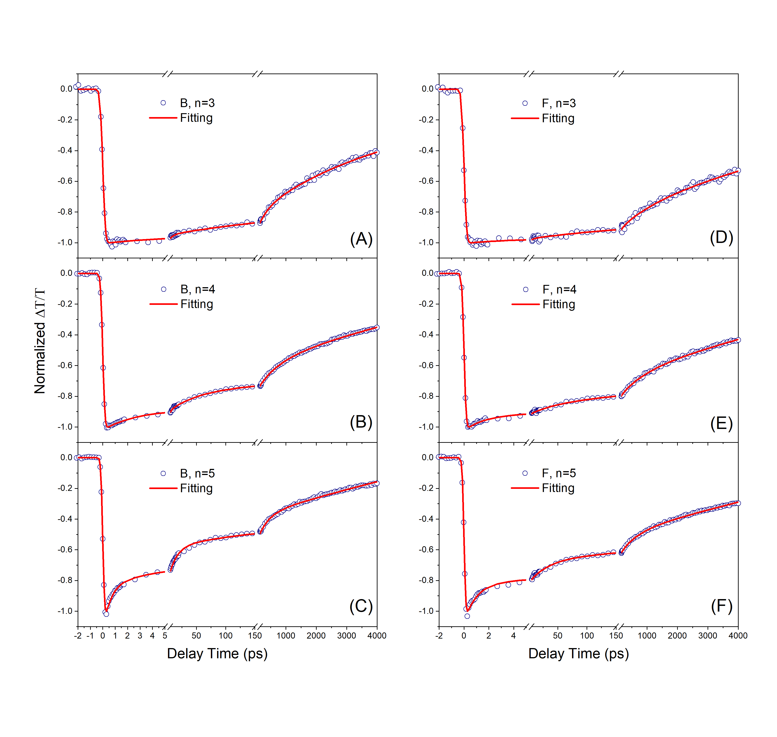Figure S7. Fitting results of TA dynamics probed at n=3, 4, 5 bands under back-excitation (A, B, C) and front-excitation (D, E, F) at 720 nm and 15 nJ per pulse.

Table S3. Fitting results of TA curve in Figure S7 by using Equation (SV-9).
 | B, n=3 | B, n=4 | B, n=5 | F, n=3 | F, n=4 | F, n=5
A₁ | 0.055±0.006 | 0.113±0.004 | 0.30±0.01 | 0.026±0.007 | 0.105±0.005 | 0.244±0.009
τ₁ (ps) | 6.8±2.0 | 2.4±0.2 | 0.67±0.05 | 3.8±3.2 | 1.7±0.2 | 1.01±0.07
A₂ | 0.13±0.05 | 0.13±0.01 | 0.23±0.01 | 0.04±0.03 | 0.09±0.01 | 0.14±0.01
τ₂ (ps) | 284±100 | 45±4 | 14±1 | 122±116 | 59±10 | 32±3
A₃ | 0.6±0.3 | 0.18±0.01 | 0.19±0.01 | 0.12±0.05 | 0.15±0.01 | 0.15±0.01
τ₃ (ps) | (4.0±1.5)×10³ | 643±48 | 321±23 | 934±877 | 739±119 | 501±60
-B₀ | 0.98±0.01 | 1.02±0.01 | 1.10±0.01 | 0.98±0.01 | 1.03±0.01 | 1.04±0.01
τ₀ (ns) | (1±1)×10³ | 14.4±0.6 | 17.9±0.6 | 12.1±0.4 | 14.2±1.0 | 17.3±0.9
Time resolution (ps) | 0.39±0.01 | 0.32±0.01 | 0.28±0.01 | 0.38±0.01 | 0.32±0.01 | 0.27±0.01

VI. Carrier dynamics under high carrier density
TA curve pumped by 3 nJ per pulse at 517.5 nm in the linear response range shows the bleach growing together, as shown in Figure S8A. Whereas the sequent growing of the bleach from small n to large n was observed with pump energy of 100 and 300 nJ per pulse in Figure S8B and S8C, which is consistent with previous reports.^{7, 8} This was once taken as the evidence of electrons transferring in sequence from small-n to large-n perovskite phases. Hence, the reported sequent growing for different n phases could result from the carrier density-dependence under the high carrier density condition. The proposed photophysical mechanism of sequent charge transferring from small-n to large-n perovskite phases was also based on the model of distribution of 2D perovskite phases in the order of their n values, that is small-n phase at the bottom glass substrate, and 3D phase at the front surface.³ If it was right, the primary bleach rising at n=∞ should be faster under front-excitation than under back-excitation. Figure S9 replots the TA spectra around zero-time delay, which clearly shows they are almost consistent. This suggests that the bleach of 3D phases under back-excitation cannot be only from the carrier transfer from 2D phases. In addition, the rising time is about 500 fs, longer than the instrument rising time (< 300 fs). This implies the rising bleach cannot be only from the excitation of 3D phase under front-excitation. Therefore, the initial bleaching signal for 3D phases is from both of direct excitation and the electron transfer from 2D phases under both back- and front-excitations.
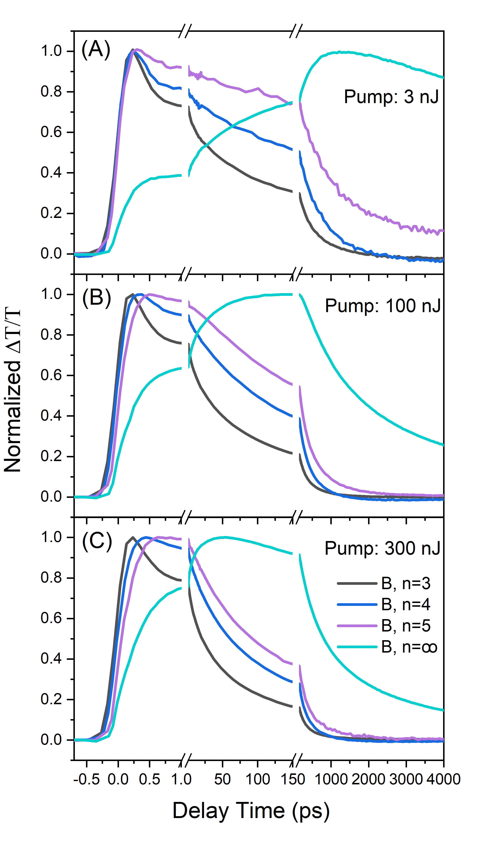
Figure S8. Carrier density-dependent TA dynamics probed at n=3, 4, 5 and ∞ bands under back-excitation with different pumping energy of 3 (A), 100 (B) and 300 nJ (C) per pulse.

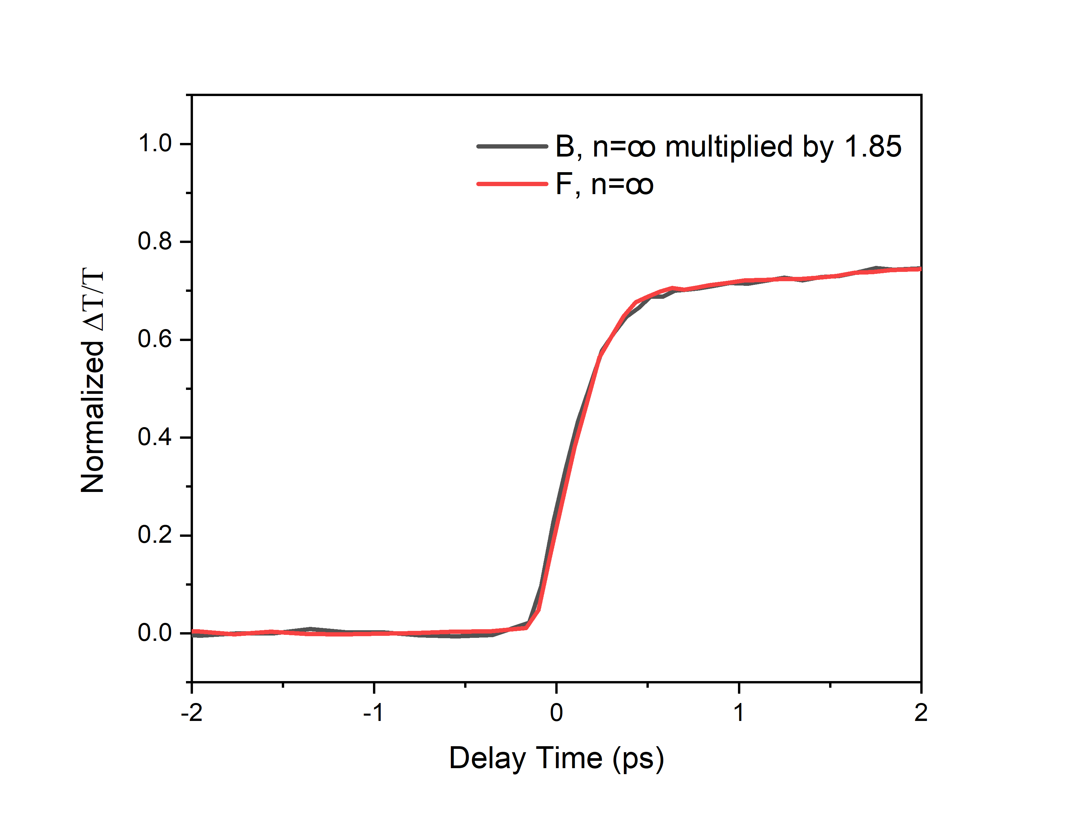
Figure S9. Comparison of the primary bleaching signal for n=∞ phases under back- (black line, multiplied by 1.85) and front-excitation (red line) with pumping energy 3 nJ per pulse at 517.5 nm.

VII. Estimation of local quasi-Fermi level
The quasi-Fermi level of electron and hole, $E_{Fe}$ and $E_{Fh}$ can be described as below,
$n=N_{C}e^{-\frac{E_{C}-E_{Fe}}{kT}}$ (SVIII-1)
$p=N_{V}e^{-\frac{E_{Fh}-E_{V}}{kT}}$ (SVIII-2)

where n and p are the electron and hole density, E_{C} and E_{V} are the energy of conduction-band and valance-band edge, N_{C} and N_{V} are the density of states of conduction-band and valance-band edges, k is the Boltzmann constant, and T is the absolute temperature. One electron in a 10×10×10 nm³ cube is equivalent to the carrier density of n₁= 10¹⁸ cm⁻³, and one electron in a 50×50×50 nm³ cube is equivalent to the carrier density of n₂= 8×10¹⁵ cm⁻³. Hence, $E_{Fe1}-E_{Fe2}$ ≈ 125 meV.
References
1. Lin, Y. et al. Unveiling the operation mechanism of layered perovskite solar cells. Nat. Commun. 10, 1008 (2019).
2. Sahayaraj, S. et al. Combination of a large cation and coordinating additive improves carrier transport properties in quasi-2D perovskite solar cells. J. Mater. Chem. A 9, 9175-9190 (2021).
3. Liu, J., Leng, J., Wu, K., Zhang, J. & Jin, S. Observation of internal photoinduced electron and hole separation in hybrid two-dimentional perovskite films. J. Am. Chem. Soc. 139, 1432-1435 (2017).
4. Song, J. et al. Unraveling the Crystallization Kinetics of 2D Perovskites with Sandwich-Type Structure for High-Performance Photovoltaics. Adv. Mater. 32, 2002784 (2020).
5. Saidaminov, M.I. et al. High-quality bulk hybrid perovskite single crystals within minutes by inverse temperature crystallization. Nat. Commun. 6, 7586 (2015).
6. Min, L., Tian, W., Cao, F., Guo, J. & Li, L. 2D Ruddlesden-Popper Perovskite with Ordered Phase Distribution for High-Performance Self-Powered Photodetectors. Adv. Mater. 33, e2101714 (2021).
7. He, T. et al. Reduced-dimensional perovskite photovoltaics with homogeneous energy landscape. Nat. Commun. 11, 1672 (2020).
8. Shang, Q. et al. Unveiling structurally engineered carrier dynamics in hybrid quasi-two-dimensional perovskite thin films toward controllable emission. J. Phys. Chem. L 8, 4431-4438 (2017).

