SI - SUPPLEMENTARY INFORMATION

Assessment of the photoprotective potential and structural characterization of secondary metabolites of Antarctic fungus Arthrinium sp.

Ana Carolina Jordão¹ (ORCID 0000-0001-8076-5967), Gustavo Souza dos Santos^{1,5} (ORCID 0000-0002-7288-2466), Thaiz Rodrigues Teixeira¹ (ORCID 0000-0001-9514-3327), Ana Júlia Pasuch Gluzezak² (ORCID 0000-0003-3383-5381), Clarissa Bechuate de Souza Azevedo² (ORCID 0000-0002-7296-6395), Karina de Castro Pereira², Ludmilla Tonani³ (ORCID 0000-0001-6892-8962), Lorena Rigo Gaspar² (ORCID 0000-0002-1550-3036), Márcia Regina von Zeska Kress³ (ORCID 0000-0003-1239-7722), Pio Colepicolo⁴ (ORCID 0000-0002-2334-1532), Hosana Maria Debonsi^{1,*} (ORCID 0000-0002-4888-0217)

¹ Department of Biomolecular Sciences, School of Pharmaceutical Sciences of Ribeirão Preto, University of São Paulo, Ribeirão Preto, SP, Brazil.
² Department of Pharmaceutical Sciences, School of Pharmaceutical Sciences of Ribeirão Preto, University of São Paulo, Ribeirão Preto, SP, Brazil.
³ Department of Clinical, Toxicological and Bromatological Analysis, School of Pharmaceutical Sciences, University of São Paulo, São Paulo, SP, Brazil.
⁴ Department of Biochemistry, Chemistry Institute, University of São Paulo, São Paulo, SP, Brazil.
⁵ Department of Life Sciences, State University of Bahia, Salvador, Bahia, Brazil.
*Corresponding author:
E-mail address: hosana@fcfrp.usp.br (H. M. Debonsi)
Contents
Page S02, Fig. S01: Fraction E chromatogram and peaks assignments
Page S02, Fig. S02: Fraction F chromatogram and peaks assignments
Page S03, Fig. S03: Mass spectrum (MS/MS) of Agonodepside B (6)
Page S03, Fig. S04: ¹H NMR spectrum of Agonodepside B (6) (in CDCl₃ at 500 MHz)
Page S04, Fig. S05: Partial ¹H NMR spectrum of Agonodepside B (6) (in CDCl₃ at 500 MHz)
Page S04, Fig. S06: Partial ¹H NMR spectrum 2 of Agonodepside B (6) (in CDCl₃ at 500 MHz)
Page S05, Fig. S07: Partial ¹H NMR spectrum 3 of Agonodepside B (6) (in CDCl₃ at 500 MHz)
Page S05, Fig. S08: HSQC spectrum of Agonodepside B (6) (in CDCl₃ at 500 MHz)
Page S06, Fig. S09: HMBC spectrum of Agonodepside B (6) (in CDCl₃ at 500 MHz)

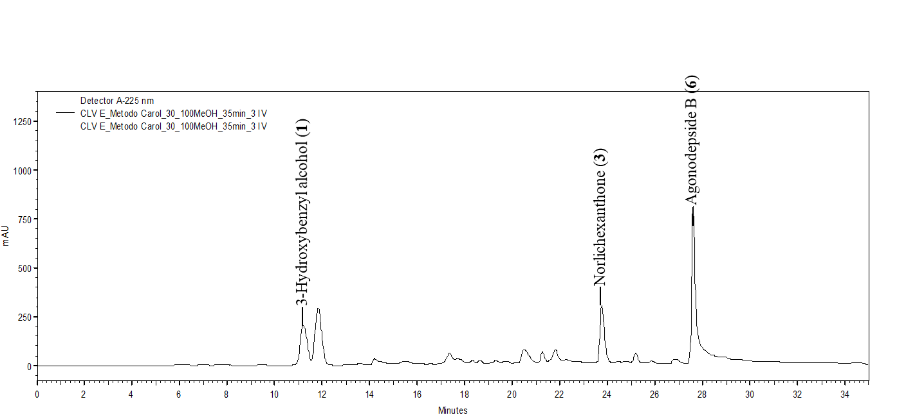
Fig. S01: Fraction E chromatogram and peaks assignments

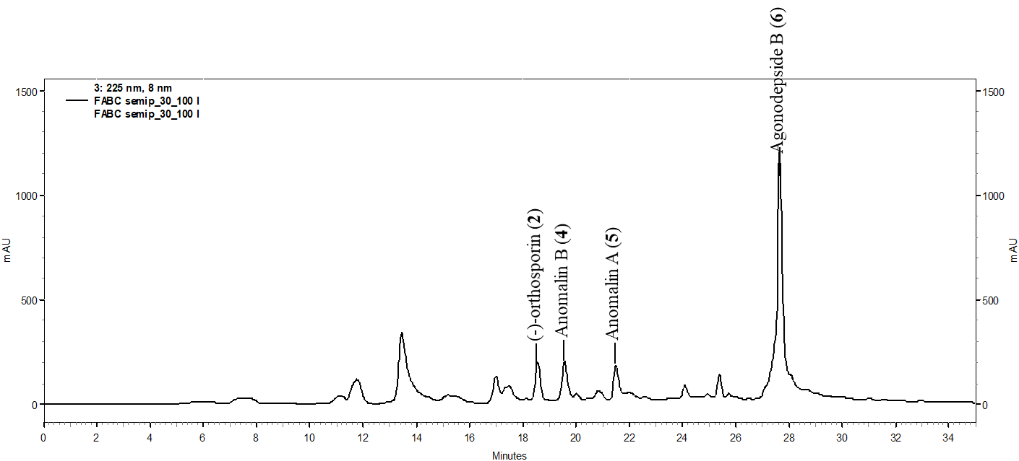
Fig. S02: Fraction F chromatogram and peaks assignments
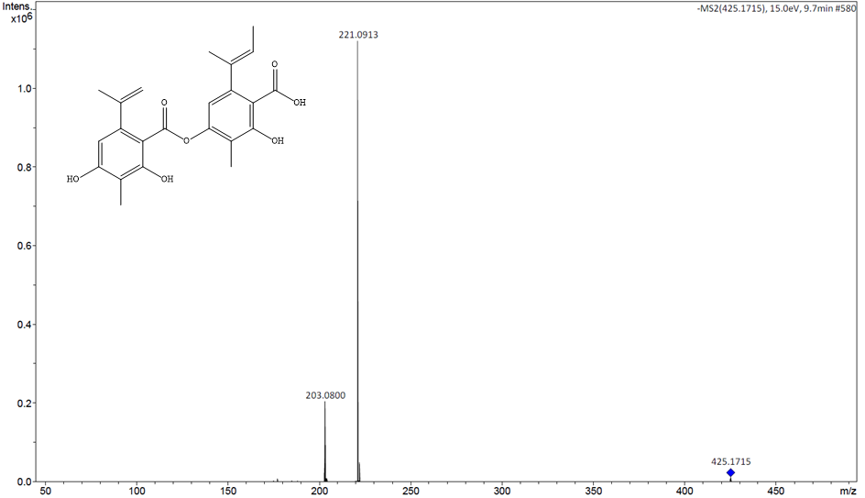
Fig. S03: Mass spectrum (MS/MS, [M-H]⁻) of Agonodepside B (6)
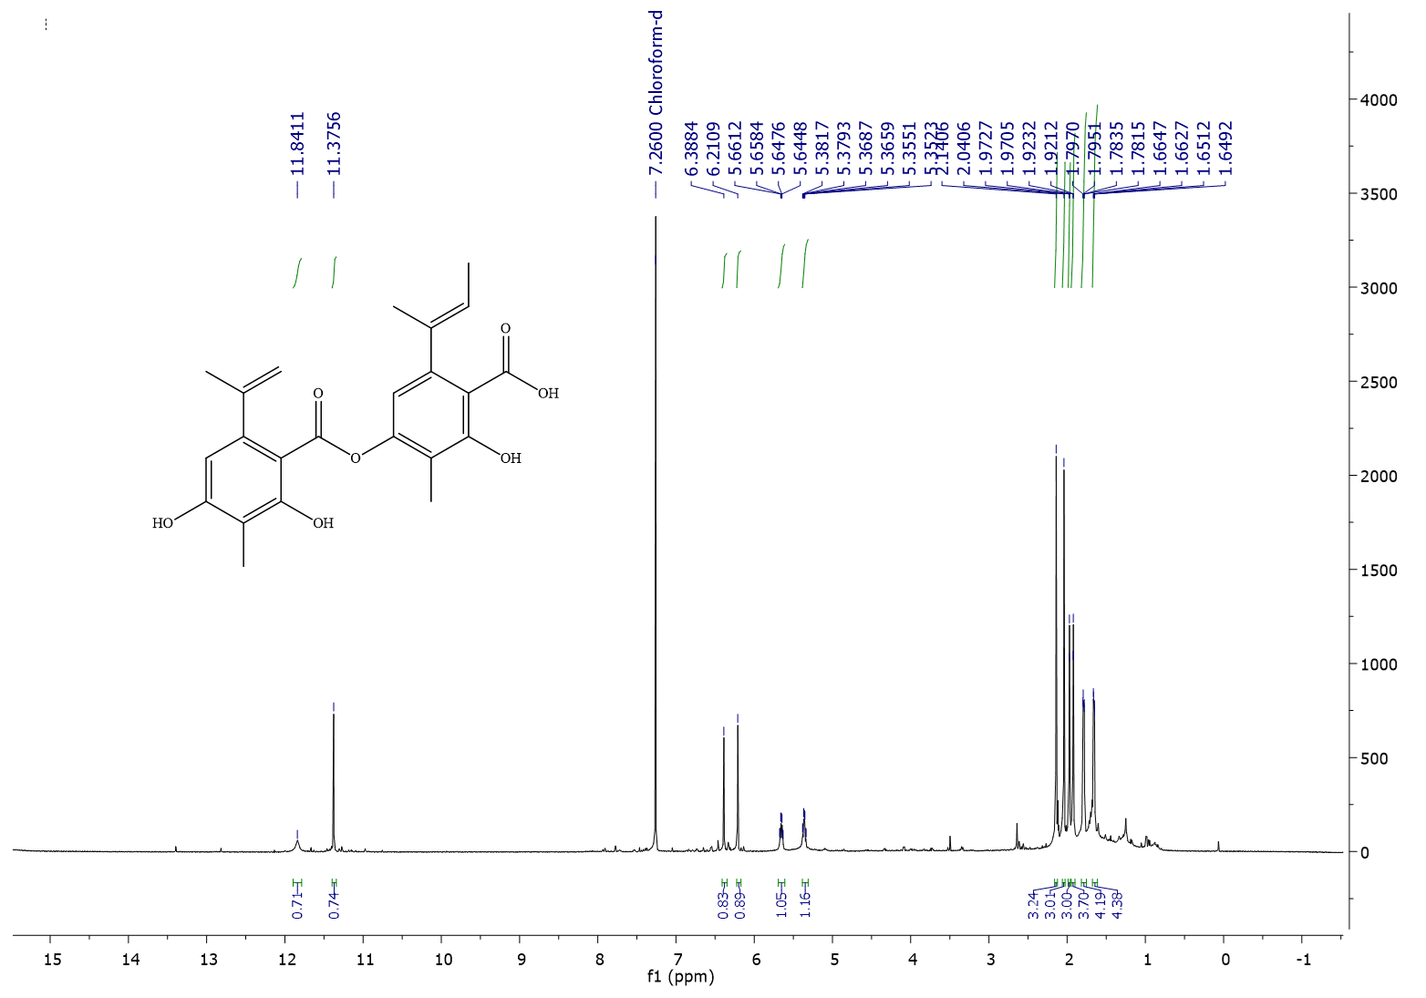
Fig. S04: ¹H NMR spectrum of Agonodepside B (6) (in CDCl₃ at 500 MHz)
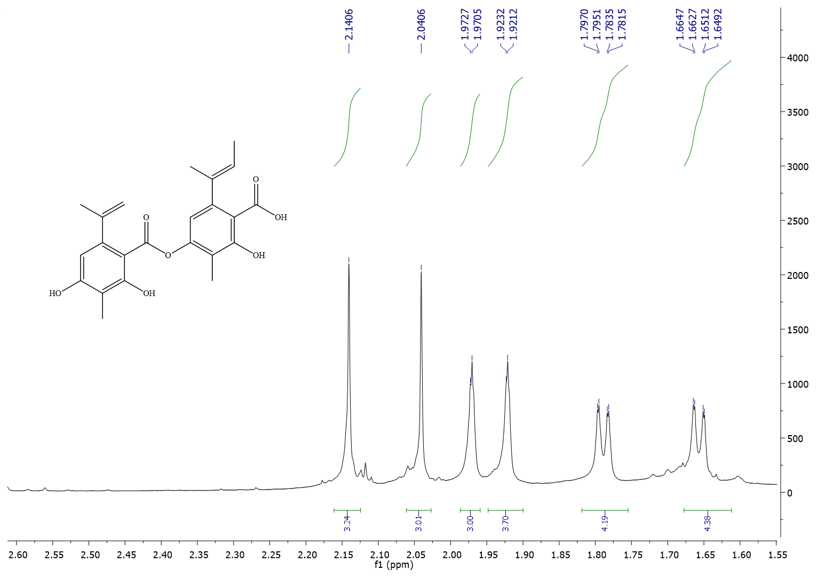
Fig. S05: Partial ¹H NMR spectrum of Agonodepside B (6) (in CDCl₃ at 500 MHz)
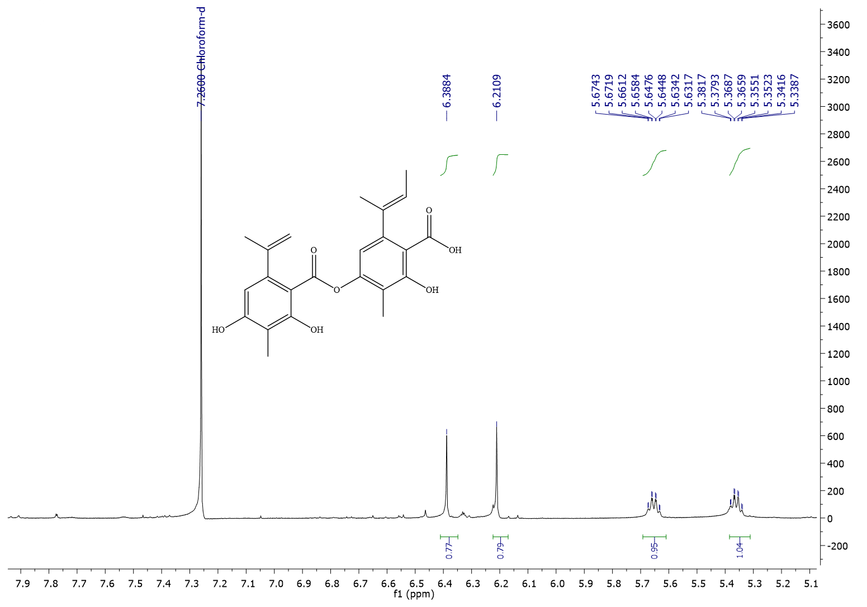
Fig. S06: Partial ¹H NMR spectrum 2 of Agonodepside B (6) (in CDCl₃ at 500 MHz)
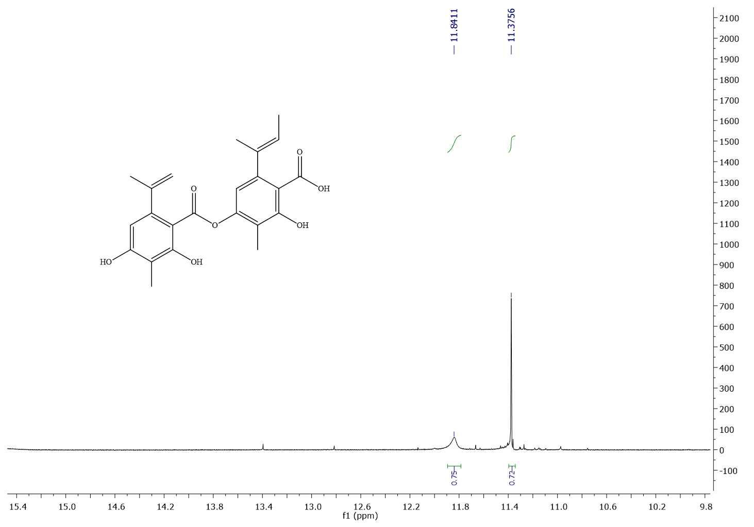
Fig. S07: Partial ¹H NMR spectrum 3 of Agonodepside B (6) (in CDCl₃ at 500 MHz)
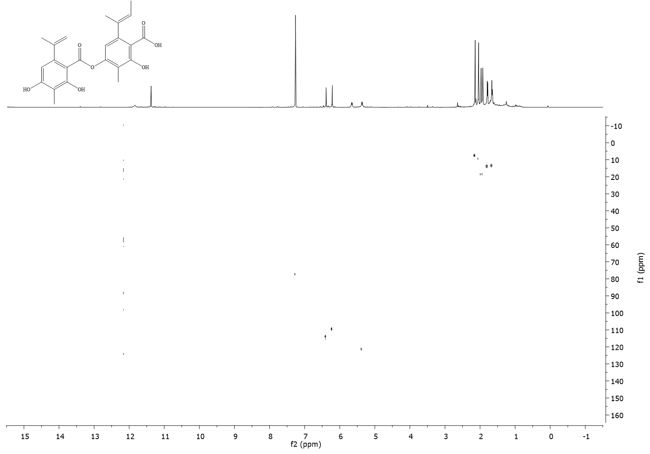
Fig. S08: HSQC spectrum of Agonodepside B (6) (in CDCl₃ at 500 MHz)
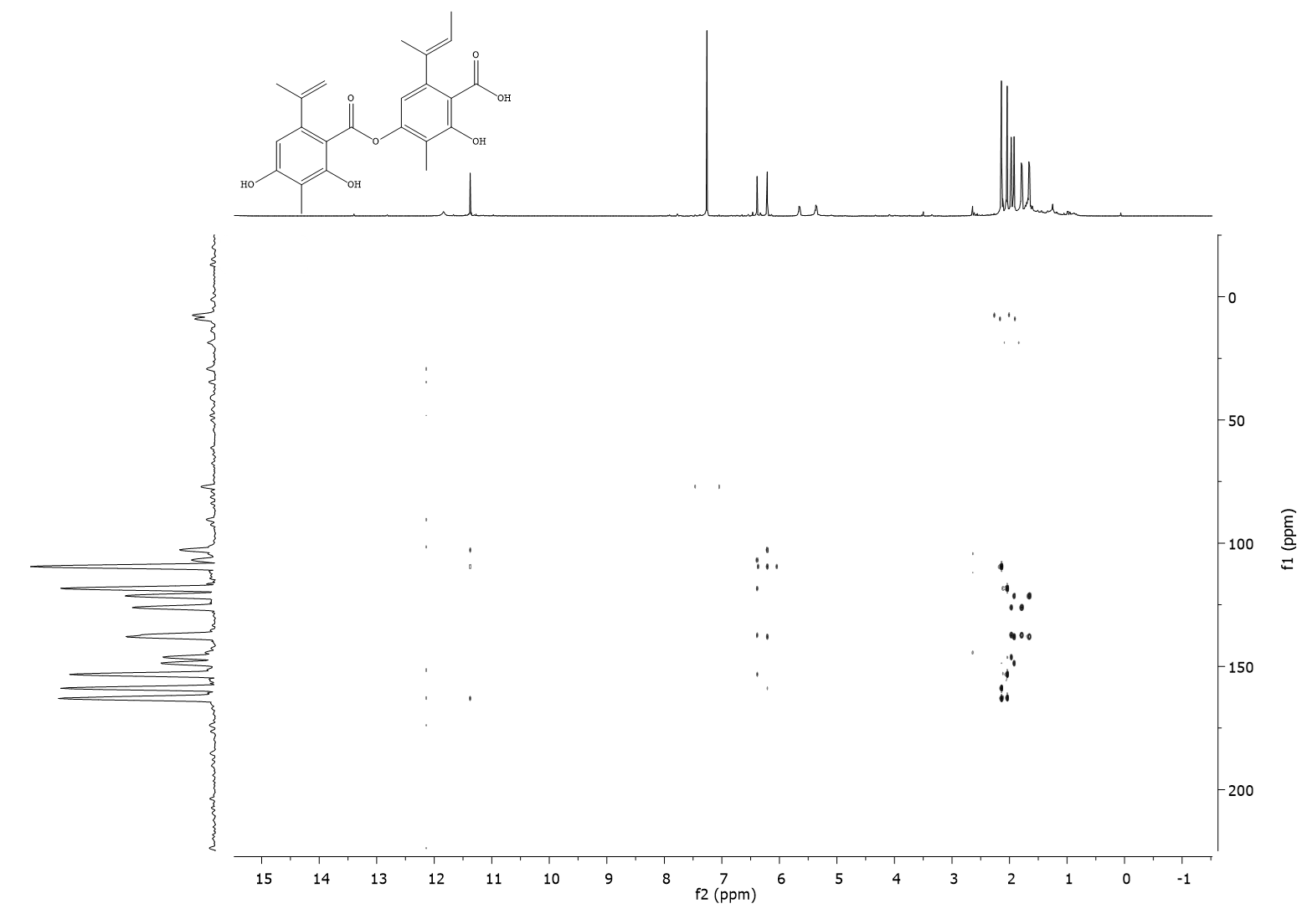
Fig. S09: HMBC spectrum of Agonodepside B (6) (in CDCl₃ at 500 MHz)

