The predictive value of total bilirubin for acute appendicitis in retrospect"

Table S1

displays whether the investigation's subjects were disperse, according to the median appendix size peri-appendix collecting, and the detection of fecolith on ultrasound of all patients (n = 636)

Acute appendicitis | Mean appendix outer diameter on USG in two groups
Acute appendicitis | n (%) | Mean diameter (mm) | SD |  | Χ² |  | df |  | p value
Uncomplicated | 433(68) | 6.64 | 0.69 |  | 21.66 |  | 1 |  | < 0.05
Complicated | 203(31.9) | 9.71 | 1.27
 | Distribution according to appendix diameter n(%)
 | < 7.6 mm | > 7.6 mm | Total | Χ² |  | df |  | p value
Absent complicated | 191(94.29) | 208(48) | 399 | 21.66 |  | 1 |  | < 0.05
Present complicated | 12(5.91) | 225(52) | 237
Total | 203(31.9) | 433(68.2) | 636

 | Peri-appendix collection
 | Present n(%) | Absent n(%) |  | Total |  | Χ² |  | df | p value
Absent | 0(0) | 433(100) |  | 433 |  | 76.67 |  | 1 | < 0.05
Present | 156(77) | 47(23) |  | 203 |  |  |  | 1 | < 0.05
Total | 156(24.5) | 480(75.5) |  | 636 |  |  |  | 1 | < 0.05
 | Appendix lumen obstruction by fecolith n(%)
 | Present n(%) |  | Absent n(%) |  | Total |  | Χ² | df | p value
Absent | 30(6.9) |  | 403(93) |  | 433 |  | 70.05 | 1 | < 0.05
Present | 180(88.6) |  | 23(11.3) |  | 203 |  | 70.05 | 1 | < 0.05
Total | 205(32.23) |  | 431(67.77) |  | 636 |  | 70.05 | 1 | < 0.05

Table S2

patients demographics according to Alvarado score
Complicated appendicitis | Alvarado score
Complicated appendicitis | n (%) | Mean | SD | t | df | p value
Present | 203(31.8) | 8.5 | 0.77 | 8.85 | 108 | < 0.05
Absent | 433(68.2) | 7.25 | 0.71 | 8.85 | 108 | < 0.05
Lowest value |  |  |  |  |  | 6.0000
Highest value | 10.0000
Arithmetic mean | 7.6636
Standard deviation | 0.9605
Median | 7.5000
 | Complicated | Uncomplicated
Alvarado score > mean (7.66) | 284 | 131
Alvarado score < mean (7.66) | 18 | 302
Total | 203 | 433

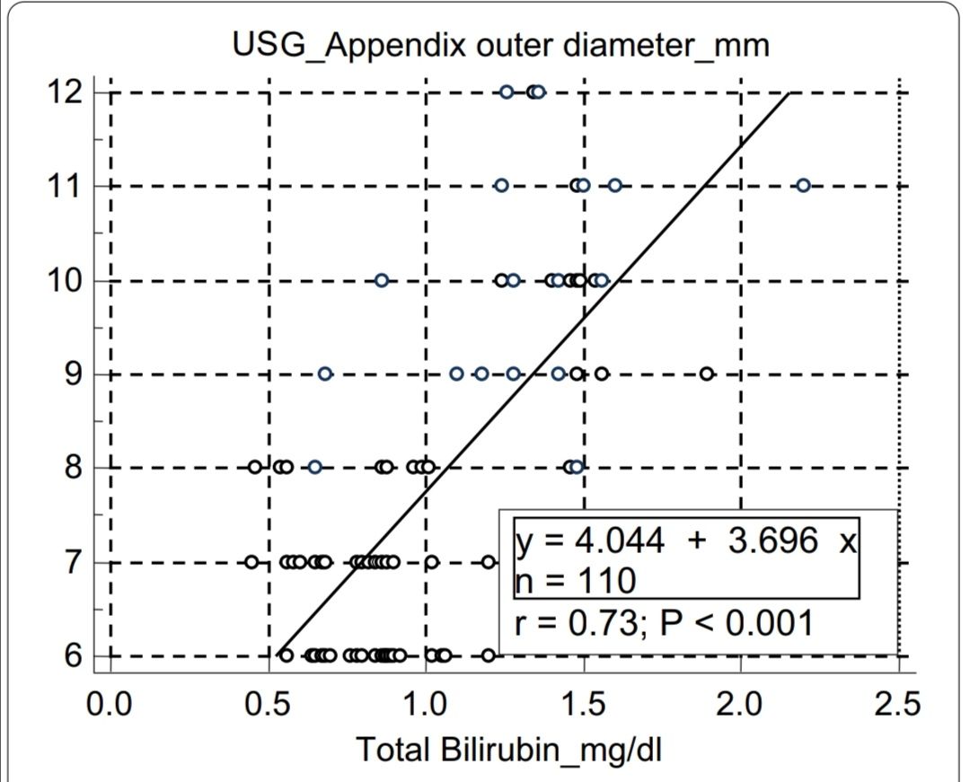

Fig. S 1
scattered plot diagram showing relationship between increase
in appendix diameter with increase in serum total bilirubin level

