Supporting Information

Ultrastrong Light-Matter Coupling in
2D Metal-Organic Chalcogenolates

Surendra B. Anantharaman^{1,*,†}, Jason Lynch^{1,†}, Mariya Aleksich^{2,3}, Christopher E. Stevens^{4,5}, Christopher Munley⁶, Bongjun Choi¹, Sridhar Shenoy¹, Thomas Darlington⁷, Arka Majumdar^{6,8}, P. James Shuck⁷, Joshua Hendrickson⁵, J. Nathan Hohman^{2,3}, Deep Jariwala^{1,*}
¹ Department of Electrical and Systems Engineering, University of Pennsylvania, Philadelphia, Pennsylvania 19104, United States

² Institute of Materials Science, University of Connecticut, Storrs CT 06269
³ Department of Chemistry, University of Connecticut, Storrs CT 06269
⁴ KBR Inc., Beavercreek, Ohio 45431, United States
⁵ Air Force Research Laboratory, Sensors Directorate, Wright-Patterson Air Force Base, Ohio 45433, United States
⁶ Department of Physics, University of Washington, Seattle, Washington 98195, United States
⁷ Department of Mechanical Engineering, Columbia University, New York, new York 10027, United States
⁸ Department of Electrical and Computer Engineering, University of Washington, Seattle, Washington 98195, United States
* Corresponding authors: sba@iitm.ac.in, dmj@seas.upenn.edu
† These authors contributed equally to this work.

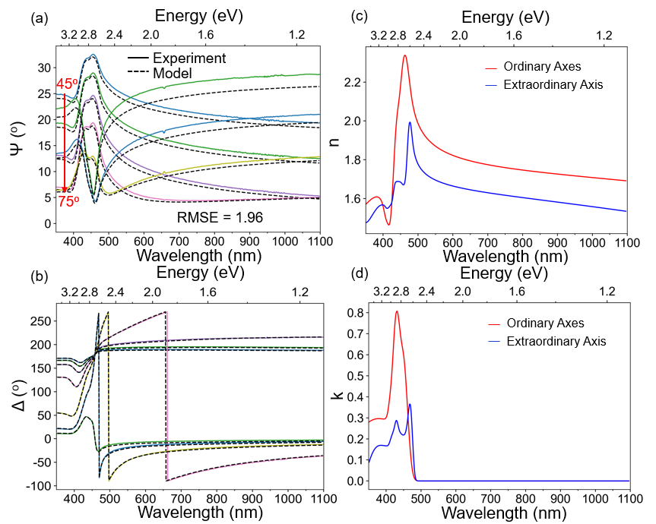
Figure S1. Complex refractive index of mithrene (a) Ψ and (b) Δ spectra that were measured using a J. A. Woollam M2000 spectroscopic ellipsometer and fitted to a multi-Lorentzian to extract the complex refractive index of mithrene. The model yielded a root-mean-square-error (RMSE = $\sqrt{\frac{1}{2p-q}\sum_{i}{{\left(Ψ_{i}^{Exp}-Ψ_{i}^{Model}\right)}^{2}+{\left(Δ_{i}^{Exp}-Δ_{i}^{Model}\right)}^{2}}}$ where p is the number of wavelengths measured, q is the number of fit parameters, and the sum is over all wavelengths) of 1.96 showing excellent agreement between experiment and model.

Section 1. Weak-, Strong-, and Ultrastrong Light-Matter Coupling in Exciton-Polaritons

The Hamiltonians of exciton-polaritons can be described as the sum of the Hamiltonian of the unperturbed exciton (H_{exciton} = $\frac{1}{2}E_{x}σ_{z}$ where E_{x} is the exciton energy and $σ_{z}$ is the exciton transition operator), the unperturbed cavity (H_{cavity} = $E_{c}a^{†}a$ where E_{c} is the cavity energy and $a^{†}$ (a) is the creation (destruction) operator for a photon in the cavity), and the interaction Hamiltonian (H_{int})¹. In the cases of weak coupling (WC) and strong coupling (SC), only the first-order effects of an exciton absorbing and emitting a photon have to be considered for H_{int}. Therefore, the interaction Hamiltonian for WC and SC can be expressed as¹:
(1)
$$H_{int}=g(σ_{+}a+a^{†}σ_{-})$$
Where g is the coupling parameter and $σ_{+}$ ($σ_{-}$) is the absorption (emission) operator of the exciton. It is clear then that the coupling parameter can be interpretted as the rate at which energy oscillates between the exciton and cavity modes. When solving this Hamiltonian, called the Jaynes-Cummings Hamiltonian, under the condition of zero detuning $(∆ =E_{x}-E_{c})$, the complex eigenenergies are found to be²:
$$E_{±}= E_{x}-i\frac{Γ_{x}+Γ_{c}}{4} ±\sqrt{g^{2}-\frac{{\left(Γ_{x}-Γ_{c}\right)}^{2}}{16}}$$
Where $Γ_{x}$ ($Γ_{c}$) is the loss rate of the exciton (cavity). Through inspection of Eq. 2, the WC regime is defined as the region where $g^{2}<\frac{{\left(Γ_{x}-Γ_{c}\right)}^{2}}{16}$. In this regime, the coupling parameter only affects the imaginary part of the eigenenergy, and therefore, it only affects the decay rate of the states and does not affect their energies. However, when $g^{2}>\frac{{\left(Γ_{x}-Γ_{c}\right)}^{2}}{16}$, the system enters the SC regime, and the states become hybrized as the coupling parameter shifts the energies of the two eigenstates.
(2)
Weakly and strongly coupled systems can both be accurately modelled while only considering the first order effects. However, as the coupling parameter increases, and energy oscillates between the exciton and cavity more rapidly, higher-order effects such as the fast-rotating components of the exciton-cavity interactions must be considered to accurately model the system. Although these effects are always present in exciton-polaritons, their effects are not significant until the coupling parameter is 10% of the exciton energy. Therefore, by convention, the ultrastrong coupling (USC) regime is when $\frac{g}{E_{x}}>0.1$ . In the USC regime, the polariton energies are the positive solutions to the bi-quadratic³:
(3)
$$\left(E_{±}^{2}-E_{c}^{2}\right)\left(E_{±}^{2}-E_{x}^{2}\right)-\frac{4g^{2}E_{±}^{2}E_{c}}{E_{x}}=0$$
The coupling parameter for both the SC and USC regimes can then be extracted by using the transfer matrix method (TMM) to calculate the thickness dependence of the UEP and LEP since the cavity wavelength depends linearly on the mithrene thickness. The dispersion of the UEP and LEP are then fitted to Eq. 2 for the SC regime and Eq. 3 for the USC regime using a least-squared-error method to determine the coupling parameter of the exciton-polaritons.
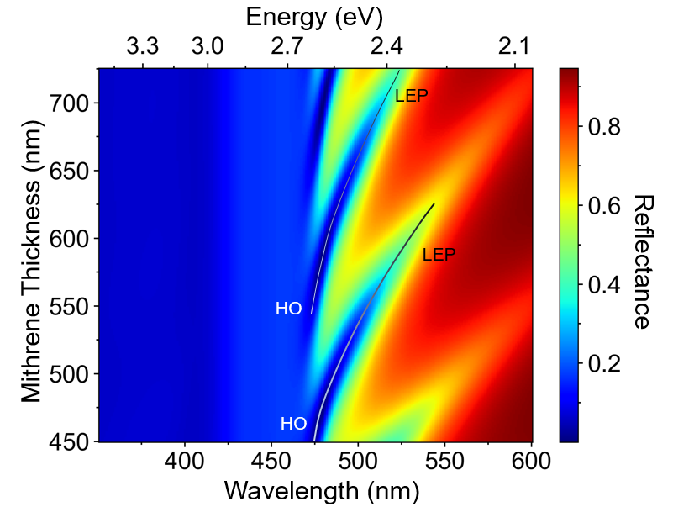
Figure S2. Simulated higher order (HO) and lower exciton-polariton (LEP) modes in mithrene on Au. Mithrene thickness-dependent reflectance spectra for a mithrene flake on an Au substrate. The HO mode can be seen to convert into an LEP mode as the mithrene thickness increases since the detuning between the exciton and cavity modes decreases.

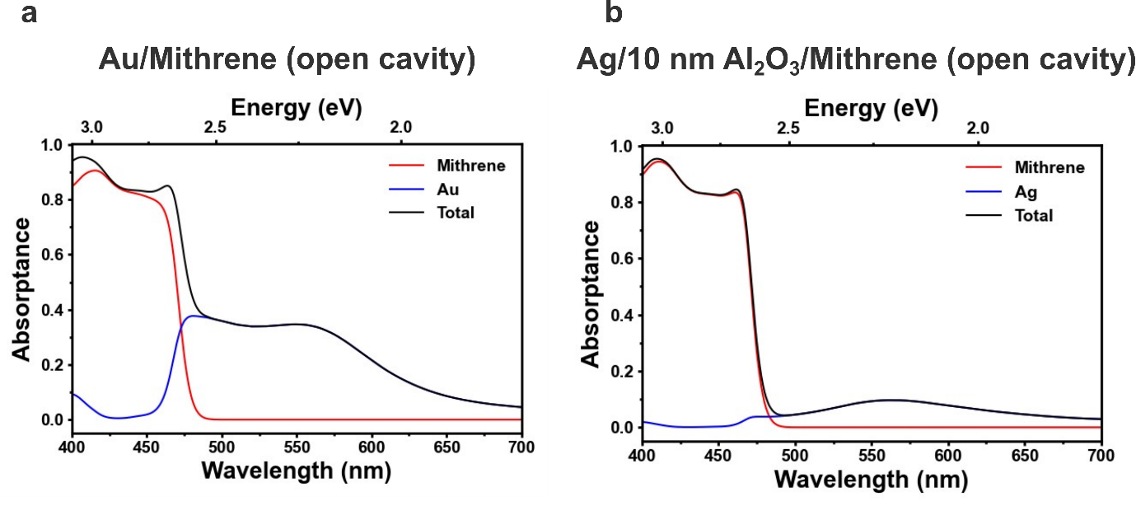
Figure S3. Simulation studies on layer-dependent absorption for open-cavity polaritons. (a) Using Au substrate for open cavity polaritons results in almost 40% light absorption around the mithrene exciton peak (475 nm). (b) By using Ag with a 10 nm Al₂O₃, the contribution from metal absorption can be drastically reduced from 40% to ~5%. Also, the 10 nm Al₂O₃ layer protects the silver from oxidation and avoids unwanted reaction between Ag and mithrene.

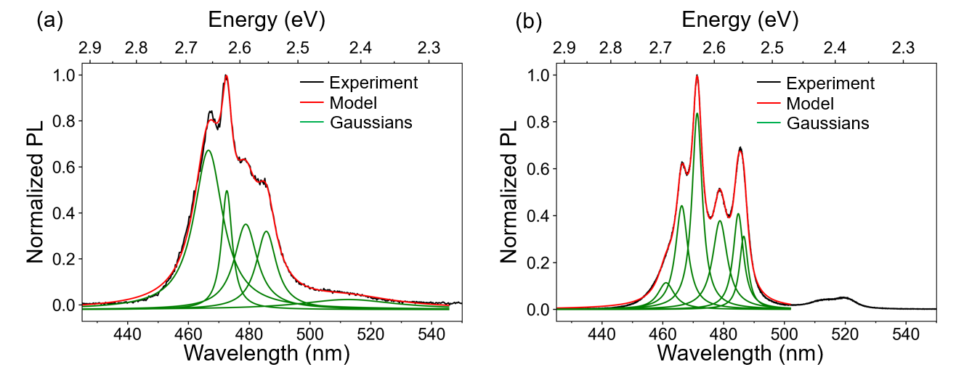
Figure S4. Q-factor of exciton-polaritons in open and closed geometries. The deconvoluted spectra of the (a) open and (b) closed cavity systems as shown in Figure 3d. The experimental data was deconvoluted into multiple Gaussian peaks and the average Q-factors were found to be 23.6 and 44.0 for the open and closed cavity systems, respectively.

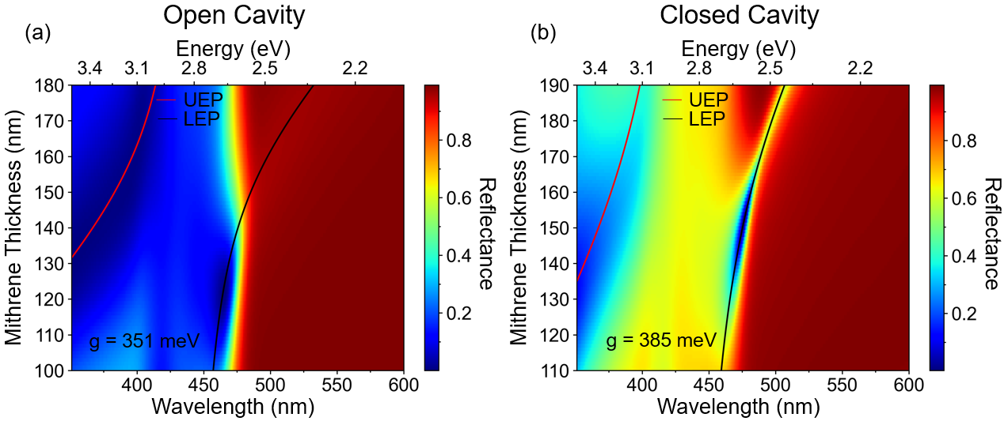
Figure S5. Dispersion of exciton-polaritons in mithrene using silver reflectors. The mithrene thickness dependence of the reflectance spectra for an (a) open and (b) closed cavity system. From top to botton, the open cavity system is mithrene/Al₂O₃ (10 nm)/Ag, and the closed cavity system is Ag (15 nm)/Al₂O₃ (10 nm)/mithrene/Al₂O₃ (10 nm)/Ag. The coupling parameters were extracted using the quantum Rabi model as discussed in section S1.

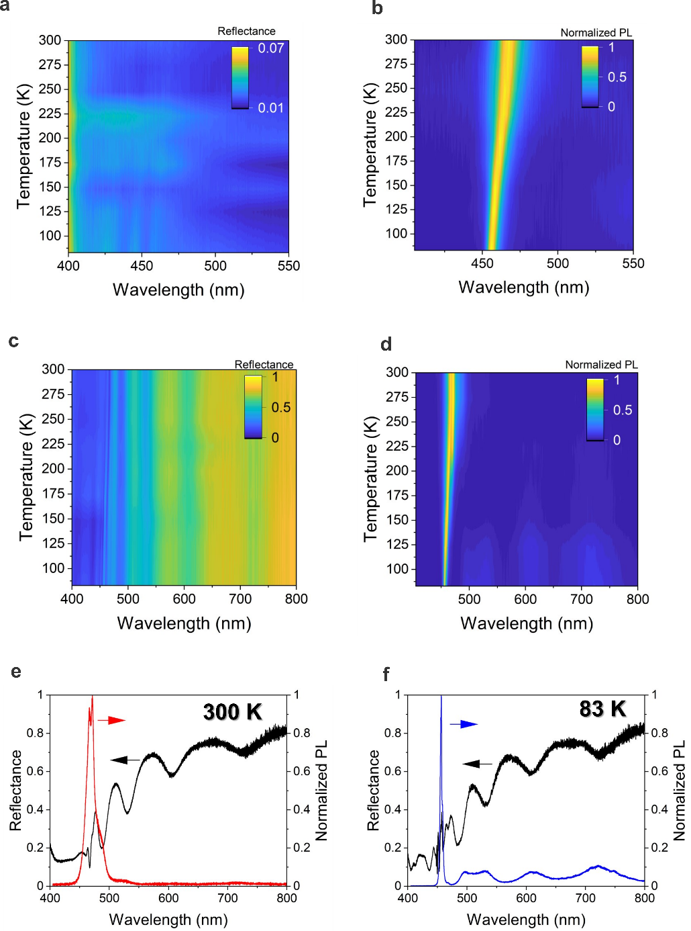
Figure S6. Temperature-dependent optical properties of exciton and exciton-polariton from mithrene. (a) reflectance and (b) PL spectra from the mithrene on quartz substrate shows a blue-shift in the exciton peak position upon cooling. (c) reflectance and (d) PL from the mithrene on Au substrate shows multiple polariton branches below the exciton peak due to the contribution from higher-order cavities. The line spectra at 300 K (e) and 80 K (f) shows the linewidth narrowing of the E-P peak and multiple polariton branches upon cooling to 80 K.

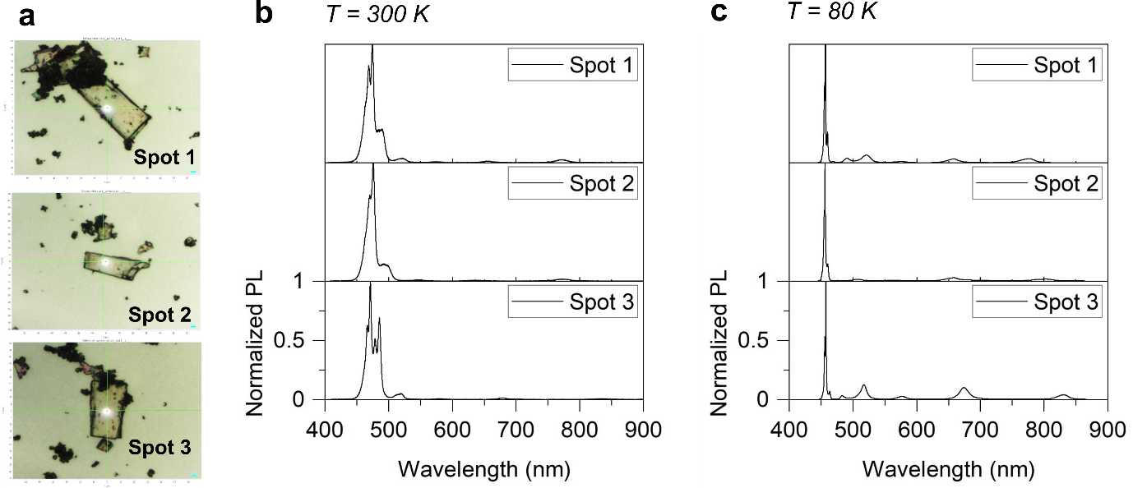

Figure S7. Emergence of multiple polariton branches from Mithrene in closed cavity. (a) Optical micrographs of mithrene in closed cavity (PMMA/15 nm Ag/10 nm Al₂O₃/PMMA/ Mithrene/10 nm Al₂O₃/100 nm Ag). (b) PL at 300 K showing a dominant exciton-polariton emission and (c) at 80 K the emergence of multiple polariton branches at longer wavelength can be observed. The linewidth of the most intense PL peak at 80 K were ~1 nm.
Slope correction to E-K measurements.
To correct for the slope in the E-K measurements caused by the slight tiltof the CCD array, a linear transform was performed on the raw data. By analyzing the spectral tilt, a slope was determined from the spectra and could be used as a correction value. The slope was measured on several spectra and an average value of 0.0176 sin(θ)/pixel was determined. This correlates to the spectra being tilted one vertical pixel approximately every 29 horizontal pixels. Once this was determined, a linear transform was performed on the dataset correcting the data only in the background region, outside of the E-K measurement. Before and after correction data can be seen in Figure S8, Supporting Information.
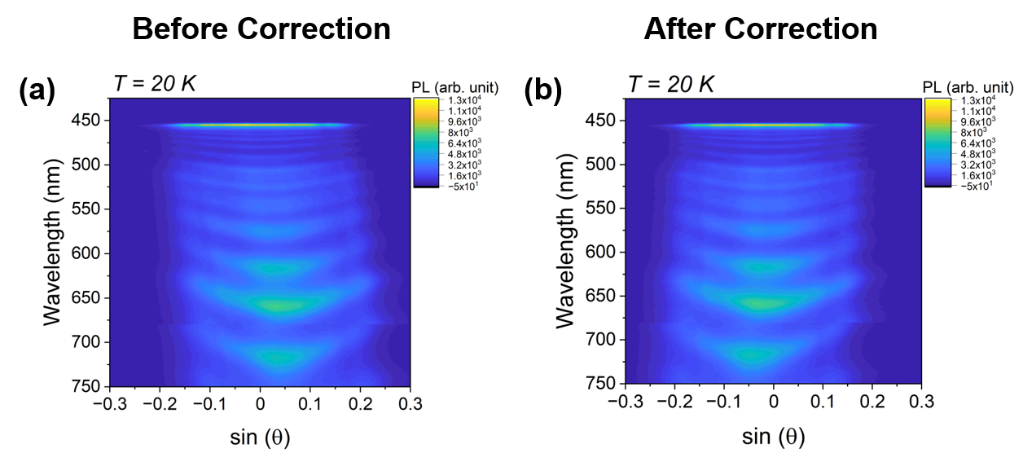
Figure S8. E-k data correction. The raw data without any data treatment (a) and correcting the drift by a slope value (b) is shown here.

Table S1. Anisotropic, complex refractive index of mithrene
Wavelength (nm) | n_{ord} | k_{ord} | n_{ext} | k_{ext}
350.9151 | 1.571173 | 0.280109 | 1.47571 | 0.088286
352.5063 | 1.574049 | 0.281995 | 1.476738 | 0.096357
354.0975 | 1.576889 | 0.283757 | 1.478456 | 0.104147
355.6887 | 1.579684 | 0.285395 | 1.480793 | 0.111581
357.2799 | 1.582424 | 0.28691 | 1.483671 | 0.1186
358.8712 | 1.5851 | 0.288304 | 1.48701 | 0.125164
360.4623 | 1.587702 | 0.289577 | 1.490733 | 0.131245
362.0535 | 1.590218 | 0.290732 | 1.494764 | 0.136829
363.6447 | 1.592637 | 0.291769 | 1.499033 | 0.141913
365.2359 | 1.594947 | 0.292691 | 1.503477 | 0.146499
366.8271 | 1.597135 | 0.2935 | 1.508036 | 0.150597
368.4183 | 1.599187 | 0.294198 | 1.512658 | 0.154222
370.0095 | 1.601087 | 0.294788 | 1.517293 | 0.157391
371.6007 | 1.602818 | 0.295273 | 1.521898 | 0.160125
373.1919 | 1.604362 | 0.295656 | 1.526432 | 0.162446
374.783 | 1.605699 | 0.29594 | 1.530859 | 0.164378
376.3742 | 1.606805 | 0.29613 | 1.535144 | 0.165947
377.9654 | 1.607654 | 0.29623 | 1.539258 | 0.167181
379.5565 | 1.608218 | 0.296245 | 1.543171 | 0.168108
381.1476 | 1.608461 | 0.296181 | 1.546858 | 0.168758
382.7388 | 1.608344 | 0.296046 | 1.550296 | 0.169163
384.3299 | 1.60782 | 0.295848 | 1.553463 | 0.169355
385.9211 | 1.606831 | 0.295597 | 1.556342 | 0.169369
387.5122 | 1.605308 | 0.295307 | 1.558918 | 0.169239
389.1033 | 1.60316 | 0.294997 | 1.561178 | 0.168997
390.6944 | 1.600273 | 0.294698 | 1.56311 | 0.168678
392.2855 | 1.596493 | 0.294465 | 1.564703 | 0.168313
393.8765 | 1.591627 | 0.294401 | 1.565946 | 0.16793
395.4676 | 1.585438 | 0.294691 | 1.566824 | 0.167553
397.0587 | 1.577678 | 0.295653 | 1.567308 | 0.167204
398.6497 | 1.568151 | 0.297783 | 1.567345 | 0.166901
400.2408 | 1.556831 | 0.301753 | 1.566839 | 0.166679
401.8318 | 1.543985 | 0.308339 | 1.565624 | 0.166635
403.4228 | 1.530261 | 0.318239 | 1.563501 | 0.167029
405.0138 | 1.516623 | 0.331817 | 1.560389 | 0.168361
406.6048 | 1.504095 | 0.348927 | 1.556575 | 0.17127
408.1957 | 1.493377 | 0.368962 | 1.552805 | 0.176184
409.7867 | 1.484573 | 0.391204 | 1.550012 | 0.182978
411.3776 | 1.477262 | 0.415348 | 1.548846 | 0.190997
412.9686 | 1.470976 | 0.441849 | 1.549418 | 0.199435
414.5595 | 1.465859 | 0.471819 | 1.551423 | 0.207695
416.1504 | 1.463119 | 0.506445 | 1.554388 | 0.21552
417.7413 | 1.46495 | 0.546182 | 1.557849 | 0.222964
419.3322 | 1.47391 | 0.590166 | 1.561461 | 0.230376
420.923 | 1.492035 | 0.636193 | 1.565181 | 0.238394
422.5139 | 1.520185 | 0.681265 | 1.569557 | 0.247783
424.1047 | 1.557893 | 0.722339 | 1.575944 | 0.258921
425.6955 | 1.603667 | 0.756908 | 1.586179 | 0.27101
427.2862 | 1.655419 | 0.783233 | 1.601455 | 0.281679
428.877 | 1.710808 | 0.800335 | 1.621014 | 0.287792
430.4678 | 1.767441 | 0.807924 | 1.641947 | 0.287228
432.0585 | 1.823002 | 0.806344 | 1.660556 | 0.280216
433.6492 | 1.875383 | 0.796555 | 1.674225 | 0.26914
435.2399 | 1.922865 | 0.780101 | 1.68241 | 0.257103
436.8305 | 1.964306 | 0.759002 | 1.686278 | 0.246446
438.4212 | 1.999361 | 0.735541 | 1.687603 | 0.238134
440.0118 | 2.028561 | 0.711942 | 1.687828 | 0.232058
441.6024 | 2.053274 | 0.689984 | 1.687746 | 0.227659
443.193 | 2.075454 | 0.670646 | 1.687621 | 0.224392
444.7835 | 2.097217 | 0.653906 | 1.687424 | 0.221898
446.3741 | 2.120349 | 0.638766 | 1.687012 | 0.220009
447.9646 | 2.145893 | 0.623543 | 1.686196 | 0.218721
449.5551 | 2.173941 | 0.606318 | 1.684783 | 0.218185
451.1456 | 2.203696 | 0.58541 | 1.682616 | 0.218731
452.736 | 2.233738 | 0.55971 | 1.679673 | 0.220888
454.3264 | 2.262382 | 0.528823 | 1.67619 | 0.225334
455.9168 | 2.287998 | 0.493026 | 1.672752 | 0.232775
457.5071 | 2.309237 | 0.45312 | 1.670309 | 0.243795
459.0975 | 2.325148 | 0.410229 | 1.670147 | 0.25876
460.6878 | 2.335189 | 0.365624 | 1.673921 | 0.277736
462.2781 | 2.339201 | 0.320592 | 1.683786 | 0.30026
463.8683 | 2.337339 | 0.276339 | 1.702363 | 0.32475
465.4586 | 2.330014 | 0.233935 | 1.732031 | 0.347754
467.0488 | 2.317833 | 0.194285 | 1.773331 | 0.363867
468.6389 | 2.301551 | 0.158107 | 1.823439 | 0.367236
470.2291 | 2.282022 | 0.12591 | 1.876279 | 0.354078
471.8192 | 2.260154 | 0.097992 | 1.924565 | 0.324384
473.4093 | 2.236852 | 0.074436 | 1.962292 | 0.281625
474.9993 | 2.212972 | 0.055119 | 1.986071 | 0.231067
476.5894 | 2.189265 | 0.039743 | 1.995016 | 0.178175
478.1794 | 2.166343 | 0.027878 | 1.99008 | 0.127858
479.7693 | 2.144657 | 0.019009 | 1.973672 | 0.084211
481.3592 | 2.124492 | 0.012592 | 1.949489 | 0.050097
482.9491 | 2.105987 | 0.008101 | 1.921966 | 0.026502
484.539 | 2.089153 | 0.005059 | 1.895155 | 0.012315
486.1288 | 2.073918 | 0.003067 | 1.87164 | 0.005002
487.7187 | 2.060149 | 0.001805 | 1.852246 | 0.001793
489.3084 | 2.047689 | 0.001031 | 1.836573 | 0.000595
490.8981 | 2.036373 | 0.000572 | 1.823773 | 0.000207
492.4879 | 2.026047 | 0.000308 | 1.813053 | 0.000091
494.0775 | 2.016572 | 0.000161 | 1.803841 | 0.000054
495.6671 | 2.007831 | 0.000082 | 1.79576 | 0.000038
497.2567 | 1.999722 | 0.000041 | 1.788564 | 0.000028
498.8463 | 1.992163 | 0.000019 | 1.782081 | 0.00002
500.4359 | 1.985087 | 0.000009 | 1.776189 | 0.000015
502.0253 | 1.978439 | 0.000004 | 1.770794 | 0.000011
503.6147 | 1.97217 | 0.000002 | 1.765825 | 0.000008
505.2042 | 1.966243 | 0.000001 | 1.761222 | 0.000006
506.7935 | 1.960625 | 0 | 1.756941 | 0.000004
508.3829 | 1.955288 | 0 | 1.752941 | 0.000003
509.9722 | 1.950207 | 0 | 1.749192 | 0.000002
511.5614 | 1.945361 | 0 | 1.745666 | 0.000002
513.1507 | 1.940731 | 0 | 1.74234 | 0.000001
514.7399 | 1.936302 | 0 | 1.739195 | 0.000001
516.329 | 1.932058 | 0 | 1.736212 | 0.000001
517.9181 | 1.927986 | 0 | 1.733379 | 0
519.5071 | 1.924075 | 0 | 1.730681 | 0
521.0961 | 1.920314 | 0 | 1.728108 | 0
522.6852 | 1.916693 | 0 | 1.725649 | 0
524.274 | 1.913204 | 0 | 1.723295 | 0
525.863 | 1.909838 | 0 | 1.721039 | 0
527.4518 | 1.906588 | 0 | 1.718873 | 0
529.0406 | 1.903448 | 0 | 1.716791 | 0
530.6294 | 1.900411 | 0 | 1.714786 | 0
532.2181 | 1.897472 | 0 | 1.712855 | 0
533.8068 | 1.894625 | 0 | 1.710992 | 0
535.3954 | 1.891866 | 0 | 1.709193 | 0
536.984 | 1.88919 | 0 | 1.707453 | 0
538.5725 | 1.886593 | 0 | 1.70577 | 0
540.161 | 1.884071 | 0 | 1.704139 | 0
541.7495 | 1.881621 | 0 | 1.702559 | 0
543.3378 | 1.879238 | 0 | 1.701025 | 0
544.9262 | 1.876921 | 0 | 1.699536 | 0
546.5145 | 1.874665 | 0 | 1.698089 | 0
548.1028 | 1.872469 | 0 | 1.696681 | 0
549.691 | 1.87033 | 0 | 1.695312 | 0
551.2792 | 1.868244 | 0 | 1.693978 | 0
552.8672 | 1.866211 | 0 | 1.692679 | 0
554.4553 | 1.864227 | 0 | 1.691412 | 0
556.0433 | 1.862291 | 0 | 1.690176 | 0
557.6313 | 1.860401 | 0 | 1.68897 | 0
559.2192 | 1.858554 | 0 | 1.687792 | 0
560.807 | 1.85675 | 0 | 1.686641 | 0
562.3949 | 1.854987 | 0 | 1.685516 | 0
563.9826 | 1.853263 | 0 | 1.684415 | 0
565.5703 | 1.851576 | 0 | 1.683338 | 0
567.158 | 1.849926 | 0 | 1.682283 | 0
568.7455 | 1.84831 | 0 | 1.68125 | 0
570.3331 | 1.846728 | 0 | 1.680238 | 0
571.9206 | 1.845179 | 0 | 1.679245 | 0
573.508 | 1.843661 | 0 | 1.678272 | 0
575.0954 | 1.842174 | 0 | 1.677316 | 0
576.6827 | 1.840715 | 0 | 1.676378 | 0
578.27 | 1.839285 | 0 | 1.675458 | 0
579.8572 | 1.837883 | 0 | 1.674553 | 0
581.4444 | 1.836506 | 0 | 1.673664 | 0
583.0315 | 1.835156 | 0 | 1.67279 | 0
584.6185 | 1.83383 | 0 | 1.671931 | 0
586.2055 | 1.832528 | 0 | 1.671085 | 0
587.7924 | 1.83125 | 0 | 1.670253 | 0
589.3793 | 1.829994 | 0 | 1.669435 | 0
590.9661 | 1.82876 | 0 | 1.66863 | 0
592.5529 | 1.827547 | 0 | 1.667836 | 0
594.1396 | 1.826355 | 0 | 1.667055 | 0
595.7262 | 1.825182 | 0 | 1.666286 | 0
597.3128 | 1.824029 | 0 | 1.665528 | 0
598.8993 | 1.822895 | 0 | 1.66478 | 0
600.4858 | 1.821779 | 0 | 1.664043 | 0
602.0721 | 1.820682 | 0 | 1.663316 | 0
603.6585 | 1.819601 | 0 | 1.6626 | 0
605.2448 | 1.818537 | 0 | 1.661892 | 0
606.8309 | 1.817489 | 0 | 1.661193 | 0
608.4171 | 1.816458 | 0 | 1.660504 | 0
610.0032 | 1.815442 | 0 | 1.659822 | 0
611.5892 | 1.81444 | 0 | 1.65915 | 0
613.1752 | 1.813454 | 0 | 1.658485 | 0
614.761 | 1.812482 | 0 | 1.657827 | 0
616.3469 | 1.811524 | 0 | 1.657178 | 0
617.9327 | 1.810579 | 0 | 1.656535 | 0
619.5184 | 1.809648 | 0 | 1.6559 | 0
621.1039 | 1.808729 | 0 | 1.655272 | 0
622.6896 | 1.807823 | 0 | 1.65465 | 0
624.275 | 1.806929 | 0 | 1.654035 | 0
625.8605 | 1.806048 | 0 | 1.653427 | 0
627.4458 | 1.805178 | 0 | 1.652824 | 0
629.0311 | 1.804319 | 0 | 1.652228 | 0
630.6163 | 1.803471 | 0 | 1.651637 | 0
632.2015 | 1.802635 | 0 | 1.651052 | 0
633.7866 | 1.801808 | 0 | 1.650473 | 0
635.3716 | 1.800993 | 0 | 1.649899 | 0
636.9565 | 1.800187 | 0 | 1.64933 | 0
638.5414 | 1.799391 | 0 | 1.648766 | 0
640.1262 | 1.798605 | 0 | 1.648208 | 0
641.711 | 1.797828 | 0 | 1.647654 | 0
643.2956 | 1.797061 | 0 | 1.647105 | 0
644.8802 | 1.796303 | 0 | 1.64656 | 0
646.4647 | 1.795554 | 0 | 1.64602 | 0
648.0492 | 1.794813 | 0 | 1.645484 | 0
649.6335 | 1.794081 | 0 | 1.644953 | 0
651.2179 | 1.793357 | 0 | 1.644425 | 0
652.8021 | 1.792641 | 0 | 1.643902 | 0
654.3862 | 1.791933 | 0 | 1.643383 | 0
655.9703 | 1.791232 | 0 | 1.642867 | 0
657.5543 | 1.79054 | 0 | 1.642356 | 0
659.1383 | 1.789854 | 0 | 1.641848 | 0
660.7221 | 1.789176 | 0 | 1.641343 | 0
662.3059 | 1.788505 | 0 | 1.640842 | 0
663.8896 | 1.787841 | 0 | 1.640345 | 0
665.4733 | 1.787183 | 0 | 1.639851 | 0
667.0568 | 1.786533 | 0 | 1.63936 | 0
668.6403 | 1.785889 | 0 | 1.638872 | 0
670.2236 | 1.785251 | 0 | 1.638387 | 0
671.8069 | 1.784619 | 0 | 1.637905 | 0
673.3902 | 1.783994 | 0 | 1.637427 | 0
674.9733 | 1.783375 | 0 | 1.636951 | 0
676.5564 | 1.782761 | 0 | 1.636478 | 0
678.1394 | 1.782153 | 0 | 1.636008 | 0
679.7223 | 1.781551 | 0 | 1.63554 | 0
681.3052 | 1.780955 | 0 | 1.635075 | 0
682.8879 | 1.780364 | 0 | 1.634613 | 0
684.4706 | 1.779778 | 0 | 1.634153 | 0
686.0532 | 1.779197 | 0 | 1.633695 | 0
687.6357 | 1.778622 | 0 | 1.63324 | 0
689.2181 | 1.778052 | 0 | 1.632788 | 0
690.8004 | 1.777486 | 0 | 1.632337 | 0
692.3827 | 1.776926 | 0 | 1.631889 | 0
693.9649 | 1.77637 | 0 | 1.631443 | 0
695.547 | 1.775819 | 0 | 1.630999 | 0
697.129 | 1.775273 | 0 | 1.630557 | 0
698.7109 | 1.774731 | 0 | 1.630118 | 0
700.2928 | 1.774193 | 0 | 1.62968 | 0
701.8745 | 1.77366 | 0 | 1.629244 | 0
703.4562 | 1.773131 | 0 | 1.62881 | 0
705.0377 | 1.772606 | 0 | 1.628378 | 0
706.6193 | 1.772086 | 0 | 1.627948 | 0
708.2006 | 1.771569 | 0 | 1.62752 | 0
709.782 | 1.771057 | 0 | 1.627093 | 0
711.3632 | 1.770548 | 0 | 1.626668 | 0
712.9443 | 1.770043 | 0 | 1.626245 | 0
714.5254 | 1.769542 | 0 | 1.625823 | 0
716.1063 | 1.769045 | 0 | 1.625403 | 0
717.6872 | 1.768551 | 0 | 1.624985 | 0
719.268 | 1.768061 | 0 | 1.624568 | 0
720.8487 | 1.767575 | 0 | 1.624152 | 0
722.4293 | 1.767092 | 0 | 1.623738 | 0
724.0098 | 1.766612 | 0 | 1.623326 | 0
725.5902 | 1.766136 | 0 | 1.622915 | 0
727.1705 | 1.765663 | 0 | 1.622505 | 0
728.7508 | 1.765193 | 0 | 1.622096 | 0
730.3309 | 1.764726 | 0 | 1.621689 | 0
731.911 | 1.764263 | 0 | 1.621283 | 0
733.4909 | 1.763802 | 0 | 1.620879 | 0
735.0708 | 1.763345 | 0 | 1.620475 | 0
736.6505 | 1.762891 | 0 | 1.620073 | 0
738.2302 | 1.762439 | 0 | 1.619672 | 0
739.8098 | 1.761991 | 0 | 1.619272 | 0
741.3893 | 1.761545 | 0 | 1.618873 | 0
742.9686 | 1.761102 | 0 | 1.618476 | 0
744.548 | 1.760662 | 0 | 1.618079 | 0
746.1271 | 1.760225 | 0 | 1.617684 | 0
747.7062 | 1.75979 | 0 | 1.617289 | 0
749.2853 | 1.759358 | 0 | 1.616895 | 0
750.8641 | 1.758929 | 0 | 1.616503 | 0
752.443 | 1.758502 | 0 | 1.616111 | 0
754.0216 | 1.758078 | 0 | 1.615721 | 0
755.6002 | 1.757656 | 0 | 1.615331 | 0
757.1788 | 1.757237 | 0 | 1.614942 | 0
758.7572 | 1.75682 | 0 | 1.614554 | 0
760.3354 | 1.756406 | 0 | 1.614167 | 0
761.9137 | 1.755994 | 0 | 1.61378 | 0
763.4918 | 1.755584 | 0 | 1.613395 | 0
765.0698 | 1.755177 | 0 | 1.61301 | 0
766.6477 | 1.754772 | 0 | 1.612626 | 0
768.2255 | 1.754369 | 0 | 1.612243 | 0
769.8032 | 1.753968 | 0 | 1.61186 | 0
771.3807 | 1.75357 | 0 | 1.611479 | 0
772.9583 | 1.753174 | 0 | 1.611098 | 0
774.5356 | 1.752779 | 0 | 1.610717 | 0
776.1129 | 1.752387 | 0 | 1.610337 | 0
777.6901 | 1.751996 | 0 | 1.609959 | 0
779.2672 | 1.751608 | 0 | 1.60958 | 0
780.8441 | 1.751221 | 0 | 1.609202 | 0
782.421 | 1.750836 | 0 | 1.608825 | 0
783.9978 | 1.750453 | 0 | 1.608449 | 0
785.5744 | 1.750072 | 0 | 1.608073 | 0
787.151 | 1.749692 | 0 | 1.607697 | 0
788.7274 | 1.749315 | 0 | 1.607322 | 0
790.3038 | 1.748939 | 0 | 1.606948 | 0
791.88 | 1.748565 | 0 | 1.606574 | 0
793.4561 | 1.748192 | 0 | 1.6062 | 0
795.0321 | 1.747822 | 0 | 1.605828 | 0
796.608 | 1.747453 | 0 | 1.605455 | 0
798.1838 | 1.747086 | 0 | 1.605083 | 0
799.7595 | 1.74672 | 0 | 1.604712 | 0
801.335 | 1.746356 | 0 | 1.604341 | 0
802.9105 | 1.745994 | 0 | 1.60397 | 0
804.4858 | 1.745633 | 0 | 1.6036 | 0
806.061 | 1.745274 | 0 | 1.60323 | 0
807.6362 | 1.744916 | 0 | 1.602861 | 0
809.2112 | 1.74456 | 0 | 1.602492 | 0
810.7861 | 1.744205 | 0 | 1.602123 | 0
812.3609 | 1.743852 | 0 | 1.601755 | 0
813.9355 | 1.7435 | 0 | 1.601387 | 0
815.5101 | 1.743149 | 0 | 1.601019 | 0
817.0846 | 1.7428 | 0 | 1.600652 | 0
818.6589 | 1.742453 | 0 | 1.600285 | 0
820.2331 | 1.742107 | 0 | 1.599918 | 0
821.8073 | 1.741762 | 0 | 1.599552 | 0
823.3812 | 1.741418 | 0 | 1.599186 | 0
824.9551 | 1.741076 | 0 | 1.59882 | 0
826.5288 | 1.740735 | 0 | 1.598455 | 0
828.1024 | 1.740395 | 0 | 1.598089 | 0
829.676 | 1.740057 | 0 | 1.597724 | 0
831.2493 | 1.73972 | 0 | 1.59736 | 0
832.8226 | 1.739384 | 0 | 1.596995 | 0
834.3958 | 1.739049 | 0 | 1.596631 | 0
835.9689 | 1.738716 | 0 | 1.596267 | 0
837.5418 | 1.738383 | 0 | 1.595903 | 0
839.1146 | 1.738052 | 0 | 1.595539 | 0
840.6873 | 1.737722 | 0 | 1.595176 | 0
842.2599 | 1.737393 | 0 | 1.594812 | 0
843.8323 | 1.737065 | 0 | 1.594449 | 0
845.4046 | 1.736738 | 0 | 1.594086 | 0
846.9769 | 1.736412 | 0 | 1.593723 | 0
848.549 | 1.736088 | 0 | 1.59336 | 0
850.1209 | 1.735764 | 0 | 1.592998 | 0
851.6927 | 1.735441 | 0 | 1.592635 | 0
853.2645 | 1.73512 | 0 | 1.592273 | 0
854.8361 | 1.734799 | 0 | 1.591911 | 0
856.4075 | 1.73448 | 0 | 1.591548 | 0
857.9788 | 1.734161 | 0 | 1.591186 | 0
859.55 | 1.733843 | 0 | 1.590824 | 0
861.1211 | 1.733526 | 0 | 1.590463 | 0
862.6921 | 1.733211 | 0 | 1.590101 | 0
864.263 | 1.732895 | 0 | 1.589739 | 0
865.8337 | 1.732581 | 0 | 1.589378 | 0
867.4043 | 1.732268 | 0 | 1.589016 | 0
868.9747 | 1.731956 | 0 | 1.588655 | 0
870.545 | 1.731644 | 0 | 1.588293 | 0
872.1152 | 1.731334 | 0 | 1.587932 | 0
873.6854 | 1.731024 | 0 | 1.58757 | 0
875.2552 | 1.730715 | 0 | 1.587209 | 0
876.8251 | 1.730407 | 0 | 1.586848 | 0
878.3948 | 1.730099 | 0 | 1.586486 | 0
879.9644 | 1.729793 | 0 | 1.586125 | 0
881.5338 | 1.729487 | 0 | 1.585764 | 0
883.1031 | 1.729182 | 0 | 1.585402 | 0
884.6724 | 1.728877 | 0 | 1.585041 | 0
886.2414 | 1.728574 | 0 | 1.58468 | 0
887.8102 | 1.728271 | 0 | 1.584318 | 0
889.3791 | 1.727969 | 0 | 1.583957 | 0
890.9478 | 1.727667 | 0 | 1.583596 | 0
892.5162 | 1.727367 | 0 | 1.583234 | 0
894.0846 | 1.727067 | 0 | 1.582873 | 0
895.6528 | 1.726767 | 0 | 1.582511 | 0
897.221 | 1.726468 | 0 | 1.58215 | 0
898.7889 | 1.72617 | 0 | 1.581788 | 0
900.3568 | 1.725873 | 0 | 1.581427 | 0
901.9245 | 1.725576 | 0 | 1.581065 | 0
903.4921 | 1.72528 | 0 | 1.580703 | 0
905.0596 | 1.724985 | 0 | 1.580341 | 0
906.6268 | 1.72469 | 0 | 1.579979 | 0
908.194 | 1.724396 | 0 | 1.579617 | 0
909.761 | 1.724102 | 0 | 1.579255 | 0
911.3279 | 1.723809 | 0 | 1.578893 | 0
912.8947 | 1.723516 | 0 | 1.578531 | 0
914.4613 | 1.723224 | 0 | 1.578168 | 0
916.0278 | 1.722933 | 0 | 1.577806 | 0
917.5941 | 1.722642 | 0 | 1.577443 | 0
919.1603 | 1.722352 | 0 | 1.57708 | 0
920.7264 | 1.722062 | 0 | 1.576717 | 0
922.2924 | 1.721773 | 0 | 1.576355 | 0
923.8582 | 1.721485 | 0 | 1.575991 | 0
925.4238 | 1.721196 | 0 | 1.575628 | 0
926.9894 | 1.720909 | 0 | 1.575265 | 0
928.5547 | 1.720622 | 0 | 1.574901 | 0
930.1199 | 1.720335 | 0 | 1.574538 | 0
931.6849 | 1.720049 | 0 | 1.574174 | 0
933.2499 | 1.719763 | 0 | 1.57381 | 0
934.8148 | 1.719478 | 0 | 1.573446 | 0
936.3794 | 1.719194 | 0 | 1.573082 | 0
937.9438 | 1.718909 | 0 | 1.572717 | 0
939.5082 | 1.718626 | 0 | 1.572353 | 0
941.0724 | 1.718342 | 0 | 1.571988 | 0
942.6365 | 1.718059 | 0 | 1.571623 | 0
944.2005 | 1.717777 | 0 | 1.571258 | 0
945.7643 | 1.717495 | 0 | 1.570893 | 0
947.3278 | 1.717214 | 0 | 1.570527 | 0
948.8914 | 1.716932 | 0 | 1.570162 | 0
950.4547 | 1.716652 | 0 | 1.569796 | 0
952.0179 | 1.716371 | 0 | 1.56943 | 0
953.5809 | 1.716091 | 0 | 1.569064 | 0
955.1439 | 1.715812 | 0 | 1.568698 | 0
956.7067 | 1.715533 | 0 | 1.568331 | 0
958.2692 | 1.715254 | 0 | 1.567964 | 0
959.8317 | 1.714975 | 0 | 1.567597 | 0
961.3939 | 1.714697 | 0 | 1.56723 | 0
962.9562 | 1.714419 | 0 | 1.566863 | 0
964.5182 | 1.714142 | 0 | 1.566495 | 0
966.08 | 1.713865 | 0 | 1.566127 | 0
967.6417 | 1.713589 | 0 | 1.565759 | 0
969.2032 | 1.713312 | 0 | 1.565391 | 0
970.7646 | 1.713036 | 0 | 1.565022 | 0
972.3259 | 1.712761 | 0 | 1.564654 | 0
973.887 | 1.712485 | 0 | 1.564284 | 0
975.4479 | 1.71221 | 0 | 1.563915 | 0
977.0087 | 1.711936 | 0 | 1.563546 | 0
978.5693 | 1.711661 | 0 | 1.563176 | 0
980.1299 | 1.711387 | 0 | 1.562806 | 0
981.6901 | 1.711114 | 0 | 1.562436 | 0
983.2504 | 1.71084 | 0 | 1.562066 | 0
984.8104 | 1.710567 | 0 | 1.561695 | 0
986.3702 | 1.710294 | 0 | 1.561324 | 0
987.93 | 1.710021 | 0 | 1.560953 | 0
989.4894 | 1.709749 | 0 | 1.560581 | 0
991.049 | 1.709477 | 0 | 1.56021 | 0
992.6081 | 1.709205 | 0 | 1.559838 | 0
994.1672 | 1.708934 | 0 | 1.559465 | 0
995.7262 | 1.708663 | 0 | 1.559093 | 0
997.2849 | 1.708392 | 0 | 1.55872 | 0
998.8434 | 1.708121 | 0 | 1.558347 | 0
1012.442 | 1.705767 | 0 | 1.555078 | 0
1015.843 | 1.705181 | 0 | 1.554257 | 0
1019.245 | 1.704595 | 0 | 1.553434 | 0
1022.646 | 1.70401 | 0 | 1.552609 | 0
1026.049 | 1.703426 | 0 | 1.551782 | 0
1029.451 | 1.702842 | 0 | 1.550954 | 0
1032.854 | 1.702259 | 0 | 1.550123 | 0
1036.257 | 1.701677 | 0 | 1.549291 | 0
1039.661 | 1.701095 | 0 | 1.548457 | 0
1043.065 | 1.700514 | 0 | 1.547621 | 0
1046.47 | 1.699933 | 0 | 1.546784 | 0
1049.874 | 1.699352 | 0 | 1.545944 | 0
1053.28 | 1.698772 | 0 | 1.545102 | 0
1056.685 | 1.698192 | 0 | 1.544259 | 0
1060.091 | 1.697613 | 0 | 1.543413 | 0
1063.497 | 1.697034 | 0 | 1.542566 | 0
1066.904 | 1.696455 | 0 | 1.541716 | 0
1070.311 | 1.695877 | 0 | 1.540864 | 0
1073.719 | 1.695298 | 0 | 1.540011 | 0
1077.126 | 1.69472 | 0 | 1.539155 | 0
1080.534 | 1.694142 | 0 | 1.538297 | 0
1083.943 | 1.693564 | 0 | 1.537437 | 0
1087.352 | 1.692986 | 0 | 1.536575 | 0
1090.761 | 1.692409 | 0 | 1.535711 | 0
1094.171 | 1.691831 | 0 | 1.534844 | 0
1097.581 | 1.691254 | 0 | 1.533976 | 0

References
1. Meystre, P. The Jaynes–Cummings Model. 75–95 (2021) doi:10.1007/978-3-030-76183-7_3.
2. Reithmaier, J. P. et al. Strong coupling in a single quantum dot–semiconductor microcavity system. Nature 2004 432:7014 432, 197–200 (2004).
3. Baranov, D. G. et al. Ultrastrong coupling between nanoparticle plasmons and cavity photons at ambient conditions. Nature Communications 2020 11:1 11, 1–9 (2020).

