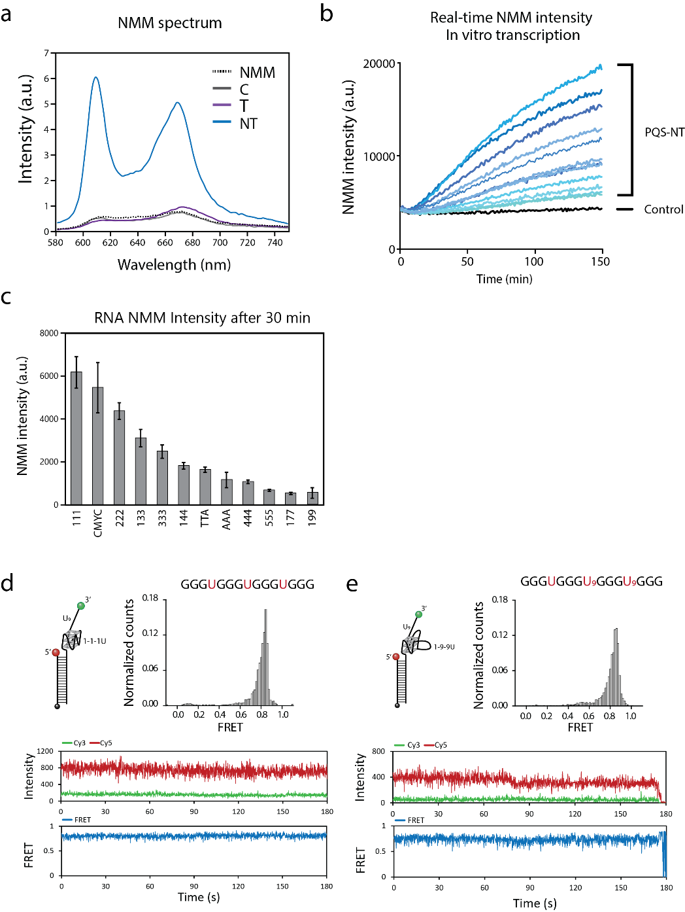
Supplementary Fig. 1: RNA G-quadruplex formation verified by G4-binding ligand and smFRET.
a-c, RNA G4 formation is examined by NMM, which selectively binds to parallel G4. a, Fluorescence spectrum of NMM excited at λ_{ex} 393 nm. CMYC-NT RNA shows a clear emission peak at λ_{em} 610 and 670 nm, indicating strong binding of NMM. b, Real-time NMM fluorescence detected in the in vitro transcription assay. All PQS-NT show an increase of NMM intensities, demonstrating the formation of RNA G4. c, The NMM intensities of all PQS-NT constructs at the 30 min time point. The intensity trend is correlated to the size of PQS (shown in Figure 3a). Data are presented as mean ± SEM of n = 3-5 independent experiments. d-e RNA G4 formation detected by smFRET assay. d, smFRET test of “111” RNA. The FRET histogram (top) shows a single peak, and the FRET trace (bottom) remains steady, indicating 111 RG4 structure is strongly folded. e, smFRET test of “199” RNA. Like d, the steady FRET indicates the bulky G4 is also stable.

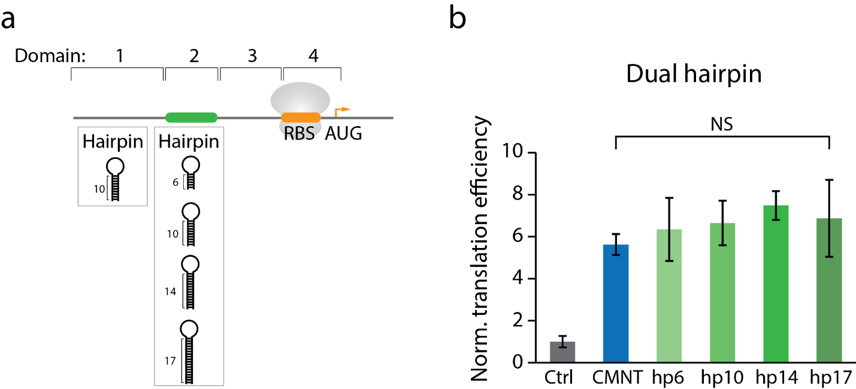
Supplementary Fig. 2: Dual hairpin structures cause the same level of enhancement.
a, Schematic of the dual hairpin constructs. The first hairpin is fixed to 10 hp. The second hairpin is inserted at domain 2 (green) to replace the PQS with either 6, 10, 14, or 17 bp stem hairpin. The folding energy is calculated by UNAfold and listed in Supplementary Table 1. b, Normalized translation efficiency of dual hairpin constructs. The data are presented as mean ± SEM of independent experiments (n = 3). NS: non-significant (two-sided paired t-test).

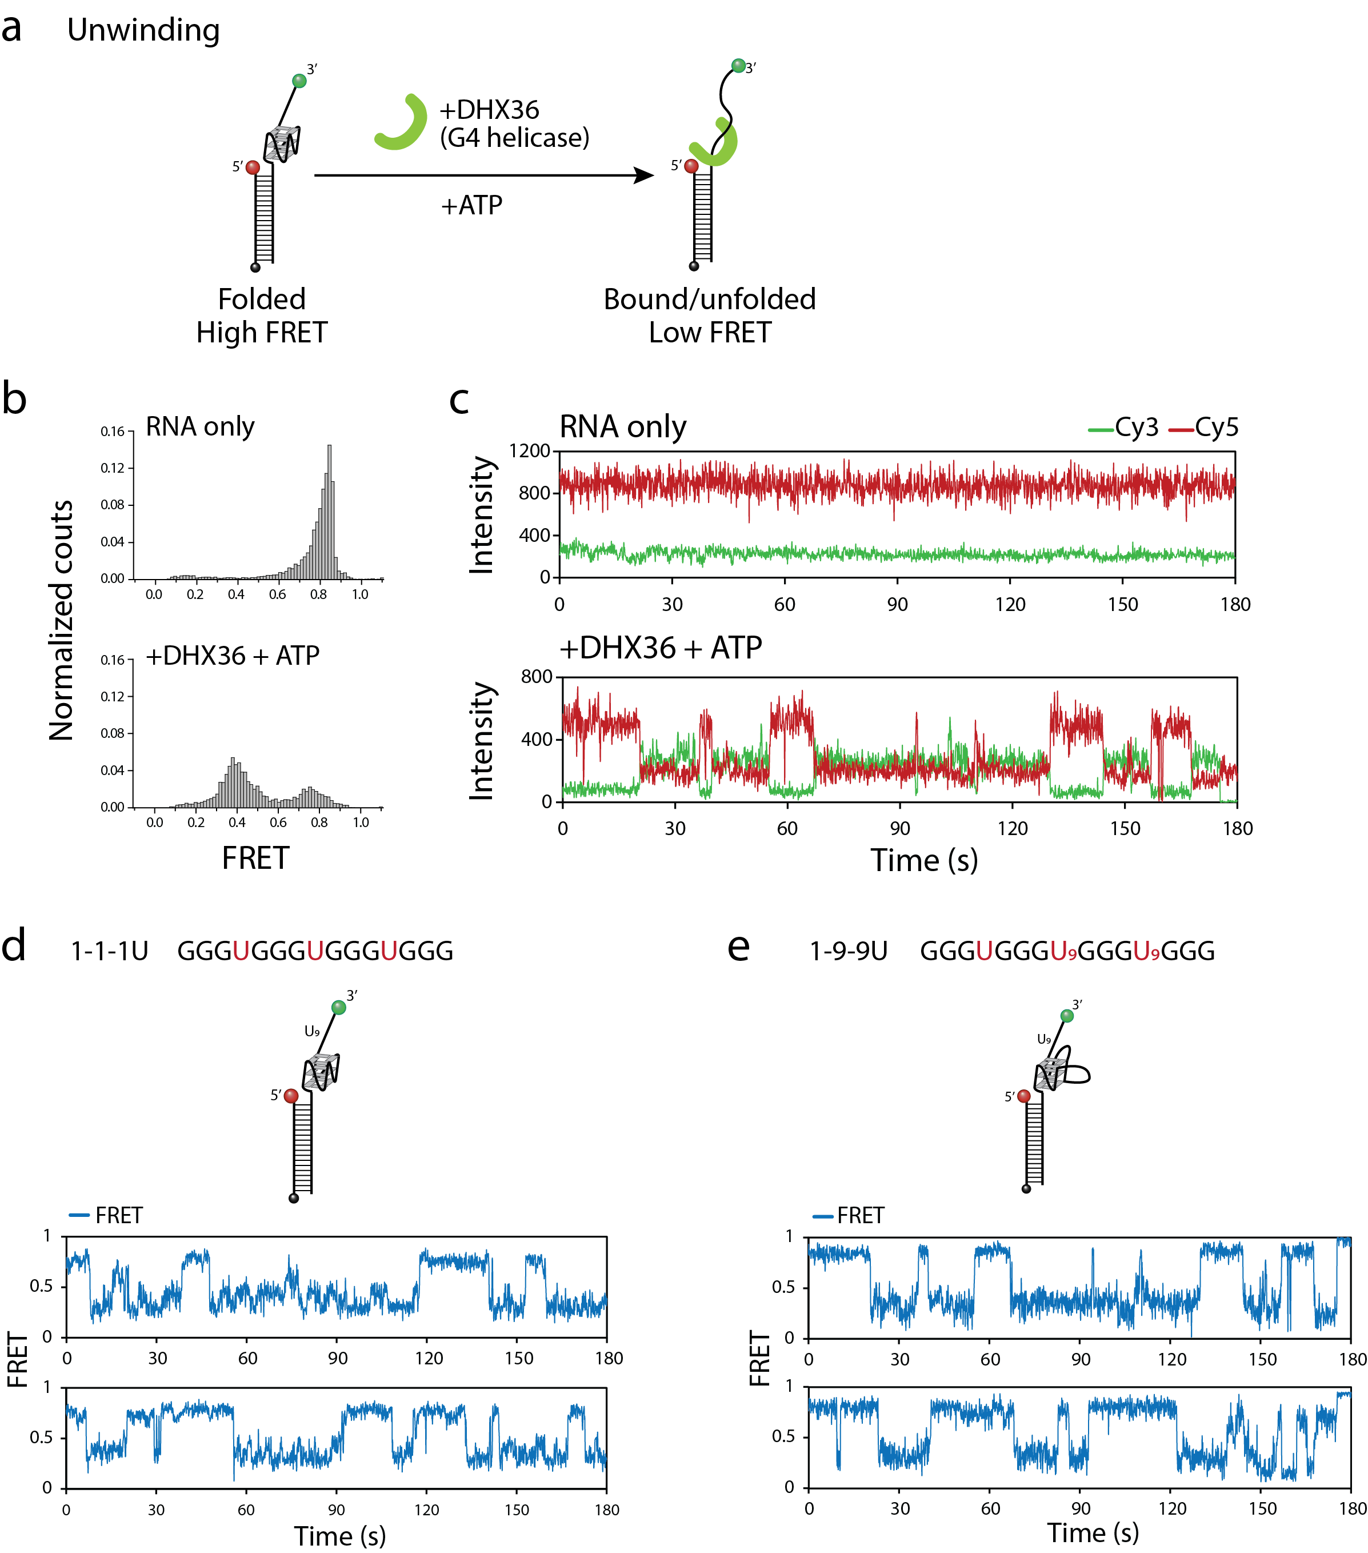
Supplementary Fig. 3: DHX36 helicase unwinds both tight and bulky RG4.
a, Schematic of smFRET RG4 unwinding assay. b, FRET efficiency shifts after adding DHX36 helicase and ATP, demonstrating unwinding. c, The FRET transition is observed in several anti-correlations of fluorescence, indicating the dynamics of unwinding process. d, e, Examples of FRET traces show unwinding events of both 111 (tight) and 199 (bulky) RG4.

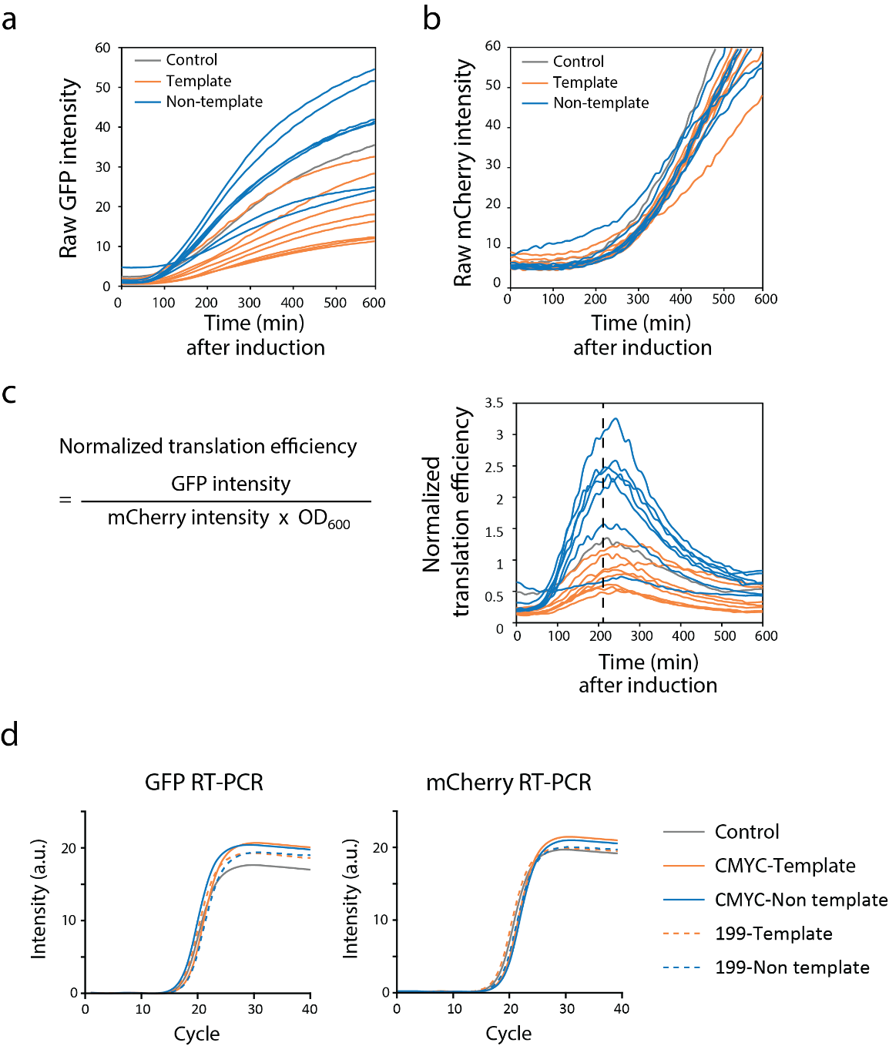
Supplementary Fig. 4: Quantification of mRNA and reporter expression.
a, b, Real-time fluorescence of GFP and mCherry detected by plate reader. The orientation dependence is observed in GFP expression due to the insertion of PQS while mCherry expression shows no difference among all the strains. c, The translation efficiency of GFP is normalized by the cell density and mCherry acts as an internal control. The efficiency varies by time because of the different maturation time between two reporters. The efficiency at 210 min time point (dash line) is defined as highest expression level and plotted in Figure 7e. d, mRNA amount for each construct shows no significant difference, indicating the enhancement is mainly induced at translation process. The data shown is a representative result from three independent experiments.

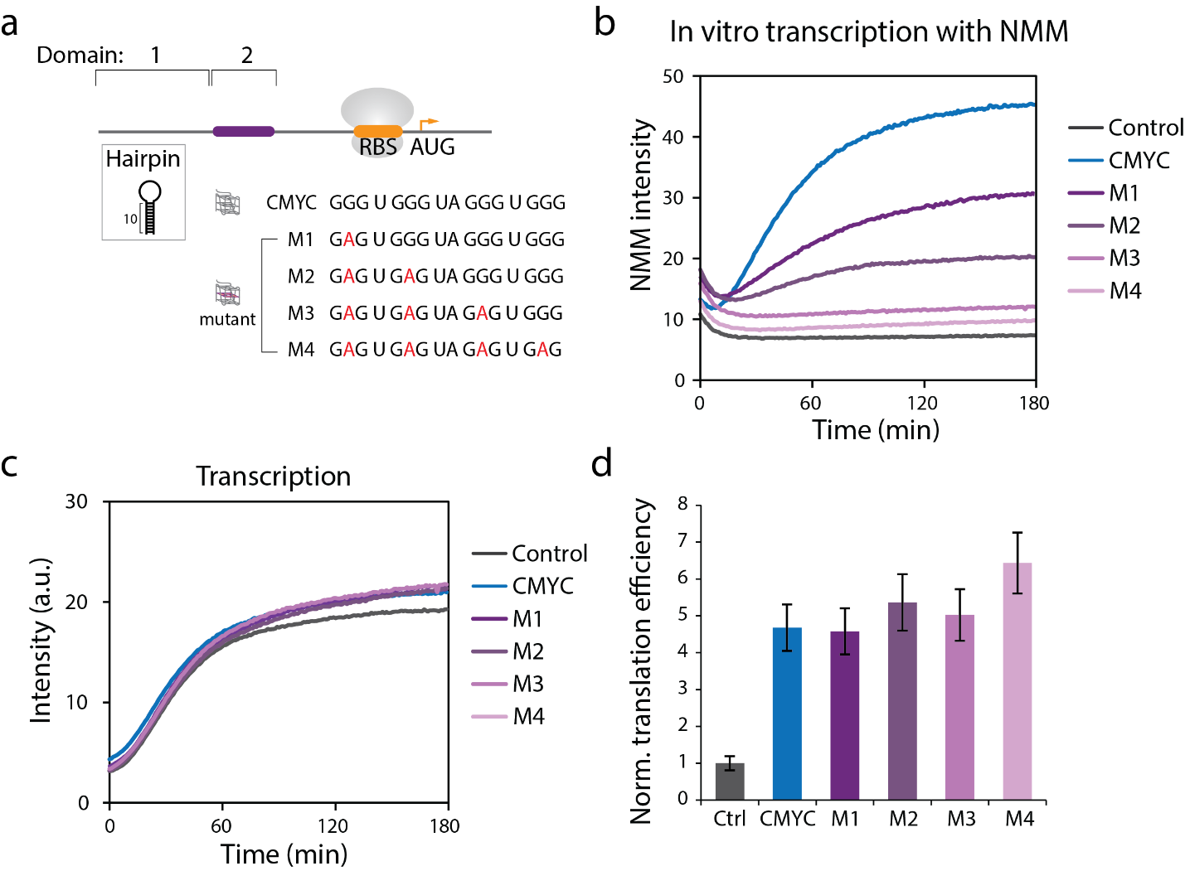
Supplementary Fig. 5: Mutant PQS enhances translation.
a, Schematic of mutant CMYC constructs. The first hairpin is fixed to 10 hp. The guanine in the second tetrad is mutated stepwise into adenine at domain 2 (purple). The folding energy is calculated by UNAfold and listed in Supplementary Table 1. b, Real-time NMM intensity shows gradual loss of the RG4 structure with increasing mutation. c, Mutant CMYC does not alter the transcription level. d, Normalized translation efficiency of CMYC and mutant constructs. The data are presented as mean ± SEM of independent experiments (n = 3).

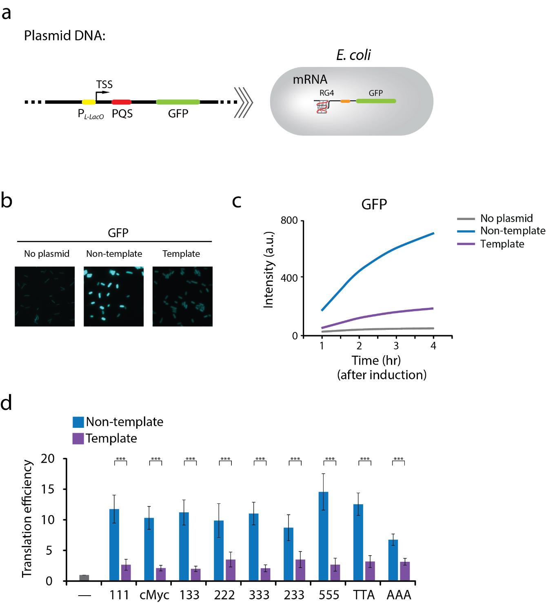
Supplementary Fig. 6: Orientation-dependence observed in E. coli promoter.
a, Schematic of PQS constructs with E. coli promoter P_{L-LacO}. b, Fluorescence imaging of GFP expression in E. coli. c, Real-time GFP intensities. The curves represent example traces of cMyc, where non-template (NT) and template (T) are colored in blue and purple, respectively. The data is collected by plate reader after IPTG induction. d, Translation efficiencies demonstrate the orientation dependence between NT and T. Data are presented as mean ± SEM of n = 3 independent experiments. Shown in d only represents the significance between template and non-template, where ***P < 0.005 (two-sided paired t-test).

Supplementary Table 1: RNA folding energy prediction.
Domain | Name | Sequence (5' → 3') | ΔG (kcal/mol)
1 | 0 hp | GGACAAUUGUGAGCGUGUAGUCAGUGAUUUGAUCAGAAUUCUUU | -3.1
 | 4 hp | GGACAAUUGUGAGCGGAUAACAAGUGAUUUGAUCAGAAUUCUUU | -5.9
 | 8 hp | GGGGAAUUGUGAGCGGAUAACAAUUCCAUUGAUCAGAAUUCUUU | -10.4
 | 10 hp | GGGGAAUUGUGAGCGGAUAACAAUUCCCCUCUAGAGAAUUCUUU | -15.9
 | 12 hp | GGGGAACGUUGUGAGCGGAUAACAACGUUCCCCUAGAAUUCUUU | -21.4
3 |  | UUACCGGUUUUGGUUGAAGGUAGUGGUAGUGGUGAUAUCCUGC | -5.6
4 |  | AGGAAAGGAGAGUAGCAAUGGGUACC | 0.9
3+4 |  | UUACCGGUUUUGGUUGAAGGUAGUGGUAGUGGUGAUAUCCUGC  AGGAAAGGAGAGUAGCAAUGGGUACC | -11.8
2 | 6 hp | UCGAACUUUUGUUCGA | -6.4
 | 10 hp | GCAGCGAGGCUUUUUGCCUCGCUGC | -21
 | 14 hp | GACGGCAGCGAGGCUUUUUGCCUCGCUGCCGUC | -31.3
 | 17 hp | GGCGACGGCAGCGAGGCUUUUUGCCUCGCUGCCGUCGCCA | -42.1
 | M1 | GAG U GGG UA GGG U GGG | 2.4
 | M2 | GAG U GAG UA GGG U GGG | 4.6
 | M3 | GAG U GAG UA GAG U GGG | 4.6
 | M4 | GAG U GAG UA GAG U GAG | 4.6

* The folding energy was calculated by UNAFold (Source: http://www.unafold.org/mfold/applications/rna-folding-form.php).
** Bold letters indicate the predicted hairpin stem.

Supplementary Table 2: Sequences of oligos in each assay.
DNA oligo for PCR
T7 forward primer | 5’- GCG AAT TAA TAC GAC TCA CTA TAG CGG ATA ACA AGA TAC TGA GCA CAG -3’
T7 Reverse primer | 5’- AAA CCC CTC CGT TTA GAG AGG GGT TAT GCT AG TTA TTT GTA GAG CTC ATC CAT GCC ATG -3’
Short-length primer 1 (reverse) | 5’- ACC AAC TTC CAT  CAC CAT CAC CAC -3’
Long-length primer 2 (reverse) | 5’-GTT CTT CTC CTT TGC TGG TAC-3’
Molecular beacons
Cy3-Probe 3 | 5’- Cy3/TTC ACC CTC TCC ACG GAC/3BHQ_2/ -3’
RBS probe | 5’- Cy5/GCT ACT CTC CTT TCC TGC A/3BHQ_2/ -3’
qPCR primers
qPCR Primer 1 forward | 5’- AGA GTA GCA ATG GGT ACC AGC -3’
qPCR Primer 1 reverse | 5’-AAA ATT TGT GCC CAT TAA CAT CAC C -3’
qPCR Primer 2 forward | 5’-TTT ACC AGA CAA CCA TTA CCT GTC G -3’
qPCR Primer 2 reverse | 5’-AGC AGC AGT TAC AAA CTC AAG AAG -3’
mCherry qPCR forward primer | 5’-CAC TAC GAC GCT GAG GTC AA-3’
mCherry qPCR reverse primer | 5’-TAG TCC TCG TTG TGG GAG GT-3’
GFP qPCR forward primer | 5’-GAT GGC CCT GTC CTT TTA CCA-3’
GFP qPCR reverse primer | 5’-CAT GTG GTC ACG CTT TTC GT-3’
RNA samples (HPLC purification)
Poly U40 RNA | 5’- rU₄₀-3’
cMyc RNA | 5’-rUrCrA rUrArG rGrGrU rGrGrG rUrArG rGrGrU rGrGrG rCrUrG rGrA-3’
Biotin 18mer | 5’-/5AmMC6/rGrCrC rUrCrG rCrUrG rCrCrG rUrCrG rCrCrA/3Bio/-3’
111-U9 RNA | 5′-rUrGrG rCrGrA rCrGrG rCrArG rCrGrA rGrGrC rUrUrG rGrGrU rGrGrG rUrGrG rGrUrG rGrGrU rUrUrU rUrUrU rUrU /3AmMO/-3′
199-U9 RNA | 5′-rUrGrG rCrGrA rCrGrG rCrArG rCrGrA rGrGrC rUrUrG rGrGrU rGrGrG rUrUrU rUrUrU rUrUrU rGrGrG rUrUrU rUrUrU rUrUrU rGrGrG rUrUrU rUrUrU rU rUrU/3AmMO/-3′

Supplementary Table 3: Statistics Result

Supplementary Table 3.1: Normalized transcription rate (Fig. 2c)
 |  |  |  | P-value
Name | Mean | SEM | N value | Control | Template
Control | 1.00 | 0.03 | 14
Template | 0.87 | 0.09 | 6 | 0.034
Non-template | 1.16 | 0.12 | 12 | 0.009 | 0.012
*N value means the number of independent events.
*SEM is presented as 95% confidence limit.
*P-values are reported by two-sided unpaired t-test.

Supplementary Table 3.2: Normalized translation efficiency (Fig. 2e)
 |  |  |  | P-value
Name | Mean | SEM | N value | Control | Template
Control | 1.00 | 0.03 | 14
Template | 0.90 | 0.23 | 6 | 0.294
Non-template | 5.73 | 1.02 | 12 | 5.95366E-05 | 4.08359E-05
*N value means the number of independent events.
*SEM is presented as 95% confidence limit.
*P-values are reported by two-sided unpaired t-test.

Supplementary Table 3.3: Normalized translation efficiency (Fig. 3c)
 |  |  |  |  | P-value
Name | Loop length | Mean | SEM | N value | Template
Control |  | 1.000 | 0.113 | 10
111-T | 3 | 1.001 | 0.365 | 3
cMyc-T | 4 | 1.377 | 0.207 | 5
222-T | 6 | 1.170 | 0.433 | 3
133-T | 7 | 1.851 | 0.317 | 3
333-T | 9 | 1.367 | 0.454 | 3
TTA-T | 9 | 1.425 | 0.257 | 3
AAA-T | 9 | 1.400 | 0.199 | 3
444-T | 12 | 1.596 | 0.237 | 3
555-T | 15 | 2.253 | 0.267 | 3
177-T | 15 | 2.175 | 0.642 | 3
199-T | 19 | 3.355 | 0.476 | 5
111-NT | 3 | 0.053 | 0.011 | 3 | 0.0295
cMyc-NT | 4 | 0.158 | 0.051 | 3 | 0.0001
222-NT | 6 | 0.116 | 0.018 | 3 | 0.0309
133-NT | 7 | 0.108 | 0.007 | 3 | 0.0060
333-NT | 9 | 0.230 | 0.023 | 3 | 0.0248
TTA-NT | 9 | 0.133 | 0.017 | 3 | 0.0062
AAA-NT | 9 | 0.142 | 0.013 | 3 | 0.0041
444-NT | 12 | 0.156 | 0.007 | 3 | 0.0050
555-NT | 15 | 0.146 | 0.016 | 3 | 0.0025
177-NT | 15 | 0.264 | 0.020 | 3 | 0.0181
199-NT | 19 | 0.042 | 0.003 | 3 | 0.0001
*N value means the number of independent events.
*SEM is presented as 95% confidence limit.
*P-values are reported by two-sided unpaired t-test.

Supplementary Table 3.4: Normalized transcription rate (Fig. 5c)
 |  |  |  | P-value
Name | Mean | SEM | N value | Control
Control | 1.00 | 0.08 | 3
Non-template | 1.13 | 0.15 | 3 | 0.350
RNA 1 | 0.86 | 0.02 | 3 | 0.014
RNA 2 | 1.02 | 0.06 | 3 | 0.636
RNA 3 | 1.02 | 0.03 | 3 | 0.451
RNA 4 | 1.10 | 0.14 | 3 | 0.415
RNA 5 | 0.99 | 0.04 | 3 | 0.716
RNA 6 | 0.92 | 0.01 | 3 | 0.004
*N value means the number of independent events.
*SEM is presented as 95% confidence limit.
*P-values are reported by two-sided paired t-test.

Supplementary Table 3.5: Probe intensity (Fig. 5h)
 |  |  |  |  | P-value
 | Name | Mean | SEM | N value | Control | Template
No heating | Control | 11.00 | 1.30 | 3
No heating | Template | 11.25 | 3.17 | 3 | 0.852
No heating | Non-template | 11.52 | 1.16 | 3 |  | 0.854
Heated | Control | 17.97 | 0.58 | 3
Heated | Template | 18.02 | 1.19 | 3 | 0.963
Heated | Non-template | 17.01 | 2.52 | 3 |  | 0.337
 | Probe only | 0.28 | 0.02 | 3
*N value means the number of independent events.
*SEM is presented as 95% confidence limit.
*P-values are reported by two-sided paired t-test.

Supplementary Table 3.6: Normalized transcription rate (Fig. 6f)
 |  |  |  | P-value
Name | Mean | SEM | N value | 0 nM
0 nM DHX36 | 1.00 | 0.04 | 3
1 nM | 1.01 | 0.05 | 3 | 0.096
2 nM | 0.96 | 0.05 | 3 | 0.715
5 nM | 0.98 | 0.05 | 3 | 0.826
*N value means the number of independent events.
*SEM is presented as 95% confidence limit.
*P-values are reported by two-sided paired t-test.

Supplementary Table 3.7: Normalized translation efficiency (Fig. 6g)
 |  |  |  | P-value
Name | Mean | SEM | N value | 0 nM
0 nM DHX36 | 1.00 | 0.04 | 3
1 nM | 0.78 | 0.04 | 3 | 9.35E-05
2 nM | 0.65 | 0.03 | 3 | 4.34E-03
5 nM | 0.25 | 0.01 | 3 | 2.15E-03
*N value means the number of independent events.
*SEM is presented as 95% confidence limit.
*P-values are reported by two-sided paired t-test.

Supplementary Table 3.8: Normalized translation (Fig. 7e)
 |  |  |  | P-value
Name | Mean | SEM | N value | Template
Control | 1.60 | 0.14 | 3
111-T | 1.08 | 0.29 | 3
cMyc-T | 1.08 | 0.29 | 5
555-T | 1.51 | 0.36 | 3
222-T | 2.99 | 1.02 | 3
133-T | 1.03 | 0.21 | 3
TTA-T | 1.69 | 0.56 | 3
199-T | 1.55 | 0.42 | 3
111-NT | 1.89 | 0.79 | 3 | 0.248
cMyc-NT | 3.09 | 0.84 | 3 | 0.034
555-NT | 4.04 | 0.93 | 3 | 0.024
222-NT | 4.39 | 1.05 | 3 | 0.246
133-NT | 4.50 | 1.02 | 3 | 0.009
TTA-NT | 4.69 | 1.21 | 3 | 0.033
199-NT | 5.75 | 1.43 | 3 | 0.016
*N value means the number of independent events.
*SEM is presented as 95% confidence limit.
*P-values are reported by two-sided paired t-test.

