Determinants of Plant Species Richness Along Elevational Gradients: Insights with Climate, Energy and Water-Energy Dynamics
Journal: Biodiversity and Conservation
Authors: Abhishek Kumar, Meenu Patil, Pardeep Kumar, Anand Narain Singh*
Affiliation: Soil Ecosystem and Restoration Ecology Lab, Department of Botany, Panjab University, Chandigarh 160014, India
*Corresponding author: dranand1212@gmail.com; ansingh@pu.ac.in

Supplementary Figures

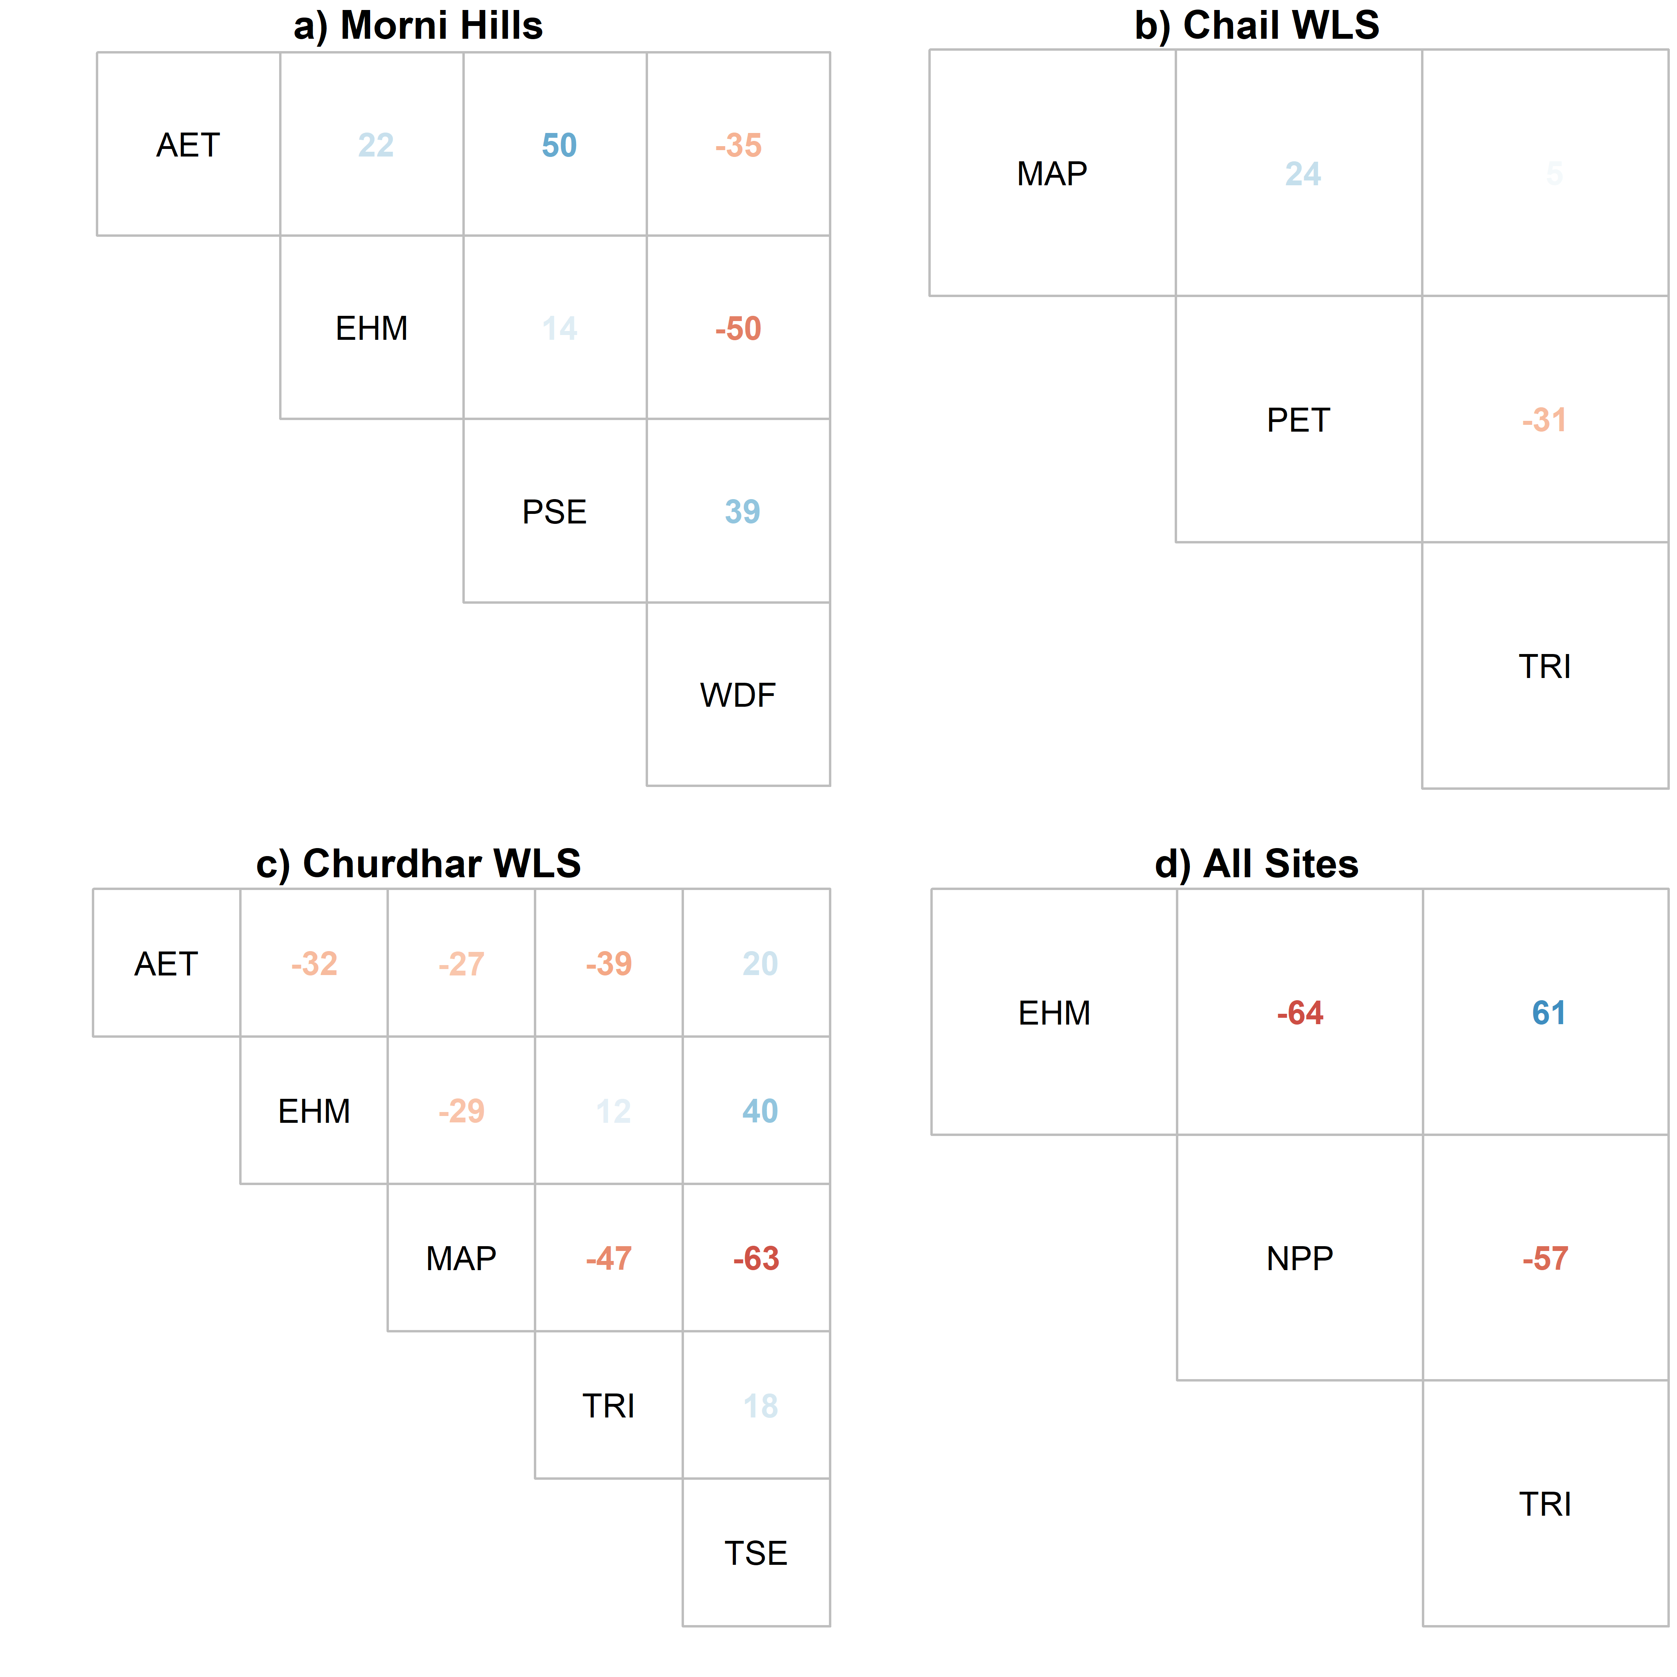
Fig. S1 Final set of uncorrelated explanatory variables for (a) Morni Hills, (b) Chail WLS, (c) Churdhar WLS, and (d) All Sites. The values represent Spearman’s correlation coefficient in precent and the transparency of these values is scaled to the magnitude of the correlation coefficient

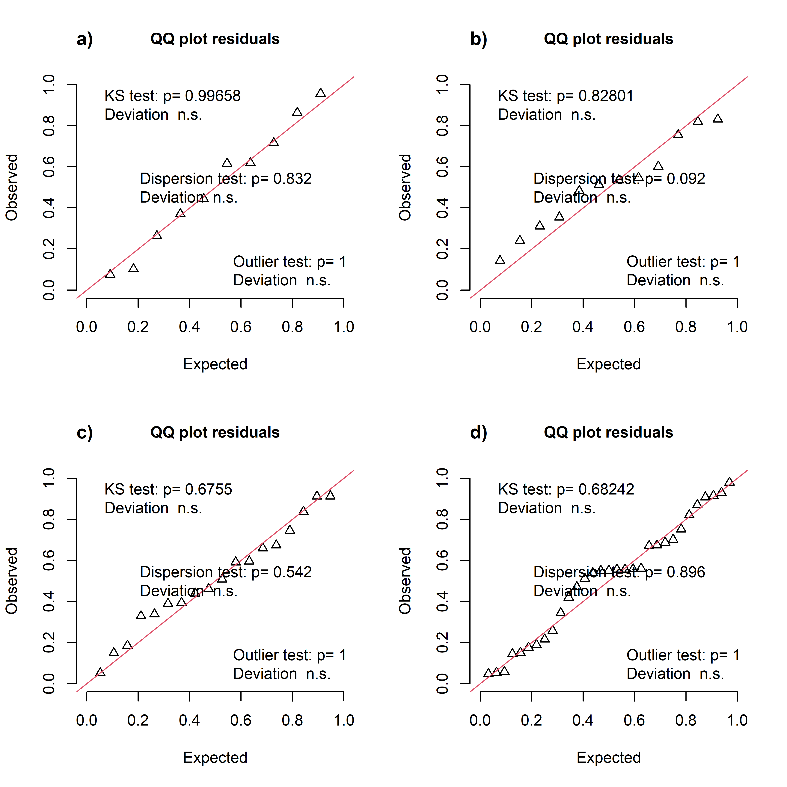
Fig. S2 Quantile-quantile (Q-Q) plot demonstrating model diagnostics for elevational patterns of species richness in (a) Morni Hills, (b) Chail WLS, (c) Churdhar WLS, and (d) All Sites. The plot shows the overall deviations from the simulation-based expected distribution with added tests for correct distribution (KS test), dispersion and outliers. The outliers are defined as values outside the simulation envelope. The plot assesses the goodness-of-fit between observed and expected quantiles, aiding in evaluating model assumptions and performance

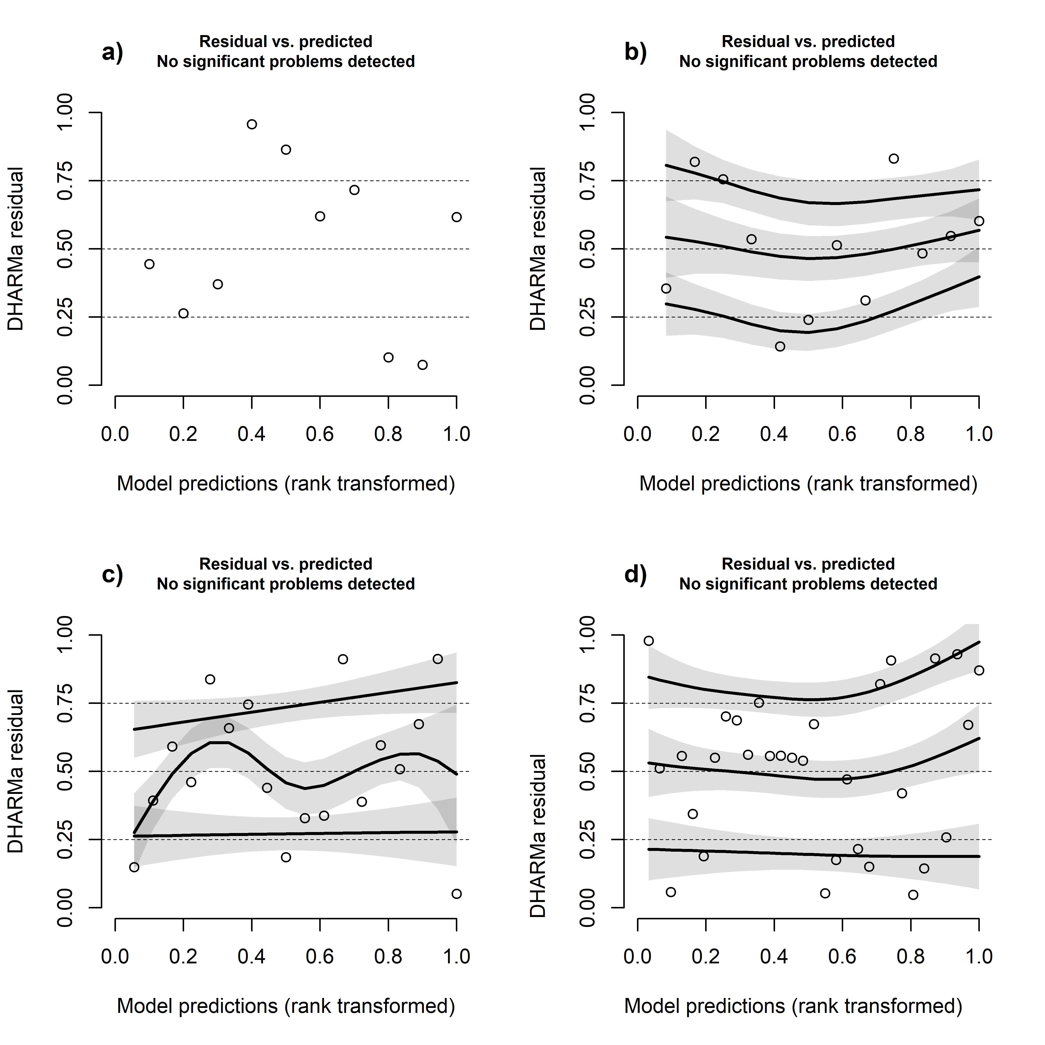
Fig. S3 Residual plots showing the deviations in model residuals against the model predictions for elevational patterns of species richness in (a) Morni Hills, (b) Chail WLS, (c) Churdhar WLS, and (d) All Sites. The deviation from the uniformity (in the y-direction) was estimated by comparing the empirical 0.25, 0.5 and 0.75 quantiles in the y-direction (red solid lines) with the theoretical 0.25, 0.5 and 0.75 quantiles (dashed black line). The simulation-based outliers are highlighted as red stars

Supplementary Tables

Table S1 Summary of primary variable selection for explaining species richness at lower (Morni), intermediate (Chail), higher (Churdhar) and full (All) elevational gradient. The species richness (S) was regressed against each explanatory variable using Poisson GLM with a log-link function. The values represent the estimated deviance-squared (D²) in percent units and higher values indicate better model fit. The variables with maximum D² values are highlighted with bold text
Variable | Morni | Chail | Churdhar | All
AET | 52.06 | 7.35 | 94.59 | 11.06
EHM | 2.94 | 16.69 | 10.77 | 3.76
ELE | 47.79 | 4.19 | 93.55 | 4.19
MAP | 71.43 | 0.97 | 11.17 | 3.34
MAT | 43.81 | 4.42 | 93.27 | 4.05
NPP | 74.06 | 0.85 | 92.74 | 45.85
PET | 53.51 | 6.60 | 92.56 | 2.86
PSE | 0.07 | 33.22 | 69.24 | 0.51
SOC | 61.64 | 0.96 | 82.86 | 11.71
TRI | 80.57 | 79.5 | 14.44 | 10.19
TSE | 66.21 | 7.54 | 19.75 | 2.46
WDF | 88.63 | 8.48 | 81.07 | 0.46

Table S2 Results of model selection for exploring determinants of species richness in selected sites. The table shows the degrees of freedom (df), log-likelihood (logLik), corrected Akaike’s Information Criteria (AICc), the difference in AICc from the top model (delta) and Akaike’s model weight (weight) for each model. Only models with a difference of four AICc units from the top model are presented for each site. The species richness (S) was regressed against the predictor variables including actual evapotranspiration (AET), enhanced vegetation index homogeneity (EHM), mean annual precipitation (MAP), potential evapotranspiration (PET), precipitation seasonality (PSE), temperature seasonality (TSE), terrain ruggedness index (TRI) and water deficit (WDF). Each model represents a generalised linear model (GLM) with Poisson distribution and the log-link function
Site | Model | df | logLik | AICc | delta | weight
Morni | S ~ AET + WDF | 3 | -38.31 | 86.62 | 0.00 | 0.48
Morni | S ~ AET + PSE | 3 | -38.83 | 87.66 | 1.04 | 0.28
Morni | S ~ AET + PSE + WDF | 4 | -36.41 | 88.83 | 2.21 | 0.16
Morni | S ~ AET + EHM + WDF | 4 | -37.09 | 90.19 | 3.57 | 0.08
Chail | S ~ TRI | 2 | -47.93 | 101.19 | 0.00 | 0.59
Chail | S ~ PET + TRI | 3 | -46.77 | 102.55 | 1.36 | 0.30
Chail | S ~ MAP + TRI | 3 | -47.81 | 104.62 | 3.43 | 0.11
Churdhar | S ~ AET + MAP | 3 | -72.50 | 152.72 | 0.00 | 0.54
Churdhar | S ~ AET + MAP + TRI | 4 | -71.74 | 154.56 | 1.84 | 0.22
Churdhar | S ~ AET + MAP + TSE | 4 | -72.15 | 155.37 | 2.65 | 0.14
Churdhar | S ~ AET + EHM + MAP | 4 | -72.50 | 156.07 | 3.35 | 0.10
All | S ~ EHM + NPP + TRI | 4 | -206.65 | 422.83 | 0.00 | 1.00

Table S3 Summary of the Poisson GLM with log-link function for selected sites in Western Himalayas. The species richness (S) was regressed against the water deficit (WDF) and actual evapotranspiration (AET) in cm units. The table displays the estimated regression coefficients (Estimate), standard errors (SE), z-scores (Z) and p-values (p) for each independent variable in the model
Site | Parameters | Estimate | SE | Z | p
Morni | Intercept | 5.02 | 0.03 | 187.18 | <0.001
Morni | AET | 0.13 | 0.03 | 3.78 | <0.001
Morni | WDF | -0.34 | 0.04 | -9.20 | <0.001
Chail | Intercept | 5.19 | 0.02 | 238.82 | <0.001
Chail | TRI | 0.16 | 0.03 | 6.45 | <0.001
Churdhar | Intercept | 5.66 | 0.01 | 385.83 | <0.001
Churdhar | AET | 0.42 | 0.02 | 27.80 | <0.001
Churdhar | MAP | -0.09 | 0.01 | -6.24 | <0.001
All | Intercept | 5.78 | 0.01 | 544.55 | <0.001
All | EHM | 0.15 | 0.02 | 8.23 | <0.001
All | NPP | 0.58 | 0.02 | 33.48 | <0.001
All | TRI | 0.36 | 0.01 | 24.14 | <0.001

Table S4 Explanatory power of species richness models for lower (Morni), intermediate (Chail), higher (Churdhar) and full (All) elevational gradient. The explanatory power of each model was evaluated using the adjusted deviance-squared (D²_{adj}) in percent units and higher values indicate better model fit. The last column (Average) represents the mean values of adjusted deviance-squared (D²_{adj}) across the four elevational gradients. The models were arranged according to their average explanatory power across elevational gradients. The species richness (S) was regressed against the predictor variables, including actual evapotranspiration (AET), enhanced vegetation index homogeneity (EHM), elevation (ELE), mean annual precipitation (MAP), mean annual temperature (MAT), potential evapotranspiration (PET), temperature seasonality (TSE), terrain ruggedness index (TRI) and water deficit (WDF). Each model represents a generalised linear model (GLM) with Poisson distribution and the log-link function
Model | Morni | Chail | Churdhar | All | Average
S ~ WDF + PET + I(PET^2) | 92.98 | 90.04 | 98.62 | 99.34 | 95.24
S ~ WDF + MAT + WDF:MAT | 95.04 | 85.69 | 97.02 | 98.68 | 94.11
S ~ PET + I(PET^2) | 93.97 | 90.04 | 97.88 | 94.32 | 94.05
S ~ MAP + PET + I(PET^2) | 93.17 | 88.75 | 97.97 | 94.95 | 93.71
S ~ MAP + I(PET - PET^2) + TRI | 95.72 | 82.31 | 77.39 | 97.11 | 88.13
S ~ NPP + EHM + TRI | 69.19 | 77.58 | 94.38 | 91.34 | 83.12
S ~ MAP + I(PET^2) | 92.95 | 88.01 | 31.44 | 92.23 | 76.16
S ~ ELE + MAP + PET | 83.09 | 59.02 | 98.16 | 32.57 | 68.21
S ~ ELE + MAP + TSE | 97.26 | 1.93 | 98.22 | 70.05 | 66.86
S ~ MAP + I(PET - PET^2) | 91.82 | -4.40 | 78.36 | 92.56 | 64.58
S ~ NPP + I(NPP^2) | 85.79 | 16.60 | 98.03 | 40.66 | 60.27
S ~ AET + WDF | 93.96 | -20.12 | 93.54 | 13.06 | 45.11
S ~ NPP | 66.64 | -21.18 | 91.77 | 41.98 | 44.80
S ~ AET + MAP | 92.59 | -27.20 | 98.65 | 6.77 | 42.70
S ~ TRI | 75.01 | 74.94 | 3.03 | 3.77 | 39.19
S ~ WDF | 85.38 | -11.86 | 78.54 | -6.65 | 36.35
S ~ AET | 38.36 | -13.23 | 93.87 | 4.70 | 30.93
S ~ MAT | 27.76 | -16.82 | 92.37 | -2.80 | 25.13
S ~ MAP | 63.27 | -21.04 | -0.67 | -3.56 | 9.50

Table S5 Summary of model averaging of competitive models (ΔAICc < 2) for Morni Hills. The table displays the estimated regression coefficients (Estimate), standard errors (SE), adjusted standard errors (SE.adj), z-scores (Z), p-values (p), 95% confidence intervals (2.5% and 97.5%) and the sum of Akaike’s weight (SW) for each independent variable (Parameters) included in the competitive models. The adjusted SE incorporates model selection uncertainty, whereas standard SE considers sampling variance only. The sum of Akaike’s weight (SW) indicates the relative importance of each predictor in the model. The parameter estimates are standardised effect sizes as the predictors have been standardised to have a mean of 0 and SD of 1
Parameters | Estimate | SE | SE.adj | Z | p | 2.5 % | 97.5 % | SW
Intercept | 5.17 | 0.15 | 0.15 | 33.80 | <0.001 | 4.87 | 5.46 | NA
PET | -0.09 | 0.14 | 0.14 | 0.68 | 0.495 | -0.37 | 0.18 | 0.32
PET^2 | -0.16 | 0.16 | 0.17 | 0.94 | 0.347 | -0.48 | 0.17 | 0.49
AET | 0.04 | 0.06 | 0.06 | 0.64 | 0.521 | -0.08 | 0.17 | 0.32
WDF | -0.11 | 0.16 | 0.16 | 0.68 | 0.497 | -0.43 | 0.21 | 0.32
ELE | -0.38 | 0.78 | 0.79 | 0.48 | 0.635 | -1.93 | 1.18 | 0.19
MAP | -0.45 | 1.12 | 1.16 | 0.39 | 0.695 | -2.72 | 1.82 | 0.36
TSE | -0.95 | 2.00 | 2.03 | 0.46 | 0.642 | -4.93 | 3.04 | 0.19

Table S6 Results of model selection to identify the best SEM model for exploring determinants of species richness along elevational gradients. The table shows the Akaike’s Information Criteria (AIC), likelihood degrees of freedom (K), number of observations (n) and corrected Akaike’s Information Criteria (AICc) for each model evaluated. The species richness (S) was used as the endogenous variables. The exogenous variables included actual evapotranspiration (AET), enhanced vegetation index homogeneity (EHM), mean annual precipitation (MAP), potential evapotranspiration (PET), precipitation seasonality (PSE), temperature seasonality (TSE), terrain ruggedness index (TRI) and water deficit (WDF)
SEM Model | Fisher.C | df | P.Value | AIC | K | n | AICc
Clim + PET + NPP | 13.591 | 8 | 0.093 | 63.332 | 25 | 31 | 78.702
Clim + PET + SOC | 8.095 | 6 | 0.231 | 122.867 | 26 | 31 | 139.606
Clim + PET | 3.368 | 2 | 0.186 | 143.111 | 19 | 31 | 154.981
Clim + PET + TRI | 14.179 | 10 | 0.165 | 158.369 | 24 | 31 | 173.453
Clim + NPP | 11.411 | 4 | 0.022 | 180.975 | 18 | 31 | 191.475
Clim + AET | 2.420 | 4 | 0.659 | 212.969 | 18 | 31 | 223.469
Clim + PET + EHM | 15.508 | 12 | 0.215 | 212.440 | 23 | 31 | 226.875
Clim + WDF | 1.815 | 4 | 0.770 | 220.928 | 18 | 31 | 231.698
Clim + SOC | 8.624 | 6 | 0.196 | 243.596 | 17 | 31 | 252.996
Clim | 4.849 | 2 | 0.089 | 260.065 | 11 | 31 | 265.965
Clim + TRI | 13.444 | 8 | 0.097 | 272.513 | 16 | 31 | 281.052
Clim + EHM | 7.239 | 4 | 0.124 | 327.264 | 18 | 31 | 337.764

