Supplementary Information

Title: Iron Photocatalysis via Brønsted Acid Unlocking Ligand-to-Metal Charge Transfer
Authors: Xiaoyu Jiang¹, Yu Lan^{1,2,3,}*, Yudong Hao¹, Kui Jiang¹, Jing He¹, Jiali Zhu¹, Shiqi Jia¹, Shi-Jun Li^{1,2,}* and Linbin Niu^{1,2,}*
Affiliations:
¹Green Catalysis Center, and College of Chemistry, Zhengzhou University, 100 Science Avenue, Zhengzhou 450001, Henan (P. R. China).
² State Key Laboratory of Antiviral Drugs, Pingyuan Laboratory, Henan Normal University, Xinxiang, Henan, 453007, P. R. China.
³School of Chemistry and Chemical Engineering, Chongqing Key Laboratory of Theoretical and Computational Chemistry, Chongqing University, Chongqing 400030, China.
*Corresponding author. E-mail: lanyu@cqu.edu.cn; lishijunzong@zzu.edu.cn; nlb@zzu.edu.cn

1. General information
All manipulations were carried out by standard Schlenk techniques. Unless otherwise stated, analytical grade solvents and commercially available reagents were used to conduct the reactions. LED irradiation was accomplished using the photochemical reactors (Fig. S1), whose wavelength is 404-499 nm (Fig. S2). Thin layer chromatography (TLC) employed glass 0.20 mm-0.25 mm silica gel plates. Purification of products was accomplished using flash chromatography on silica gel. All the new compounds were characterized by ¹H NMR, ¹³C NMR, ¹⁹F NMR and HRMS. The known compounds were characterized by ¹H NMR, ¹³C NMR, ¹⁹F NMR and HRMS. NMR spectra were recorded on a Bruker 400 instrument operating at 400, 101, and 376 MHz for ¹H NMR, ¹³C NMR and ¹⁹F NMR respectively. Chemical shifts (δ) were reported in ppm, and coupling constants (J) are in Hertz (Hz). Data was reported in ppm using CDCl₃ (¹H NMR δ 7.26, ¹³C NMR δ 77.16) or DMSO-d₆ (¹H NMR δ 2.50, ¹³C NMR δ 39.53) as solvent unless otherwise specified. The following abbreviations were used to explain the multiplicities: s = singlet, d = doublet, t = triplet, q = quartet, m = multiplet, br = broad. High-resolution mass data was recorded on mass spectrometers in the ESI mode.
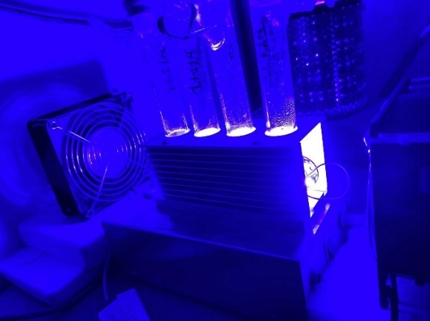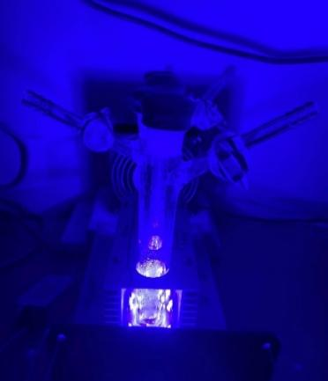
Fig. S1 The photochemical reactors.
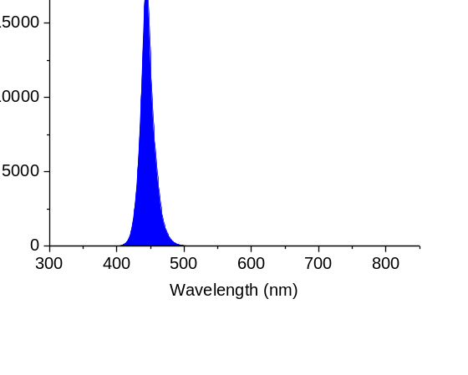
Fig. S2 The wavelength spectrum of photochemical reactors.

2. Preparation of substrates and catalysts
Methods of structural synthesis
To a 50 mL Schlenk tube, 4-dimethylaminopyridine (0.5 mmol), Et₃N (10.0 mmol) and alcohol (5.0 mmol) were dissolved in dichloromethane (12.0 mL). Acyl chloride (7.5 mmol) was added dropwise at 0 ºC. The solution was stirred for 2 h at room temperature. Sat. NaHCO₃ aq. was poured into the reaction mixture. The organic layer was separated and extracted from water with EtOAc. The combined organic phase was washed with brine, dried over Na₂SO₄, filtered, and concentrated under vacuum. The residue was purified by silica gel column chromatography to afford the products.^{[1]}
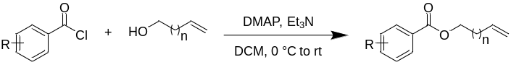
Fig. S3 Method A for the synthesis of non-activated alkenes.
To a 50 mL Schlenk tube, 4-dimethylaminopyridine (0.5 mmol), Et₃N (10.0 mmol) and alcohol (5.0 mmol) were dissolved in dichloromethane (12.0 mL). sulfonyl chloride (7.5 mmol) was dropwise added at 0 ºC. The reaction mixture was stirred for 2 h at room temperature. Sat. NaHCO₃ aq. was poured into the reaction mixture. The organic layer was separated and extracted from water with EtOAc. The combined organic phase was washed with brine, dried over Na₂SO₄, filtered, and concentrated under vacuum. The residue was purified by silica gel column chromatography to afford the products.^{[1]}
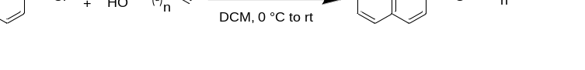
Fig. S4 Method B for the synthesis of non-activated alkenes.
To a 50 mL Schlenk tube, tetrabutylammonium iodide (0.5 mmol), Cs₂CO₃ (6.5 mmol) and phenol (6.0 mmol) were dissolved in dichloromethane (12.0 mL), alkenyl halide (5.0 mmol) was added and the mixture was stirred for 16 h at 50 ºC. Diluted NaOH aq. was poured into the reaction mixture. The organic layer was separated and extracted from water with tert-Butyl methyl ether. The combined organic phase was washed with brine, dried over Na₂SO₄, filtered, and concentrated under vacuum. The residue was purified by silica gel column chromatography to afford the products.^{[1]}
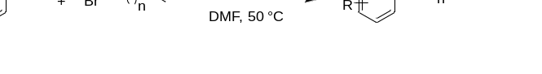
Fig. S5 Method C for the synthesis of non-activated alkenes.
To a 100 mL Schlenk tube, isoindoline-1, 3-dione (10.0 mmol), alkenyl halide (13.0 mmol) and K₂CO₃ (13.0 mmol) were dissolved in DMF (30.0 mL). The reaction mixture was stirred at room temperature, and the progress of the reaction was monitored by the TLC analysis. After 6 h the reaction was completed, as judged by TLC. The reaction mixture was slowly poured into water (100.0 mL). The aqueous phase was extracted with CH₂Cl₂ (5 × 20.0 mL). The organic extract was washed with water (3 × 40.0 mL), and dried over Na₂SO₄. After filtration, the volatile material from the filtrate was evaporated under reduced pressure. The residue was purified by silica gel column chromatography to afford the products.¹
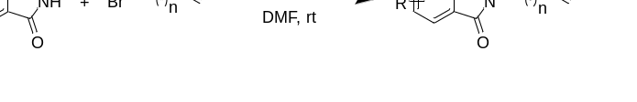
Fig. S6 Method D for the synthesis of non-activated alkenes.
The synthesis of Fe(CF₃COO)₃: To a 50 mL Schlenk tube, iron(Ⅲ) chloride (5.0 mmol) and silver trifluoroacetate (15.0 mmol) were dissolved in dichloromethane (15.0 mL) were reacted for 3 h at room temperature. The precipitate AgCl was filtered and the residue was washed with acetone. The corresponding filtrate was concentrated under reduced pressure and the resulting product was dried at 80 ºC for 1 h. Iron(Ⅲ) tri-fluoroacetate was obtained as red solid.^{[3]} ESI calc’ d for C₆F₉FeO₆Na⁺: 417.8793; found: 417.8811.
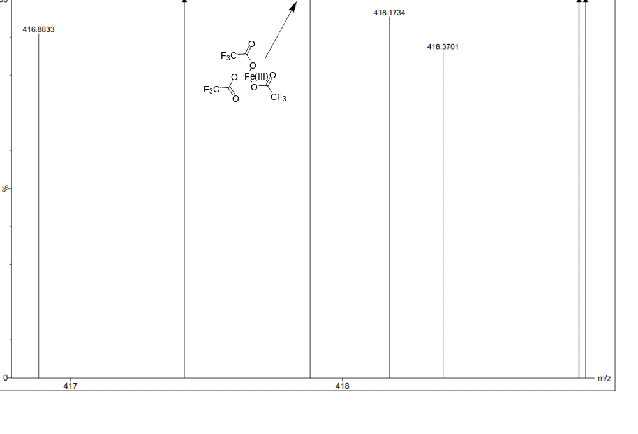
Fig. S7 The synthesis of Fe(CF₃COO)₃ and ESI detection of Fe(CF₃COO)₃.
3. Experimental procedures for fluoro-polyhaloalkylation
General procedure for fluoro-polyhaloalkylation of alkenes: A 25 mL Schlenk flask equipped with a magnetic bar was charged with Fe(acac)₃ (7.1 mg, 0.02 mmol) and selectfluor (106.3 mg, 0.3 mmol). The flask was evacuated and refilled with N₂ for three times. The vessel was then charged with extra dry CH₃CN (2.0 mL), alkene (0.2 mmol), (C_{n}X_{m}CO)₂O (1.0 or 1.4 mmol), oxydibenzene (17.0 mg, 0.1 mmol) and isopropanol (24.0 mg, 0.4 mmol). The reaction mixture was stirred under nitrogen atmosphere and irradiated by blue LEDs for 12 or 24 or 36 h. After completion of the reaction, CO₂ was detected by TCD-GC. Then the reaction system was quenched by triethylamine, diluted with EtOAc. After concentrated under vacuum, the resulting residue was purified by silica gel flash column chromatography to give the products.
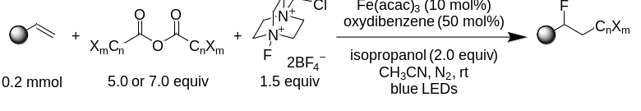
Fig. S8 Brønsted acid unlocking iron LMCT photocatalysis for radical fluoro-polyhaloalkylation of alkenes.
General procedure for gram scale synthesis: A 100 mL Schlenk flask equipped with a magnetic bar was charged with Fe(acac)₃ (0.1766 g, 0.5 mmol) and selectfluor (2.6570 g, 7.5 mmol). The flask was evacuated and refilled with N₂ for three times. The vessel was then charged with extra dry CH₃CN (50.0 mL), alkene (5.0 mmol), TFAA (5.2508 g, 25.0 mmol), oxydibenzene (0.4255 g, 2.5 mmol) and isopropanol (0.6010 g, 10.0 mmol). The reaction mixture was stirred under nitrogen atmosphere and irradiated by blue LEDs for 72 h. After completion of the reaction. Then the reaction system was quenched by triethylamine, diluted with EtOAc. After concentrated under vacuum, the resulting residue was purified by silica gel flash column chromatography to give the product.
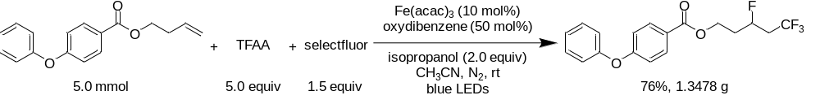
Fig. S9 The scale up reaction.
4. Investigation of conditions
Investigation of anisoles
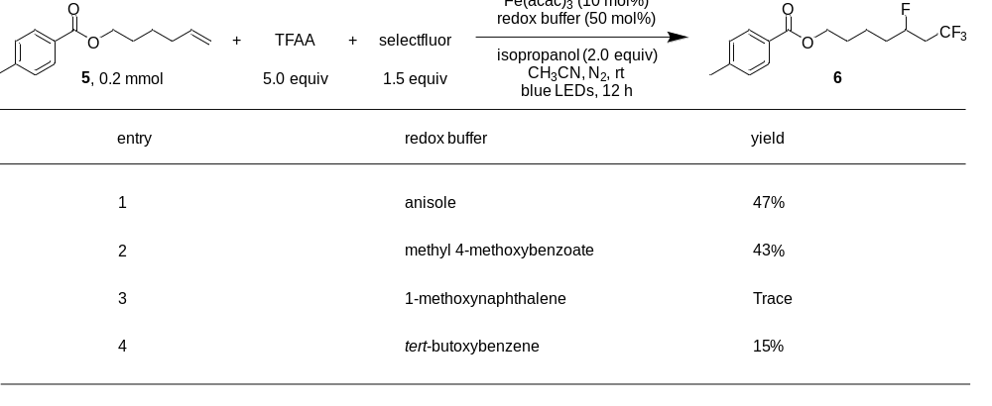
Fig. S10 The results of investigation of anisoles. Yields were determined by GC analysis of the crude reaction mixture, using biphenyl as an internal standard.
Investigation of iron salts
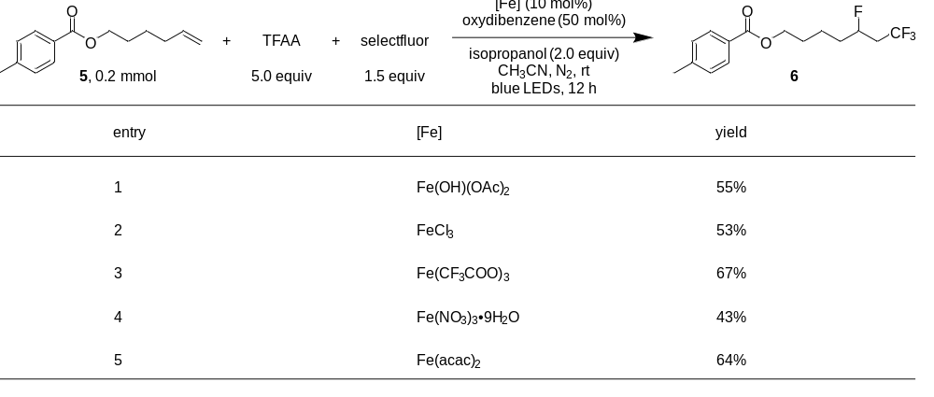
Fig. S11 The results of investigation of iron salts. Yields were determined by GC analysis of the crude reaction mixture, using biphenyl as an internal standard.

Deviation from standard conditions
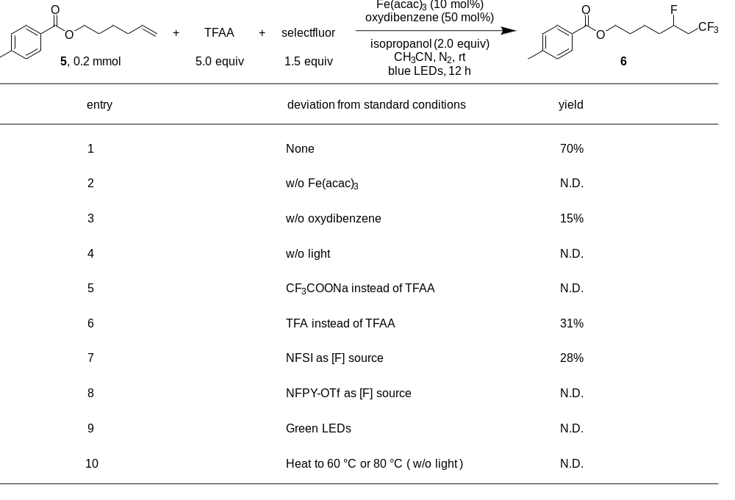
Fig. S12 The results of deviation from standard conditions. Yields were determined by GC analysis of the crude reaction mixture, using biphenyl as an internal standard.
4. Mechanistic studies
The advantage of using (CF₃CO)₂O and alcohol to in-situ generate Brønsted acid: A 25 mL Schlenk flask equipped with a magnetic bar was charged with Fe(acac)₃ (7.1 mg, 0.02 mmol) and selectfluor (106.3 mg, 0.3 mmol). The flask was evacuated and refilled with N₂ for three times. The vessel was then charged with extra dry CH₃CN (2.0 mL), alkene (0.2 mmol), TFAA (210.0 mg, 1.0 mmol), oxydibenzene (17.0 mg, 0.1 mmol) and isopropanol (24.0 mg, 0.4 mmol). The reaction mixture was stirred under nitrogen atmosphere and irradiated by blue LEDs. After completion of the reaction. Then the reaction system was quenched by triethylamine, diluted with EtOAc. Yields were determined by GC analysis of the crude reaction mixture, using biphenyl as an internal standard. (Fig. S13 a). When TFAA was replaced into TFA, a very slow reaction rate was observed (Fig. S13 b).
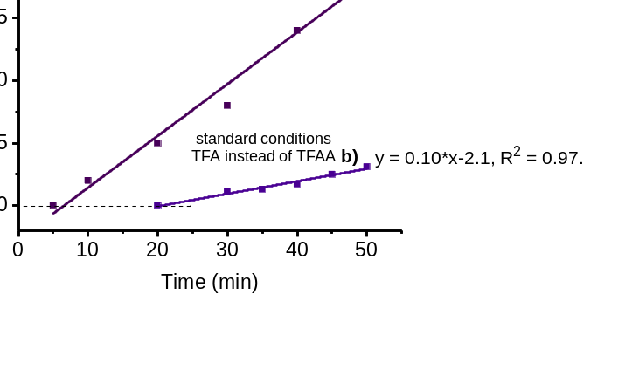
Fig. S13 The initial reaction rates with TFAA or TFA as CF₃ source.
General procedure for gas experimental analysis: A 25 mL Schlenk flask equipped with a magnetic bar was charged with Fe(acac)₃ (7.1 mg, 0.02 mmol) and selectfluor (106.3 mg, 0.3 mmol). The flask was evacuated and refilled with N₂ for three times. The vessel was then charged with extra dry CH₃CN (2.0 mL), alkene (0.2 mmol), TFAA (210.0 mg, 1.0 mmol), oxydibenzene (17.0 mg, 0.1 mmol) and isopropanol (24.0 mg, 0.4 mmol). The reaction mixture was stirred under nitrogen atmosphere and irradiated by blue LEDs for 12 h. After completion of the reaction, CO₂ was detected by TCD-GC.
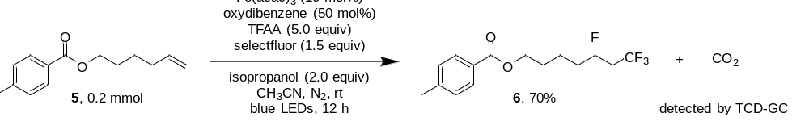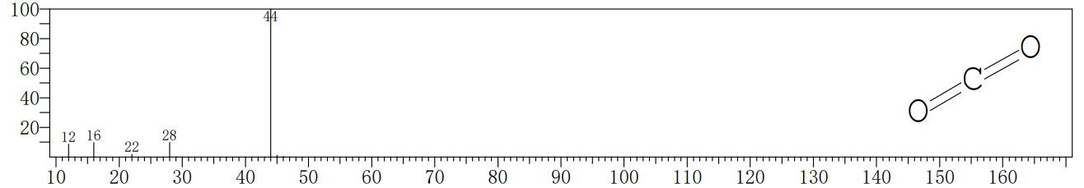
Fig. S14 The detection of CO₂.
General procedure for radical trapping experiments: A 25 mL Schlenk flask equipped with a magnetic bar was charged with Fe(acac)₃ (7.1 mg, 0.02 mmol), selectfluor (106.3 mg, 0.3 mmol) and 2,2,6,6-tetramethyl-1-piperidinyloxy (TEMPO) (62.5 mg, 0.4 mmol) or butylated hydroxytoluene (BHT) (88.1 mg, 0.4 mmol). The flask was evacuated and refilled with N₂ for three times. The vessel was then charged with extra dry CH₃CN (2.0 mL), alkene (0.2 mmol), TFAA (210.0 mg, 1.0 mmol), oxydibenzene (17.0 mg, 0.1 mmol) and isopropanol (24.0 mg, 0.4 mmol). The reaction mixture was stirred under nitrogen atmosphere and irradiated by blue LEDs for 12 h. After completion of the reaction. Then the reaction system was quenched by triethylamine, diluted with EtOAc. The reaction results were monitored by TLC and GC. Yields were determined by GC analysis of the crude reaction mixture, using biphenyl as an internal standard. No desired product 2 was detected.
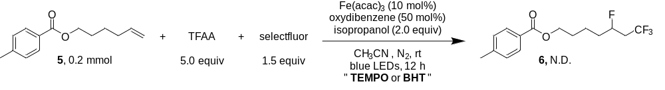
Fig. S15 The radical inhibition experiments.
General Procedure for ¹⁹F NMR experiments: TFAA (0.5 mmol, 105.0 mg), isopropanol (0.4 mmol, 24.0 mg), trifluoroacetophenone (0.1 mmol, 17.4 mg) as internal standard, and CH₃CN (0.5 mL) were added in a vial, which was generated esters 1 and TFA 2, the corresponding product was detected by ¹⁹F NMR.
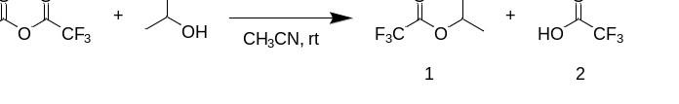
Fig. S16 TFAA and alcohol in-situ generating Brønsted acid.
Reaction conditions:
(1) TFAA (0.5 mmol) + internal standard (0.1 mmol) + CH₃CN (0.5 mL).
(2) TFAA (0.5 mmol) + isopropanol (0.4 mmol) + internal standard (0.1 mmol) + CH₃CN (0.5 mL).
(3) isopropyl 2,2,2-trifluoroacetate (0.5 mmol) + internal standard (0.1 mmol) + CH₃CN (0.5 mL).
(4) TFA (0.5 mmol) + internal standard (0.1 mmol) + CH₃CN (0.5 mL).
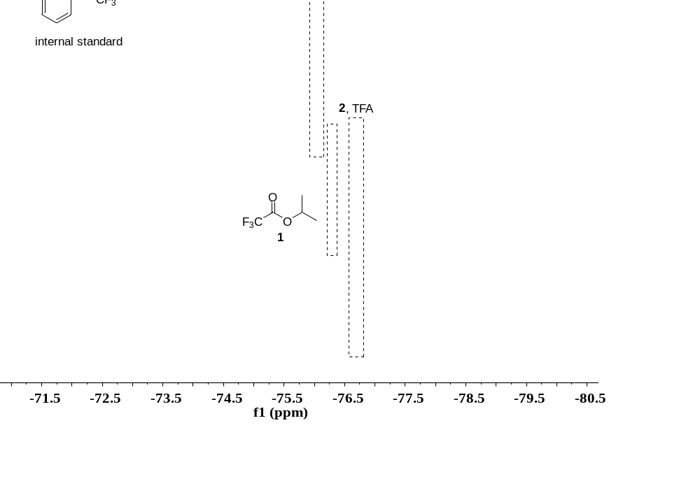
Fig. S17 ¹⁹F NMR analysis of TFAA and alcohol.

ESI-HRMS detection
ESI calc’ d for C₁₆H₁₀F₆O₄Na⁺ (3): 403.0375; found: 403.0388.
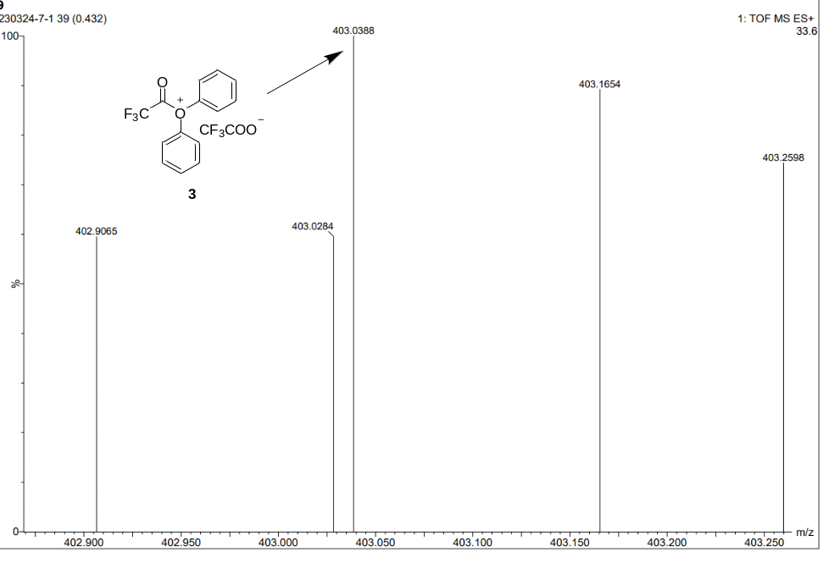

Fig. S18 ESI detection of 3.
ESI calc’ d for C₆H₆F₆NO₃Na⁺ (4): 273.9909; found: 273.9912.
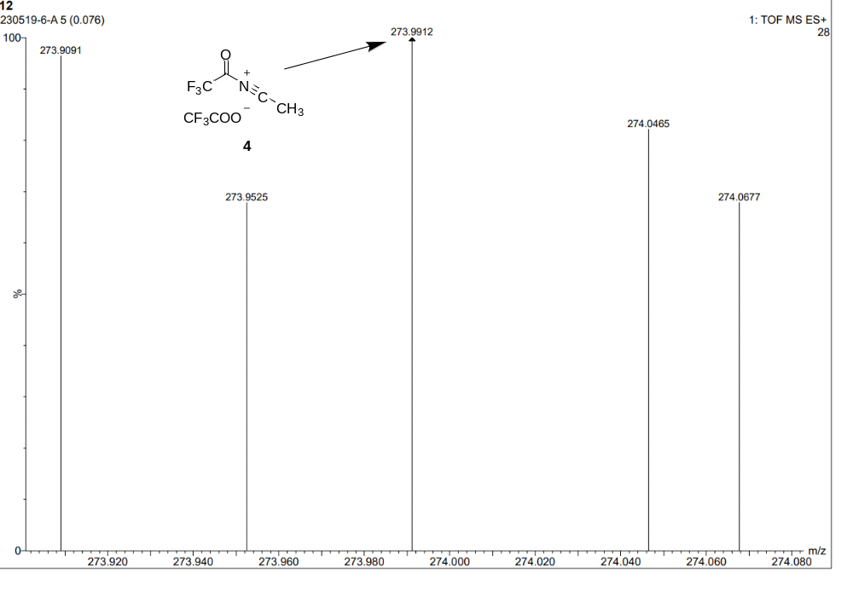
Fig. S19 ESI detection of 4.

ESI calc’ d for C₂₂H₃₂B₂ClF₁₁N₂O₂H⁺ (7, by-product): 623.2236; found: 623.2227.
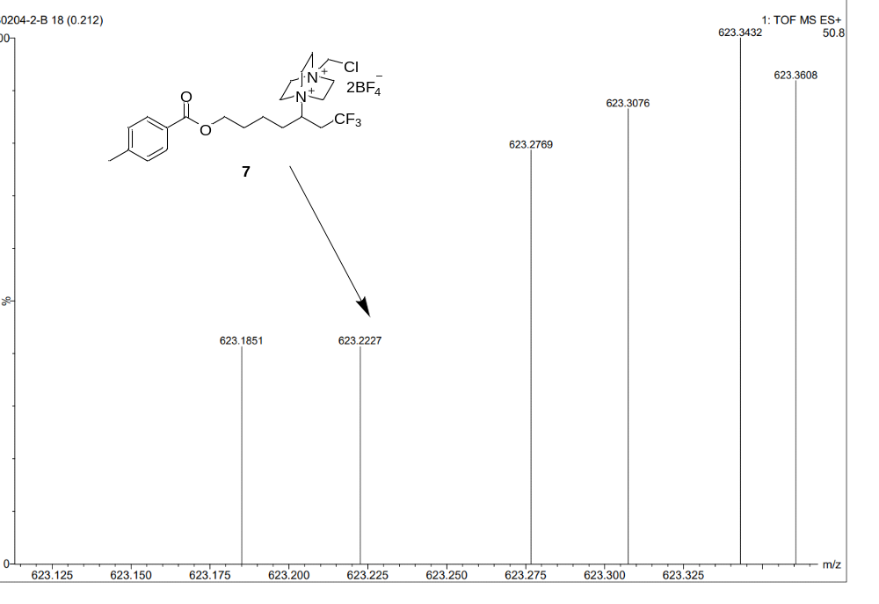
Fig. S20 ESI detection of 7.
General procedure for UV-vis experiments:
1. (1) Fe(OH)(OAc)₂ : TFAA : isopropanol : dibenzene (1 : 5 : 2 : 0.5).
(2) FeCl₃ : TFAA : isopropanol : dibenzene (1 : 5 : 2 : 0.5).
(3) Fe(CF₃COO)₃.
CH₃CN as solvent, the mixture was stirred 30 min in darkness, [iron] salt 0.25 mM.
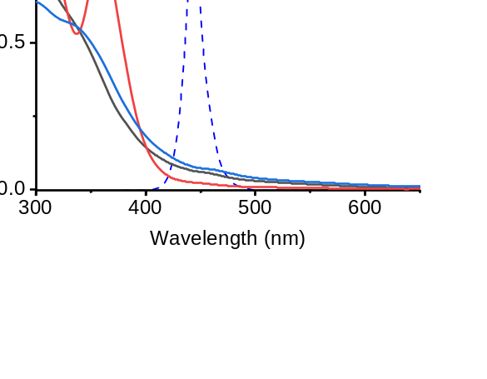
Fig. S21 Absorbance profiles of different [iron] salt.
2. (1) Fe(CF₃CO₂)₃ under darkness.
(2) Fe(acac)₃ under darkness.
(3) Fe(acac)₃ : TFA (1:3) under darkness.
(4) Fe(acac)₃ : TFA (1:3) under blue LEDs.
CH₃CN as solvent, the mixture was stirred 30 min, [iron] salt 0.25 mM.
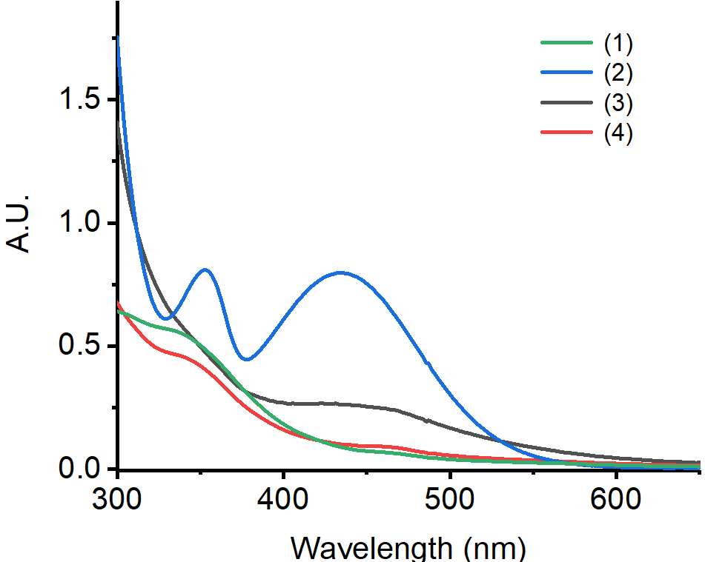
Fig. S22 Absorbance profiles of [iron] salt and Brønsted acid.
General procedure for light on/off experiments: A 25 mL Schlenk flask equipped with a magnetic bar was charged with Fe(acac)₃ (7.1 mg, 0.02 mmol) and selectfluor (106.3 mg, 0.3 mmol). The flask was evacuated and refilled with N₂ for three times. The vessel was then charged with extra dry CH₃CN (2.0 mL), alkene (0.2 mmol), TFAA (210.0 mg, 1.0 mmol), oxydibenzene (17.0 mg, 0.1 mmol) and isopropanol (24.0 mg, 0.4 mmol). The reaction mixture was stirred under nitrogen atmosphere and irradiated by blue LEDs. After completion of the reaction. Then the reaction system was quenched by triethylamine, diluted with EtOAc. Yields were determined by GC analysis of the crude reaction mixture, using biphenyl as an internal standard. Observed product 6 formation occurred only during periods of light irradiation, which ruled out a radical chain mechanism.
General procedure for kinetic of Fe(acac)₃: A 25 mL Schlenk flask equipped with a magnetic bar was charged with Fe(acac)₃ (0.001 mmol, 0.002 mmol, 0.003 mmol, 0.004 mmol, 0.005 mmol, 0.006 mmol) and selectfluor (106.3 mg, 0.3 mmol). The flask was evacuated and refilled with N₂ for three times. The vessel was then charged with extra dry CH₃CN (2.0 mL), alkene (0.2 mmol), TFAA (210.0 mg, 1.0 mmol), oxydibenzene (17.0 mg, 0.1 mmol) and isopropanol (24.0 mg, 0.4 mmol). The reaction mixture was stirred under nitrogen atmosphere and irradiated by blue LEDs for 1.5 h. After completion of the reaction. Then the reaction system was quenched by triethylamine, diluted with EtOAc. Yields were determined by GC analysis of the crude reaction mixture, using biphenyl as an internal standard.
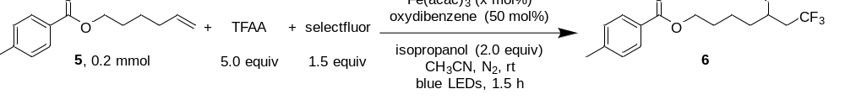
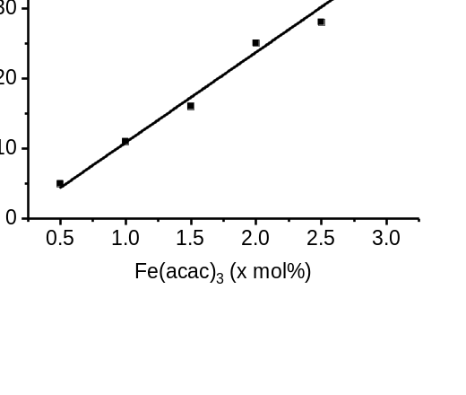
Fig. S23 Kinetic studies for Fe(acac)₃.
General procedure for kinetic of TFAA: A 25 mL Schlenk flask equipped with a magnetic bar was charged with Fe(acac)₃ (7.1 mg, 0.02 mmol) and selectfluor (106.3 mg, 0.3 mmol). The flask was evacuated and refilled with N₂ for three times. The vessel was then charged with extra dry CH₃CN (2.0 mL), alkene (0.2 mmol), TFAA (0.4 mmol, 0.45 mmol, 0.5 mmol, 0.55 mmol, 0.6 mmol), oxydibenzene (17.0 mg, 0.1 mmol) and isopropanol (24.0 mg, 0.4 mmol). The reaction mixture was stirred under nitrogen atmosphere and irradiated by blue LEDs for 1.5 h. After completion of the reaction. Then the reaction system was quenched by triethylamine, diluted with EtOAc. Yields were determined by GC analysis of the crude reaction mixture, using biphenyl as an internal standard.
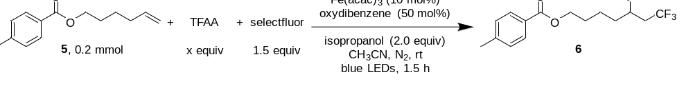
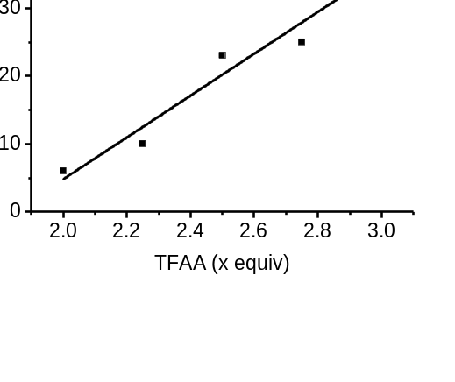
Fig. S24 Kinetic studies for TFAA.

5. Data for compounds
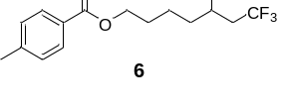
5,7,7,7-Tetrafluoroheptyl 4-methylbenzoate (6): 42.7 mg colorless liquid was isolated, yield: 70%. ¹H NMR (400 MHz, Chloroform-d) δ 7.92 (d, J = 8.2 Hz, 2H), 7.23 (d, J = 8.0 Hz, 2H), 4.82 (dtt, J = 48.7, 8.2, 3.3 Hz, 1H), 4.32 (t, J = 6.4 Hz, 2H), 2.62 – 2.19 (m, 2H), 2.40 (s, 3H), 1.88 – 1.48 (m, 6H). ¹³C NMR (101 MHz, Chloroform-d) δ 166.75, 143.73, 129.42 (d, J = 46.3 Hz), 127.64, 125.54 (dq, J = 3.4, 276.8 Hz), 87.51 (dq, J = 172.4, 3.2 Hz), 64.39, 39.46 (qd, J = 28.5, 22.9 Hz), 34.82, 34.61, 28.45, 21.71, 21.47 (d, J = 4.1 Hz). ¹⁹F NMR (376 MHz, Chloroform-d) δ -64.12 (d, J = 7.6 Hz, 3F), -182.40 (q, J = 7.8 Hz, 1F). HRMS (ESI) exact mass calculated for [C₁₅H₁₈F₄O₂Na⁺]: 329.1135, found 329.1139.
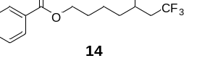
5,7,7,7-Tetrafluoroheptyl benzoate (14): 29.2 mg colorless liquid was isolated, yield: 50%. ¹H NMR (400 MHz, Chloroform-d) δ 8.06 – 8.02 (m, 2H), 7.56 (t, J = 7.4 Hz, 1H), 7.44 (t, J = 7.7 Hz, 2H), 4.83 (dtt, J = 48.8, 8.1, 3.5 Hz, 1H), 4.34 (t, J = 6.4 Hz, 2H), 2.63 – 2.20 (m, 2H), 1.88 – 1.54 (m, 6H). ¹³C NMR (101 MHz, Chloroform-d) δ 166.71, 133.07, 130.42, 129.65, 128.50, 125.54(dq, J = 3.6, 276.8 Hz), 87.53 (dq, J = 172.5, 3.2 Hz), 64.60, 39.54 (qd, J = 28.5, 23.0 Hz), 34.75 (d, J = 20.9 Hz), 28.47, 21.50 (d, J = 4.1 Hz). ¹⁹F NMR (376 MHz, Chloroform-d) δ -64.11 (d, J = 7.4 Hz, 3F), -182.39 (q, J = 7.4 Hz, 1F). HRMS (ESI) exact mass calculated for [C₁₄H₁₆F₄O₂Na⁺]: 315.0979, found 315.0981.
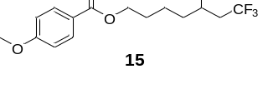
5,7,7,7-Tetrafluoroheptyl 4-methoxybenzoate (15): 43.8 mg colorless liquid was isolated, yield: 68%. ¹H NMR (400 MHz, Chloroform-d) δ 7.99 – 7.95 (m, 2H), 6.93 – 6.80 (m, 2H), 4.82 (dtt, J = 49.0, 8.2, 3.5 Hz, 1H), 4.30 (t, J = 6.4 Hz, 2H), 3.84 (s, 3H), 2.62 – 2.19 (m, 2H), 1.89 – 1.47 (m, 6H). ¹³C NMR (101 MHz, Chloroform-d) δ 166.40, 163.47, 131.62, 125.55 (dq, J = 3.4, 276.8 Hz), 122.80, 113.71, 87.51 (dq, J = 172.4, 3.2 Hz), 64.24, 55.47, 39.45 (qd, J = 28.5, 22.9 Hz), 34.70 (d, J = 20.9 Hz), 28.48, 21.46 (d, J = 4.1 Hz). ¹⁹F NMR (376 MHz, Chloroform-d) δ -64.14 (d, J = 7.5 Hz, 3F), -182.44 (q, J = 7.4 Hz, 1F). HRMS (ESI) exact mass calculated for [C₁₅H₁₈F₄O₃Na⁺] :345.1084, found 345.1092.
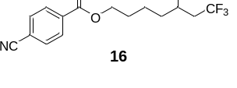
5,7,7,7-Tetrafluoroheptyl 4-cyanobenzoate (16): 39.3 mg colorless liquid was isolated, yield: 62%. ¹H NMR (400 MHz, DMSO-d₆) δ 8.08 (d, J = 8.4 Hz, 2H), 7.97 (d, J = 8.3 Hz, 2H), 4.95 – 4.73 (m, 1H), 4.30 (t, J = 6.4 Hz, 2H), 2.78 – 2.57 (m, 2H), 1.81 – 1.63 (m, 4H), 1.62 – 1.43 (m, 2H). ¹³C NMR (101 MHz, DMSO-d₆) δ 164.52, 133.73, 132.76, 129.77, 126.19 (q, J = 277.0 Hz), 118.04, 115.49, 87.91 (dq, J = 169.9, 3.2 Hz), 65.16, 37.92 (qd, J = 27.3, 21.1 Hz), 33.62 (d, J = 20.2 Hz), 27.70, 20.74 (d, J = 4.3 Hz). ¹⁹F NMR (376 MHz, DMSO-d₆) δ -62.62 (d, J = 7.6 Hz, 3F), -182.36 (q, J = 7.6 Hz, 1F). HRMS (ESI) exact mass calculated for [C₁₅H₁₅F₄NO₂Na⁺]: 340.0931, found 340.0943.
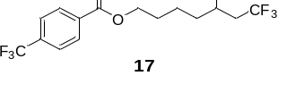
5,7,7,7-Tetrafluoroheptyl 4-(trifluoromethyl)benzoate (17): 43.2 mg colorless liquid was isolated, yield: 60%. ¹H NMR (400 MHz, DMSO-d₆) δ 8.14 (d, J = 8.1 Hz, 2H), 7.88 (d, J = 8.3 Hz, 2H), 4.94 – 4.73 (m, 1H), 4.32 (t, J = 6.4 Hz, 2H), 2.67 (ddtt, J = 22.5, 11.3, 7.5, 4.1 Hz 2H), 1.82 – 1.63 (m, 4H), 1.62 – 1.43 (m, 2H). ¹³C NMR (101 MHz, DMSO-d₆) δ 164.68, 133.56, 132.87 (d, J = 32.0 Hz), 129.97, 126.20 (q, J = 277.0 Hz), 125.74 (q, J = 3.7 Hz), 123.73 (q, J = 272.7 Hz), 87.92 (dq, J = 169.8, 3.3 Hz), 65.04, 37.91 (qd, J = 27.3, 21.0 Hz), 33.61 (d, J = 20.0 Hz), 27.72, 20.74 (d, J = 4.2 Hz). ¹⁹F NMR (376 MHz, DMSO-d₆) δ -61.84 (s, 3F), -62.61 (d, J = 7.7 Hz, 3F), -182.40 (q, J = 7.6 Hz, 1F). HRMS (ESI) exact mass calculated for [C₁₅H₁₅F₇O₂Na⁺]: 383.0852, found 383.0859.
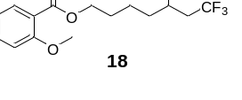
5,7,7,7-Tetrafluoroheptyl 2-methoxybenzoate (18): 43.8 mg colorless liquid was isolated, yield: 68%. ¹H NMR (400 MHz, Chloroform-d) δ 7.77 (dd, J = 7.9, 1.8 Hz, 1H), 7.46 (td, J = 8.0, 7.5, 1.8 Hz, 1H), 7.01 – 6.94 (m, 2H), 4.92 – 4.72 (m, 1H), 4.31 (t, J = 6.3 Hz, 2H), 3.89 (s, 3H), 2.61 – 2.21 (m, 2H), 1.88 – 1.51 (m, 6H). ¹³C NMR (101 MHz, Chloroform-d) δ 166.44, 159.26, 133.60, 131.63, 125.55 (dq, J = 3.5, 276.9 Hz), 120.39, 120.26, 112.16, 87.57 (dq, J = 172.4, 3.2 Hz), 64.41, 56.04, 39.54 (qd, J = 28.7, 23.3 Hz), 34.73 (d, J = 20.8 Hz), 28.44, 21.44 (d, J = 4.2 Hz). ¹⁹F NMR (376 MHz, Chloroform-d) δ -64.13 (d, J = 7.6 Hz, 3F), -182.23 – -182.41 (m, 1F). HRMS (ESI) exact mass calculated for [C₁₅H₁₈F₄O₃Na⁺]: 345.1084, found 345.1081.
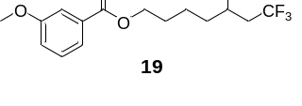
5,7,7,7-Tetrafluoroheptyl 3-methoxybenzoate (19): 42.5 mg colorless liquid was isolated, yield: 66%. ¹H NMR (400 MHz, Chloroform-d) δ 7.62 (dt, J = 7.7, 1.2 Hz, 1H), 7.55 (dd, J = 2.6, 1.5 Hz, 1H), 7.33 (t, J = 8.0 Hz, 1H), 7.08 (ddd, J = 8.3, 2.7, 1.0 Hz, 1H), 4.91 – 4.71 (m, 1H), 4.32 (t, J = 6.5 Hz, 2H), 3.82 (s, 3H), 2.59 – 2.19 (m, 2H), 1.87 – 1.50 (m, 6H). ¹³C NMR (101 MHz, Chloroform-d) δ 166.45, 159.65, 131.67, 129.45, 125.54 (dq, J = 3.3, 276.8 Hz), 121.91, 119.27, 114.23, 87.45 (dq, J = 172.5, 3.2 Hz), 64.60, 55.38, 39.36 (qd, J = 28.5, 22.8 Hz), 34.62 (d, J = 20.9 Hz), 28.35, 21.38 (d, J = 4.1 Hz). ¹⁹F NMR (376 MHz, Chloroform-d) δ -64.15 (d, J = 6.9 Hz, 3F), -182.50 (q, J = 7.5 Hz, 1F). HRMS (ESI) exact mass calculated for [C₁₅H₁₈F₄O₃Na⁺]: 345.1084, found 383.1089.
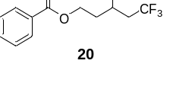
3,5,5,5-Tetrafluoropentyl benzoate (20): 27.5 mg colorless liquid was isolated, yield: 52%. ¹H NMR (400 MHz, DMSO-d₆) δ 7.98 (d, J = 7.4 Hz, 2H), 7.66 (t, J = 7.4 Hz, 1H), 7.53 (t, J = 7.7 Hz, 2H), 5.16 – 4.94 (m, 1H), 4.48 – 4.34 (m, 2H), 2.92 – 2.69 (m, 2H), 2.22 – 2.07 (m, 2H). ¹³C NMR (101 MHz, DMSO-d₆) δ 165.66, 133.42, 129.67, 129.20, 128.79, 126.16 (q, J = 277.0 Hz), 85.77 (dq, J = 170.4, 3.4 Hz), 60.50 (d, J = 4.7 Hz), 37.86 (qd, J = 27.5, 20.6 Hz), 33.26 (d, J = 20.2 Hz). ¹⁹F NMR (376 MHz, DMSO-d₆) δ -62.54 (d, J = 7.8 Hz, 3F), -184.51 (q, J = 8.2 Hz, 1F). HRMS (ESI) exact mass calculated for [C₁₂H₁₂F₄O₂Na⁺]: 287.0666, found 287.0661.
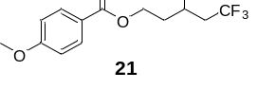
3,5,5,5-Tetrafluoropentyl 4-methoxybenzoate (21): 41.2 mg colorless liquid was isolated, yield: 70%. ¹H NMR (400 MHz, Chloroform-d) δ 8.01 – 7.95 (m, 2H), 6.95 – 6.90 (m, 2H), 5.15 – 4.94 (m, 1H), 4.54 – 4.37 (m, 2H), 3.85 (s, 3H), 2.72 – 2.29 (m, 2H), 2.21 – 2.01 (m, 2H). ¹³C NMR (101 MHz, Chloroform-d) δ 166.17, 163.69, 131.73, 125.37 (dq, J = 3.6, 276.8 Hz), 122.36, 113.85, 85.02 (dq, J = 173.3, 3.3 Hz), 59.98 (d, J = 4.8 Hz), 55.56, 39.57 (qd, J = 28.8, 22.7 Hz), 34.44 (d, J = 20.9 Hz). ¹⁹F NMR (376 MHz, Chloroform-d) δ -64.02 (d, J = 7.4 Hz, 3F), -184.46 (q, J = 7.4 Hz, 1F). HRMS (ESI) exact mass calculated for [C₁₃H₁₄F₄O₃Na⁺]: 317.0771, found 317.0775.
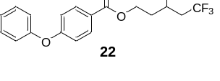
3,5,5,5-Tetrafluoropentyl 4-phenoxybenzoate (22): 58.4 mg colorless liquid was isolated, yield: 82%. ¹H NMR (400 MHz, Chloroform-d) δ 8.00 (d, J = 8.8 Hz, 2H), 7.39 (td, J = 7.7, 1.8 Hz, 2H), 7.20 (t, J = 7.4 Hz, 1H), 7.09 – 7.06 (m, 2H), 7.03 – 6.95 (m, 2H), 5.04 (dtt, J = 48.8, 8.2, 3.6 Hz, 1H), 4.54 – 4.41 (m, 2H), 2.71 – 2.31 (m, 2H), 2.20 – 2.03 (m, 2H). ¹³C NMR (101 MHz, Chloroform-d) δ 165.91, 162.21, 155.64, 131.81, 130.17, 125.35 (dq, J = 3.6, 276.8 Hz), 124.72, 124.19, 120.27, 117.45, 84.98 (dq, J = 173.5, 3.3 Hz), 60.16 (d, J = 4.7 Hz), 39.56 (qd, J = 28.8, 22.7 Hz), 34.40 (d, J = 20.9 Hz). ¹⁹F NMR (376 MHz, Chloroform-d) δ -63.98 (d, J = 7.5 Hz, 3F), -184.48 (q, J = 7.7 Hz, 1F). HRMS (ESI) exact mass calculated for [C₁₈H₁₆F₄O₃H⁺]: 357.1108, found 357.1111.
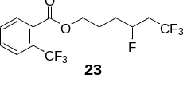
4,6,6,6-Tetrafluorohexyl 2-(trifluoromethyl)benzoate (23): 44.5 mg colorless liquid was isolated, yield: 65%. ¹H NMR (400 MHz, DMSO-d₆) δ 7.89 – 7.74 (m, 4H), 5.00 – 4.78 (m, 1H), 4.32 (t, J = 5.5 Hz, 2H), 2.81 – 2.59 (m, 2H), 1.92 – 1.68 (m, 4H). ¹³C NMR (101 MHz, DMSO-d₆) δ 166.28, 132.87, 131.87, 130.87 (q, J = 2.0 Hz), 123.00, 126.75 (q, J = 31.8 Hz), 126.72 (q, J = 5.2 Hz), 124.86 (p, J = 275.1, 273.3 Hz), 87.80 (dq, J = 169.9, 3.3 Hz), 65.35, 37.88 (qd, J = 27.4, 21.0 Hz), 30.75, 30.54, 23.46 (d, J = 4.1 Hz). ¹⁹F NMR (376 MHz, DMSO-d₆) δ -58.28 (s, 3F), -62.60 (d, J = 7.7 Hz, 3F), -182.74 (q, J = 7.6 Hz, 1F). HRMS (ESI) exact mass calculated for [C₁₄H₁₃F₇O₂H⁺]: 369.0696, found 369.0706.
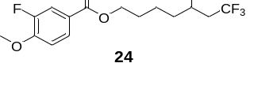
5,7,7,7-Tetrafluoroheptyl 3-fluoro-4-methoxybenzoate (24): 41.5 mg colorless liquid was isolated, yield: 61%. ¹H NMR (400 MHz, Chloroform-d) δ 7.78 – 7.75 (m, 1H), 7.70 – 7.65 (m, 1H), 6.94 (t, J = 8.4 Hz, 1H), 4.89 – 4.69 (m, 1H), 4.27 (t, J = 6.4 Hz, 2H), 3.89 (d, J = 1.4 Hz, 3H), 2.59 – 2.17 (m, 2H), 1.84 – 1.47 (m, 6H). ¹³C NMR (101 MHz, Chloroform-d) δ 165.57 (d, J = 2.8 Hz), 151.83 (d, J = 10.7 Hz), 151.80 (d, J = 246.8 Hz), 126.75 (d, J = 3.4 Hz), 125.52 (dq, J = 3.7, 276.8 Hz), 123.13 (d, J = 6.3 Hz), 117.27 (d, J = 19.6 Hz), 112.45 (d, J = 2.0 Hz), 87.52 (dq, J = 172.5, 3.1 Hz), 64.68, 56.37, 39.53 (qd, J = 28.6, 23.1 Hz), 34.74 (d, J = 20.9 Hz), 28.46, 21.48 (d, J = 4.1 Hz). ¹⁹F NMR (376 MHz, Chloroform-d) δ -64.10 (d, J = 7.5 Hz, 3F), -134.65 (s, 1F), -182.40 (q, J = 7.9 Hz, 1F). HRMS (ESI) exact mass calculated for [C₁₅H₁₇F₅O₃Na⁺]: 363.0990, found 363.0997.
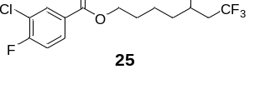
5,7,7,7-Tetrafluoroheptyl 3-chloro-4-fluorobenzoate (25): 39.9 mg colorless liquid was isolated, yield: 58%. ¹H NMR (400 MHz, Chloroform-d) δ 8.07 (dd, J = 7.1, 2.2 Hz, 1H), 7.92 (ddd, J = 8.6, 4.7, 2.1 Hz, 1H), 7.19 (t, J = 8.6 Hz, 1H), 4.83 (dtt, J = 48.7, 8.3, 3.3 Hz, 1H), 4.33 (t, J = 6.5 Hz, 2H), 2.62 – 2.20 (m, 2H), 1.89 – 1.50 (m, 6H). ¹³C NMR (101 MHz, Chloroform-d) δ 164.67 (d, J = 0.5 Hz), 161.16 (d, J = 256.1 Hz), 132.42 (d, J = 1.1 Hz), 130.05 (d, J = 8.6 Hz), 127.61 (d, J = 3.9 Hz), 125.52 (dq, J = 3.7, 276.8 Hz), 121.55 (d, J = 18.3 Hz), 116.75 (d, J = 21.8 Hz), 87.48 (dq, J = 172.6, 3.5 Hz), 65.15, 39.49 (qd, J = 28.8, 22.8 Hz), 34.69 (d, J = 21.1 Hz), 28.37, 21.43 (d, J = 4.4 Hz). ¹⁹F NMR (376 MHz, Chloroform-d) δ -64.14 (d, J = 7.5 Hz, 3F), -108.13 (s, 1F), -182.54 (q, J = 7.8 Hz, 1F). HRMS (ESI) exact mass calculated for [C₁₄H₁₄ClF₅O₂Na⁺]: 367.0495, found 367.0502.
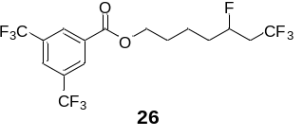
5,7,7,7-Tetrafluoroheptyl 3,4-bis(trifluoromethyl)benzoate (26): 52.2 mg colorless liquid was isolated, yield: 61%. ¹H NMR (400 MHz, Chloroform-d) δ 8.47 (s, 2H), 8.06 (s, 1H), 4.83 (dtt, J = 48.9, 8.0, 3.6 Hz, 1H), 4.42 (t, J = 6.6 Hz, 2H), 2.63 – 2.22 (m, 2H), 1.94 – 1.54 (m, 6H). ¹³C NMR (101 MHz, Chloroform-d) δ 164.06, 132.57, 132.38 (q, J = 34.0 Hz), 129.84 (d, J = 3.8 Hz), 126.51 (dt, J = 7.4, 3.6 Hz), 125.49 (dq, J = 4.0, 276.7 Hz), 123.02 (q, J = 272.9 Hz), 87.46 (dq, J = 172.6, 3.1 Hz), 65.90, 39.59 (qd, J = 28.6, 23.2 Hz), 34.72 (d, J = 20.9 Hz), 28.37, 21.45 (d, J = 4.0 Hz). ¹⁹F NMR (376 MHz, Chloroform-d) δ -63.03 (s, 3F), -63.04 (s, 3F), -64.16 (t, J = 7.1 Hz, 3F), -182.59 (q, J = 8.0 Hz, 1F). HRMS (ESI) exact mass calculated for [C₁₆H₁₄F₁₀O₂Na⁺]: 451.0726, found 451.0739.
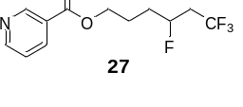
5,7,7,7-Tetrafluoroheptyl nicotinate (27): 41.4 mg colorless liquid was isolated, yield: 74%. ¹H NMR (400 MHz, Chloroform-d) δ 9.24 – 9.16 (m, 1H), 8.81 – 8.73 (m, 1H), 8.26 (dt, J = 7.9, 1.6 Hz, 1H), 7.38 (dd, J = 8.0, 4.9 Hz, 1H), 4.86 (dtt, J = 49.1, 7.9, 3.7, Hz, 1H), 4.48 – 4.33 (m, 2H), 2.64 – 2.22 (m, 2H), 2.07 – 1.70 (m, 4H). ¹³C NMR (101 MHz, Chloroform-d) δ 165.25, 153.62, 150.93, 137.08, 126.07, 125.38 (dq, J = 3.9, 276.8 Hz), 123.42, 87.23 (dq, J = 173.0, 3.2 Hz), 64.64, 39.49 (qd, J = 28.6, 23.0 Hz), 31.74 (d, J = 21.2 Hz), 24.24 (d, J = 3.9 Hz). ¹⁹F NMR (376 MHz, Chloroform-d) δ -64.12 (d, J = 7.3 Hz, 3F), -182.90 (q, J = 7.5 Hz, 1F). HRMS (ESI) exact mass calculated for [C₁₂H₁₃F₄NO₂H⁺]: 280.0955, found 280.0956.
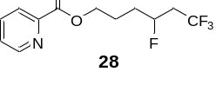
4,6,6,6-Tetrafluorohexyl picolinate (28): 40.2 mg colorless liquid was isolated, yield: 72%. ¹H NMR (400 MHz, Chloroform-d) δ 8.74 (d, J = 4.7 Hz, 1H), 8.10 (d, J = 7.8 Hz, 1H), 7.83 (td, J = 7.7, 1.7 Hz, 1H), 7.46 (ddd, J = 7.6, 4.8, 1.2 Hz, 1H), 4.86 (dtt, J = 49.2, 8.3, 3.6 Hz, 1H), 4.44 (tt, J = 11.1, 5.6 Hz, 2H), 2.62 – 2.21 (m, 2H), 2.09 – 1.70 (m, 4H). ¹³C NMR (101 MHz, Chloroform-d) δ 165.32, 150.07, 148.07, 137.18, 127.13, 125.44 (dq, J =3.4, 279.8 Hz), 125.31, 87.31 (dq, J = 173.0, 3.1 Hz), 65.18, 39.55 (qd, J = 28.6, 22.8 Hz), 31.80 (d, J = 21.2 Hz), 24.32 (d, J = 4.0 Hz). ¹⁹F NMR (376 MHz, Chloroform-d) δ -64.12 (d, J = 7.5 Hz, 3F), -182.81 (q, J = 7.7 Hz, 1F). HRMS (ESI) exact mass calculated for [C₁₂H₁₃F₄NO₂Na⁺]: 302.0775, found 302.0785.
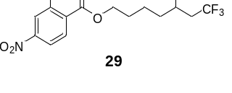
5,7,7,7-Tetrafluoroheptyl-2-chloro-4-nitrobenzoate (29): 23.8 mg colorless liquid was isolated, yield: 32%. ¹H NMR (400 MHz, Chloroform-d) δ 8.29 (d, J = 2.2 Hz, 1H), 8.14 (dd, J = 8.6, 2.2 Hz, 1H), 7.93 (d, J = 8.5 Hz, 1H), 4.91 – 4.72 (m, 1H), 4.39 (t, J = 6.5 Hz, 2H), 2.63 – 2.21 (m, 2H), 1.90 – 1.50 (m, 6H). ¹³C NMR (101 MHz, Chloroform-d) δ 164.38, 149.50, 136.12, 134.70, 132.06, 126.06, 125.48 (dq, J = 3.6, 276.8 Hz), 121.58, 87.44 (dq, J = 172.5, 3.1 Hz), 66.06, 39.43 (qd, J = 28.6, 23.0 Hz), 34.56 (d, J = 20.9 Hz), 28.17, 21.38 (d, J = 4.0 Hz). ¹⁹F NMR (376 MHz, Chloroform-d) δ -64.12 (d, J = 7.1 Hz, 3F), -182.59 (q, J = 7.4 Hz, 1F). HRMS (ESI) exact mass calculated for [C₁₄H₁₄ClF₄O₄Na⁺]: 394.0440, found 394.0446.
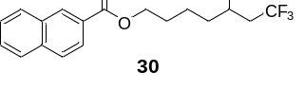
5,7,7,7-Tetrafluoroheptyl-2-naphthoate (30): 32.8 mg colorless liquid was isolated, yield: 48%. ¹H NMR (400 MHz, Chloroform-d) δ 8.62 (s, 1H), 8.07 (dd, J = 8.6, 1.7 Hz, 1H), 7.96 (d, J = 8.0 Hz, 1H), 7.88 (dd, J = 8.4, 3.2 Hz, 2H), 7.57 (dddd, J = 18.4, 8.1, 6.9, 1.3 Hz, 2H), 4.93 – 4.73 (m, 1H), 4.41 (t, J = 6.5 Hz, 2H), 2.64 – 2.22 (m, 2H), 1.92 – 1.55 (m, 6H). ¹³C NMR (101 MHz, Chloroform-d) δ 166.81, 135.62, 132.59, 131.07, 129.42, 128.35, 128.26, 127.85, 127.63, 126.76, 125.55 (dq, J = 3.4, 276.8 Hz), 125.27, 87.50 (dq, J = 172.5, 3.2 Hz), 64.72, 39.47 (qd, J = 28.5, 23.0 Hz), 34.71 (d, J = 20.8 Hz), 28.47, 21.48 (d, J = 4.2 Hz). ¹⁹F NMR (376 MHz, Chloroform-d) δ -64.04 (d, J = 7.6 Hz, 3F), -182.36 (q, J = 8.0 Hz, 1F). HRMS (ESI) exact mass calculated for [C₁₈H₁₈F₄O₂Na⁺]: 365.1135, found 365.1142.
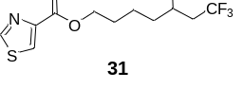
5,7,7,7-Tetrafluoroheptyl thiazole-4-carboxylate (31): 42.5 mg white solid was isolated, yield: 71%. ¹H NMR (400 MHz, Chloroform-d) δ 8.81 (d, J = 2.1 Hz, 1H), 8.19 (d, J = 2.1 Hz, 1H), 4.86 – 4.65 (m, 1H), 4.33 (t, J = 6.6 Hz, 2H), 2.56 – 2.14 (m, 2H), 1.85 – 1.44 (m, 6H). ¹³C NMR (101 MHz, Chloroform-d) δ 161.26, 153.53, 147.94, 127.35, 125.42 (dq, J = 3.2, 276.8 Hz), 87.36 (dq, J = 172.4, 3.2 Hz), 64.98, 39.30 (qd, J = 28.5, 22.8 Hz), 34.51 (d, J = 20.9 Hz), 28.22, 21.24 (d, J = 4.2 Hz). ¹⁹F NMR (376 MHz, DMSO-d₆) δ -62.42 (d, J = 8.0 Hz, 3F), -182.31 (q, J = 8.1 Hz, 1F). HRMS (ESI) exact mass calculated for [C₁₁H₁₃F₄NO₂SNa⁺]: 322.0495, found 322.0498.
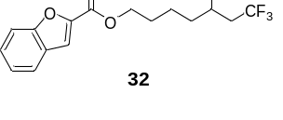
5,7,7,7-Tetrafluoroheptyl benzofuran-2-carboxylate (32): 31.2 mg colorless liquid was isolated, yield: 47%. ¹H NMR (400 MHz, Chloroform-d) δ 7.67 (d, J = 7.8 Hz, 1H), 7.58 (dd, J = 0.2, 2.1 Hz, 1H), 7.52 (d, J = 0.9 Hz, 1H), 7.44 (ddd, J = 8.4, 7.2, 1.2 Hz, 1H), 7.32 - 7.26 (m, 1H), 4.92 – 4.72 (m, 1H), 4.38 (t, J = 6.5 Hz, 2H), 2.62 – 2.20 (m, 2H), 1.88 – 1.50 (m, 6H). ¹³C NMR (101 MHz, Chloroform-d) δ 159.67, 155.85, 145.59, 127.77, 127.03, 125.52 (dq, J = 3.3, 276.6 Hz), 123.92, 122.93, 114.03, 112.45, 87.48 (dq, J = 172.5, 3.2 Hz), 65.05, 39.49 (qd, J = 28.6, 23.0 Hz), 34.66 (d, J = 20.9 Hz), 28.38, 21.37 (d, J = 4.1 Hz). ¹⁹F NMR (376 MHz, Chloroform-d) δ -64.08 (d, J = 7.5 Hz, 3F), -182.44 (q, J = 7.9 Hz, 1F). HRMS (ESI) exact mass calculated for [C₁₆H₁₆F₄O₃Na⁺]: 355.0928, found 355.0930.
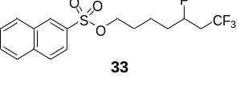
5,7,7,7-Tetrafluoroheptyl naphthalene-2-sulfonate (33): 34.0 mg colorless liquid was isolated, yield: 45%. ¹H NMR (400 MHz, DMSO-d₆) δ 8.68 – 8.61 (m, 1H), 8.23 (dd, J = 16.0, 8.4 Hz, 2H), 8.10 (d, J = 8.1 Hz, 1H), 7.87 (dd, J = 8.7, 1.9 Hz, 1H), 7.83 – 7.67 (m, 2H), 4.72 (dtt, J = 50.1, 7.9, 4.2 Hz, 1H), 4.09 (t, J = 6.3 Hz, 2H), 2.66 – 2.51 (m, 2H), 1.65 – 1.28 (m, 4H), 1.43 – 1.26 (m, 2H). ¹³C NMR (101 MHz, Chloroform-d) δ 135.42, 132.91, 132.08, 129.86, 129.85, 129.57, 129.46, 128.15, 128.03, 125.43 (dq, J = 3.7, 276.9 Hz), 122.62, 87.35 (dq, J = 172.8, 3.2 Hz), 70.38, 39.42 (qd, J = 28.6, 22.9 Hz), 34.34 (d, J = 20.9 Hz), 28.54, 20.91 (d, J = 4.1 Hz). ¹⁹F NMR (376 MHz, Chloroform-d) δ -57.76 (d, J = 7.5 Hz, 3F), -177.66 (q, J = 7.6 Hz, 1F). HRMS (ESI) exact mass calculated for [C₁₇H₁₈F₄O₃SNa⁺]: 401.0805, found 401.0803.
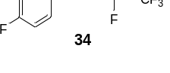
1-Fluoro-4-((3,5,5,5-tetrafluoropentyl)oxy)benzene (34): 37.1 mg colorless liquid was isolated, yield: 73%. ¹H NMR (400 MHz, Chloroform-d) δ 7.02 – 6.96 (m, 2H), 6.88 – 6.83 (m, 2H), 5.22 – 5.01 (m, 1H), 4.13 – 4.03 (m, 2H), 2.71 – 2.34 (m, 2H), 2.20 – 2.08 (m, 2H). ¹³C NMR (101 MHz, Chloroform-d) δ 157.59 (d, J = 238.5 Hz), 154.77 (d, J = 2.1 Hz), 125.53 (dq, J = 2.9, 276.8 Hz), 116.01 (d, J = 23.2 Hz), 115.63 (d, J = 8.0 Hz), 84.98 (dq, J = 172.5, 3.3 Hz), 63.62 (d, J = 4.9 Hz), 39.60 (qd, J = 28.7, 22.4 Hz), 34.88 (d, J = 20.7 Hz). ¹⁹F NMR (376 MHz, Chloroform-d) δ -64.08 (d, J = 7.6 Hz, 3F), -123.62 (s, 1F), -184.82 (q, J = 8.3, 7.5 Hz, 1F). HRMS (ESI) exact mass calculated for [C₁₁H₁₁F₅ONa⁺]: 277.0622, found 277.0628.
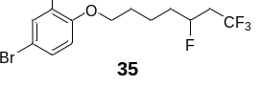
4-Bromo-2-chloro-1-((5,7,7,7-tetrafluoroheptyl)oxy)benzene (35): 45.8 mg colorless liquid was isolated, yield: 61%. ¹H NMR (400 MHz, Chloroform-d) δ 7.49 (d, J = 2.4 Hz, 1H), 7.30 (dd, J = 8.7, 2.4 Hz, 1H), 6.77 (d, J = 8.8 Hz, 1H), 4.84 (dtt, J = 48.3, 7.9, 3.2 Hz, 1H), 4.01 (t, J = 6.1 Hz, 2H), 2.56 – 2.13 (m, 2H), 1.85 – 1.50 (m, 6H). ¹³C NMR (101 MHz, Chloroform-d) δ 153.90, 132.82, 130.63, 125.57 (dq, J = 3.4, 276.8 Hz), 124.21, 114.62, 112.67, 87.59 (dq, J = 172.4, 3.2 Hz), 69.08, 39.52 (qd, J = 28.5, 22.9 Hz), 34.76 (d, J = 20.8 Hz), 28.67, 21.55 (d, J = 4.3 Hz). ¹⁹F NMR (376 MHz, Chloroform-d) δ -64.09 (d, J = 7.5 Hz, 3F), -182.33 (q, J = 7.4 Hz, 1F). HRMS (ESI) exact mass calculated for [C₁₃H₁₄BrClF₄ONa⁺]: 398.9745, found 3989.9756.
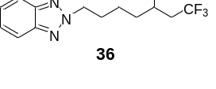
2-(5,7,7,7-Tetrafluoroheptyl)-2H-benzo[d][1,2,3]triazole (36): 28.3 mg colorless liquid was isolated, yield: 49%. ¹H NMR (400 MHz, Chloroform-d) δ 7.85 (dd, J = 6.5, 3.1 Hz, 2H), 7.38 (dd, J = 6.5, 3.1 Hz, 2H), 4.77 (dtt, J = 12.1, 8.0, 3.5 Hz, 1H), 4.75 (t, J = 6.9 Hz, 2H), 2.65 – 2.08 (m, 2H), 2.22 – 2.12 (m, 2H), 1.87 – 1.38 (m, 4H). ¹³C NMR (101 MHz, Chloroform-d) δ 144.43, 126.43, 125.45 (dq, J = 3.6, 276.9 Hz), 118.06, 87.34 (dq, J = 172.7, 3.2 Hz), 56.21, 39.43 (qd, J = 28.6, 22.9 Hz), 34.41 (d, J = 20.9 Hz), 29.58, 21.90 (d, J = 4.1 Hz). ¹⁹F NMR (376 MHz, Chloroform-d) δ -64.12 (d, J = 7.4 Hz, 3F), -182.43 (q, J = 7.4 Hz, 1F). HRMS (ESI) exact mass calculated for [C₁₃H₁₅F₄N₃Na⁺]: 312.1094, found 312.1100.
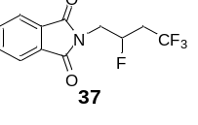
2-(1,3,3,3-Tetrafluoropropyl)isoindoline-1,3-dione (37): 31.9 mg white solid was isolated, yield: 58%. ¹H NMR (400 MHz, Chloroform-d) δ 7.84 (dd, J = 5.5, 3.1 Hz, 2H), 7.72 (dd, J = 5.5, 3.1 Hz, 2H), 5.08 (dtt, J = 48.7, 7.3, 3.7 Hz, 1H), 4.02 (dtt, J = 16.2, 14.4, 7.3 Hz, 1H), 3.85 (ddd, J = 23.5, 14.5, 4.2 Hz, 1H), 2.65 – 2.38 (m, 2H). ¹³C NMR (101 MHz, Chloroform-d) δ 167.92, 134.44, 131.77, 125.17 (dq, J = 2.0, 276.8, Hz), 123.66, 84.83 (dq, J = 179.0, 3.2 Hz), 41.02 (d, J = 23.7 Hz), 37.49 (qd, J = 29.4, 21.7 Hz). ¹⁹F NMR (376 MHz, Chloroform-d) δ -63.95 (d, J = 7.3 Hz, 3F), -187.53 (q, J = 7.2 Hz, 1F). HRMS (ESI) exact mass calculated for [C₁₂H₉F₄NO₂Na⁺]: 298.0462, found 298.0469.
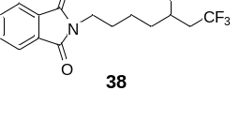
2-(5,7,7,7-Tetrafluoroheptyl)isoindoline-1,3-dione (38): 34.7 mg white solid was isolated, yield: 55%. ¹H NMR (400 MHz, Chloroform-d) δ 7.80 (dd, J = 5.4, 3.0 Hz, 2H), 7.68 (dd, J = 5.5, 3.0 Hz, 2H), 4.76 (dtt, J = 49.1, 8.1, 3.6 Hz, 1H), 3.67 (t, J = 7.1 Hz, 2H), 2.57 – 2.19 (m, 2H), 1.78 – 1.38 (m, 6H). ¹³C NMR (101 MHz, DMSO-d₆) δ 167.95, 134.35, 131.62, 126.20 (q, J = 277.0 Hz), 122.99, 87.88 (dq, J = 169.8, 3.3 Hz), 37.84 (qd, J = 27.2, 21.0 Hz), 37.18, 33.53 (d, J = 20.2 Hz), 27.58, 21.45 (d, J = 4.3 Hz). ¹⁹F NMR (376 MHz, DMSO-d₆) δ -62.49 (d, J = 7.5 Hz, 3F), -182.16 (q, J = 7.6 Hz, 1F). HRMS (ESI) exact mass calculated for [C₁₅H₁₅F₄NO₂Na⁺]: 340.0931, found 340.0938.
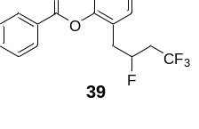
2-(2,4,4,4-Tetrafluorobutyl)phenyl benzoate (39): 35.7 mg colorless liquid was isolated, yield: 55%. ¹H NMR (400 MHz, Chloroform-d) δ 8.21 – 8.17 (m, 2H), 7.68 – 7.62 (m, 1H), 7.52 (t, J = 7.7 Hz, 2H), 7.38 – 7.31 (m, 2H), 7.28 – 7.18 (m, 2H), 5.17 – 4.16 (m, 1H), 3.08 – 2.88 (m, 2H), 2.57 – 2.19 (m, 2H). ¹³C NMR (101 MHz, Chloroform-d) δ 165.07, 149.57, 134.06, 131.57, 130.24, 129.13, 128.91, 128.80, 127.88 (d, J = 4.5 Hz), 126.57, 125.45 (dq, J = 3.1, 276.9 Hz), 123.01, 87.11 (dq, J = 175.8, 3.0 Hz), 38.93 (qd, J = 28.7, 22.6 Hz), 35.81 (d, J = 22.1 Hz). ¹⁹F NMR (376 MHz, Chloroform-d) δ -63.98 (d, J = 7.5 Hz, 3F), -179.35 (q, J = 8.0 Hz, 1F). HRMS (ESI) exact mass calculated for [C₁₇H₁₄F₄O₂Na⁺]: 349.0822, found 349.0827.
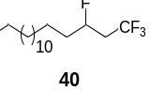
1,1,1,3-Tetrafluorooctane (40): 40.5 mg colorless liquid was isolated, yield: 65%; ¹H NMR (400 MHz, Chloroform-d) δ 4.79 (dtt, J = 49.0, 8.0, 3.7 Hz, 1H), 2.60 – 2.19 (m, 2H), 1.80 – 1.56 (m, 2H), 1.50 – 1.24 (m, 24H), 0.88 (t, J = 6.7 Hz, 3H). ¹³C NMR (101 MHz, Chloroform-d) δ 125.66 (dd, J = 276.7, 3.3 Hz), 87.79 (dq, J = 172.1, 3.2 Hz), 39.56 (qd, J = 28.5, 23.0 Hz), 35.28, 35.07, 32.09, 29.85, 29.83, 29.81, 29.76, 29.66, 29.58, 29.52, 29.35, 24.73 (d, J = 4.3 Hz), 22.85, 14.27. ¹⁹F NMR (376 MHz, Chloroform-d) δ -64.17 (d, J = 7.3 Hz, 3F), -181.69 (q, J = 7.4 Hz, 1F). HRMS (ESI) exact mass calculated for [C₁₇H₃₂F₄H⁺]: 313.2513, found 313.2526.
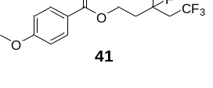
3,5,5,5-Tetrafluoro-3-methylpentyl 4-methoxybenzoate (41): 22.2 mg colorless liquid was isolated, yield: 36%. ¹H NMR (400 MHz, Chloroform-d) δ 8.00 – 7.94 (m, 2H), 6.94 – 6.90 (m, 2H), 4.52 – 4.41 (m, 2H), 3.85 (s, 3H), 2.59 (dqd, J = 17.9, 11.0, 3.3 Hz, 2H), 2.21 (dtt, J = 21.6, 14.9, 7.5 Hz, 2H), 1.57 (d, J = 22.1 Hz, 3H). ¹³C NMR (101 MHz, Chloroform-d) δ 166.19, 163.64, 131.69, 125.20 (dq, J = 8.4, 277.5 Hz), 122.43, 113.83, 92.39 (dq, J = 172.8, 2.2 Hz), 59.78 (d, J = 6.2 Hz), 55.54, 43.28 (qd, J = 27.9, 26.1 Hz), 38.74 (dd, J = 22.5, 1.6 Hz), 24.80 (dd, J = 24.2, 1.8 Hz). ¹⁹F NMR (376 MHz, Chloroform-d) δ -60.78 (d, J = 8.9 Hz, 3F), -143.12 (q, J = 8.9 Hz, 1F). HRMS (ESI) exact mass calculated for [C₁₄H₁₆F₄O₃Na⁺]: 331.0928, found 331.0938.
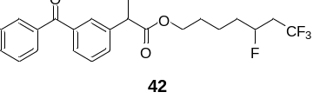
5,7,7,7-Tetrafluoroheptyl-2-(3-benzoylphenyl)propanoate (42): 60.2 mg colorless liquid was isolated, yield: 71%. ¹H NMR (400 MHz, Chloroform-d) δ 7.82 – 7.75 (m, 3H), 7.66 (d, J = 7.6 Hz, 1H), 7.59 (t, J = 7.4 Hz, 1H), 7.54 (d, J = 7.8 Hz, 1H), 7.46 (dt, J = 18.8, 7.7 Hz, 3H), 4.83 – 4.63 (m, 1H), 4.16 – 4.04 (m, 2H), 3.80 (q, J = 7.2 Hz, 1H), 2.55 – 2.37 (m, 1H), 2.35 – 2.15 (m, 1H), 1.75 – 1.57 (m, 4H), 1.54 (d, J = 7.2 Hz, 3H), 1.51 – 1.42 (m, 1H), 1.42 – 1.32 (m, 1H). ¹³C NMR (101 MHz, Chloroform-d) δ 196.53, 174.12, 141.06 (d, J = 1.7 Hz), 138.06, 137.59, 132.63, 131.56, 130.15, 129.22 (d, J = 1.5 Hz), 129.13, 128.59, 128.41, 125.51 (dq, J = 3.4, 276.8 Hz), 87.43 (dq, J = 172.6, 3.0 Hz), 64.52, 45.55, 39.41 (qd, J = 28.5, 22.9 Hz), 34.56 (d, J = 20.8 Hz), 28.22, 21.20 (d, J = 4.1 Hz), 18.47. ¹⁹F NMR (376 MHz, Chloroform-d) δ -64.08 (d, J = 7.4 Hz, 3F), -182.38 (p, J = 7.5 Hz, 1F). HRMS (ESI) exact mass calculated for [C₂₃H₂₄F₄O₃Na⁺]: 447.1554, found 447.1565.
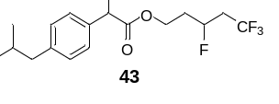
3,5,5,5-Tetrafluoropentyl-2-(4-isobutylphenyl)propanoate (43): 36.9 mg colorless liquid was isolated, yield: 53%. ¹H NMR (400 MHz, Chloroform-d) δ 7.18 (d, J = 8.1 Hz, 2H), 7.10 (d, J = 8.0 Hz, 2H), 4.76 (dtt, J = 48.5, 8.1, 4.0 Hz, 1H), 4.34 – 4.09 (m, 2H), 3.70 (q, J = 7.2 Hz, 1H), 2.45 (d, J = 7.2 Hz, 2H), 2.53 – 2.31 (m, 1H), 2.30 – 2.10 (m, 1H), 2.01 – 1.78 (m, 3H), 1.50 (dd, J = 7.2, 1.3 Hz, 3H), 0.90 (d, J = 6.6 Hz, 6H). ¹³C NMR (101 MHz, Chloroform-d) δ 174.57, 140.91 (d, J = 1.4 Hz), 137.57 (d, J = 4.5 Hz), 129.56 (d, J = 1.0 Hz), 127.18 (d, J = 0.7 Hz), 125.29 (dq, J = 3.1, 277.3 Hz), 84.78 (ddq, J = 173.72, 6.7, 3.3 Hz), 59.82 (dd, J = 6.4, 5.3 Hz), 45.23 (d, J = 6.3 Hz), 45.13, 39.38 (qd, J = 28.8, 23.0 Hz), 34.12 (dd, J = 21.0, 5.0 Hz), 30.29, 22.49, 18.36. ¹⁹F NMR (376 MHz, Chloroform-d) δ -58.90 -64.31 (m, 3F), -184.63 (dq, J = 68.4, 7.4 Hz, 1F); HRMS (ESI) exact mass calculated for [C₁₈H₂₄F₄O₂H⁺]: 349.1785, found 349.1793.
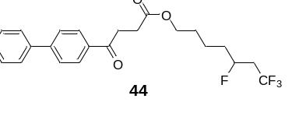
5,7,7,7-Tetrafluoroheptyl-4-([1,1'-biphenyl]-4-yl)-4-oxobutanoate (44): 36.5 mg solid with color was isolated, yield: 43%. ¹H NMR (400 MHz, Chloroform-d) δ 8.04 (d, J = 8.4 Hz, 2H), 7.67 (d, J = 8.4 Hz, 2H), 7.63 – 7.59 (m, 2H), 7.45 (t, J = 7.4 Hz, 2H), 7.41 – 7.36 (m, 1H), 4.80 (dtt, J = 49.2, 8.1, 3.5 Hz, 1H), 4.13 (t, J = 6.4 Hz, 2H), 3.31 (t, J = 6.5 Hz, 2H), 2.77 (t, J = 6.5 Hz, 2H), 2.57 – 2.22 (m, 2H), 1.80 – 1.41 (m, 6H). ¹³C NMR (101 MHz, Chloroform-d) δ 197.56, 172.80, 145.71, 139.67, 135.21, 128.92, 128.56, 128.22, 127.14 (d, J = 3.2 Hz), 125.53 (dq, J = 2.8, 276.9 Hz), 87.39 (dq, J = 172.4, 3.1 Hz), 64.06, 39.16 (qd, J = 28.4, 22.7 Hz), 34.53, 34.33, 33.30, 28.19, 28.14, 21.10 (d, J = 4.3 Hz). ¹⁹F NMR (376 MHz, Chloroform-d) δ -63.99 (d, J = 7.7 Hz, 3F), -182.24 (q, J = 7.9 Hz, 1F); HRMS (ESI) exact mass calculated for [C₂₃H₂₄F₄O₃Na⁺]: 477.1554, found 477.1561.
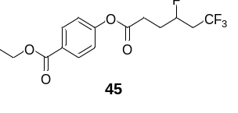
Ethyl 4-((4,6,6,6-tetrafluorohexanoyl)oxy)benzoate (45):26.9 mg white solid was isolated, yield: 40%. ¹H NMR (400 MHz, Chloroform-d) δ 8.11 – 8.05 (m, 2H), 7.20 – 7.13 (m, 2H), 4.95 (dtt, J = 49.1, 8.1, 4.1 Hz, 1H), 4.38 (q, J = 7.2 Hz, 2H), 2.80 (td, J = 7.2, 2.8 Hz, 2H), 2.70 – 2.52 (m, 1H), 2.49 – 2.32 (m, 1H), 2.20 – 2.06 (m, 2H), 1.39 (t, J = 7.1 Hz, 3H). ¹³C NMR (101 MHz, Chloroform-d) δ 170.66, 165.89, 154.12, 131.29, 128.38, 125.29 (dq, J = 4.2, 276.9 Hz), 121.55, 86.73 (dq, J = 173.2, 3.2 Hz), 61.26, 39.61 (qd, J = 28.8, 22.8 Hz), 30.16 (d, J = 20.7 Hz), 29.67 (d, J = 4.1 Hz), 14.45; ¹⁹F NMR (376 MHz, Chloroform-d) δ -64.04 (d, J = 7.4 Hz, 3F), -184.67 (q, J = 7.3 Hz, 1F); HRMS (ESI) exact mass calculated for [C₁₅H₁₆F₄O₄Na⁺]: 359.0877, found 359.0877.
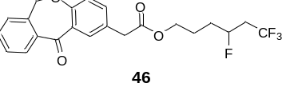
4,6,6,6-Tetrafluorohexyl-2-(11-oxo-6,11-dihydrodibenzo[b,e]oxepin-2-yl)acetate (46): 41.6 mgcolorless liquid was isolated, yield: 49%. ¹H NMR (400 MHz, Chloroform-d) δ 8.12 (d, J = 2.4 Hz, 1H), 7.89 (dd, J = 7.7, 1.4 Hz, 1H), 7.56 (td, J = 7.5, 1.4 Hz, 1H), 7.47 (td, J = 7.6, 1.3 Hz, 1H), 7.42 (dd, J = 8.4, 2.4 Hz, 1H), 7.37 (d, J = 7.4 Hz, 1H), 7.03 (d, J = 8.4 Hz, 1H), 5.19 (s, 2H), 4.81 (dtt, J = 49.1, 7.7, 3.7 Hz, 1H), 4.16 (h, J = 5.7 Hz, 2H), 3.64 (s, 2H), 2.61 – 2.20 (m, 2H), 1.91 – 1.60 (m, 4H). ¹³C NMR (101 MHz, Chloroform-d) δ 190.92, 171.43, 160.63, 140.51, 136.40, 135.68, 132.95, 132.52, 129.60, 129.41, 127.97, 127.85, 125.45 (dq, J = 3.6, 276.9 Hz), 125.30, 121.23, 87.27 (dq, J = 172.9, 3.2 Hz), 73.77, 64.23, 40.38, 39.50 (qd, J = 28.6, 22.9 Hz), 31.71 (d, J = 21.0 Hz), 24.16 (d, J = 4.0 Hz). ¹⁹F NMR (376 MHz, Chloroform-d) δ -64.07 (d, J = 7.5 Hz, 3F), -182.91 (q, J = 7.9 Hz, 1F). HRMS (ESI) exact mass calculated for [C₂₂H₂₀F₄O₄Na⁺]: 447.1190, found 447.1193.
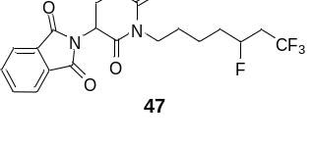
2-(2,6-Dioxo-1-(5,7,7,7-tetrafluoroheptyl)piperidin-3-yl)isoindoline-1,3-dione (47): 64.2 mg solid with color was isolated, yield: 75%. ¹H NMR (400 MHz, Chloroform-d) δ 7.86 – 7.77 (m, 2H), 7.76 – 7.67 (m, 2H), 5.02 – 4.93 (m, 1H), 4.86 – 4.63 (m, 1H), 3.76 (d, J = 6.7 Hz, 2H), 2.97 – 2.86 (m, 1H), 2.80 – 2.66 (m, 2H), 2.54 – 2.16 (m, 2H), 2.14 – 2.03 (m, 1H), 1.79 – 1.30 (m, 6H). ¹³C NMR (101 MHz, Chloroform-d) δ 170.97, 168.73, 167.38, 134.44, 131.68, 125.57 (tq, J = 2.3, 276.8 Hz), 123.64, 87.44 (dp, J = 172.1, 2.9 Hz), 50.07, 39.96 (d, J = 9.1 Hz), 39.06 (qdd, J = 29.0, 22.9, 8.2 Hz), 34.39 (d, J = 22.3 Hz), 31.88, 27.29 (d, J = 7.5 Hz), 21.92, 21.61 (d, J = 4.2 Hz). ¹⁹F NMR (376 MHz, Chloroform-d) δ -64.09 (t, J = 7.8 Hz, 3F), -181.90 (dq, J = 65.3, 7.4 Hz, 1F). HRMS (ESI) exact mass calculated for [C₂₀H₂₀F₄N₂O₄Na⁺]: 451.1251, found 451.1254.
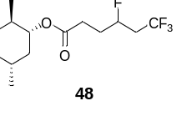
(1R,2S,5R)-2-Isopropyl-5-methylcyclohexyl 4,6,6,6-tetrafluorohexanoate (48): 40.4 mg colorless liquid was isolated, yield: 62%. ¹H NMR (400 MHz, Chloroform-d) δ 4.96 – 4.75 (m, 1H), 4.70 (td, J = 10.9, 4.4 Hz, 1H), 2.63 – 2.42 (m, 2H), 2.42 – 2.23 (m, 2H), 2.06 – 1.92 (m, 3H), 1.83 (dqd, J = 12.2, 6.9, 2.6 Hz, 1H), 1.66 (ddd, J = 9.1, 6.8, 3.1 Hz, 2H), 1.48 (ddtq, J = 15.7, 9.3, 6.0, 3.1 Hz, 1H), 1.41 – 1.32 (m, 1H), 1.11 – 0.84 (m, 9H), 0.75 (d, J = 7.0 Hz, 3H). ¹³C NMR (101 MHz, Chloroform-d) δ 172.12 (d, J = 1.3 Hz), 125.40 (dq, J = 3.7, 276.8 Hz), 86.86 (dp, J = 172.9, 3.1 Hz), 74.79 (d, J = 1.3 Hz), 47.15, 41.04 (d, J = 3.2 Hz), 39.59 (qd, J = 28.8, 22.8 Hz), 34.37, 31.54, 30.43 (d, J = 21.0 Hz), 29.76 (dd, J = 5.8, 4.2 Hz) , 25.49 (d, J = 1.6 Hz), 23.58 (d, J = 2.8 Hz), 21.12, 20.86, 16.42 (d, J = 1.9 Hz); ¹⁹F NMR (376 MHz, Chloroform-d) δ -64.16 (dd, J = 7.5, 2.0 Hz, 3F), -184.41 (q, J = 7.8 Hz, 1F); HRMS (ESI) exact mass calculated for [C₁₆H₂₆F₄O₂Na⁺]: 349.1761, found 349.1770.
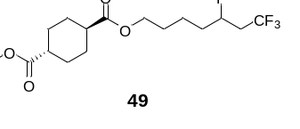
1-Methyl-4-(5,7,7,7-tetrafluoroheptyl) (1r,4r)-cyclohexane-1,4-dicarboxylate (49): 22.8 mg solid with color was isolated, yield: 32%. ¹H NMR (400 MHz, Chloroform-d) δ 4.78 (dtt, J = 48.9, 8.3, 3.5 Hz, 1H), 4.06 (t, J = 6.4 Hz, 2H), 3.65 (s, 3H), 2.50 (tqd, J = 15.7, 10.3, 8.4 Hz, 1H), 2.40 – 2.19 (m, 3H), 2.08 – 1.97 (m, 4H), 1.81 – 1.49 (m, 6H), 1.44 (qd, J = 11.5, 10.1, 4.4 Hz, 4H). ¹³C NMR (101 MHz, Chloroform-d) δ 175.98, 175.55, 125.50 (dq, J = 3.6, 276.8 Hz), 87.46 (dq, J = 172.5, 3.2 Hz), 63.93, 51.69, 42.61, 42.50, 39.49 (qd, J = 28.5, 23.1 Hz), 34.76, 34.55, 28.32, 28.13 (d, J = 2.5 Hz), 21.31 (d, J = 4.1 Hz). ¹⁹F NMR (376 MHz, Chloroform-d) δ -64.14 (d, J = 7.5 Hz, 3F), -182.45 (q, J = 7.8 Hz, 1F). HRMS (ESI) exact mass calculated for [C₁₆H₂₄F₄O₄Na⁺]: 379.1503, found 379.1512.
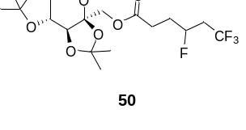
((3aS,5aR,8aR,8bS)-2,2,7,7-Tetramethyltetrahydro-3aH-bis([1,3]dioxolo)[4,5-b:4',5'-d]pyran-3a-yl)methyl 4,6,6,6-tetrafluorohexanoate (50): 38.7 mg colorless liquid was isolated, yield: 45%. ¹H NMR (400 MHz, Chloroform-d) δ 4.95 – 4.75 (m, 1H), 4.58 (dd, J = 7.9, 2.6 Hz, 1H), 4.42 (dd, J = 11.6, 2.0 Hz, 1H), 4.27 (dd, J = 2.5, 1.5 Hz, 1H), 4.23 – 4.20 (m, 1H), 4.03 (d, J = 11.6 Hz, 1H), 3.88 (dd, J = 13.0, 1.7 Hz, 1H), 3.74 (d, J = 13.0 Hz, 1H), 2.62 – 2.22 (m, 4H), 2.11 – 1.92 (m, 2H), 1.51 (s, 3H), 1.45 (s, 3H), 1.37 (s, 3H), 1.32 (s, 3H). ¹³C NMR (101 MHz, Chloroform-d) δ 171.85, 125.33 (dq, J = 3.4, 276.8 Hz), 109.22, 108.85 (d, J = 1.7 Hz), 101.53, 86.63 (dq, J = 173.0, 3.2 Hz), 70.83, 70.71, 70.13, 65.67 (d, J = 5.4 Hz), 61.35, 39.48 (qdd, J = 28.7, 22.6, 2.2 Hz), 30.08 (d, J = 20.9 Hz), 29.14 (dd, J = 4.0, 2.1 Hz), 26.50, 25.95, 25.23, 24.11. ¹⁹F NMR (376 MHz, Chloroform-d) δ -64.09 (dd, J = 7.6, 3.4 Hz; 3F), -184.85 (q, J = 7.9 Hz, 1F); HRMS (ESI) exact mass calculated for [C₁₈H₂₆F₄O₇Na⁺]: 453.1507, found 453.1514.
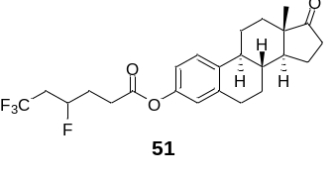
(8R,9S,13S,14S)-13-Methyl-17-oxo-7, 8, 9, 11, 12, 13, 14, 15, 16, 17-decahydro-6H-cyclopenta[a]phen-anthren-3-yl 5,7,7,7-tetra-fluoroheptanoate (51): 44.2 mg white solid was isolated, yield: 50%. ¹H NMR (400 MHz, Chloroform-d) δ 7.29 (d, J = 8.5 Hz, 1H), 6.85 (d, J = 2.5 Hz, 1H), 6.81 (s, 1H), 5.06 – 4.84 (m, 1H), 2.94 – 2.86 (m, 2H), 2.76 (td, J = 7.2, 2.7 Hz, 2H), 2.66 – 2.21 (m, 5H), 2.20 – 1.93 (m, 6H), 1.69 – 1.38 (m, 6H), 0.90 (s, 3H). ¹³C NMR (101 MHz, Chloroform-d) δ 171.43, 148.45, 138.20, 137.66, 126.55, 125.31 (dq, J = 3.7, 276.8 Hz), 121.53, 118.69, 86.73 (dq, J = 173.2, 3.3 Hz), 50.49, 48.02, 44.23, 39.52 (qd, J = 28.9, 22.7 Hz), 38.06, 35.94, 31.63, 30.21 (d, J = 20.9 Hz), 29.55, 29.51, 29.49, 26.40, 25.83, 21.67, 13.90. ¹⁹F NMR (376 MHz, Chloroform-d) δ -64.03 (d, J = 7.6 Hz, 3F), -184.61 (q, J = 7.6 Hz, 1F). HRMS (ESI) exact mass calculated for [C₂₄H₂₈F₄O₃Na⁺]: 463.1867, found 463.1862.
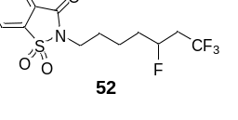
2-(5,7,7,7-Tetrafluoroheptyl)benzo[d]isothiazol-3(2H)-one 1,1-dioxide (52): 38.8 mg liquid with color was isolated, yield: 55%. ¹H NMR (400 MHz, Chloroform-d) δ 8.05 (dd, J = 6.7, 1.4 Hz, 1H), 7.92 (dd, J = 6.8, 1.4 Hz, 1H), 7.85 (dtd, J = 16.0, 7.3, 1.3 Hz, 2H), 4.81 (dtt, J = 48.8, 8.2, 3.5 Hz, 1H), 3.79 (t, J = 7.3 Hz, 2H), 2.62 – 2.20 (m, 2H), 1.96 – 1.87 (m, 2H), 1.84 – 1.45 (m, 4H). ¹³C NMR (101 MHz, Chloroform-d) δ 159.12, 137.79, 134.90, 134.48, 127.46, 125.53 (dq, J = 3.4, 276.8 Hz), 125.30, 121.05, 87.44 (dq, J = 172.6, 3.2 Hz), 39.46 (qd, J = 28.5, 22.9 Hz), 39.04, 34.47 (d, J = 20.9 Hz), 28.07, 21.99 (d, J = 4.2 Hz); ¹⁹F NMR (376 MHz, Chloroform-d) δ -64.10 (d, J = 7.5 Hz, 3F), -182.30 (q, J = 7.3 Hz, 1F); HRMS (ESI) exact mass calculated for [C₁₄H₁₅F₄NO₃SNa⁺]: 376.0601, found 376.0604.
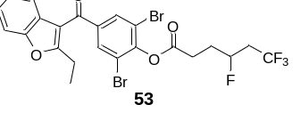
2,6-Dibromo-4-(2-ethylbenzofuran-3-carbonyl)phenyl 4,6,6,6-tetrafluorohexanoate (53): 53.2 mg liquid with color was isolated, yield: 45%. ¹H NMR (400 MHz, Chloroform-d) δ 8.03 (s, 2H), 7.51 (d, J = 8.1 Hz, 1H), 7.41 (d, J = 7.7 Hz, 1H), 7.32 (t, J = 7.3 Hz, 1H), 7.26 (t, J = 7.4 Hz, 1H), 5.10 – 4.90 (m, 1H), 3.01 – 2.87 (m, 4H), 2.69 – 2.32 (m, 2H), 2.28 – 2.11 (m, 2H), 1.37 (t, J = 7.5 Hz, 3H). ¹³C NMR (101 MHz, Chloroform-d) δ 187.84, 168.58, 167.52, 153.82, 149.35, 139.22, 133.19, 126.34, 125.28 (dq, J = 3.8, 276.9 Hz), 124.95, 124.14, 121.12, 118.20, 115.31, 111.34, 86.45 (dq, J = 173.6, 3.2 Hz), 39.58 (qd, J = 28.9, 22.7 Hz), 30.02 (d, J = 21.0 Hz), 29.19 (d, J = 4.3 Hz), 22.20, 12.32. ¹⁹F NMR (376 MHz, Chloroform-d) δ -63.95 (d, J = 7.3 Hz, 3F), -184.91 (q, J = 7.4 Hz, 1F); HRMS (ESI) exact mass calculated for [C₂₃H₁₈Br₂F₄O₄Na⁺]: 614.9400, found 614.9404.
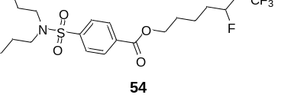
5,7,7,7-Tetrafluoroheptyl 4-(N,N-dipropylsulfamoyl)benzoate (54): 54.6 mg colorless liquid was isolated, yield: 60%. ¹H NMR (400 MHz, Chloroform-d) δ 8.09 (d, J = 8.3 Hz, 2H), 7.82 (d, J = 8.3 Hz, 2H), 4.77 (dtt, J = 49.1, 8.2, 3.4 Hz, 1H), 4.31 (t, J = 6.4 Hz, 2H), 3.04 (t, J = 8.0 Hz, 4H), 2.57 – 2.18 (m, 2H), 1.83 – 1.54 (m, 6H), 1.48 (h, J = 7.4 Hz, 4H), 0.80 (t, J = 7.4 Hz, 6H). ¹³C NMR (101 MHz, Chloroform-d) δ 165.14, 144.19, 133.55, 130.13, 126.95, 125.45 (dq, J = 3.0, 276.8 Hz), 87.39 (dq, J = 172.4, 3.1 Hz), 65.11, 49.90, 39.25 (qd, J = 28.4, 22.7 Hz), 34.47 (d, J = 20.7 Hz), 28.18, 21.88, 21.28 (d, J = 4.1 Hz), 11.03. ¹⁹F NMR (376 MHz, Chloroform-d) δ -64.14 (d, J = 7.1 Hz, 3F), -182.74 (q, J = 7.4 Hz, 1F). HRMS (ESI) exact mass calculated for [C₂₀H₂₉F₄NO₄SNa⁺]: 478.1646, found 478.1653.
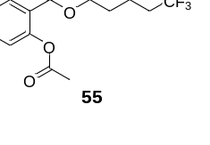
3,5,5,5-Tetrafluoropentyl 2-acetoxybenzoate (55): 31.5 mg colorless liquid was isolated, yield: 49%. ¹H NMR (400 MHz, Chloroform-d) δ 7.98 (dd, J = 7.8, 1.6 Hz, 1H), 7.63 – 7.52 (m, 1H), 7.32 (td, J = 7.8, 1.1 Hz, 1H), 7.15 – 7.05 (m, 1H), 5.12 – 4.90 (m, 1H), 4.54 – 4.34 (m, 2H), 2.68 – 2.28 (m, 5H), 2.18 – 1.99 (m, 2H). ¹³C NMR (101 MHz, Chloroform-d) δ 169.74, 164.28, 150.84, 134.20, 131.62, 126.18, 125.30 (dq, J = 3.4, 276.8 Hz), 123.97, 123.08, 84.84 (dq, J = 173.3, 3.3 Hz), 60.39 (d, J = 4.7 Hz), 39.47 (qd, J = 28.8, 22.5 Hz), 34.22 (d, J = 20.8 Hz), 21.04. ¹⁹F NMR (376 MHz, Chloroform-d) δ -63.97 (d, J = 7.4 Hz, 3F), -184.90 (q, J = 7.4 Hz, 1F). HRMS (ESI) exact mass calculated for [C₁₄H₁₄F₄O₄Na⁺]: 345.0720, found 345.0726.
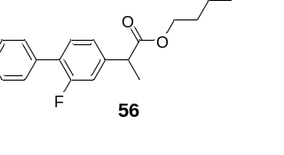
3,5,5,5-Tetrafluoropentyl 2-(2-fluoro-[1,1'-biphenyl]-4-yl)propanoate (56): 45.3 mg colorless liquid was isolated, yield: 59%. ¹H NMR (400 MHz, Chloroform-d) δ 7.56 (d, J = 7.3 Hz, 2H), 7.50 – 7.35 (m, 4H), 7.20 – 7.10 (m, 2H), 4.96 – 4.73 (m, 1H), 4.36 – 4.20 (m, 2H), 3.79 (q, J = 7.1 Hz, 1H), 2.61 – 2.16 (m, 2H), 2.08 – 1.85 (m, 2H), 1.60 – 1.52 (m, 3H). ¹³C NMR (101 MHz, Chloroform-d) δ 173.77, 161.05, 158.58, 141.64 (dd, J = 7.6, 4.0 Hz), 135.50, 131.02 (d, J = 3.8 Hz), 129.03 (d, J = 2.9 Hz), 128.56, 128.11 (d, J = 13.5 Hz), 127.81, 125.29 (dq, J = 3.5, 277.0 Hz), 123.57 (d, J = 3.3 Hz), 84.76 (ddq, J = 173.2, 6.7, 3.3 Hz), 60.20 (dd, J = 6.4, 4.9 Hz), 45.06 (dd, J = 4.4, 1.4 Hz), 39.35 (qd, J = 28.7, 22.8 Hz), 34.04 (dd, J = 21.0, 5.1 Hz), 18.25. ¹⁹F NMR (376 MHz, Chloroform-d) δ -64.11 (dd, J = 7.7, 3.9 Hz, 3F), -117.46 (d, J = 11.0 Hz, 1F), -184.52 (dq, J = 84.8, 7.7 Hz, 1F). HRMS (ESI) exact mass calculated for [C₂₀H₁₉F₅O₂H⁺]: 387.1378, found 387.1385.
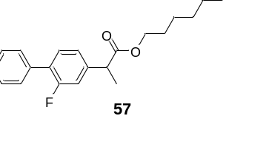
5,7,7,7-Tetrafluoroheptyl 2-(2-fluoro-[1,1'-biphenyl]-4-yl)propanoate (57): 57.9 mg colorless liquid was isolated, yield: 70%. ¹H NMR (400 MHz, Chloroform-d) δ 7.58 – 7.50 (m, 2H), 7.48 – 7.34 (m, 4H), 7.19 – 7.10 (m, 2H), 4.77 (dtt, J = 48.9, 7.6, 3.2 Hz, 1H), 4.13 (t, J = 6.4 Hz, 2H), 3.77 (q, J = 7.1 Hz, 1H), 2.58 – 2.15 (m, 2H), 1.78 – 1.57 (m, 4H), 1.55 (d, J = 7.2 Hz, 3H), 1.53 – 1.34 (m, 2H). ¹³C NMR (101 MHz, Chloroform-d) δ 174.07, 161.01, 158.55, 141.98 (d, J = 7.7 Hz), 135.54, 130.90 (d, J = 3.9 Hz), 129.02 (d, J = 3.0 Hz), 128.56, 127.93 (d, J = 13.5 Hz), 127.79, 125.51 (dq, J = 3.5, 276.9 Hz), 123.64 (d, J = 3.3 Hz), 87.44 (dq, J = 172.7, 3.3 Hz), 64.57, 45.17 (d, J = 1.2 Hz), 39.41 (qd, J = 28.5, 23.0 Hz), 34.57 (d, J = 20.8 Hz), 28.21, 21.22 (d, J = 4.1 Hz), 18.38. ¹⁹F NMR (376 MHz, Chloroform-d) δ -64.09 (d, J = 7.7 Hz, 3F), -117.66 (s, 1F), -182.41 (q, J = 7.7 Hz, 1F). HRMS (ESI) exact mass calculated for [C₂₂H₂₃F₅O₂H⁺]: 415.1691, found 415.1688.
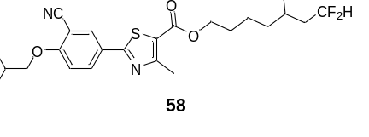
5,7,7-Trifluoroheptyl 2-(3-cyano-4-isobutoxyphenyl)-4-methylthiazole-5-carboxylate (58): 64.6 mg white solid was isolated, yield: 69%. ¹H NMR (400 MHz, Chloroform-d) δ 8.13 (d, J = 2.1 Hz, 1H), 8.05 (dd, J = 8.8, 2.2 Hz, 1H), 6.99 (d, J = 8.9 Hz, 1H), 5.98 (tdd, J = 56.6, 6.7, 2.8 Hz, 1H), 4.84 – 4.61 (m, 1H), 4.29 (t, J = 6.4 Hz, 2H), 3.88 (d, J = 6.5 Hz, 2H), 2.73 (s, 3H), 2.29 – 1.94 (m, 3H), 1.85 – 1.48 (m, 6H), 1.07 (d, J = 6.7 Hz, 6H). ¹³C NMR (101 MHz, Chloroform-d) δ 167.27, 162.55, 162.04, 161.29, 132.61, 132.08, 126.00, 121.70, 115.44, 115.10 (dt, J = 4.9, 233.8 Hz), 112.70, 102.99, 88.97 (ddd, J = 168.7, 8.8, 4.1 Hz), 75.75, 64.97, 40.04 (q, J = 21.3 Hz), 34.74 (d, J = 20.5 Hz), 28.38, 28.23, 21.52 (d, J = 4.3 Hz), 19.11, 17.55. ¹⁹F NMR (376 MHz, Chloroform-d) δ -117.15 (dd, J = 518.9, 288.0 Hz, 2F), -183.71 (s, 1F). HRMS (ESI) exact mass calculated for [C₂₃H₂₇F₃N₂O₃SNa⁺]: 491.1587, found 491.1592.
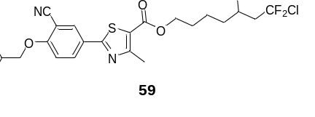
7-Chloro-5,7,7-trifluoroheptyl 2-(3-cyano-4-isobutoxyphenyl)-4-methylthiazole-5-carboxylate (59): 59.2 mg white solid was isolated, yield: 59%. ¹H NMR (400 MHz, Chloroform-d) δ 8.14 – 8.11 (m, 1H), 8.01 (dt, J = 8.8, 1.7 Hz, 1H), 6.98 (d, J = 8.9 Hz, 1H), 4.87 (dtt, J = 49.2, 8.0, 3.4 Hz, 1H), 4.29 (t, J = 6.4 Hz, 2H), 3.87 (d, J = 6.5 Hz, 2H), 2.73 (d, 3H), 2.82 – 2.40 (m, 2H), 2.17 (dp, J = 13.3, 6.6 Hz, 1H), 1.86 – 1.45 (m, 6H), 1.07 (d, J = 6.7 Hz, 6H). ¹³C NMR (101 MHz, Chloroform-d) δ 167.25, 162.54, 162.00 161.28, 132.59, 132.03, 127.76 (dt, J = 2.7, 292.6 Hz), 125.97, 121.66, 115.42, 112.69, 102.97, 88.21 (dt, J = 173.3, 2.9 Hz), 75.74, 64.89, 47.02 (dd, J = 22.8, 23.9 Hz), 34.63 (d, J = 20.9 Hz), 28.32, 28.21, 21.37 (d, J = 4.2 Hz), 19.09, 17.53. ¹⁹F NMR (376 MHz, Chloroform-d) δ -49.39 (dddd, J = 267.0, 165.5, 8.3, 3.0 Hz 2F), -181.86 (t, J = 9.0 Hz, 1F). HRMS (ESI) exact mass calculated for [C₂₃H₂₆ClF₃N₂O₃SNa⁺]: 525.1197, found 525.1199.
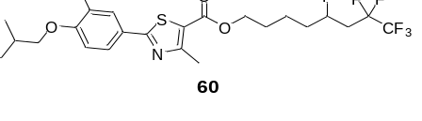
5,7,7,8,8,8-Hexafluorooctyl 2-(3-cyano-4-isobutoxyphenyl)-4-methylthiazole-5-carboxylate (60): 72.3 mg white solid was isolated, yield: 68%. ¹H NMR (400 MHz, Chloroform-d) δ 8.15 (d, J = 2.2 Hz, 1H), 8.07 (dd, J = 8.8, 2.2 Hz, 1H), 7.00 (d, J = 8.9 Hz, 1H), 4.93 (dtt, J = 48.8, 8.0, 3.4 Hz, 1H), 4.31 (t, J = 6.4 Hz, 2H), 3.89 (d, J = 6.6 Hz, 2H), 2.75 (s, 3H), 2.59 – 2.12 (m, 3H), 1.93 – 1.54 (m, 6H), 1.08 (d, J = 6.7 Hz, 6H). ¹³C NMR (101 MHz, Chloroform-d) δ 167.35, 162.61, 162.08, 161.39, 132.39 (d, J = 49.7 Hz), 130.09 (d, J = 225.0 Hz), 126.05, 121.71, 120.34 (t, J = 35.7 Hz), 117.51 (t, J = 35.8 Hz), 115.46, 114.56 (dd, J = 38.2, 2.7 Hz), 112.72, 103.07, 86.70 (dt, J = 173.2, 3.0 Hz), 75.81, 64.91, 36.45 (dt, J = 23.2, 21.4 Hz), 35.16 (d, J = 20.9 Hz), 28.31 (d, J = 9.5 Hz), 21.44 (d, J = 4.1 Hz), 19.13, 17.58. ¹⁹F NMR (376 MHz, Chloroform-d) δ -85.82 (d, J = 3.3 Hz, 3F), -116.99 (dd, J = 9.1, 3.8 Hz, 2F), -180.70 – -180.78 (m, 1F). HRMS (ESI) exact mass calculated for [C₂₄H₂₆F₆N₂O₃SNa⁺]: 559.1461, found 559.1466.
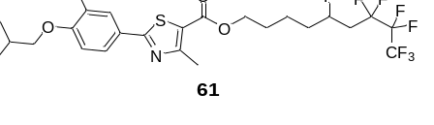
5,7,7,8,8,9,9,9-Octafluorononyl 2-(3-cyano-4-isobutoxyphenyl)-4-methylthiazole-5-carboxylate (61): 83.2 mg white solid was isolated, yield: 71%. ¹H NMR (400 MHz, Chloroform-d) δ 8.17 (d, J = 2.0 Hz, 1H), 8.08 (dd, J = 8.8, 2.1 Hz, 1H), 7.00 (d, J = 8.9 Hz, 1H), 4.96 (dtt, J = 48.9, 7.9, 3.4 Hz, 1H), 4.32 (t, J = 6.4 Hz, 2H), 3.90 (d, J = 6.5 Hz, 2H), 2.76 (s, 3H), 2.66 – 2.13 (m, 3H), 1.93 – 1.53 (m, 6H), 1.09 (d, J = 6.7 Hz, 6H). ¹³C NMR (101 MHz, Chloroform-d) δ 167.18, 162.50, 161.94, 161.22, 132.53, 131.92, 125.91, 121.62, 117.79 (tq, J = 34.0, 287.3 Hz), 116.60 (tt, J = 31.4, 256.0 Hz), 115.37, 112.64, 108.60 (dqt, J = 2.4, 37.4, 264.6 Hz), 102.89, 86.58 (dt, J = 173.6, 2.7 Hz), 75.70, 64.84, 36.18 (q, J = 21.9 Hz), 35.11 (d, J = 20.9 Hz), 28.27, 28.18, 21.36 (d, J = 4.1 Hz), 18.99, 17.44. ¹⁹F NMR (376 MHz, Chloroform-d) δ -80.39 (t, J = 11.3 Hz, 3F), -114.11 (dq, J = 37.3, 9.9 Hz, 2F), -127.86 (t, J = 3.8 Hz, 2F), -180.48 – -180.57 (m, 1F). HRMS (ESI) exact mass calculated for [C₂₅H₂₆F₈N₂O₃SNa⁺]: 609.1429, found 609.1439.
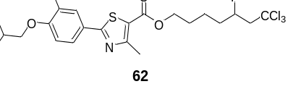
7,7,7-Trichloro-5-fluoroheptyl-2-(3-cyano-4-isobutoxyphenyl)-4-methylthiazole-5-carboxylate (62): 57.7 mg white solid was isolated, yield: 54%. ¹H NMR (400 MHz, Chloroform-d) δ 8.14 (d, J = 2.1 Hz, 1H), 8.06 (dt, J = 8.8, 1.9 Hz, 1H), 6.99 (d, J = 8.9 Hz, 1H), 4.34 – 4.24 (m, 3H), 3.88 (d, J = 6.5 Hz, 2H), 3.33 – 3.07 (m, 2H), 2.74 (d, J = 1.2 Hz, 3H), 2.19 (dp, J = 13.2, 6.6 Hz, 1H), 2.08 – 1.57 (m, 6H), 1.07 (d, J = 6.7 Hz, 6H). ¹³C NMR (101 MHz, Chloroform-d) δ 167.31, 162.57, 162.05, 161.34, 132.63, 132.12, 126.02, 121.72, 115.45, 112.71, 103.04, 96.89, 75.78, 64.91, 62.28, 57.46, 38.52, 28.24, 28.04, 22.71, 19.15, 17.61. ¹⁹F NMR (376 MHz, Chloroform-d) δ -178.46 (s, 1F). HRMS (ESI) exact mass calculated for [C₂₃H₂₆Cl₃FN₂O₃SH⁺]: 535.0787, found 535.0788.
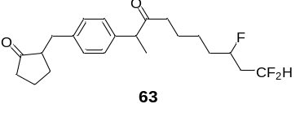
2-(4-(8,10,10-Trifluoro-3-oxodecan-2-yl)benzyl)cyclopentan-1-one (63): 34.1 mg colorless liquid was isolated, yield: 45%. ¹H NMR (400 MHz, Chloroform-d) δ 7.20 (d, J = 8.1 Hz, 2H), 7.11 (d, J = 8.0 Hz, 2H), 5.96 (tdd, J = 56.5, 6.8, 2.8 Hz, 1H), 4.64 (dt, J = 49.4, 8.7 Hz, 1H), 4.07 (t, J = 6.3 Hz, 2H), 3.68 (q, J = 7.1 Hz, 1H), 3.12 (dd, J = 13.9, 4.1 Hz, 1H), 2.50 (dd, J = 13.9, 9.5 Hz, 1H), 2.38 – 2.27 (m, 2H), 2.16 – 2.04 (m, 3H), 2.03 – 1.87 (m, 2H), 1.77 – 1.51 (m, 6H), 1.48 (d, J = 7.2 Hz, 3H), 1.44 – 1.28 (m, 2H). ¹³C NMR (101 MHz, Chloroform-d) δ 220.30, 174.74, 139.00, 138.50, 129.21, 127.61, 115.13 (dt, J = 4.9, 238.6 Hz), 89.00 (ddd, J = 168.6, 8.9, 4.1 Hz), 64.29 (d, J = 2.0 Hz), 51.07, 45.27, 40.02 (q, J = 21.3 Hz), 38.29, 35.29, 34.69 (d, J = 20.5 Hz), 29.35, 28.26, 21.29 (d, J = 4.5 Hz), 20.65, 18.53. ¹⁹F NMR (376 MHz, Chloroform-d) δ -116.00 – -118.41 (m, 2F), -183.54 – -183.61 (m, 1F). HRMS (ESI) exact mass calculated for [C₂₂H₂₉F₃O₂H⁺]: 383.2192, found 383.2210.
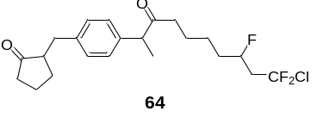
2-(4-(10-Chloro-8,10,10-trifluoro-3-oxodecan-2-yl)benzyl)cyclopentan-1-one (64): 47.1 mg colorless liquid was isolated, yield: 57%. ¹H NMR (400 MHz, Chloroform-d) δ 7.20 (d, J = 8.0 Hz, 2H), 7.11 (d, J = 8.1 Hz, 2H), 4.78 (dtt, J = 49.2, 7.3, 3.1 Hz, 1H), 4.07 (t, J = 6.3 Hz, 2H), 3.68 (q, J = 7.1 Hz, 1H), 3.11 (dd, J = 13.9, 4.1 Hz, 1H), 2.68 (dddt, J = 18.3, 10.6, 5.4, 2.4 Hz, 1H), 2.54 – 2.27 (m, 4H), 2.16 – 2.01 (m, 2H), 1.96 (dtt, J = 12.6, 6.5, 2.7 Hz, 1H), 1.79 – 1.31 (m, 11H). ¹³C NMR (101 MHz, Chloroform-d) δ 220.27, 174.73, 139.01, 138.48 (d, J = 1.2 Hz), 129.21, 127.80 (dt, J = 2.8, 292.4 Hz), 127.60, 88.23 (dt, J = 173.3, 3.0 Hz), 64.27, 51.06, 47.01 (q, J = 23.9 Hz), 45.26, 38.28, 35.30, 34.59 (d, J = 21.0 Hz), 29.35, 28.20, 21.16 (d, J = 4.3 Hz), 20.64, 18.53. ¹⁹F NMR (376 MHz, Chloroform-d) δ -48.50 – -50.44 (m, 2F), -181.68 – -181.76 (m, 1F). HRMS (ESI) exact mass calculated for [C₂₂H₂₈ClF₃O₂Na⁺]: 439.1622, found 439.1631.
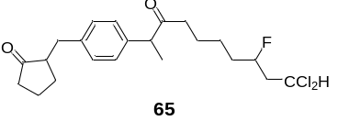
2-(4-(10,10-Dichloro-8-fluoro-3-oxodecan-2-yl)benzyl)cyclopentan-1-one (65): 44.6 mg colorless liquid was isolated, yield: 54%. ¹H NMR (400 MHz, Chloroform-d) δ 7.20 (d, J = 8.1 Hz, 2H), 7.12 (d, J = 8.1 Hz, 2H), 5.87 (dd, J = 10.1, 3.0 Hz, 1H), 4.76 – 4.56 (m, 1H), 4.07 (t, J = 6.4 Hz, 2H), 3.68 (q, J = 7.1 Hz, 1H), 3.12 (dd, J = 13.9, 4.1 Hz, 1H), 2.54 – 2.45 (m, 2H), 2.37 – 2.20 (m, 3H), 2.15 – 2.04 (m, 2H), 2.00 – 1.90 (m, 1H), 1.80 – 1.51 (m, 6H), 1.48 (d, J = 7.2 Hz, 3H), 1.45 – 1.27 (m, 2H). ¹³C NMR (101 MHz, Chloroform-d) δ 220.25, 174.73, 138.99, 138.49, 129.22, 127.60, 90.54 (d, J = 169.7 Hz), 69.69 (d, J = 4.5 Hz), 64.33, 51.07, 49.27 (d, J = 20.8 Hz), 45.26, 38.29, 35.32, 34.25 (dd, J = 20.3, 1.7 Hz), 29.36, 28.29 (d, J = 1.4 Hz), 21.35 (d, J = 4.5 Hz), 20.66, 18.54. ¹⁹F NMR (376 MHz, Chloroform-d) δ -185.21 (d, J = 13.4 Hz, 1F). HRMS (ESI) exact mass calculated for [C₂₂H₂₉Cl₂FO₂Na⁺]: 437.1421, found 437.1440.
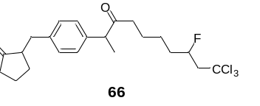
2-(4-(10,10,10-Trichloro-8-fluoro-3-oxodecan-2-yl)benzyl)cyclopentan-1-one (66): 41.6 mg colorless liquid was isolated, yield: 46%. ¹H NMR (400 MHz, Chloroform-d) δ 7.21 (d, J = 8.0 Hz, 2H), 7.12 (d, J = 8.0 Hz, 2H), 4.98 – 4.78 (m, 1H), 4.08 (t, J = 6.4 Hz, 2H), 3.69 (q, J = 7.1 Hz, 1H), 3.17 – 3.04 (m, 2H), 2.83 (ddd, J = 26.3, 15.6, 1.7 Hz, 1H), 2.50 (dd, J = 13.9, 9.5 Hz, 1H), 2.38 – 2.28 (m, 2H), 2.16 – 2.02 (m, 2H), 2.01 – 1.90 (m, 1H), 1.79 – 1.68 (m, 2H), 1.65 – 1.50 (m, 4H), 1.48 (d, J = 7.2 Hz, 3H), 1.46 – 1.30 (m, 2H). ¹³C NMR (101 MHz, Chloroform-d) δ 220.26, 174.73, 139.00, 138.49, 129.22, 127.61, 96.63, 90.29 (d, J = 174.4 Hz), 64.32, 59.56 (d, J = 22.5 Hz), 51.08, 45.27, 38.29, 35.32, 35.03 (d, J = 21.3 Hz), 29.36, 28.24, 21.21 (d, J = 4.5 Hz), 20.66, 18.56 (d, J = 1.8 Hz). ¹⁹F NMR (376 MHz, Chloroform-d) δ -178.32 – -178.36 (m, 1F). HRMS (ESI) exact mass calculated for [C₂₂H₂₈Cl₃FO₂Na⁺]: 471.1031, found 471.1035.
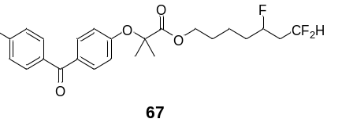
5,7,7-Trifluoroheptyl 2-(4-(4-chlorobenzoyl)phenoxy)-2-methylpropanoate (67): 28.1 mg colorless liquid was isolated, yield: 30%. ¹H NMR (400 MHz, DMSO-d₆) δ 7.71 (dd, J = 8.3, 6.2 Hz, 4H), 7.61 (d, J = 8.4 Hz, 2H), 6.90 (d, J = 8.7 Hz, 2H), 6.12 (tt, J = 56.1, 4.6 Hz, 1H), 4.61 (dtt, J = 49.7, 8.0, 4.3 Hz, 1H), 4.13 (t, J = 6.3 Hz, 2H), 2.21 – 1.98 (m, 2H), 1.65 – 1.44 (m, 10H), 1.37 – 1.17 (m, 2H). ¹³C NMR (101 MHz, Chloroform-d) δ 194.29, 173.87, 159.78, 138.53, 136.46, 132.16, 131.28, 130.49, 128.67, 117.21, 115.08 (dt, J = 4.9, 238.7 Hz), 88.92 (ddd, J = 168.7, 8.7, 4.1 Hz), 79.52, 65.44, 39.99 (q, J = 21.4 Hz), 34.68 (d, J = 20.4 Hz), 28.18, 25.56 (d, J = 4.3 Hz), 21.36 (d, J = 4.3 Hz). ¹⁹F NMR (376 MHz, Chloroform-d) δ -115.96 – -118.38 (m, 2F), -183.71 (s, 1F). HRMS (ESI) exact mass calculated for [C₂₄H₂₆ClF₃O₄H⁺]: 471.1544, found 471.1542.
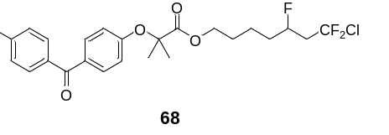
7-Chloro-5,7,7-trifluoroheptyl 2-(4-(4-chlorobenzoyl)phenoxy)-2-methylpropanoate (68): 41.0 mg colorless liquid was isolated, yield: 41%. ¹H NMR (400 MHz, Chloroform-d) δ 7.77 – 7.65 (m, 4H), 7.47 – 7.40 (m, 2H), 6.89 – 6.81 (m, 2H), 4.74 (dtt, J = 49.1, 8.1, 3.4 Hz, 1H), 4.17 (t, J = 6.4 Hz, 2H), 2.66 (tddd, J = 15.7, 13.7, 10.6, 8.1 Hz, 1H), 2.53 – 2.30 (m, 1H), 1.67 (s, 6H), 1.68 – 1.26 (m, 6H). ¹³C NMR (101 MHz, Chloroform-d) δ 194.26, 173.84, 159.76, 138.51, 136.42, 132.13, 131.26, 130.48, 128.65, 127.72 (dt, J = 3.0, 292.5 Hz), 117.19, 88.17 (dt, J = 173.3, 3.0 Hz), 79.50, 65.35, 46.96 (q, J = 23.6 Hz), 34.56 (d, J = 20.9 Hz), 28.12, 25.54 (d, J = 4.8 Hz), 21.22 (d, J = 4.1 Hz). ¹⁹F NMR (376 MHz, Chloroform-d) δ -48.63 – -50.33 (m, 2F), -181.92 – -182.00 (m, 1F). HRMS (ESI) exact mass calculated for [C₂₄H₂₅Cl₂F₃O₄H⁺]: 505.1155, found 505.1153.
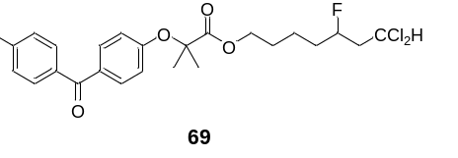
7,7-Dichloro-5-fluoroheptyl 2-(4-(4-chlorobenzoyl)phenoxy)-2-methylpropanoate (69): 50.8 mg colorless liquid was isolated, yield: 51%. ¹H NMR (400 MHz, DMSO-d₆) δ 7.71 (dd, J = 8.5, 5.8 Hz, 4H), 7.61 (d, J = 8.5 Hz, 2H), 6.90 (d, J = 8.8 Hz, 2H), 6.26 (dd, J = 8.8, 4.2 Hz, 1H), 4.67 – 4.45 (m, 1H), 4.13 (t, J = 6.2 Hz, 2H), 2.47 – 2.27 (m, 2H), 1.54 (m, 10H), 1.26 (m, 2H). ¹³C NMR (101 MHz, DMSO-d₆) δ 193.19, 172.78, 159.24, 137.08, 136.24, 131.94, 131.19, 129.58, 128.62, 117.06, 90.69 (d, J = 168.6 Hz), 79.12, 71.06 (d, J = 4.4 Hz), 65.05, 47.81 (d, J = 20.6 Hz), 33.27 (d, J = 19.8 Hz), 27.57, 25.12, 20.71 (d, J = 4.4 Hz). ¹⁹F NMR (376 MHz, Chloroform-d) δ -178.15 (s, 1F). HRMS (ESI) exact mass calculated for [C₂₄H₂₆Cl₃FO₄H⁺]: 503.0953, found 503.0953.
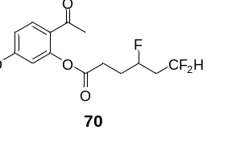
2-Acetyl-5-methoxyphenyl 4,6,6-trifluorohexanoate (70): 19.8 mg colorless liquid was isolated, yield: 31%. ¹H NMR (400 MHz, Chloroform-d) δ 7.83 (d, J = 8.8 Hz, 1H), 6.83 (dd, J = 8.8, 2.5 Hz, 1H), 6.60 (d, J = 2.5 Hz, 1H), 6.01 (tdd, J = 56.1, 6.6, 2.9 Hz, 1H), 4.99 – 4.79 (m, 1H), 3.86 (s, 3H), 2.90 – 2.75 (m, 2H), 2.50 (s, 3H), 2.36 – 2.07 (m, 4H). ¹³C NMR (101 MHz, Chloroform-d) δ 195.85, 171.37, 163.97, 151.39, 132.84, 122.78, 115.02 (td, J = 238.9, 5.0 Hz), 111.82, 109.53, 88.36 (ddd, J = 169.5, 8.7, 4.4 Hz), 55.89, 40.10 (q, J = 21.2 Hz), 30.14 (d, J = 20.7 Hz), 29.78 (d, J = 4.4 Hz), 28.90. ¹⁹F NMR (376 MHz, Chloroform-d) δ -115.89 – -118.23 (m, 2F), -185.73(s, 1F). HRMS (ESI) exact mass calculated for [C₁₅H₁₇F₃O₄Na⁺]: 341.0971, found 341.0988.
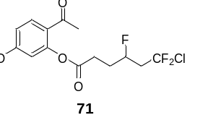
2-Acetyl-5-methoxyphenyl 6-chloro-4,6,6-trifluorohexanoate (71): 36.2 mg colorless liquid was isolated, yield: 51%. ¹H NMR (400 MHz, DMSO-d₆) δ 7.93 (d, J = 8.8 Hz, 1H), 6.95 (dd, J = 8.5, 2.2 Hz, 1H), 6.78 (d, J = 2.4 Hz, 1H), 5.11 – 4.91 (m, 1H), 3.82 (s, 3H), 3.05 – 2.87 (m, 2H), 2.76 (t, J = 7.5 Hz, 2H), 2.45 (s, 3H), 2.13 – 1.96 (m, 2H). ¹³C NMR (101 MHz, Chloroform-d) δ 195.82, 171.26, 163.97, 151.36, 132.86, 127.67 (dt, J = 2.6, 293.4 Hz), 122.69, 111.82, 109.52, 87.62 (dt, J = 173.5, 3.1 Hz), 55.87, 47.09 (td, J = 24.3, 22.2 Hz), 30.06 (d, J = 20.9 Hz), 29.61 (d, J = 4.2 Hz), 28.85. ¹⁹F NMR (376 MHz, Chloroform-d) δ -48.56 – -50.43 (m, 2F), -183.95 – -184.03 (m, 1F). HRMS (ESI) exact mass calculated for [C₁₅H₁₆ClF₃O₄Na⁺]: 375.0581, found 375.0587.
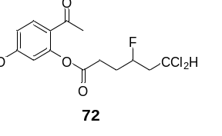
2-Acetyl-5-methoxyphenyl 6,6-dichloro-4-fluorohexanoate (72): 30.1 mg colorless liquid was isolated, yield: 43%. ¹H NMR (400 MHz, Chloroform-d) δ 7.83 (d, J = 8.8 Hz, 1H), 6.83 (dd, J = 8.8, 2.5 Hz, 1H), 6.60 (d, J = 2.5 Hz, 1H), 5.91 (dd, J = 10.0, 3.2 Hz, 1H), 5.00 – 4.79 (m, 1H), 3.85 (s, 3H), 2.90 – 2.75 (m, 2H), 2.70 – 2.57 (m, 1H), 2.50 (s, 3H), 2.49 – 2.35 (m, 1H), 2.25 – 2.05 (m, 2H). ¹³C NMR (101 MHz, Chloroform-d) δ 195.80, 171.32, 163.94, 151.37, 132.83, 122.73, 111.78, 109.52, 89.91 (d, J = 170.4 Hz), 69.46 (d, J = 4.5 Hz), 55.87, 49.22 (d, J = 20.5 Hz), 29.79, 29.71 (d, J = 25.5 Hz), 28.88. ¹⁹F NMR (376 MHz, Chloroform-d) δ -187.26 (s, 1F). HRMS (ESI) exact mass calculated for [C₁₅H₁₇Cl₂FO₄Na⁺]: 373.0380, found 373.0384.
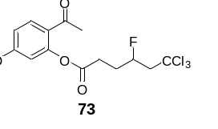
2-Acetyl-5-methoxyphenyl 6,6,6-trichloro-4-fluorohexanoate (73): 40.8 mg colorless liquid was isolated, yield: 53%. ¹H NMR (400 MHz, Chloroform-d) δ 7.83 (d, J = 8.8 Hz, 1H), 6.83 (dd, J = 8.8, 2.5 Hz, 1H), 6.61 (d, J = 2.5 Hz, 1H), 5.22 – 5.02 (m, 1H), 3.85 (s, 3H), 3.23 (ddd, J = 18.9, 15.6, 7.1 Hz, 1H), 2.99 (ddd, J = 26.3, 15.6, 2.3 Hz, 1H), 2.92 – 2.79 (m, 2H), 2.51 (s, 3H), 2.31 – 2.14 (m, 2H). ¹³C NMR (101 MHz, Chloroform-d) δ 195.79, 171.27, 163.96, 151.37, 132.84, 122.71, 111.81, 109.52, 96.35, 89.64 (d, J = 174.7 Hz), 59.54 (d, J = 22.2 Hz), 55.87, 30.46 (d, J = 21.4 Hz), 29.70 (d, J = 4.4 Hz), 28.88. ¹⁹F NMR (376 MHz, Chloroform-d) δ -180.74 (s, 1F). HRMS (ESI) exact mass calculated for [C₁₅H₁₆Cl₃FO₄Na⁺]: 406.9990, found 407.0002.
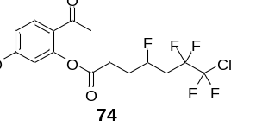
2-Acetyl-5-methoxyphenyl 7-chloro-4,6,6,7,7-pentafluoroheptanoate (74): 33.7 mg colorless liquid was isolated, yield: 42%. ¹H NMR (400 MHz, Chloroform-d) δ 7.84 (d, J = 8.8 Hz, 1H), 6.83 (dd, J = 8.8, 2.5 Hz, 1H), 6.61 (d, J = 2.5 Hz, 1H), 5.20 – 5.00 (m, 1H), 3.86 (s, 3H), 2.94 – 2.78 (m, 2H), 2.69 – 2.53 (m, 1H), 2.51 (s, 3H), 2.47 – 2.28 (m, 1H), 2.27 – 2.11 (m, 2H). ¹³C NMR (101 MHz, Chloroform-d) δ 195.80, 171.24, 163.97, 151.36, 132.85, 123.45 (tt, J = 298.9, 37.1 Hz), 122.68, 116.06 (tt, J = 255.8, 33.7 Hz), 111.81, 109.51, 86.40 (dt, J = 173.6, 2.7 Hz), 55.86, 36.31 (q, J = 22.0 Hz), 30.54 (d, J = 20.9 Hz), 29.65 (d, J = 4.3 Hz), 28.82. ¹⁹F NMR (376 MHz, Chloroform-d) δ -71.68 – -71.72 (m, 2F), -111.96 – -114.02 (m, 2F), -182.64 – -182.76 (m, 1F). HRMS (ESI) exact mass calculated for [C₁₆H₁₆ClF₅O₄Na⁺]: 425.0549, found 425.0551.
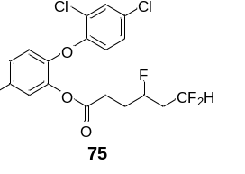
5-Chloro-2-(2,4-dichlorophenoxy)phenyl 4,6,6-trifluorohexanoate (75): 28.5 mg colorless liquid was isolated, yield: 32%. ¹H NMR (400 MHz, DMSO-d₆) δ 7.76 (d, J = 2.4 Hz, 1H), 7.51 (d, J = 2.4 Hz, 1H), 7.39 (td, J = 9.1, 2.5 Hz, 2H), 7.12 (d, J = 8.8 Hz, 1H), 6.97 (d, J = 8.8 Hz, 1H), 6.16 (tt, J = 56.1, 4.6 Hz, 1H), 4.89 – 4.67 (m, 1H), 2.64 (t, J = 7.5 Hz, 2H), 2.32 – 2.06 (m, 2H), 2.02 – 1.83 (m, 2H). ¹³C NMR (101 MHz, DMSO-d₆) δ 170.15, 150.66, 146.21, 141.47, 130.09, 128.81, 128.50, 128.28, 127.39, 124.63, 124.56, 121.20, 120.46, 115.79 (dt, J = 4.5, 237.3 Hz), 88.15 (dt, J = 167.5, 6.8 Hz), 29.61, 29.40, 28.66 (d, J = 4.6 Hz). ¹⁹F NMR (376 MHz, DMSO-d₆) δ -115.70 (dd, J = 12.4, 3.5 Hz, 2F), -183.53 (t, J = 3.5 Hz, 1F). HRMS (ESI) exact mass calculated for [C₁₈H₁₄Cl₃F₃O₃Na⁺]: 462.9853, found 462.9852.
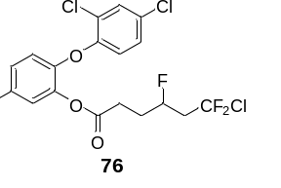
5-Chloro-2-(2,4-dichlorophenoxy)phenyl 6-chloro-4,6,6-trifluorohexanoate (76): 55.8 mg colorless liquid was isolated, yield: 59%. ¹H NMR (400 MHz, DMSO-d₆) δ 7.73 (d, J = 2.5 Hz, 1H), 7.49 (d, J = 2.5 Hz, 1H), 7.37 (ddd, J = 10.6, 8.9, 2.6 Hz, 2H), 7.08 (d, J = 8.8 Hz, 1H), 6.96 (d, J = 8.8 Hz, 1H), 5.01 – 4.76 (m, 1H), 2.98 – 2.78 (m, 2H), 2.66 (t, J = 7.4 Hz, 2H), 2.06 – 1.83 (m, 2H). ¹³C NMR (101 MHz, DMSO-d₆) δ 170.28, 150.73, 146.40, 141.55, 130.22, 128.93, 128.72, 128.57 (t, J = 292.9 Hz), 128.40, 127.54, 124.86, 124.64, 121.17, 120.68, 87.90 (dt, J = 171.6, 3.3 Hz), 45.39 (td, J = 23.2, 21.0 Hz), 29.27 (d, J = 20.6 Hz), 28.59 (d, J = 4.6 Hz). ¹⁹F NMR (376 MHz, DMSO-d₆) δ -46.48 – -48.87 (m, 2F), -183.61 (t, J = 9.9 Hz, 1F). HRMS (ESI) exact mass calculated for [C₁₈H₁₃Cl₄F₃O₃H⁺]: 474.9644, found 474.9652.
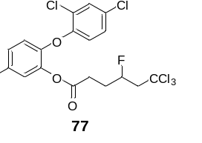
5-Chloro-2-(2,4-dichlorophenoxy)phenyl 6,6,6-trichloro-4-fluorohexanoate (77): 50.3 mg colorless liquid was isolated, yield: 50%. ¹H NMR (400 MHz, Chloroform-d) δ 7.46 (d, J = 2.4 Hz, 1H), 7.23 – 7.14 (m, 3H), 6.86 (dd, J = 15.7, 8.7 Hz, 2H), 5.11 – 4.92 (m, 1H), 3.18 (ddd, J = 19.1, 15.6, 6.9 Hz, 1H), 2.91 (ddd, J = 25.6, 15.6, 2.3 Hz, 1H), 2.73 (t, J = 7.1 Hz, 2H), 2.14 – 2.00 (m, 2H). ¹³C NMR (101 MHz, Chloroform-d) δ 170.10, 150.92, 146.67, 141.59, 130.56, 129.74, 129.36, 128.31, 127.25, 126.02, 124.41, 120.51, 120.17, 96.12, 89.30 (d, J = 175.3 Hz), 59.41 (d, J = 22.4 Hz), 30.52 (d, J = 21.4 Hz), 29.18 (d, J = 4.4 Hz). ¹⁹F NMR (376 MHz, Chloroform-d) δ -180.68 (s, 1F). HRMS (ESI) exact mass calculated for [C₁₈H₁₃Cl₆FO₃Na⁺]: 528.8872, found 528.8871.
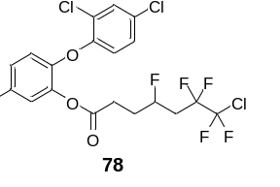
5-Chloro-2-(2,4-dichlorophenoxy)phenyl 7-chloro-4,6,6,7,7-pentafluoroheptanoate (78): 68.5 mg colorless liquid was isolated, yield: 65%. ¹H NMR (400 MHz, DMSO-d₆) δ 7.74 (d, J = 2.5 Hz, 1H), 7.50 (d, J = 2.6 Hz, 1H), 7.38 (ddd, J = 11.4, 8.8, 2.6 Hz, 2H), 7.09 (d, J = 8.8 Hz, 1H), 6.98 (d, J = 8.8 Hz, 1H), 5.09 – 4.86 (m, 1H), 2.79 – 2.53 (m, 4H), 2.13 – 1.88 (m, 2H). ¹³C NMR (101 MHz, DMSO-d₆) δ 170.12, 150.62, 146.29, 141.45, 130.07, 128.77, 128.57, 128.25, 127.36, 124.74, 124.52, 123.11 (tt, J = 37.4, 298.0 Hz), 121.03, 120.55, 116.42 (tt, J = 33.5, 257.6 Hz), 86.53 (tt, J = 172.2, 2.5 Hz), 34.70 (q, J = 21.0 Hz), 29.57 (d, J = 20.4 Hz), 28.55 (d, J = 4.4 Hz). ¹⁹F NMR (376 MHz, DMSO-d₆) δ -71.32 (d, J = 2.4 Hz, 2F), -110.53 – -113.46 (m, 2F), -182.25 – -182.40 (m, 1F). HRMS (ESI) exact mass calculated for [C₁₉H₁₃Cl₄F₅O₃H⁺]: 524.9612, found 524.9628.
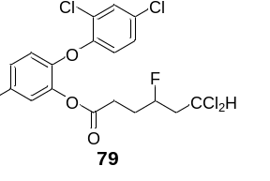
5-Chloro-2-(2,4-dichlorophenoxy)phenyl 6,6-dichloro-4-fluorohexanoate (79): 36.8 mg colorless liquid was isolated, yield: 39%. ¹H NMR (400 MHz, DMSO-d₆) δ 7.76 (d, J = 2.4 Hz, 1H), 7.50 (d, J = 2.5 Hz, 1H), 7.38 (ddd, J = 11.4, 9.0, 2.5 Hz, 2H), 7.10 (d, J = 8.8 Hz, 1H), 6.98 (d, J = 8.8 Hz, 1H), 6.30 (dd, J = 8.8, 4.2 Hz, 1H), 4.86 – 4.63 (m, 1H), 2.65 (t, J = 7.4 Hz, 2H), 2.61 – 2.39 (m, 2H), 2.04 – 1.82 (m, 2H). ¹³C NMR (101 MHz, DMSO-d₆) δ 170.14, 150.63, 146.28, 141.42, 130.08, 128.81, 128.54, 128.22, 127.37, 124.73, 124.50, 121.07, 120.58, 89.79 (d, J = 169.2 Hz), 70.88 (d, J = 4.4 Hz), 47.57 (d, J = 20.2 Hz), 29.05 (d, J = 20.4 Hz), 28.64 (d, J = 4.6 Hz). ¹⁹F NMR (376 MHz, DMSO-d₆) δ -184.75 (s, 1F). HRMS (ESI) exact mass calculated for [C₁₈H₁₄Cl₅FO₃Na⁺]: 494.9262, found 494.9261.

6. Reference
1. Zhang, Y., Torker, S., Sigrist, M., Bregovic, N., Dydio, P. Binuclear Pd(Ⅰ)-Pd(Ⅰ) Catalysis Assisted by Iodide Ligands for Selective Hydroformylation of Alkenes and Alkynes. J. Am. Chem. Soc. 142, 18251-18265 (2020).
2. Ouyang, Y., Xu, X. H., Qing, F. L. Hydrotrifluoromethylthiolation of Unactivated Alkenes and Alkynes with Trifluoromethanesulfonic Anhydride through Deoxygenative Reduction and Photoredox Radical Processes. Angew. Chem. Int. Ed. 58, 18508-18512 (2019).
3. Min S. J. et al. Chemoselective Activities of Fe(Ⅲ) Catalysts in the Hydrofunctionalization of Allenes. Org. Lett. 14, 6262-6265 (2012).

7. Copies of ¹H NMR, ¹³C NMR and ¹⁹F NMR spectra
