Table No.1 Urban axis
NUTS_ID | URBAN AXIS -COUNTRY | LOCATION
RO112-RO113 | Bistrița -Cluj-Napoca Romania | 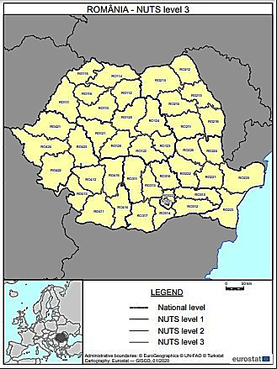
HU321-HU332 | Debrecen-Békéscsaba  Hungary | 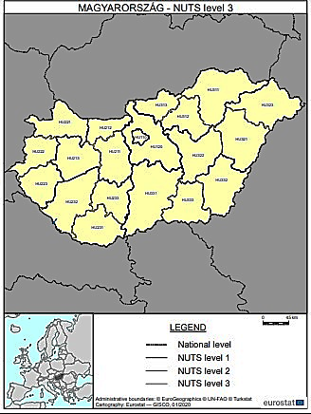
FRB01-FRB03 | Bourges – Chateauroux  France | 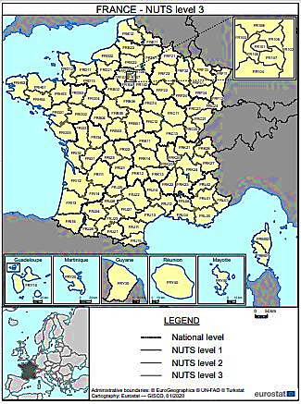
ES220- ES243 | Pamplona -Zaragoza  Spain | 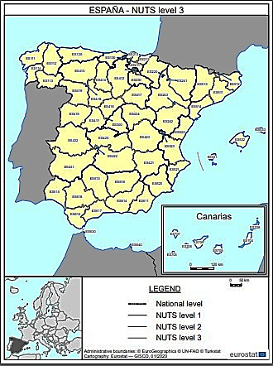
Source: Realized by the author, maps for location were taken from :
https://ec.europa.eu/eurostat/web/nuts/nuts-maps (accessed on 22.02.2023)

Table No.3 Value of Socio-economic Parameters in the Urban Axis
 | Urban Axis | Parameters Values
 | Bistrița -Cluj-Napoca
  The number of residents in the household | 479,851
 | 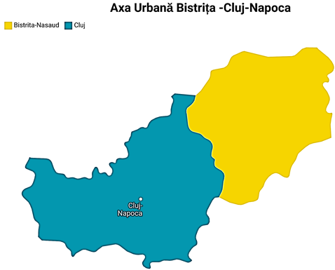  Source: https://www.arcgis.com/
  household type | apartment building
  The size of the dwelling in square meters | 62.776,5
  The number of rooms in the dwelling | 121,982,8
  population density | 241,5
  building density | 249,95
  The number of new efficient dwellings built. | 2.554
  Cost of housing | 91,146
  Rent level | 280
  Cost of housing maintenance | 417,02
  Cost of utilities | 181,45
  Total area in the urban axis | 324,790
  The total population in the urban axis | 399,494

.
Urban Axis | Parameters Values
Debrecen-Békéscsaba
  The number of residents in the household | 429,464
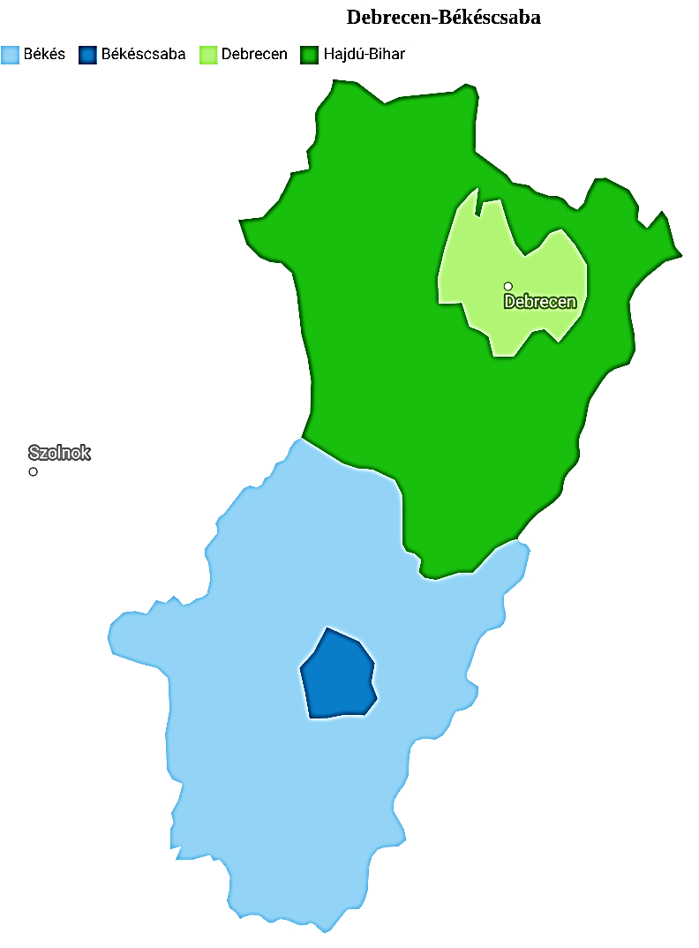  Source: https://www.arcgis.com/
  household type | apartment building
  The size of the dwelling in square meters | 43.084,5
  The number of rooms in the dwelling | 713,490,4
  population density | 492,7
  building density | 250
  The number of new efficient dwellings built. | 1495
  Cost of housing | 157,050
  Rent level | 795,8
  Cost of housing maintenance | 1,190
  Cost of utilities | 108,5
  The total population in the urban axis | 280,432
  Total area in the urban axis | 560,900

Urban Axis | Parameters Values
Bourges – Chateauroux
  The number of residents in the household | 740,015
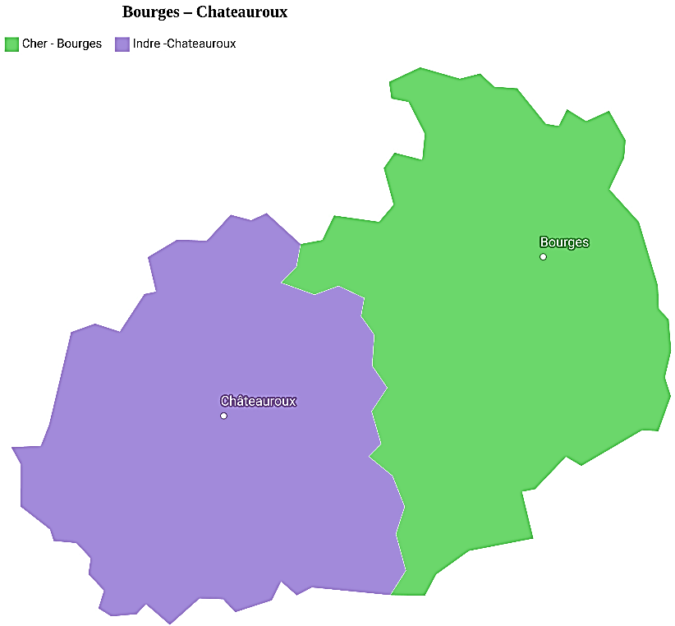  Source: https://www.arcgis.com/
  household type | apartment building
  The size of the dwelling in square meters | 57,964
  The number of rooms in the dwelling | 875,087,98
  population density | 2,055
  building density | 250
  The number of new efficient dwellings built. | 281
  Cost of housing | 228,901
  Rent level | 1,170
  Cost of housing maintenance | 2,160
  Cost of utilities | 213
  The total population in the urban axis | 193,795
  Total area in the urban axis | 94,28

Urban Axis | Parameters Values
Pamplona -Zaragoza
  The number of residents in the household | 1,305,432
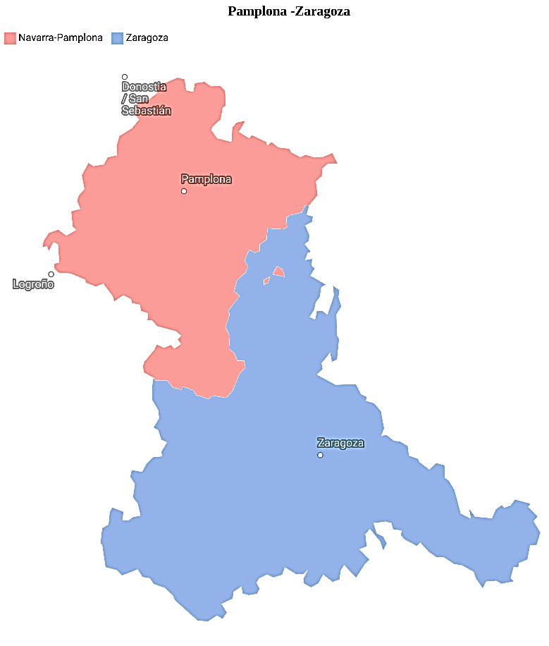  Source: https://www.arcgis.com/
  household type | apartment building
  The size of the dwelling in square meters | 58,567
  the number of rooms in the dwelling. | 1,456,069
  population density | 4,399
  building density | 249,9
  The number of new efficient dwellings built. | 840
  Cost of housing | 410,650
  Rent level | 1,149
  Cost of housing maintenance | 2,225
  Cost of utilities | 226
The total population in the urban axis | 885,026
Total area in the urban axis | 998,94

Source: Realised by the authors

