Supplementary Data
A novel biological process for recycling phosphorus from wastewater as fertilizer
Lordina Ekua Eshun^{a*}, Ana Maria García-López^{b}, Ramiro Recena Garrido^{b}, Victoria Cokerª, Jonathan Lloydª, Samuel Shawª, Antonio Delgado^{b}.

ªUniversity of Manchester, Department of Earth and Environmental Sciences, Geomicrobiology Group, Williamson Building, M13 9QQ, Oxford Road, Manchester, UK

^{b}University of Seville, Agronomy Department, ETSIA, Ctra. Utrera km 1, 41013 Sevilla, Spain

ªlordina.eshun@manchester.ac.uk; ^{b}agarcia14@us.es; ^{b}rrecena@us.es; ªvicky.coker@manchester.ac.uk; ªjon.lloyd@manchester.ac.uk; ªsam.shaw@manchester.ac.uk; ^{b}adelgado@us.es.

* Corresponding author: Phone: +447309452965; e-mail: lordina.eshun@manchester.ac.uk

Soil properties
Soils were sampled in different locations in Spain (alfisol: 37º 32´03´´ N, 06º 13´22´´ W, vertisol: 37º 24´03´´ N, 05º 35´15´´ W), showing different soil properties (Table S1).

Table S1: Soil properties used in the growth experiments
Soil properties | Unit | Alfisol¹ | Vertisol²
Clay | g kg⁻¹ | 150 | 502
SOC | g kg⁻¹ | 4.5 | 10
CaCO_{3 eq} | g kg ⁻¹ | 33 | 28
Olsen P | mg kg ⁻¹ | 3.4 | 6.6
pH |  | 8.3 | 8.0
CEC | cmol_{c} kg ⁻¹ | 10.4 | 44.1
SOC, soil organic carbon; CEC, exchangeable capacity
¹Alfisol was used for the Fe experiment with white lupin
²Vertisol was used for the P experiment with durum wheat

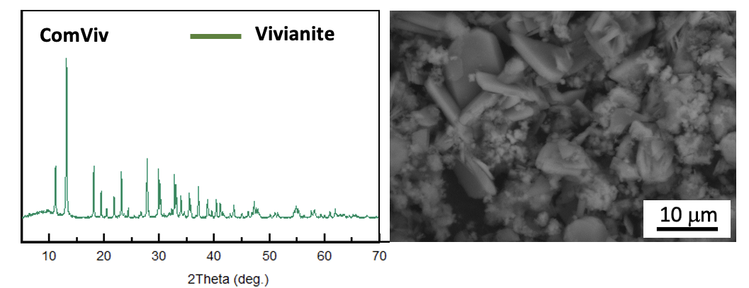
XRD and SEM image of the synthesized vivianite used (ComViv)

Fig. S1: XRD diffractogram and SEM image of the chemically synthesized vivianite (ComViv) showing vivianite as the main mineral.

Crystallite size calculation
The Scherrer formula was used to calculate the crystallite size of the vivianite used in this study.

L = λK /β.COS(θ)………… Eq. S1

L is the average crystallite size in nm (ordered crystalline domain), λ is the X-ray wavelength (0.15406 nm), K is the Scherrer constant (range between 0.8 – 1.2, K = 0.89), β is the Full Width at Half Maximum (FWHM) (Line broadening in radians) and Theta is the Bragg angle in radians.
Fe and P concentrations in the roots and shoots of white lupin and wheat
Table S2: Amounts of P and Fe in the shoot and roots of White lupin (A) and wheat (B) respectively.
(A) |  | White lupin
Treatments (Fe source) | Fe in root | P in shoot | P in root | Total P uptake
 | mg/pot | mg/pot | mg/pot | mg/kg
Fe(II)-sulfate | 1.53 ± 0.97 abc | 0.23 ± 0.06 ab | 0.25 ± 0.08 a | 0.48 ± 0.13 a
No Fe | 0.07 ± 0.04 c | 0.20 ± 0.02 b | 0.19 ± 0.02 a | 0.39 ± 0.04 a
Fe-EDDHA | 2.29 ± 0.63 abc | 0.24 ± 0.04 ab | 0.15 ± 0.03 a | 0.39 ± 0.04 a
VivSol | 0.96 ± 0.56 bc | 0.29± 0.05 ab | 0.29 ± 0.06 a | 0.58 ± 0.08 a
VivInsol6.5 | 0.69 ± 0.62 c | 0.32 ± 0.04 ab | 0.24 ± 0.06 a | 0.57 ± 0.10 a
VivInsol7.0 | 4.76 ± 1.01 a | 0.24 ± 0.04 ab | 0.29 ± 0.05 a | 0.52 ± 0.05 a
ComViv | 4.04 ± 0.86 ab | 0.45 ± 0.09 a | 0.23 ± 0.05 a | 0.67 ± 0.09 a

(B) |  |  | Durum wheat
Treatments (P source) |  | P in root |  | Fe in shoot |  | Fe in root |  | Total Fe uptake
 |  | mg/pot |  | mg/pot |  | mg/pot |  | mg/kg
KH₂PO₄ |  | 0.09 ± 0.03 c |  | 0.05 ± 0.00 ab |  | 0.32 ± 0.05 c |  | 0.37 ± 0.05 c
No P |  | 0.35 ± 0.01 a |  | 0.02 ± 0.00 b |  | 1.05 ± 0.17 ab |  | 1.06 ± 0.17 ab
VivSol |  | 0.23 ± 0.02 b |  | 0.07 ± 0.01 a |  | 0.69 ± 0.10 bc |  | 0.76 ± 0.10 bc
VivInsol6.5 |  | 0.16 ± 0.03 bc |  | 0.06 ± 0.02 ab |  | 0.56 ± 0.1 bc |  | 0.62 ± 0.10 bc
VivInsol7.0 |  | 0.17 ± 0.02 bc |  | 0.03 ± 0.00 ab |  | 1.07 ± 0.21 ab |  | 1.10 ± 0.20 ab
ComViv |  | 0.22 ± 0.02 b |  | 0.03 ± 0.0 ab |  | 1.51 ± 0.22 a |  | 1.54 ± 0.22 a
Means with different letters for both tables are significantly different according to the Tukey test at a probability of 0.05.

Enzymatic activities for white lupin and durum wheat
Table S3: Enzymatic activities measured at harvest using soils from lupin (A) and wheat (B).
(A) White lupin
 |  | Alkaline Phosphatase |  | Acid Phosphatase
Treatments |  | (mg pnp/kg soil h) |  | (mg pnp/kg soil h)
VivInsol6.5 |  | 360.869 | ± 7.98 | 236.745 | ± 11.24
VivSol |  | 371.311 | ± 9.36 | 207.168 | ± 35.79
Fe(II)-sulfate |  | 372.310 | ± 11.25 | 222.467 | ± 34.67
No Fe |  | 364.971 | ± 16.23 | 201.353 | ± 22.99
VivInsol7.0 |  | 349.141 | ± 6.61 | 217.887 | ± 42.67
ComViv |  | 372.018 | ± 8.23 | 274.398 | ± 36.32
Fe-EDDHA |  | 371.587 | ± 10.76 | 151.902 | ± 15.48

(B) Durum wheat
 |  | Alkaline Phosphatase |  | Acid Phosphatase
Treatments |  | (mg pnp/kg soil h) |  | (mg pnp/kg soil h)
VivInsol6.5 |  | 246.374 | ± 7.66 | 88.205 | ± 2.01
VivSol |  | 273.103 | ± 10.52 | 91.653 | ± 1.91
KH₂PO₄ |  | 281.244 | ± 7.78 | 101.925 | ± 9.67
No P |  | 267.397 | ± 5.62 | 98.859 | ± 13.28
VivInsol7.0 |  | 264.054 | ± 9.67 | 90.926 | ± 8.32
ComViv |  | 267.139 | ± 3.69 | 109.010 | ± 5.93

There was no statistically significant difference between the treatments according to Tukey test at a probability of 0.05.

DTPA extracted Fe and Olsen P from the soils after harvest.
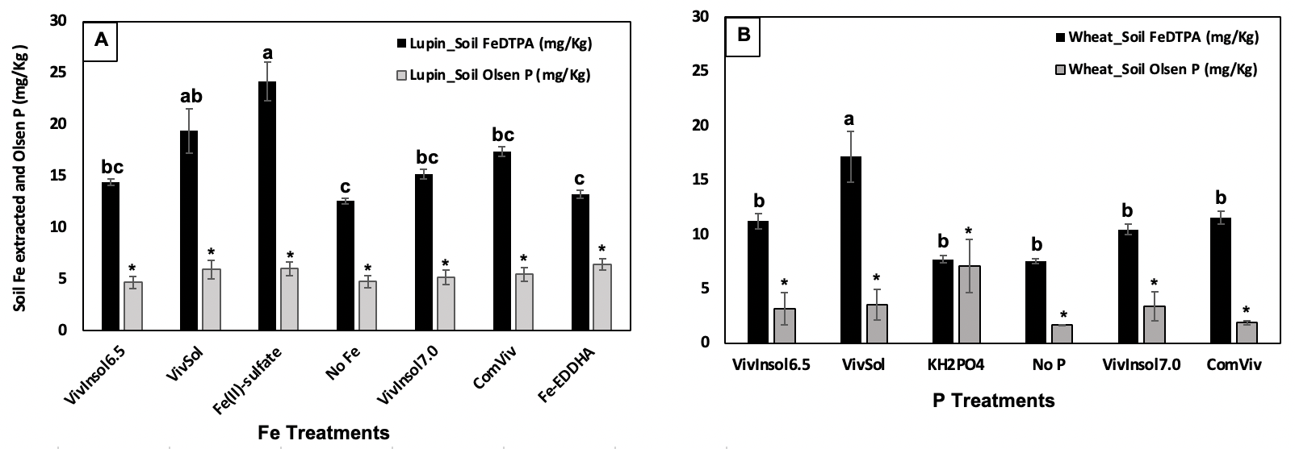
Fig. S2: Soil Fe_{DTPA} extracted and Olsen P from white lupin (A) and Wheat (B). Data points with different letters are significantly different according to the Tukey test at a probability of 0.05. Data points with * are not statistically significant at a probability level of 0.05.

Correlation coefficient for both white lupin and wheat
Table S4: Correlation coefficient between chlorophyll content of leaves and the Fe concentration in the shoot
Correlation Coefficient (r) | White lupin |  | Durum wheat
Correlation Coefficient (r) | [Chl] vs. Fe in Shoot | [Chl] vs. total Fe uptake | [Chl] vs. Fe in Shoot for wheat | [Chl] vs. total Fe uptake
No Fe/ No P | - 0.59 | - 0.61 | - 0.21 | 0.20
Fe(II)-sulfate/ KH₂PO₄ | - 0.49 | - 0.09 | - 0.47 | - 0.67
ComViv | 0.02 | 0.47 | - 0.87 | 0.66
VivSol | 0.50 | 0.75 | - 0.67 | 0.09
VivInsol6.5 | 0.88 | - 0.35 | 0.41 | 0.82
VivInsol7.0 | - 0.52 | - 0.57 | 0.39 | 0.58
Fe-EDDHA | 0.00 | - 0.07
Chlorophyll concentration of white lupin = 0.2 exp (0.04 SPAD) [1]; Chlorophyll concentration of wheat = SPAD/136 [2].

Summary of ANOVA
Table S5: A summary of an analysis of the variance of several parameters of white lupin (A) and wheat (B) for all treatments studied.
 | (A). White lupin
 | ρ value
 | SPAD at 28DAT | Biomass |  | Fe Concentration |  | Total Fe uptake | Enzyme activity |  | Olsen P | Fe_DTPA
 |  | Aerial part | Root | Aerial part | Root |  | Alkaline phosphatase | Acid phosphatase
Treatments | 0.1887 | 0.5146 | 0.3806 | 0.0849 | 0.0006 | 0.0063 | 0.6681 | 0.2200 | 0.4820 | 0.0000

 | (B). Durum wheat
 | ρ value
 | SPAD at 34DAT | Biomass |  | P Concentration |  | Total P uptake | Enzyme activity |  | Olsen P | Fe_DTPA
 |  | Aerial part | Root | Aerial part | Root |  | Alkaline phosphatase | Acid phosphatase
Treatments | 0.0001 | 0.0000 | 0.0000 | 0.0000 | 0.0000 | 0.0000 | 0.0887 | 0.4461 | 0.1349 | 0.0000

References
- de Santiago A, Delgado A. Predicting Iron Chlorosis of Lupin in Calcareous Spanish soils from Iron Extracts. Soil Science Society of America Journal. 2006;70(6):1945 - 50.
- de Santiago A, Quintero JM, Avilés M, Delgado A. Effect of Trichoderma asperellum strain T34 on iron, copper, manganese, and zinc uptake by wheat grown on a calcareous medium. Plant and Soil. 2011;342(1-2):97-104.

