Supporting Information
Unveiling Intrinsic Charge Transfer Dynamics in "Bone-joint" S-Scheme Heterostructures for Promoting Photocatalytic Hydrogen Peroxide Generation
Yuhui Liu¹, Xiaoxu Deng², Meiyang Song¹, Henghui Song¹, Yi Wang¹, Peng Chen^{1,} *, Shuang-Feng Yin^{3,} *
¹Provincial Guizhou Key Laboratory of Green Chemical and Clean Energy Technology, School of Chemistry and Chemical Engineering, Guizhou University, Guiyang 550025, Guizhou, China.
2School of Electronics and Information Engineering, Guiyang University, Guiyang, Guizhou 550025, China.
³College of Chemistry and Chemical Engineering, Advanced Catalytic Engineering Research Center of the Ministry of Education, State Key Laboratory of Chemo/Biosensing and Chemometrics, Hunan University, Changsha 410082, PR China; College of Science, Central South University of Forestry and Technology, Changsha 410004, P.R. China.
# These authors contributed equally to this work
* Correspondence: pchen3@gzu.edu.cn; sf_yin@hnu.edu.cn
Supplementary Table 1 AQY of photocatalytic production of H₂O₂.
Wavelength (nm) | 405 | 420 | 450 | 500 | 520 | 550 | 575 | 600
H₂O₂ yield rate  (10⁻⁹ mol s⁻¹) | 30.57 | 25.81 | 31.16 | 22.84 | 17.50 | 10.96 | 5.02 | 2.05
Light intensity  (W m⁻²) | 144.93 | 112.80 | 222.54 | 382.91 | 301.86 | 368.93 | 503.70 | 289.93
Irradiation area (10⁻⁴ m²) | 18.47 | 18.47 | 18.47 | 18.47 | 18.47 | 18.47 | 18.47 | 18.47
AQY (%) | 6.77 | 7.08 | 4.04 | 1.55 | 1.45 | 0.70 | 0.23 | 0.15

Supplementary Table 2. Zn and In contents of prepared samples based on ICP-MS Results.
Catalyst | Zn / ωt% | In / ωt% | Mole ratio of Zn:In | Ideal mole ratio of Zn:In
ZnIn₂S₄ | 10.21 | 34.68 | 0.52 | 0.50
ZIS-1 | 12.88 | 30.68 | 0.74 | 0.75
ZIS-2 | 13.78 | 29.32 | 0.82 | 0.83
ZIS-3 | 14.04 | 28.95 | 0.85 | 0.88
ZIS-4 | 14.57 | 28.15 | 0.91 | 0.90
ZIS-5 | 14.67 | 27.99 | 0.92 | 0.92
Zn₂In₂S₅ | 15.5 | 26.75 | 1.02 | 1.00

Supplementary Table 3. Element molar ratio of the prepared samples calculated by XPS.
Catalyst | S / % | In / % | Zn / %
ZnIn₂S₄ | 34.49 | 17.94 | 8.75
Zn₂In₂S₅ | 32.78 | 15.74 | 14.62
ZIS-2 | 26.84 | 17.66 | 12.25
ZIS-R | 28.76 | 17.98 | 10.23

Supplementary Table 4. Comparison of different catalysts for photocatalytic produce H₂O₂.
Entry | Catalyst | Reaction condition | H₂O₂ production (μmol·g_{cat}⁻¹·h⁻¹) | Reference
1 | MIL-125-NH₂ | O₂/water | 1111 | ¹
2 | MIL-125-PDI | O₂/water | 4800 | ¹
3 | RF523@333 K | O₂/water | ~80 | ²
4 | Cd_{0.5}Zn_{0.5}S | air/water | 152 | ³
5 | PEI/C₃N₄ | O₂/water | 208 | ⁴
6 | α-Fe₂O₃/CQD@g-C₃N₄ | O₂/water | 139 | ⁵
7 | CTF-BDDBN | O₂/water | 887 | ⁶
8 | MIL-111/001 | O₂/water | 917 | ⁷
9 | TiO₂/PEI/AgNP | air/water | 1605 | ⁸
10 | NMT400 | O₂/water | 271 | ⁹
11 | ORP/GCN | O₂/water | 4167 | ¹⁰
12 | CDA300 | air/water | 557 | ¹¹
13 | Bpy-TAPT | O₂/water | 4038 | ¹²
14 | Bpt-CTF | O₂/water | 3268 | ¹³
15 | HTCC | O₂/water | 1160 | ¹⁴
16 | Furan-BILP | O₂/water | 2200 | ¹⁵
17 | CdS NRs | O₂/water | 5132 | ¹⁶
18 | C₃N_{5−x}-CN | O₂/water | 1359 | ¹⁷
19 | Nv–CN–CN | O₂/water | 137 | ¹⁸
20 | This work | O₂/water | 5939 | -

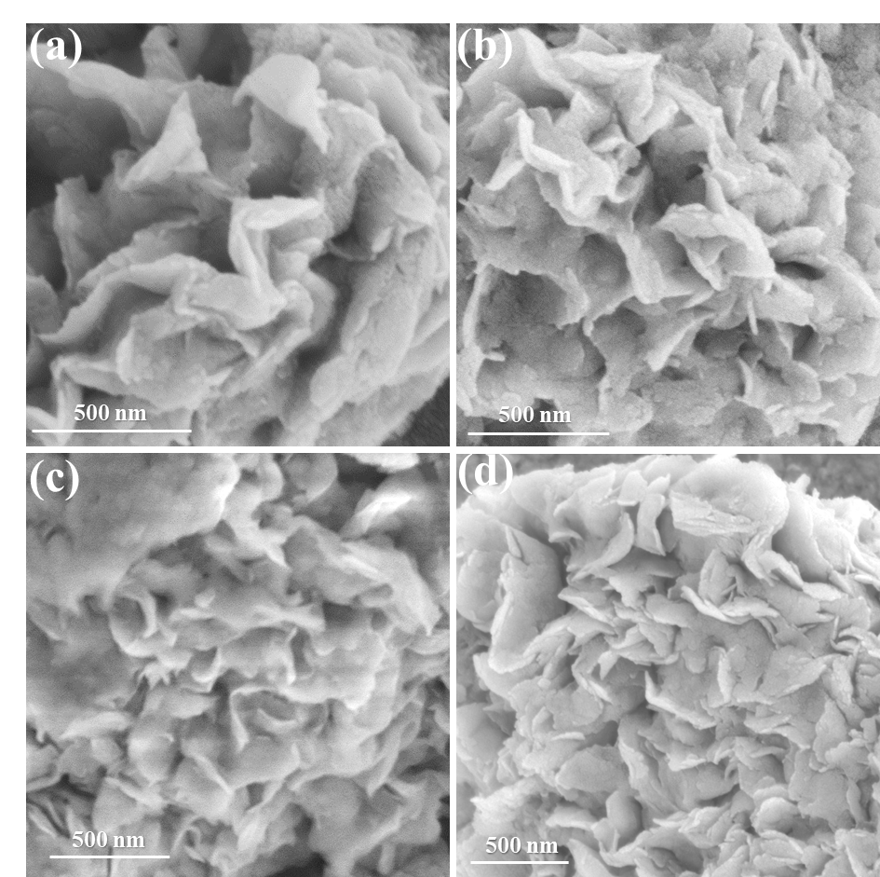
Supplementary Fig. 1. SEM images of (a) ZnIn₂S₄, (b) Zn₂In₂S₅, (c) ZIS-R, and (d) ZIS-2.
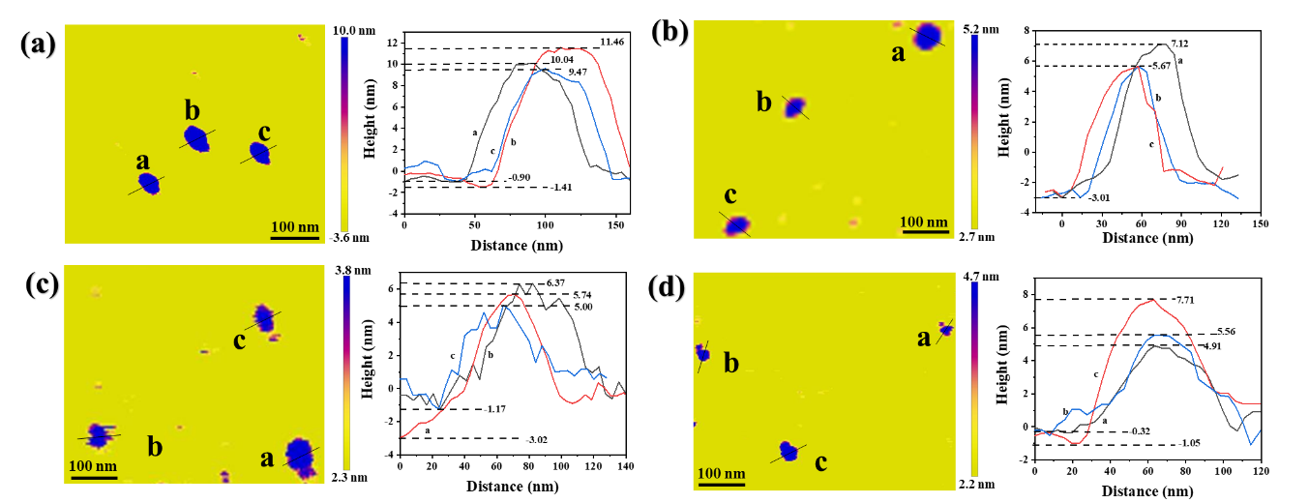
Supplementary Fig. 2. AFM height images and corresponding height profiles of (a) ZnIn₂S₄, (b) Zn₂In₂S₅, (c) ZIS-R, (d) ZIS-2.
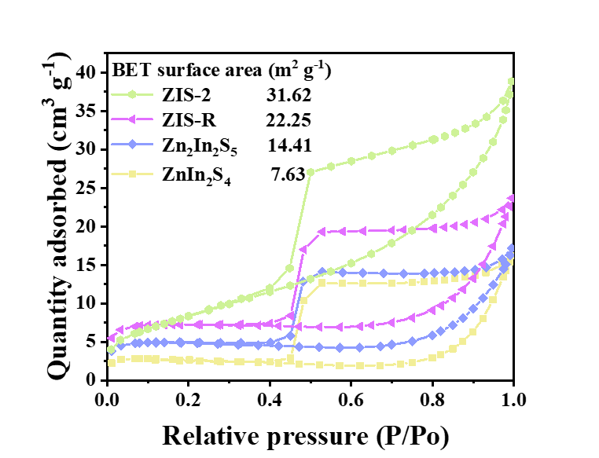
Supplementary Fig. 3. The N₂ adsorption-desorption isotherms of ZnIn₂S₄, Zn₂In₂S₅, ZIS-R, and ZIS-2.
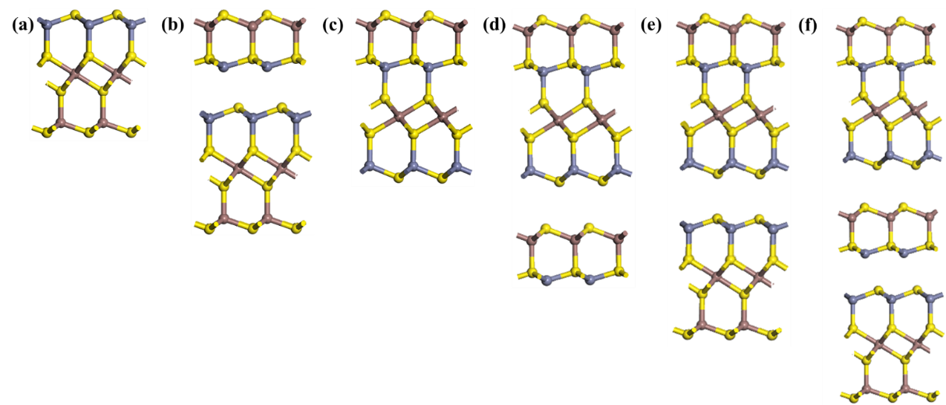
Supplementary Fig. 4. The molecular models of (a) ZnIn₂S₄, (b) ZnIn₂S₄-(006), (c) Zn₂In₂S₅, (d) Zn₂In₂S₅-(006), (e) ZIS-R, and (f) ZIS.
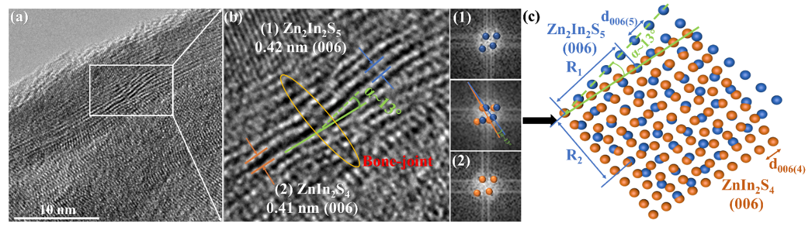
Supplementary Fig. 5. Another schematic model based on the observed HR-TEM image. The filled-blue and filled-red circles are the atoms of Zn₂In₂S₅ and ZnIn₂S₄, respectively.
According to the HRTEM image, the angle between the normal vectors of the Zn₂In₂S₅ (006) plane and the ZnIn₂S₄ (006) plane is about 13°. Therefore, we construct cubic lattices and rotate them by α angle. We then observe that the atoms in these lattices can be matched if α = 13°, which is consistent with our observation. Our model suggests that there is still a small mismatch between the two lattices due to interatomic distances and different crystal symmetries. The mismatches are along the (006) planes of Zn₂In₂S₅ and ZnIn₂S₄, respectively: (I) Two and six cations of Zn₂In₂S₅ and ZnIn₂S₄ can be matched that shows by (i.e. 1R₁ || 5d₀₀₆₍₄₎ blocks), and (II) The five and two cations of Zn₂In₂S₅ and ZnIn₂S₄ can be matched that shows by (i.e. 4d₀₀₆₍₅₎ || 1R₂ blocks), where and are the dimensionless mismatches, and block means the interatomic distance. Here,
${\text{δ}}_{\text{1}}\text{ = }\left|\text{1 - }\frac{\text{1}{\text{R}}_{\text{1}}}{\text{5}{\text{d}}_{\text{006(4)}}}\right|$ and ${\text{δ}}_{\text{2}}\text{ =}\left|\text{1 - }\frac{\text{4}{\text{d}}_{\text{006(5)}}}{\text{1}{\text{R}}_{\text{2}}}\right|$,
where and are the interatomic distance of the cations in the corresponding planes, respectively.
$R_{1}=\sqrt{{(4d_{006(5)})}^{2} + {(1d_{006(5)})}^{2}}$ and $R_{2}=\sqrt{{(5d_{006(4)})}^{2} + {(1d_{006(4)})}^{2}}$.
Our calculations display that δ₁ = 0.16 and δ₂ = 0.20.
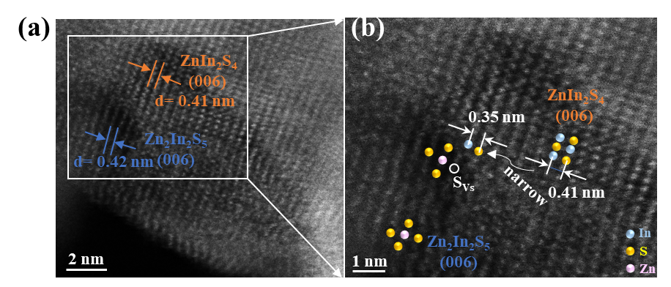
Supplementary Fig. 6. HAADF-STEM at the phase interface in ZIS-2.
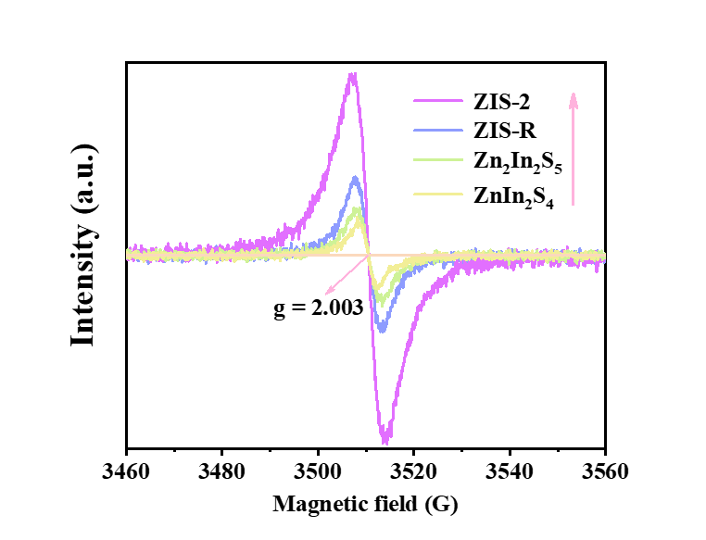
Supplementary Fig. 7. EPR spectra of ZnIn₂S₄, Zn₂In₂S₅, ZIS-R, and ZIS-2.
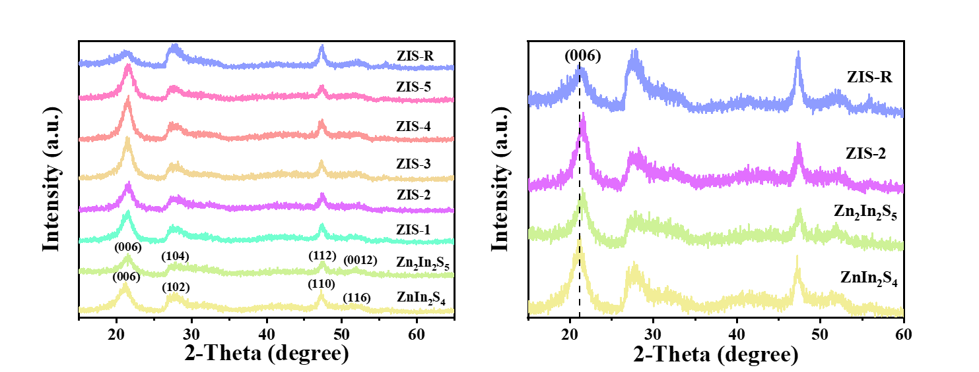
Supplementary Fig. 8. XRD patterns of ZnIn₂S₄, Zn₂In₂S₅, ZIS-R, and ZIS.
As shown in Supplementary Fig. 8, the crystallographic structures of the as-obtained samples were analyzed by X-ray diﬀraction. The XRD patterns of ZnIn₂S₄, Zn₂In₂S₅ and ZIS composites present similar profiles, which are ascribed to the analogous repeating structural unit.¹⁹ As seen, pure ZnIn₂S₄ exhibits diffraction peaks at 2θ = 21.1º, 27.7º, 47.5º, and 52.4º, which are indexed to (006), (102), (110), and (116) structural planes of the hexagonal ZnIn₂S₄ respectively (JCPDS No.65-2023).²⁰ In addition, pure Zn₂In₂S₅ presents diffraction peaks at 2θ = 21.3 º, 27.9 º, 47.5 º, and 51.7 º, which belong to the (006), (102), (112), and (0012) structural planes of the hexagonal Zn₂In₂S₅ respectively. (PDF No.65-6907).²¹
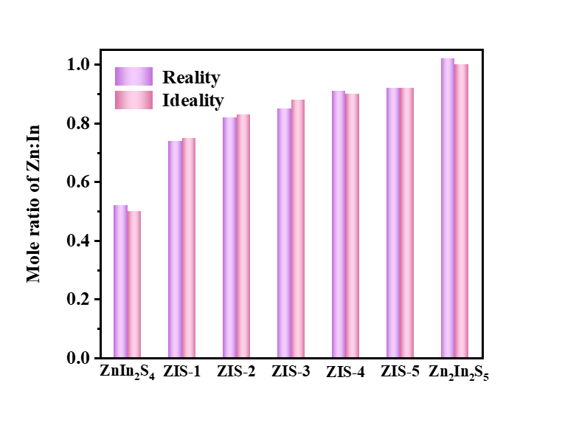
Supplementary Fig. 9. Zn and In contents of prepared samples based on ICP-MS Results.
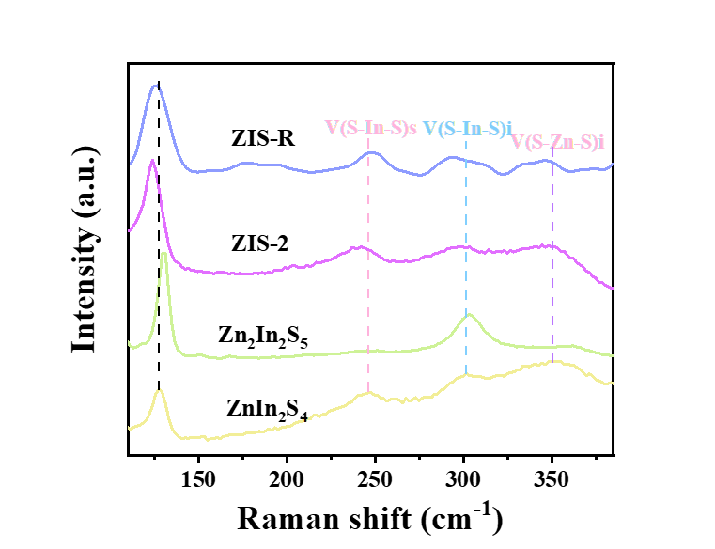
Supplementary Fig. 10. The Raman spectrum of ZnIn₂S₄, Zn₂In₂S₅, ZIS-R and ZIS-2.
The Raman peaks at roughly 128, 247, 302, and 355 cm⁻¹ for the single ZIS can be distinguished clearly, which is consistent with the featured layer structure, LO₁, TO₂, and LO₂ modes of ZIS, and are associated to V(S-In-S)s (surface), V(S-In-S)i (interior), and V(S-Zn-S)s (surface), respectively.²² Moreover, the Raman peaks of ZIS shift to a lower wavenumber, which is assigned to the interaction between the "bone joints" of the semicoherent interface.
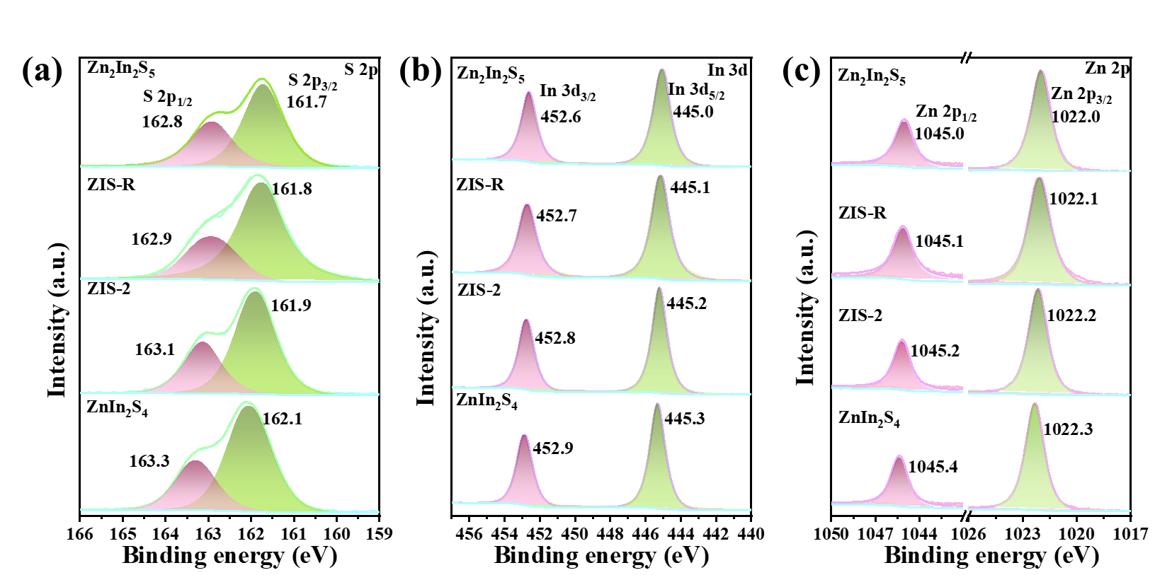
Supplementary Fig. 11. High-resolution XPS spectra of (a) S 2p, (b) In 3d, (c) Zn 2p for ZnIn₂S₄, Zn₂In₂S₅, ZIS-R and ZIS-2.
The Zn 2p, In 3d, and S 2p doublets have been investigated as well in ZnIn₂S₄, Zn₂In₂S₅, ZIS-R, and ZIS-2 (Supplementary Fig. 11), which demonstrates the existence of Zn²⁺, In³⁺, and S²⁻ in both samples.^{23,24} The binding energies of S 2p_{3/2} and S 2p_{1/2} of ZnIn₂S₄, Zn₂In₂S₅, ZIS-R, and ZIS-2 (Supplementary Fig. 11a) are 162.1 and 163.3 eV, 161.7 and 162.8 eV, 161.8 and 162.9 eV, 161.9 and 163.1 eV, respectively. Simultaneously, the binding energies for In 3d_{5/2} and In 3d_{3/2} of ZnIn₂S₄, Zn₂In₂S₅, ZIS-R, and ZIS-2 (Supplementary Fig. 11b) are 445.3 and 452.9 eV, 445.0 and 452.6 eV, 445.1 and 452.7 eV, 445.2 and 452.8 eV, respectively. The Zn 2p_{3/2} and Zn 2p_{1/2} spectrum of ZnIn₂S₄, Zn₂In₂S₅, ZIS-R, and ZIS-2 sample displays two peaks with binding energies of 1022.3 and 1045.4 eV, 1022.0 and 1045.0 eV, 1022.1 and 1045.1 eV, 1022.2 and 1045.2 eV, respectively (Supplementary Fig. 11c). It also demonstrates the feasibility of S-scheme heterojunctions.²⁵
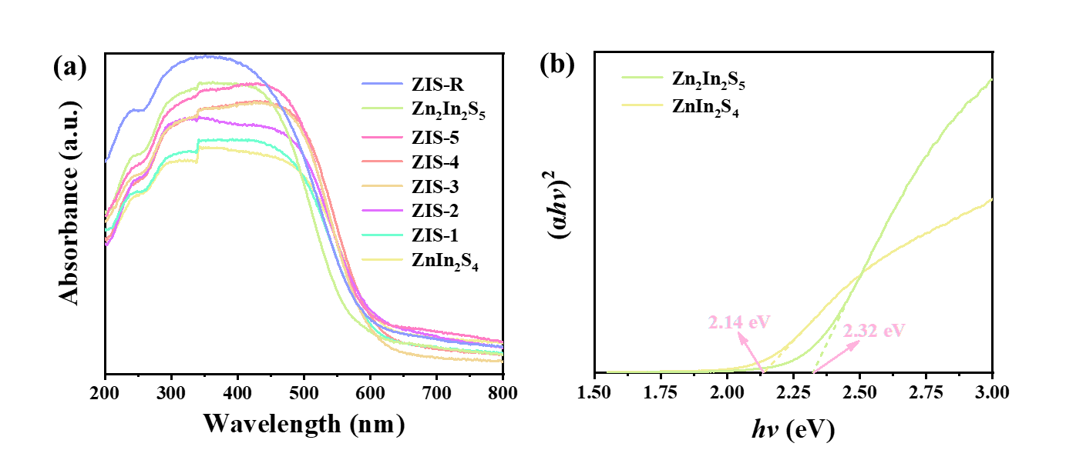
Supplementary Fig. 12. (a) UV-vis diffuse reflectance spectra, and (b) calculated band structure of as prepared samples.
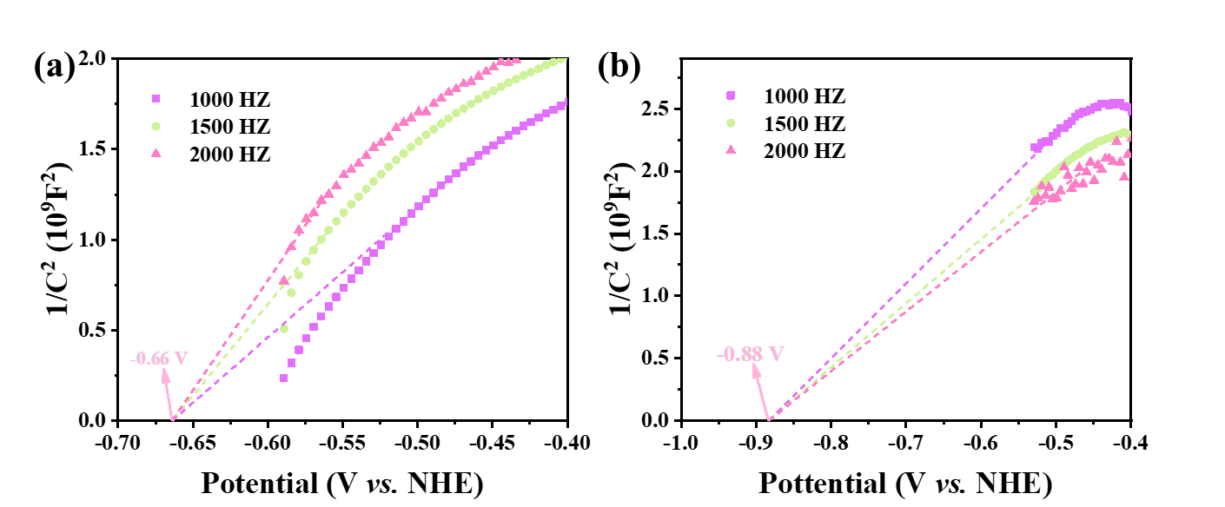
Supplementary Fig. 13. Mott-Schottky plots of fabricated samples: (a) ZnIn₂S₄ and (b) Zn₂In₂S₅.
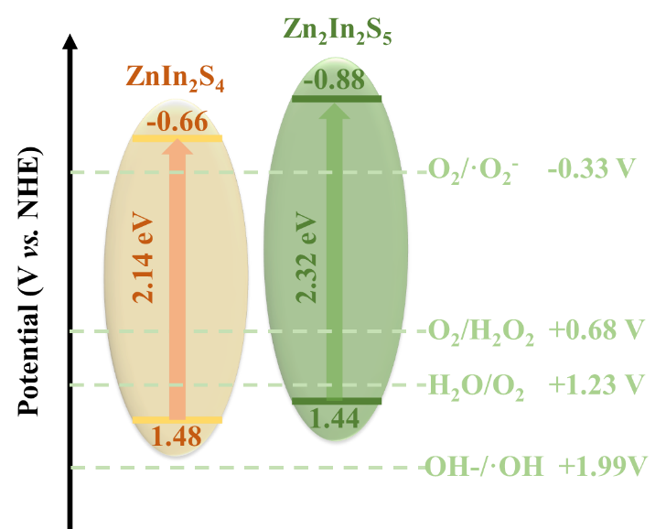
Supplementary Fig. 14. Energy band structure of ZnIn₂S₄ and Zn₂In₂S₅.
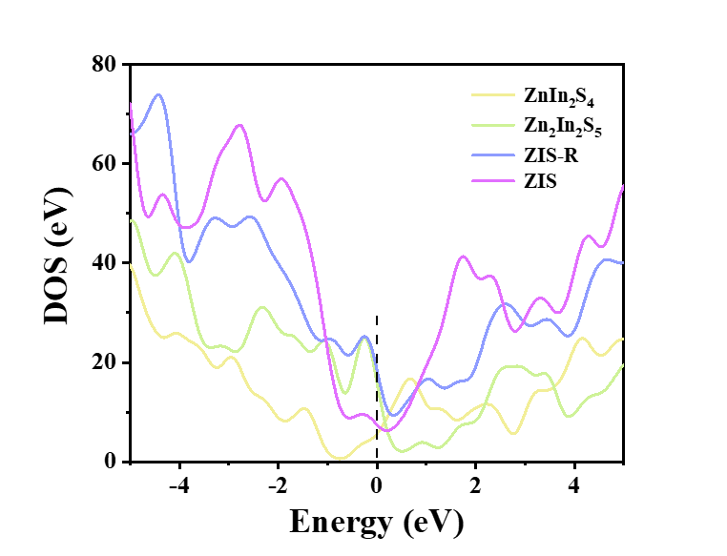
Supplementary Fig. 15. Density of states (DOS) of ZnIn₂S₄, Zn₂In₂S₅, ZIS-R, and ZIS.
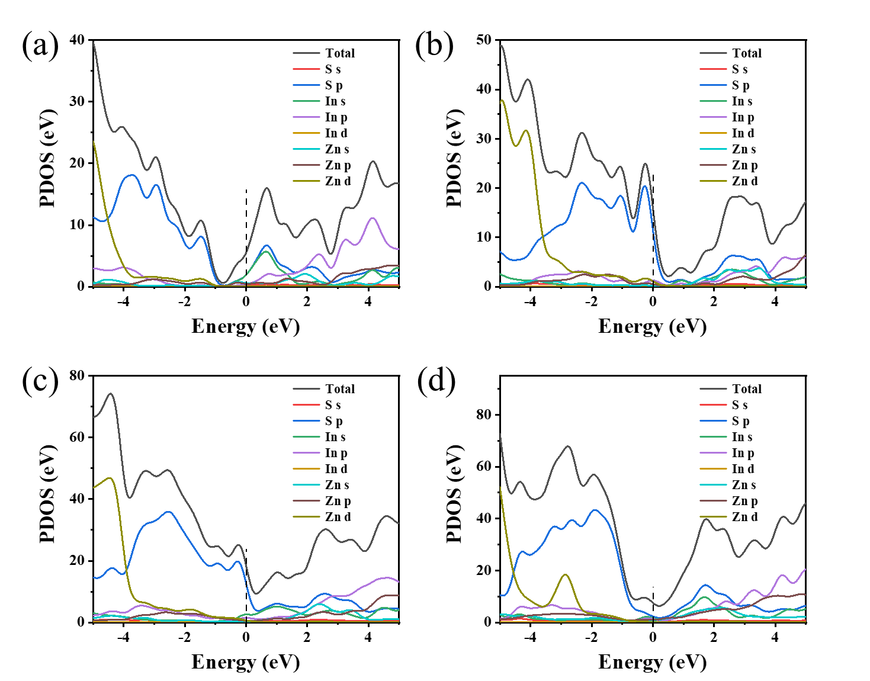
Supplementary Fig. 16. The PDOS of S, In, and Zn element of (a) ZnIn₂S₄, (b) Zn₂In₂S₅, (c) ZIS-R, and (d) ZIS.
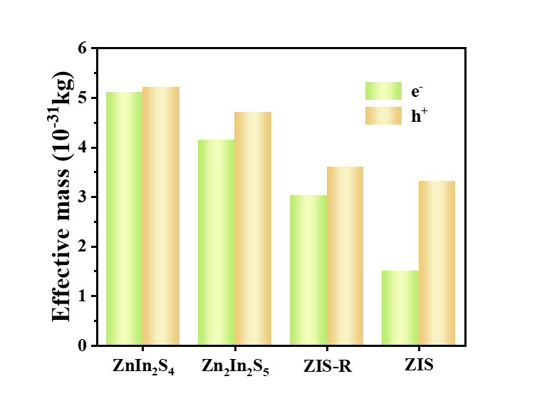
Supplementary Fig. 17. The charge effective mass in the ZnIn₂S₄, Zn₂In₂S₅, ZIS-R, and ZIS.
Carrier effective mass deduced from energy band E-k curves energy band E-k curve. The value of the effective mass depends on the second derivative or curvature near the bottom and top of the energy band. For the conduction band, electrons are generally located near the bottom of the conduction band, while for the valence band, holes are generally located near the top of the valence band. Therefore, we only need to calculate the curvature of the bottom of the conduction band and the top of the valence band to obtain the curvature of the electrons and holes. Mathematically, the data from the E-k curve can be fitted with a quadratic curve E(k) = E₀ + d₁k + d₂k².²⁶ Using the fitted the formula obtained from the fit it is straightforward to obtain the second order differential, i.e. ∂²E/∂k² = 2d₂.
The effective mass is then: $m^{*} = \frac{h^{2}}{{2d}_{2}a^{2}}$
Among them, the energy E unit for the electron volt (eV = 1.602 × 10⁻¹⁹ J), the lattice constant a unit for the Egyptian (10⁻¹⁰ m), Planck's constant is 6.626 × 10⁻³⁴ J·s, the static mass of the electron is 9.108 × 10⁻³¹ kg. Considering that the effective mass is generally expressed in terms of the rest mass of the electron, then the above equation can be transformed into:
$\frac{m^{*}}{m^{0}} = \frac{3.01×{10}^{2}}{{2d}_{2}a^{2}}$
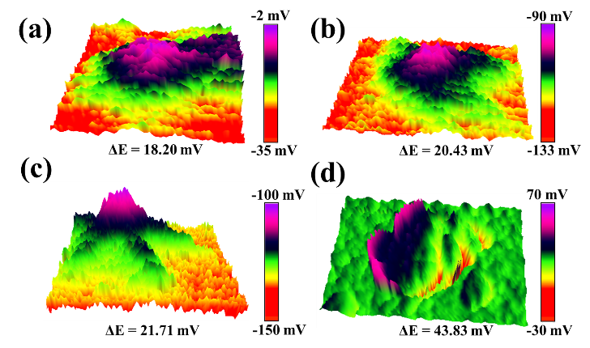
Supplementary Fig. 18. The surface potential was detected with KPFM of (a) ZnIn₂S₄, (b) Zn₂In₂S₅, (c) ZIS-R, and (d) ZIS-2.
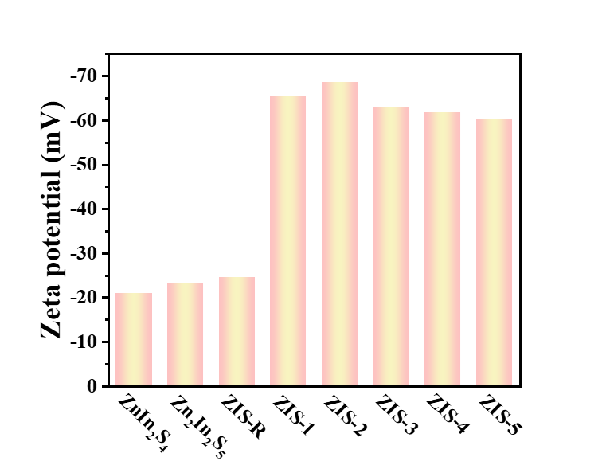
Supplementary Fig. 19. The zeta potential of ZnIn₂S₄, Zn₂In₂S₅, ZIS-R, and ZIS.
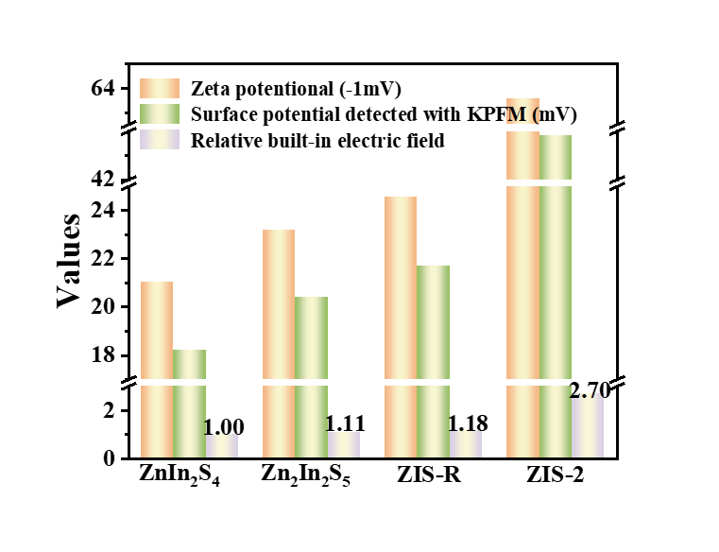
Supplementary Fig. 20. The relative built-in electric field of as prepared samples.
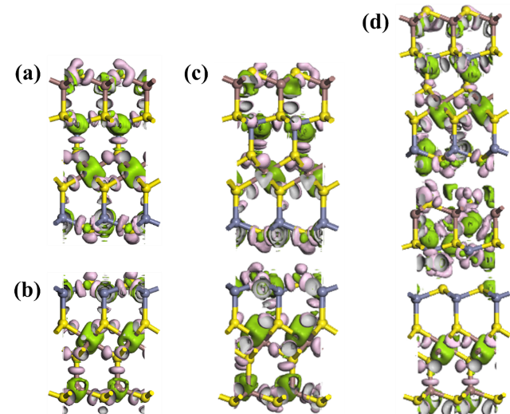
Supplementary Fig. 21. Differential charge density of (a) ZnIn₂S₄, (b) Zn₂In₂S₅, (c) ZIS-R, and (d) ZIS.
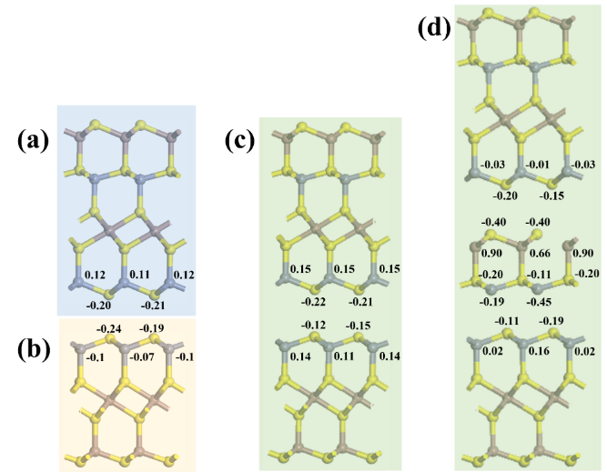
Supplementary Fig. 22. The charge at the active site on the surface of (a) ZnIn₂S₄, (b) Zn₂In₂S₅, (c) ZIS-R, and (d) ZIS.
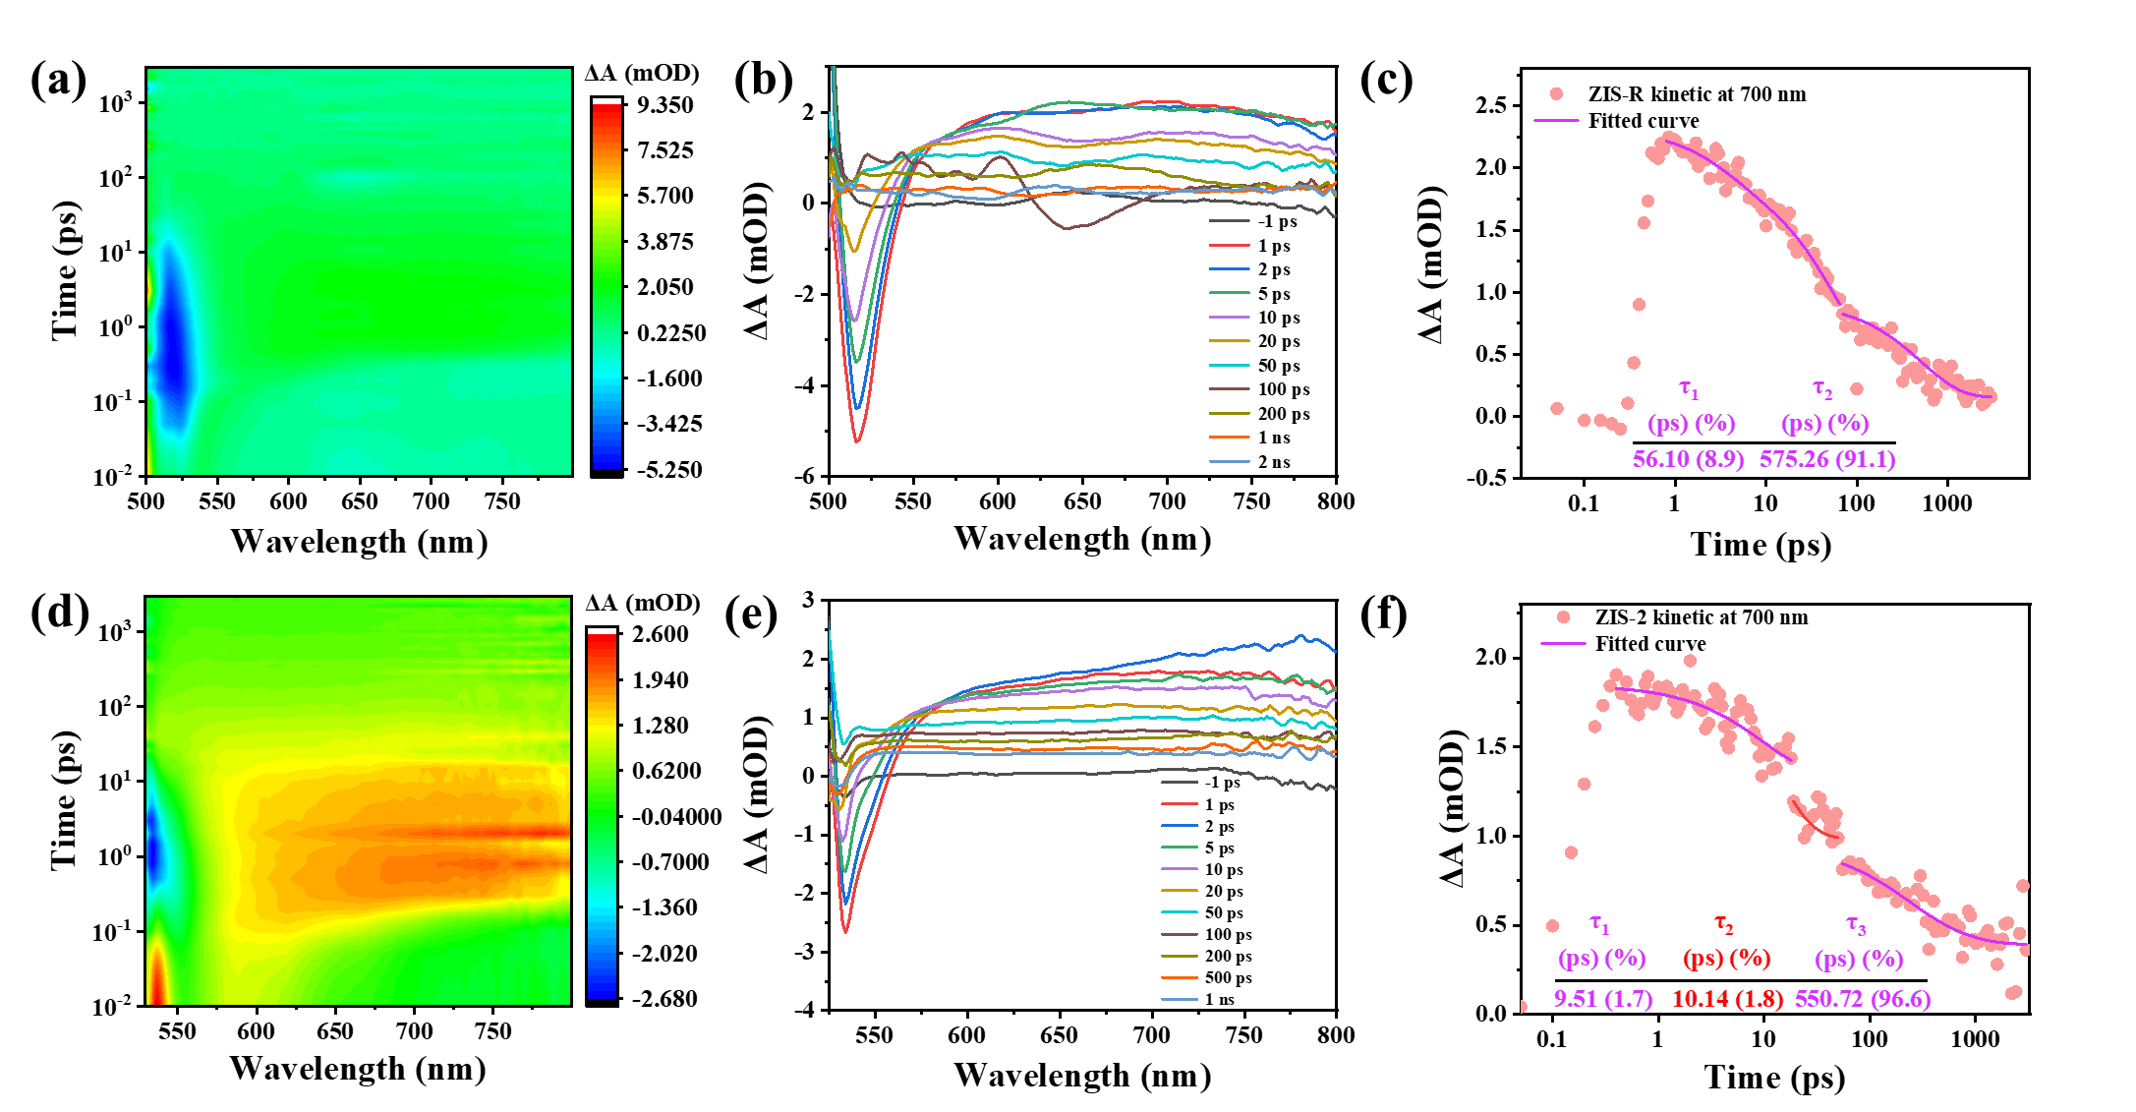
Supplementary Fig. 23. Photogenerated carrier dynamics examined by fs-TA spectroscopy. Pseudocolor TA spectra of ZIS-R (a) and ZIS-2 (d) in the initial time window of 100 ps. The representative TA spectra at several probe delays for ZIS-R (b) and ZIS-2 (e). The typical TA kinetics probed at 700 nm for ZIS-R (c) and ZIS-2 (f).
During the TA conduction, a femtosecond UV pump/white-light continuous probe was used, in which a pump laser with a center wavelength of 400 nm was used to stimulate electron exciton from the valence band to the conduction band. Because the WLC probes at 550–750 nm could almost always acquire the same TA kinetics for each sample, the data was obtained at 700 nm. The delay process of the electrons in pure ZIS-R can be fitted by a two-exponential function, and the time constants are τ₁ = 56.10 ps and τ₂ = 575.26 ps (Supplementary Fig. 23c), where the τ₁ reflects the stage where the electron goes from the conduction band to the trap state, and the τ₂ is the migration to the valence band.²⁷ While ZIS-2 values are τ₁ = 9.51 ps, τ₂ = 10.14 ps, and τ₃ = 550.72 ps (Supplementary Fig. 23f), which are assigned to the stage where the electron goes from the conduction band to the trap state, the charge recombination on the semicoherent interface, and the migration to the valence band.²⁷ The results demonstrate that the intermediate transition state provides a composite platform for electron holes.
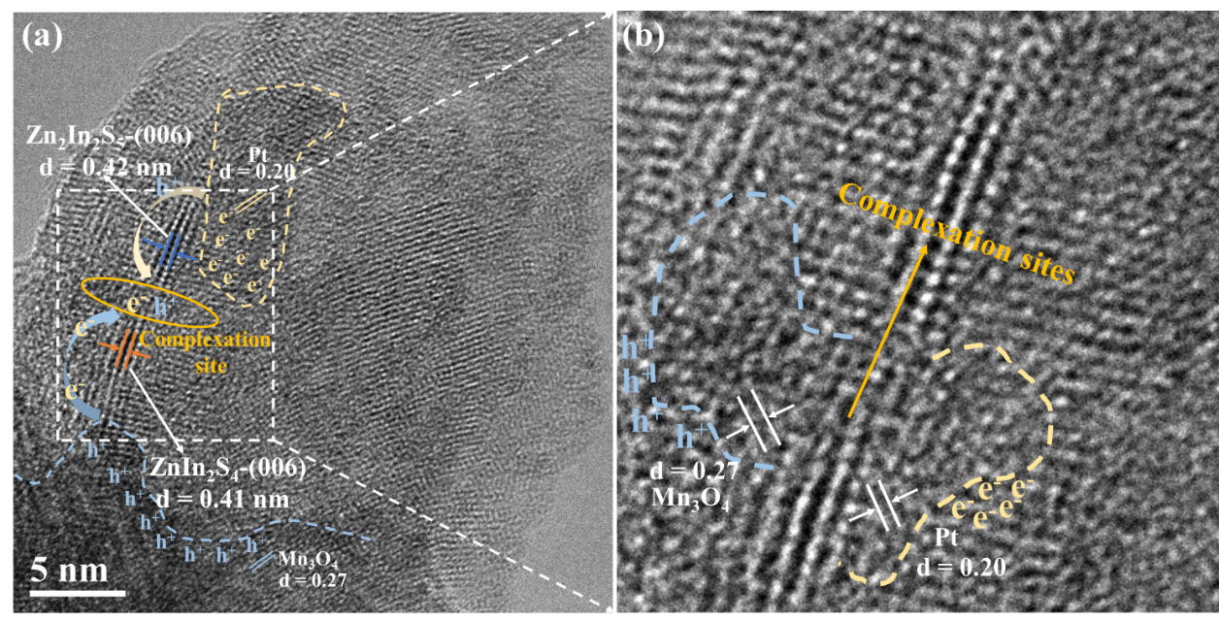
Supplementary Fig. 24. HRTEM images of the ZIS-2 composite after Pt and Mn₃O₄ nanoparticles photodeposition experiments.
To further investigate the electron migration path, a metal nanoparticle photodeposition experiment was carried out. ²⁸ In the procedure, Pt⁴⁺ in aqueous hexachloroplatinic acid (H₂PtCl₆) was converted to Pt⁰ through the use of light irradiation, and Pt⁰ was subsequently deposited as nanoparticles on the surface of the composite. In addition, Mn²⁺ is oxidized from MnCl₂ to Mn₃O₄. The HR-TEM image of the composite after Pt and Mn₃O₄ photodeposition experiment (Supplementary Fig. S24) show different lattice spacings of around 0.20, 0.27, 0.41 and 0.42 nm, which match the lattice fringes of Pt (200), Mn₃O₄ (103), ZnIn₂S₄ (006) and Zn₂In₂S₅ (006), respectively. ^{21,29,30,31} Pt nanoparticles are deposited on the edge of Zn₂In₂S₅ lattice and Mn₃O₄ nanoparticles are deposited on the edge of ZnIn₂S₄ lattice, indicating that the reduction reaction occurs on the Zn₂In₂S₅ conduction band where electrons are aggregated and the oxidation reaction occurs on the ZnIn₂S₄ valence band where holes are aggregated. Confirming that the transition layer (006) acts as the charge recombination sites.
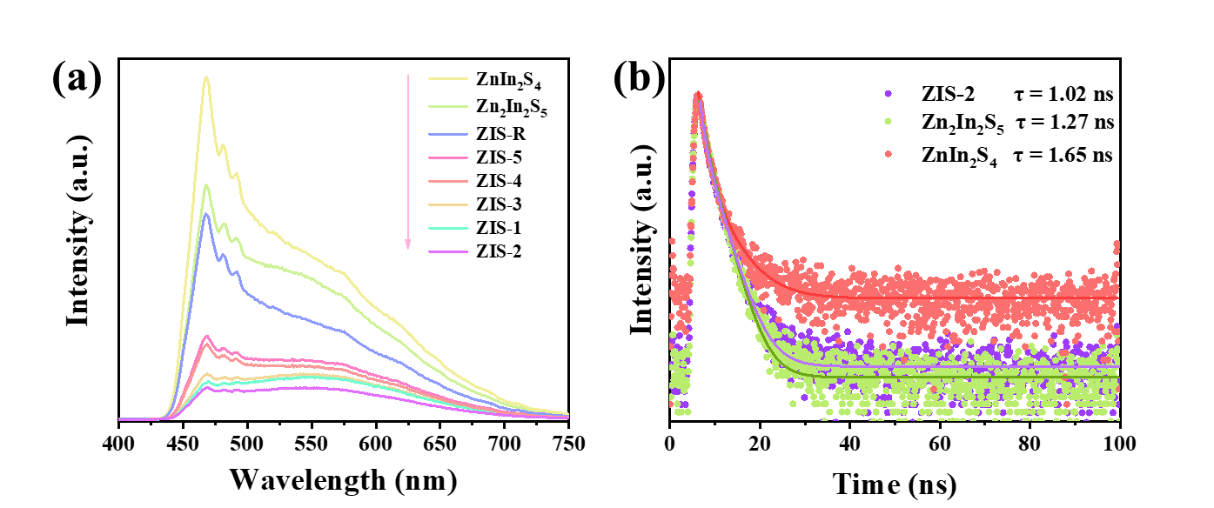
Supplementary Fig. 25. (a) PL spectroscopy and (b) transient fluorescence of as prepared samples.
The I_{(t)} and τ_{ave} can be calculated by the following equation:
I_{(t)} = A₁exp(−t/τ₁) + A₂exp(−t/τ₂)
τ_{ave} = (A₁τ₁² + A₂τ₂²)/(A₁τ₁ + A₂τ₂)
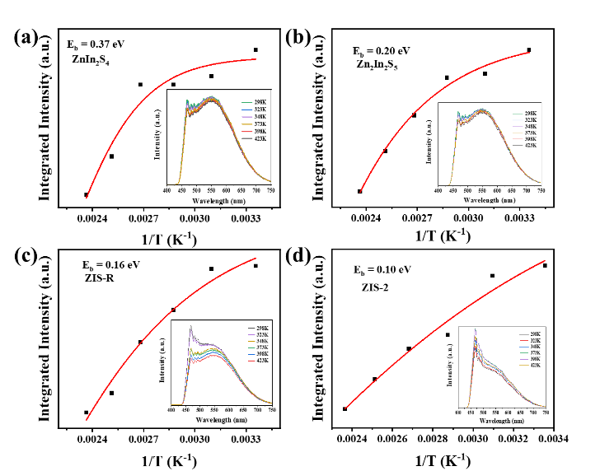
Supplementary Fig. 26. Temperature-dependent PL spectra of (a) ZnIn₂S₄, (b) Zn₂In₂S₅, (c) ZIS-R, and (d) ZIS-2.
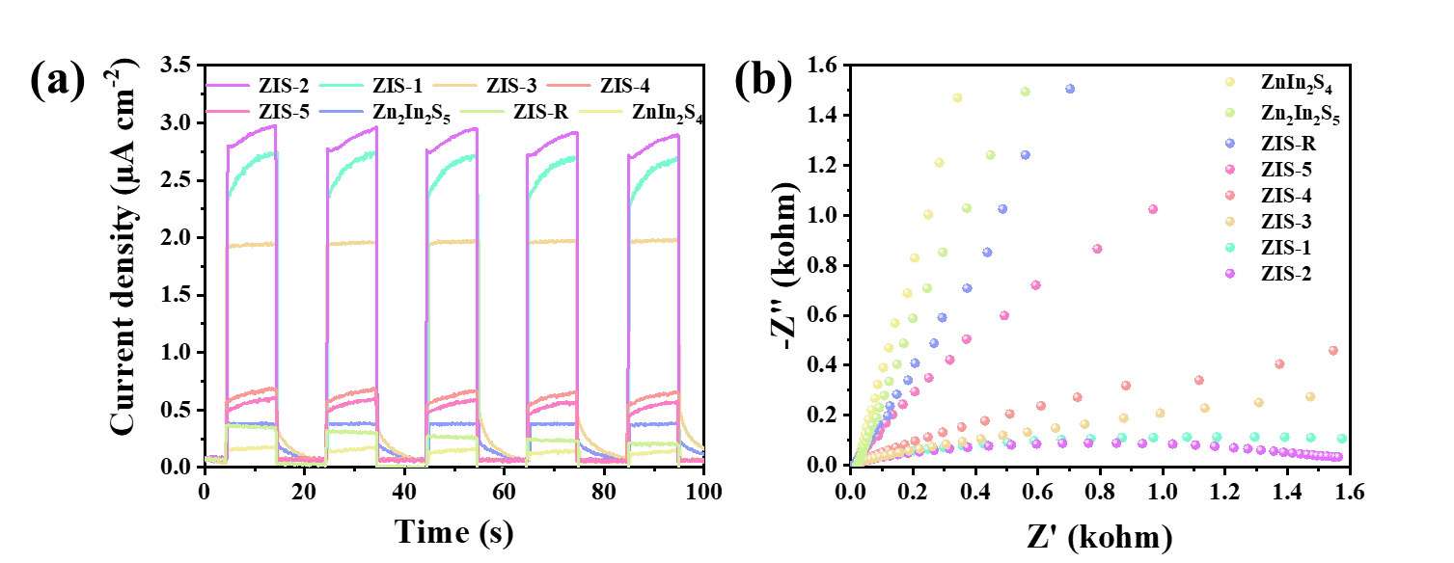
Supplementary Fig. 27. (a) i-t curves (b) and electrochemical impedance spectroscopy of the photocatalyst.
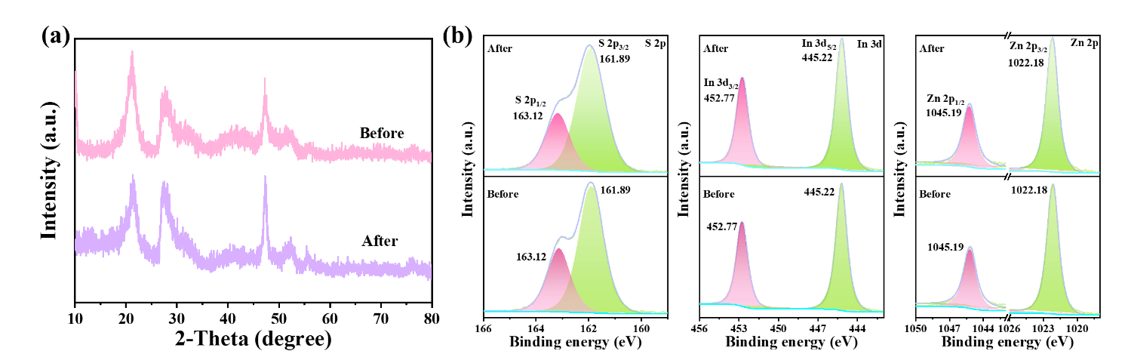
Supplementary Fig. 28. The XRD (a) and XPS (b) spectra of ZIS-2 before or after the recycling test.
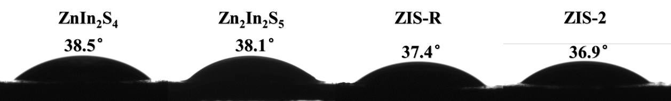
Supplementary Fig. 29. Contact-angle of water on the surface of ZnIn₂S₄, Zn₂In₂S₅, ZIS-R, and ZIS-2.
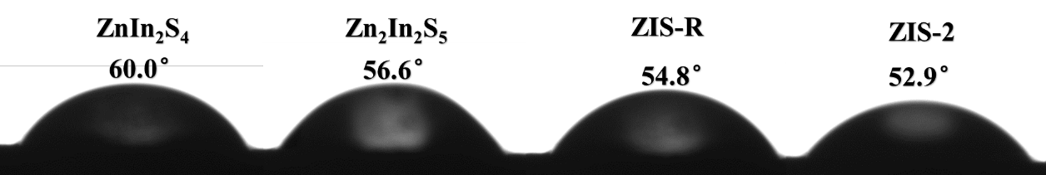
Supplementary Fig. 30. Contact-angle of H₂O₂ on the surface of ZnIn₂S₄, Zn₂In₂S₅, ZIS-R, and ZIS-2.
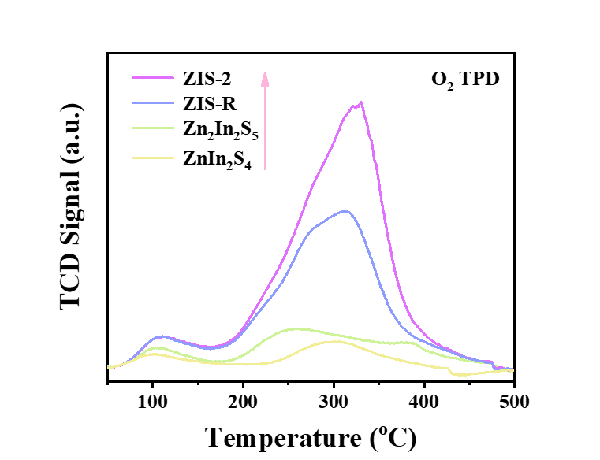
Supplementary Fig. 31. O₂-temperature programmed desorption spectra of fabricated samples.
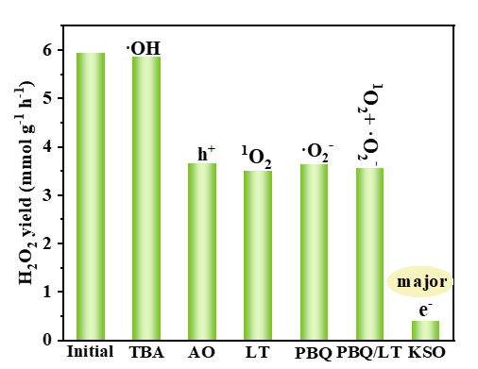
Supplementary Fig. 32. Photocatalytic produce H₂O₂ on ZIS-2 with or without scavengers (initial). ammonium oxalate (AO), tert-butyl alcohol (TBA), p-benzoquinone (PBQ), L-Tryptophan (LT) and Potassium persulfate (KSO), were used as trapping agents for holes (h⁺), hydroxyl radicals (·OH), superoxide radical (·O₂⁻), Singlet oxygen (¹O₂) and electrons (e⁻), respectively.
During the experiment, the addition of tert-butanol had almost no effect on the yield of H₂O₂, ruling out the role of hydroxyl radicals; when ammonium oxalate, L-tryptophan, and p-benzoquinone were added, the yield decreased by nearly half, proving that electron hole, single-linear oxygen, and superoxide radicals are influential; The addition of potassium persulfate resulted in a very severe drop in yield, proving that electrons were the main player. The addition of p-benzoquinone and L-tryptophan at the same time gave another half of the yield, proving that O₂ can be directly converted to H₂O₂. The possible reaction pathways are as follows:³²
$${2H}_{2}O+4h^{+}→O_{2}+4H^{+} (+1.23 V vs. NHE)$$
$O_{2}+2H^{+}+2e^{-}→H_{2}O_{2} (+0.68 V vs. NHE)$ (major)
$$O_{2}+e^{-}→·O_{2}^{-} (-0.33 V vs. NHE)$$
$$·O_{2}^{-}+h^{+}→{}_{ }^{1}{O_{2}}$$
$$·O_{2}^{-}+{2H}^{+}+e^{-}→H_{2}O_{2} (+1.44 V vs. NHE)$$
${}_{ }^{1}{O_{2}}+2H^{+}+e^{-}→H_{2}O_{2}$
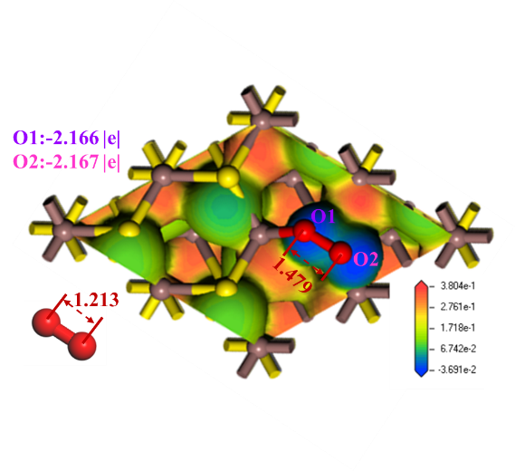
Supplementary Fig. 33. Comparison of chemical bond lengths and charge density before and after O₂ adsorption.
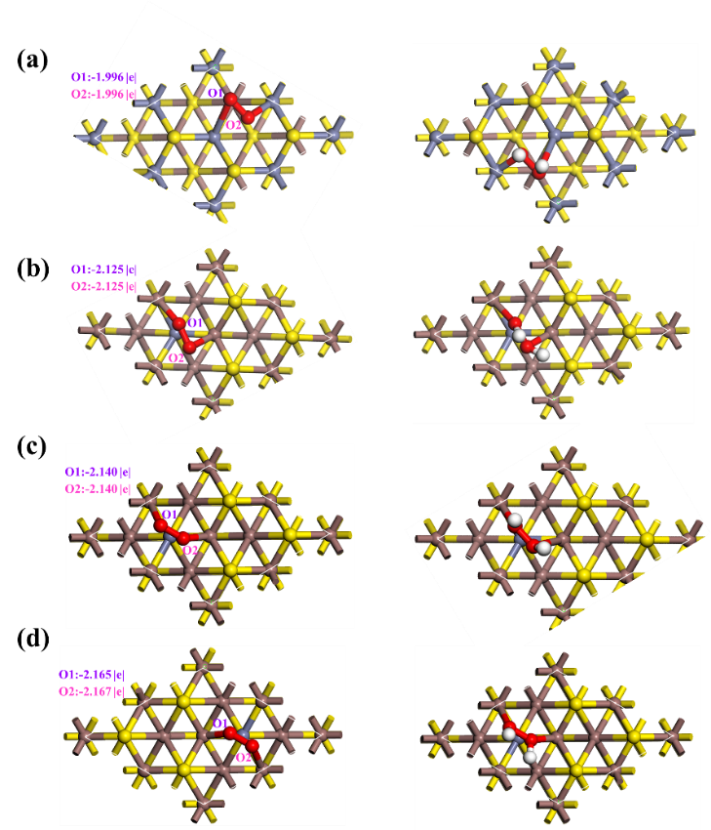
Supplementary Fig. 34 DFT structure of the two-step H₂O₂ formation process for (a) ZnIn₂S₄, (b) Zn₂In₂S₅, (c) ZIS-R, and (d) ZIS.
Reference
1 Bai, P. et al. Junction of Zn_{m}In₂S_{3+m} and bismuth vanadate as Z-scheme photocatalyst for enhanced hydrogen evolution activity: The role of interfacial interactions. J. Colloid Interface Sci. 628, 488-499 (2022).
2 Chong, W.-K. et al. Non-metal doping induced dual p-n charge properties in a single ZnIn₂S₄ crystal structure provoking charge transfer behaviors and boosting photocatalytic hydrogen generation. Appl. Catal. B Environ. 325, 122372 (2023).
3 Du, C. et al. π-π conjugation driving degradation of aromatic compounds with in-situ hydrogen peroxide generation over Zn₂In₂S₅ grown on nitrogen-doped carbon spheres. Appl. Catal. B Environ. 310, 121298 (2022).
4 Yang, W. et al. Minimized external electric field on asymmetric monolayer maximizes charge separation for photocatalysis. Appl. Catal. B Environ. 295, 120266 (2021).
5 Zhang, G. et al. Preparation of ZnIn₂S₄ nanosheet-coated CdS nanorod heterostructures for efficient photocatalytic reduction of Cr(VI). Appl. Catal. B Environ. 232, 164-174 (2018).
6 Cao, S. et al. H₂-production and electron-transfer mechanism of a noble-metal-free WO₃@ZnIn₂S₄ S-scheme heterojunction photocatalyst. J. Mater. Chem. A 10, 17174−17184 (2022).
7 Zhang, L. Y. et al. Emerging S-Scheme photocatalyst. Adv. Mater. 34, 2107668 (2022).
8 Supka, A. et al. Two-layer high-throughput: effective mass calculations including warping. Eng. 10, 74-80 (2022).
9 Jiao, X. et al. Defect-mediated electron–hole separation in one-unit-cell ZnIn₂S₄ layers for boosted solar-driven CO₂ reduction. J. Am. Chem. Soc. 139, 7586-7594 (2017).
10 Sabbah, A. et al. Boosting photocatalytic CO₂ reduction in a ZnS/ZnIn₂S₄ heterostructure through strain-induced direct Z-scheme and a mechanistic study of molecular CO₂ interaction thereon. Nano Energy 93, 106809 (2022).
11 Hua, S. et al. Highly efficient p-type Cu₃P/n-type g-C₃N₄ photocatalyst through Z-scheme charge transfer route. Appl. Catal. B Environ. 240, 253−261 (2019).
12 Li, N. et al. Efficient removal of chromium from water by Mn₃O₄@ZnO/Mn₃O₄ composite under simulated sunlight irradiation: Synergy of photocatalytic reduction and adsorption. Appl. Catal. B Environ. 214, 126−136 (2017).
13 Dang, X. et al. The in situ construction of ZnIn₂S₄/CdIn₂S₄ 2D/3D nano hetero-structure for an enhanced visible-light-driven hydrogen production. J. Mater. Chem. A 9, 14888−14896 (2021).
14 Chen, X. et al. Visible-light-driven hydrogen peroxide production from water and dioxygen by perylenetetracarboxylic diimide modified titanium-based metal–organic frameworks. J. Mater. Chem. A 9, 26371−26380 (2021).
15 Shiraishi, Y. et al. Resorcinol-formaldehyde resins as metal-free semiconductor photocatalysts for solar-to-hydrogen peroxide energy conversion. Nat. Mater. 18, 985-993 (2019).
16 Lin, S. et al. Piezocatalytic and photocatalytic hydrogen peroxide evolution of sulfide solid solution nano-branches from pure water and air. Small 18, 2200914 (2022).
17 Zeng, X. et al. Simultaneously tuning charge separation and oxygen reduction pathway on graphitic carbon nitride by polyethylenimine for boosted photocatalytic hydrogen peroxide production. ACS Catal. 10, 3697−3706 (2020).
18 Chen, X. et al. Sacrificial agent-free photocatalytic H₂O₂ evolution via two-electron oxygen reduction using a ternary α-Fe₂O₃/CQD@g-C₃N₄ photocatalyst with broad-spectrum response. J. Mater. Chem. A 8, 18816−18825 (2020).
19 Chen, L. et al. Acetylene and Diacetylene Functionalized Covalent Triazine Frameworks as Metal-Free Photocatalysts for Hydrogen Peroxide Production: A New Two-Electron Water Oxidation Pathway. Adv. Mater. 32, 1904433 (2020).
20 Zheng, Y. et al. Photocatalytic production of H₂O₂ over facet-dependent Ti-MOF. Catal. Sci. Technol. 12, 969−975 (2022).
21 Li, X. et al. Boosting photocatalytic H₂O₂ production in pure water over a plasmonic photocatalyst with polyethylenimine modification. J. Mater. Chem. A 11, 1503−1510 (2023).
22 Yang, C. et al Calcination-regulated Microstructures of Donor-Acceptor Polymers towards Enhanced and Stable Photocatalytic H₂O₂ Production in Pure Water. Angew. Chem. Int. Ed. 61, e202208438 (2022).
23 Zhang, J. et al. Efficient photocatalytic H₂O₂ production from oxygen and pure water over graphitic carbon nitride decorated by oxidative red phosphorus. Appl. Catal. B Environ. 298, 120522 (2021).
24 Chu, C. et al. Photocatalytic H₂O₂ production driven by cyclodextrin-pyrimidine polymer in a wide pH range without electron donor or oxygen aeration. Appl. Catal. B Environ. 314, 121485 (2022).
25 Liu, Y. et al. Substoichiometric covalent organic frameworks with uncondensed aldehyde for highly efficient hydrogen peroxide photosynthesis in pure water. Appl. Catal. B Environ. 331, 122691 (2023).
26 Wu, C. B. et al. Polarization engineering of covalent triazine frameworks for highly efficient photosynthesis of hydrogen peroxide from molecular oxygen and water. Adv. Mater. 34, 2110266 (2022).
27 Xu, L. et al. Fabrication of a photocatalyst with biomass waste for H₂O₂ synthesis. ACS Catal. 11, 14480−14488 (2021).
28 Yang, T. et al. Covalent furan-benzimidazole-linked polymer hollow fiber membrane for clean and efficient photosynthesis of hydrogen peroxide. Adv. Funct. Mater. 33, 2300714 (2023).
29 Zhang, Y. et al. Water flow induced piezoelectric polarization and sulfur vacancy boosting photocatalytic hydrogen peroxide evolution of cadmium sulfide nanorods. Appl. Catal. B Environ. 331, 122714 (2023).
30 Fu, C. et al. Unraveling the dual defect effects in C₃N₅ for piezo-photocatalytic degradation and H₂O₂ generation. Appl. Catal. B Environ. 332, 122752 (2023).
31 Zhang, X. et al. Unraveling the dual defect sites in graphite carbon nitride for ultra-high photocatalytic H₂O₂ evolution. Energy Environ. Sci. 15, 830-842 (2022).
32 Yong, Z. et al. Solar-to-H₂O₂ catalyzed by covalent organic frameworks. Angew. Chem. Int. Ed., e202308980 (2023).

