Supplementary Tables
Table S1. The volume concentration and composition of residual gases in shales and metapelites from old accretionary prisms exposed in the Shikoku region. The maximum temperatures of shales were estimated from VR (vitrinite reflectance) using Easy%RoV (Burnham, 2019), assuming the heating rate as 30℃/myr (accretionary prisms) and 125℃/myr (underthrust sediments), respectively. The present temperatures of the MITI Mishima well are almost the same as the maximum temperatures. The maximum temperatures of metapelites were estimated from metamorphic mineral assemblages and sampling locations. A part of the data is from Suzuki et al. (2017).

Supplementary Figures

Fig. S1
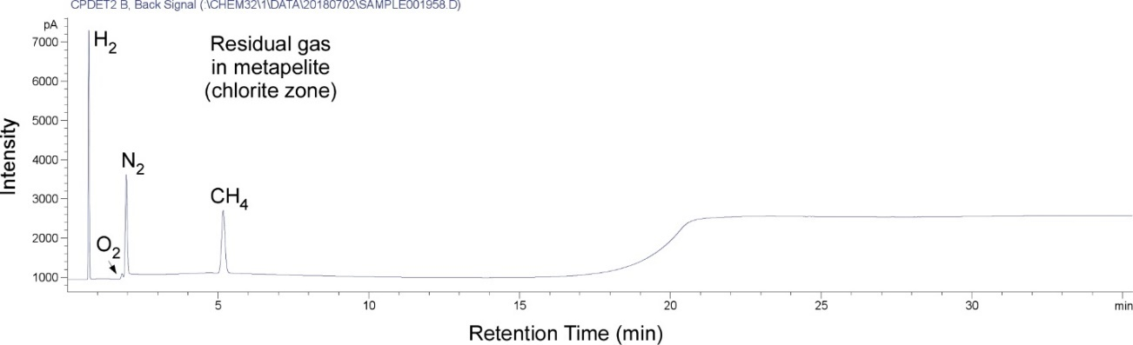

Fig. S1. A typical GC-PDHID chromatogram of the residual gas in metapelite ((d) in Fig. 3. The metapelite sample was from the old accretionary prism (Sanbagawa metamorphic belt) in the Shikoku region. The O₂ peak is tiny compared to the N₂ peak, showing negligible air contamination during analysis.

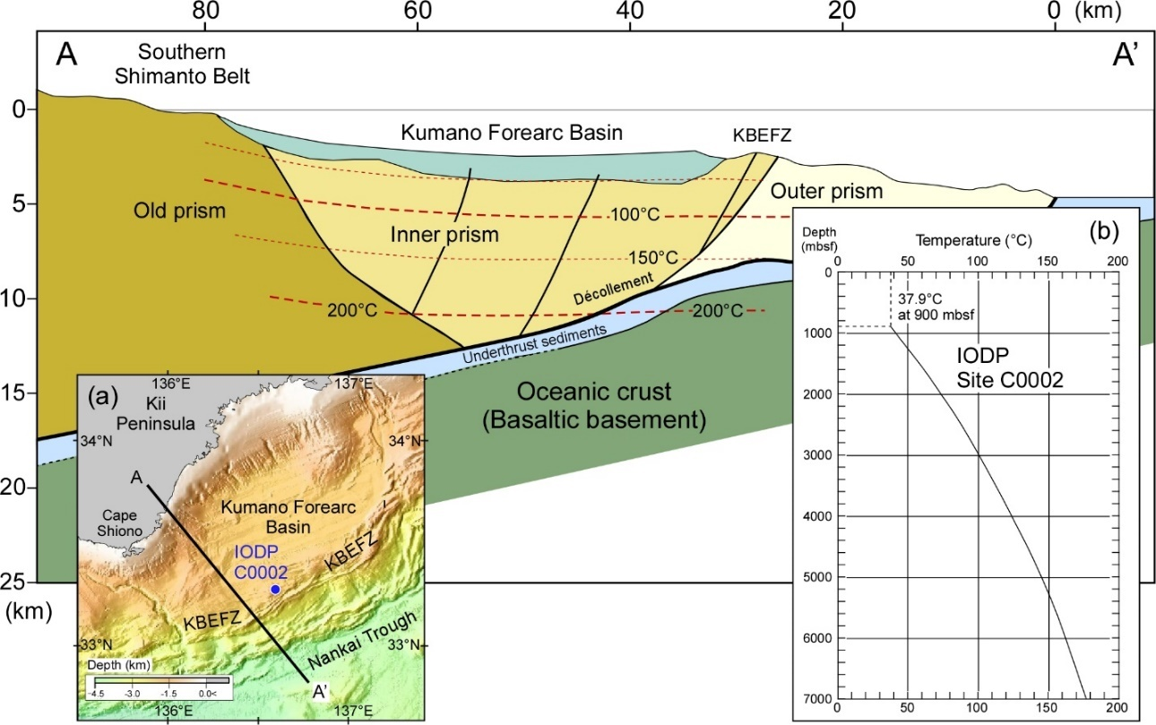
Fig. S2

Fig. S2. The depth-temperature relationship in the temperature zone below 200°C. (a) The location of Site C0002 of the IODP Expedition 332. (b) The depth-temperature relationship in the Kumano-nada region (Sugihara et al., 2014). The depth-temperature relationship at the IDOP Site C0002 was extrapolated to the subsurface temperature distribution below 200°C in the Kumano-nada region.

Fig. S3
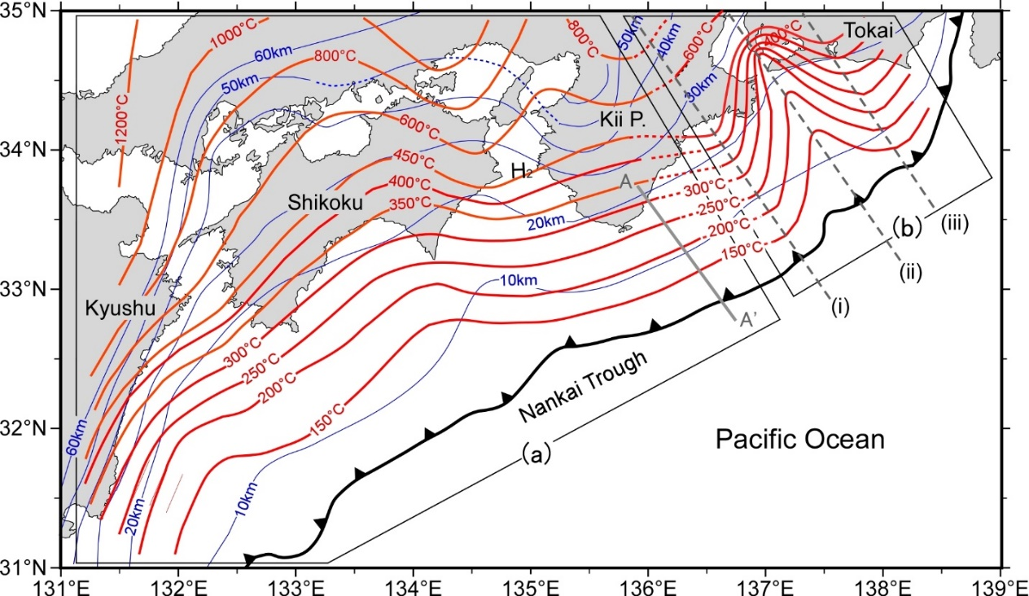

Fig. S3. The temperatures of the upper surface of the Philippine Sea Plate. (a) The temperature contours in the Kyushu, Shikoku, and Kii Peninsula regions according to 3D modeling from (Ji et al., 2016). (b) The temperature contours in the Tokai regions based on 2D modeling at the sections of (i) to (iii) by (Suenaga et al., 2019). The blue contours show the depths of the upper boundary of the Philippine Sea Plate (Baba et al., 2002; Nakajima and Hasegawa, 2006; Hirose et al., 2008). The black line with triangles represents the trench axis of the Nankai Trough.

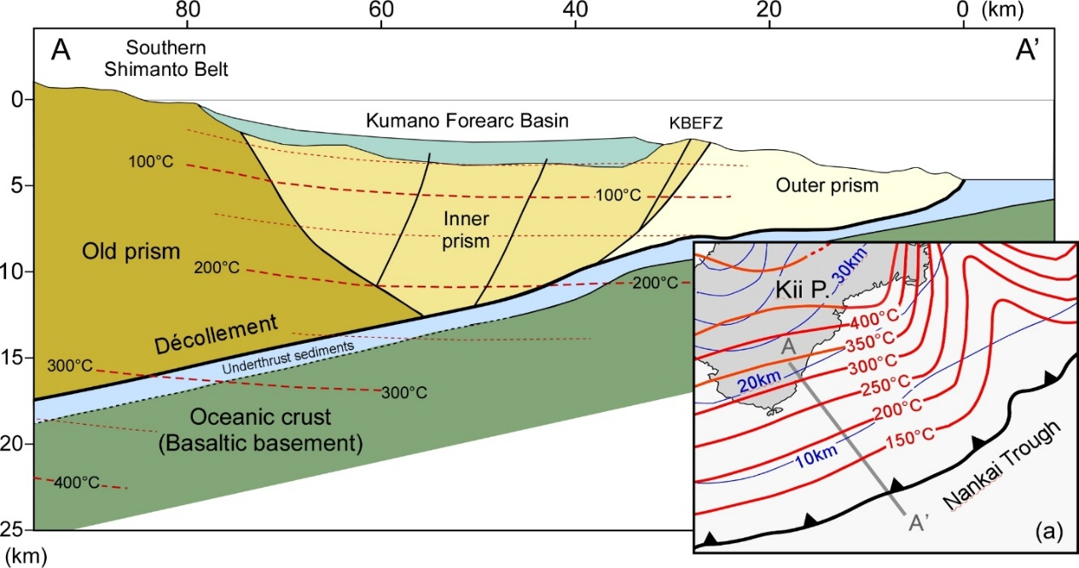
Fig. S4

Fig. S4. The depth-temperature relationship in the subduction zone of the Kumano-nada region. (a) The temperatures of the upper surface of the Philippine Sea Plate in the Kumano-nada region with the depths of the upper boundary of the Philippine Sea Plate (blue contours) from Fig. S5. The depth-temperature relationship in the temperature zone of more than 200°C is from the depth-temperature relationship in (a).

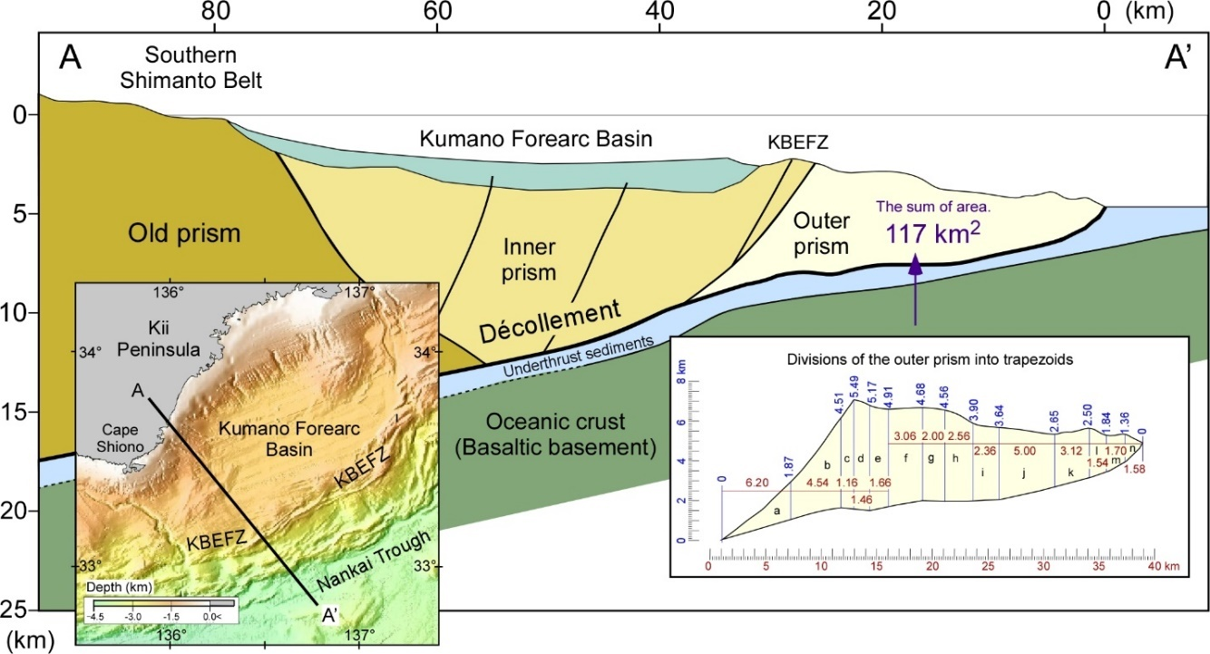
Fig. S5

Fig. S5. The area estimation of the outer prism. The outer prism in the geologic section of the Kumano-nada region, off the Kii Peninsula, was divided into 14 trapezoids for area estimation. The area of the outer prism was estimated to be approximately 117 km² from the sum of the areas of each trapezoid.

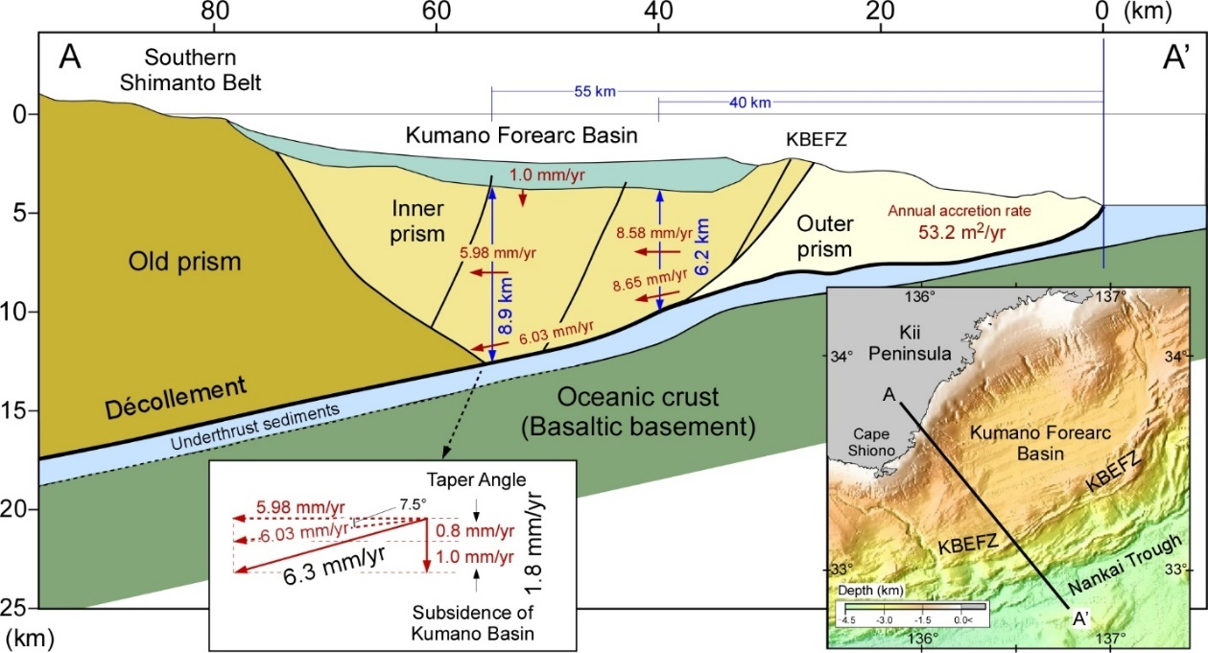
Fig. S6

Fig. S6. The estimation of the vector velocity at the bottom of the inner accretionary prism. The average annual sediment accretion rate was estimated to be about 53.2 m²/yr, assuming the initiation of the outer prism formation 2.2 myr ago (Screaton et al., 2009; Strasser et al., 2009; Moore et al., 2015; Kimura et al., 2018). The lateral velocity of the inner prism was estimated by dividing the annual accretion rate by the thickness of the accretionary prism. The lateral velocities of the inner prism at 40 km away (6.2 km thick) and 55 km away (8.9 km thick) from the trough are estimated to be approximately 8.58 mm/yr and 5.98 mm/yr, respectively. The vertical velocity at the deepest part of the inner prism (55 km away from the trough) is estimated to be 1.8 mm/yr, considering the vertical velocities due to the taper angle (7.5°) of the Philippine Sea Plate (0.8 mm/yr) and due to the subsidence of the Kumano forearc basin (1.0 mm/yr). Therefore, the vector velocity of the deepest part of the inner prism is approximately 6.3 mm/yr, considering the lateral velocity of 5.98 mm/yr and the vertical velocity of 1.8 mm/yr.

