ADDITIONAL FILES
Additional file 1
Supplementary Table 1. Definitions of the Post-operative Morbidity Survey 2
Supplementary Table 2. Treatment choice comparison between the intervention and control groups 3
Supplementary Figure 1: Time-weighted average mean arterial pressure < 65mmHg, calculated for one patient. 4

Supplementary Table 1. Definitions of the Post-operative Morbidity Survey
Complications | Criteria | Source of data
Pulmonary complications | New requirement of oxygen or respiratory support | Patient observation and treatment chart
Infection | Temperature >38 °C in the last 24 h and newly prescribed antibiotics | Treatment chart and observation chart
Kidney injury | Oliguria (500 mL/24 h) noted or increased serum creatinine (>30 % from preoperative level) | Patient observation, fluid balance chart, and biochemistry result
Gastrointestinal complications | Patient cannot tolerate oral or enteral diet; nausea, vomiting, and abdominal distension | Patient questioning, fluid balance chart, and treatment chart
Cardiovascular complications | Diagnostic tests/therapy within the last 24 h, showing new myocardial infarction or ischemia, atrial or ventricular arrhythmias, cardiogenic pulmonary edema or thrombotic events | Treatment chart and note review
Neurological complications | New focal deficit delirium or coma | Note review and patient questioning
Wound complications | Operation wound requires surgical exploration or drainage of pus | Note review and pathology result
Hematological requirement | Requirement for blood transfusion within the last 24 h | Treatment chart and fluid balance chart
New-onset pain | New-onset severe postoperative pain that requires a new strong opioid or new nerve block. | Treatment chart and patient questioning
The Post-operative Morbidity Survey was based on Grocott et al., J Clin Epidemiol., 2007.

Supplementary Table 2. Treatment choice comparison between the intervention and control groups

Treatment, total times | Intervention (n = 279) | Control (n = 307) | P value
Fluid + vasopressor | 59 | 58 | 1.00
Fluid + inotropic agent | 9 | 3 | 0.60
Fluid | 22 | 32 | 0.23
Vasopressor | 172 | 195 | 0.44
Inotropic agent | 5 | 9 | 0.65
Observation | 12 | 10 | 0.95

Intervention: Hypotension Prediction Index guidance; control: no Hypotension Prediction Index guidance; n: total treatment times. P value calculated using the Mann-Whitney U test.

Supplementary Figure 1: Time-weighted average mean arterial pressure < 65mmHg, calculated for one patient.
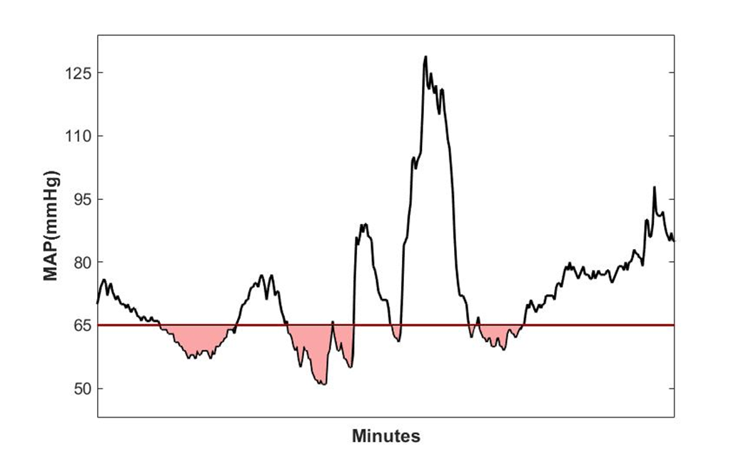
MAP: mean arterial pressure

