Fig. S1 Transmission electron micrograph of the strain JX-17^{T} cell cultured on TSA plate at 37 °C for 2 days. Scale bar = 2.0 μm
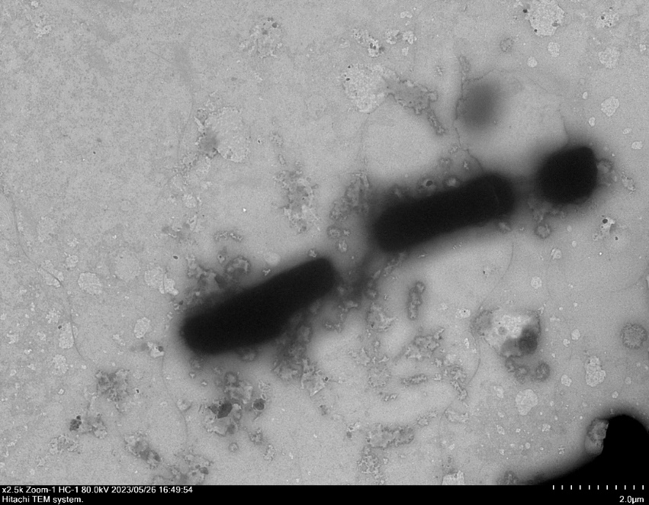

Fig. S2 Maximum-likelihood (ML) phylogenetic tree based on 16S rRNA gene sequences, showing the taxonomic position of strain JX-17^{T} and related type strains in the genus Paenibacillus. Bacillus subtilis DSM10^{T} was used as an outgroup. Bootstrap values were calculated from 1000 replications and values below 50% are not indicated at branch points. Bar, 0.02 substitutions per nucleotide position.
Paenibacillus sabinae T27^{T} (DQ338444)
Paenibacillus forsythiae T98^{T} (DQ338443)
Paenibacillus apii 7124^{T} (KX017285)
Paenibacillus azotofixans ATCC 35681^{T} (X60608)
Paenibacillus durus DSM 1735^{T} (X77846)
Paenibacillus stellifer DSM 14472^{T} (AJ316013)
Paenibacillus typhae CGMCC 1.11012^{T} (JN256679)
Paenibacillus albidus Q4-3^{T} (KY674517)
Paenibacillus tritici RTAE36^{T} (KX530777)
Paenibacillus jiangxiensis JX-17^{T} (OQ781845)
Paenibacillus gelatinilyticus PG1^{T} (KP231650)
Paenibacillus bovis BD3526^{T} (KM978955)
Paenibacillus wulumuqiensis Y24^{T} (KM243343)
Paenibacillus shenyangensis A9^{T} (KF834270)
Paenibacillus ottowii MS2379^{T} (MH842737)
Paenibacillus polymyxa ATCC 842^{T} (AJ320493)
Paenibacillus peoriae DSM 8320^{T} (AJ320494)
Paenibacillus kribbensis AM49^{T} ( AF391123)
Paenibacillus terrae AM141^{T} (AF391124)
Paenibacillus barengoltzii NBRC 101215^{T} (AB681405)
Paenibacillus macerans IAM 12467^{T} (AB073196)
Paenibacillus timonensis 2301032^{T} (AY323610)
Paenibacillus physcomitrellae XB^{T} (KP334123)
Paenibacillus lemnae L7-75^{T} (AB819817)
Paenibacillus xylanilyticus XIL14^{T} (AY427832)
Paenibacillus terreus D33^{T} (KF479658)
Paenibacillus massiliensis DSM 16942^{T} (AY230766)
Paenibacillus panacisoli Gsoil 1411^{T} (AB245384)
Paenibacillus lentus DSM 25539^{T} (KC800716)
Paenibacillus ihumii AT5^{T} (LN884296)
Paenibacillus dokdonensis YH-JAE5^{T} (KX025137)
Bacillus subtilis DSM10^{T} (AJ276351)
100
57
99
92
88
87
99
99
96
92
75
91
52
92
63
88
57
68
0.02

Fig. S3 Minimum evolution (ME) phylogenetic tree based on 16S rRNA gene sequences, showing the taxonomic position of strain JX-17^{T} and related type strains in the genus Paenibacillus. Bacillus subtilis DSM10^{T} was used as an outgroup. Bootstrap values were calculated from 1000 replications and values below 50% are not indicated at branch points. Bar, 0.01 substitutions per nucleotide position.
Paenibacillus bovis BD3526^{T} (KM978955)
Paenibacillus shenyangensis A9^{T} (KF834270)
Paenibacillus wulumuqiensis Y24^{T} (KM243343)
Paenibacillus gelatinilyticus PG1^{T} (KP231650)
Paenibacillus jiangxiensis JX-17^{T} (OQ781845)
Paenibacillus terreus D33^{T} (KF479658)
Paenibacillus xylanilyticus XIL14^{T} (AY427832)
Paenibacillus massiliensis DSM 16942^{T} (AY230766)
Paenibacillus panacisoli Gsoil 1411^{T} (AB245384)
Paenibacillus terrae AM141^{T} (AF391124)
Paenibacillus ottowii MS2379^{T} (MH842737)
Paenibacillus polymyxa ATCC 842^{T} (AJ320493)
Paenibacillus peoriae DSM 8320^{T} (AJ320494)
Paenibacillus kribbensis AM49^{T} (AF391123)
Paenibacillus lemnae L7-75^{T} (AB819817)
Paenibacillus physcomitrellae XB^{T} (KP334123)
Paenibacillus macerans IAM 12467^{T} (AB073196)
Paenibacillus timonensis 2301032^{T} (AY323610)
Paenibacillus barengoltzii NBRC 101215^{T} (AB681405)
Paenibacillus typhae CGMCC 1.11012^{T} (JN256679)
Paenibacillus albidus Q4-3^{T} (KY674517)
Paenibacillus tritici RTAE36^{T} (KX530777)
Paenibacillus stellifer DSM 14472^{T} (AJ316013)
Paenibacillus sabinae T27^{T} (DQ338444)
Paenibacillus forsythiae T98^{T} (DQ338443)
Paenibacillus apii 7124^{T} (KX017285)
Paenibacillus azotofixans ATCC 35681^{T} (X60608)
Paenibacillus durus DSM 1735^{T} (X77846)
Paenibacillus dokdonensis YH-JAE5^{T} (KX025137)
Paenibacillus lentus DSM 25539^{T} (KC800716)
Paenibacillus ihumii AT5^{T} (LN884296)
Bacillus subtilis DSM10^{T} (AJ276351)
100
95
88
100
88
56
96
97
100
100
70
52
95
63
96
92
81
55
90
66
53
50
0.01

Fig. S4 Two dimensional TLC profile of polar lipids extracted from strain JX-17^{T}. DPG, diphosphatidylglycerol; PE, diphosphatidylethanolamine; PG, phosphatidylglycerol; GL, glycolypid; APL, aminophospholipid; PI, Phosphatidylinositol.

