SUPPLEMENTAL INFORMATION FOR:
Semi-arid irrigation farm dams are a small source of greenhouse gas emissions

Jackie R. Webb^{1*}, Wendy C. Quayle¹, Carlos Ballester¹, Naomi S. Wells²

¹Centre for Regional and Rural Futures (CeRRF), Faculty of Science, Engineering and Built Environment, Deakin University, Griffith, NSW 2680, Australia
²Dept of Soil & Physical Sciences, Faculty of Agriculture & Life Sciences, Lincoln University, Lincoln 7647, New Zealand

*Correspondence:
Jackie Webb
j.webb@deakin.edu.au

Introduction
This supplementary document contains two figures, seven tables, results description of farm dam characteristics and sediment properties, and detail of how irrigation dam gas transfer velocity was calculated for each gas. Figure 1 provides a regional scale map of the 38 farm dam sites surveyed in the Murrumbidgee Irrigation Area (MIA) with detail of natural and irrigation waterways (blue lines), major roads (black lines) and major townships. Table S1 provides definitions of how the irrigation farm dams were classified in this study which was based on anecdotal information. Table S2 relates to the description of dam physical and sediment properties and Table S3 the dam-specific gas transfer velocity data. Figure S2 is a presentation of bar plots for the CO₂, CH₄, and N₂O flux of each site for each field campaign and indicates the proportion of greenhouse gas (GHG) sources and sinks. Table S4-S7 provides statistics of the linear mixed-effect models (LMEM) for results presented in Figures 1-4 of the main article.
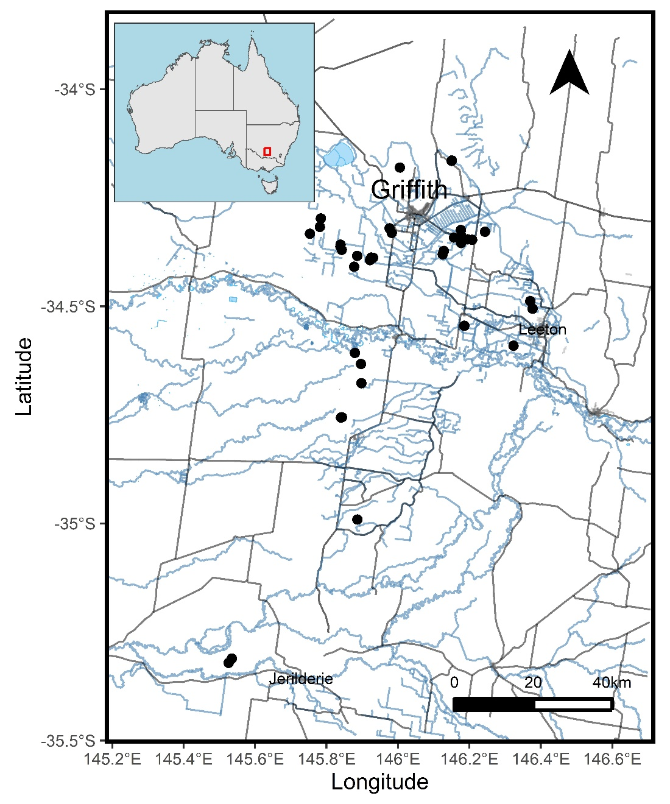
Figure S1: Locations of irrigation farm dams sampled in the Riverina.

Table S1: Definitions of irrigation farm dams classified in this study.
Dam type | Definition | Example
Settling pond | Dam on horticultural farms using drip irrigation, including fruit, nuts, and wine grapes. These earthen dams typically act as sediment settling ponds and remain flooded permanently due to year-round irrigation requirement. | 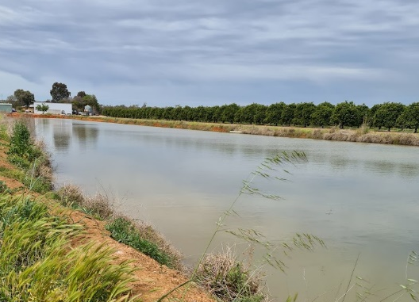
Storage | Any dam not on a horticultural farm that is primarily used to store water for surface irrigation. Stores rain, river, and any excess irrigation water. Typically, not as actively connected to field irrigation channels. | 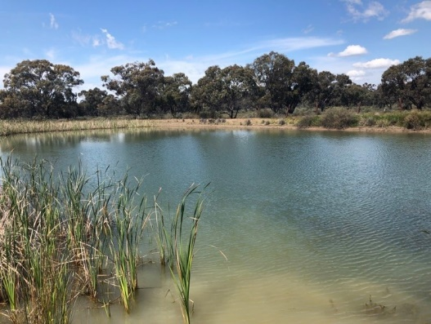
Recycle | Represents a dam connected to on-farm field channels that recycles irrigation water between fields. Often dry out when the irrigation season ends and not treated as permanent water storage. | 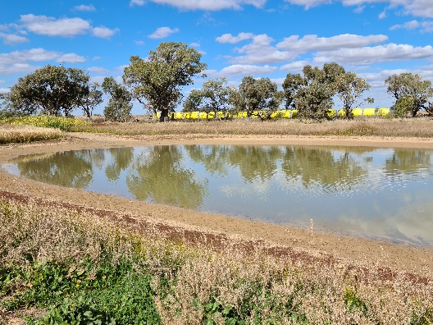
Turkey nest | Dam that stores water above the ground level to allow gravity-feed irrigation. Usually very large (>10,000 m²). Constructed by bringing embarkment material from the outside (i.e. not a hole dug into the ground). As such, does not capture any surface water runoff from catchment. | 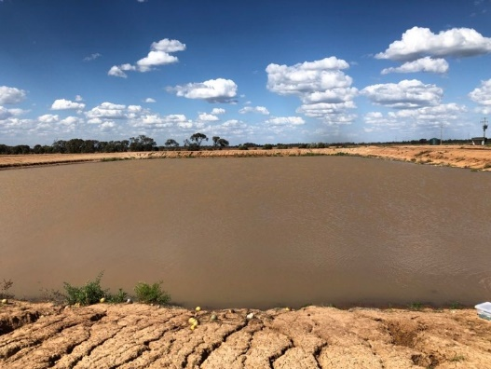

Irrigation dam physical properties
Several differences were observed between farm dam type. Soil EC and pH was significantly different in settling ponds (Table S2), which may represent the different soil types or area citrus and wine grapes are grown in (loams and sandy loams) compared with broadacre (red brown earths and clay rich vertosols). As expected, turkey nests had a larger average area of 6.51 ha, while storage dams had the smallest area of 0.23 ha. Settling ponds had a significantly higher average sediment carbon concentration of 1.33%, although the highest concentration of 10.20% was observed in a very old (~90 years) recycle dam. Additionally, settling ponds had distinctly higher sediment d¹³C signature and C/N ratios of -11‰ and 35, respectively.
Table S2: Summary of irrigation farm dam types and their physical, sediment, and soil properties. Presented as mean with range in parathesis.
Characteristic¹ | Settling ponds  (n = 10) | Recycle,  (n = 30) | Storage,  (n = 16) | Turkey nest,  (n = 12) | p-value²
Soil EC, mS cm⁻¹ | 0.59 (0.18 – 1.17) | 0.99 (0.23 - 2.35) | 1.10 (0.31 - 1.97) | 1.66 (0.89 - 2.11) | <0.001
Soil pH | 7.52 (6.70 - 8.12) | 6.62 (5.86 – 7.47) | 6.48 (5.79 - 7.13) | 6.72 (6.02 - 7.50) | <0.001
Area, ha | 1.19 (0.53 – 2.33) | 1.42 (0.02 - 13.70) | 0.23 (0.05 - 0.63) | 6.51 (0.16 - 14.50) | <0.001
Perimeter, m | 665 (399 - 1,560) | 397 (62 - 1,390) | 293 (86 - 1,340) | 1,006 (359 - 1,340) | <0.001
Sediment C, % | 1.33 (0.58 - 2.76) | 1.20 (0.31 - 10.20) | 0.68 (0.31 - 1.75) | 0.47 (0.14 - 0.63) | 0.007
Sediment N, % | 0.047 (0.020 – 0.095) | 0.101 (0.020 - 0.870) | 0.047 (0.020 - 0.080) | 0.037 (0.010 - 0.050) | 0.314
Sediment δ¹³C, ‰ | -11 (-23.4 - 13.5) | -21.7 (-27.8 - -4.6) | -20.3 (-24.9 - -13.5) | -21.5 (-23.1 - -19.0) | 0.014
Sediment δ¹⁵N, ‰ | 16 (8 – 21) | 13 (5 – 28) | 27 (9 – 125) | 19 (11 – 42) | 0.038
Sediment C/N ratio | 35 (11 – 68) | 13 (9 – 39) | 15 (8 – 29) | 13 (12 – 15) | 0.002
Sediment carbon stock, t C ha⁻¹
NH₄-N, mg L⁻¹ | 0.20 (0.14) | 0.62 (0.53) | 0.37 (0.29) | 0.38 (0.39) | 0.006
NO₃-N, mg L⁻¹ | 0.53 (0.74) | 0.91 (1.12) | 1.02 (1.18) | 1.00 (0.81) | 0.040
Trophic status |  |  |  |  | 0.356³
Oligotrophic | 4 (40.0%) | 2 (6.7%) | 1 (6.3%) | 1 (8.3%)
Mesotrophic | 3 (30.0%) | 5 (16.7%) | 3 (18.8%) | 2 (16.7%)
Eutrophic | 1 (10.0%) | 12 (40.0%) | 5 (31.3%) | 4 (33.3%)
Hypereutrophic | 2 (20.0%) | 11 (36.7%) | 7 (43.8%) | 5 (41.7%)
¹Soil and sediment characteristics measured once, all water-based measurements taken twice (spring and summer).
²Kruskal-Wallis rank sum test
³Fisher's exact test

Gap-filled CO₂ concentrations
In spring, 10 sites were gap-fill for CO₂ concentrations due to high pH values of 8.55 to 10.70 causing CO₂ concentrations to be below the detection limit of the GC (<50 ppm). We used the below equation based on the relationship between CO₂ concentrations and surface water pH in summer from other sites to gap-fill undetected CO₂ concentrations (Figure S2).
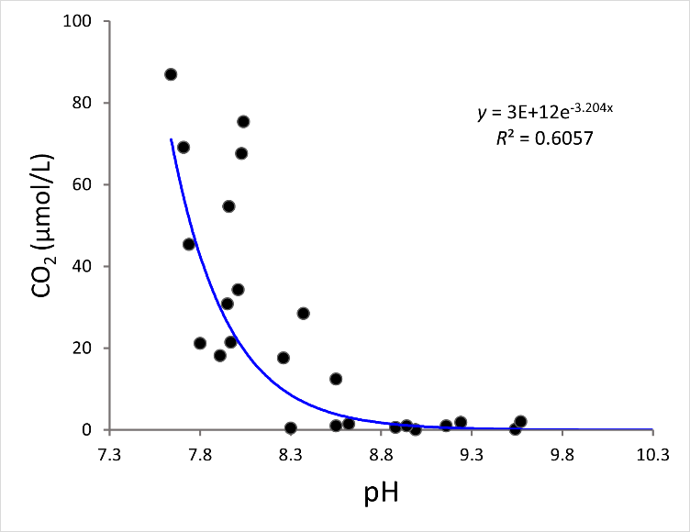
Figure S2: Relationship between spring CO₂ concentrations and surface water pH. Blue line and equation represents an exponential decay regression.
Dam-specific gas transfer velocity
The gas transfer velocity (k) specific to this study’s irrigation farm dam sites were estimated using direct measurement of floating chamber fluxes and dissolved concentrations of GHGs in a subset of 18 sites (Table S3). First, k was calculated by rearranging the flux equation:
$$k_{GHG} = F_{GHG}\frac{F_{GHG}}{K_{H}\left(p_{GHG water}-p_{GHG air}\right)}$$
where F_{GHG} is the measured CO₂, (mmol m⁻² d⁻¹), CH₄ (mmol m⁻² d⁻¹) or N₂O flux (µmol m⁻² d⁻¹), k_{H} is Henry’s constant, and p_{GHG}-water and p_{GHG-air} are the CO₂, CH₄, or N₂O concentrations in the water and at atmospheric equilibrium, respectively. The average global mixing ratios for the sampling period of 416, 1.91, and 0.335 μatm were used for CO₂, CH₄, and N₂O, respectively (Mauna Loa NOAA station, September 2021–March 2022). Individual measurements that showed evidence of ebullition were removed from diffusive methane flux calculations. We normalised k values to a k600 for each gas using the following equation (Jähne et al., 1987):
$$k_{600} = k_{GHG*}*\left(\frac{600}{{Sc}_{GHG}}\right){^}^{0.67}$$
Where k₆₀₀ is the k value for each greenhouse gas at the measured temperature in-field which corresponds to a Schmidt number of 600 (Raymond et al., 2012), Sc is the Schmidt number of the gas of interest, and 0.67 is the Schmidt exponent assuming low-wind conditions (Jähne et al., 1987).
Table S3: Environmental characteristics and gas transfer velocity of the 17 irrigation dams calculated during floating chamber incubations in May 2021.
 | Units | N | Mean | SD | Min | Max
Surface area | m² | 17 | 7,313 | 7,456 | 850 | 28,560
Average Depth | m² | 17 | 1.11 | 0.63 | 0.15 | 2.5
Average water temperature | °C | 17 | 15.17 | 3.13 | 9.45 | 20.83
k₆₀₀-CO₂ | m s⁻¹ | 14 | 0.78 | 0.43 | 0.16 | 1.80
k₆₀₀-CH₄ | m s⁻¹ | 15 | 0.48 | 0.42 | 0.11 | 1.70
k₆₀₀-N₂O | m s⁻¹ | 14 | 0.76 | 0.41 | 0.06 | 1.51

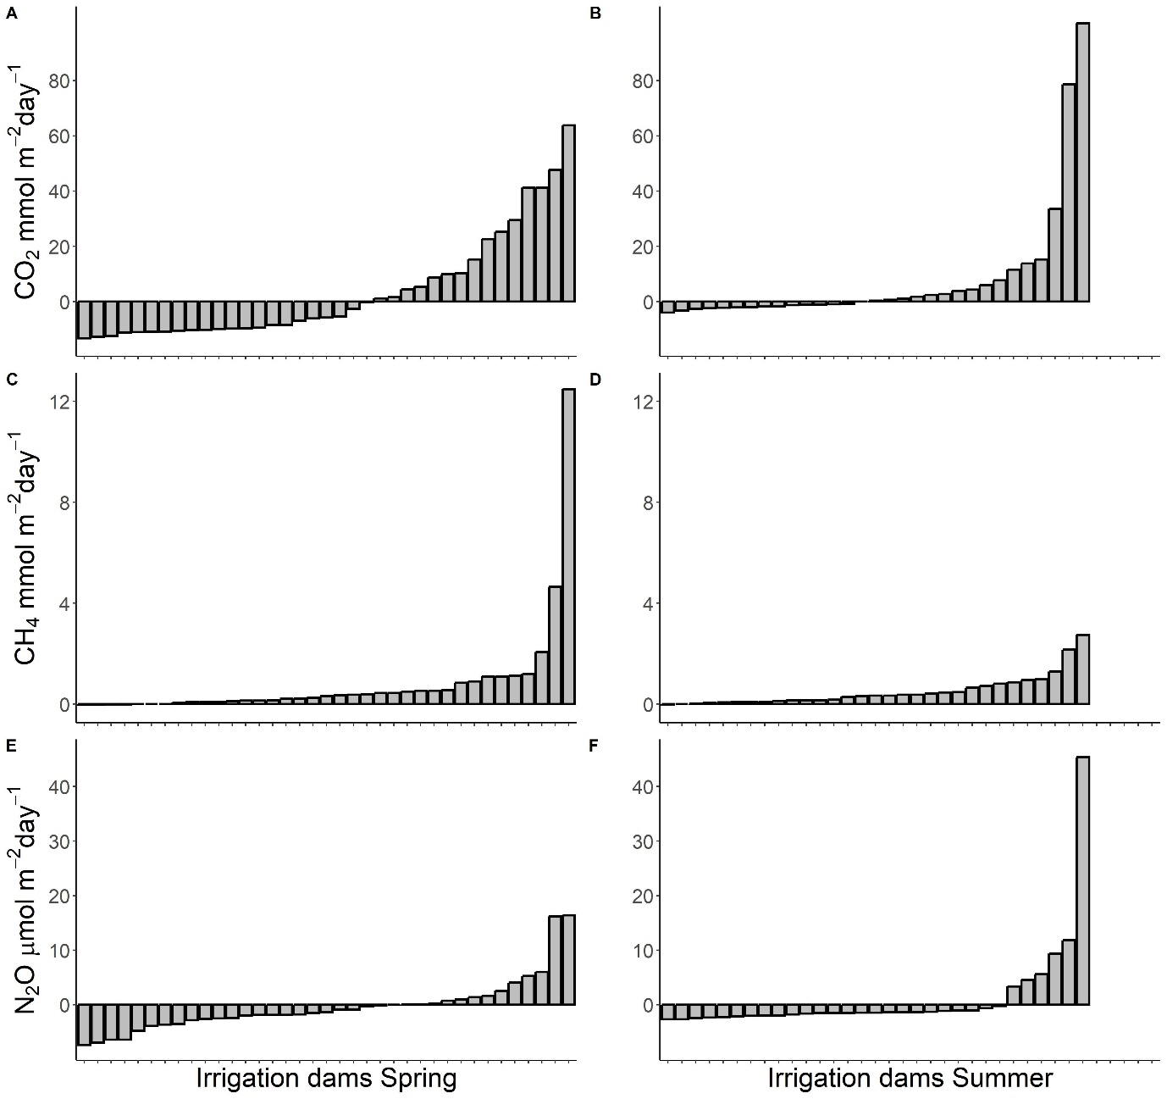
Figure S3: Bar plots of mean daily CO₂ (A, B), CH₄ (C, D), and N₂O (E, F) fluxes of all irrigation farm dams in the spring and summer surveys.
Table S4: Summary of the best-fitting linear mixed effects models used to explain variation in dissolved CO₂, CH₄, N₂O concentrations and CO₂-equivalent emissions. Only models with significant predictor variables are shown. Candidate predictor variables that had a statistically significant effect (p<0.05) are highlighted in bold. Coefficient of determination (r²), p-value (p), root mean squared error (rmse), and number of observations (n) are reported for each model.
Dependent variable | Predictor variables | Final model
Dependent variable | Predictor variables | r² | p | rmse | n
log(CO₂) | DO +  log(NH₄-N) + log(Sediment C) + Size class +  Season | 0.54 | <0.001 | 1.25 | 67
log(CH₄) | sqrt(Soil EC)*Trophic class + Size class +  Season | 0.81 | 0.016 | 0.49 | 67
log10(N₂O) | log(NH₄-N)*DO +  Size class*Season | 0.44 | <0.001 | 0.18 | 68
Log(CO₂-eq + 130) | Size class +  Season | 0.36 | <0.001 | 0.65 | 68
Log(CO₂-eq + 130) | Dam type +  Season | 0.27 | <0.001 | 0.72 | 68

Detailed model outputs of fixed effects for Figures 1-3 in the main article
Table S5: CO₂ LMEM model (Figure 1) fixed effects:
Estimate Std. Error df t value Pr(>|t|)
(Intercept) 5.765707 0.795486 58.878922 7.248 1.04e-09 ***
DO. -0.023045 0.005396 56.997897 -4.271 7.47e-05 ***
log(NH4_N) 0.871055 0.288353 51.099963 3.021 0.00393 **
log(Sediment_C) 0.587910 0.288989 35.421459 2.034 0.04945 *
Size_class0.001-0.01 -0.814865 0.510803 33.345805 -1.595 0.12009
Size_class0.01-0.1 -0.739436 0.578951 30.463833 -1.277 0.21118
Size_class0.1-1 0.741592 1.016561 38.557824 0.730 0.47010
SeasonSummer 1.583313 0.498286 53.204240 3.178 0.00247 **
Signif. codes: 0 ‘***’ 0.001 ‘**’ 0.01 ‘*’ 0.05 ‘.’ 0.1 ‘ ’ 1

Table S6: CH₄ LMEM model (Figure 2) fixed effects:
Estimate Std. Error df t value Pr(>|t|)
(Intercept) 4.1807 1.6789 53.3455 2.490 0.0159 *
sqrt(Soil_EC) -3.4034 1.5785 54.7818 -2.156 0.0355 *
Trophic.classMesotrophic -2.3230 1.7103 46.2460 -1.358 0.1810
Trophic.classEutrophic -4.3170 1.7893 43.4406 -2.413 0.0201 *
Trophic.classHypereutrophic -1.8603 1.9085 52.3434 -0.975 0.3342
Size_class0.001-0.01 -1.5253 0.6238 30.8195 -2.445 0.0204 *
Size_class0.01-0.1 -1.6519 0.7209 32.0658 -2.291 0.0287 *
Size_class0.1-1 -1.1919 1.2374 32.4219 -0.963 0.3426
SeasonSummer 0.3509 0.2241 25.9781 1.566 0.1294
sqrt(Soil_EC):Trophic.classMesotrophic 2.3329 1.5860 40.8279 1.471 0.1490
sqrt(Soil_EC):Trophic.classEutrophic 3.9429 1.7804 43.2983 2.215 0.0321 *
sqrt(Soil_EC):Trophic.classHypereutrophic 1.8651 1.9302 52.1036 0.966 0.3384

Table S6: N₂O LMEM model (Figure 3) fixed effects:
Estimate Std. Error df t value Pr(>|t|)
(Intercept) 1.033469 0.198697 56.929185 5.201 2.8e-06 ***
log(NH4_N) 0.475830 0.141771 55.812759 3.356 0.00143 **
DO. -0.001790 0.001603 56.823263 -1.117 0.26890
Size_class0.001-0.01 0.250693 0.104111 54.682902 2.408 0.01944 *
Size_class0.01-0.1 0.353704 0.120182 54.519931 2.943 0.00477 **
Size_class0.1-1 0.297986 0.194019 54.270964 1.536 0.13038
SeasonSummer 0.420151 0.152423 35.113497 2.756 0.00920 **
log(NH4_N):DO. -0.002549 0.001137 55.487750 -2.241 0.02902 *
Size_class0.001-0.01:SeasonSummer -0.252519 0.160562 26.553257 -1.573 0.12762
Size_class0.01-0.1:SeasonSummer -0.466528 0.174942 24.599510 -2.667 0.01334 *
Size_class0.1-1:SeasonSummer -0.685889 0.320620 31.735205 -2.139 0.04021 *
Signif. codes: 0 ‘***’ 0.001 ‘**’ 0.01 ‘*’ 0.05 ‘.’ 0.1 ‘ ’ 1

References
Jähne, B., Heinz, G., Dietrich, W., 1987. Measurement of the diffusion coefficients of sparingly soluble gases in water. Journal of Geophysical Research: Oceans 92, 10767-10776.
Raymond, P. A., C. J. Zappa, D. Butman, T. L. Bott, J. Potter, P. Mulholland, A. E. Laursen, W. H. McDowell, and D. Newbold (2012), Scaling the gas transfer velocity and hydraulic geometry in streams and small rivers, Limnol. Oceanogr. Fluids Environ., 2(1), 41–53, doi:10.1215/ 21573689‐1597669.

