Table S1 Comparison of global annual ecosystem respiration (ER) estimates by different studies during a defined period.
Period | Annual ER  (mean±sd) | Spatial resolution | Model | Source
1989-2018 | 122.77±0.73 | 0.5°×0.5° | DT-RH | This study
1989-2015 | 121.86±1.01 | 0.5°×0.5° | DT-RH_NDVI | This study
1989-2018 | 115.51±0.31 | 0.5°×0.5° | NT | Jung et al., 2020
1989-2018 | 116.21±0.31 | 0.5°×0.5° | DT | Jung et al., 2020
1989-2014 | 130.04±5.25 | 1.13°×1.12° | BCC-CSM2-MR | Wu et al., 2018
1989-2014 | 101.71±3.78 | 2.81°×2.79° | BCC-ESM1 | Zhang et al., 2018
1989-2014 | 136.13±4.17 | 1.25°×0.94° | CESM2 | Danabasoglu et al., 2019
1989-2014 | 135.05±3.9 | 1.25°×0.94° | CMCC-ESM2 | Lovato et al., 2021
1989-2014 | 136.14±4.55 | 1.25°×0.94° | CMCC-CM2-SR5 | Lovato et al., 2020
1989-2014 | 150.37±5.92 | 1.88°×0.87° | MPI-ESM1-2-LR | Wieners et al., 2019

Table S2 Summary of model performance evaluation for random forest (RF) method. For RMSE, MAE, and RMSLE, the units of those were g C m⁻² month⁻¹. R²: the coefficient of determination; RMSE: the root mean squared error; MAE: the mean absolute error; RMSLE: the root mean squared logarithmic error.

RF model evaluation statistics | R² | RMSE | MAE | RMSLE
Training dataset | 0.713 | 26.462 | 18.528 | 0.401
Testing dataset | 0.715 | 26.322 | 18.525 | 0.402

Fig. S1 Comparison of ER with other products. Global distribution of mean annual ER for the period 1989–2018 derived from DT-RH (a) and the average of 2 FLUXCOM models (b), while for the period 1989-2014 derived from six CMIP6 models (c). (d) The latitudinal distribution of mean annual ER estimated by DT-RH and FLUXCOM and CMIP6 models.

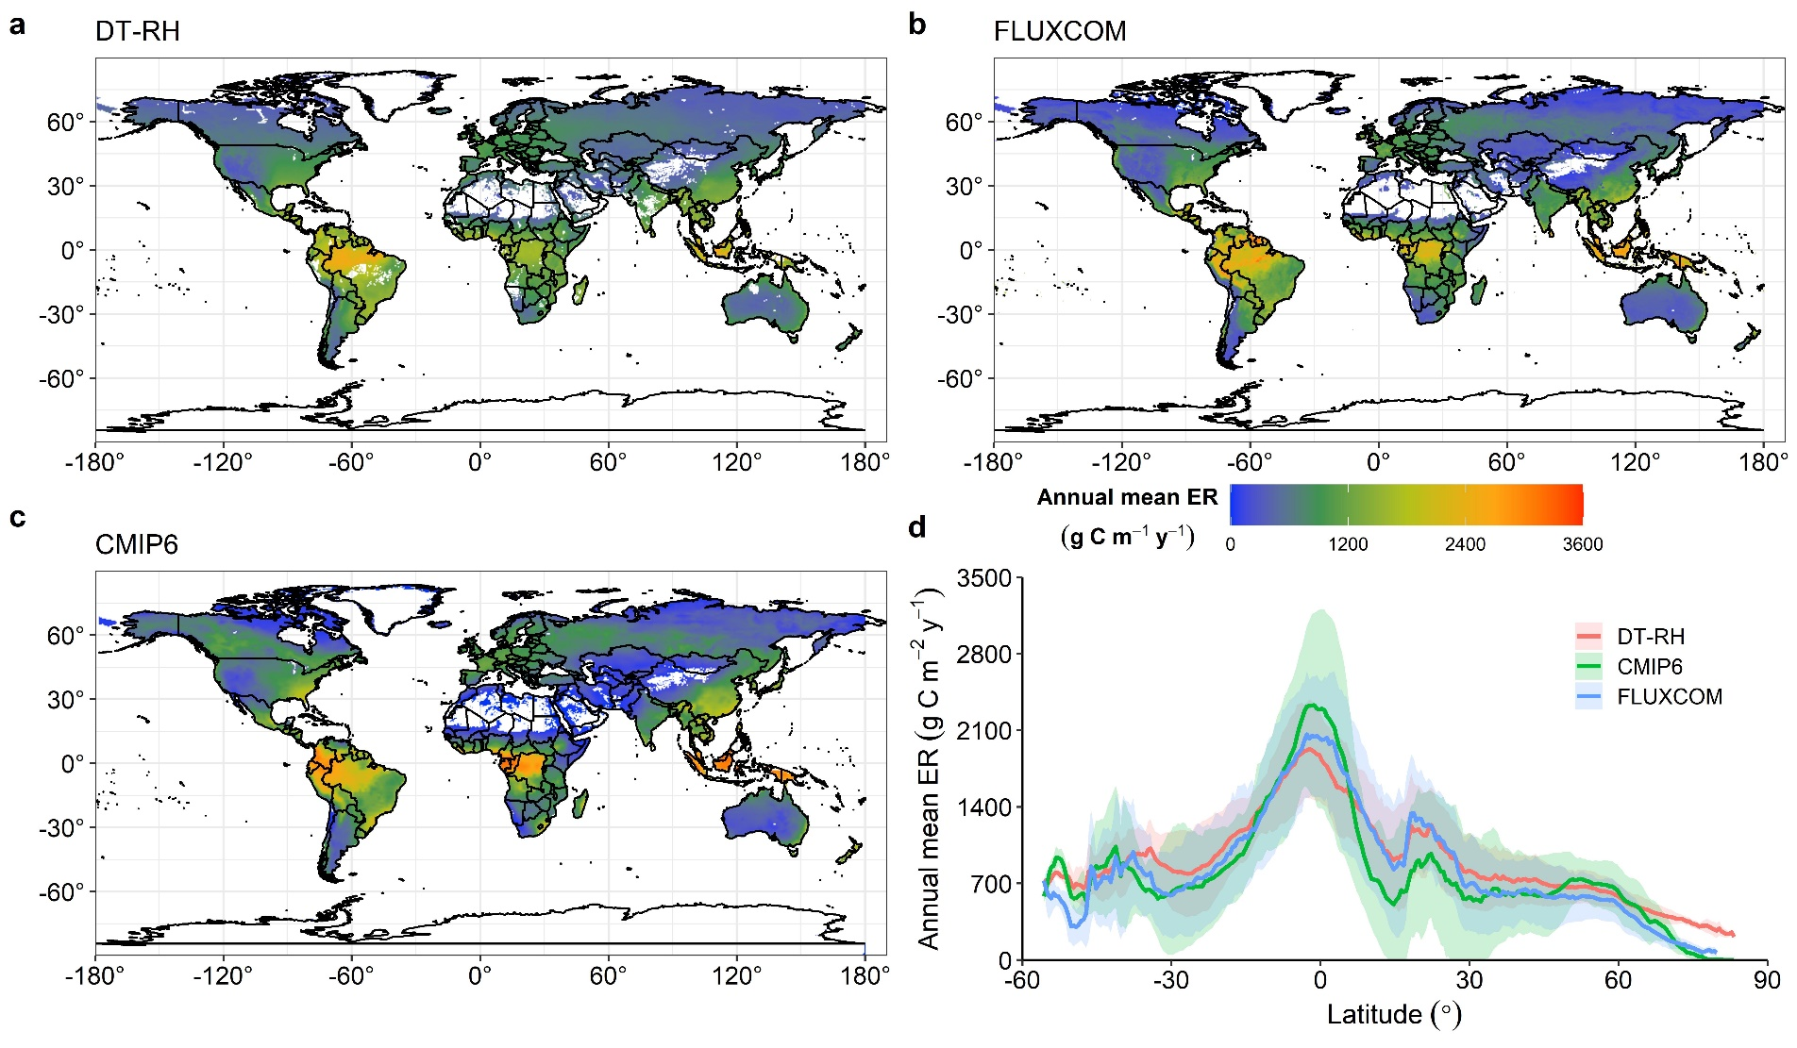

Fig. S2 A difference map of DT-RH minus FLUXCOM and CMIP6 annual sums at the 0.5° grid.
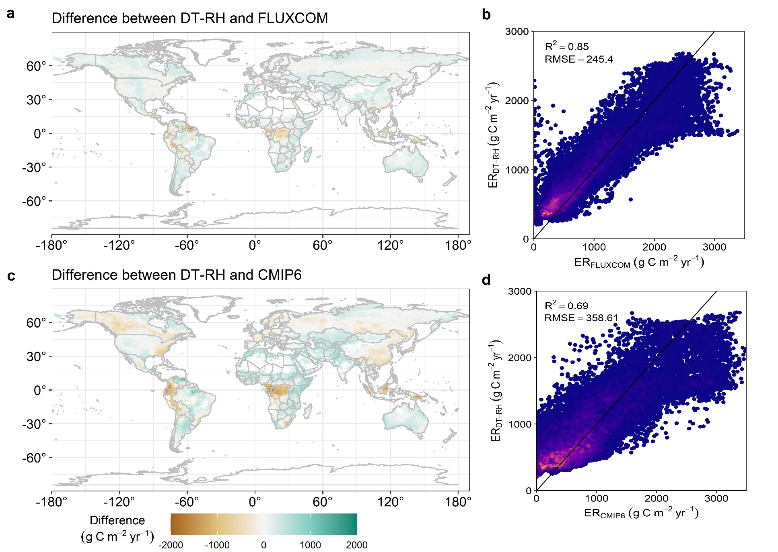

Fig. S3 Long-term changes in annual and monthly integrated ecosystem respiration (ER) model during 1989-2018. (a) Comparison of the changes in trend of global land ER derived from DT-RH (red dots and line), FLUXCOM (blue dots and line) and CMIP6 (green dots and line) during their studied periods. (b-d) The trend of global monthly ER based on DT-RH from January to December.
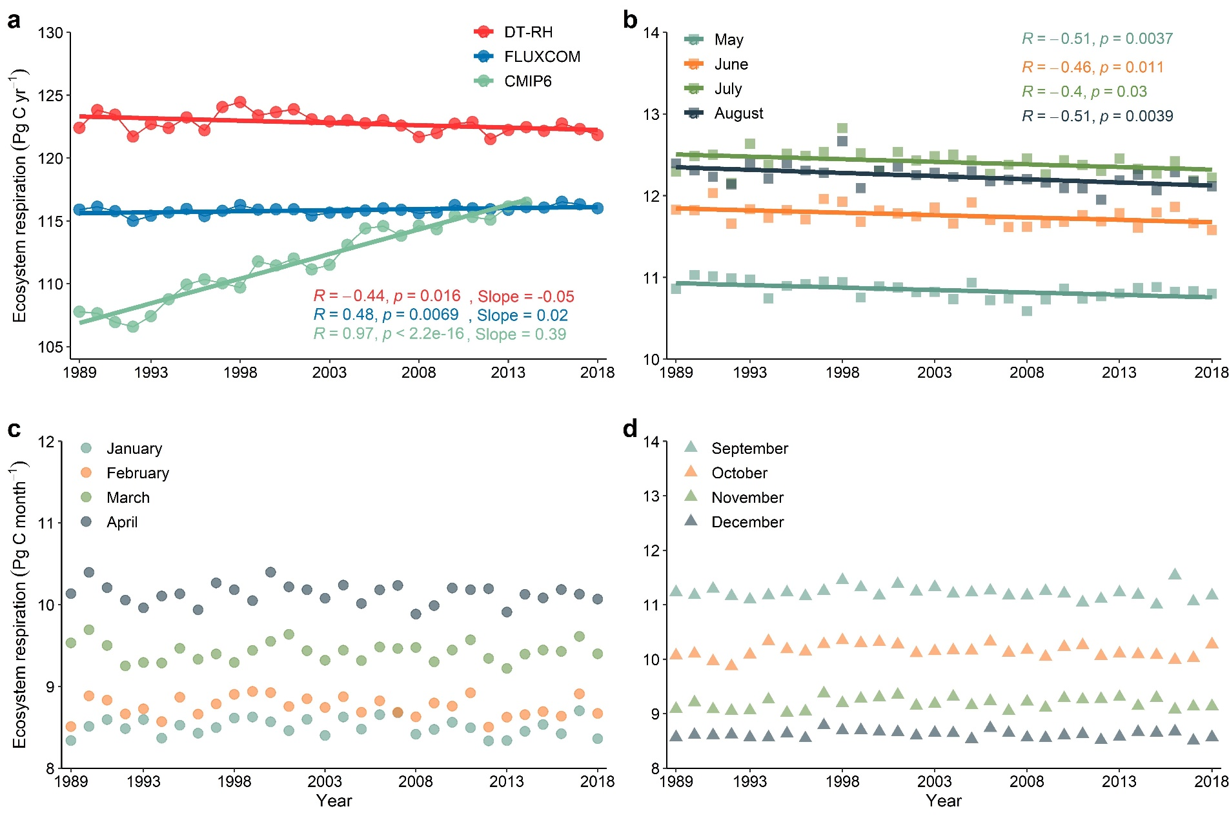

Fig. S4 Spatially explicit trends in annual ER from DT-RH over 1989-2018 (a-b), DT-RH with NDVI over 1989-2015 (c-d), FLUXCOM over 1989-2018 (e-f), and CMIP6 over 1989-2014 (g-h), respectively. Per-pixel trend was characterized using a Theil-Sen median trend analysis and a two-sided Mann-Kendall test. Significant and slight increasing trends correspond to the Theil-Sen estimates greater than or equal to 0.0005, with significant (p < 0.05) and nonsignificant (p > 0.05) Mann-Kendall test, respectively. Significant and slight decreasing trends correspond to the Theil-Sen estimates lower than or equal to -0.0005, with significant (p < 0.05) and nonsignificant (p > 0.05) Mann-Kendall test, respectively. Stable trends correspond to the Theil-Sen estimates from -0.0005 to 0.0005. (b, d, f, h) Normalized frequency distribution of trends derived using the map presented in a, c, e, g, respectively. The color scheme of the histogram bars matches that of the map legend.
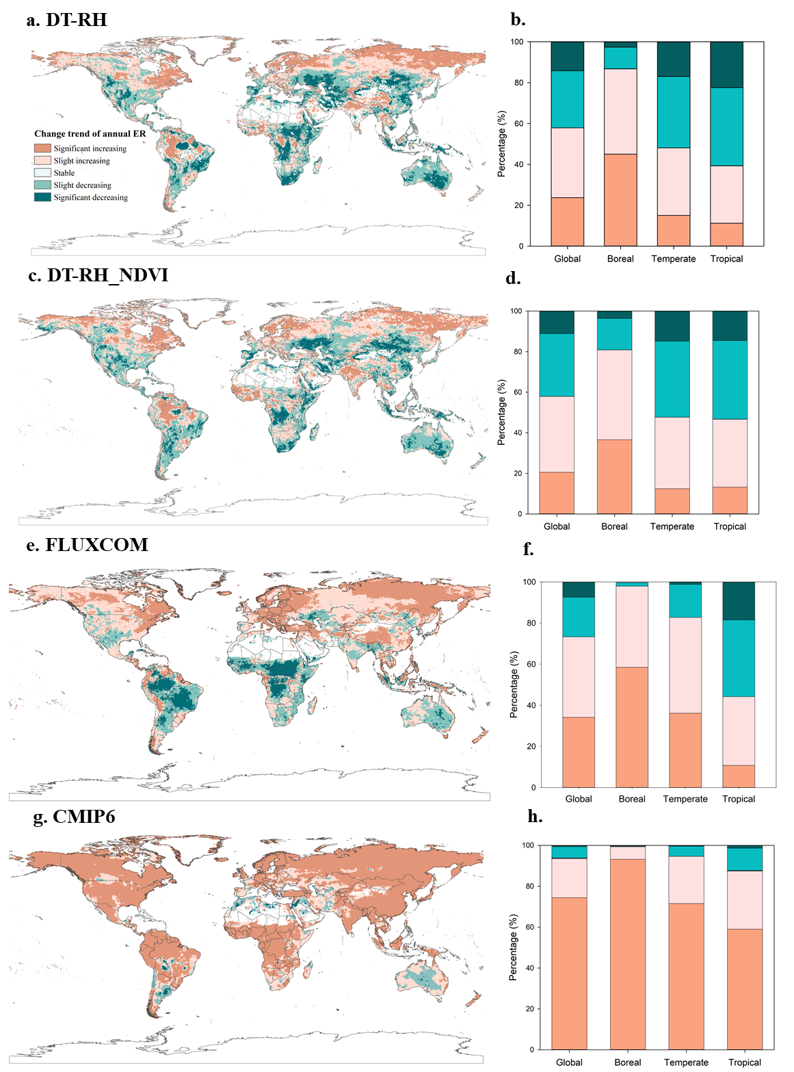

Fig. S5 Temporal changes of climate factors from 1989 to 2018. MAT, mean annual temperature; MAP, mean annual precipitation; Rg, surface solar radiation downwards; SWC, volume of water in soil layer; SPEI, standard precipitation-evapotranspiration index.
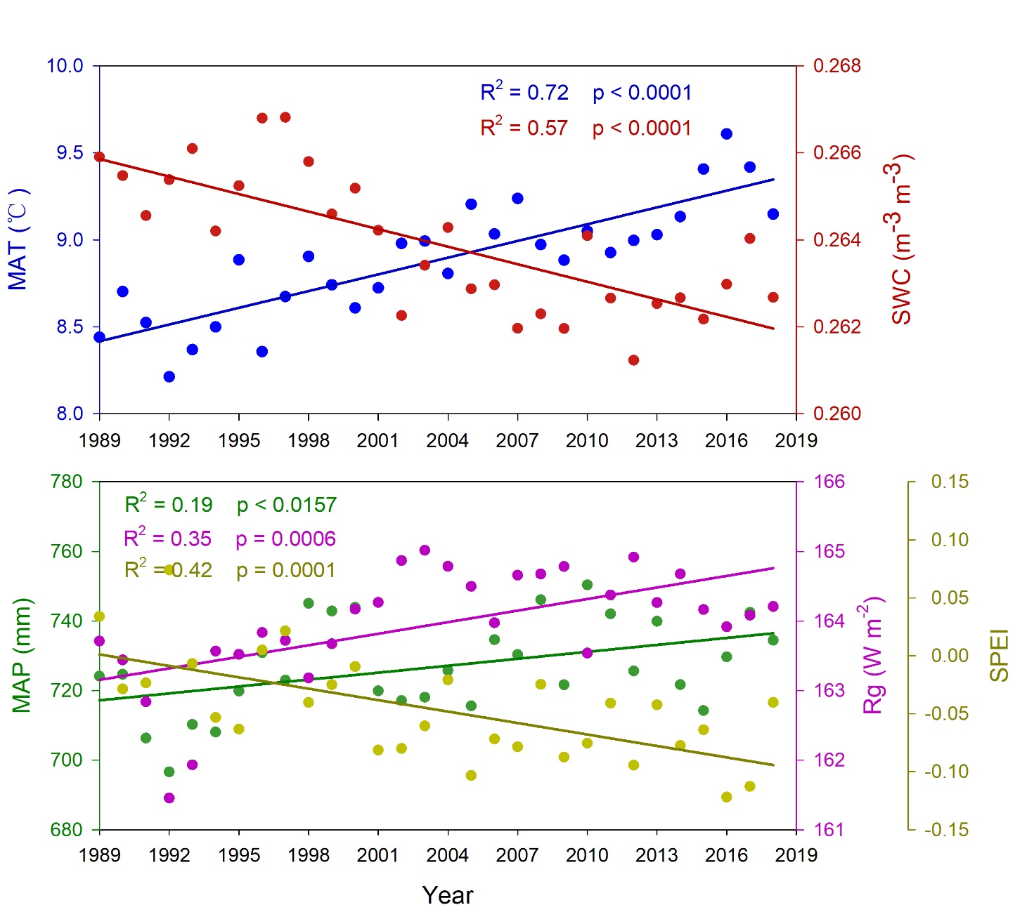

Fig. S6 Spatially explicit trends in annual SWC at 0.5° spatial resolution between 1989-2018(a), 1989-1998(b), and 1998-2018(c). Per-pixel trend was characterized using a Theil-Sen median trend analysis and a two-sided Mann-Kendall test. Significant and slight increasing trends correspond to the Theil-Sen estimates greater than or equal to 0.0005, with significant (p < 0.05) and nonsignificant (p > 0.05) Mann-Kendall test, respectively. Significant and slight decreasing trends correspond to the Theil-Sen estimates lower than or equal to -0.0005, with significant (p < 0.05) and nonsignificant (p > 0.05) Mann-Kendall test, respectively. Stable trends correspond to the Theil-Sen estimates from -0.0005 to 0.0005.

Fig. S7 Partial correlation coefficient between long-term change in annual ER and those in mean annual temperature (MAT) and soil moisture (SWC) during the study periods. Spatial and latitude patterns of partial correlation coefficient between detrended MAT/SWC and detrended annual ER estimated by DT-RH (a, d), FLUXCOM (b, e) and CMIP6 (c, f), respectively.
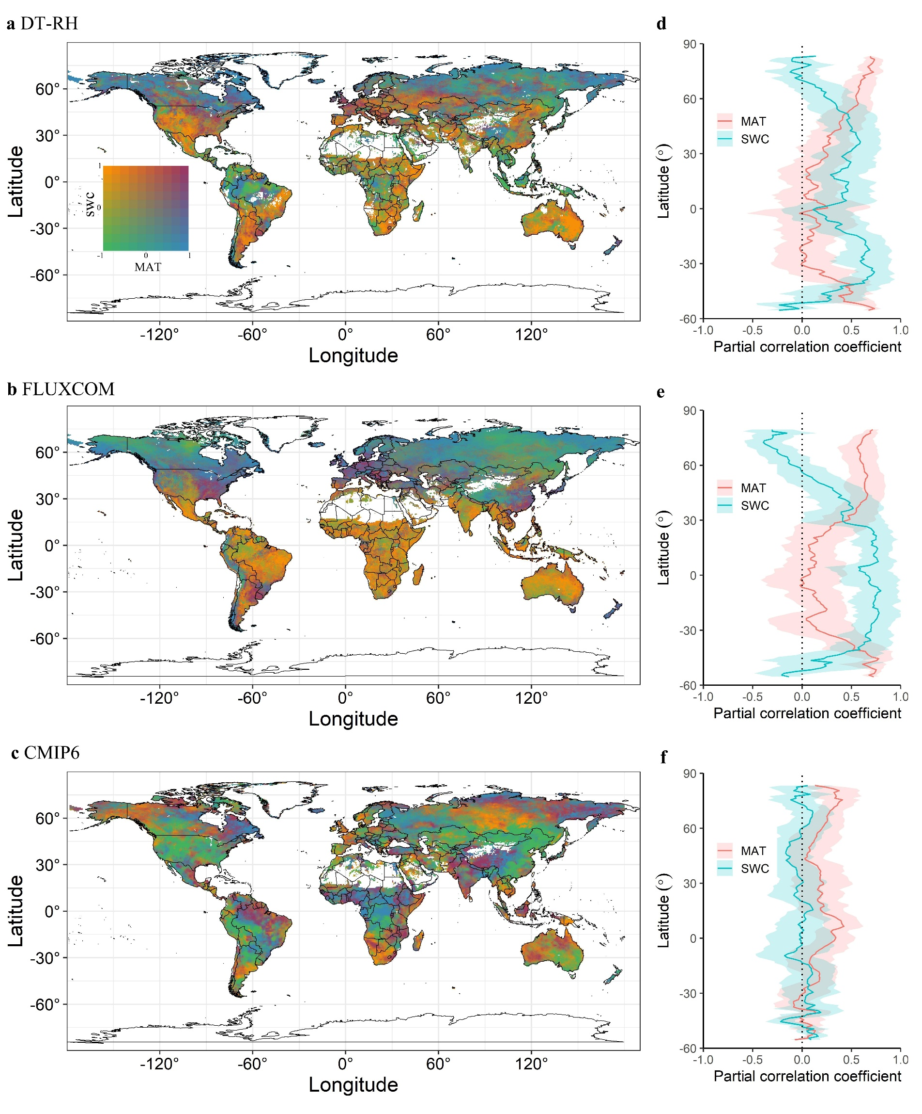

Fig. S8 Global map of flux site. This research collected 197 flux sites with nine type of ecosystem type, including cropland (CRO), deciduous broadleaf forest (DBF), evergreen broadleaf forest (EBF), evergreen needleleaf forest (ENF), mixed froest (MF), grassland (GRA), savannas (SAV), shrubland (SHR), wetland (WET).
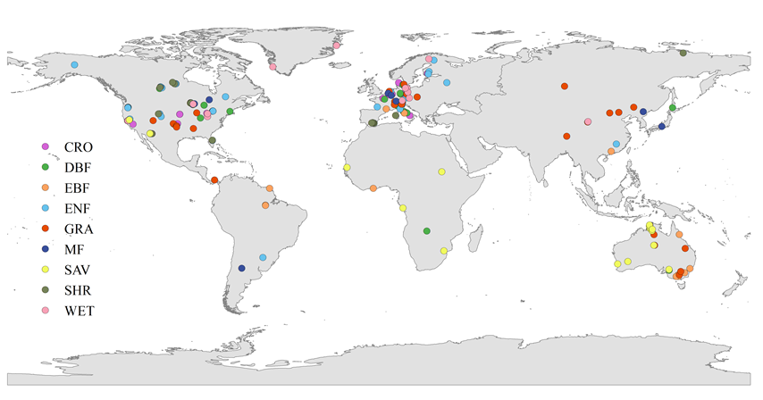

Fig. S9 Summary of model performance evaluation for DT-RH, nighttime (NT) and daytime (DT) partitioning method at site scale. R²: the coefficient of determination; RMSE: the root mean squared error.
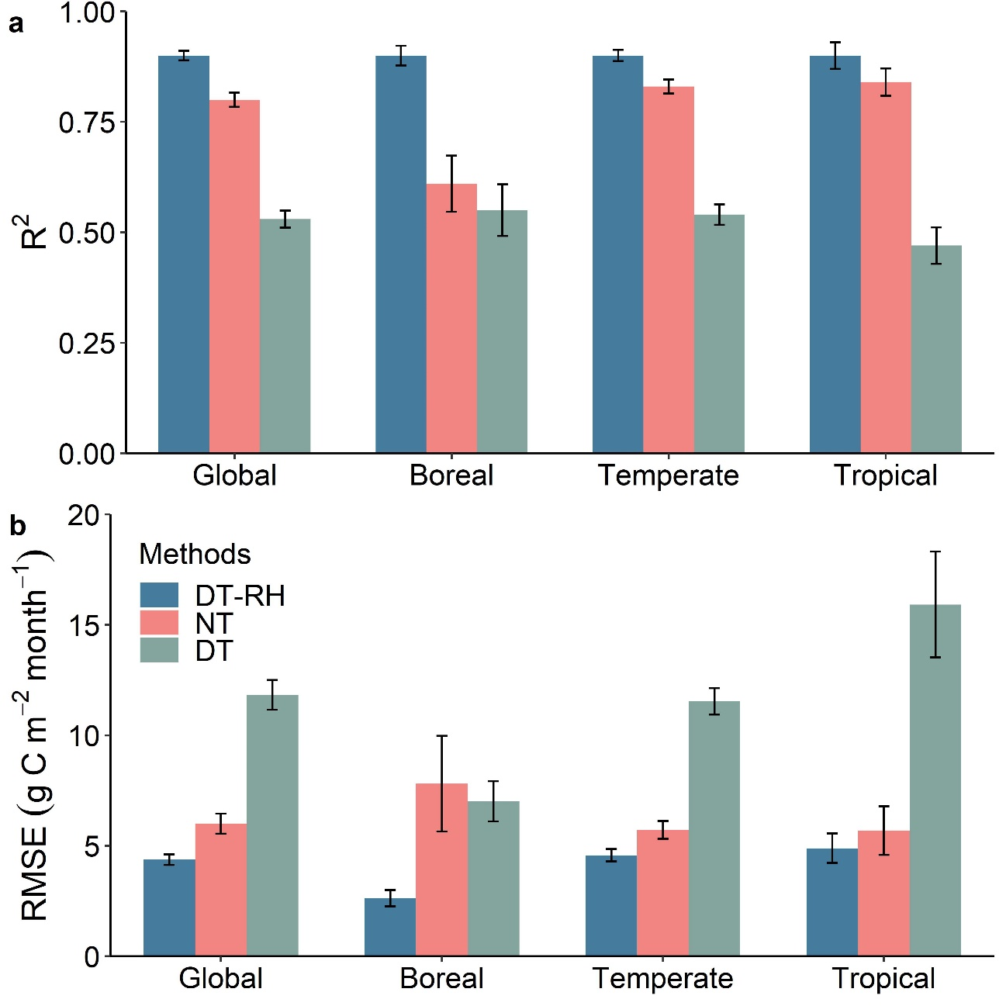

Reference
Danabasoglu, G. NCAR CESM2 model output prepared for CMIP6 CMIP. Earth System Grid Federation. https://doi.org/10.22033/ESGF/CMIP6.7627 (2019)
Lovato, T. & Peano, D. CMCC CMCC-CM2-SR5 model output prepared for CMIP6 CMIP historical. Earth System Grid Federation https://doi.org/10.22033/ESGF/CMIP6.3825 (2020).
Lovato, T., Peano, D. & Butenschön, M. CMCC CMCC-ESM2 model output prepared for CMIP6 CMIP historical. Earth System Grid Federation https://doi.org/10.22033/ESGF/CMIP6.13195 (2021).
Jung, M. et al. Scaling carbon fluxes from eddy covariance sites to globe: synthesis and evaluation of the FLUXCOM approach. Biogeosciences 17, 1343–1365 (2020).
Wieners, K.-H. et al. MPI-M MPI-ESM1.2-LR model output prepared for CMIP6 CMIP historical. Earth System Grid Federation https://doi.org/10.22033/ESGF/CMIP6.6595 (2019).
Wu, T. et al. BCC BCC-CSM2MR model output prepared for CMIP6 CMIP historical. Earth System Grid Federation https://doi.org/10.22033/ESGF/CMIP6.2948 (2018).
Zhang, J. et al. BCC BCC-ESM1 model output prepared for CMIP6 CMIP historical. Earth System Grid Federation https://doi.org/10.22033/ESGF/CMIP6.2949 (2018).

