Supplementary Materials for
Alcohol consumption, Smoking, Coffee and Tea intake do not affect the risk of Cutaneous melanoma: a two-sample Mendelian randomization study
Yuming Sun¹⁻⁵, Qian Zhou¹⁻⁴, Yating Dian¹⁻⁴, Lifang Zhang⁶, Yu Meng¹⁻⁴, Daishi Li¹⁻⁴, Yihuang Liu¹⁻⁴, Furong Zeng⁷, Shaorong Lei*⁵, Guangtong Deng*¹⁻⁴

Correspondence: Guangtong Deng, dengguangtong@outlook.com

The file includes:

Figure. S1 to S64

Figure S1 the scatter plot of the effect of alcohol consumption on cutaneous melanoma (2021 Jiang et al.)

Figure S2 the funnel plot of the effect of alcohol consumption on cutaneous melanoma (2021 Jiang et al.)

Figure S3 the forest plot of the effect of alcohol consumption on cutaneous melanoma (2021 Jiang et al.)
Figure S4 the leave-one-out plot of the effect of alcohol consumption on cutaneous melanoma (2021 Jiang et al.)

Figure S5 the scatter plot of the effect of alcohol consumption on cutaneous melanoma (2018 UKB)
Figure S6 the funnel plot of the effect of alcohol consumption on cutaneous melanoma (2018 UKB)

Figure S7 the forest plot of the effect of alcohol consumption on cutaneous melanoma (2018 UKB)
Figure S8 the leave-one-out plot of the effect of alcohol consumption on cutaneous melanoma (2018 UKB)

Figure S9 the scatter plot of the effect of alcoholic drinks per week on cutaneous melanoma (2021 Jiang et al.)
Figure S10 the funnel plot of the effect of alcoholic drinks per week on cutaneous melanoma (2021 Jiang et al.)

Figure S11 the forest plot of the effect of alcoholic drinks per week on cutaneous melanoma (2021 Jiang et al.)
Figure S12 the leave-one-out plot of the effect of alcoholic drinks per week on cutaneous melanoma (2021 Jiang et al.)

Figure S13 the scatter plot of the effect of alcoholic drinks per week on cutaneous melanoma (2018 UKB)
Figure S14 the funnel plot of the effect of alcoholic drinks per week on cutaneous melanoma (2018 UKB)

Figure S15 the forest plot of the effect of alcoholic drinks per week on cutaneous melanoma (2018 UKB)
Figure S16 the leave-one-out plot of the effect of alcoholic drinks per week on cutaneous melanoma (2018 UKB)
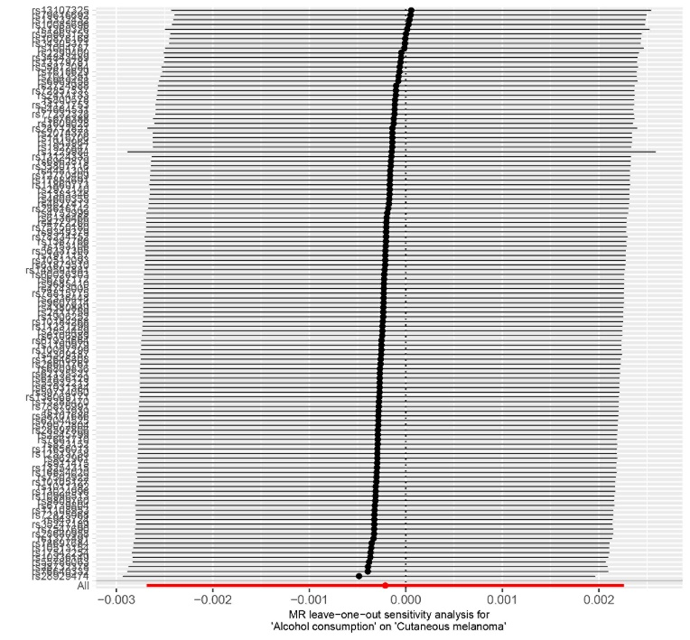
Figure S17 the scatter plot of the effect of alcohol dependence on cutaneous melanoma (2021 Jiang et al.)
Figure S18 the funnel plot of the effect of alcohol dependence on cutaneous melanoma (2021 Jiang et al.)

Figure S19 the forest plot of the effect of alcohol dependence on cutaneous melanoma (2021 Jiang et al.)
Figure S20 the leave-one-out plot of the effect of alcohol dependence on cutaneous melanoma (2021 Jiang et al.)

Figure S21 the scatter plot of the effect of alcohol dependence on cutaneous melanoma (2018 UKB)
Figure S22 the funnel plot of the effect of alcohol dependence on cutaneous melanoma (2018 UKB)

Figure S23 the forest plot of the effect of alcohol dependence on cutaneous melanoma (2018 UKB)
Figure S24 the leave-one-out plot of the effect of alcohol dependence on cutaneous melanoma (2018 UKB)
Figure S25 the scatter plot of the effect of smoking initiation on cutaneous melanoma (2021 Jiang et al.)
Figure S26 the funnel plot of the effect of smoking initiation on cutaneous melanoma (2021 Jiang et al.)

Figure S27 the forest plot of the effect of smoking initiation on cutaneous melanoma (2021 Jiang et al.)
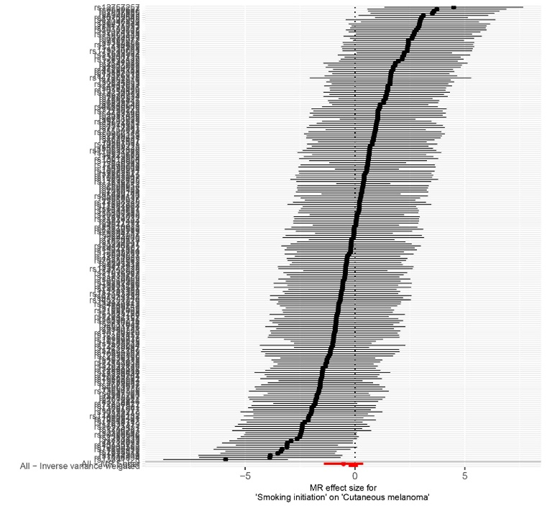
Figure S28 the leave-one-out plot of the effect of smoking initiation on cutaneous melanoma (2021 Jiang et al.)
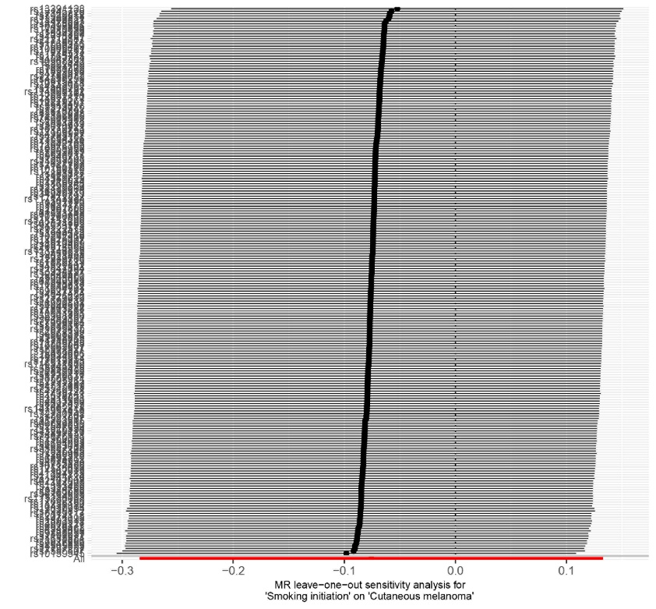

Figure S29 the scatter plot of the effect of smoking initiation on cutaneous melanoma (2018 UKB)
Figure S30 the funnel plot of the effect of smoking initiation on cutaneous melanoma (2018 UKB)

Figure S31 the forest plot of the effect of smoking initiation on cutaneous melanoma (2018 UKB)
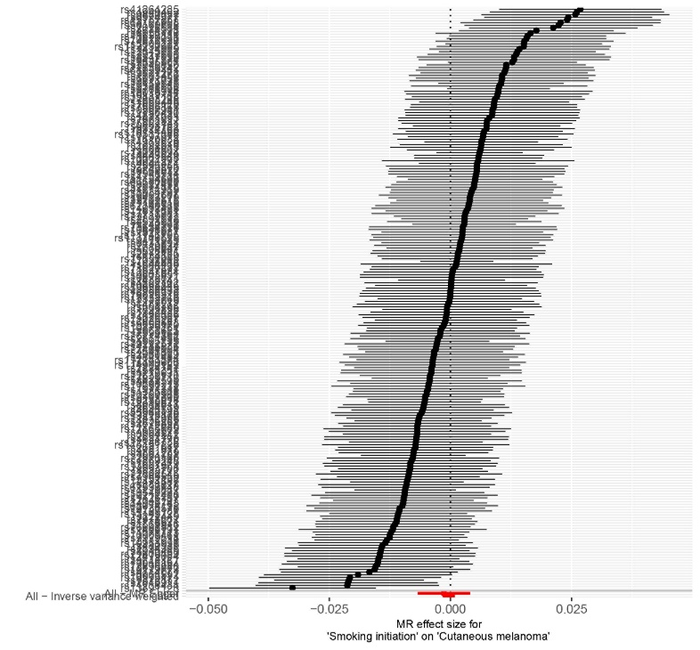
Figure S32 the leave-one-out plot of the effect of smoking initiation on cutaneous melanoma (2018 UKB)
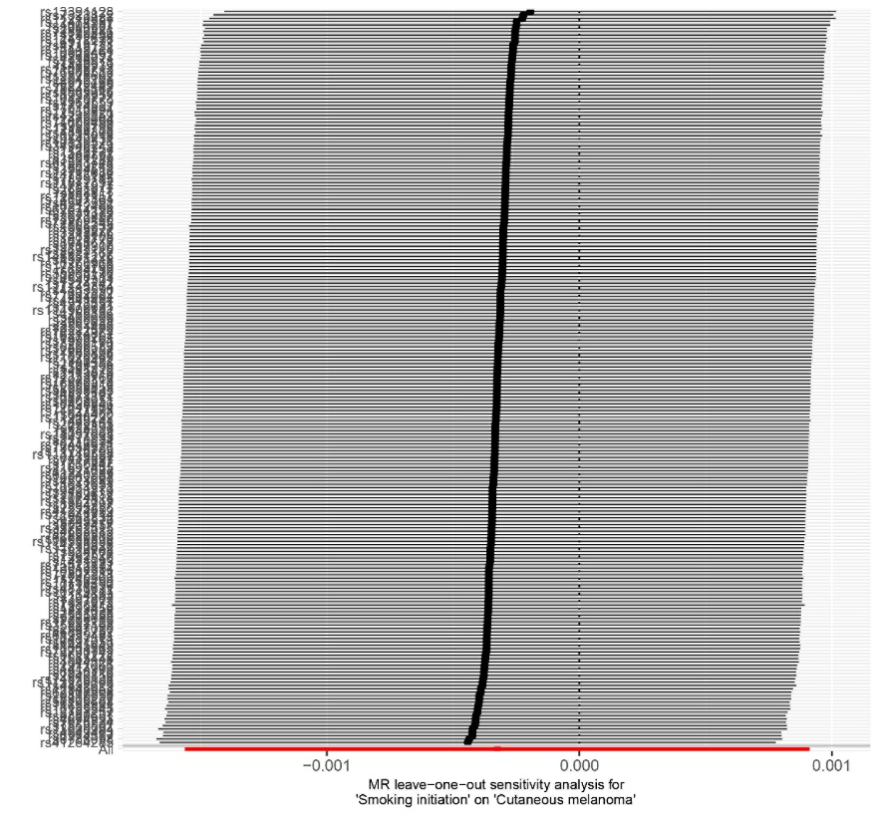
Figure S33 the scatter plot of the effect of cigarettes per day on cutaneous melanoma (2021 Jiang et al.)
Figure S34 the funnel plot of the effect of cigarettes per day on cutaneous melanoma (2021 Jiang et al.)

Figure S35 the forest plot of the effect of cigarettes per day on cutaneous melanoma (2021 Jiang et al.)
Figure S36 the leave-one-out plot of the effect of cigarettes per day on cutaneous melanoma (2021 Jiang et al.)

Figure S37 the scatter plot of the effect of cigarettes per day on cutaneous melanoma (2018 UKB)
Figure S38 the funnel plot of the effect of cigarettes per day on cutaneous melanoma (2018 UKB)

Figure S39 the forest plot of the effect of cigarettes per day on cutaneous melanoma (2018 UKB)
Figure S40 the leave-one-out plot of the effect of cigarettes per day on cutaneous melanoma (2018 UKB)
Figure S41 the scatter plot of the effect of smoking cessation on cutaneous melanoma (2021 Jiang et al.)
Figure S42 the funnel plot of the effect of smoking cessation on cutaneous melanoma (2021 Jiang et al.)

Figure S43 the forest plot of the effect of smoking cessation on cutaneous melanoma (2021 Jiang et al.)
Figure S44 the leave-one-out plot of the effect of smoking cessation on cutaneous melanoma (2021 Jiang et al.)

Figure S45 the scatter plot of the effect of smoking cessation on cutaneous melanoma (2018 UKB)
Figure S46 the funnel plot of the effect of smoking cessation on cutaneous melanoma (2018 UKB)

Figure S47 the forest plot of the effect of smoking cessation on cutaneous melanoma (2018 UKB)
Figure S48 the leave-one-out plot of the effect of smoking cessation on cutaneous melanoma (2018 UKB)
Figure S49 the scatter plot of the effect of coffee intake on cutaneous melanoma (2021 Jiang et al.)
Figure S50 the funnel plot of the effect of coffee intake on cutaneous melanoma (2021 Jiang et al.)

Figure S51 the forest plot of the effect of coffee intake on cutaneous melanoma (2021 Jiang et al.)
Figure S52 the leave-one-out plot of the effect of coffee intake on cutaneous melanoma (2021 Jiang et al.)

Figure S53 the scatter plot of the effect of coffee intake on cutaneous melanoma (2018 UKB)
Figure S54 the funnel plot of the effect of coffee intake on cutaneous melanoma (2018 UKB)

Figure S55 the forest plot of the effect of coffee intake on cutaneous melanoma (2018 UKB)
Figure S56 the leave-one-out plot of the effect of coffee intake on cutaneous melanoma (2018 UKB)
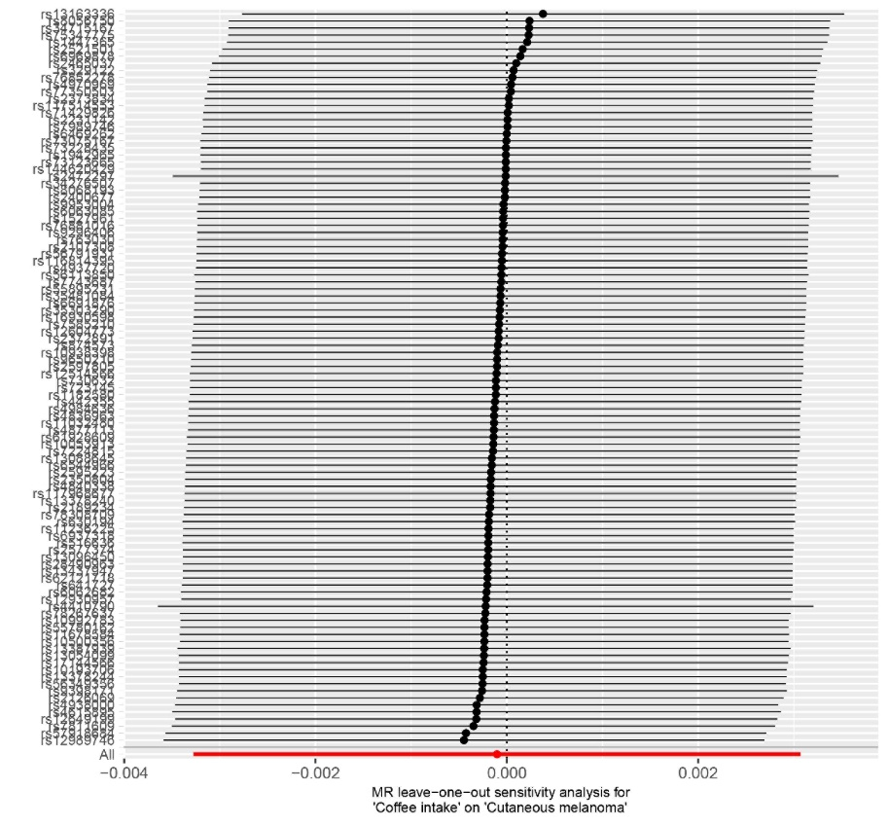
Figure S57 the scatter plot of the effect of tea intake on cutaneous melanoma (2021 Jiang et al.)
Figure S58 the funnel plot of the effect of tea intake on cutaneous melanoma (2021 Jiang et al.)

Figure S59 the forest plot of the effect of tea intake on cutaneous melanoma (2021 Jiang et al.)
Figure S60 the leave-one-out plot of the effect of tea intake on cutaneous melanoma (2021 Jiang et al.)
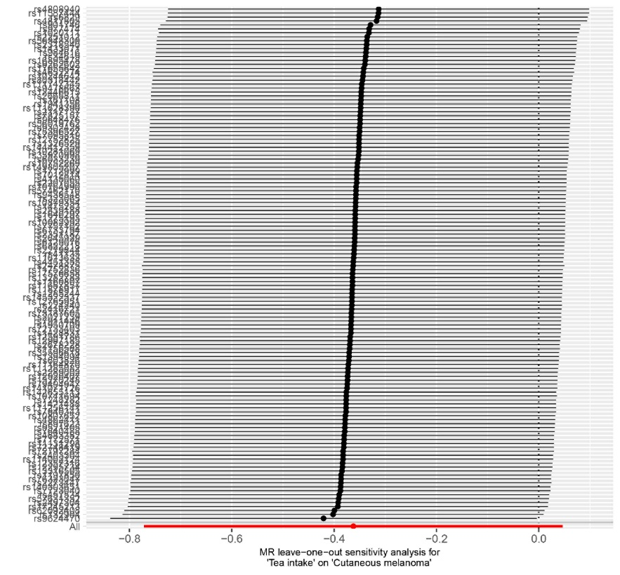

Figure S61 the scatter plot of the effect of tea intake on cutaneous melanoma (2018 UKB)
Figure S62 the funnel plot of the effect of tea intake on cutaneous melanoma (2018 UKB)

Figure S63 the forest plot of the effect of tea intake on cutaneous melanoma (2018 UKB)
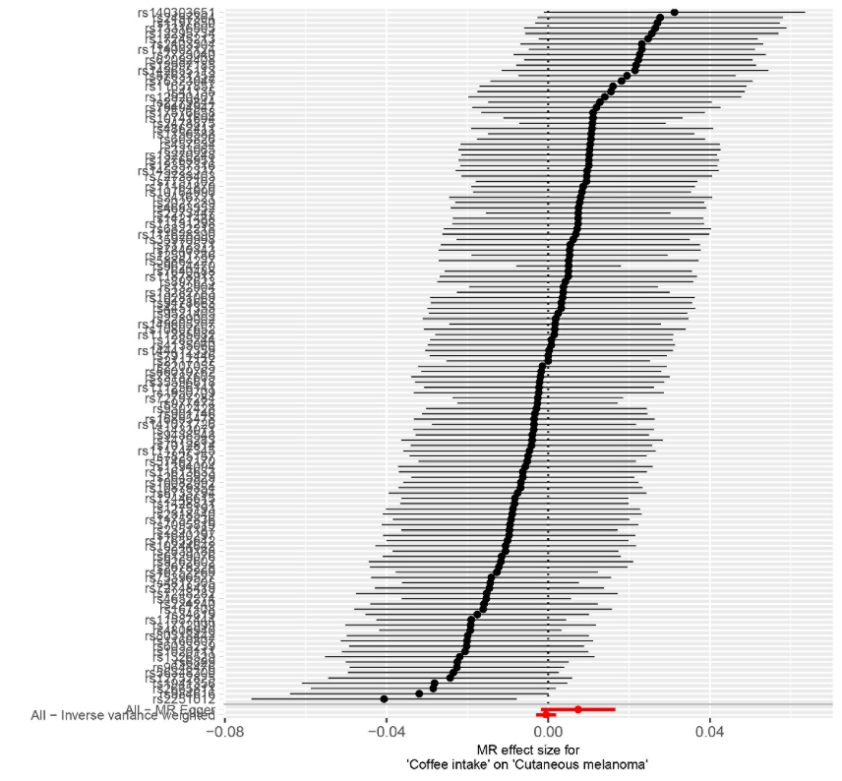
Figure S64 the leave-one-out plot of the effect of tea intake on cutaneous melanoma (2018 UKB)
