Carbon Consumption and Adsorption-Regeneration of H₂S on Activated Carbon for Coke Oven Flue Gas Purification
Yuting Lin ¹, Yuran Li ^{1, *}, Zhicheng Xu ^{1, 3}, Junxiang Guo ¹, Tingyu Zhu ^{1, 2 *}
¹ CAS Key Laboratory of Green Process and Engineering, Institute of Process Engineering, Innovation Academy for Green Manufacture, Chinese Academy of Sciences, Beijing 100190, China
² Center for Excellence in Regional Atmospheric Environment, Institute of Urban Environment, Chinese Academy of Sciences, Xiamen 361021, China
³ University of Chinese Academy of Sciences, Beijing 100049, China
E-mail: yrli@ipe.ac.cn
The amount of the sulfur-containing products in different AC samples was analyzed by XPS measurements and the results are presented in Fig. S1. The presence of peaks can be assigned to S 2p_{1/2} at 165.4 eV, S 2p_{3/2} at 164.2 eV, SO₃²⁻ at 166.7 eV; and SO₄²⁻ at 169.2 eV. The sum of areas of the S 2p_{1/2} and S 2p_{3/2} represents elemental sulfur.
Fig. S1 S 2p spectra from XPS for the activated carbon samples
To further clarify the difference in surface morphology of activated carbon before and after regeneration, XPS was employed to investigate the chemical composition of C and O, with the obtained spectra shown in Fig. S2. C 1s spectra were well-fitted with six peaks, which were signed to peak 1 at 290.4 eV (π-π*), peak 2 at 288.6 eV (O-C=O), peak 3 at 287.3 eV (C=O), peak 4 at 286.4 eV (C-O), peak 5 at 285.5 eV (C-S), peak 6 at 284.7 eV (C-C/C=C). The O 1s spectra included peak1 at 531.5 eV (C=O), peak 2 at 532.6 eV (OH), peak 3 at 533.5 eV (C-O-C), peak 4 at 534.8 eV (COOH), peak 5 at 536.3 eV (adsorbed water and/or oxygen). The C 1s and O 1s peaks are described in detail in Tables S1 and S2.
Fig. S2 C 1s and O 1s XPS spectra for one activated carbon sample
Table S1 Content of different carbon functional groups in the samples (%)
Samples | π-π* | O-C=O | C=O | C-O | C-S | C-C/C=C
Fresh AC | 1.3 | 5.7 | 7.2 | 7.0 | 20.9 | 57.9
Blank | 0.9 | 3.7 | 7.9 | 10.2 | 18.7 | 58.6
AC₁ | 0.4 | 5.2 | 3.3 | 12.7 | 25.5 | 52.9
AC₂ | 1.2 | 6.2 | 6.5 | 8.1 | 19.6 | 58.4
AC₃ | 1.9 | 5.9 | 6.4 | 7.4 | 21.3 | 57.1
Blank-re | 2.9 | 3.3 | 13.4 | 10.3 | 12.1 | 58.0
AC₁-re | 4.1 | 6.1 | 17.0 | 12.5 | 10.1 | 50.2
AC₂-re | 3.2 | 6.0 | 19.5 | 15.7 | 8.9 | 46.7
AC₃-re | 6.1 | 7.2 | 20.7 | 12.4 | 9.6 | 44.0
Table S2 Content of different oxygen functional groups in the samples (%)
Samples | C=O | OH | C-O-C | COOH | H₂O
Fresh AC | 31.6 | 25.6 | 23.4 | 14.7 | 4.7
Blank | 33.1 | 23.7 | 22.9 | 13.9 | 6.4
AC₁ | 20.9 | 36.4 | 22.1 | 15.6 | 5.0
AC₂ | 34.9 | 15.6 | 24.0 | 17.9 | 7.6
AC₃ | 35.4 | 12.4 | 27.2 | 18.1 | 6.9
Blank-re | 57.6 | 10.9 | 22.8 | 4.6 | 4.1
AC₁-re | 52.8 | 14.4 | 24.1 | 7.5 | 1.2
AC₂-re | 58.4 | 11.7 | 23.9 | 5.1 | 0.9
AC₃-re | 56.5 | 13.1 | 24.5 | 5.3 | 0.6
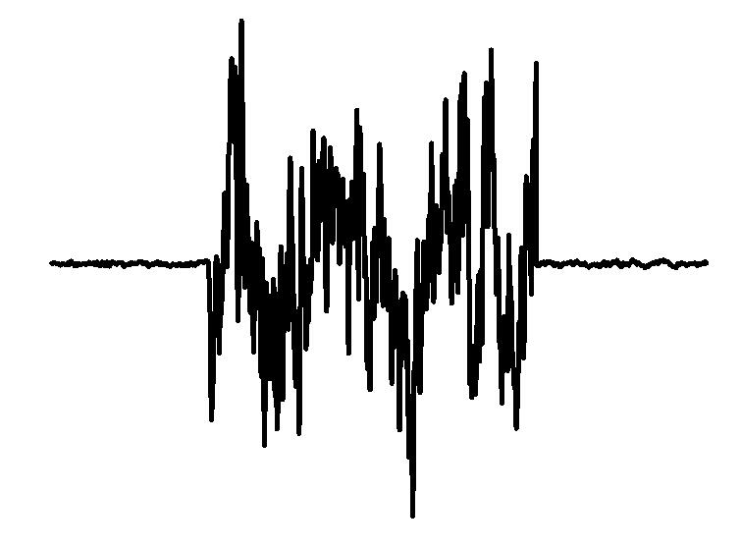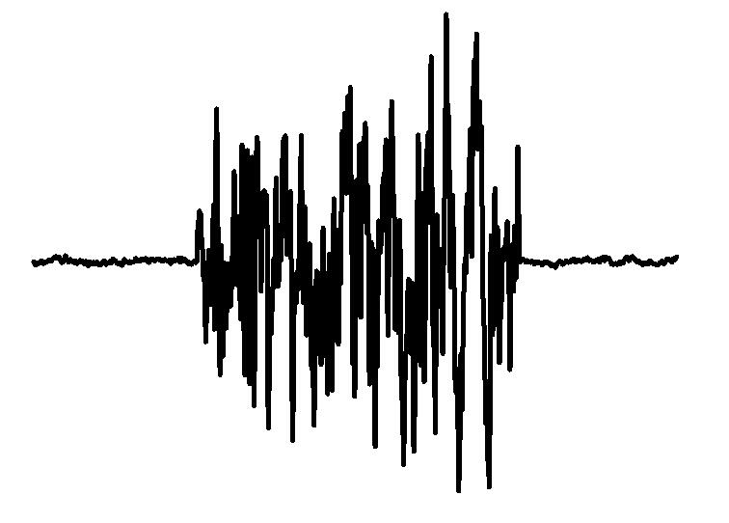
- (b)
Fig. S3 ESR spectra of elemental sulfur in 150 ℃ (a) and 400 ℃ (b)

