Supplementary material

Bioactive VS₄-based sonosensitizer for robust chemodynamic, sonodynamic and osteogenic therapy of infected bone defects

Yaqi He¹, Xin Liu², Jie Lei¹, Liang Ma¹, Xiaoguang Zhang¹, Hongchuan Wang¹, Chunchi Lei¹, Xiaobo Feng¹, Cao Yang¹, and Yong Gao¹

¹ Department of Orthopaedics, Union Hospital, Tongji Medical College, Huazhong University of Science and Technology, 430022 Wuhan, China
² Department of Ophthalmology, Union Hospital, Tongji Medical College, Huazhong University of Science and Technology, Wuhan 430022, China

Corresponding authors: Cao Yang and Yong Gao.
E-mail: caoyangunion@hust.edu.cn (C. Yang); docgao@163.com (Y. Gao)

Yaqi He and Xin Liu contributed equally to this work, regarding as the first author.

Figure S1. Temperature changes during antibacterial treatment. The thermal energy produced by ultrasound during antibacterial treatment was observed with a thermal imager. The material had little effect on the temperature variation.

Figure S2. H₂O₂ reduction test. Hydrogen Peroxide Assay Kit was used to test the H₂O₂ reduction rate, which was mainly benefit by the Pox-like activity of VS₄

Figure S3. Materials morphology. a TEM of VS₄ nanorods; b TEM of MXene nanosheets

Figure S4. characterization of nanoparticles. a Zeta potential of VS₄, MXene and 3VSM. b the survey XPS spectra of VS₄, MXene and 3VSM. c XPS spectrum in Ti 2p mode d Schottky junction mechanism.

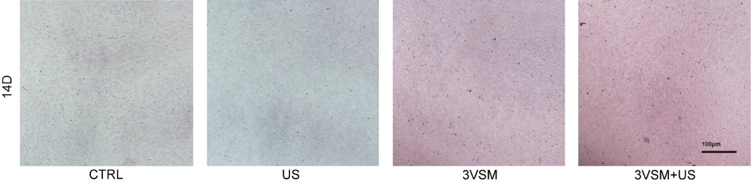
Figure S5. ARS staining of hBMSCs on day 14. After 14 days culture, hBMSCs was stained with ARS.

