Additional file 5:

(a)  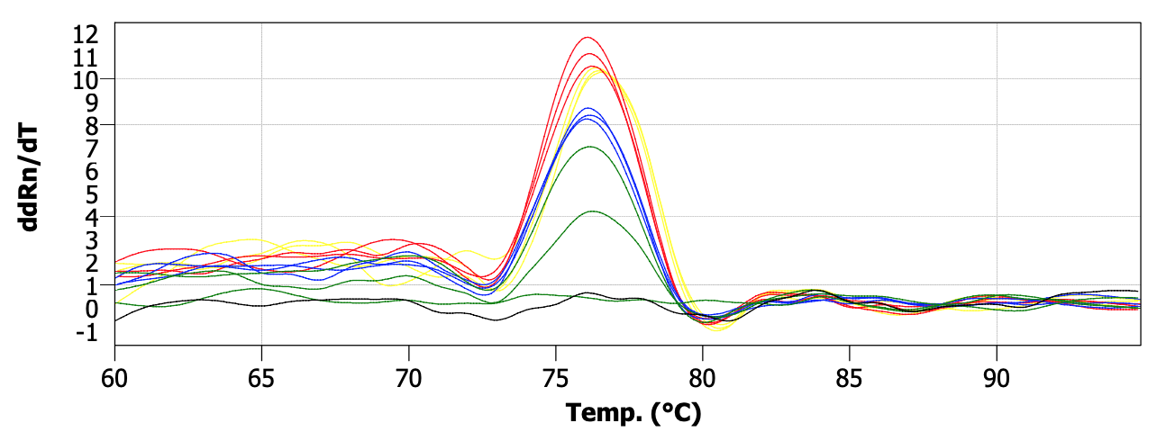 | (b)  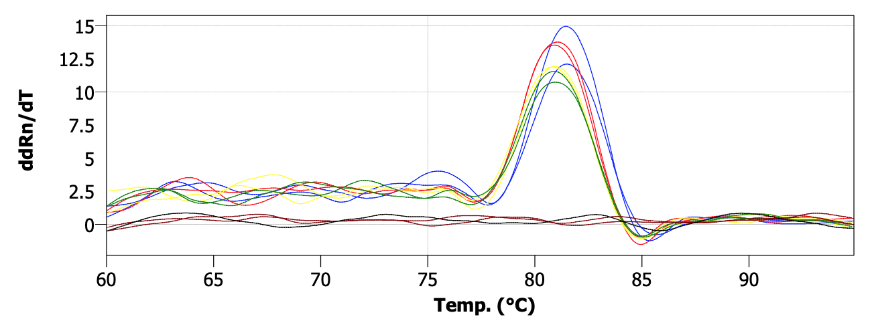
(c)  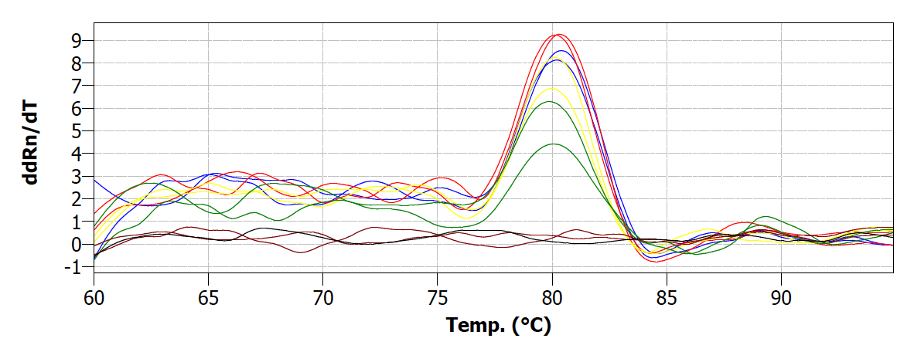 | (d)  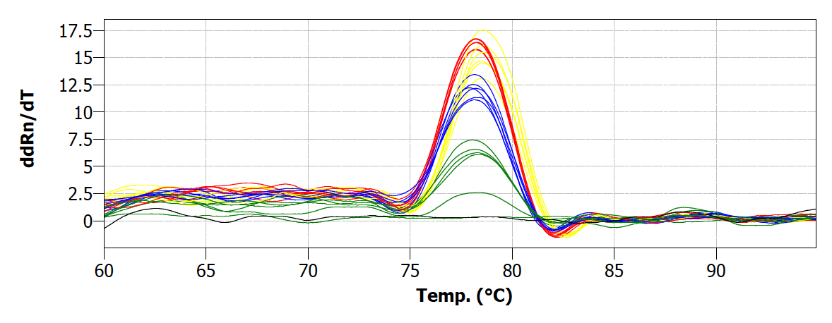
(e)  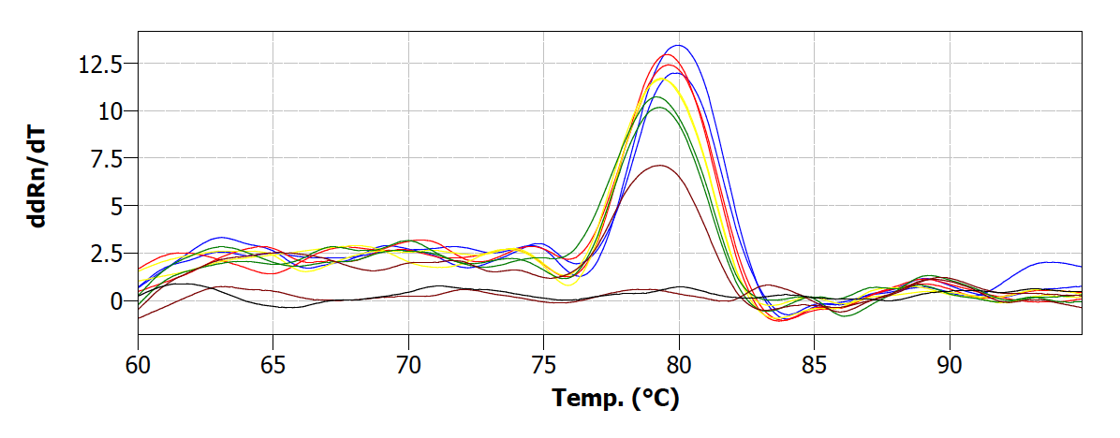 | (f)  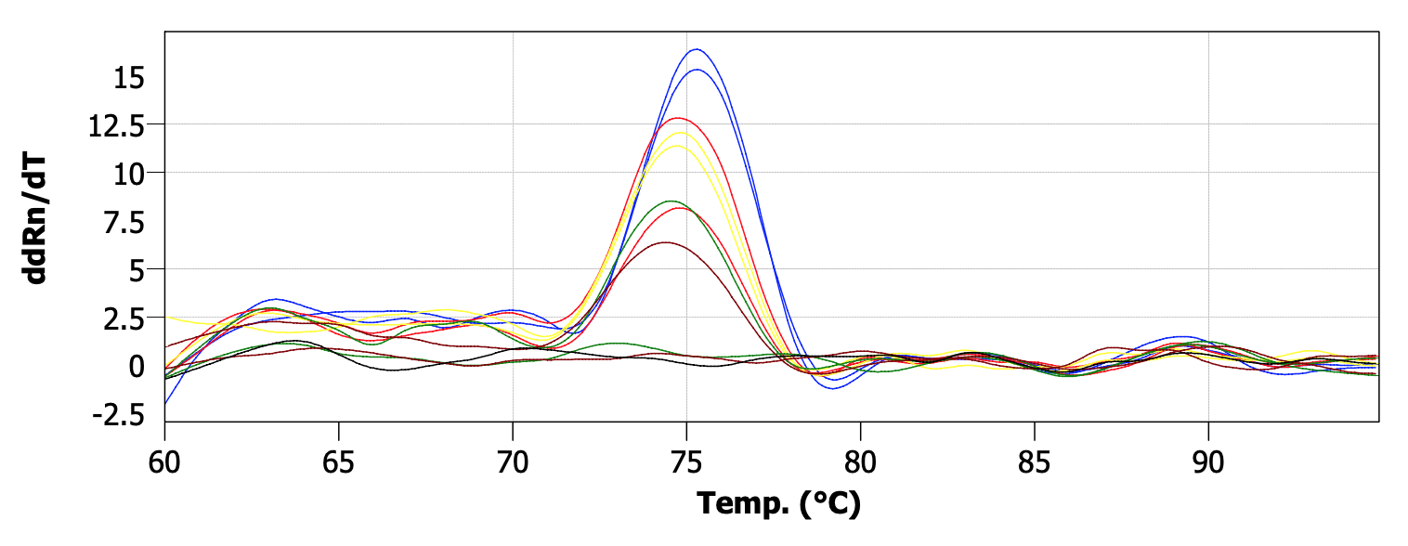
(g)  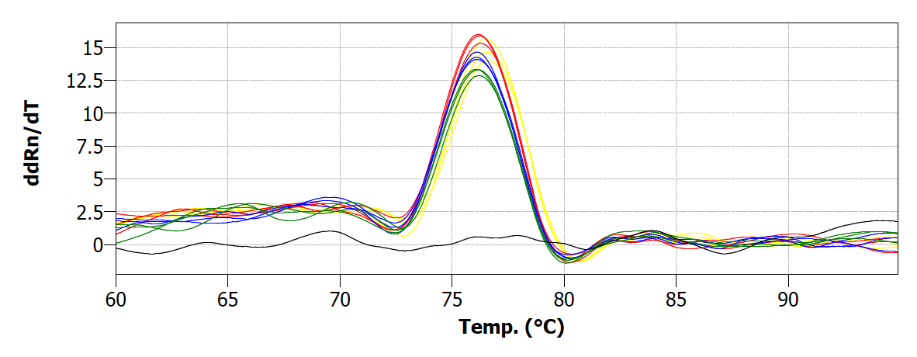 | (h)  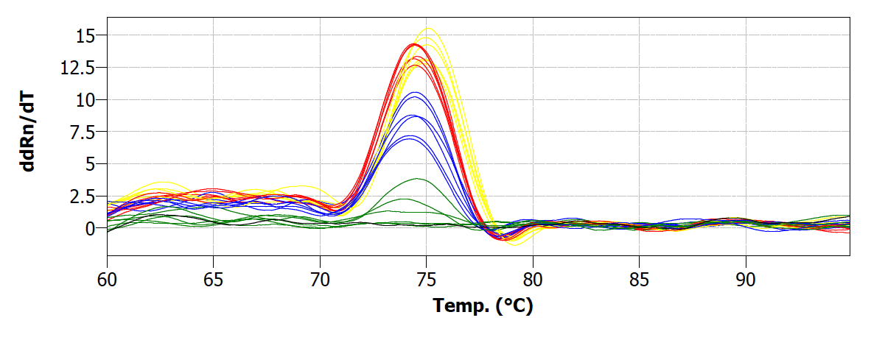
(i)  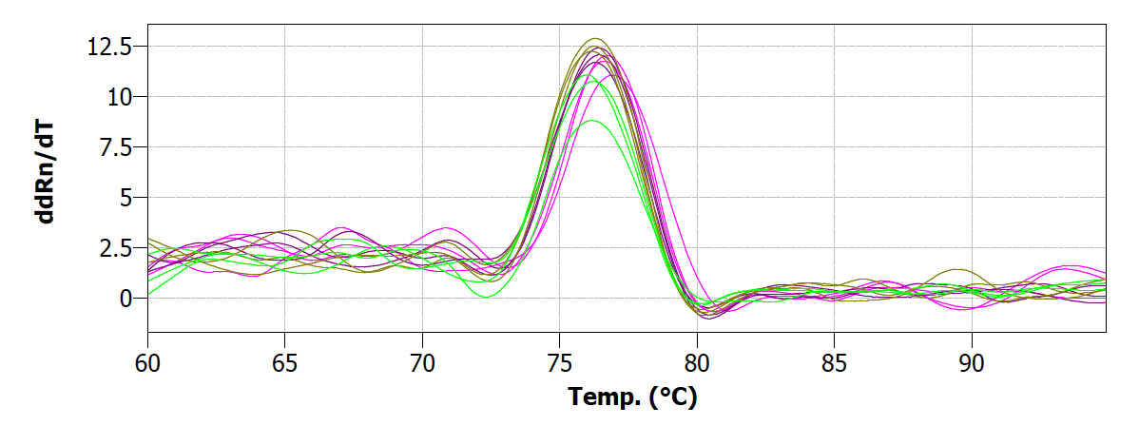 | (j)  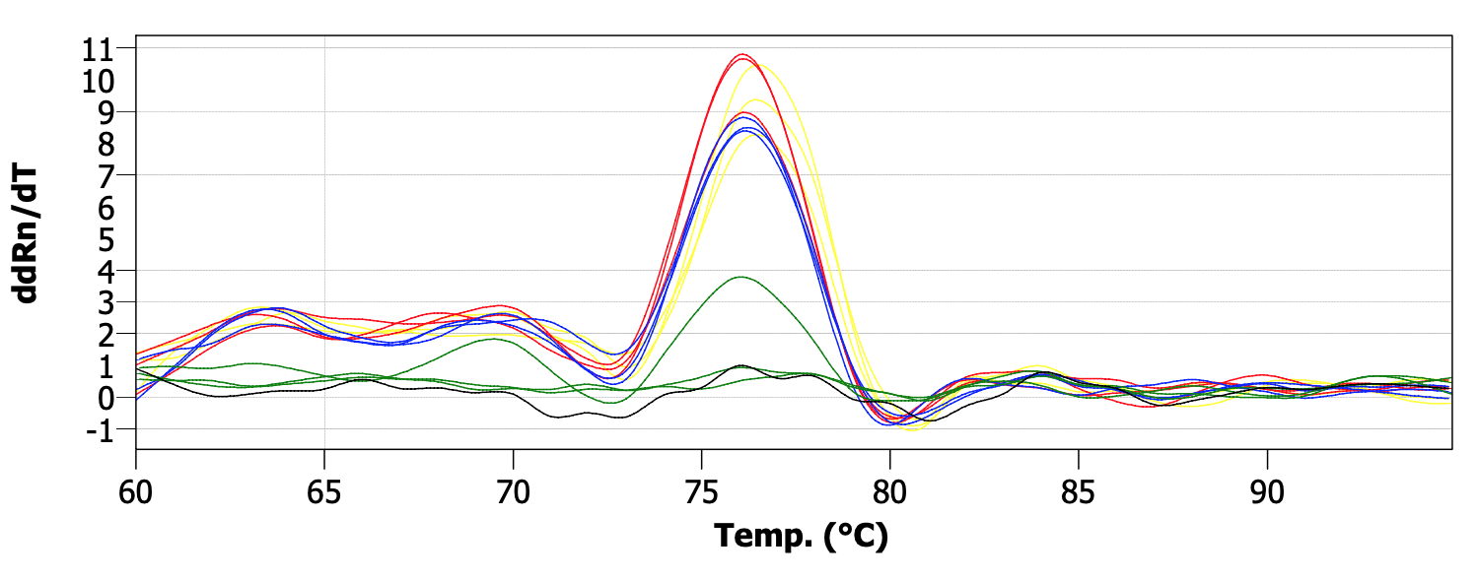
(k)
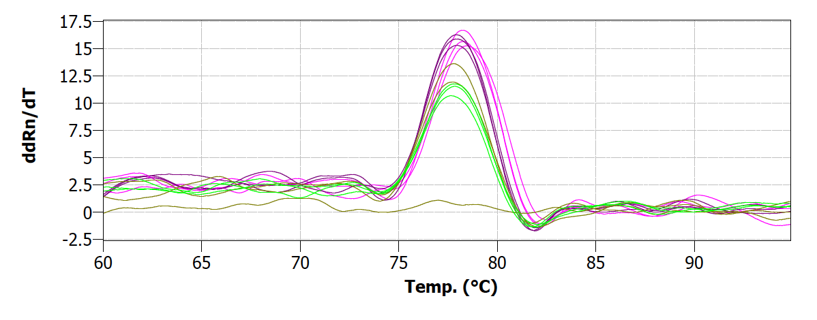
Fig. S3 Amplification specificity of the candidate reference genes and the cuticle biosynthesis-related transcripts (a-h) Melting curve analysis of the candidate reference genes Actin 7 (StACT7) (a), α-tubulin (StTUA) (b), elongation factor 1-alpha (StEF1a) (c), COP1-interactive protein 1 (StCIP1) (d), plasma membrane ATPase 4 (StPMA4) (e), BEL1-like homeodomain protein 1 (StBLH1) (f), polyubiquitin 3 (StUBQ3) (g), and plastidic ATP/ADP-transporter (StTLC1) (h). (i-k) Melting curve analysis of the cuticle biosynthesis-related transcripts cytochrome p450 family 77 subfamily A (StCYP77A) (i), Gly-Asp-Ser-Leu motif lipase/esterase 1 (StGDSL1) (j), and ATP binding cassette transporter family G member 11 (StABCG11) (k). Transcript quantification and melting curve were recorded in a QIAquant 96 5 plex (QIAGEN) following the manufacturer's protocol.

