Additional file 7:

(a)  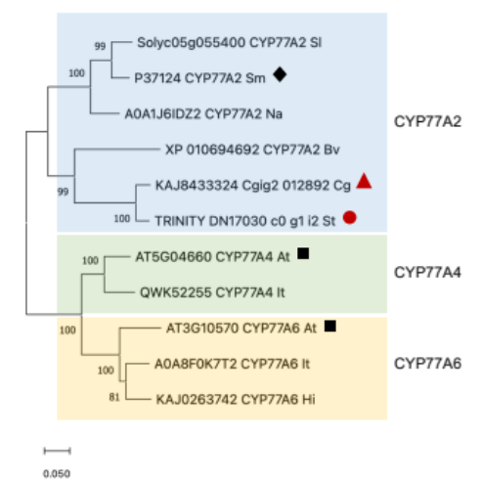 | (b)  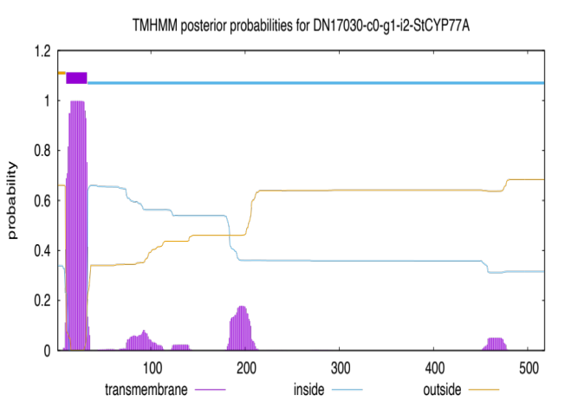
(c)

Fig. S4 Analysis of the predicted protein StCYP77A from Stenocereus thurberi. (a) Phylogenetic tree of StCYP77A and related proteins of the subfamily CYP77A (CYP77A2, CYP77A4, and CYP77A6) from Solanum lycopersicum (Sl), Solanum melongena (Sm), Nicotiana attenuata (Na), Beta vulgaris (Bv), Carnegiea gigantean (Cg), Arabidopsis thaliana (At), Isatis tinctoria (It), and Hirschfeldia incana (Hi). The database accession number is included next to the protein name. The scale bar of 0.05 represented a sequence divergence of 5%. The number in the branches is the percentage bootstrap value of 1000 replicates. The highest percentages represent more significant results. The black square shows AtCYP77A4 and AtCYP77A6 from A. thaliana. The black diamond shows the homologous SmCYP77A2 from S. melongena. The red circle and red triangle show StCYP77A from S. thurberi and a protein from the closest related species C. gigantean, respectively. Neighbor-joining (NJ) phylogenetic tree constructed by MEGA11 software. (b) The predicted membrane-spanning region of StCYP77A. The probability of membrane insertion (Y-axis) and transmembrane region represented by purple color was determined by TMHMM software. (c) Predicted protein domains contained in StCYP77A amino acid sequences determined by InterProScan.

