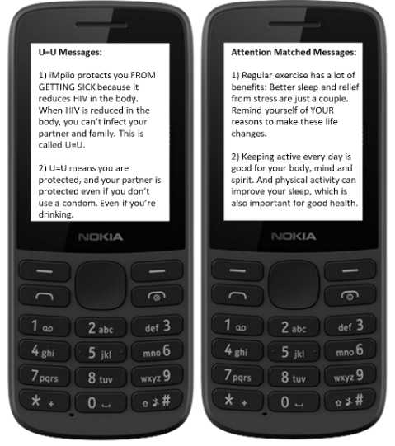
Supplemental Figure 1: Example U=U and Attention Matched SMS monthly booster messages

